

National Pricing Model 2025–26

Risk adjustments for hospital acquired complications

Technical Specifications

March 2025

**National Pricing Model 2025–26 – Risk adjustments for hospital acquired complications – Technical Specifications – March 2025**

© Independent Health and Aged Care Pricing Authority 2025

This publication is available for your use under a Creative Commons Attribution 4.0 International licence, with the exception of the Independent Health and Aged Care Pricing Authority logo, photographs, images, signatures and where otherwise stated. The full licence terms are available from the Creative Commons website.



Use of Independent Health and Aged Care Pricing Authority material under a Creative Commons Attribution 4.0 International licence requires you to attribute the work (but not in any way that suggests that the Independent Health and Aged Care Pricing Authority endorses you or your use of the work).

Independent Health and Aged Care Pricing Authority material used 'as supplied'.

Provided you have not modified or transformed Independent Health and Aged Care Pricing Authority material in any way including, for example, by changing Independent Health and Aged Care Pricing Authority text – then the Independent Health and Aged Care Pricing Authority prefers the following attribution:

Source: The Independent Health and Aged Care Pricing Authority

# Contents

Contents 3

Table of acronyms and abbreviations 5

Glossary of terms 6

1. Introduction 7

1.1 Purpose 7

1.2 Background 7

1.3 Risk adjustment for hospital acquired complications 8

1.4 Changes to HAC risk adjustment model for NEP25 8

2. Hospital Acquired Complication (HAC) 9

2.1 Definition of a HAC 9

2.2 List of HACs 9

2.3 Identification of HACs 10

3. Data preparation 11

3.1 Datasets 11

3.2 Data trimming 12

3.3 Distribution of HACs 14

4. HAC risk adjustment model 16

4.1 Overview 16

4.2 Model description 16

4.3 Risk factors 16

4.4 Assessment of model performance 20

5. Complexity groups, complexity points, complexity scores and complexity bounds 23

5.1 Complexity groups 23

5.2 Complexity points and complexity scores 24

5.3 Complexity bounds 25

6. Incremental cost of a HAC 27

6.1 Overview 27

6.2 Incremental cost model 27

6.3 Ad-hoc modifications to the incremental cost model 28

6.4 Incremental cost of HAC 29

7. Dampening factors and risk adjustments 31

7.1 Overview 31

7.2 How do the dampening factors work? 31

7.3 Calculating the dampening factors and risk adjustment values 32

8. Calculating HAC risk adjusted NWAU 34

8.1 Process to calculate HAC risk adjusted NWAU 34

8.2 Vignettes 35

Appendix A – Risk factor definitions 41

Appendix B – Developing the initial HAC risk adjustment model 43

Appendix C – Selection of and reassessment of risk factors 46

Appendix D – Model performance curves 48

ROC curves 48

PRC curves 51

Appendix E – Complexity points 54

Appendix F – Complexity bounds, dampening factors, risk adjustments and complexity profile distributions 61

Complexity profile distributions 63

Appendix G – Change tracker 68

Appendix H: HAC trajectory over time 69

# Table of acronyms and abbreviations

|  |  |
| --- | --- |
| **Acronym/abbreviation** | **Description** |
| ACHI | Australian Classification of Health Interventions |
| ACS | Australian Coding Standards |
| ADRG | Adjacent diagnosis related group |
| APC | Admitted patient care |
| AR-DRG | Australian Refined Diagnosis Related Groups |
| CAC | Clinical Advisory Committee |
| COAG | Council of Australian Governments |
| COF | Condition onset flag |
| Commission | Australian Commission on Safety and Quality in Health Care |
| GWAU | Gross weighted activity unit |
| HACs | Hospital acquired complications |
| ICD-10-AM | International Statistical Classification of Diseases and Related Health Problems, Tenth Revision, Australian Modification |
| ICU | Intensive care unit |
| IHACPA | Independent Health and Aged Care Pricing Authority |
| MDC | Major diagnostic category |
| NEC | National efficient cost |
| NEP | National efficient price |
| NHCDC | National hospital cost data collection |
| NMDS | National minimum data set |
| NWAU | National weighted activity unit |
| PRC | Precision recall curves |
| ROC | Receiver operating characteristic |
| SEIFA | Socio economic indexes for areas |

# Glossary of terms

|  |  |
| --- | --- |
| **Term** | **Description** |
| Complexity bound  Cut-off point | This refers to the threshold value which separate episodes within a single HAC into its complexity groups. |
| Complexity group | This refers to the grouping of episodes within a single HAC. HAC01-HAC04 and HAC06-14 have three complexity groups (low, moderate and high) while HAC15.02 has two complexity groups (low and high). |
| Complexity point | These are transformed logistic regression estimates for each risk factor variable. |
| Complexity score | This is the sum of complexity points for all risk factors relevant to a single HAC. Each episode of care can have up to 14 complexity scores, one for each HAC. |
| Condition onset flag | This flag is used to identify whether a diagnosis occurred during an episode of admitted care. |
| Dampening factor | This factor dampens the impact of the incremental cost adjustment, based on the complexity of an episode of care. |
| Funding adjustment  Funding reduction | The base price weight multiplied by the largest HAC risk adjustment value (relevant if it is a multi-HAC episode). |
| HAC risk adjusted NWAU | The NWAU of the episode of care minus the funding adjustment or funding reduction amount. |
| HAC risk adjustment | The incremental cost adjustment multiplied by the dampening factor. |
| HAC risk adjustment model | This predicts the likelihood of a specific HAC occurring within an episode of care. It consists of a series of logistic regression models, one for each HAC. |
| Incremental cost of HAC | This refers to the additional cost of a hospital admission due to a HAC. |
| Incremental cost model | This is a logistic regression model that uses AR-DRG and length of stay to predict the cost of non-HAC episodes. |
| Incremental cost adjustment | This refers to the incremental cost of a HAC as an adjustment value. |
| Risk factor | A variable which is associated with the likelihood of a specific HAC occurring within an episode of care. |

# Introduction

## Purpose

This document has been produced as an accompaniment to the National Efficient Price 2025‑26 (NEP25) Determination. It provides the technical specifications for how the Independent Health and Aged Care Pricing Authority (IHACPA) developed the hospital acquired complication (HAC) funding approach and risk adjustment methodology, which has been in effect since 1 July 2018. It also provides guidance to hospitals, local hospital networks (LHNs) and state and territory health authorities on how to apply these to hospital activity.

## Background

In April 2016, all Australian governments signed a Heads of Agreement that committed to improve Australians’ health outcomes and decrease avoidable demand for public hospital services through a series of reforms including the development and implementation of funding and pricing approaches for safety and quality.

The commitment by governments to pricing for safety and quality followed a four-year work program jointly undertaken by IHACPA and the Australian Commission on Safety and Quality in Health Care (the Commission) to undertake research and develop options for incorporating safety and quality into IHACPA’s annual Pricing Framework for Australian Public Hospital Services (the Pricing Framework). One of the outcomes of this collaboration was the development, through a clinician-led process, of an agreed Australian list of HACs.

In August 2016, IHACPA was given a direction by the then Commonwealth Minister for Health and Aged Care, acting under subsection 226(1) of the *National Health Reform Act 2011* (the Act). IHACPA was directed to advise the Council of Australian Governments (COAG) Health Council of options on how funding and pricing could be used to improve patient outcomes across three key areas: sentinel events, HACs and avoidable hospital readmissions (AHRs).

On 30 November 2016, IHACPA provided advice to the COAG Health Council on options for integrating safety and quality into public hospital pricing and funding models. This was informed by feedback from the Consultation Paper on the Pricing Framework for Australian Public Hospital Services 2017‑18.

In February 2017, the Commonwealth Minister for Health directed IHACPA to undertake implementation of three recommendations of the COAG Health Council relating to sentinel events, HACs and AHRs. IHACPA’s decisions in relation to this were set out in the Pricing Framework for Australian Public Hospital Services 2017‑18.

## Risk adjustment for hospital acquired complications

Consistent with ministerial direction, IHACPA was to reduce the funding level for all HACs across every hospital to reflect the extra cost of a hospital admission with a complication by 1 July 2018, subject to the results of a shadow year from 1 July 2017.

In addition to this, IHACPA was required to develop a risk adjustment methodology that would consider different patient complexity levels or specialisation across jurisdictions and hospitals. The design of risk adjustment for safety and quality needed to balance two perspectives, namely that:

* 1. Hospitals which treat more high-risk patients should not be disadvantaged compared to hospitals which treat fewer such patients.
  2. However, from the perspective of patients, high-risk patients want assurance that hospitals take all necessary action to manage their risks and mitigate the occurrence of any adverse events.

This meant that risk adjustment should account for the higher risks experienced by some patients. Pricing and funding approaches should balance the likelihood that some patients will be at higher risk of experiencing an adverse event while ensuring that all hospitals have ongoing responsibility to mitigate risks, to reduce and manage any negative impacts for all patients, and to improve safety and quality systemically.

## Changes to HAC risk adjustment model for NEP25

For NEP25, the model has not been completely re-fit using stepwise regression. The individual Charlson comorbidity conditions (instead of the Charlson Score) continues to be used as risk factors in the HAC risk adjustment model.

All other risk factors remain the same as those used in the original model developed for consultation and presented in the Risk Adjustment Model for Hospital Acquired Complications – Technical Specifications (HAC Technical Specifications) in July 2018. Checks for the significance of risk factors will be carried out in future NEP cycles to ensure that the most appropriate risk factors are being used for each HAC category.

For the NEP25 HAC risk adjustment model, the diagnosis codes used to identify each Charlson comorbidity condition were updated to reflect International Statistical Classification of Diseases and Related Health Problems, Tenth Revision, Australian Modification (ICD-10-AM) Twelfth Edition. The updated list of diagnosis codes used to flag each comorbidity condition is provided in **Appendix A**.

# Hospital Acquired Complication (HAC)

## Definition of a HAC

|  |  |
| --- | --- |
|  | A hospital acquired complication (HAC) refers to a complication for which clinical risk mitigation strategies may reduce (but not necessarily eliminate) the risk of that complication occurring. |

## List of HACs

In 2012, the Commission and IHACPA established a joint working group and over the years have refined and developed the current national list of HACs (the HAC list). The HACs list consists of 16 agreed, high-priority complications which clinicians, managers and others can work together to address and improve patient care.

The development of pricing for HACs in NEP25 has used the HAC list Version 3.1 as at April 2022. This list contains 16 HACs summarised in Table 1. The only change in moving from Version 3.0 to Version 3.1 is the inclusion of mental health cohorts which do not impact HAC counts.

Table 1: List of hospital acquired complications (Version 3.1).[1]

|  |  |
| --- | --- |
| **Number** | **Complication** |
| 1 | Pressure injury |
| 2 | Falls resulting in fracture or intracranial injury |
| 3 | Healthcare-associated infection |
| 4 | Surgical complications requiring unplanned return to theatre |
| 5 | Unplanned intensive care unit admission |
| 6 | Respiratory complications |
| 7 | Venous thromboembolism |
| 8 | Renal failure |
| 9 | Gastrointestinal bleeding |
| 10 | Medication complications |
| 11 | Delirium |
| 12 | Incontinence |
| 13 | Endocrine complications |
| 14 | Cardiac complications |
| 15 | Third and fourth degree perineal laceration during delivery |
| 16 | Neonatal birth trauma |

## Identification of HACs

A HAC is identified using a combination of ICD-10-AM codes to identify the diagnosis and the condition onset flag (COF) to indicate that the diagnosis occurred during the episode of admitted patient care. Some HACs also require other codes to define the complication such as procedure and external cause codes. The latest specifications used to identify HACs, including exclusion criteria, is available on the Commission’s website.[2] For modelling HACs during NEP25, HACs were identified using ICD-10-AM/ACHI/ACS Twelfth edition.

# Data preparation

## Datasets

The development of the risk adjustment model and funding adjustments for HACs used hospital activity and cost data for admitted acute separations.

Three years of hospital activity data were used to develop the risk adjustment model, using the admitted patient care (APC) datasets for the 2020‑21, 2021‑22 and 2022-23 years. These datasets contain episode-level information about the hospital, patient and importantly, diagnoses and COF information which allowed for HAC identification.

Hospital cost data was used in the modelling to determine the incremental cost of a HAC. This data was sourced from the 2020‑21, 2021‑22 and 2022-23 National Hospital Cost Data Collection (NHCDC). These data sources are summarised in Table 2.

Table 2: Data used in the development of pricing for HACs.[3]

|  |  |  |
| --- | --- | --- |
| **Data source** | **Risk adjustment model** | **Incremental cost model** |
| APC 2020-21 | Yes | Yes |
| APC 2021-22 | Yes | Yes |
| APC 2022-23 | Yes | Yes |
| NHCDC 2020-21 | No | Yes |
| NHCDC 2021-22 | No | Yes |
| NHCDC 2022-23 | No | Yes |

## Data trimming

There are two types of trimming applied to the datasets used to develop the risk adjustment model: hospital level and episode level trimming.

### Hospital level trimming

To develop a robust risk adjustment model, the APC data was trimmed such that only records which were of a certain quality and reflective of hospital experience would be included in the modelling dataset. It was particularly important to only retain records from hospitals which had a high quality of COF reporting. This process was carried out at a hospital level.

Three rules were developed to identify whether a hospital would be trimmed:

* 1. Hospitals with fewer than 100 episodes were trimmed. This removed low-volume hospitals where it is not possible to determine the quality of COF reporting.
  2. Hospitals where less than 1% of episodes contained conditions arising in the hospital (that is, where less than 1% of records had a COF = ‘1’ for any diagnosis). This removed hospitals deemed to have unusually few episodes with any condition arising during episode.
  3. Hospitals where more than 10% of episodes had no reported COF (that is, where more than 10% of episodes only reported COF = ‘9’ for all diagnoses). This removed hospitals deemed to have poor quality COF reporting due to the high proportion of unknown condition onset statuses.

The number of hospitals trimmed is summarised in Table 3.

Table 3: Summary of hospitals (and associated episodes) trimmed for NEP25.

|  |  |  |  |
| --- | --- | --- | --- |
|  | **2020-21** | **2021-22** | **2022-23** |
| Total number of hospitals in dataset | 798 | 739 | 729 |
| Number of hospitals trimmed from dataset | 284 | 211 | 208 |
| Percentage of episodes trimmed from dataset | 2.7% | 1.6% | 3.2% |

### Episode level trimming

Records were also trimmed based on characteristics of the episode of care to improve the robustness of the risk adjustment model as some types of admissions would not be expected to receive a HAC. These trimmed records generally fell into three categories.

The first category involved trimming episodes considered to be outliers. This was after discussions with risk adjustment experts Professors Scott and Yong, who advised that including such episodes would disproportionately skew the risk adjustment model. These outlier episodes included:

* 1. Long-stay patients (patients with a length of stay greater than 200 days).
  2. Patients over 95 years old.
  3. Episodes where the patient died.

The second category involved trimming episodes where the admission characteristics could not lead to a HAC or that they were generally not representative of a HAC, as advised by the Commission. This category included:

* 1. Episodes classified as same-day dialysis, chemotherapy or radiotherapy, on the basis that these are high-volume, same-day episodes with very low HAC counts and have the potential to ‘wash’ out the analysis.
  2. Episodes from rehabilitation, mothercraft, psychiatric, other non-acute and unpeered hospitals as these hospitals had a very low prevalence of HAC.

The final category involved trimming episodes considered out-of-scope for the purpose of developing the risk adjustment model and calculating the funding adjustments. This included:

* 1. Episodes not from activity based funding (ABF) public hospitals (that is, private or block-funded hospitals).
  2. Episodes with error or ungroupable end classes.
  3. Episodes containing poor quality data as advised by jurisdictions.

Additionally, episodes with input errors were removed from the in-scope datasets. These include:

* 1. Episodes where the separation date is before the admission date.
  2. Episodes where the admission date is before the birth date.
  3. Episodes where the separation date is before the birth date.
  4. Episodes with the default birth date of 1 January 1900.

### Summary of trimmed records

Table 4 summarises the trimmed hospital activity records for NEP25.

Table 4: Breakdown of trimmed episodes for the 2020‑21, 2021‑22 and 2022-23 activity data.

|  |  |  |  |
| --- | --- | --- | --- |
|  | **Number of episodes** | | |
| **2020-21** | **2021-22** | **2022-23** |
| **Total episodes before trimming** | **7,054,704** | **6,787,446** | **7,067,482** |
| **Breakdown of trimmed episodes** |  |  |  |
| **Non-public hospitals** | 261,386 | 163,576 | 128,339 |
| **Hospital level trimming** |  |  |  |
| Stage 1: low volume | 4,639 | 4,348 | 4,657 |
| Stage 2: COF = 1 less than 1% | 184,759 | 99,359 | 127,539 |
| Stage 3: COF = 9 greater than 10% | 0 | 3,168 | 93,366 |
| **Episode level trimming** |  |  |  |
| Jurisdictional advice | 84,439 | 85,245 | 88,261 |
| Error AR-DRGs | 283 | 990 | 938 |
| Peer group | 2,387 | 2,375 | 1,653 |
| Non-ABF hospital | 167,872 | 208,854 | 200,021 |
| Same-day dialysis | 1,275,733 | 1,299,443 | 1,321,611 |
| Same-day chemotherapy | 293,827 | 309,100 | 311,452 |
| Patient over 95 | 19,594 | 20,616 | 21,907 |
| Death | 29,646 | 34,568 | 35,114 |
| Long stay patient | 133 | 159 | 193 |
| Same-day radiotherapy | 2,859 | 3,397 | 3,485 |
| Input error | 0 | 0 | 0 |
| **Total episodes remaining (untrimmed)** | **4,727,147** | **4,552,248** | **4,728,946** |
| **% of episodes trimmed from public hospitals** | **30.41%** | **31.28%** | **31.85%** |

## Distribution of HACs

The number of episodes identified for each HAC is shown in Table 5. Episodes with multiple HACs have been counted more than once (in their respective HAC) and thus the total HAC episodes will be less than the sum of the individual HAC.

Table 5: Number of HACs identified in 2020‑21, 2021‑22 and 2022-23 activity data.

|  |  |  |  |
| --- | --- | --- | --- |
|  | **Number of episodes** | | |
| **2020-21** | **2021-22** | **2022-23** |
| **Total episodes with a HAC** | **90,924** | **86,806** | **89,350** |
| **% of untrimmed episodes with a HAC** | **1.9%** | **1.9%** | **1.9%** |
| **Breakdown of episodes by HAC** |  |  |  |
| 1 Pressure Injury | 1,370 | 1,511 | 1,651 |
| 2 Falls resulting in fracture or intracranial injury | 1,341 | 1,517 | 1,652 |
| 3 Healthcare-associated infection | 33,019 | 33,650 | 35,572 |
| 4 Surgical complications requiring unplanned return to theatre | 17,116 | 14,004 | 14,341 |
| 5 Unplanned intensive care unit admission[4] | n/a | n/a | n/a |
| 6 Respiratory complications | 9,660 | 10,087 | 9,955 |
| 7 Venous thromboembolism | 3,037 | 2,998 | 3,113 |
| 8 Renal failure | 454 | 426 | 399 |
| 9 Gastrointestinal bleeding | 3,091 | 2,963 | 3,178 |
| 10 Medication complications | 2,831 | 2,152 | 2,172 |
| 11 Delirium | 15,211 | 14,719 | 15,026 |
| 12 Incontinence | 1,422 | 1,143 | 1,120 |
| 13 Endocrine complications | 9,157 | 9,550 | 9,586 |
| 14 Cardiac complications | 12,780 | 11,396 | 11,869 |
| 15 Third and fourth degree perineal laceration during delivery | 4,642 | 4,582 | 4,029 |
| 16 Neonatal birth trauma | 1,084 | 1,025 | 1,003 |

# HAC risk adjustment model

## Overview

IHACPA notes the need to balance the perspectives of both hospitals and patients when incorporating safety and quality into pricing. Hospitals that treat high-risk patients should not be disadvantaged compared to hospitals that treat fewer such patients. Likewise, high risk patients should have confidence that hospitals take all necessary actions to manage their risks and mitigate the occurrence of adverse events.

The equitable risk adjustment criterion used by IHACPA states that:

|  |  |
| --- | --- |
|  | Pricing and funding approaches should balance the likelihood that some patients will be at higher risk of experiencing an adverse event while recognising that all hospitals have scope to improve safety and quality. |

**Appendix B** contains details of the development leading up to the implementation of the HAC risk adjustment model in the national pricing model.

## Model description

The HAC risk adjustment model consists of a series of logistic regression models, one for each HAC. The logistic regression models calculate a loading for each risk factor relevant to the HAC category. The model predictors (also referred to as ‘risk factors’) for each HAC are different and are detailed in the next section.

## Risk factors

Table 6 outlines the individual risk factors used as predictors for each HAC logistic regression model.

The risk factors for all HACs have largely remained unchanged since the introduction of a safety and quality adjustment for HACs into the national pricing model back in NEP18. For NEP24, there was a change to replace the Charlson Score with its constituent individual comorbidity conditions as risk factors for all HACs except for HAC15.02 which did not use Charlson Score as a risk factor in the first place.

The risk factors for HAC15.02 Fourth degree perineal laceration during delivery remain unchanged since their introduction in NEP20.

The process used to select the risk factors for each HAC is outlined in **Appendix C**. Risk factors which were previously considered but dropped are discussed in Appendix C. The underlying ICD-10-AM/ACHI/ACS codes used to flag various risk factors is outlined in Appendix A.

Table 6: Risk factors adopted for each HAC in the HAC risk adjustment model.

|  |  |  |  |  |  |  |  |  |  |  |  |  |  |  |
| --- | --- | --- | --- | --- | --- | --- | --- | --- | --- | --- | --- | --- | --- | --- |
| **Risk factors** | **1. Pressure injury** | **2. Falls resulting in fracture or intracranial injury** | **3. Healthcare-associated infection** | **4. Surgical complications requiring unplanned return to theatre** | **6. Respiratory complications** | **7. Venous thromboembolism** | **8. Renal failure** | **9. Gastrointestinal bleeding** | **10. Medication complications** | **11. Delirium** | **12. Incontinence** | **13. Endocrine complications** | **14. Cardiac complications** | **15.02 Fourth degree perineal laceration during delivery** |
| Emergency admission status[5] | ✓ | ✓ | ✓ | ✓ | ✓ | ✓ | ✓ | ✓ | ✓ | ✓ | ✓ | ✓ | ✓ | ✓ |
| Patient age | ✓ | ✓ | ✓ | ✓ | ✓ | ✓ | ✓ | ✓ | ✓ | ✓ | ✓ | ✓ | ✓ | ✓ |
| Major diagnosis category 11 | ✓ | ✓ | ✓ | ✓ | ✓ | ✓ | ✓ | ✓ | ✓ | ✓ | ✓ | ✓ | ✓ |  |
| Intensive care unit status | ✓ | ✓ | ✓ | ✓ | ✓ | ✓ | ✓ | ✓ | ✓ | ✓ | ✓ | ✓ | ✓ |  |
| AR-DRG11 type | ✓ | ✓ | ✓ | ✓ | ✓ | ✓ | ✓ | ✓ | ✓ | ✓ | ✓ | ✓ | ✓ |  |
| Acute myocardial function | ✓ | ✓ | ✓ | ✓ | ✓ | ✓ | ✓ | ✓ | ✓ | ✓ | ✓ | ✓ | ✓ |  |
| Congestive heart failure | ✓ | ✓ | ✓ | ✓ | ✓ | ✓ | ✓ | ✓ | ✓ | ✓ | ✓ | ✓ | ✓ |  |
| Peripheral vascular disease | ✓ | ✓ | ✓ | ✓ | ✓ | ✓ | ✓ | ✓ | ✓ | ✓ | ✓ | ✓ | ✓ |  |
| Cerebral vascular accident | ✓ | ✓ | ✓ | ✓ | ✓ | ✓ | ✓ | ✓ | ✓ | ✓ | ✓ | ✓ | ✓ |  |
| Dementia | ✓ | ✓ | ✓ | ✓ | ✓ | ✓ | ✓ | ✓ | ✓ | ✓ | ✓ | ✓ | ✓ |  |
| Pulmonary disease | ✓ | ✓ | ✓ | ✓ | ✓ | ✓ | ✓ | ✓ | ✓ | ✓ | ✓ | ✓ | ✓ |  |
| Connective tissue disorder | ✓ | ✓ | ✓ | ✓ | ✓ | ✓ | ✓ | ✓ | ✓ | ✓ | ✓ | ✓ | ✓ |  |
| Peptic ulcer | ✓ | ✓ | ✓ | ✓ | ✓ | ✓ | ✓ | ✓ | ✓ | ✓ | ✓ | ✓ | ✓ |  |
| Liver disease | ✓ | ✓ | ✓ | ✓ | ✓ | ✓ | ✓ | ✓ | ✓ | ✓ | ✓ | ✓ | ✓ |  |
| Diabetes | ✓ | ✓ | ✓ | ✓ | ✓ | ✓ | ✓ | ✓ | ✓ | ✓ | ✓ | ✓ | ✓ |  |
| Diabetes complications | ✓ | ✓ | ✓ | ✓ | ✓ | ✓ | ✓ | ✓ | ✓ | ✓ | ✓ | ✓ | ✓ |  |
| Paraplegia | ✓ | ✓ | ✓ | ✓ | ✓ | ✓ | ✓ | ✓ | ✓ | ✓ | ✓ | ✓ | ✓ |  |
| Renal disease | ✓ | ✓ | ✓ | ✓ | ✓ | ✓ | ✓ | ✓ | ✓ | ✓ | ✓ | ✓ | ✓ |  |
| Cancer | ✓ | ✓ | ✓ | ✓ | ✓ | ✓ | ✓ | ✓ | ✓ | ✓ | ✓ | ✓ | ✓ |  |
| Metastatic cancer | ✓ | ✓ | ✓ | ✓ | ✓ | ✓ | ✓ | ✓ | ✓ | ✓ | ✓ | ✓ | ✓ |  |
| Severe liver disease | ✓ | ✓ | ✓ | ✓ | ✓ | ✓ | ✓ | ✓ | ✓ | ✓ | ✓ | ✓ | ✓ |  |
| Human Immunodeficiency Virus (HIV) | ✓ | ✓ | ✓ | ✓ | ✓ | ✓ | ✓ | ✓ | ✓ | ✓ | ✓ | ✓ | ✓ |  |
| Sex[6] |  | ✓ | ✓ |  | ✓ | ✓ | ✓ | ✓ | ✓ | ✓ | ✓ |  |  |  |
| Admission transfer status | ✓ | ✓ | ✓ | ✓ | ✓ | ✓ |  | ✓ | ✓ | ✓ | ✓ | ✓ | ✓ |  |
| Fetal distress |  |  |  |  |  |  |  |  |  |  |  |  |  | ✓ |
| Instrument use |  |  |  |  |  |  |  |  |  |  |  |  |  | ✓ |
| Persistent posterior occiput presentation |  |  |  |  |  |  |  |  |  |  |  |  |  | ✓ |
| Young and mature aged primigravida |  |  |  |  |  |  |  |  |  |  |  |  |  | ✓ |

## Assessment of model performance

IHACPA has generally used receiver operating characteristic (ROC) curves to measure the performance of the HAC risk adjustment model and early iterations of the readmissions risk adjustment model. However, ROC curve metrics alone may not clearly reflect significant changes in model performance where the number of episodes with no HACs is far greater than the number of episodes with at least one HAC. To account for this, IHACPA has computed precision recall curves (PRC), which are more informative that ROC curves on highly unbalanced data, alongside ROC curves in evaluating the HAC risk modelling.

**Appendix D** provides the ROC and PRC curves for each HAC in the HAC risk adjustment model.

### 4.4.1 Receiver operating characteristic curve

The ROC curve is an analytical method that can be used to evaluate a model’s ability to predict a binary outcome. In the context of the HAC risk adjustment model, we seek to evaluate the ability of this model to identify an episode with a HAC.

The ROC curve is a parametric plot of the true positive rate (TPR) versus the false positive rate (FPR) of the model where:

* 1. the TPR is the proportion of observations that are correctly predicted to be positive out of all positive observations; that is, how well does the model correctly predict the occurrence of a HAC in an episode.
  2. the FPR is the proportion of observations that are incorrectly predicted to be positive out of all negative observations; that is, how often does the model incorrectly predict the occurrence of a HAC for episodes which don’t have a HAC.

The ROC graph plots both parameters against a theoretical threshold varied between 0 and 1 to illustrate the tradeoff between TPR and FPR at different threshold values.

Figure 1: Example of ROC curves

A sample ROC curve plot is provided in Figure 1. This example plot is for a general system, rather than the HAC model itself and is purely explanatory. A ROC curve lying on the diagonal line (grey line) is reflective of a model that performs no better than chance level (random guessing). The closer the ROC curve is to the upper lefthand corner, the better the model can discriminate between two outcomes (by maximising the TPR and minimising the FPR). With reference to Figure 1, it shows that Model A (red line) performs better than Model B (blue line). In the context of the HAC risk adjustment model, this means that Model A is better at predicting the occurrence of a HAC in an admitted episode of care than Model B.

The area under the ROC curve (AUROC) provides an aggregate measure of the performance of the model across all the thresholds, and its value ranges between 0 and 1. A model that will predict 100% of categories wrong has an AUROC of 0.0 and a model which predicts all positive classes with 100% accuracy has an AUROC of 1.0. A model with an AUROC of 0.5 (also referred to as the baseline) is represented by the grey diagonal line in the graph. In Figure 1, Model A has a higher AUROC than Model B which indicates that the former model performs better than the latter model and this result is consistent with their respective ROC curves.

The issue with using the ROC curve to assess model performance on imbalanced data is that the rates (TPR and FPR) being compared have different denominators, the former’s denominator being the count of positive events and the latter’s denominator being the count of negative events. In the three years of data used in the HAC model, there are usually around 14 million negative events (i.e. episodes without a HAC). For each HAC group, the number of positive events (i.e. episodes with a HAC) are much lower, ranging from around 600 positive events for HAC15.02 to around 100,000 positive events for HAC03. Taking these figures into consideration and with reference to Figure 1, this effectively means that each incremental increase in the true positive rate (i.e. correctly identified HAC episodes) comes with an exponential increase in the false positive rate (i.e. number of incorrectly identified HAC episodes). Note that these figures are used for comparison of risk models only; in practice, risk models assign a probability and do not use thresholds to assign definite positive/negative outcomes.

### 4.4.2 Precision recall curve

The precision recall curve (PRC) is a complement to the ROC curve. It may give additional insight when evaluating model performance on imbalanced data.

The PRC curve is parametric plot of the precision and recall of the model where:

* 1. Precision is the number of true positives out of all the predicted positives, meaning the number of episodes which actually had a HAC out of those predicted to have had a HAC.
  2. Recall is another name of the true positive rate and represents how successful the model is in identifying an episode with a HAC. That is, the number of HAC episodes that the model can successfully identify out of all the HAC episodes in the data set.

The PRC graph plots both parameters against a theoretical threshold varied between 0 and 1 to illustrate the tradeoff between precision and recall at different threshold values.

Figure 2: Example of PRC curve

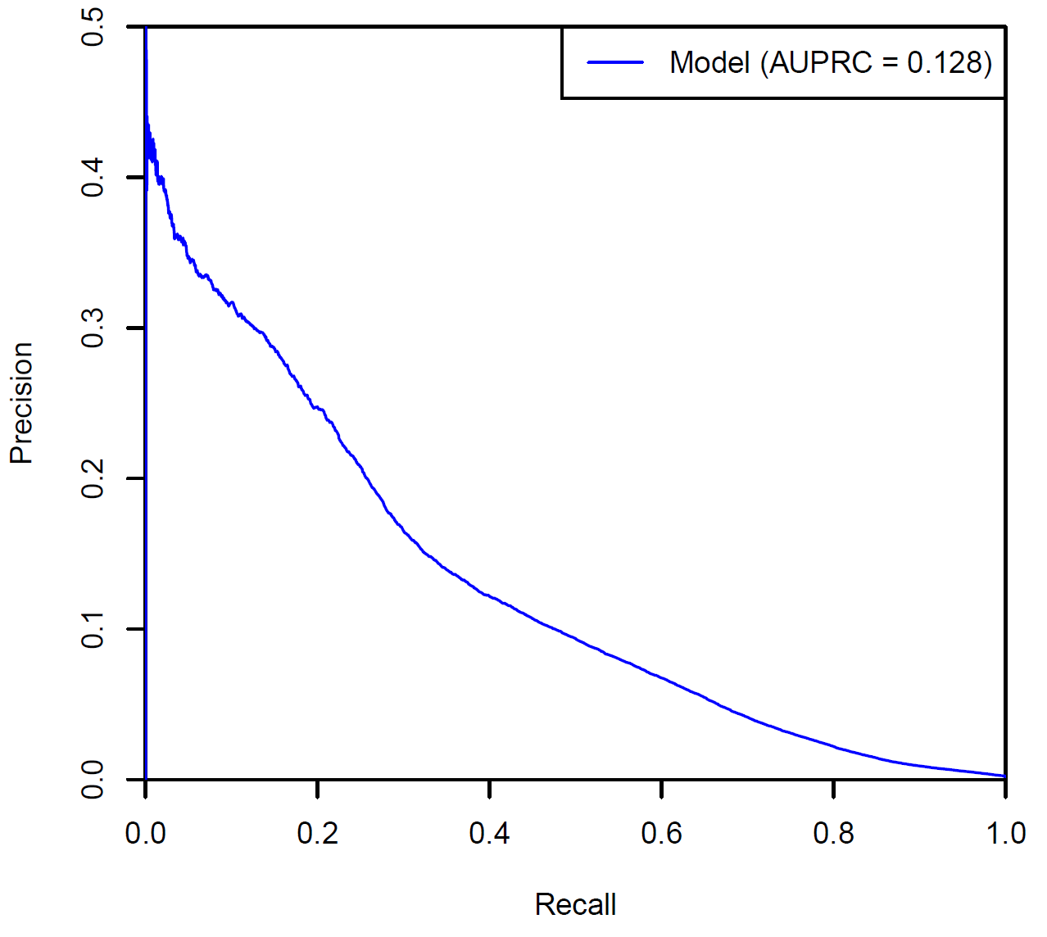

A sample PRC curve is provided in Figure 2. The closer the PRC curve is to the upper righthand corner, the better the model can discriminate between two outcomes (by maximising the precision and recall and thereby maximising the area under the curve).

The area under the PRC curve (AUPRC) provides an aggregate measure of the performance of the model across all thresholds. A higher AUPRC represents both high recall and high precision which is indicative of a better performing model. Generally, the AUPRC is considerably smaller in magnitude than the AUROC for the same model since the baseline is calculated as the proportion of positive observations over total observations which generally less than 0.5 in real-world datasets.

# Complexity groups, complexity points, complexity scores and complexity bounds

## Complexity groups

As noted in Section 1.3, the risk adjustment methodology of HACs is required to consider different patient complexity levels or specialisation across jurisdictions and hospitals. This is achieved through the creation of complexity groups for each HAC, with differing risk adjustments applied based on the complexity. Each HAC is split into three complexity groups (low, moderate and high). HAC15.02 only has two complexity groups (low and high). These complexity groups are set up such that patients at a higher risk of experiencing an adverse event are classified as ‘high complexity’ and attract a lower funding adjustment. Conversely, patients with a low risk of experiencing an adverse event are classified as ‘low complexity’ and attract a higher funding adjustment.

|  |  |
| --- | --- |
|  | The assignment of complexity group is undertaken separately for each HAC flagged in the episode, since there are separate risk adjustment models for each HAC:   * + A complexity score is calculated for each HAC in the episode based on the different risk factors relevant to that HAC.   + The complexity score is then compared to complexity bounds for that HAC to determine the complexity group for that HAC.   This effectively means that an episode can have up to 14 different complexity scores and complexity groups assigned, one for each HAC. |

To enable the assignment of complexity group for each HAC in the episode, IHACPA undertakes the following key steps:

1. Converts logistic regression estimates from the risk adjustment model into complexity points, which are summed together to calculate the complexity score for each HAC.
2. Determines complexity bounds for each HAC, to enable assignment of a low, moderate or high complexity group for each HAC in the episode.

## Complexity points and complexity scores

The logistic regression estimates for each risk factor variable coming out of the risk adjustment model (and the intercept term) are transformed into complexity points. See **Appendix E** for the complete breakdown of complexity points for each risk factor, for each HAC.

Table 7 provides an illustrative example of the conversion of estimates to complexity points for HAC02 (falls resulting in facture or intracranial injury). It shows that older patients are assigned a higher complexity points value.

Table 7: HAC02 – Falls resulting in fracture or intracranial injury – Patient age complexity points.

|  |  |  |  |
| --- | --- | --- | --- |
| **Parameters** | **Group** | **Estimate value** | **Complexity point value** |
| Age group | 000 to 039 | 0 | 0 |
| 040 to 049 | 0.7728 | 3.8642 |
| 050 to 054 | 1.1157 | 5.5785 |
| 055 to 059 | 1.3736 | 6.8682 |
| 060 to 064 | 1.5957 | 7.9784 |
| 065 to 069 | 1.7203 | 8.6017 |
| 070 to 074 | 1.8823 | 9.4117 |
| 075 to 079 | 2.2229 | 11.1147 |
| 080 to 084 | 2.5861 | 12.9305 |
| 085 to 089 | 2.8029 | 14.0145 |
| 090 to 099 | 2.9582 | 14.7912 |

Based on the attributes of the episode, the complexity points for each risk factor variable are summed together to calculate the episode’s complexity score for that HAC. The complexity score is set up to fall between zero and 100. Zero is set with reference to an extremely low-risk profile in the model (i.e. the lowest chance of acquiring that HAC), and 100 is set with reference to an extremely high-risk profile in the model. The complexity score is not an indication of the probability of a HAC occurring in an episode.

|  |  |
| --- | --- |
|  |  |

Refer to Section 8.2 for examples on how the complexity points are used to calculate the complexity scores.

Figure 3 shows the non-HAC and HAC complexity profiles for HAC10 (medication complications). The x-axis shows the complexity score values. The left y-axis displays the percentage of episodes with a specific complexity score value (relevant for the non-HAC and HAC distributions). The right y-axis lists probability values for the red line which shows the probability of a HAC at each complexity score value. In general, episodes with a HAC are assigned a higher complexity score compared to episodes without a HAC (non-HAC).

Figure 3: HAC10 – Medication complications – Complexity profile.

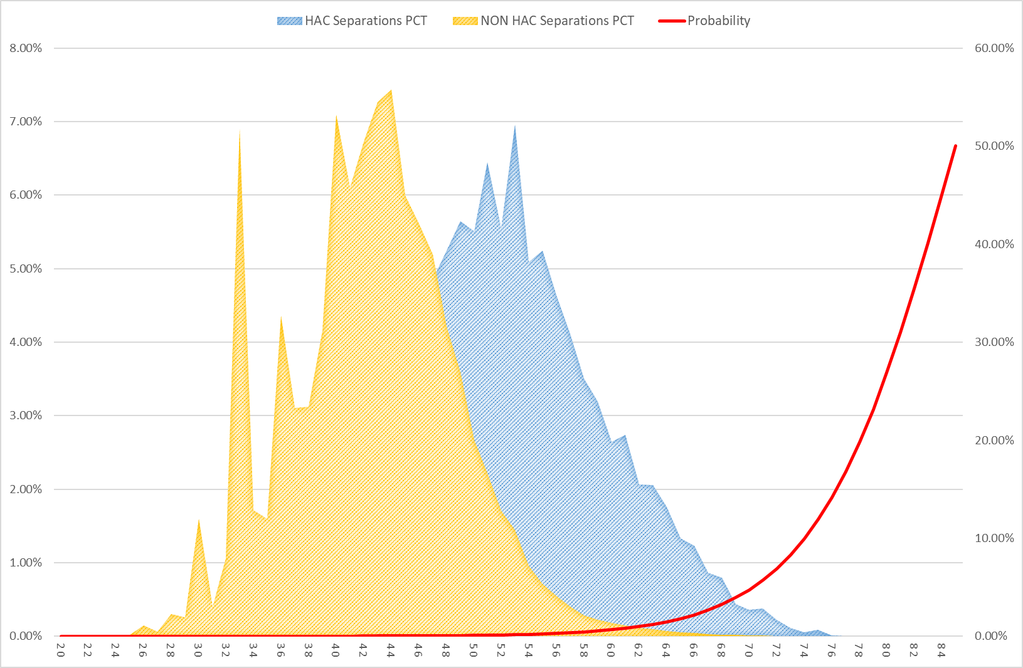

## Complexity bounds

There are three complexity groupings of ‘low’, ‘moderate’ and ‘high’ for each HAC. This has been adopted to provide an optimal balance between complexities, risk homogeneity and sample size within each complexity group. Due to the small cohort for HAC15.02, only two complexity groupings of ‘low’ and ‘high’ have been adopted.

To assign a complexity group for each HAC in an episode of care, IHACPA determined complexity bounds (or cut-off points) to separate low and moderate complexity episodes, and moderate and high complexity episodes (or just low and high complexity for HAC15.02). The process to calculate the complexity bounds involved:

1. Calculating the cumulative distribution of probability-weighted episodes with a HAC.
2. Determining the complexity score which divides the cumulative distribution into three quantiles (or two quantiles for HAC15.02).

The complexity bounds represent the lowest complexity score required to be assigned to a complexity group.

Figure 4 shows the HAC10 (medication complications) complexity profile with its complexity bounds and corresponding average weighted probabilities for each complexity group. Refer to **Appendix F** for the non-HAC and HAC complexity profiles, including the complexity bounds and weighted probabilities, for all HAC categories.

Figure 4: HAC10 – Medication complications – Complexity bounds.

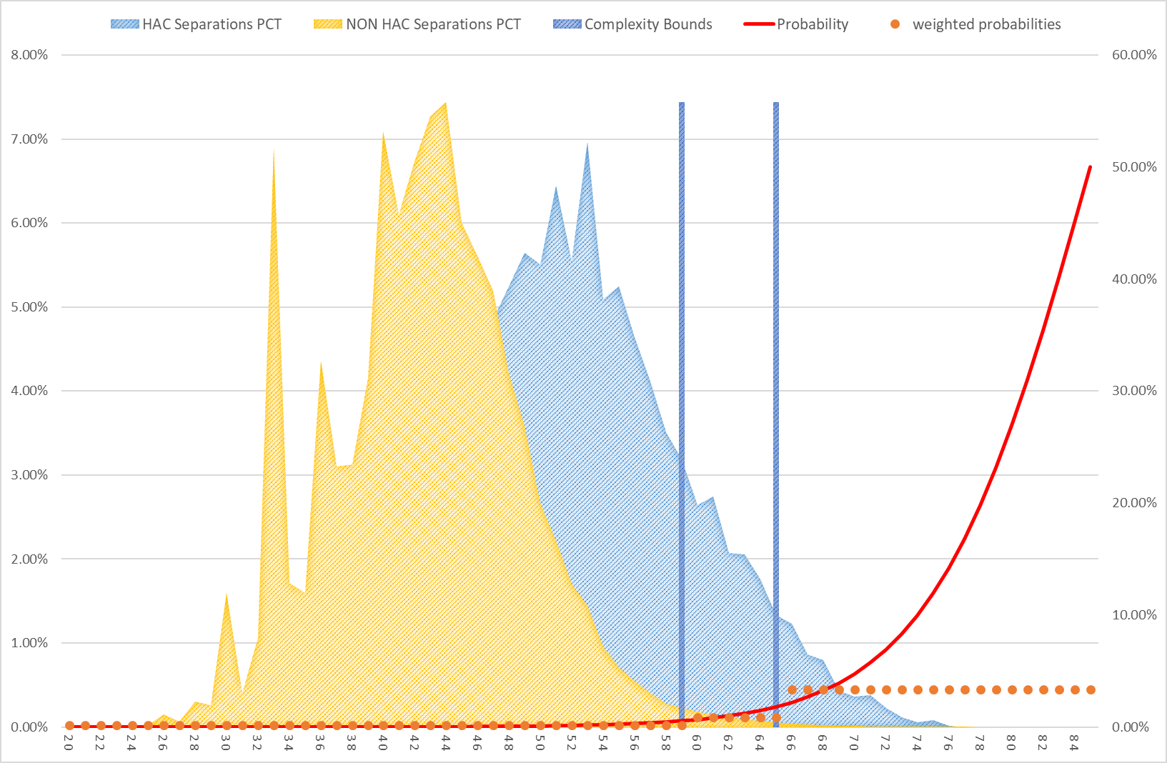

|  |  |  |  |  |  |  |  |  |  |
| --- | --- | --- | --- | --- | --- | --- | --- | --- | --- |
|  | **Example: How to assign complexity group based on complexity bounds**   |  |  | | --- | --- | | **Complexity group** | **Complexity bounds** | | Low | 1 | | Moderate | 59 | | High | 65 |   This means that episodes with a complexity score:   * + Greater than or equal to 65 are assigned to the high complexity group.   + Greater than or equal to 59, and less than 65, are assigned to the moderate complexity group.   + Less than 59 are assigned to the low complexity group. |

# Incremental cost of a HAC

## Overview

The funding approach for HACs requires that the funding level for all HACs across every hospital be reduced to reflect the extra cost of a hospital admission with a complication. This additional cost may be the result of a more complex episode of stay or due to an increase in the length of stay than would have otherwise occurred.

Therefore, it is necessary to determine the value of only the incremental cost relating to the HAC and use this as the basis of the funding adjustment. There are several challenges to this:

1. In episodes that contain a HAC, it is impossible to identify what components of the cost directly result from the HAC in the NHCDC data.
2. The presence of a HAC may increase the length of stay, but it is impossible to determine the additional length of stay directly attributable to the HAC in the current data collections as there is no record of the date that the HAC occurred.
3. The presence of a HAC may increase the complexity of an episode (resulting in a more complex AR-DRG) and this may confound analysis to determine the incremental cost and how an episode should be classified.

The following sections describe the methodology used to determine the incremental cost of a HAC.

## Incremental cost model

The methodology used to determine the incremental cost of a HAC uses similar principles to that adopted for the national cost models, in that it uses linear regression to predict the cost of an episode. The incremental cost model uses the episode’s AR-DRG and length of stay as predictors since these characteristics represent the most significant drivers of cost. Other drivers of avoidable costs included in the national cost models such as remoteness and Indigenous status were not included to retain simplicity. These cost drivers may be considered in future refinements of the model.

Three years of activity and cost data were used for the incremental cost model and the model was fit using untrimmed episodes only. The approach taken to determining the incremental cost can be summarised in the following steps:

1. A ‘best fit’ model was developed using a length of stay by AR-DRG linear regression to predict the cost of non-HAC episodes only. This model provides the best estimate for a cost of an episode with no HAC occurrence.
2. The modelled parameters were then applied to HAC episodes (using AR-DRG and length of stay) to calculate a predicted cost. This is the cost predicted for the HAC episode with the same AR-DRG and length of stay, but assuming that the HAC was not present.
3. A cost ratio was then calculated to compare actual in-scope cost to the predicted cost for the HAC episodes.

$$\text{Cost ratio} \text{=}\frac{\text{Actual in-scope cost}}{\text{Predicted cost}}$$

Under the hypothesis that a HAC leads to greater cost, it would be expected that the actual in scope cost of a HAC episode would be greater than what is predicted for a non-HAC episode with the same AR-DRG and length of stay. This would result in a cost ratio which is greater than 1.0 for HAC episodes.

This cost ratio forms the basis of the incremental cost calculation and was carried out for all HAC episodes in aggregate, as well as each HAC separately to determine whether the incremental cost varied between HACs.

This approach was considered appropriate because of its relative simplicity, using a ‘best fit’ model that accounts for the main drivers of cost. Several modifications were made the incremental cost model to improve the overall results of the model as described below.

## Ad-hoc modifications to the incremental cost model

### Low volume AR-DRGs and cost ratios less than 1

The overall HAC rates observed in the activity data are generally low and therefore, HAC episodes can be very volatile by AR-DRG. Some AR-DRGs also have a low volume of non-HAC episodes which results in greater instability in the modelled parameters coming out of the incremental cost model.

In some cases, the cost ratio of HAC episodes for some AR-DRGs are less than 1.0 despite HAC episodes being more costly than non-HAC episodes at the aggregate and HAC level. Some AR-DRGs have substantially more HAC episodes compared to non-HAC episodes, which skews the cost ratio calculation. This is the case for some of the obstetrics AR-DRGs which in particular, impacts results for HAC 15.02 (fourth degree perineal laceration during delivery).

As a result, the decision was made to trim AR-DRGs where the cost ratio was below 1.0 and calculate the aggregate cost ratio for the HAC on the remaining AR-DRGs.

### Treatment of HAC02 and HAC12

HAC02 (falls resulting in fracture or intracranial injury) and HAC12 (incontinence) have a very low number of HAC episodes, leading to less robust incremental cost calculations compared to other HACs. In particular, the incremental cost for HAC episodes in these two groups are very close to 1.0. This suggests that the actual in-scope cost of a HAC episode is almost equal to the predicted cost of the episode if it didn’t have a HAC, which is counterintuitive.

The decision was made to implement an alternative approach for HAC02 and HAC12, by using the regrouped AR-DRG in the incremental cost calculation. This regrouped AR-DRG is determined by grouping the episode’s AR-DRG after removing all HAC-triggering diagnosis and surgical codes (i.e. determining the episode’s AR-DRG as if the HAC did not occur). This approach acknowledges that the presence of a HAC has the potential to increase the complexity of the episode, thereby increasing the complexity of the episode’s AR-DRG. Using the original AR-DRG to apply the modelled parameters could result in the episode being compared to significantly more costly episodes in that AR-DRG for reasons other than the HAC.

This alternative approach applies the incremental cost model parameters based on the regrouped AR-DRG instead of the original AR-DRG. This results in a lower predicted cost, and all else being equal, a potentially higher cost ratio.

The argument could be made that the incremental cost model parameters should be applied based on regrouped AR‑DRG for all HACs. However, current price weights for the AR‑DRGs are developed using a mix of HAC and non-HAC episodes for that AR‑DRG and accordingly, the funding adjustment should be calibrated using the same AR‑DRG assignments.

### Treatment of HAC15.02

When a fourth degree perineal laceration occurs during delivery (HAC15.02), the episode’s ADRG usually changes from O60 Vaginal Delivery to O02 Vaginal Delivery with GIs. Therefore, it is not appropriate to use the original AR-DRG to determine the predicted non-HAC cost of episodes with HAC15.02.

Therefore, the incremental cost model parameters are also applied based on the regrouped AR-DRG for HAC15.02, which results in a more accurate predicted cost and cost ratio.

## Incremental cost of HAC

Table 8 summarises the final incremental cost of a HAC for each HAC and overall (across all HACs). The ad-hoc modifications detailed in Section 6.3 have been applied to these results.

The final incremental cost for each HAC is then converted into adjustment values using the formula:

$$\text{Adjustment =} \text{1} \text{-} \frac{\text{1}}{\text{1 +} \text{Incremental cost}}$$

These adjustment values form the basis for determining the reduction in funding due to a HAC.

Table 8: Incremental cost of a HAC and incremental cost adjustments by HAC (rounded to 1 decimal place).[7]

|  |  |  |
| --- | --- | --- |
| **Complication** | **Incremental cost** | **Incremental cost adjustment** |
| **All HACs** | **9.8%** | **8.9%** |
| 1 Pressure injury | 16.7% | 14.3% |
| 2 Falls resulting in fracture or intracranial injury | 3.7% | 3.6% |
| 3 Healthcare-associated infection | 9.6% | 8.8% |
| 4 Surgical complications requiring unplanned return to theatre | 13.5% | 11.9% |
| 5 Unplanned intensive care unit admission | n/a | n/a |
| 6 Respiratory complications | 16.4% | 14.1% |
| 7 Venous thromboembolism | 13.8% | 12.1% |
| 8 Renal failure | 25.6% | 20.4% |
| 9 Gastrointestinal bleeding | 11.0% | 9.9% |
| 10 Medication complications | 12.1% | 10.8% |
| 11 Delirium | 12.1% | 10.8% |
| 12 Incontinence | 7.9% | 7.3% |
| 13 Endocrine complications | 9.7% | 8.9% |
| 14 Cardiac complications | 14.3% | 12.5% |
| 15.01 Third degree perineal laceration during delivery | n/a | n/a |
| 15.02 Fourth degree perineal laceration during delivery | 48.9% | 32.8% |
| 16 Neonatal birth trauma | n/a | n/a |

# Dampening factors and risk adjustments

## Overview

As discussed in Section 5.1, the funding approach for HACs is risk adjusted to consider different patient complexity levels or specialisation across jurisdictions and hospitals. This is achieved through the construction of dampening factors which vary depending on the episode’s complexity, or risk, of a particular HAC occurring.

## How do the dampening factors work?

Dampening factors adjust the funding reduction for an episode containing a HAC based on the risk of that patient acquiring a HAC. Without dampening, episodes with higher complexity scores would be penalised the same amount for the same HAC as those episodes with a lower complexity score. This goes against the intent of the pricing for safety and quality. Dampening factors have been developed to adjust for these differences in risk among patient profiles for different hospitals.

Dampening factors are a set of percentage scores for each complexity group. The product of the dampening factors and incremental cost adjustment values (Table 8) determine the reduction in funding to an episode due to the presence of a HAC; the smaller the dampening factor applied, the smaller the reduction in NWAU. Table 9 provides an illustrative example.

Table 9: Example – Dampening factor calculations.

|  |  |  |  |
| --- | --- | --- | --- |
| **Complexity group** | **Incremental cost adjustment (a)** | **Dampening Factor (b)** | **Reduction in NWAU**  **(c) = (a) x (b)** |
| Low | 10% | 100% | 10% |
| Moderate | 10% | 50% | 5% |
| High | 10% | 20% | 2% |

Table 9 shows that by varying the dampening factor, episodes in the:

* 1. Low complexity group receives a 10% reduction in NWAU.
  2. Moderate complexity group receives a 5% reduction in NWAU.
  3. High complexity group receives a 2% reduction in NWAU.

The dampening factors allowing the funding approach for HACs to be risk-adjusted depending on the complexity of the episode.

## Calculating the dampening factors and risk adjustment values

The dampening factors are derived by assessing the difference in the cost profiles between HAC and non-HAC cohorts in each complexity group within the same HAC. Figure 5 illustrates the cost profile for HAC10 (medical complications).

Figure 5: HAC10 Medical Complications - Cost profile analysis.

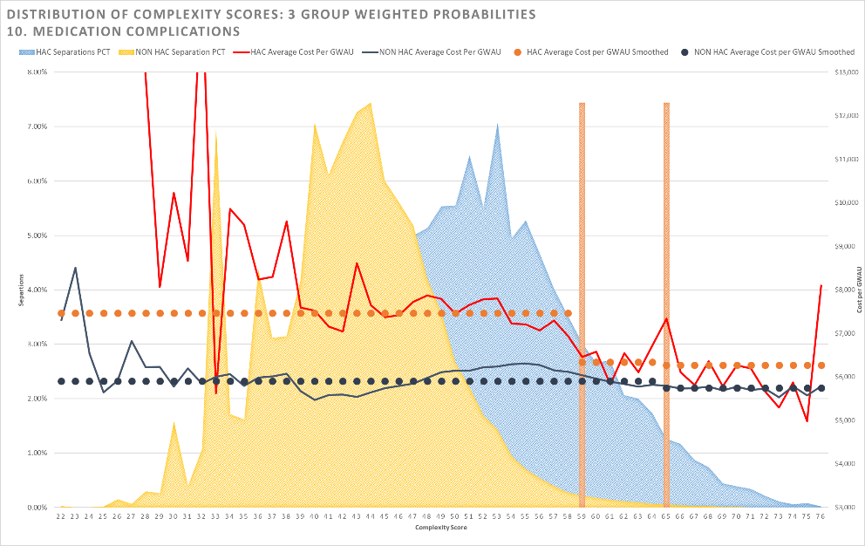

Figure 5 shows the cost differential between HAC and non-HAC cohorts. The red jagged line shows the average cost per GWAU for the HAC cohorts (the dotted horizontal orange lines represent the smoothed average cost within the complexity group). The corresponding lines in dark blue show the average cost per GWAU for the non-HAC cohorts. The GWAU has been calculated based on last year’s Determination.

It was observed that the differential between the HAC and non-HAC cohorts changes depending on the complexity group, and that this differential is reduced as the complexity increased (as demonstrated by the converging lines).

The differentials in the average cost per GWAU between HAC and non-HAC cohorts form the basis for determining the dampening factors in the following way:

* 1. Episodes belonging to the lowest complexity group receive no dampening, that is, these episodes receive the full funding adjustment (maximum reduction in NWAU) for that HAC.
  2. The dampening factors for episodes in moderate or high complexity group are calculated by dividing the cost differential in that group by the cost differential in the lowest complexity group. That is, the cost differential in the lowest complexity group is used as a benchmark against which the moderate and high complexity groups are compared.

|  |  |
| --- | --- |
|  | **Formula to calculate dampening factors: $$\text{Dampening factor = }\frac{\text{Difference between }{\text{X}}_{\text{HAC episodes}}\text{ and }{\text{X}}_{\text{Non-HAC episodes}}\text{ with Y complexity }}{\text{Difference between }{\text{X}}_{\text{HAC episodes}}\text{ and }{\text{X}}_{\text{Non-HAC episodes}}\text{ with low complexity}}$$**  Where:  X = Average cost per GWAU  Y = Low, Moderate or High |

|  |  |
| --- | --- |
|  | **Formula to calculate HAC risk adjustments: $$\text{HAC risk adjustment} \text{=} \text{Incremental cost adjustment ×} \text{Dampening factor}$$** |

Table 10 shows the calculation of the dampening factors and HAC risk adjustments for HAC10 Medical Complications. The dampening factor is calculated by using the cost differential for the lowest complexity group as a benchmark. These are then multiplied by the incremental cost adjustment value for this HAC (refer to Table 8) to derive the final risk adjustment.

Table 10: Dampening factor and HAC risk adjustment calculation for HAC10 Medical Complications.

|  |  |  |  |
| --- | --- | --- | --- |
| **Complexity group** | **% $\frac{\text{HAC cost profile}}{\text{non-HAC cost profile}} \text{-} \text{1}$** | **Dampening Factor** | **HAC risk adjustment** |
| **Low** | $$\frac{\text{\$7,466}}{\text{\$5,906}}\text{ - 1 = 26.4\%}$$ | $$\frac{\text{26.4\%}}{\text{26.4\%}}\text{ = 1.0000}$$ | $$\text{1.0000 × 0.108 = 0.108}$$ |
| **Moderate** | $$\frac{\text{\$7,067}}{\text{\$5,906}}\text{ - 1 = 19.7\%}$$ | $$\frac{\text{19.7\%}}{\text{26.4\%}}\text{ = 0.7441}$$ | $$\text{0.7441 × 0.108 = 0.08}$$ |
| **High** | $$\frac{\text{\$6,930}}{\text{\$5,902}}\text{ - 1 = 17.4\%}$$ | $$\frac{\text{17.4\%}}{\text{26.4\%}}\text{ = 0.6596}$$ | $$\text{0.6596 × 0.108 = 0.071}$$ |

The magnitude of the dampening factors are derived from empirically observed cost differentials and as such, the dampening factors can vary between the different complexity and HACs.

The dampening factors and HAC risk adjustment values for the different HAC and complexity group combinations can be found at Appendix F.

# Calculating HAC risk adjusted NWAU

## Process to calculate HAC risk adjusted NWAU

|  |  |
| --- | --- |
|  | The following steps are used to determine the HAC risk adjusted NWAU: |
| 1. | For each HAC in an episode:   1. Calculate a complexity score by summing the complexity points for each risk factor variable relevant to that HAC (Refer to Appendix E). 2. Assign a complexity group by comparing the complexity score to that HAC’s complexity bounds (Refer to Appendix F). 3. Determine the applicable risk adjustment based on the HAC and complexity group (Refer to Appendix F). |
| 2. | If an episode contains more than one HAC, then the maximum adjustment is used in the next step to calculate the risk adjusted NWAU (regardless of the complexity of the HAC). |
| 3. | Calculate the HAC adjusted NWAU as:  **Adjusted NWAU = NWAU - base price weight × HAC risk adjustment factor** |

For episodes containing more than one HAC, a complexity score will be calculated for each applicable HAC based on the risk factors relevant to that HAC. Since each HAC has its own set of complexity bounds, it is possible that when we compare each complexity score to the relevant complexity bounds, a single episode may be considered a low complexity group for one HAC and a moderate or high complexity for another HAC. Therefore, the final adjustment that is applied does not necessarily belong to the highest complexity, but rather the maximum adjustment value.

Table 11 presents an example of how the HAC risk adjustment factor is determined for an episode with more than one HAC. Even though the episode was considered as high complexity for HAC group Y, the adjustment for HAC group X was greater and therefore selected for the adjustment. This assessment is performed on an episode level for each HAC episode.

Table 11: Example calculation of adjustment factor for an episode with more than one HAC.

|  |  |  |  |
| --- | --- | --- | --- |
| **HACs present in the episode** | **Complexity score** | **Complexity group** | **HAC risk adjustment** |
| HAC group X | 75 | Low | 13.5% |
| HAC group Y | 76 | High | 1.5% |
| Selected adjustment |  |  | 13.5% |

The adjustments have been designed and calculated at an episode level allowing for aggregation to a jurisdiction, LHN or hospital level to determine the aggregate impact.

## Vignettes

The following clinical examples demonstrate the application of the risk adjustment model and safety and quality adjustments to individual episodes.

### Case 1: Falls resulting in fracture or intracranial injury – low risk

A 27 year old female patient was a booked admission to day-surgery for a cholecystectomy. She had no comorbid conditions. Following the surgery, she fell off the bed in the ward, hitting her head on the floor. A computed tomography (CT) scan showed a subdural haematoma. The patient remained in hospital for further treatment and surgery.

Table 12: Case one breakdown: HAC02 Falls resulting in fracture or intracranial injury.

| **Complexity score calculations** | |
| --- | --- |
| **Risk factor breakdown** | **Complexity Score** |
| Baseline | 29.4969 |
| Age Group: 025 to 029 | 0.0000 |
| Acute myocardial function: No | 0.0000 |
| Congestive heart failure: No | 0.0000 |
| Peripheral vascular disease: No | 0.0000 |
| Cerebral vascular accident: No | 0.0000 |
| Dementia: No | 0.0000 |
| Pulmonary disease: No | 0.0000 |
| Connective tissue disorder: No | 0.0000 |
| Peptic ulcer: No | 0.0000 |
| Liver disease: No | 0.0000 |
| Diabetes: No | 0.0000 |
| Diabetes complications: No | 0.0000 |
| Paraplegia: No | 0.0000 |
| Renal disease: No | 0.0000 |
| Cancer: No | 0.0000 |
| Metastatic cancer: No | 0.0000 |
| Severe liver disease: No | 0.0000 |
| HIV: No | 0.0000 |
| DRG Type: Intervention | 3.5008 |
| Sex: Female | -0.1259 |
| MDC: Diseases & Disorders of the Hepatobiliary System & Pancreas | -2.1674 |
| Emergency admission: No | 0.0000 |
| ICU Hours: No | 0.0000 |
| Admission transfer status: No | 0.0000 |
| **Total** | **31** |
| **Adjustment calculations** |  |
| Complexity group | Low |
| Maximum adjustment | 3.6% |
| Dampening | 1.0000 |
| **Final adjustment** | **3.6%** |

As illustrated from the above table, an episode in the ‘low risk’ category for this HAC is subject to a negative funding adjustment equivalent to 3.6% of the funding for this episode of care.

### Case 2: Falls resulting in fracture or intracranial injury – moderate risk

The patient is a 73 year old male who was admitted through emergency for acute shortness of breath. The patient has a background of congestive heart failure, hypertension, peripheral vascular disease and type 2 diabetes managed with oral medication.

The patient was transferred to the ICU for non-invasive ventilation due to pneumonia before being transferred to the ward seven days later. While on the ward, the patient slipped and fell heavily while in the shower, resulting in a fracture of the lumbar vertebra L4-L5. The fracture was managed conservatively and the patient was discharged home 12 days following admission.

Table 13: Case two breakdown: HAC02 Falls resulting in fracture or intracranial injury.

| **Complexity score calculations** | |
| --- | --- |
| **Risk factor breakdown** | **Complexity Score** |
| Baseline | 29.4969 |
| Age Group: 070 to 074 | 9.4117 |
| Acute myocardial function: No | 0.0000 |
| Congestive heart failure: Yes | 2.1109 |
| Peripheral vascular disease: Yes | 3.3680 |
| Cerebral vascular accident: No | 0.0000 |
| Dementia: No | 0.0000 |
| Pulmonary disease: No | 0.0000 |
| Connective tissue disorder: No | 0.0000 |
| Peptic ulcer: No | 0.0000 |
| Liver disease: No | 0.0000 |
| Diabetes: Yes | -0.5203 |
| Diabetes complications: No | 0.0000 |
| Paraplegia: No | 0.0000 |
| Renal disease: No | 0.0000 |
| Cancer: No | 0.0000 |
| Metastatic cancer: No | 0.0000 |
| Severe liver disease: No | 0.0000 |
| HIV: No | 0.0000 |
| DRG Type: Intervention | 3.5008 |
| Sex: Male | 0.0000 |
| MDC: Diseases & Disorders of the Respiratory System | -2.3675 |
| Emergency admission: Yes | 6.7791 |
| ICU Hours: Yes | 3.5505 |
| Admission transfer status: No | 0.0000 |
| **Total** | **55** |
| **Adjustment calculations** |  |
| Complexity group | Moderate |
| Maximum adjustment | 3.6% |
| Dampening | 0.5438 |
| **Final adjustment** | **1.9%** |

As illustrated from the above table, an episode in the ‘moderate risk’ category for this HAC is subject to a negative funding adjustment equivalent to 1.9% of the funding for this episode of care.

### Case 3: Falls resulting in fracture or intracranial injury – high risk

The patient is an 87 year old female who was admitted to hospital via the emergency department with a principal diagnosis of stroke. The patient has a background of dementia, severe liver disease, chronic renal failure, chronic obstructive pulmonary disease and type 2 diabetes managed with insulin.

The patient was treated conservatively. On the second day of her admission, she fell while trying to take herself to the bathroom unsupervised, which resulted in a fractured neck of femur. A total hip replacement was performed. The patient was discharged to her residential aged care accommodation 25 days following admission. During her admission, she also spent some time in an intensive care unit.

Table 14: Case three breakdown: HAC02 Falls resulting in fracture or intracranial injury.

| **Complexity score calculations** | |
| --- | --- |
| **Risk factor breakdown** | **Complexity Score** |
| Baseline | 29.4969 |
| Age Group: 085 to 089 | 14.0145 |
| Acute myocardial function: No | 0.0000 |
| Congestive heart failure: No | 0.0000 |
| Peripheral vascular disease: No | 0.0000 |
| Cerebral vascular accident: No | 0.0000 |
| Dementia: Yes | 3.6870 |
| Pulmonary disease: Yes | 1.6358 |
| Connective tissue disorder: No | 0.0000 |
| Peptic ulcer: No | 0.0000 |
| Liver disease: No | 0.0000 |
| Diabetes: Yes | -0.5203 |
| Diabetes complications: No | 0.0000 |
| Paraplegia: No | 0.0000 |
| Renal disease: Yes | 2.1151 |
| Cancer: No | 0.0000 |
| Metastatic cancer: No | 0.0000 |
| Severe liver disease: Yes | 4.7527 |
| HIV: No | 0.0000 |
| DRG Type: Medical | 0.0000 |
| Sex: Female | -0.1259 |
| MDC: Diseases & Disorders of the Nervous System | 0.9519 |
| Emergency admission: Yes | 6.7791 |
| ICU Hours: Yes | 3.5505 |
| Admission transfer status: No | 0.0000 |
| **Total** | **66** |
| **Adjustment calculations** |  |
| Complexity group | High |
| Maximum adjustment | 3.6% |
| Dampening | 0.2987 |
| **Final adjustment** | **1.1%** |

As illustrated from the above table, an episode in the ‘high risk’ category for this HAC is subject to a negative funding adjustment equivalent to 1.1% of the funding for this episode of care.

# Appendix A – Risk factor definitions

Table 15: ICD-10-AM/ACHI/ACS Twelfth Edition codes used for to flag risk factors in the HAC risk adjustment model.

|  |  |
| --- | --- |
| **Risk factor** | **ICD-10-AM/ACHI/ACS codes** |
| Acute myocardial infarction | I21-prefix I22-prefix |
| Congestive heart failure | I50-prefix I11.0-prefix I13.0-prefix I13.2-prefix U82.2 |
| Peripheral vascular disease | I70-prefix I71-prefix I73-prefix |
| Cerebral vascular accident | I60-prefix to I66-prefix I67.0-prefix to I67.9-prefix I68.0-prefix to I68.2-prefix I68.8-prefix I69-prefix |
| Dementia | F00-prefix F01-prefix F03-prefix U79.1-prefix |
| Pulmonary disease | J40-prefix to J47-prefix J60-prefix to J67-prefix U83.1 U83.2 U83.3 U83.4 |
| Connective tissue disorder | M30-prefix to M36-prefix M05-prefix M06-prefix U86.1 U86.3 |
| Peptic ulcer | K25-prefix to K28-prefix |
| Liver disease | K70.0-prefix to K70.3-prefix K70.9-prefix K71.0-prefix K71.2-prefix to K71.9-prefix K72.0-prefix K73-prefix to K75-prefix K76.0-prefix to K76.4-prefix K76.8-prefix K76.9-prefix B18-prefix |
| Diabetes | E10.8 E10.9 E11.8 E11.9 E13.8 E13.9 E14.8 E14.9-prefix |
| Diabetes complications | E10.0-prefix to E10.7-prefix E11.0-prefix to E11.7-prefix E13.0-prefix to E13.7-prefix E14.0-prefix to E14.7-prefix |
| Paraplegia | G81-prefix G82.0-prefix to G82.2-prefix |
| Renal disease | N03-prefix N05.2-prefix to N05.6-prefix N07.2-prefix to N07.4-prefix N01-prefix N18.3-prefix to N18.5-prefix N18.9-prefix N19-prefix N25-prefix I12.0-prefix I13.1-prefix Z49.0-prefix to Z49.2-prefix U87.1 |
| Cancer | C0-prefix to C3-prefix C40-prefix C41-prefix C43-prefix C45-prefix to C49-prefix C5-prefix C6-prefix C70-prefix to C76-prefix C80-prefix to C86-prefix C88.0-prefix C88.2-prefix to C88.4-prefix C88.7-prefix C88.9-prefix C90.0-prefix to C90.3-prefix C91.1-prefix C91.3-prefix to C91.9-prefix C92-prefix C93.0-prefix C93.1-prefix C93.3-prefix C93.7-prefix C93.9-prefix C94.0-prefix C94.2-prefix to C94.4-prefix C94.6-prefix C94.7-prefix C95.0-prefix C95.1-prefix C95.7-prefix C95.9-prefix D46-prefix D45 |
| Metastatic cancer | C77-prefix to C79-prefix |
| Severe liver disease | K70.4-prefix K71.1-prefix K72.1-prefix K72.9-prefix K76.5-prefix to K76.7-prefix Z94.4-prefix U84.3 |
| HIV | B20-prefix to B24-prefix R75-prefix Z21-prefix |
| Fetal distress (HAC15.02 only) | O68-prefix |
| Instrument use (HAC15.02 only) | 90468-00 90468-01 90468-02 90468-03 90468-04 90468-05 90468-06 90469-00 90469-01 90470-02 90470-04 |
| Persistent posterior occiput presentation (HAC15.02 only) | O328-prefix O640-prefix |
| Young and mature aged primigravida (HAC15.02 only) | Z3551-prefix Z356-prefix |

# Appendix B – Developing the initial HAC risk adjustment model

**Determining the risk factors for the risk adjustment model**

IHACPA undertook an extensive consultation process with the Commission, IHACPA’s CAC and jurisdictions to investigate potential risk factors for HACs.

Empirical evidence suggested that patient age was a strong predictor for the probability of a specific HAC occurring within an episode of care. Thus, the preliminary risk adjustment model developed in 2016 used patient age as the only risk factor (the age only model). This model was conceptually simple and easy to explain, however it did not appear to adequately adjust for specialist paediatric and tertiary hospitals. Further, it was believed that there may be other risk factors which could significantly impact the probability of a particular patient acquiring a HAC which should be also considered in the model. IHACPA sought consultation from the Commission and the CAC regarding risk factors that should be considered in a refined risk adjustment model.

Advice was sought in relation to the potential use of length of stay and presence of another HAC within the same episode as risk factors within the model. Advice from the CAC was that the lines of causation and correlation between these risk factors and HACs occurrence were blurred, and that it was not appropriate to include them within the model. For example, an episode with a higher length of stay has a higher exposure to risk receiving a HAC (correlation). However, conversely, the episode may have a longer length of stay due to a HAC occurring (causation). Risk factors deemed nonviable due to clinical advice were also removed.

The various risk factors investigated for the model and presented for consultation in the HAC Technical Specifications in July 2017 are provided in Table 16.

Table 16: List of potential risk factors investigated during initial model development.

|  |  |
| --- | --- |
| **HAC01-HAC14 risk factors** | **HAC-specific factors** |
| Patient age | Liver disease (HAC04) |
| Sex | Heart failure (HAC07) |
| MDC | Myocardial infarction (HAC07) |
| AR-DRG type (medical, intervention) | Stroke with immobility (HAC07) |
| Intensive care unit status | Cardiovascular disease (HAC08) |
| Presence of another HAC | Malignancy (HAC08) |
| Patient Indigenous status | Mechanical ventilation (HAC09) |
| Patient remoteness | Parkinson’s disease (HAC13) |
| Patient SEIFA[8] | Dementia (HAC13) |
| Admission transfer status |  |
| Chronic disease count |  |
| Highly specialised procedures |  |
| Emergency admission status |  |
| Length of stay |  |
| Charlson score[9] |  |

In early 2019, the Commission convened condition-specific HAC curation clinical advisory panels for delirium, pressure injuries, renal failure, cardiac complications, respiratory complications, third and fourth degree perineal lacerations and neonatal birth trauma.

The panels considered the pricing of perineal lacerations and neonatal birth trauma, neither of which were included for a funding adjustment in NEP18 or NEP19. This was due to difficulty in identifying suitable risk factors to construct a robust risk adjustment model.

The clinical review supported further investigation into a risk adjustment model for fourth degree perineal lacerations. HAC funding adjustment for fourth degree perineal lacerations was implemented from NEP20. They did not support a HAC funding adjustment for third degree perineal laceration or neonatal birth trauma.

Based on advice from the Commission, a unique set of risk factors were investigated for the HAC15.02 (fourth degree perineal laceration during delivery) risk model, as shown in Table 17. This includes the use of young and mature aged primigravida instead of primiparity due to the lack of consistent documentation in the latter category. The panel has recommended advocating for routine coding of parity. Another risk factor that was noted by the panel, but not included in the model due to lack of documentation, was mothers of Asian ethnicity.

Table 17: Risk factors investigated for HAC15.02.

|  |  |
| --- | --- |
| **HAC15-specific risk factors** | **Diagnosis (surgical) codes** |
| Fetal distress | O680, O682, O683, O688, O689 |
| Use of instruments | (9047002), (9047004), (9046800), (9046801), (9046802), (9046803), (9046804), (9046805), (9046900), (9046901) and (9046806) for ICD10AM v.10 and above. |
| Young and mature aged primigravida | Z3551, Z356 |
| Persistent posterior occiput presentation | O328, O640 |

**Determining the number of complexity groups for each HAC**

A range of complexity groups were investigated to provide balance between having enough volume of data for each grouping, to ensure reasonable separation between the cut-off points for each group and to distinguish the distribution of complexity scores for HAC and non-HAC separations.

A range of options were tested, including two, three, five, eight and ten complexity groups. Three complexity groupings of ‘low’, ‘moderate’ and ‘high’ have been adopted to provide an optimal balance between complexities, risk homogeneity and sample size within each group. Due to the small cohort for HAC15.02, only two complexity groupings of ‘low’ and ‘high’ have been adopted.

**Treatment of episodes with multiple HACs**

IHACPA initially considered whether the presence of multiple HACs could be addressed through the funding approach. An additive funding approach was evaluated, where the funding adjustment for each HAC that occurred is deducted from the NWAU of an episode. This approach assumed that HACs occur independently, which is not the case and therefore found to overly penalise episodes with more than one HAC.

IHACPA then considered developing a model where the funding adjustment for episodes with multiple HACs would be scaled depending on the underlying correlation of one HAC to another. It was decided that the additional complexity of this approach was not warranted given the expected minimal funding impact.

Funding impacts have therefore been calculated using the HAC that results in the highest funding adjustment for an episode, with the additional costs of other HACs not considered in the funding adjustment.

# Appendix C – Selection of and reassessment of risk factors

The HAC risk adjustment model consists of a series of logistic regression models, one for each HAC. Each logistic regression model predicts the likelihood of a specific HAC occurring within an episode of care using a set of risk factors specific to that HAC.

|  |  |
| --- | --- |
|  | IHACPA has established a general process for assessing risk factors included in the risk adjustment model. The process involves:   * 1. (For new risk factors) A preliminary assessment to determine whether there is adequate volume of information to allow for their use.   2. Assessing the statistical performance of the risk factor in predicting the occurrence of a HAC.   3. Assessing the breakdown of classes within each significant risk factor.   4. Seeking clinical advice on the appropriateness of the proposed risk factor. |

**Testing risk factor significance**

A stepwise selection methodology is used to evaluate the risk factors included in the logistic regression model for each HAC.

The stepwise selection methodology involves starting with a model with no variables and then iteratively adding each risk factor that provides the highest statistically significant improvement to the model’s objective function. Variables are added to the model in an iterative approach where:

* 1. The starting model includes only the intercept term.
  2. For each iteration, the chi-squared statistic[10] is calculated for every potential risk factor variable to test the null hypothesis that ‘a specific risk factor that is not already in the model has no effect on the model performance.’ For the first iteration, the ‘model’ refers to the starting model that only has the intercept term. For every iteration after that, the ‘model’ refers to the starting model (i.e. intercept term) plus all risk factor variables added in previous iterations.
  3. For each iteration, the risk factor that is statistically significant with the highest chi-squared statistic is added as a new variable/predictor in the model.
  4. New variables continue to be added to the model until there are no other risk factors which meet the significance criteria for inclusion in the model.

Risk factors identified in the above process must be considered significant for two of the past three years before it is considered for implementation.

As the risk factors for HAC15.02 are limited and based on clinical advice, a stepwise selection was not used to assess statistical significance for this HAC.

**Individual parameter assessment**

The individual parameter assessment examines the statistical performance of each class within the risk factors. Class refers to how the risk factor is split into different categories (e.g. the age risk factor has 20 classes). This step is undertaken to investigate any further improvements in the performance of logistic regression model for each HAC.

The classes within each risk factor were assessed under several criteria including:

* 1. The statistical significance of each parameter (0.05 threshold was adopted).
  2. The statistical estimates of a class compared with subsequent classes (that is, if there are overlaps between confidence intervals indicating potential groupings of parameters).
  3. Analysing trends in overall estimates within the risk factors and comparing them to clinical expectations.
  4. Impact on model performance.

This process is undertaken in an iterative manner where various scenarios of different groupings of parameters are investigated.

**Seeking clinical advice**

IHACPA will seek the advice of the CAC on the selection, addition and removal of risk factors in the HAC risk adjustment model. This will generally be undertaken in two stages, firstly to propose risk factors for broad consideration and exploration and then subsequently, after statistical analysis, seek advice on any finalised updates to the risk model.

IHACPA has previously sought advice on the use of length of stay and the presence of another HAC within the same episode as risk factors within the model. Advice from CAC was that the lines of causation and correlation between these risk factors and HAC occurrence is blurred and it was not appropriate to include them in the model.

**Other general considerations**

Any changes to the risk factors in the HAC risk adjustment model should seek to optimise the statistical model performance and reduce the overall complexity of each logistic regression model. The following items should be considered when proposing changes to the risk factors:

* 1. Complexity of identification (for example, if there are any interaction effects between patient age and ICU status).
  2. The consistency of the risk factor across each HAC model (that is, how prominent each risk factor is across the HAC logistic regression models).
  3. The odds ratio for each of the parameters.
  4. The impact on model performance if specific risk factors are added or removed.

# Appendix D – Model performance curves

Refer to Section 4.4 for details on how to interpret these graphs.

## ROC curves

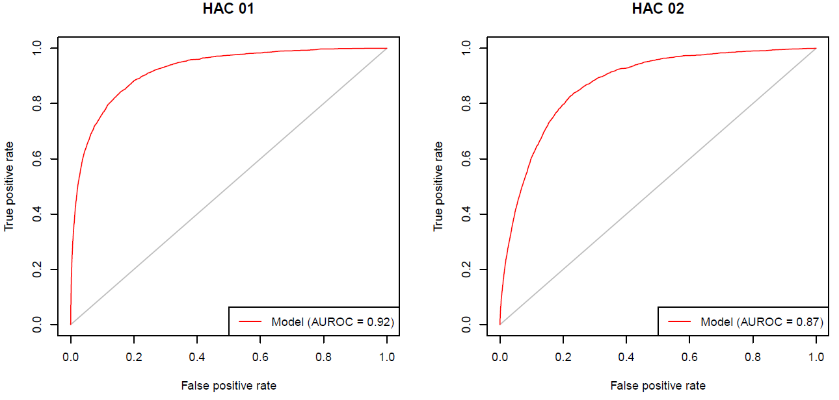

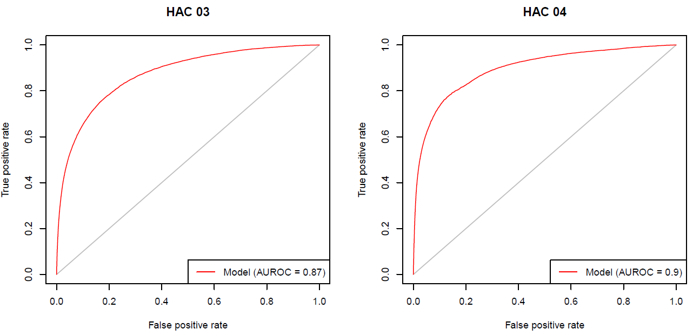

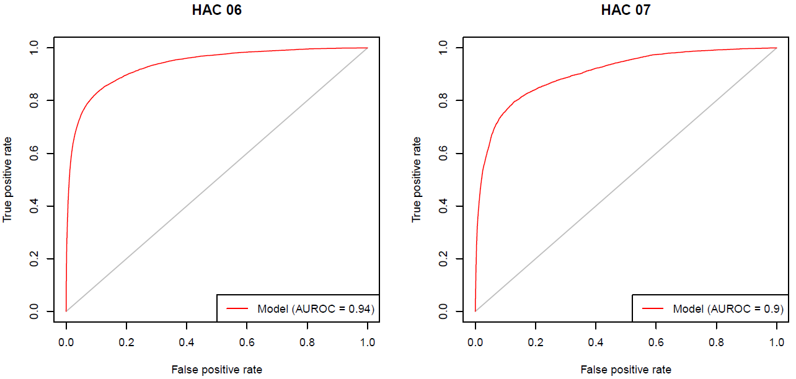

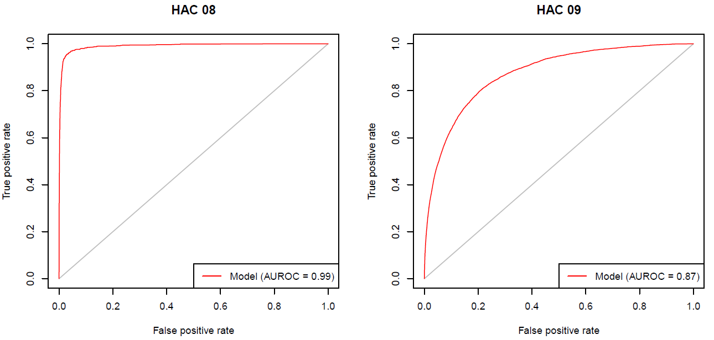

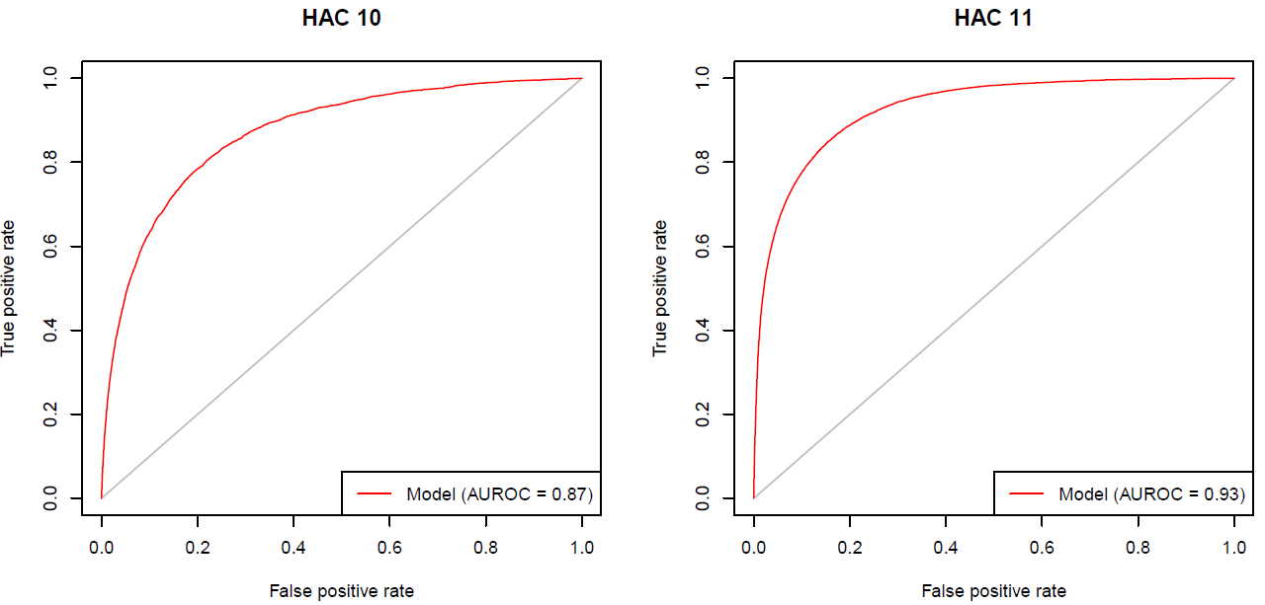

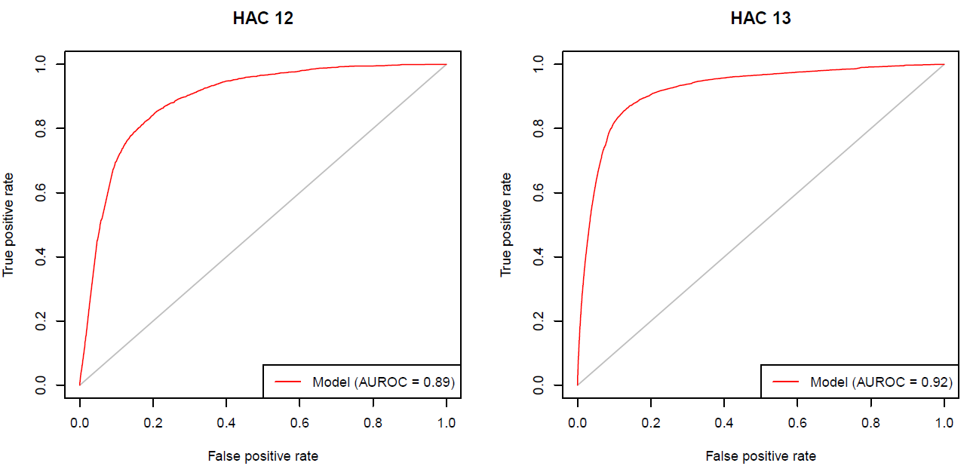

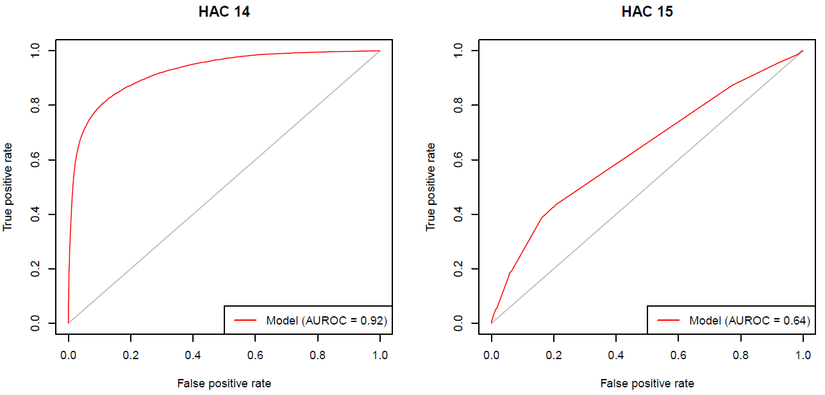

## PRC curves

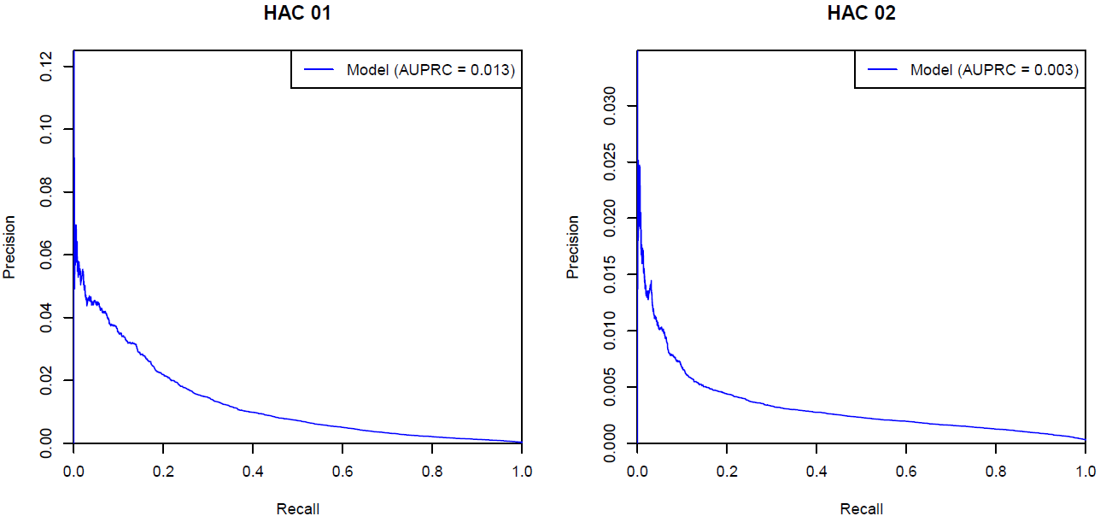

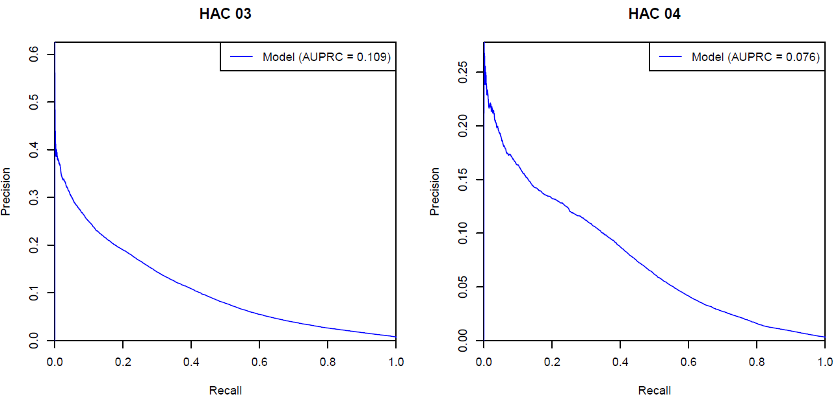

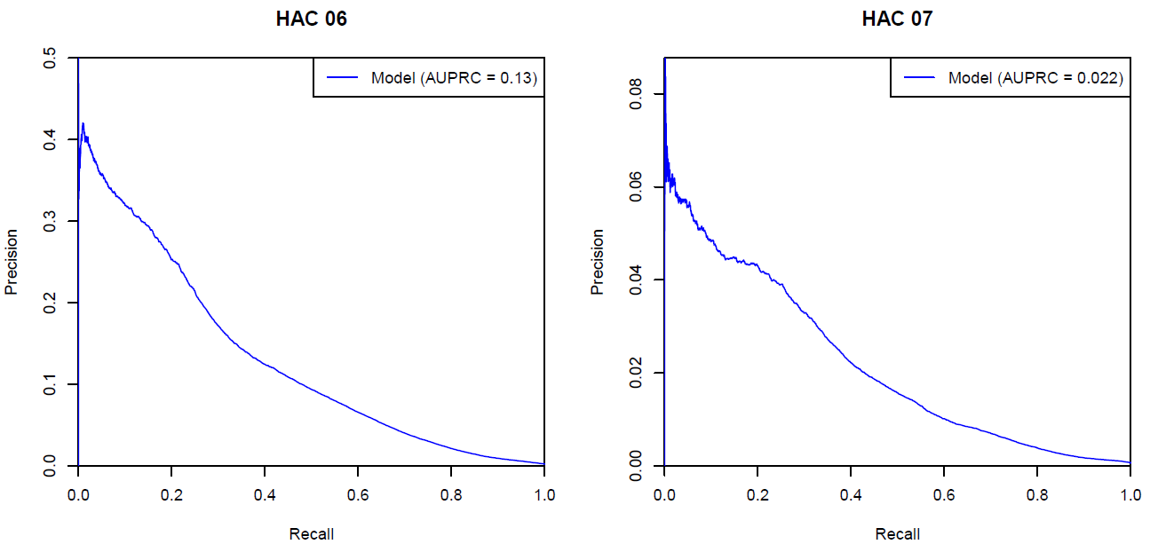

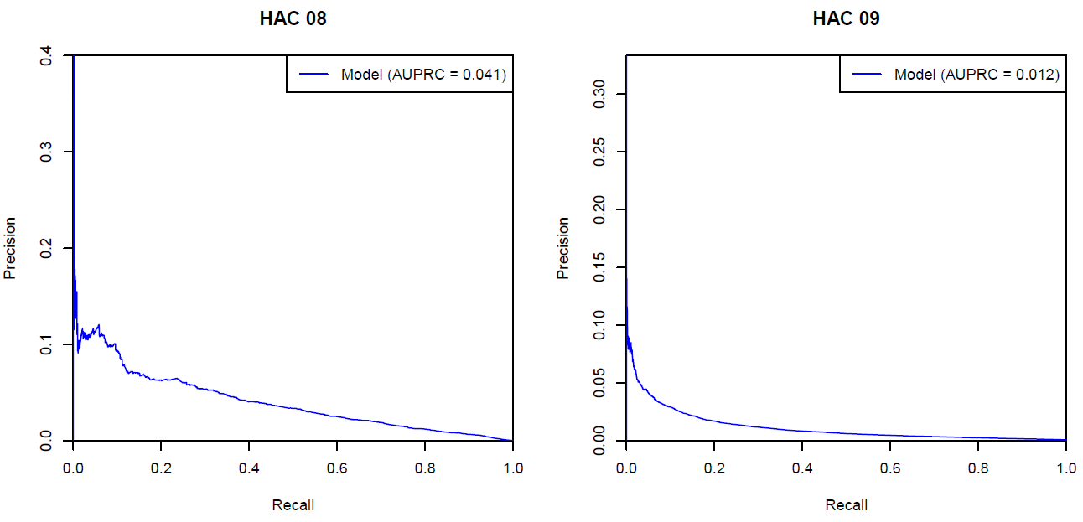

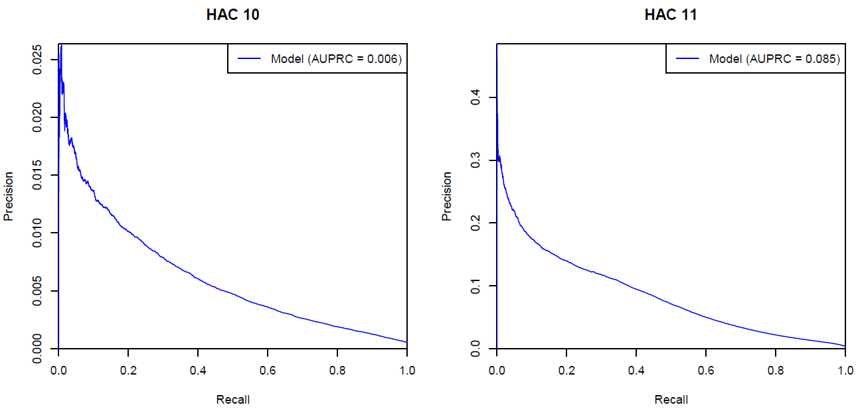

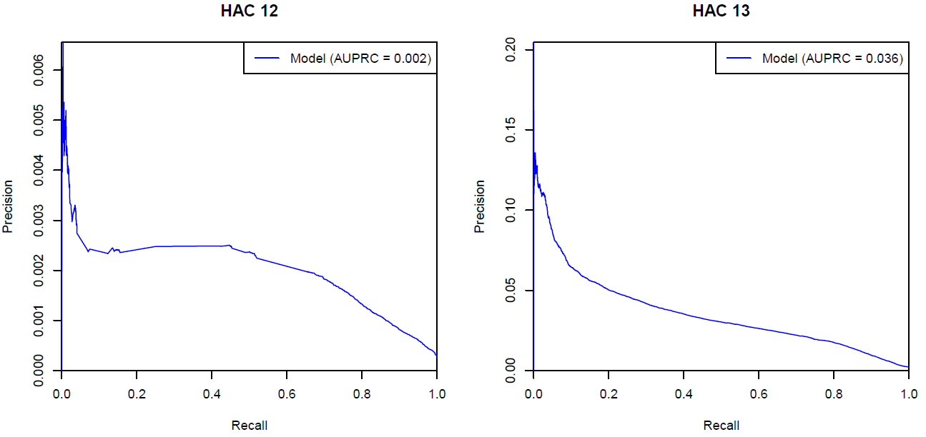

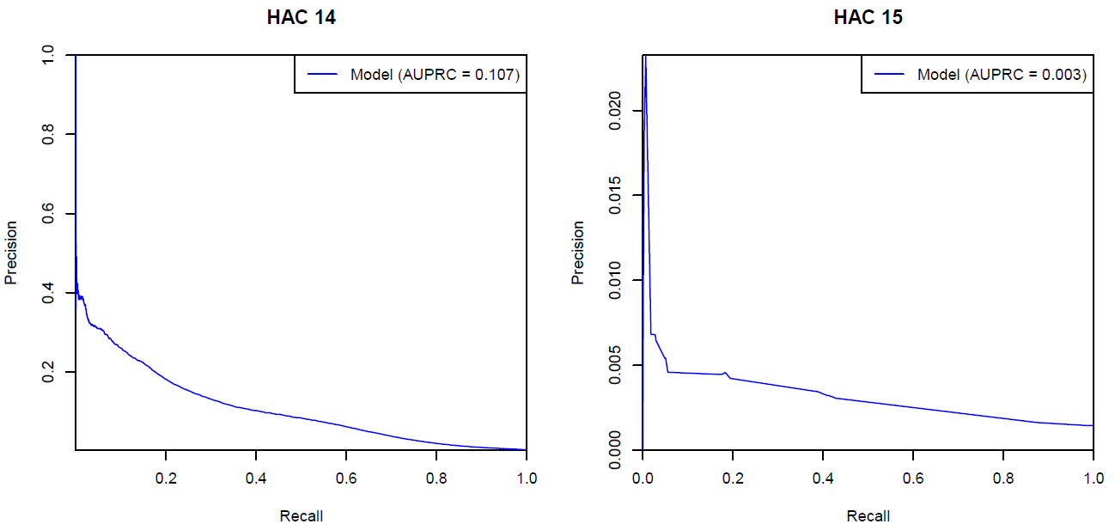

# Appendix E – Complexity points

Table 18: Complexity points for HAC01 to HAC14.

|  |  |  |  |  |  |  |  |  |  |  |  |  |  |
| --- | --- | --- | --- | --- | --- | --- | --- | --- | --- | --- | --- | --- | --- |
| **Groups** | **1. Pressure injury** | **2. Falls resulting in fracture or intracranial injury** | **3. Healthcare-associated infection** | **4. Surgical complications requiring unplanned return to theatre** | **6. Respiratory complications** | **7. Venous thromboembolism** | **8. Renal failure** | **9. Gastrointestinal bleeding** | **10. Medication complications** | **11. Delirium** | **12. Incontinence** | **13. Endocrine complications** | **14. Cardiac complications** |
| Baseline | 39.8234 | 29.4969 | 53.7775 | 48.5270 | 51.1576 | 37.3677 | 34.1718 | 42.3552 | 38.0579 | 45.4906 | 36.8702 | 48.2994 | 47.1136 |
| Emergency admission[11] | 5.7242 | 6.7791 | 4.0762 | 1.0521 | 3.3144 | 3.9333 | -1.3290 | 3.1817 | 4.1095 | 3.7715 | 4.5124 | 4.4909 | 0.0472 |
| ICU Hours | 8.9245 | 3.5505 | 10.5152 | 11.4558 | 14.6391 | 11.6291 | 23.5476 | 6.8166 | 8.8122 | 10.6394 | 8.8430 | 6.3127 | 12.2126 |
| Admission Transfer Status | 2.6640 | 2.2447 | 2.4220 | 1.3929 | 0.7157 | 2.1352 | 0.0000 | 2.2864 | 1.1870 | 1.5710 | 1.7246 | 2.2309 | 0.4242 |
| **AR-DRG 11 Type** | | | | | | | | | | | | | | |
| Medical | 0.0000 | 0.0000 | 0.0000 | 0.0000 | 0.0000 | 0.0000 | 0.0000 | 0.0000 | 0.0000 | 0.0000 | 0.0000 | 0.0000 | 0.0000 |
| Intervention | 6.5686 | 3.5008 | 6.1624 | 11.7550 | 6.1277 | 8.2475 | 7.2553 | 4.1709 | 3.6148 | 7.6937 | 1.6665 | 3.7012 | 5.6740 |
| **Sex[12]** | | | | | | | | | | | | | | |
| Male | 0.0000 | 0.0000 | 0.0000 | 0.0000 | 0.0000 | 0.0000 | 0.0000 | 0.0000 | 0.0000 | 0.0000 | 0.0000 | 0.0000 | 0.0000 |
| Female | 0.0000 | -0.1259 | 0.4581 | 0.0000 | -1.5089 | 0.1392 | -1.3894 | -0.2085 | 0.1016 | -0.7580 | 0.4095 | 0.0000 | 0.0000 |

| **Groups** | **1. Pressure injury** | **2. Falls resulting in fracture or intracranial injury** | **3. Healthcare-associated infection** | **4. Surgical complications requiring unplanned return to theatre** | **6. Respiratory complications** | **7. Venous thromboembolism** | **8. Renal failure** | **9. Gastrointestinal bleeding** | **10. Medication complications** | **11. Delirium** | **12. Incontinence** | **13. Endocrine complications** | **14. Cardiac complications** |
| --- | --- | --- | --- | --- | --- | --- | --- | --- | --- | --- | --- | --- | --- |
| Pre MDC | 0.0000 | 0.0000 | 0.0000 | 0.0000 | 0.0000 | 0.0000 | 0.0000 | 0.0000 | 0.0000 | 0.0000 | 0.0000 | 0.0000 | 0.0000 |
| Diseases & Disorders of the Nervous System | -8.5021 | 0.9519 | -5.6429 | -7.2176 | -9.0411 | -6.0643 | -14.4380 | -5.1530 | -0.4881 | -7.5013 | -4.6977 | -5.1840 | -5.0772 |
| Diseases & Disorders of the Eye | -17.1059 | -5.7424 | -20.1500 | -18.3655 | -23.3220 | -22.5103 | -14.4380 | -20.3999 | -16.1512 | -20.0933 | -15.6375 | -7.7988 | -16.3408 |
| Diseases & Disorders of the Ear, Nose, Mouth & Throat | -15.8833 | -5.1329 | -11.7042 | -9.4663 | -12.2815 | -12.9347 | -14.4380 | -9.0551 | -6.4556 | -10.3950 | -15.6375 | -9.0814 | -7.5876 |
| Diseases & Disorders of the Respiratory System | -9.2996 | -2.3675 | -7.7630 | -5.1973 | -11.0446 | -7.0056 | -14.4380 | -4.2231 | -2.3170 | -8.0474 | -8.3698 | -5.6694 | -4.1066 |
| Diseases & Disorders of the Circulatory System | -11.8629 | -3.3928 | -7.4484 | -2.8379 | -11.9027 | -9.7648 | -8.0465 | -6.2079 | -3.2447 | -8.8584 | -10.6821 | -7.1959 | -4.1815 |
| Diseases & Disorders of the Digestive System | -12.1189 | -4.6061 | -5.9266 | -4.9677 | -9.3294 | -7.7147 | -14.0738 | -4.5408 | -5.9792 | -9.0336 | -6.1263 | -4.8612 | -4.5140 |
| Diseases & Disorders of the Hepatobiliary System & Pancreas | -9.4437 | -2.1674 | -4.1341 | -3.4661 | -8.5565 | -6.5884 | -7.5868 | -0.8696 | -4.0009 | -6.0750 | -5.7388 | -2.9446 | -1.8999 |
| Diseases & Disorders of the Musculoskeletal System & Connective Tissue | -5.3095 | -1.2952 | -3.9344 | -0.7054 | -8.8499 | -1.2325 | -10.3877 | -4.0157 | -1.6598 | -2.6885 | -1.8585 | -5.3729 | -2.3109 |
| Diseases & Disorders of the Skin, Subcutaneous Tissue & Breast | -9.8530 | -3.2338 | -8.1478 | -6.0425 | -14.0842 | -9.6093 | -14.4380 | -7.7501 | -5.2651 | -10.9933 | -10.5977 | -7.6044 | -6.3731 |
| Endocrine, Nutritional & Metabolic Diseases & Disorders | -8.2273 | 0.2519 | -6.5250 | -5.4157 | -11.0766 | -7.4083 | -14.4380 | -4.9559 | -4.7966 | -8.4291 | -7.1683 | -3.6102 | -4.3606 |
| Diseases & Disorders of the Kidney & Urinary Tract | -10.2650 | -2.8872 | -6.9754 | -5.1634 | -12.0397 | -8.5023 | -10.3877 | -5.8201 | -4.9017 | -9.6005 | -6.8196 | -6.2260 | -4.4671 |
| Diseases & Disorders of the Male Reproductive System | -17.1059 | -5.7424 | -9.5403 | -5.8683 | -14.6547 | -9.8376 | -14.4380 | -9.2334 | -7.8161 | -9.3760 | -2.5626 | -10.4953 | -5.5460 |
| Diseases & Disorders of the Female Reproductive System | -17.1059 | -5.7424 | -8.8664 | -5.1577 | -14.6547 | -9.8376 | -14.4380 | -9.8378 | -8.4343 | -10.6570 | -0.6768 | -10.4953 | -6.0396 |
| Pregnancy, Childbirth & the Puerperium | -19.3349 | -6.1529 | -5.1687 | -4.7790 | -17.3380 | -10.4874 | -14.4380 | -13.7448 | -12.2868 | -16.7884 | 14.6841 | -7.7988 | -4.1897 |
| Newborns & Other Neonates | -0.6828 | -6.1529 | -3.0201 | -0.4522 | -10.0190 | -5.8051 | -14.4380 | -2.9361 | -12.1050 | -24.1506 | -20.6721 | -7.7988 | -3.0576 |
| Diseases & Disorders of Blood, Blood Forming Organs, Immunological Disorders | -11.4789 | -5.7424 | -7.3808 | -4.5234 | -11.8313 | -7.1646 | -14.4380 | -5.4614 | -8.5546 | -10.8666 | -12.7605 | -7.1347 | -5.4514 |
| Neoplastic Disorders (Haematological & Solid Neoplasms) | -6.9856 | -3.3928 | -0.2244 | -4.1220 | -7.2769 | -2.9715 | -8.0465 | -1.8011 | -2.4063 | -6.1054 | -2.9581 | -1.1842 | -1.2435 |
| Infectious & Parasitic Diseases | -5.6631 | 0.2012 | -5.3264 | -2.8715 | -9.3271 | -3.3057 | -9.4134 | -1.4610 | -2.0012 | -6.3052 | -4.5872 | -3.7920 | -1.5891 |
| Mental Diseases & Disorders | -7.6733 | 4.2718 | -5.3125 | -10.5265 | -9.4686 | -7.3343 | -26.0587 | -6.7426 | 2.1728 | -9.5356 | -1.9400 | -1.5542 | -7.0841 |
| Alcohol/Drug Use & Alcohol/Drug Induced Organic Mental Disorders | -16.5349 | 3.7632 | -6.5925 | -9.7257 | -11.1220 | -12.4728 | -26.2115 | -5.0392 | 0.5723 | -7.7629 | -12.0055 | -8.1366 | -6.7109 |
| Injuries, Poisonings & Toxic Effects of Drugs | -6.1675 | 0.9519 | -5.3332 | -4.2377 | -7.2214 | -1.2325 | -12.3287 | -5.9464 | -4.5333 | -5.4947 | -7.1809 | -6.0914 | -4.6944 |
| Burns | -2.0145 | 4.4064 | 0.0317 | -1.7818 | -3.7444 | -1.2192 | -9.4134 | -3.8975 | -2.2099 | -0.6348 | -6.1263 | -5.6694 | -1.6881 |
| Factors Influencing Health Status & Other Contacts with Health Services | -9.6154 | 4.4064 | -8.2068 | -9.0946 | -12.9578 | -8.9929 | -14.4380 | -6.4240 | -5.1434 | -11.6695 | -11.4088 | -6.9777 | -6.4546 |

| **Age Group** | **1. Pressure injury** | **2. Falls resulting in fracture or intracranial injury** | **3. Healthcare-associated infection** | **4. Surgical complications requiring unplanned return to theatre** | **6. Respiratory complications** | **7. Venous thromboembolism** | **8. Renal failure** | **9. Gastrointestinal bleeding** | **10. Medication complications** | **11. Delirium** | **12. Incontinence** | **13. Endocrine complications** | **14. Cardiac complications** |
| --- | --- | --- | --- | --- | --- | --- | --- | --- | --- | --- | --- | --- | --- |
| 000 to 004 | 0.0000 | 0.0000 | 0.0000 | 0.0000 | 0.0000 | 0.0000 | 0.0000 | 0.0000 | 0.0000 | 0.0000 | 0.0000 | 0.0000 | 0.0000 |
| 005 to 009 | 0.0000 | 0.0000 | -1.5092 | -2.8382 | -1.4434 | -1.6615 | 0.0000 | 0.0000 | 0.0000 | 0.0295 | 0.0000 | 0.0000 | -2.5415 |
| 010 to 014 | 0.3622 | 0.0000 | -0.9621 | -2.4645 | -0.6098 | -1.6615 | 0.0000 | 0.0000 | 0.0000 | -1.0779 | 0.0000 | 0.0000 | -2.7597 |
| 015 to 019 | 1.4136 | 0.0000 | 0.1519 | -1.1648 | 1.5253 | 3.3157 | 0.0000 | 0.0000 | 3.2026 | -0.4695 | 0.7797 | 0.8353 | -2.1368 |
| 020 to 024 | -0.6677 | 0.0000 | -0.1338 | -1.7031 | 1.5880 | 3.6553 | 0.0000 | 0.0000 | 2.6886 | 0.3865 | 0.7797 | 0.8353 | -1.1060 |
| 025 to 029 | 0.7564 | 0.0000 | 0.2323 | -1.2213 | 1.0416 | 4.3344 | 0.0000 | 0.3279 | 2.6106 | 0.1012 | 0.7797 | 0.8353 | -0.6157 |
| 030 to 034 | 0.4431 | 0.0000 | 0.4219 | -0.8525 | 1.7026 | 5.4534 | 0.3586 | 0.1895 | 2.6020 | 1.1050 | 3.6908 | 0.8353 | -0.1922 |
| 035 to 039 | 0.4431 | 0.0000 | 1.0839 | -0.2682 | 1.7220 | 5.9298 | 0.3586 | 0.9656 | 3.2051 | 1.7521 | 3.7510 | 0.5029 | 0.5850 |
| 040 to 044 | 0.4084 | 3.8642 | 1.5392 | 0.1405 | 1.8543 | 6.2827 | 0.3586 | 1.7693 | 3.8901 | 3.1385 | 3.5290 | -0.0703 | 1.2371 |
| 045 to 049 | 1.5505 | 3.8642 | 2.0607 | 0.8761 | 2.4596 | 6.6424 | 0.3586 | 2.5776 | 4.2133 | 4.0559 | 4.7804 | -0.0910 | 2.7653 |
| 050 to 054 | 1.2183 | 5.5785 | 2.6557 | 1.2451 | 2.9740 | 7.0783 | 0.3586 | 3.0167 | 4.9520 | 5.1581 | 4.8067 | -0.3620 | 3.3709 |
| 055 to 059 | 2.5093 | 6.8682 | 3.1069 | 1.2556 | 3.2446 | 7.2523 | 0.3586 | 3.5665 | 5.2158 | 5.8223 | 5.8068 | -0.1463 | 4.5571 |
| 060 to 064 | 2.5093 | 7.9784 | 3.6592 | 1.7509 | 3.6832 | 7.3597 | 0.3586 | 4.0794 | 5.8428 | 7.6064 | 6.1113 | 0.4062 | 5.5404 |
| 065 to 069 | 3.2835 | 8.6017 | 4.1966 | 2.0966 | 4.2739 | 7.8525 | 0.3586 | 4.6841 | 6.4927 | 9.1665 | 7.5532 | 0.6251 | 6.5431 |
| 070 to 074 | 3.5806 | 9.4117 | 4.5875 | 2.3623 | 4.9774 | 8.5971 | 0.3586 | 5.6292 | 7.0973 | 11.1061 | 8.8588 | 0.4623 | 7.1111 |
| 075 to 079 | 5.1714 | 11.1147 | 5.3603 | 2.7120 | 5.5469 | 8.6313 | 0.3586 | 6.2712 | 7.3585 | 12.8210 | 8.3132 | 0.6814 | 7.6490 |
| 080 to 084 | 5.8356 | 12.9305 | 6.3399 | 3.1390 | 6.6346 | 9.1779 | 0.3586 | 7.3401 | 8.2375 | 14.7232 | 9.8114 | 0.9851 | 8.3149 |
| 085 to 089 | 7.5457 | 14.0145 | 7.2956 | 3.7879 | 8.2495 | 10.1127 | 0.3586 | 8.2310 | 8.4677 | 16.2750 | 9.6473 | 1.3930 | 9.0443 |
| 090 to 094 | 9.1883 | 14.7912 | 8.4041 | 4.6396 | 9.8637 | 9.5255 | 0.3586 | 9.3278 | 8.8771 | 17.6681 | 9.8351 | 1.5675 | 9.9062 |
| 095 to 099 | 9.1883 | 14.7912 | 8.4041 | 4.6396 | 9.8637 | 9.5255 | 0.3586 | 9.3278 | 8.8771 | 17.6681 | 9.8351 | 1.5675 | 9.9062 |

| **Charlson comorbidity condition** | **1. Pressure injury** | **2. Falls resulting in fracture or intracranial injury** | **3. Healthcare-associated infection** | **4. Surgical complications requiring unplanned return to theatre** | **6. Respiratory complications** | **7. Venous thromboembolism** | **8. Renal failure** | **9. Gastrointestinal bleeding** | **10. Medication complications** | **11. Delirium** | **12. Incontinence** | **13. Endocrine complications** | **14. Cardiac complications** |
| --- | --- | --- | --- | --- | --- | --- | --- | --- | --- | --- | --- | --- | --- |
| Acute myocardial function | -0.1575 | 0.2321 | 1.3505 | 0.5636 | 1.5011 | -0.1119 | 0.2837 | 3.9341 | 3.7104 | 1.0994 | 2.5036 | 0.3600 | 11.0226 |
| Congestive heart failure | 3.5480 | 2.1109 | 3.2846 | 0.7018 | 3.2623 | 1.6189 | 5.3885 | 2.8587 | 3.1143 | 1.9706 | 1.5848 | 1.7465 | 5.6821 |
| Peripheral vascular disease | 6.6436 | 3.3680 | 4.1960 | 5.2673 | 2.4352 | 2.4541 | 4.9196 | 4.5713 | 4.7688 | 4.5541 | 3.6918 | 3.3560 | 4.0716 |
| Cerebral vascular accident | 0.2449 | 2.5459 | 2.8178 | 1.2487 | 3.1042 | 2.2747 | -0.1469 | 4.0248 | 2.2012 | 3.5612 | 1.9901 | 2.8458 | 2.7442 |
| Dementia | 2.1406 | 3.6870 | 2.1927 | 1.4543 | 3.8114 | 0.4698 | -5.9704 | 1.5439 | 2.7156 | 0.9346 | -0.6117 | 2.0479 | 1.3487 |
| Pulmonary disease | 0.6320 | 1.6358 | 1.5762 | 0.5790 | 2.1413 | 0.6464 | -1.2095 | 0.9781 | 1.2692 | 1.0585 | 1.6123 | 0.4663 | 0.4441 |
| Connective tissue disorder | 1.2640 | 1.6370 | 1.8594 | 1.6136 | 1.0392 | 0.9522 | 1.4653 | 2.0168 | 1.3729 | 0.9896 | 3.1386 | 2.7973 | 1.3315 |
| Peptic ulcer | 3.2329 | 2.5482 | 1.8925 | 0.7540 | 0.9159 | 3.9852 | 1.9539 | 9.4941 | 4.3589 | 0.7601 | 0.6242 | 2.6752 | 1.5630 |
| Liver disease | 3.0171 | 4.0796 | 2.9564 | 2.3519 | 1.5181 | 1.4856 | 3.8832 | 3.7553 | 2.8762 | 2.5198 | 2.7901 | 2.1259 | 1.6257 |
| Diabetes | -1.3947 | -0.5203 | -0.9909 | -1.0285 | -1.5989 | -1.7891 | -19.1566 | -1.9456 | -1.6664 | -0.6544 | -0.8749 | -6.0698 | -0.9242 |
| Diabetes complications | 4.0727 | 2.2306 | 2.1106 | 1.3291 | 1.1448 | 1.3715 | 1.2556 | 1.5326 | 1.3842 | 1.9626 | 2.3631 | 13.8098 | 0.8203 |
| Paraplegia | 2.7987 | 1.5248 | 2.4128 | 0.4882 | 3.8150 | 2.0600 | 0.7285 | 1.7269 | 1.3356 | 0.6537 | 4.1582 | 0.9871 | 0.7863 |
| Renal disease | 1.7838 | 2.1151 | 2.2579 | 2.4535 | 0.8113 | 0.2844 | 2.5984 | 2.9516 | 2.7298 | 1.6016 | 1.3380 | 1.8953 | 0.8123 |
| Cancer | 3.3347 | 4.3235 | 4.7533 | 4.9819 | 1.9553 | 4.2433 | 3.2503 | 4.5562 | 2.5446 | 2.8143 | 6.3106 | 3.2547 | 2.6565 |
| Metastatic cancer | 1.7609 | 1.2255 | 1.4378 | 0.6049 | 1.5962 | 2.6749 | -2.9783 | 1.0369 | 1.7379 | 1.6385 | 0.7258 | 0.9795 | 1.0767 |
| Severe liver disease | 2.6320 | 4.7527 | 3.4302 | 2.1447 | 3.3878 | 0.0144 | 3.5789 | 4.5614 | 3.1193 | 3.7997 | 2.6999 | 1.0710 | 2.2932 |
| HIV | 0.7569 | -0.9087 | 0.9913 | 0.1824 | 0.9101 | -0.5059 | -1.7083 | 1.3154 | -0.2548 | 0.5267 | 1.3323 | 0.4833 | 0.0775 |

Table 19: Complexity points for HAC15.02.

|  |  |
| --- | --- |
| **Groups** | **15.02 Fourth degree perineal tears** |
| Baseline | 52.9666 |
| Emergency admission | -1.9355 |
| Fetal distress | -1.6801 |
| Instrument use | 6.3178 |
| PPOP | 2.8358 |
| Primigravida | -6.99 |
| **Age group** | |
| 000 to 015 | 4.2065 |
| 016 to 034 | 0 |
| 035 to 099 | -1.6243 |

# Appendix F – Complexity bounds, dampening factors, risk adjustments and complexity profile distributions

Table 20: Complexity bounds, dampening factors and HAC risk adjustments.

|  |  |  |  |  |  |  |  |  |  |  |  |  |  |  |
| --- | --- | --- | --- | --- | --- | --- | --- | --- | --- | --- | --- | --- | --- | --- |
| **Complexity groups** | **1. Pressure injury** | **2. Falls resulting in fracture or intracranial injury** | **3. Healthcare-associated infection** | **4. Surgical complications requiring unplanned return to theatre** | **6. Respiratory complications** | **7. Venous thromboembolism** | **8. Renal failure** | **9. Gastrointestinal bleeding** | **10. Medication complications** | **11. Delirium** | **12. Incontinence** | **13. Endocrine complications** | **14. Cardiac complications** | **15.02 Fourth degree perineal tears** |
| **Complexity bounds** | | | | | | | | | | | | | | |
| Low | 1 | 1 | 1 | 1 | 1 | 1 | 1 | 1 | 1 | 1 | 1 | 1 | 1 | 1 |
| Moderate | 66 | 54 | 75 | 73 | 77 | 67 | 68 | 64 | 59 | 73 | 59 | 67 | 76 | N/A |
| High | 72 | 60 | 81 | 77 | 82 | 71 | 73 | 72 | 65 | 79 | 61 | 74 | 83 | 55 |
| **Dampening factors** | | | | | | | | | | | | | | |
| Low | 1.0000 | 1.0000 | 1.0000 | 1.0000 | 1.0000 | 1.0000 | 1.0000 | 1.0000 | 1.0000 | 1.0000 | 1.0000 | 1.0000 | 1.0000 | 1.0000 |
| Moderate | 0.7288 | 0.5438 | 0.2864 | 0.5558 | 0.4917 | 0.5960 | 0.6259 | 0.8067 | 0.7441 | 0.1852 | 0.6161 | 0.4348 | 0.3739 | N/A |
| High | 0.6422 | 0.2987 | 0.2038 | 0.4491 | 0.2520 | 0.4235 | 0.4126 | 0.7636 | 0.6596 | 0.0996 | 0.2910 | 0.1972 | 0.3307 | 0.9736 |

|  |  |  |  |  |  |  |  |  |  |  |  |  |  |  |
| --- | --- | --- | --- | --- | --- | --- | --- | --- | --- | --- | --- | --- | --- | --- |
| **Complexity groups** | **1. Pressure injury** | **2. Falls resulting in fracture or intracranial injury** | **3. Healthcare-associated infection** | **4. Surgical complications requiring unplanned return to theatre** | **6. Respiratory complications** | **7. Venous thromboembolism** | **8. Renal failure** | **9. Gastrointestinal bleeding** | **10. Medication complications** | **11. Delirium** | **12. Incontinence** | **13. Endocrine complications** | **14. Cardiac complications** | **15.02 Fourth degree perineal tears** |
| **Risk Adjustments** | | | | | | | | | | | | | | |
| Low | 14.3% | 3.6% | 8.8% | 11.9% | 14.1% | 12.1% | 20.4% | 9.9% | 10.8% | 10.8% | 7.3% | 8.9% | 12.5% | 32.8% |
| Moderate | 10.4% | 1.9% | 2.5% | 6.6% | 6.9% | 7.2% | 12.8% | 8.0% | 8.0% | 2.0% | 4.5% | 3.9% | 4.7% | N/A |
| High | 9.2% | 1.1% | 1.8% | 5.4% | 3.6% | 5.1% | 8.4% | 7.6% | 7.1% | 1.1% | 2.1% | 1.7% | 4.1% | 32.0% |

## Complexity profile distributions

This section provides the complexity profiles of non-HAC and HAC episodes for each HAC:

1. **x-axis:** complexity score values
2. **left y-axis:** percentage of episodes with a specific complexity score value (relevant for the non-HAC and HAC distributions)
3. **right y-axis:** probability values with reference to the red probability line
4. **red probability line:** shows the probability of the HAC at each complexity score value
5. **weighted probabilities:** the probability of the HAC averaged over the entire complexity group.

Figure 6: HAC01 Pressure Injury – Complexity bounds.

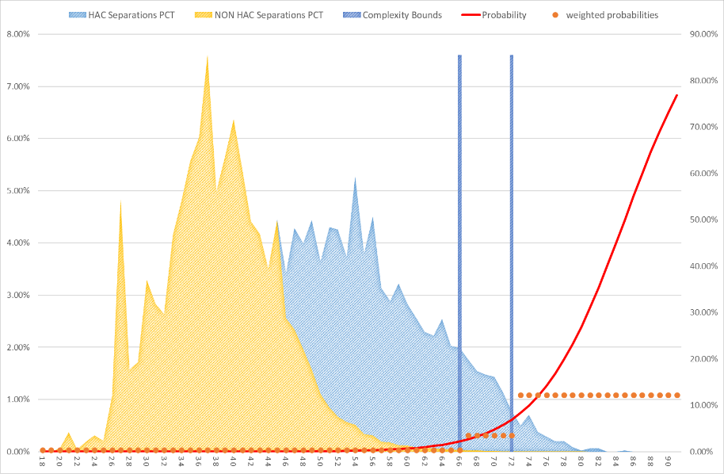

Figure 7: HAC02 Falls resulting in fracture or intracranial injury – Complexity bounds.

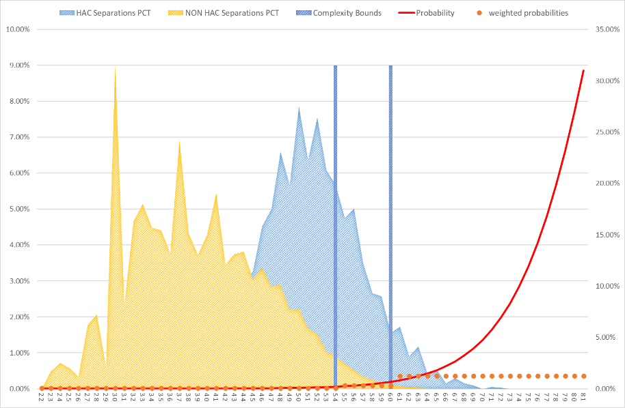

Figure 8: HAC03 Healthcare-associated infections – Complexity bounds.

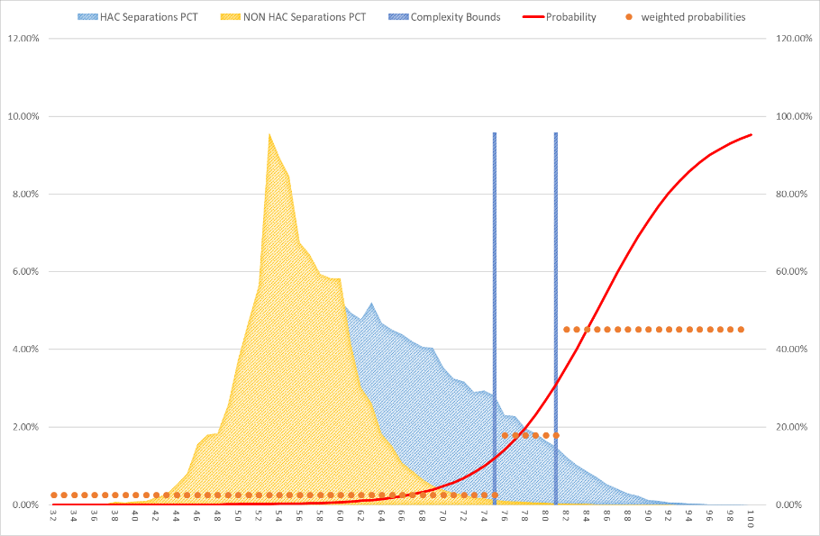

Figure 9: HAC04 Surgical complications requiring unplanned return to theatre – Complexity bounds.

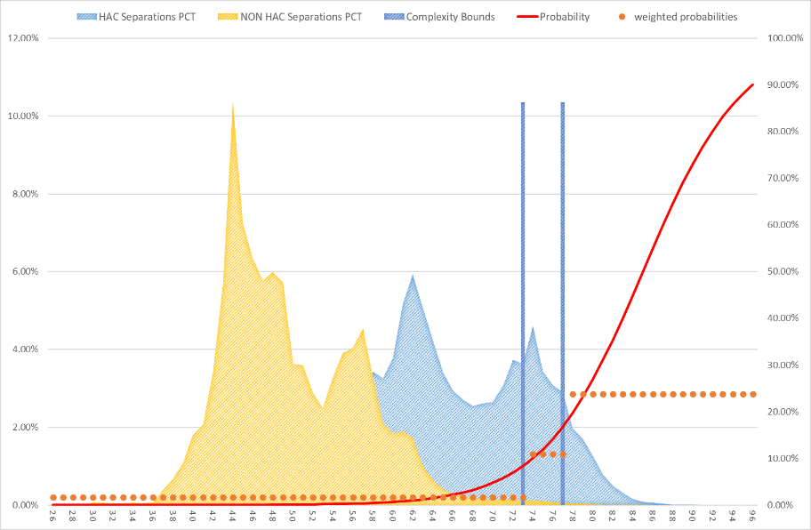

Figure 10: HAC06 Respiratory complications – Complexity bounds.

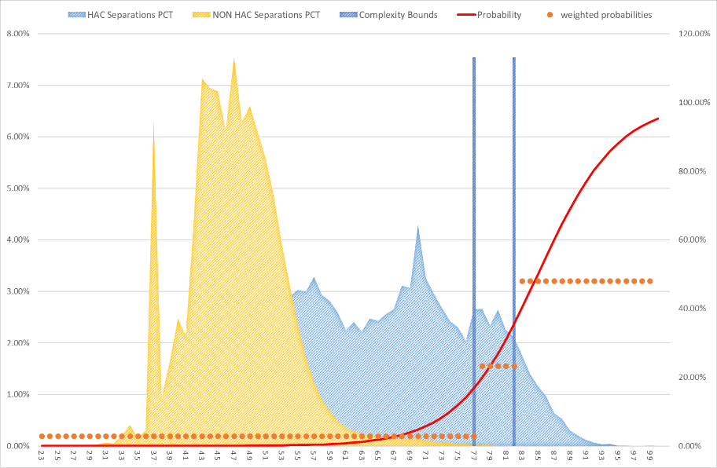

Figure 11: HAC07 Venous thromboembolism – Complexity bounds.

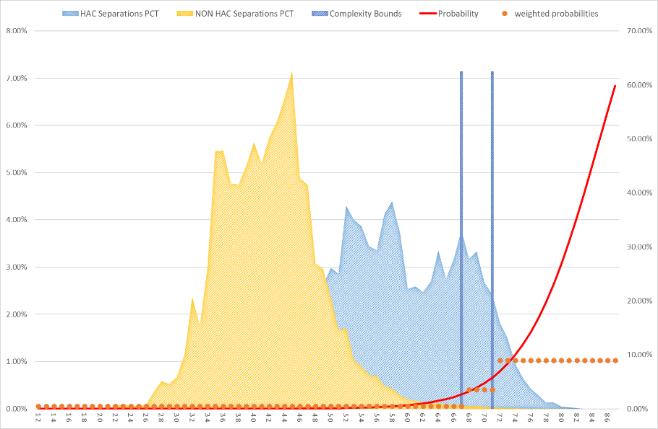

Figure 12: HAC08 Renal failure – Complexity bounds.

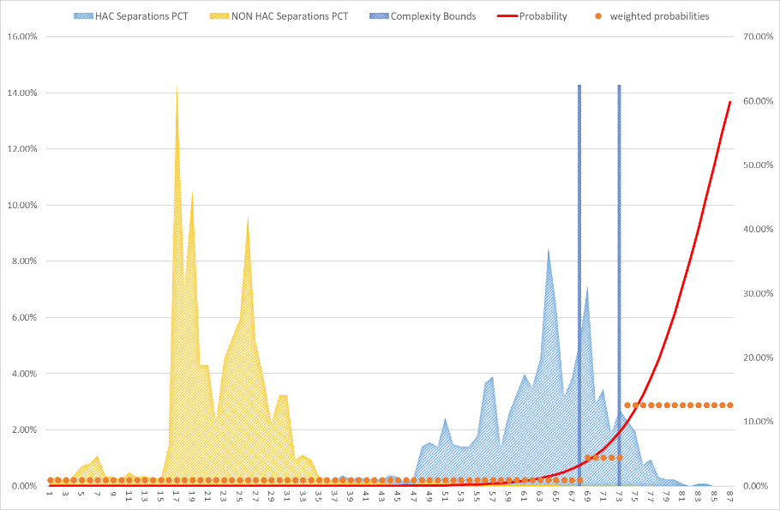

Figure 13: HAC09 Gastrointestinal bleeding – Complexity bounds.

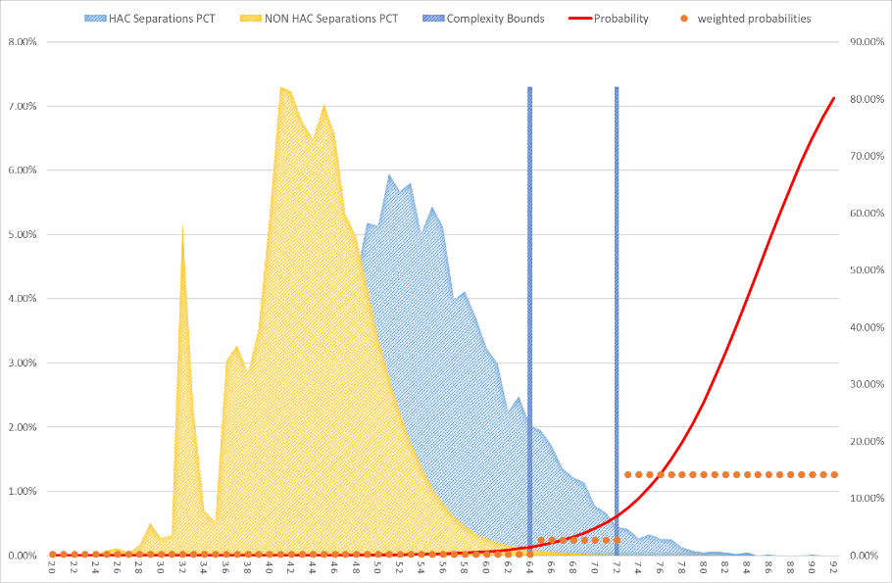

Figure 14: HAC10 Medication complications – Complexity bounds.

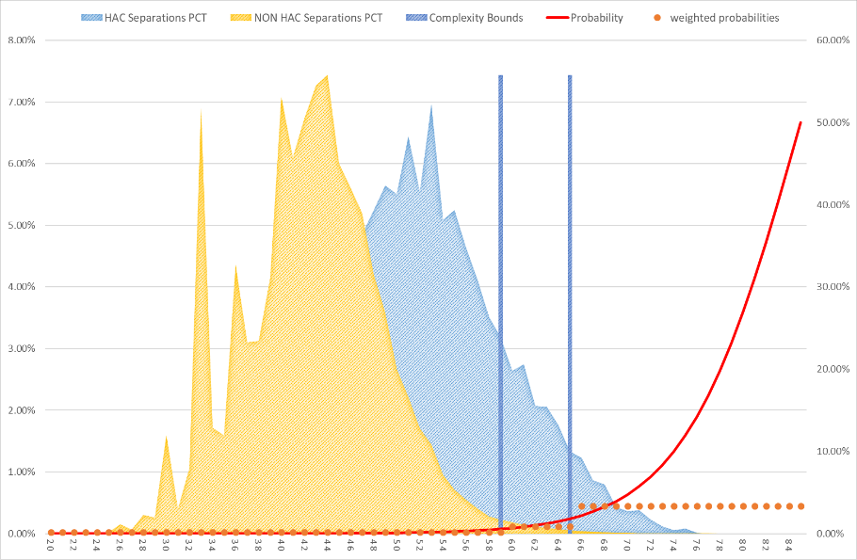

Figure 15: HAC11 Delirium – Complexity bounds.

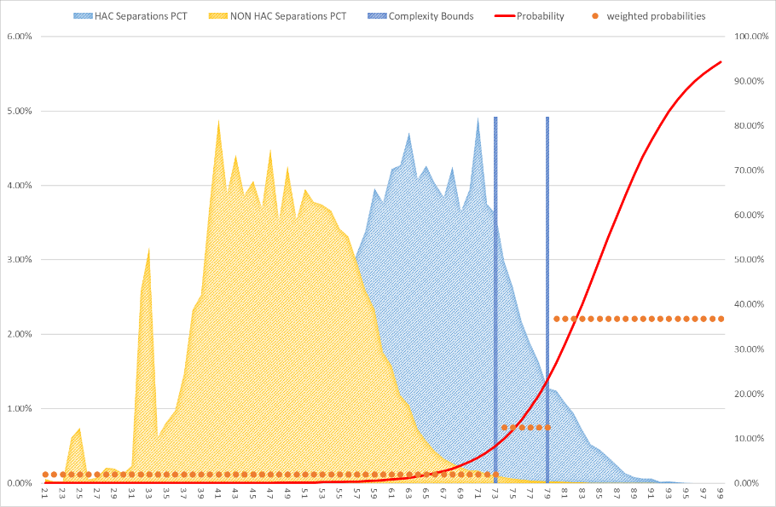

Figure 16: HAC12 Incontinence – Complexity bounds.

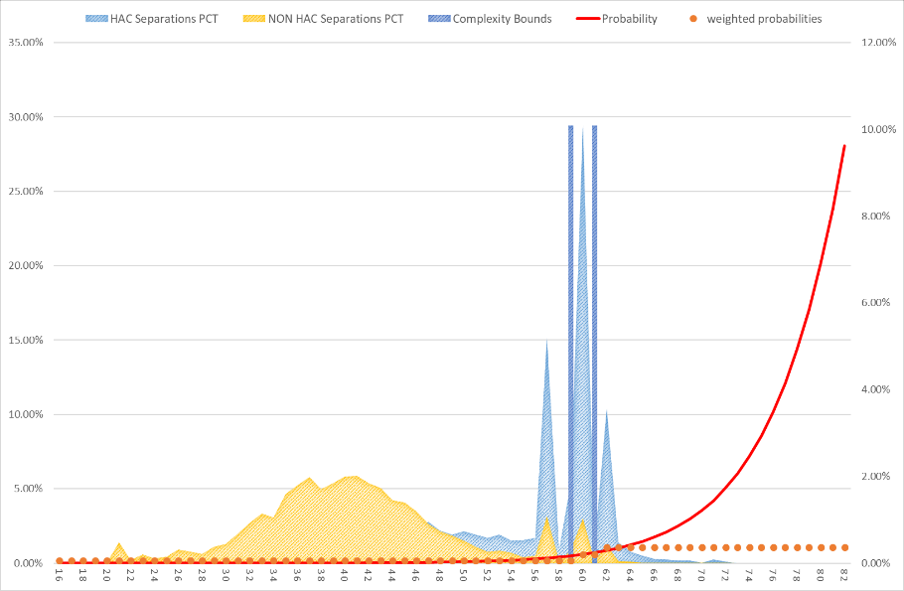

Figure 17: HAC13 Endocrine complications – Complexity bounds.

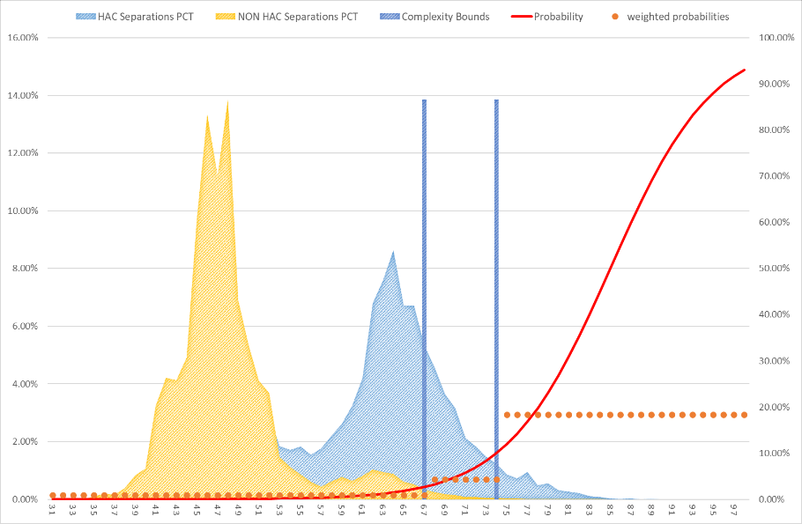

Figure 18: HAC14 Cardiac complications – Complexity bounds.

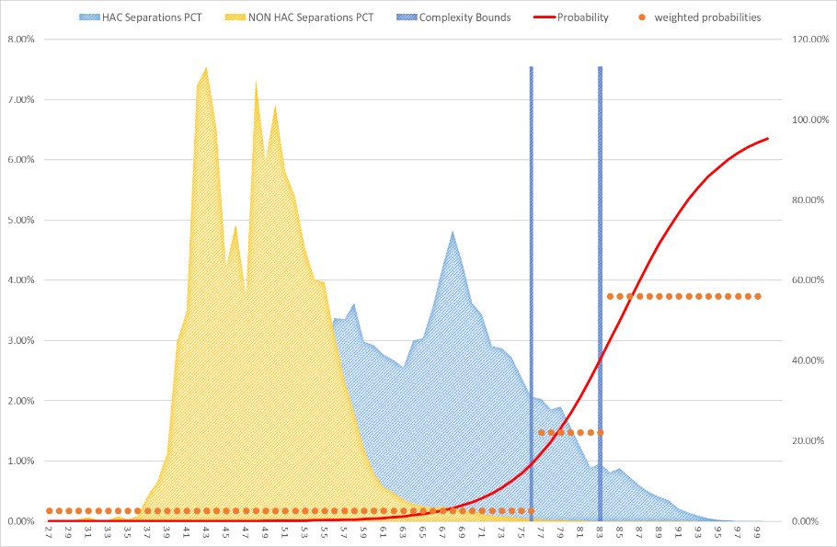

Figure 19: HAC15.02 Fourth degree perineal laceration during delivery – Complexity bounds.

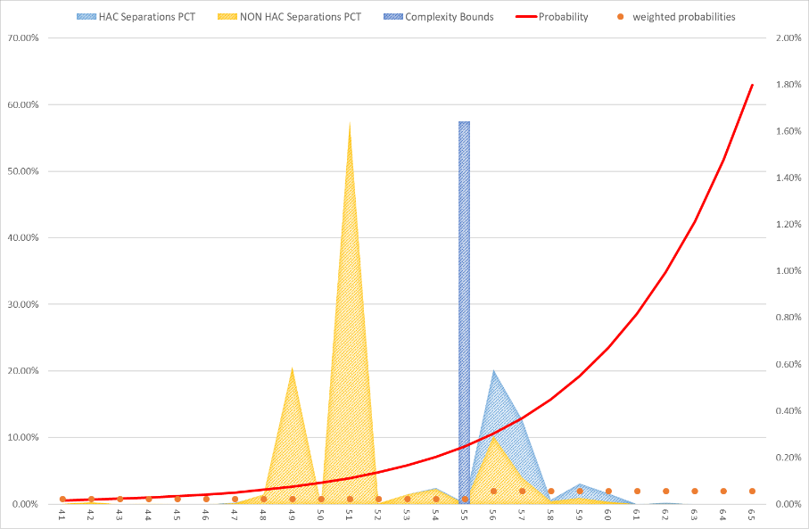

# Appendix G – Change tracker

Table 21: Change tracker for HAC risk adjustment model.

|  |  |  |
| --- | --- | --- |
| **NEP year** | **HAC list version** | **Description of key changes** |
| NEP18 | 1.0 | Introduction of safety and quality adjustment for HACs into the national pricing model (HAC01-HAC04, HAC06-HAC14). |
| NEP19 | 1.1 | N/A |
| NEP20 | 2.0 | Introduction of safety and quality adjustment for HAC15.02 Fourth degree perineal laceration during delivery into the national pricing model. |
| NEP21 | 3.0 | N/A |
| NEP22 | 3.1 | N/A |
| NEP23 | 3.1 | N/A |
| NEP24 | 3.1 | Replaced Charlson Score with its individual comorbidity conditions as risk factors for HAC01-HAC04 and HAC06-HAC14 logistic regression models.  Update of ICD-10-AM and ACHI codes to the ICD-10-AM/ACHI/ACS Eleventh Edition; these codes underpin the identification of Charlson comorbidity conditions and flagging of instrument use for HAC15.02. |
| NEP25 | 3.1 | Minor updates to the diagnosis codes used to identify Charlson comorbidity conditions. This included updates to use ICD-10-AM/ACHI/ACS Twelfth Edition. |

# Appendix H: HAC trajectory over time

The HAC risk adjustment model forms part of a program of work aimed at improving Australians’ health outcomes and decreasing avoidable demand for public hospital services through the implementation of funding and pricing approaches for safety and quality.

To measure the performance of the HAC model in reducing hospital acquired complications within public hospitals, the percentage of HACs identified in admitted acute episodes for each data year is provided in Figure 20. These values use datasets with trimming rules applied. These HAC counts also exclude multi-HAC episodes, that is episodes which are flagged for more than one HAC group. The results in Figure 20 illustrate trends based on the modelling data; refer to [HAC dashboard](https://benchmarking.ihacpa.gov.au/extensions/ihpanbp/index.html#/periodic-insights/hac-trends) on IHACPA’s National Benchmarking Portal for an indication of ‘real world’ HAC trends.

Figure 20: Summary of annual HAC counts by HAC group since 2017-18.

|  |  |  |
| --- | --- | --- |
|  |  |  |



Independent Health and Aged Care Pricing Authority

Eora Nation, Level 12, 1 Oxford Street  
Sydney NSW 2000

Phone 02 8215 1100  
Email [enquiries.ihacpa@ihacpa.gov.au](mailto:enquiries.ihacpa@ihacpa.gov.au)

[www.ihacpa.gov.au](http://www.ihacpa.gov.au/)

1. Due to difficulty in constructing robust risk adjustment models, HAC15.01 Third degree perineal laceration during delivery and HAC16 Neonatal birth trauma were not considered for the funding adjustments. There are no funding adjustments for HAC05 Unplanned intensive care unit admission because current dataset specifications do not collect information which can identify an unplanned ICU admission.
2. <https://www.safetyandquality.gov.au/our-work/indicators/hospital-acquired-complications/>
3. Details on these datasets can be found at: <https://www.ihacpa.gov.au/health-care/data/data-specifications/>
4. The presence of HAC05 in an admitted episode cannot be determined because the current dataset specifications do not collect information which can identify an unplanned intensive care unit (ICU) admission.
5. This risk factor flags the ‘expectedness’ of a hospital admission based on its admission urgency status. All episodes except those with “urgency status assigned – elective”, are flagged as having an emergency admission status = 1.
6. In previous NEP technical specifications, this category was referred as ‘gender.’ It has been updated in this technical specification to distinguish it from the reporting of ‘gender’ in APC datasets from 2022‑23 onwards. For the purposes of the HAC risk adjustment model, the ‘male’ sex category includes all patients who are not reported as ‘female.’ This treatment has not changed since the implementation of the HAC risk adjustment in NEP18.
7. Due to difficulty in constructing robust risk adjustment models, HAC15.01 Third degree perineal laceration during delivery and HAC16 Neonatal birth trauma were not considered for the funding adjustments. There are no funding adjustments for HAC05 Unplanned intensive care unit admission because current dataset specifications do not collect information which can identify an unplanned ICU admission.
8. Socio-Economic Indexes for Areas is a product developed by the Australian Bureau of Statistics that ranks areas in Australia according to relative socio-economic advantage and disadvantage.
9. The Charlson index is a score that predicts the one-year mortality for a patient with a range of specific comorbidities.
10. The University of Melbourne suggested to use this statistic to select new risk factors, in response to the Review of Risk Adjustment Methodology for the Pricing and Funding of Avoidable Hospital Readmissions.
11. This risk factor flags the ‘expectedness’ of a hospital admission based on its admission urgency status. All episodes except those with “urgency status assigned – elective”, are flagged as having an emergency admission status = 1.
12. In previous NEP technical specifications, this category was referred as ‘gender.’ It has been updated in this technical specification to distinguish it from the reporting of ‘gender’ in APC datasets from 2022-23 onwards. For the purposes of the HAC risk adjustment model, the ‘male’ sex category includes all patients who are not reported as ‘female.’ This treatment has not changed since the implementation of the HAC risk adjustment in NEP18.