**National Hospital Cost Data**

**Collection**

**Private Hospital Report 2021-22**

National Hospital Cost Data Collection Private Hospital Report 2021-22 — March 2024

© Independent Health and Aged Care Pricing Authority 2024

This publication is available for your use under a Creative Commons BY Attribution 3.0 Australia licence, with the exception of the Independent Health and Aged Care Pricing Authority logo, photographs, images, signatures and where otherwise stated. The full licence terms are available from the Creative Commons website.



Use of Independent Health and Aged Care Pricing Authority material under a Creative Commons BY Attribution 3.0 Australia licence requires you to attribute the work (but not in any way that suggests that the Independent Health and Aged Care Pricing Authority endorses you or your use of the work).

Independent Health and Aged Care Pricing Authority material used 'as supplied'.

Provided you have not modified or transformed Independent Health and Aged Care Pricing Authority material in any way including, for example, by changing Independent Health and Aged Care Pricing Authority text – then the Independent Health and Aged Care Pricing Authority prefers the following attribution:

Source: The Independent Health and Aged Care Pricing Authority

**Contents**

Tables and Figures 4

1. Executive summary 6

2. Introduction 10

3. Scope and methodology 12

4. Results 16

5. COVID-19 36

Appendix A: Methodology 39

Appendix B: Private sector costing approaches 41

Appendix C: Standard error range for the NHCDC Private Sector 2021-22 43

Appendix D: Cost weight tables by AR‑DRG Version 11.0 44

Appendix E: Cost weight tables by AR‑DRG Version 10.0 45

Appendix F: Cost weight tables by AR‑DRG Version 9.0 46

Appendix G: Cost weight tables by AR‑DRG Version 8.0 47

Appendix H: Cost bucket matrix 48

# Tables and Figures

### List of Tables

Table 1. Summary of private hospital participation, 2016-17 to 2021-22 10

Table 2. Summary of private hospital statistics for overnight hospitals 11

Table 3. Comparison of separations and hospitals, 2016-17 to 2021-22 18

Table 4. NHCDC Private Sector Summary by Major Diagnostic Category (AR-DRG v11) 20

Table 5. Top 10 AR-DRGs ranked by highest cost weight, 2021-22 compared to 2020-21 25

Table 6. Top 10 AR-DRGs ranked by highest volume of population-adjusted separations 28

Table 7. Top 10 AR-DRGs ranked by highest cost weighted separations 30

Table 8. Top 10 AR-DRGs for costs allocated to the operating room and specialist procedures suites cost bucket between 2019-20 to 2021-22. 33

Table 9. Top 10 AR-DRGs for costs allocated to the critical care cost bucket in 2021-22. 34

Table 10. Top 10 AR-DRGs for costs allocated to the prostheses cost bucket 35

Table 11. Number of AR-DRGs by standard error range 43

Table 12. 2021-22 national consolidation cost weight tables - version 11.0 44

Table 13. 2021-22 national consolidation cost weight tables - version 10.0 45

Table 14. 2021-22 national consolidation cost weight tables - version 9.0 46

Table 15. 2021-22 national consolidation cost weight tables - version 8.0 47

### List of Figures

Figure 1. Participating hospitals in the NHCDC 16

Figure 2. Total private hospital separations and NHCDC participation rate 16

Figure 3. Average Length of Stay (ALOS) 17

Figure 4. Separations and cost for MDC 06: Diseases and Disorders of the Digestive System 21

Figure 5. Separations and Cost for MDC 04: Diseases and Disorders of the Respiratory System 22

Figure 6. Separations and Cost for MDC 19: Mental Diseases and Disorders 22

Figure 7. Comparison of top 10 AR-DRGs ranked by highest cost weight, 2019-20 to 2021-22 23

Figure 8. Total Weighted Separations and ALOS 26

Figure 9. Comparison of top 10 AR-DRGs by highest volume of population-adjusted separations, 2018-19 to 2021-22 27

Figure 10. Comparison of top 10 AR-DRGs by highest cost weighted separations, 2019-20 to 2021-22 29

Figure 11. Breakdown of costs by cost bucket group 31

Figure 12. Separations in Participant Private Hospitals by jurisdiction 37

Figure 13. Separations by month for intervention episodes 38

Figure 14. Separations by month for medical episodes 38

Figure 15. Cost bucket matrix 48

# Executive summary

The National Hospital Cost Data Collection (NHCDC) Private Sector is a voluntary collection that produces a range of hospital cost and activity information by Australian Refined Diagnosis Related Groups (AR-DRG). This report includes the findings from the 2021-22 NHCDC, for admitted acute care provided by 103 in-scope overnight private hospitals and represents 65.4% of private hospital activity.

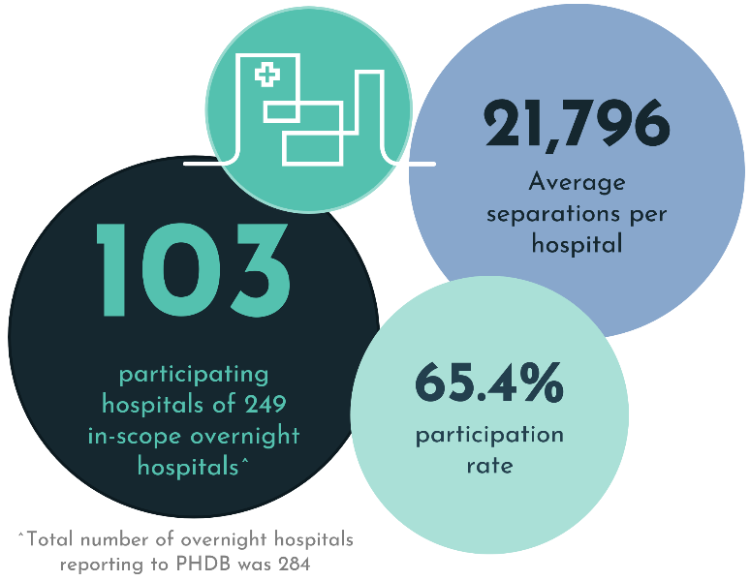The COVID-19 global pandemic impacted Australia from March 2020 onwards, resulting in jurisdictional lockdowns and restrictions on elective surgeries. This significantly impacted hospital services (both public and private), reflected in the activity volumes and cost profiles of the data collection. This has been an area of focused analysis of the NHCDC Private Sector 2021-22.

## Participation

Twelve hospital groups nationally participated in 2021-22. Analysis of the data confirmed that the volume of participating hospitals and separations (65.4% participation rate) was sufficient for the Independent Health and Aged Care Pricing Authority (IHACPA) to publish this report. Full details can be found in Table 1.

## Key findings

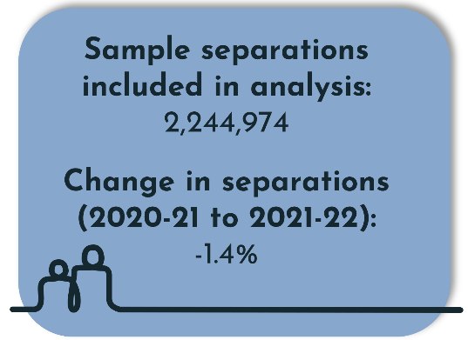The 2021-22 dataset included 2,244,974 separations, representing 65.4% of the population separations as per the Private Hospital Data Bureau (PHDB). This participation rate has been relatively steady over the last 5 years, and the change in the 2021-22 year has been minimal, increasing slightly from 65.3% participation in 2020-21.

The number of sample separations in 2021-22 was comparable to the previous year (2,277,973) and the pre-COVID-19 year of 2018-19 (2,234,143). The separations in 2019-20 however were significantly lower (2,067,714), influenced by the initial COVID-19 impact in the final quarter of that financial year. The slight 1.4% decrease in separations from 2020-21 to 2021-22 also aligns with the surge in post-lockdown separations in 2020-21.

Although the number of separations has broadly returned to pre-COVID-19 levels, average costs continue to rise. The 5.7% increase in 2021-22 brings the cumulative average cost increase from 2018-19 to 10.1%. However, it should be noted that this 5.7% incorporates both changes in AR-DRG distribution as well as increased cost pressures and underestimates the underlying increase in costs.

### Analysis by Major Diagnostic Category and AR-DRG

Considering the commercial sensitivities in publishing detailed cost information, the analysis in this report focuses on cost weights which consider differences in cost relativities across a number of dimensions. This analysis has been completed by Major Diagnostic Category (MDC) and the top 10   
Australian Refined Diagnosis Related Groups (AR-DRGs) across a range of metrics. MDC is a less granular category than AR-DRG enabling analysis by medical specialties.

At the MDC level, activity broadly followed the sample level activity with the number of sample separations decreasing. However, the following 3 MDCs saw significant increases in separations from 2020-21 to 2021-22:

* 20: Alcohol/Drug Use and Alcohol/Drug Induced Organic Mental Disorders (33%)
* 11: Diseases and Disorders of the Kidney and Urinary Tract (5%)
* 17: Neoplastic Disorders (Haematological and Solid) (5%)

Average costs also increased across the MDCs in line with the sample level activity. The net result being minimal changes in cost weights, with the exception of a few low-volume MDCs.

Other notable observations at the MDC level include:

* + The highest volume MDC was MDC 06: Disorders of the Digestive System, responsible for 17% of all private sector separations, consistent with prior years.
  + A gradual decrease in separations was observed for the MDC 04: Diseases and Disorders of the Respiratory System from 2017-18 to 2020-21 (20%), however, activity levels have stabilised and remain level in 2021-22.
  + MDC 19: Mental, Behavioural and Neurodevelopmental Disorders saw a decrease in separations in both 2020-21 (3%) and 2021-22 (6%) while average costs increased over the 2 years (14.6%).

Overall, the analysis of top 10 AR-DRGs showed a high level of consistency with the prior year, with most AR-DRGs in the top 10 not changing. Analysis across the top 10 AR-DRGs for volume and cost identified that:

* + The majority of the listed AR-DRGs with the highest cost weights relate to some form of ventilation AR-DRGs. These AR-DRG’s are typically high in cost and low in volume. The AR-DRG with the highest cost weight remained the same as the prior year (A13A: Ventilation >=336hours, Major Complexity).
  + The AR-DRG with the most population-adjusted separations remained the same (R63Z: Pharmacotherapy for Neoplastic Disorders). AR-DRGs with the highest population-adjusted separations are generally high-volume, sameday separations.
  + The top two AR-DRGs with the highest cost weighted separations were I04B: Knee Replacement, Minor Complexity and I33B: Hip Replacement, Minor Complexity. AR-DRGs with the highest cost weighted separations tend to be common procedures in the private sector.

Analysis was also undertaken at a cost bucket level to understand drivers of movement in total costs:

* + Both operating room and specialist procedure suites (combined cost bucket group) and prostheses have seen slight decreases in their proportion of total cost. Together, these cost buckets made up 46% of total cost in 2021-22 compared to 47.5% in 2020-21.
  + The critical care cost bucket made up 5.7% of total cost in 2020-21, remaining similar in proportion to total cost compared to previous years. Critical care is highly concentrated within certain AR-DRGs, leading to volatility in the proportion of total cost. Of the top 10 AR‑DRGs with the highest critical care cost, over half of the total cost was in critical care.

## Methodology

In the NHCDC Private Sector 2021-22, private hospitals were invited to submit costed data of in-scope activity. This included activity in the admitted acute, subacute and mental health streams. This report combines data from the admitted acute and mental health streams due to insufficient participation and hence volume of data to enable separate reporting.

Submitted data was validated by IHACPA in accordance with the data request specifications (DRS) that IHACPA prepared and distributed to participants. IHACPA performed quality assurance (QA) checks to ensure accuracy and suitability of the data submission.

The validated data was then used to produce the *NHCDC Private Hospital Report 2021-22*, and individualised reports including cost tables for each participating hospital group. There were no adjustments made for the impact of COVID-19 in the national costed dataset or private sector reports.

The COVID-19 pandemic continued to impact Australia in 2021-22, with jurisdictional lockdowns continuing into the first half of the financial year in some jurisdictions and varying responses to manage elective surgeries. This impacted hospital operations (both public and private) and had financial impacts that are reflected in the activity volumes and cost profiles of the data collection. IHACPA released the *COVID-19 Response – Costing and pricing guidelines[1]* guidance document for costing and pricing for COVID‑19 and recognises thatthere may be variations in the approach to costing for 2021-22. The results in this cost report should be reviewed with this context in mind.

## Considerations

The following factors can have a material impact on the reported costs and cost weights, and should be considered when interpreting the information in this report:

* + application of the Australian Hospital Patient Costing Standards (AHPCS) Version 4.1
  + mapping of general ledger to the appropriate and consistent cost buckets
  + allocation of cost centres to care areas
  + whether costs are allocated using patient level data or service weights
  + the impact of COVID-19 on private hospital activity and cost profile
  + the hospitals contributing data each year (sample hospitals) may differ. Therefore, it should be taken into consideration when performing year-on-year comparisons.

Further investigations into the 2021-22 NHCDC submission identified variations in cost profiles, specifically pharmacy costs, driven by variation of insourced and outsourced models for hospital pharmacy functions. Readers of this report should consider this when interpreting the results of this report, particularly for AR-DRGs that have a high proportion of Pharmaceutical Benefits Scheme (PBS) costs.

# Introduction

## Purpose of this report

The purpose of this report is to provide an overview of hospital cost and activity information voluntarily reported to the National Hospital Cost Data Collection (NHCDC) Private Sector   
2021-22.

The information is grouped by Australian Refined Diagnosis Related Groups (AR-DRGs), a classification system that provides a clinically meaningful way to relate the number and type of patients treated in a hospital to the resources required by the hospital[2]. The AR-DRG is derived from a range of data collected on admitted patients, including diagnosis and procedure information, classified using International Statistical Classification of Diseases and Related Health Problems, Tenth Revision, Australian Modification (ICD-10-AM[3]).

This report documents the data, processes, methodology and results for admitted acute care provided by overnight private hospitals. The results of the collection are expressed as national cost weights by AR-DRG Version 11.0. Cost weight tables are provided for AR-DRG Versions 11.0, 10.0, 9.0 and 8.0 in the appendices.

## History of the NHCDC Private Sector

The NHCDC Private Sector was first conducted for 1996-97 with 23 hospitals and 240,000 episodes being represented. The collection has grown steadily since that time, although no publication was released for years 2003‑04, 2004-05 and 2009‑10 due to low participation rates. No collections were carried out for years 2005-06, 2010-11 and 2014-15.

Table 1. Summary of private hospital participation, 2016-17 to 2021-22

|  |  |  |  |  |  |  |
| --- | --- | --- | --- | --- | --- | --- |
| **Summary** | **2016-17** | **2017-18** | **2018-19** | **2019-20** | **2020-21** | **2021-22** |
| Number of hospitals | 105 | 112 | 108 | 103 | 103 | 103 |
| Sample separations | 1,923,310 | 2,173,847 | 2,234,143 | 2,067,714 | 2,277,973 | 2,244,974 |
| Participation rate* (%) | 59.3 | 65.9 | 65.1 | 64.9 | 65.3 | 65.4 |
| AR-DRG version | 9.0 | 9.0 | 10.0 | 10.0 | 10.0 | 11.0 |

* Participation rate refers to the percentage of sample separations compared to the population separations.

## Private Hospital statistics for 2021-22

A total of 596 private hospitals reported to the Private Hospital Data Bureau (PHDB) in 2021‑22, submitting 4.7 million patient separations in 2021‑22. Of this total, 284 (47.7%) were overnight hospitals submitting 3.7 million (80%) separations. The number of in-scope overnight hospitals in the population file for 2021-22 is 249 as outlined in the scope and methodology section below.

Table 2. Summary of private hospital statistics for overnight hospitals

|  |  |  |  |  |
| --- | --- | --- | --- | --- |
| **Summary** | **2020-21** | **2021-22** | **Change** | **Change (%)** |
| Number of overnight hospitals reporting to PHDB | 280 | 284 | 4.0 | 1.4 |
| Total separations (million) | 3.8 | 3.7 | -0.1 | -2.1 |
| Sameday separations (million) | 2.5 | 2.5 | 0.0 | 0.0 |
| Acute, Newborn and Mental Health Care separations (million) | 3.4 | 3.4 | 0 | 0.0 |
| Total patient days of care (million) | 9.1 | 8.9 | -0.2 | -2.2 |
| Average Length of Stay (day) | 2.4 | 2.4 | 0 | 0.0 |

## COVID-19 and the NHCDC

The COVID-19 global pandemic impacted Australia from March 2020 onwards, resulting in jurisdictional lockdowns and restrictions on elective surgeries. This impacted hospital operations (both public and private) and had financial impacts that were reflected in the activity volumes and cost profiles of the data collection. The pandemic continued into 2021-22, though the impact on the private sector activity and costs differed to the impact in 2020-21 due to varying public health responses and recoveries across the country. Section 5 of this report provides further background information, outlining the costing approaches utilised for COVID-19 and shows analyses on the activity volumes in the private sector.

## Public and private sector differences

This report does not compare the average cost per separation between the public and private sectors as the scope of costs between the 2 sectors is different.

Many of the cost items present in the public sector such as medical specialist costs, including doctors’ fees, pathology and imaging are not represented in private hospital general ledgers. These costs are generally not reported for the private sector as they are funded through arrangements between patients and medical professionals.

Additionally, some private hospitals outsource their pharmacy function to external vendors. This results in variations in whether Pharmaceutical Benefits Scheme (PBS) rebates are received by the hospitals, and whether pharmacy costs are reported including or excluding the PBS rebate.

## Confidentiality of data

Due to the commercial nature of the sector, all participating hospitals in 2021-22 are requested to sign a confidentiality agreement before any final reports are released.

In this report, cost weight information will not be presented (masked) if there is insufficient volume. If a cost weight for an AR-DRG is based on fewer than 5 separations and/or fewer than 3 hospitals contributing to a particular AR-DRG, the figures for this cost weight have been replaced by asterisks (*****).

# Scope and methodology

## Scope

The scope of the NHCDC Private Sector 2021-22 includes acute patients admitted to overnight private hospitals in Australia who were discharged in the 2021-22 financial year. This includes patients that were admitted to a hospital, were classified under the Australian Refined Diagnosis Related Group (AR-DRG) and had a care type of admitted acute, qualified newborn[4], mental health or other admitted patient care (see ‘In-scope care types’ below). Any references to admitted acute in this report relate to these care types unless stated otherwise.

For this report, an overnight hospital was considered in-scope if it performed at least 200 admitted acute separations in the relevant year.

Participants were invited to submit subacute data again in 2021‑22, but analysis of subacute data has not been included due to insufficient participation. This remains unchanged from the previous three financial years, as its inclusion would lead to potentially inappropriate or biased representation of the cost profile for subacute activity in the population.

The 2018-19 NHCDC was the first year where some hospital groups began submitting admitted mental health episodes under care type 11.0. Prior to the introduction of care type 11.0, admitted mental health episodes were classified as admitted acute. In the past four years, mental health activity has been combined with other admitted acute activity due to insufficient volume. As all four years include mental health, it enables like-for-like comparisons to be made between the years.

Similar to the previous financial year, participants were invited to submit phase-level data for both subacute and mental health activity in 2021-22. The results of the analysis using this data were not included in this report due to insufficient participation.

IHACPA will continue to work with the sector to improve the data collection so that the subacute and mental health streams can be reported separately in future years.

### In-scope care types

Separations for admitted acute care and newborn care with qualified care days are in-scope and are included in the calculation of the AR-DRG cost weights. The costs associated with unqualified neonate separations[5] have been included in the costs of the maternal separations (as described below for the neonatal adjustment).

Admitted acute care type 1.0 is care where the clinical intent or treatment goal is to:

* + manage labour (obstetric)
  + cure illness or provide definitive treatment of injury
  + perform surgery
  + relieve symptoms of illness or injury (excluding palliative care)
  + reduce severity of an illness or injury
  + protect against exacerbation and/or complication of an illness and/or injury which could threaten life or normal function
  + perform diagnostic or therapeutic procedures[6].

Newborn care type 7.0 is initiated when the patient is born in hospital or is nine days old or less at the time of admission. Newborn care continues until the care type changes or the patient is separated:

* + Patients who turn 10 days of age and do not require clinical care are separated and, if they remain in the hospital, are designated as boarders.
  + Patients who turn 10 days of age and require clinical care continue in a newborn episode of care until separated.
  + Patients aged less than 10 days and not admitted at birth (for example, transferred from another hospital) are admitted with newborn care type.
  + Patients aged greater than 9 days not previously admitted (for example, transferred from another hospital) are either boarders or admitted with an acute care type.
  + Within a newborn episode of care, until the baby turns 10 days of age, each day is either a qualified or unqualified day.
  + A newborn is qualified when it meets at least one of the criteria detailed in newborn qualification status.

Within a newborn episode of care, each day after the baby turns 10 days of age is counted as a qualified patient day. Newborn qualified days are equivalent to acute days and may be denoted as such.[7]

Mental health care type 11.0[8] is care where the primary clinical purpose or treatment goal is improvement in the symptoms and/or psychosocial, environmental, and physical functioning related to a patient’s mental disorder. Mental health care:

* + is delivered under the management of, or regularly informed by, a clinician with specialised expertise in mental health
  + is evidenced by an individualised formal mental health assessment and the implementation of a documented mental health plan
  + may include significant psychosocial components, including family and carer support.

Other admitted patient care (care type 88[9]) is care that does not meet the definitions for other care types but is deemed in-scope for this report.

### Reporting requirements

The Australian Hospital Patient Costing Standards Version 4.1[10] (AHPCS) guide the hospitals with costing processes for their NHCDC submissions to ensure a consistent treatment of costs between hospitals nationally. Version 4.1 of the AHPCS was released in August 2021 and applied for the third time in the 2021-22 NHCDC. The Australian Hospital Patient Costing Standards Version 4.2[11] was published and released in September 2023 and will be applied to future NHCDC analysis.

The AHPCS prescribes the set of line items and cost centres used for mapping hospital costs in the costing process. These costs are then allocated to, and reported under, the NHCDC-defined ‘cost buckets’ (see Appendix H: Cost bucket matrix). Cost buckets represent different combinations of the NHCDC line items and cost centres and can be considered as cost pools within the hospital.

### Work in progress patients

A work in progress (WIP) episode is a patient who was discharged within the reporting period for 2021‑22, but who was admitted prior to the reporting period. Patients who have not been discharged in 2021-22 are out of scope.

In 2021-22, all WIP patients were admitted in 2020-21 and discharged in 2021‑22. These records are in-scope and they have been included in the results.

## Data adjustments

The following adjustments were applied to the dataset during the NHCDC process.

### Neonate adjustment

The costs for newborn infants with zero qualified days in respect of care type 7.0 (newborn care) were allocated to the delivery episodes of mothers at the same hospital.

The definition of unqualified days in the National Health Data Dictionary[12] relates to the first nine days of a newborn’s life unless the newborn is a second or subsequent live born infant or if intensive care is required. The adjustment for unqualified days for this financial year was conducted in a similar way to the previous financial year.

### Market share adjustment process

To ensure appropriate representation in the report, market share was determined for each hospital group. This was calculated as the relevant group’s share of the PHDB separations amongst all participating hospital groups. The market share was then compared to the submitted data to determine if any hospital groups submitted more separations than their market share would warrant, and if so, whether this would lead to an inappropriate representation. An adjustment was made for the 2021-22 NHCDC to better align the share for hospital groups in the NHCDC to their market share.

### Population adjustment process

To ensure the results reflect the full range of Australia’s private hospitals, an estimation process was undertaken to create representative national costing and activity figures from sample data. The estimation process produces population data by estimating “strata weights” based on admitted acute separations. These are applied to the sample data so that the admitted acute separations equal the total population figures. The weights are calculated based on the number of separations in each hospital group in the submitted data and nationally, as per the total population in PHDB.

The total population was defined as the total number of private acute separations in the PHDB data in 2021-22. All private acute hospitals in Australia (excluding private day hospital facilities) with more than 200 admitted acute separations during the financial year were included. The number of in-scope hospitals in the population file for 2021-22 is 249.

### AR-DRG flipping adjustment process

The dataset was reviewed for AR-DRG flipping. This occurs when the cost weight of a lower complexity AR-DRG within the related adjacent AR-DRG is greater than the one with higher complexity. For example, AR-DRG flipping would occur if the cost weight for the lower complexity AR-DRG E40B: Respiratory System Disorders W Ventilator Support, Minor Complexity was greater than the cost weight of the higher complexity AR-DRG E40A: Respiratory System Disorders W Ventilator Support, Major Complexity.

A small number of instances of AR-DRG flipping were identified in 2021-22. Each instance was analysed and investigated by the key stakeholders to ensure the appropriate treatment had been applied. This included reviewing patient data. One outlier was removed from the sample.

### Additional data considerations for PBS rebates for this collection

For some AR-DRGs, significant differences were observed by hospital group for the pharmacy cost bucket. For 2021-22, a detailed analysis was carried out to understand the differences and develop an approach to align the hospital groups.

Investigations conducted with the hospital groups have uncovered that the variance is primarily driven by whether the pharmacy function is outsourced to an external vendor and the subsequent treatment of the Pharmaceutical Benefits Scheme (PBS) rebate. For those that do outsource, the hospital group does not receive the PBS rebate and so the pharmacy cost reported in the NHCDC reflects the amount charged to the hospital, resulting in the cost net of the PBS rebate. For those with an internal pharmacy function, the PBS rebate is received and recorded as revenue (in line with the AHPCS Version 4.1 costing standards) and the pharmacy cost is reported as the gross amount.

This variation is most notable in AR-DRGs that attract pharmaceuticals with PBS rebates, such as R63Z: Pharmacotherapy for Neoplastic Disorders.

For 2021-22, no adjustment has been made in this report. The reader should be aware of these variations when interpreting the results in this report.

IHACPA will work with hospital groups on an approach to better align the costing process for future collections.

# Results

## Participation

The participation of the NHCDC Private Sector has changed over time, with hospital groups entering and exiting the collection, as well as individual hospitals changing hospital groups or ceasing to operate. The following figures illustrate how the participation has changed over the last 7 years.

Figure 1. Participating hospitals in the NHCDC

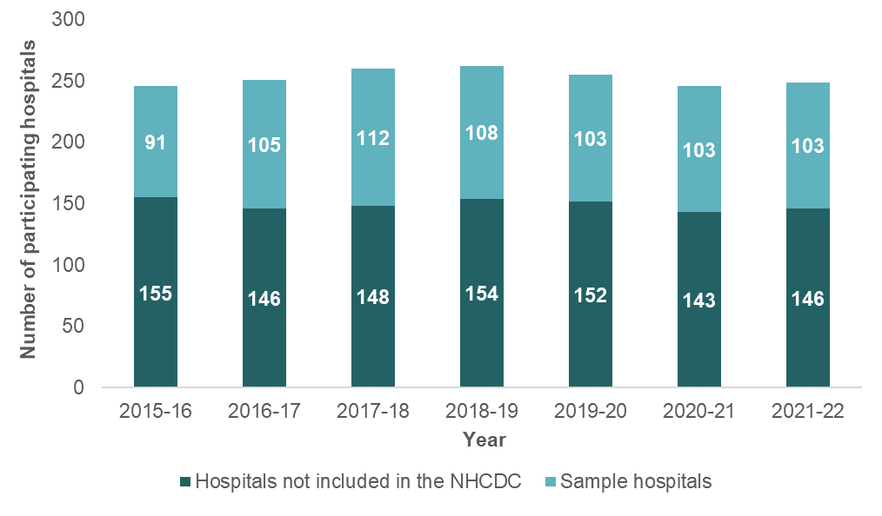

The population of separations in 2021‑22 is defined as all private admitted acute separations performed at 249 in-scope overnight private hospitals in 2021‑22, totalling 3,431,160 separations.

Figure 2. Total private hospital separations and NHCDC participation rate

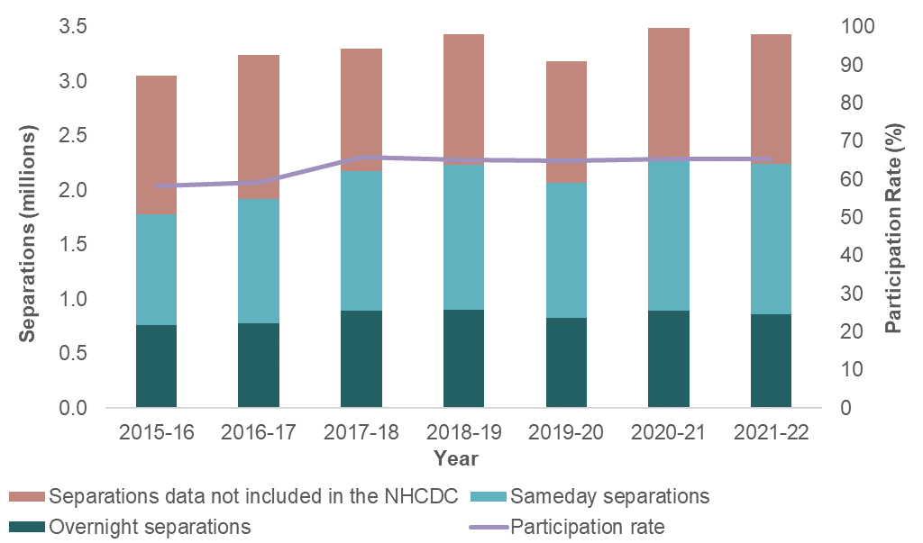

The number of sample separations (that is, separations submitted to the NHCDC) in 2021‑22 was 2,244,974, demonstrating a 1.4% decrease in the sample separations compared to 2020-21. This decrease in separations is also observed in the population overall. This can potentially be explained by the activity stabilisation following an increase in activity due to relaxation of COVID-19 restrictions.

The participation rate is calculated as the number of sample separations submitted to the NHCDC as a proportion of the total population separations reported to the PHDB. In 2021‑22, the participation rate was 65.4% of separations, compared to 65.3% of separations in 2020‑21 (a marginal increase of 0.1%).

Figure 3. Average Length of Stay (ALOS)

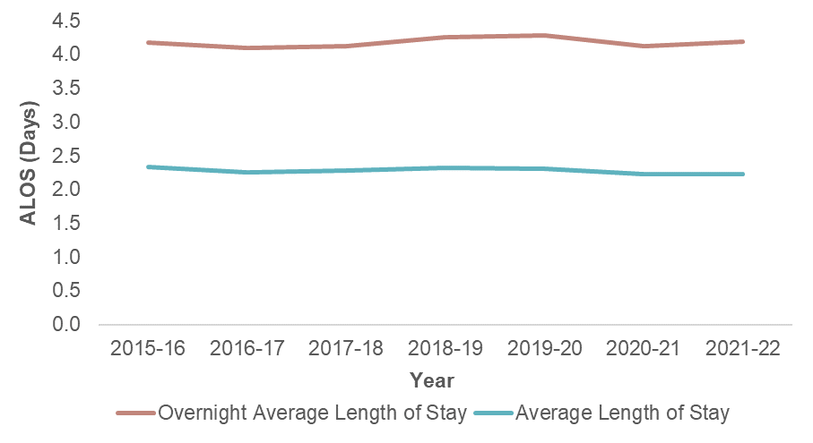

The average length of stay (ALOS) for 2021-22 (2.2 days) has remained constant compared to 2020-21. The overnight ALOS for 2021-22 has increased by 0.1 days (0.24%) compared to 2020-21.

In Table 3, percentage change represents a comparison to the previous NHCDC year. There was a 1.4% decrease in sample separations between 2020-21 and 2021-22. The number of participating hospitals was unchanged, with the decrease in separations driven by a lower average number of separations per hospital. Whilst it is observed that activity appears to have returned to similar levels prior to COVID-19, further analysis on trend data has not been conducted.

Table 3. Comparison of separations and hospitals, 2016-17 to 2021-22

|  |  |  |  |  |  |  |
| --- | --- | --- | --- | --- | --- | --- |
| **Summary** | **2016-17** | **2017-18** | **2018-19** | **2019-20** | **2020-21** | **2021-22** |
| Sample separations | 1,923,310 | 2,173,847 | 2,234,143 | 2,067,714 | 2,277,973 | 2,244,974 |
| Change in separations (%) | 7.9 | 13.0 | 2.8 | -7.4 | 10.2 | -1.4 |
| Sameday separations^ | 1,145,180 | 1,276,764 | 1,333,671 | 1,240,161 | 1,381,333 | 1,381,173 |
| Change in sameday separations (%) | 12.1 | 11.5 | 4.5 | -7.0 | 11.4 | 0.0 |
| Population separations | 3,242,411 | 3,297,288 | 3,430,288 | 3,184,312 | 3,487,127 | 3,431,160 |
| Participation rate (%) | 59.3 | 65.9 | 65.1 | 64.9 | 65.3 | 65.4 |
| Sample hospitals | 105 | 112 | 108 | 103 | 103 | 103 |
| Change in sample hospitals (%) | 15.4 | 6.7 | -3.6 | -4.6 | 0.0 | 0.0 |
| Population hospitals | 251 | 260 | 262 | 255 | 246 | 249 |
| Sample hospitals to population hospitals (%) | 41.8 | 43.1 | 41.2 | 40.4 | 41.9 | 41.4 |
| Average sample separations per hospital | 18,317 | 19,409 | 20,687 | 20,075 | 22,116 | 21,796 |
| Average population separations per hospital | 12,918 | 12,682 | 13,093 | 12,487 | 14,175 | 13,780 |
| Average Length of Stay | 2.3 | 2.3 | 2.3 | 2.3 | 2.2 | 2.2 |
| Change in Average Length of Stay (%) | -3.2 | 0.9 | 1.4 | -0.2 | -3.4 | -0.2 |
| Overnight Average Length of Stay | 4.1 | 4.1 | 4.3 | 4.3 | 4.1 | 4.2 |

* Figures may not reconcile due to rounding.

^ Sameday separations are a subset of sample separations.

## Analysis by MDC

The 2021-22 NHCDC submission has been analysed by Major Diagnosis Category (MDC) a summarised categorisation in the Australian Refined Diagnosis Related Groups (AR-DRG) classification, broadly aligned to the specialty of provider care. Episodes are assigned to an MDC based on their principal diagnosis. This section of the report provides a breakdown by MDC to highlight trends and drivers of cost in different medical specialities.

## Key findings

Table 4 captures data for each MDC, the key findings observed from analysis conducted are:

* + MDC 20: Alcohol/Drug Use and Alcohol/Drug Induced Organic Mental Disorders had the greatest percentage increase (33%) in the number of separations in 2021-22. This follows the 19% decrease in the number of separations in 2020-21.
  + MDC 00 (Pre MDC) consists of episodes that relate to critical care and life support and as such has the highest cost weight (23.65) and ALOS (29.4).
  + MDC 06 (Digestive System) has the highest volume of episodes (578,576 weighted separations or 16.9%). Minor elective procedures such as endoscopy and colonoscopy make up a large volume of the activity, driving the low cost weight (0.6) and short ALOS (1.7).
  + MDC 08 (Musculoskeletal System and Connective Tissue) has the next highest volume of episodes (468,580 weighted separations or 13.7%). Within the private sector, orthopaedic elective surgery is common, however it does attract a higher cost weight (2.01) and length of stay (2.9). As such it is the MDC with the highest number of cost weighted separations (941,846).
  + MDC 15 (Newborns and Other Neonates) and MDC 80 (DRGs operational room procedure unrelated to PD) have the next longest ALOS of 7.9 days and 7.6 respectively.
  + MDC 02 (Eye) and MDC 03 (Ear, Nose, Mouth and Throat) have the lowest average lengths of stay with 1.1 and 1.2 respectively. This reflects the sameday nature of these MDCs.

Table 4. NHCDC Private Sector Summary by Major Diagnostic Category (AR-DRG v11)

|  |  |  |  |  |  |  |
| --- | --- | --- | --- | --- | --- | --- |
| **MDC** | **MDC Description** | **Cost weight (a)** | **No. of weighted seps (b)** | **Cost weighted seps (c)=(a)x(b)** | **Number of days (d)** | **ALOS (days) (e)=(d)/(b)** |
| 00 | Pre MDC | 23.65 | 1,177 | 27,836 | 34,634 | 29.4 |
| 01 | Diseases and Disorders of the Nervous System | 1.19 | 105,569 | 125,627 | 353,106 | 3.3 |
| 02 | Diseases and Disorders of the Eye | 0.50 | 71,689 | 35,845 | 75,502 | 1.1 |
| 03 | Diseases and Disorders of the Ear, Nose, Mouth and Throat | 0.71 | 192,657 | 136,786 | 234,039 | 1.2 |
| 04 | Diseases and Disorders of the Respiratory System | 1.14 | 102,950 | 117,363 | 387,333 | 3.8 |
| 05 | Diseases and Disorders of the Circulatory System | 2.26 | 220,289 | 497,853 | 751,828 | 3.4 |
| 06 | Diseases and Disorders of the Digestive System | 0.60 | 578,576 | 347,146 | 960,705 | 1.7 |
| 07 | Diseases and Disorders of the Hepatobiliary System and Pancreas | 1.41 | 48,950 | 69,020 | 151,559 | 3.1 |
| 08 | Diseases and Disorders of the Musculoskeletal System and Connective Tissue | 2.01 | 468,580 | 941,846 | 1,381,255 | 2.9 |
| 09 | Diseases and Disorders of the Skin, Subcutaneous Tissue and Breast | 1.00 | 157,199 | 157,199 | 347,207 | 2.2 |
| 10 | Endocrine, Nutritional and Metabolic Diseases and Disorders | 1.28 | 90,481 | 115,816 | 192,400 | 2.1 |
| 11 | Diseases and Disorders of the Kidney and Urinary Tract | 0.44 | 307,890 | 135,472 | 480,280 | 1.6 |
| 12 | Diseases and Disorders of the Male Reproductive System | 0.91 | 86,320 | 78,551 | 129,987 | 1.5 |
| 13 | Diseases and Disorders of the Female Reproductive System | 0.78 | 155,058 | 120,945 | 222,602 | 1.4 |
| 14 | Pregnancy, Childbirth and the Puerperium | 1.46 | 116,676 | 170,347 | 421,160 | 3.6 |
| 15 | Newborns and Other Neonates | 3.34 | 7,204 | 24,061 | 56,696 | 7.9 |
| 16 | Diseases and Disorders of the Blood and Blood Forming Organs and Immunological Disorders | 0.40 | 59,890 | 23,956 | 101,303 | 1.7 |
| 17 | Neoplastic Disorders (Haematological and Solid Neoplasms) | 0.31 | 326,215 | 101,127 | 409,839 | 1.3 |
| 18 | Infectious and Parasitic Diseases | 2.01 | 16,650 | 33,467 | 122,463 | 7.4 |
| 19 | Mental Diseases and Disorders | 0.71 | 95,575 | 67,858 | 415,822 | 4.4 |
| 20 | Alcohol /Drug Use and Alcohol /Drug Induced Organic Mental Disorder | 0.56 | 19,566 | 10,957 | 74,418 | 3.8 |
| 21 | Injuries, Poisoning and Toxic Effects of Drugs: Multiple Trauma | 1.08 | 29,845 | 32,233 | 100,033 | 3.4 |
| 22 | Burns | 1.12 | 230 | 258 | 901 | 3.9 |
| 23 | Factors Influencing Health Status and Other Contacts with Health Services | 0.32 | 168,628 | 53,961 | 214,653 | 1.3 |
| 80 | DRGs operational room procedure unrelated to PD | 2.89 | 3,179 | 9,187 | 24,200 | 7.6 |
| 96 | Error DRGs | 0.62 | 118 | 73 | 199 | 1.7 |
| **All MDCs** |  | 1.00 | 3,431,160 | 3,434,788 | 7,644,124 | 2.2 |

#### Comparison with previous years

This section of the report analyses 3 MDCs and looks at how their sample separations and totals costs for 2021-22 compare with 2020-21 and 2019-20. The MDCs that have been selected are:

* + MDC 06 (Digestive System), shown in Figure 4, was selected as it has the highest number of sample separations.
  + MDC 04 (Respiratory System), shown in Figure 5, was selected to observe if there have been any impacts resulting from COVID-19 on respiratory AR-DRGs.
  + MDC 19 (Mental Diseases and Disorders), shown in Figure 6, was selected as it has seen a large decrease in activity since 2019‑20.

Figure 4. Separations and cost for MDC 06: Diseases and Disorders of the Digestive System

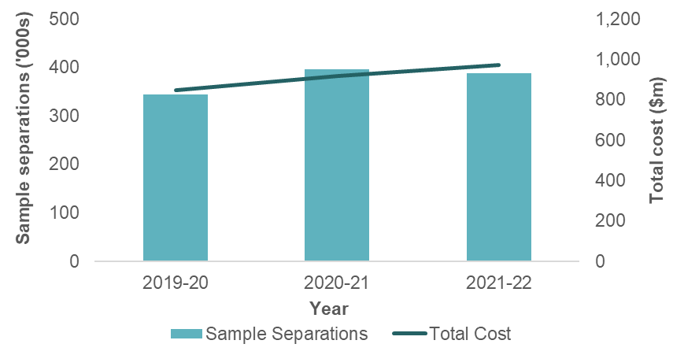

Total costs in MDC 06 have increased over the 3 year period from 2019‑20 to 2021‑22. In 2021‑22, there was a slight decrease in separations despite the total costs increasing. This decrease occurred predominantly in intervention type episodes rather than medical type episodes that saw a slight increase, with intervention episodes comprising the majority of MDC 06. The average cost increased by 8.3% which exceeded the overall average cost increase of 5.7%.

The following 3 intervention type AR‑DRGs alone comprise almost 65% of MDC 06:

* + G46B: Complex Endoscopy, Minor Complexity
  + G47C: Gastroscopy, Minor Complexity
  + G48B: Colonoscopy, Minor Complexity.

Figure 5. Separations and Cost for MDC 04: Diseases and Disorders of the Respiratory System

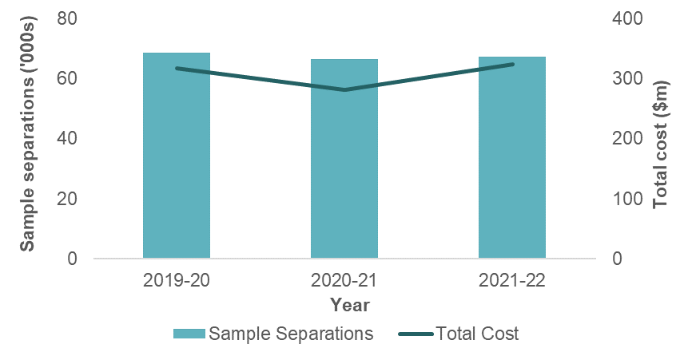

In 2021-22, MDC 04 sample separations were 1% higher than 2020-21, remaining 4.4% below 2019-20 levels. This trend indicates there is less respiratory support being accessed through private hospitals with the decrease consistent across most AR-DRGs within this MDC.

Total cost increased in 2021-22 by 15%, following a decrease in 2020-21. The resulting 14% increase in average cost was higher than the overall population change in average cost.

MDC 04 was examined to understand whether COVID‑19 had any impact on respiratory admissions in the private sector. There were only a small number of episodes in the 2021‑22 NHCDC submission with a COVID-19 diagnosis code. These episodes were more commonly assigned to MDC 23: Factors Influencing Health Status and Other Contacts with Health Services. MDC 23 sample separations were 1% lower than 2020-21. However, there was a 3% increase in total cost leading to a 4% increase in the average cost across the MDC.

Figure 6. Separations and Cost for MDC 19: Mental Diseases and Disorders

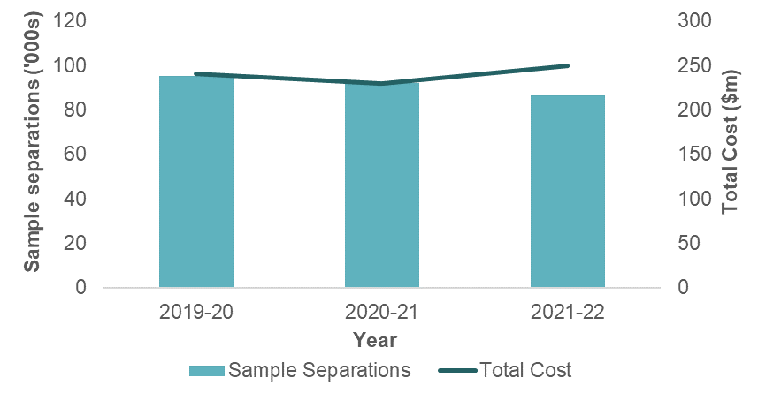

Total costs in MDC 19 increased in 2021-22, while sample separations have decreased across the 3year period.

The decrease in separations in 2021-22 is primarily driven by the 2 AR-DRGs with the largest volume of separations:

* + U60Z: Mental Health Treatment W/O ECT, Sameday
  + U63B: Major Affective Disorders, Minor Complexity.

Both AR-DRGs have maintained a similar level of total cost despite the decrease in separations. As evidenced in the chart, the decrease in separations occurred in 2020‑21 and continued into 2020‑22.

## Analysis of Top 10 AR-DRGs

Analysing the top 10 AR-DRGs provides insight into the consistency between years, facilitates the identification of trends and highlights the AR-DRGs that are driving costs. This section of the report provides an analysis of the top 10 AR-DRGs by the following categories:

* + cost weight
  + number of population-adjusted separations
  + cost weighted separations.

### Top 10 AR-DRGs ranked by highest cost weight

#### Key findings

As shown in Figure 7 below, the highest cost weight AR-DRG was A13A: Ventilation >=336 hours, Major Complexity. This was also the AR-DRG with the highest cost weight in the previous year and has had the highest cost weight since 2015-16. Of the 10 highest cost weight AR-DRGs, 7 belong to the MDC 00 (Pre MDC).

The AR-DRGs in Table 5have been ranked by highest cost weight comparing 2021-22 to 2020-21.

Figure 7. Comparison of top 10 AR-DRGs ranked by highest cost weight, 2019-20 to 2021-22

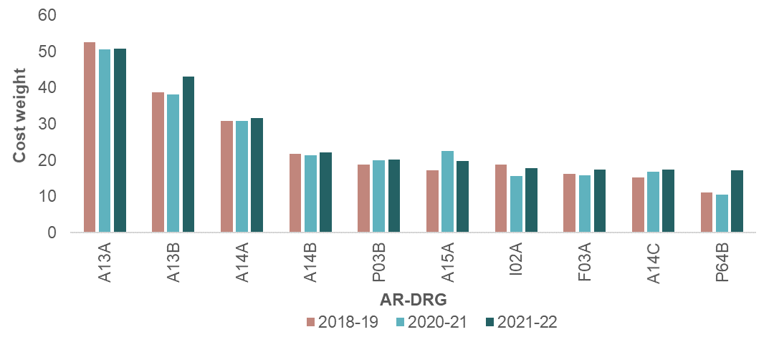

It should be noted that the typically small number of separations in these AR-DRGs means that variation in cost weights between years is not unexpected. There were three new AR-DRGs in the top 10 by cost weight for 2021-22:

* + I02A: Microvascular Tissue Transfers or Skin Grafts, Excluding Hand, Major Complexity
  + F03A: Cardiac Valve Interventions with CPB Pump with Invasive Cardiac Investigation, Major Complexity
  + P64B: Neonate, Admission Weight 1250-1499g without Significant GI or Ventilation >= 96 Hours, Minor Complexity.

Table 5. Top 10 AR-DRGs ranked by highest cost weight, 2021-22 compared to 2020-21

|  |  |  |  |  |  |  |  |  |  |  |  |  |  |  |
| --- | --- | --- | --- | --- | --- | --- | --- | --- | --- | --- | --- | --- | --- | --- |
|  |  |  |  | **2021-22** | | | | | | | | **2020-21** | | |
| **Top 10 2020-21** | **Rank 2021-22** | **AR-DRG** | **AR-DRG Description** | **Cost weight (a)** | **No. of weighted seps (b)** | **Cost weighted seps (c)=(a)x(b)** | **Number of days (d)** | **ALOS (days) (e)=(d)/(b)** | **Std error** | **% of total seps** | **% of CW seps** | **Cost weight** | **Rank** | **No. of weighted seps** |
| Yes | 1 | A13A | Ventilation >= 336 Hours, Major Complexity | **50.82** | 24 | 1,220 | 1,589 | 67.3 | 8.08 | 0.00% | 0.04% | 50.54 | 1 | 74 |
| Yes | 2 | A13B | Ventilation >= 336 Hours, Minor Complexity | **43.13** | 102 | 4,399 | 4,699 | 46.0 | 2.58 | 0.00% | 0.13% | 38.11 | 2 | 83 |
| Yes | 3 | A14A | Ventilation >= 96 Hours and < 336 Hours, Major Complexity | **31.65** | 206 | 6,520 | 8,513 | 41.3 | 1.73 | 0.01% | 0.19% | 30.82 | 3 | 248 |
| Yes | 4 | A14B | Ventilation >= 96 Hours and < 336 Hours, Intermediate Complexity | **22.27** | 370 | 8,240 | 10,285 | 27.8 | 0.80 | 0.01% | 0.24% | 21.33 | 6 | 325 |
| Yes | 5 | P03B | Neonate, Admission Weight 1000-1499g with Significant GI or Ventilation >= 96 Hours, Minor Complexity | **20.21** | 57 | 1,152 | 2,306 | 40.2 | 1.83 | 0.00% | 0.03% | 20.04 | 7 | 37 |
| Yes | 6 | A15A | Tracheostomy, Major Complexity | **19.73** | 19 | 375 | 554 | 29.7 | 2.69 | 0.00% | 0.01% | 22.49 | 5 | 21 |
| No | 7 | I02A | Microvascular Tissue Transfers or Skin Grafts, Excluding Hand, Major Complexity | **17.95** | 52 | 933 | 2,522 | 48.3 | 2.65 | 0.00% | 0.03% | 15.67 | 12 | 67 |
| No | 8 | F03A | Cardiac Valve Interventions with CPB Pump with Invasive Cardiac Investigation, Major Complexity | **17.45** | 91 | 1,588 | 2,384 | 26.2 | 0.94 | 0.00% | 0.05% | 15.85 | 11 | 284 |
| Yes | 9 | A14C | Ventilation >= 96 Hours and < 336 Hours, Minor Complexity | **17.43** | 288 | 5,020 | 6,613 | 23.0 | 0.87 | 0.01% | 0.15% | 16.77 | 10 | 178 |
| No | 10 | P64B | Neonate, Admission Weight 1250-1499g without Significant GI or Ventilation >= 96 Hours, Minor Complexity | **17.28** | 12 | 207 | 426 | 34.2 | 1.50 | 0.00% | 0.01% | 10.52 | 40 | 40 |
| 7 in  top 10 | **Sub-total, top 10 highest cost weight** | | | **24.27** | **1,222** | **29,654** | **39,892** | **32.7** |  | **0.04%** | **0.86%** |  |  |  |
| **All AR-DRGs** | | | **1.00** | **3,431,160** | **3,431,160** | **7,644,124** | **2.2** |  | **100%** | **100%** |  |  |  |
| **Top 10 highest cost weight, % of all AR-DRGs** | | |  | **0.0%** | **0.9%** | **0.5%** |  |  |  |  |  |  |  |

**Notes**

* + 1. For cost weight (cost bucket specific) calculations please refer to Appendix D: Cost weight tables by AR-DRG Version 10.0
    2. Separations shown are strata weighted
    3. ALOS means Average Length of Stay

### Top 10 AR-DRGs ranked by highest volume of population-adjusted separations

#### Key findings

Table 6 and Figure 9show the AR-DRGs with the highest population-adjusted separations for 2021-22. This is a measure of the volume of separations in the entire overnight private hospital population (the separations in the 2021-22 sample, adjusted using weights to reflect the whole population).

Table 6 shows that for 2020-21, R63Z: Pharmacotherapy for Neoplastic Disorders was ranked as having the most population-adjusted separations, consistent with its ranking in the previous year. This is expected given the high-frequency, sameday nature of treatments required for R63Z. Table 6 also shows that the top 10 AR-DRGs represented 33.3% of the total population-adjusted separations (1,142,886 population-adjusted separations out of 3,431,160 total separations). However, these AR-DRGs represented only 8.2% (281,717) of the total population cost weighted separations. This indicates that these AR-DRGs were predominantly high-volume and low-cost.

The ALOS for the top 10 AR-DRGs is 1.0 days compared to the population average of 2.2 days, as the majority of these AR-DRGs were sameday procedures.

#### Comparison with previous years

Figure 8. Total Weighted Separations and ALOS

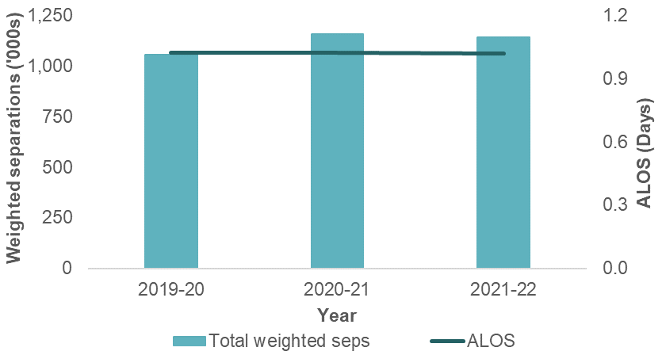

Figure 8 shows the change in total population-adjusted separations and ALOS for the top 10 AR‑DRGs in the period from 2019-20 to 2021-22. The change in ALOS has been minimal over the years, since these AR‑DRGs are generally high-volume, sameday separations. For total cost weighted separations, the increase in 2020-21 (compared to 2019-20) reflects the increase in activity as COVID-19 restrictions were lifted.

Figure 9. Comparison of top 10 AR-DRGs by highest volume of population-adjusted separations, 2018-19 to 2021-22

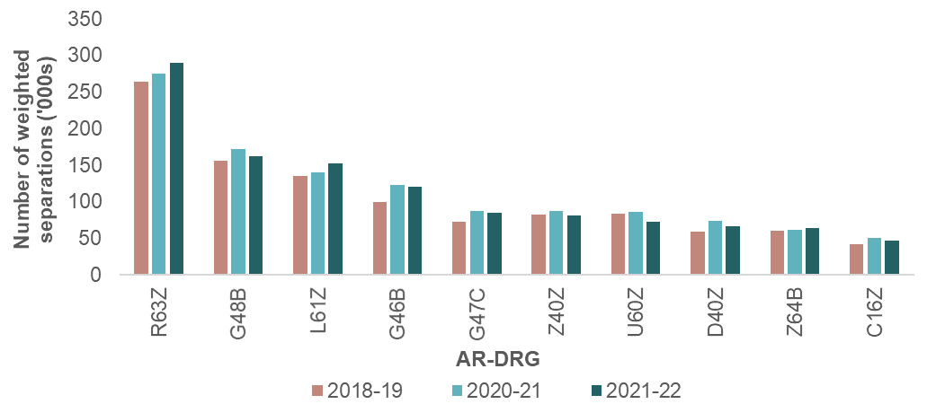

There have been minor movements within the top 10 AR-DRGs with the highest population-adjusted separations, however there were no changes to the composition.

Table 6. Top 10 AR-DRGs ranked by highest volume of population-adjusted separations

|  |  |  |  |  |  |  |  |  |  |  |  |  |  |  |  |  |
| --- | --- | --- | --- | --- | --- | --- | --- | --- | --- | --- | --- | --- | --- | --- | --- | --- |
|  | |  |  |  | **2021-22** | | | | | | | | **2020-21** | | | |
| **Top 10 2020-21** | **Rank 2021-22** | | **AR-DRG** | **AR-DRG Description** | **Cost weight (a)** | **No. of weighted seps (b)** | **Cost weighted seps (c)=(a)x(b)** | **Number of days (d)** | **ALOS (days) (e)=(d)/(b)** | **Std error** | **% of total seps** | **% of CW seps** | **Cost weighted seps** | **Rank** | **No. Of weighted seps** | **No. of weighted seps** |
| Yes | | 1 | R63Z | Pharmacotherapy for Neoplastic Disorders | 0.22 | 290,171 | 63,838 | 290,176 | 1.0 | 0.001 | 8.46% | 1.9% | 275,269 | 1 | 0.20 | 263,801 |
| Yes | | 2 | G48B | Colonoscopy, Minor Complexity | 0.32 | 162,242 | 51,917 | 167,051 | 1.0 | 0.001 | 4.73% | 1.5% | 171,739 | 2 | 0.30 | 155,803 |
| Yes | | 3 | L61Z | Haemodialysis | 0.10 | 152,009 | 15,201 | 152,018 | 1.0 | 0.000 | 4.43% | 0.4% | 140,690 | 3 | 0.11 | 135,126 |
| Yes | | 4 | G46B | Complex Endoscopy, Minor Complexity | 0.36 | 120,602 | 43,417 | 128,305 | 1.1 | 0.001 | 3.51% | 1.3% | 123,236 | 4 | 0.35 | 99,888 |
| Yes | | 5 | G47C | Gastroscopy, Minor Complexity | 0.24 | 85,373 | 20,490 | 90,607 | 1.1 | 0.001 | 2.49% | 0.6% | 87,435 | 5 | 0.22 | 72,820 |
| Yes | | 6 | Z40Z | Other Contacts with Health Services with Endoscopy | 0.26 | 81,596 | 21,215 | 82,860 | 1.0 | 0.001 | 2.38% | 0.6% | 87,119 | 6 | 0.25 | 82,864 |
| Yes | | 7 | U60Z | Mental Health Treatment without ECT, Sameday | 0.09 | 72,276 | 6,505 | 72,276 | 1.0 | 0.000 | 2.11% | 0.2% | 85,985 | 7 | 0.10 | 83,814 |
| Yes | | 8 | D40Z | Dental Extractions and Restorations | 0.42 | 67,156 | 28,206 | 67,343 | 1.0 | 0.001 | 1.96% | 0.8% | 73,591 | 8 | 0.43 | 59,153 |
| Yes | | 9 | Z64B | Other Factors Influencing Health Status, Minor Complexity | 0.15 | 64,094 | 9,614 | 66,445 | 1.0 | 0.002 | 1.87% | 0.3% | 62,195 | 9 | 0.15 | 60,445 |
| Yes | | 10 | C16Z | Lens Interventions | 0.45 | 47,367 | 21,315 | 47,490 | 1.0 | 0.001 | 1.38% | 0.6% | 50,548 | 10 | 0.44 | 41,653 |
| 10 in  top 10 | | **Sub-total, top 10 highest volume of population-adjusted separations** | | | **0.25** | **1,142,886** | **281,717** | **1,164,571** | **1.0** |  | **33.31%** | **8.2%** |  |  |  |  |
| **All AR-DRGs** | | | **1.00** | **3,431,160** | **3,431,160** | **7,644,124** | **2.2** |  | **100%** | **100%** |  |  |  |  |
| **Top 10 highest volume of population-adjusted separations, % of all AR-DRGs** | | |  | **33.3%** | **8.2%** | **15.2%** |  |  |  |  |  |  |  |  |

**Notes**

1. For cost weight (cost bucket specific) calculations please refer to Appendix D: Cost weight tables by AR-DRG Version 10.0
2. Separations shown are strata weighted
3. ALOS means Average Length of Stay

### Top 10 AR-DRGs ranked by highest cost weighted separations

#### Key findings

Table 7 and Figure 10 present the top 10 AR-DRGs ranked by highest cost weighted separations. A cost weighted separation refers to the number of population-adjusted separations multiplied by the cost weight for that AR-DRG. It measures the total cost, or resource utilisation, associated with that AR-DRG.

Figure 10 shows that the highest cost weight AR-DRG was I04B: Knee Replacement, Minor Complexity, and is consistent with its ranking in the previous year. This procedure is a common procedure within the private sector, and it is frequently ranked amongst the highest cost weighted AR-DRGs.

Table 7 sets out the top 10 AR-DRGs by highest cost weighted separations. These predominantly fall into 2 groups: procedures requiring high-cost prostheses (such as orthopaedic or cardiac procedures) and high-volume procedures (such as colonoscopy or chemotherapy, are also in Table 6).

The top 10 AR-DRGs by cost weighted separations represented 20.3% of the total population cost weighted separations (695,058 cost weighted separations out of 3,431,160 total separations). These AR-DRGs represented 21.8% of the total population-adjusted separations, reflecting the combination of high-volume and high-cost AR-DRGs.

#### Comparison with previous years

Figure 10. Comparison of top 10 AR-DRGs by highest cost weighted separations, 2019-20 to 2021-22

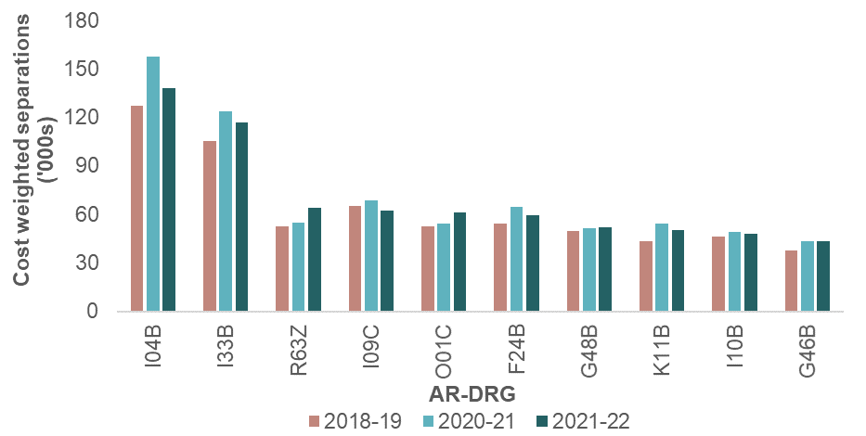

Table 7 shows there has been minimal movement in the rank of individual AR-DRGs, with no new AR-DRGs entering the top 10 list in 2021-22. Both I04B: Knee Replacement, Minor Complexity and I33B: Hip Replacement for Non-Trauma, Minor Complexity have seen decreases in cost weighted separations of 12.35% and 5.81% respectively.

Table 7. Top 10 AR-DRGs ranked by highest cost weighted separations

|  |  |  |  |  |  |  |  |  |  |  |  |  |  |  |  |
| --- | --- | --- | --- | --- | --- | --- | --- | --- | --- | --- | --- | --- | --- | --- | --- |
|  |  |  |  | **2021-22** | | | | | | | | **2020-21** | | | |
| **Top 10 2020-21** | **Rank 2021-22** | **AR-DRG** | **AR-DRG Description** | **Cost weight (a)** | **No. of weighted seps (b)** | **Cost weighted seps (c)=(a)x(b)** | **Number of days (d)** | **ALOS (days) (e)=(d)/(b)** | **Std error** | **% of total seps** | **% of CW seps** | **Cost weighted seps** | **Rank** | **No. of weighted seps** | **Cost weight** |
| Yes | 1 | I04B | Knee Replacement, Minor Complexity | 3.66 | 37,759 | **138,198** | 160,786 | 4.3 | 0.01 | 1.10% | 4.0% | 157,665 | 1 | 41,821 | 3.77 |
| Yes | 2 | I33B | Hip Replacement for Non-Trauma, Minor Complexity | 4.08 | 28,610 | **116,729** | 113,443 | 4.0 | 0.01 | 0.83% | 3.4% | 123,929 | 2 | 29,648 | 4.18 |
| Yes | 3 | R63Z | Pharmacotherapy for Neoplastic Disorders | 0.22 | 290,171 | **63,838** | 290,176 | 1.0 | 0.00 | 8.46% | 1.9% | 55,054 | 5 | 275,269 | 0.20 |
| Yes | 4 | I09C | Spinal Fusion, Minor Complexity | 6.24 | 9,966 | **62,188** | 46,893 | 4.7 | 0.04 | 0.29% | 1.8% | 68,552 | 3 | 10,728 | 6.39 |
| Yes | 5 | O01C | Caesarean Delivery, Minor Complexity | 2.00 | 30,489 | **60,978** | 131,175 | 4.3 | 0.00 | 0.89% | 1.8% | 54,050 | 7 | 27,718 | 1.95 |
| Yes | 6 | F24B | Interventional Coronary Procedures, Not Admitted for AMI, Minor Complexity | 2.48 | 24,052 | **59,649** | 34,637 | 1.4 | 0.01 | 0.70% | 1.7% | 64,474 | 4 | 26,209 | 2.46 |
| Yes | 7 | G48B | Colonoscopy, Minor Complexity | 0.32 | 162,242 | **51,917** | 167,051 | 1.0 | 0.00 | 4.73% | 1.5% | 51,522 | 8 | 171,739 | 0.30 |
| Yes | 8 | K11B | Major Laparoscopic Interventions for Obesity, Minor Complexity | 2.09 | 24,079 | **50,325** | 48,611 | 2.0 | 0.01 | 0.70% | 1.5% | 54,330 | 6 | 26,120 | 2.08 |
| Yes | 9 | I10B | Other Back and Neck Interventions, Minor Complexity | 2.24 | 21,348 | **47,820** | 62,680 | 2.9 | 0.02 | 0.62% | 1.4% | 48,993 | 10 | 21,027 | 2.33 |
| No | 10 | G46B | Complex Endoscopy, Minor Complexity | 0.36 | 120,602 | **43,417** | 128,305 | 1.1 | 0.00 | 3.51% | 1.3% | 43,133 | 11 | 123,236 | 0.35 |
| 9 in  top 10 | **Sub-total, top 10 highest cost weighted separations** | | | **0.93** | **749,318** | **695,058** | **1,183,758** | **1.6** |  | **21.84%** | **20.3%** |  |  |  |  |
| **All AR-DRGs** | | | **1.00** | **3,431,160** | **3,431,160** | **7,644,124** | **2.2** |  | **100%** | **100%** |  |  |  |  |
| **Top 10 highest cost weighted separations, % of all AR-DRGs** | | |  | **21.8%** | **20.3%** | **15.5%** |  |  |  |  |  |  |  |  |

**Notes**

1. For cost weight (cost bucket specific) calculations please refer to Appendix D: Cost weight tables by AR-DRG Version 10.0
2. Separations shown are strata weighted
3. ALOS means Average Length of Stay

## Analysis of cost buckets

Analysis of the cost buckets (operating room and specialist procedure suites, critical care, prostheses and miscellaneous) has been undertaken to identify the top 10 AR-DRGs by proportion of cost for each of these buckets. The NHCDC Private Sector analysis has reported on the following cost buckets groups since 2012-13:

* + operating room and specialist procedure suites (OR and SPS)
  + critical care
  + prostheses
  + miscellaneous (representing the remainder of the cost buckets – see Appendix B for the list of cost buckets).

The same cost bucket groups have been considered for 2021-22, with additional analysis on the ward nursing cost bucket presented in this year’s report.

#### Comparison with previous years

Figure 11. Breakdown of costs by cost bucket group

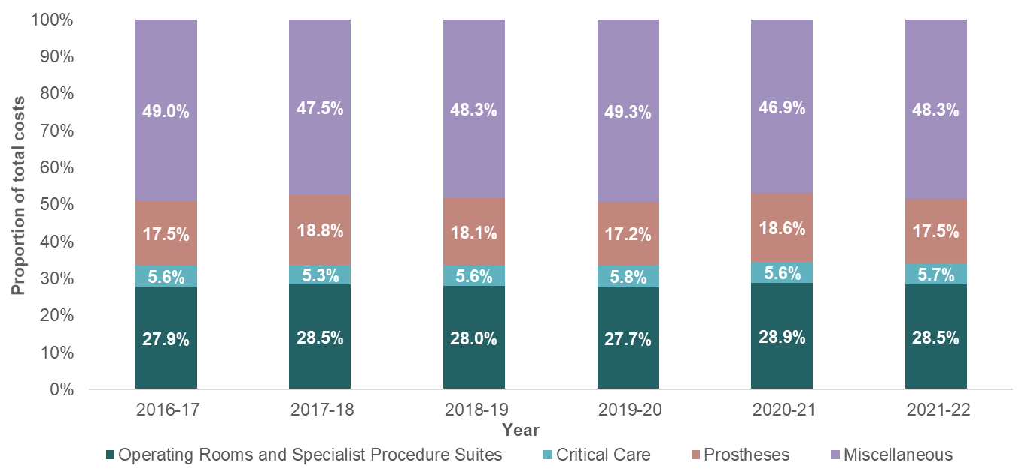

Figure 11 illustrates the differences in the cost bucket group proportions over the last six years. The distribution of costs across the four cost bucket groups has remained reasonably consistent, despite the changes to the volume of activity and costs incurred by the private sector as result of the resurgence from the COVID-19 pandemic.

* + The proportion of costs allocated to operating rooms and specialist procedure suites in 2021-22 has decreased by 0.4 percentage points to 28.5% in comparison to 2020‑21.
  + The proportion of costs allocated to critical care has remained reasonably stable in   
    2021-22 at 5.7%. This cost bucket consistently makes up the smallest proportion of total costs.
  + The proportion of costs allocated to prostheses in 2021-22 has decreased by 1.1 percentage points to 17.5% in comparison to 2020‑21.
  + Costs allocated to the miscellaneous cost bucket in 2021-22 has increased by 1.4 percentage points to 48.3% in comparison to 2020-21. This is the largest change across all the grouped cost buckets.

Whilst aggregated reporting of cost buckets does not necessarily present the changes in granular costs, for example at the line item level, several factors would change the reported cost for a cost bucket in each year. Cost buckets may be changed by:

* + improvements in the accuracy of cost allocations through quality improvement of the participant’s feeder data and/or allocation statistics
  + changes in service weights
  + increases in sameday theatre related separations
  + changes in casemix.

### Operating room and specialist procedure suites cost bucket

#### Key findings

Table 8 shows that the AR-DRG with the highest proportion of their total cost belonging to the OR and SPS bucket is M63Z: Male Sterilisation Interventions (68.4%). This percentage has increased compared to 2020-21 (67.6%). For the remaining nine AR-DRGs in Table 8, the OR and SPS cost weights have been relatively stable over the last three years.

The AR-DRGs listed are all minor complexity procedures that would require minimal time and resources to perform, with the operating room being the biggest contributor to cost weight.

Table 8. Top 10 AR-DRGs for costs allocated to the operating room and specialist procedures suites cost bucket between 2019-20 to 2021-22.

|  |  |  |  |  |  |  |  |  |  |  |  |  |
| --- | --- | --- | --- | --- | --- | --- | --- | --- | --- | --- | --- | --- |
| **Rank 2021-22** | **AR-DRG** | **AR-DRG Description** | **No. of weighted seps** | **Overall cost weight** | **OR and SPS Cost Weight** | | | **% of AR-DRG total cost** | | | | |
| **2019-20** | **2020-21** | **2021-22** | **2019-20** | | **2020-21** | | **2021-22** |
| 1 | M63Z | Male Sterilisation Interventions | 4,714 | 0.35 | 0.23 | 0.23 | 0.24 | 63.4% | | 67.6% | | 68.4% |
| 2 | J10B | Plastic GIs for Skin, Subcutaneous Tissue and Breast Disorders, Minor Complexity | 17,263 | 0.71 | 0.42 | 0.48 | 0.48 | 64.4% | | 67.0% | | 67.5% |
| 3 | M05Z | Circumcision | 5,809 | 0.47 | 0.31 | 0.32 | 0.32 | 64.8% | | 68.1% | | 67.4% |
| 4 | B05Z | Carpal Tunnel Release | 15,733 | 0.39 | 0.25 | 0.25 | 0.26 | 65.9% | | 67.5% | | 66.8% |
| 5 | D40Z | Dental Extractions and Restorations | 67,156 | 0.42 | 0.27 | 0.28 | 0.28 | 63.8% | | 64.5% | | 66.6% |
| 6 | U40Z | Mental Health Treatment with ECT, Sameday | 4,094 | 0.22 | 0.22 | 0.16 | 0.14 | 58.5% | | 69.4% | | 66.3% |
| 7 | M40Z | Cystourethroscopy for Male Reproductive System Disorder, Sameday | 11,879 | 0.36 | 0.24 | 0.21 | 0.24 | 65.6% | | 65.2% | | 66.2% |
| 8 | C11Z | Eyelid Interventions | 6,183 | 0.69 | 0.45 | 0.46 | 0.46 | 65.8% | | 67.2% | | 66.1% |
| 9 | M04B | Testes Interventions, Minor Complexity | 6,359 | 0.62 | n/a | n/a | 0.41 | n/a | | n/a | | 66.1% |
| 10 | N09B | Other Vagina, Cervix and Vulva Interventions, Minor Complexity | 12,173 | 0.38 | 0.23 | 0.24 | 0.25 | 63.4% | | 66.0% | | 66.0% |
| **Sub-total, top 10 highest OR and SPS cost weight %** | | | **151,362** | **0.46** | **0.28** | **0.29** | **0.30** | **64.2%** | | **65.9%** | | **66.7%** |
| **All OR and SPS AR-DRGs** | | | **3,430,229** | **1.00** | **0.28** | **0.29** | **0.28** | **27.7%** | | **28.9%** | | **28.5%** |
| **Top 10 highest OR and SPS cost weights proportion (% of all OR and SPS AR-DRGs)** | | | **4.4%** |  |  |  | |  |  | |  |  |

**Notes**

1. Separations shown are strata weighted
2. The overall cost weight represents the cost weight across all cost buckets (total cost) of the strata weighted separations.
3. For cost weight (cost bucket specific) calculations please refer to Appendix D: Cost weight tables by AR-DRG Version 11.0
4. AR-DRG’s which are not present in previous AR-DRG versions are presented by n/a
5. For AR-DRG’s with no previous data, Sub-total cost weight percentage are calculated excluding the particular AR-DRG

### Critical care cost bucket

#### Key findings

Table 9 shows that the AR-DRG with the highest percentage of its total cost belonging to the critical care bucket was X40B: Injuries, Poisoning and Toxic Effects of Drugs with Ventilator Support, Minor Complexity (71.2%). All AR-DRGs in this table are related to ventilator support, indicating the intensive care nature of these separations.

Table 9. Top 10 AR-DRGs for costs allocated to the critical care cost bucket in 2021-22.

|  |  |  |  |  |  |  |  |  |  |
| --- | --- | --- | --- | --- | --- | --- | --- | --- | --- |
| **Rank 2021-22** | **AR-DRG** | **AR-DRG Description** | **No. of weighted seps** | **Overall cost weight** | **Critical Care Cost Weight** | **% of AR-DRG total cost** | | | |
| **2021-22** | **2021-22** | | | |
| 1 | X40B | Injuries, Poisoning and Toxic Effects of Drugs with Ventilator Support, Minor Complexity | 10 | 2.89 | 2.06 | **71.2%** | | | |
| 2 | X40A | Injuries, Poisoning and Toxic Effects of Drugs with Ventilator Support, Major Complexity | 9 | 5.50 | 3.83 | **69.6%** | | | |
| 3 | F40B | Circulatory Disorders with Ventilator Support, Minor Complexity | 17 | 5.41 | 3.66 | **67.7%** | | | |
| 4 | E40A | Respiratory System Disorders with Ventilator Support, Major Complexity | 58 | 9.83 | 6.28 | **63.8%** | | | |
| 5 | E40B | Respiratory System Disorders with Ventilator Support, Minor Complexity | 64 | 6.70 | 4.24 | **63.3%** | | | |
| 6 | B42B | Nervous System Disorders with Ventilator Support, Intermediate Complexity | 19 | 7.30 | 4.58 | **62.7%** | | | |
| 7 | A13A | Ventilation >= 336 Hours, Major Complexity | 24 | 50.82 | 30.32 | **59.7%** | | | |
| 8 | A14A | Ventilation >= 96 Hours and < 336 Hours, Major Complexity | 206 | 31.65 | 18.48 | **58.4%** | | | |
| 9 | A13B | Ventilation >= 336 Hours, Minor Complexity | 102 | 43.13 | 24.53 | **56.9%** | | | |
| 10 | A14C | Ventilation >= 96 Hours and < 336 Hours, Minor Complexity | 288 | 17.43 | 9.89 | **56.7%** | | | |
| **Sub-total, top 10 critical care cost weight %** | | | **797** | **23.16** | 13.45 | 58.1% | | | |
| **All critical care AR-DRGs** | | | **3,416,106** | **1.00** | 0.06 | 5.7% | | | |
| **Top 10 highest critical care cost weights proportion (% of all critical care AR-DRGs)** | | | **0.02%** |  |  |  |  |  |  | |

**Notes**

1. Separations shown are strata weighted
2. The overall cost weight represents the cost weight across all cost buckets (total cost) of the strata weighted separations.
3. For cost weight (cost bucket specific) calculations please refer to Appendix D: Cost weight tables by AR-DRG Version 11.0

### Prostheses cost bucket

#### Key findings

Table 10 shows that the AR-DRG with the highest proportion of their total cost belonging to the prostheses cost bucket was F10B: Implantation and Replacement of AICD, Total System, Minor Complexity (84.2%). The cost weight and prostheses cost allocation has been relatively stable for this AR-DRG over the past 3 years. The overall cost weight for the AR-DRGs in Table 10 (6.08) is higher than the population average, with 64.6% (3.93) of this relating to the prostheses cost bucket. Overall, the proportion of costs allocated to the prostheses cost bucket was relatively stable over the last 3 years for these   
AR-DRGs, although this varied more for some AR-DRGs with lower separation volumes.

Table 10. Top 10 AR-DRGs for costs allocated to the prostheses cost bucket

|  |  |  |  |  |  |  |  |  |  |  |  |
| --- | --- | --- | --- | --- | --- | --- | --- | --- | --- | --- | --- |
| **Rank 2021-22** | **AR-DRG** | **AR-DRG Description** | **No. of weighted seps** | **Overall cost weight** | **Prostheses Cost Weight** | | | **% of AR-DRG total cost** | | | |
| **2019-20** | **2020-21** | **2021-22** | **2019-20** | **2020-21** | | **2021-22** |
| 1 | F01B | Implantation and Replacement of AICD, Total System, Minor Complexity | 2,503 | 10.74 | 9.12 | 9.57 | 9.04 | 83.4% | 84.8% | | **84.2%** |
| 2 | D01Z | Cochlear Implant | 858 | 7.26 | 6.18 | 6.37 | 5.77 | 79.8% | 80.8% | | **79.5%** |
| 3 | F17B | Insertion and Replacement of Pacemaker Generator, Minor Complexity | 3,578 | 3.15 | 2.39 | 2.52 | 2.40 | 74.0% | 76.9% | | **76.0%** |
| 4 | F01A | Implantation and Replacement of AICD, Total System, Major Complexity | 333 | 14.63 | 9.32 | 10.40 | 9.74 | 65.4% | 67.2% | | **66.6%** |
| 5 | F25B | Percutaneous Heart Valve Replacement with Bioprosthesis, Minor Complexity | 2,180 | 8.64 | n/a | n/a | 5.61 | n/a | n/a | | **64.9%** |
| 6 | F12B | Implantation and Replacement of Pacemaker, Total System, Minor Complexity | 7,889 | 4.02 | 2.53 | 2.64 | 2.54 | 63.0% | 64.1% | | **63.2%** |
| 7 | I06Z | Spinal Fusion for Deformity | 1,071 | 13.28 | 7.13 | 7.49 | 7.71 | 55.3% | 55.4% | | **58.1%** |
| 8 | F19B | Trans-Vascular Percutaneous Cardiac Intervention, Minor Complexity | 1,170 | 3.33 | 1.88 | 1.89 | 1.88 | 55.8% | 56.2% | | **56.5%** |
| 9 | I09C | Spinal Fusion, Minor Complexity | 9,966 | 6.24 | 3.50 | 3.58 | 3.44 | 54.9% | 56.0% | | **55.1%** |
| 10 | F17A | Insertion and Replacement of Pacemaker Generator, Major Complexity | 205 | 4.17 | 2.32 | 2.47 | 2.29 | 49.8% | 59.6% | | **54.8%** |
| **Sub-total, top 10 highest prostheses cost weight %** | | | **29,753** | **6.08** | 3.83 | 5.00 | 3.93 | 63.4% | | 64.9% | **64.6%** |
| **All Prostheses AR-DRGs** | | | **3,413,516** | **1.00** | 0.17 | 0.19 | 0.17 | 17.2% | | 18.6% | **17.5%** |
| **Top 10 highest prostheses cost weights proportion (% of all Prostheses AR-DRGs)** | | | **0.87%** |  |  |  |  |  | |  |  |

**Notes**

1. For cost weight (cost bucket specific) calculations please refer to Appendix D: Cost weight tables by AR-DRG Version 10.0
2. Separations shown are strata weighted
3. The overall cost weight represents the cost weight across all cost buckets (total cost) of the strata weighted separations.

# COVID-19

## Background

The COVID‑19 pandemic affected the healthcare system within Australia, causing systemic impacts that directly and indirectly affected the private hospital sector. Actions from governments as part of the COVID-19 response impacted hospital activity and hence expenditure submitted to the NHCDC private sector. Differences in both impact and responses varied from state to state, with financial implications that are reflected in this report.

At the beginning of the pandemic in March 2020, national lockdowns impacted non-essential activities, pausing or reducing activities under the ‘stay at home’ orders. This had the following impact on public hospital activities:

* + elective surgeries were suspended, except for category 1 and urgent category 2
  + emergency department presentations were reduced
  + hospitals incurred additional costs related to preparedness activities.

In April 2020, some category 2 and 3 elective surgeries were resumed, and by May 2020 a 3‑stage plan to resume elective surgeries was announced. These events directly impacted the level of activity in hospitals across the country.

Following these initial national lockdowns, government responses to the pandemic varied across states. Jurisdictions had different COVID-19 restrictions imposed during 2020‑21, that lead to varied activity and costs between jurisdictions and individual facilities within hospital groups.

## Costing Approach to COVID-19

In June 2020, IHACPA released the *COVID-19 Response - Costing and pricing guidelines*[13] for the costing and pricing of activity for the COVID‑19 response. This relates to the National Partnership on COVID-19 Response (NPCR) entered into by the Commonwealth Government and state and territory governments. This document was also a reference for private sector hospitals undertaking costing in the COVID-19 period.

Although provided with the guidelines by IHACPA, due to the timing and uncertainty of the pandemic response, the participating hospital groups undertook different approaches to costing for 2021‑22. Some utilised COVID-19 cost centres to capture the pandemic related costs and others excluded these costs from their NHCDC submission. These differences in costing approach resulted in variations in how costs were spread across time periods and episodes.

## Impacts by jurisdiction

Following the nation-wide lockdown in the last quarter of 2019-20, state governments varied in their public health orders and restrictions on activity throughout 2020-21. Figure 12 below shows the number of sample separations by jurisdiction across years 2019-20, 2020-21, and 2021-22.

The jurisdictional data is based on the location of private sector facilities. The 3 states comprising the most private sector activity in the NHCDC (Victoria, New South Wales and Queensland) are shown separately. The remaining states and territories are grouped under the ‘other’ jurisdiction.

Victorian hospitals submitted the highest volume of separations to the NHCDC sample. As a result, the 2021-22 NHCDC continues to be impacted by COVID-19, as Victoria had the most restrictions on elective surgeries and lockdowns due to the mandated response to manage COVID-19 cases.

Figure 12. Separations in Participant Private Hospitals by jurisdiction

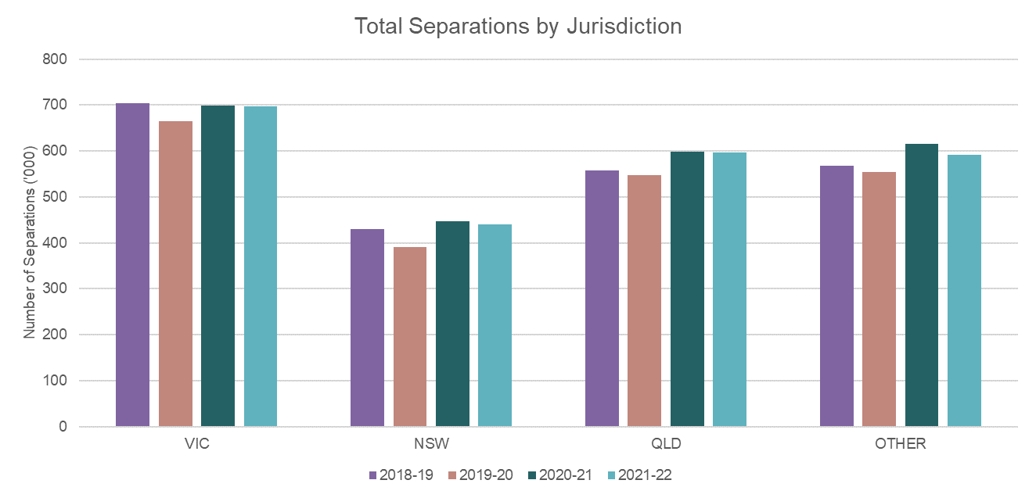

Around one-third of private sector activity reported to the 2021-22 NHCDC were from hospitals based in Victoria. Queensland reported around 25%, followed by NSW reporting around 20% .

All jurisdictions experienced an increase in the volume of separations in 2020-21, with variations ranging from 5.2% in Victoria to 14.7% in New South Wales. These reductions in activity were followed by decrease in activity for all jurisdictions in 2021-22. Other experienced the largest reduction in the volume of separations in 2021-22.

## Impact on medical and intervention type activity

Through 2021‑22, state governments eased COVID‑19 elective surgery restrictions at different points in time. Analyses of intervention type Australian Refined Diagnosis Related Group (AR-DRG) activity (as a proxy for surgery or other procedures) was undertaken to understand how the restrictions may have impacted surgical hospital activity in the private sector.

Approximately 60% of separations were classified as intervention type activities based on the grouping in the AR-DRG Version 11.0 classification.

The number of intervention episodes fell by 4.2% in 2020‑21, while the number of medical episodes increased by 2.6% driven by a return to pre-pandemic activity levels following the heightened intervention activity post the COVID-19 pandemic. Figure 13 and Figure 14 show the separations by month for intervention and medical episodes.

Figure 13. Separations by month for intervention episodes

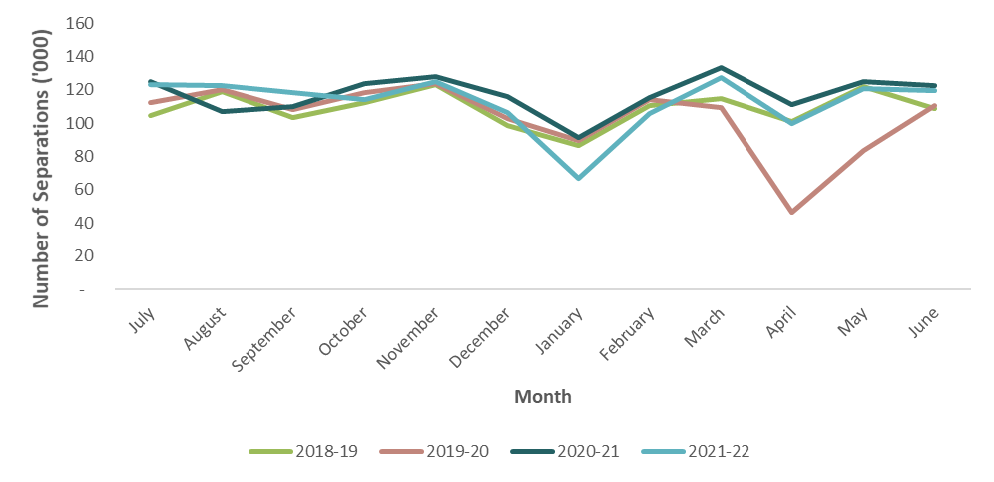

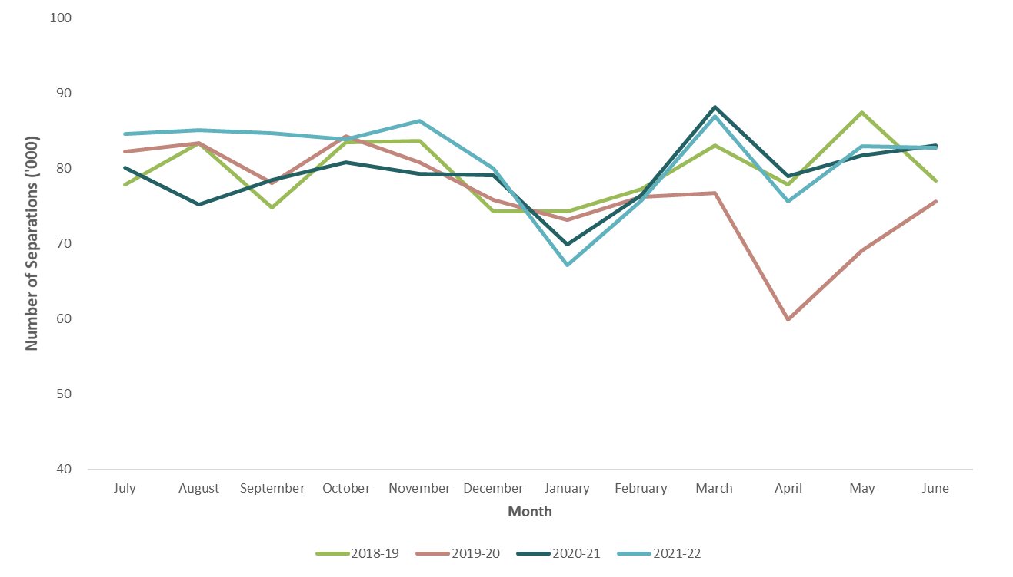Figure 14. Separations by month for medical episodes

# Appendix A: Methodology

There are eight stages of the NHCDC private sector process.

## Stage 1: Stakeholder engagement

IHACPA sought costed data directly from private hospitals for the NHCDC private sector. Participants were requested to provide a methodology that outlined their costing processes.

## Stage 2: Data collection

At the commencement of the data collection phase, a data request specification (DRS) for the NHCDC Private Sector 2021‑22 was prepared and distributed to all participants.

Participants performed their own data collection.

## Stage 3: Data preparation

Participants performed their own quality assurance checks on their data to verify that they were appropriate to use in their costing processes.

## Stage 4: Costing

The costing phase involved participants performing episode-level and phase-level (where available) costing using commercial costing software.

## Stage 5: Data submission

IHACPA required that the participating hospital groups submit data in accordance with the DRS, along with a data quality checklist that set out the hospital costing process. The various costing methodologies used by private sector hospitals are outlined in Appendix B: Private sector costing approaches.

Participants were informed of the timeframes for the costed data collection and provided access to a secure data portal to upload and submit their data.

## Stage 6: Data validation and quality assurance

Participants were required to submit their costed data as csv files, that had to pass data checks documented in the DRS. IHACPA accepted data with zero critical errors.

Where the costed data did not meet the DRS requirements, participants were asked to review the files and make the necessary changes before resubmitting the data.

Once the data was validated, quality assurance (QA) reports were produced to assist participants in confirming the accuracy and suitability of their data submission. These included checks in areas with potential to have a material impact on results, such as zero or negative cost buckets, extreme high or low-cost separations and AR-DRG flipping[14].

If the QA reports identified unexpected variation in the submitted data, the participant was asked to investigate and either adjust the data or justify the variation. Once all unexpected variation was understood, the participant confirmed their data was final. On finalisation of the valid costed data submission, participants were required to submit a data quality statement. The data quality statements informed IHACPA of the key issues that may impact each participant’s data submission and provided assurance that the data was fit for purpose.

IHACPA then consolidated the data submission into a national costed dataset.

Stage 7: Data analysis (including adjustments)

The national costed dataset was reviewed to ensure that the separations were in scope. PHDB data was used to develop a national estimate of both the number of in-scope private hospitals and the number of in-scope separations in 2021-22.

The data was also analysed by hospital group and compared against PHDB data, to ensure that no hospital group was over-represented in the dataset in a way that would potentially bias the analysis. An adjustment was made to the activity data in 2021-22 to align the cost profile of each hospital group more closely in the NHCDC to that of the population activity. Population activity is defined as all in-scope private hospital episodes that take place within the financial year.

An overall participation rate was calculated relative to population activity. Hospital groups were consulted to ensure they were satisfied with the level of participation throughout the year. The separations in the submitted data were then scaled up using estimated weights to be reflective of the population activity.

The national costed dataset was then reviewed to identify whether there were any instances of   
AR-DRG flipping (where the cost weight of a lower complexity AR-DRG within the related adjacent AR-DRG is higher than the one with greater complexity). A single outlier episode was removed from the sample.

Based on the adjustments described above, the cost weight tables were produced, verified and compared to results from the previous financial year.

## Stage 8: Reporting

The national costed dataset was then used to produce the NHCDC Private Hospital Report 2021-22 and the associated cost weight tables.

# Appendix B: Private sector costing approaches

## Costing methodologies

Hospital costing is the process of identifying the resources and inputs used during an episode and applying the costs of those inputs to the different types of clinical procedures and treatments provided to each patient in a hospital.

From 2015-16, the participating hospitals have been required to undertake their own costing and during 2015-16 and 2016-17 they were asked to provide a summary of their costing methodology process as well as the process they used to submit the costing data. During 2021-22, participating hospitals were asked to indicate which of the costing methodologies (outlined below) they used.

IHACPA also released the *COVID-19 Response - Costing and pricing guidelines* to guide costing practitioners on the steps to capturing end-to-end COVID-19 activity and expenses.

There are 2 main methods adopted by participants for hospital cost allocations: cost modelling or patient costing. In recent years of the NHCDC, hospital groups have moved away from cost modelling to patient costing approaches, although some hospital groups continue to use cost modelling for specific cost buckets.

Patient costing (also known as bottom-up costing) uses activity feeder systems to provide actual resource consumption. For example, a prostheses system within a hospital will record what type of prostheses has been implanted into a patient and the cost of the implant. This data is used to allocate costs to patients from the prostheses patient care area.

Patient level costing yields results that are closer to the true cost of an encounter within a hospital, however due to the dependency on feeder systems, perfect patient level costing can be difficult to achieve.

Cost modelling (also known as top-down costing) takes the total admitted acute costs for patient areas (such as wards) and allocates costs to encounters based on an assumed level of consumption using service weights. Service weights are the relative costs of a service for each type of patient care product. Service weights are applied to apportion costs to patient groups defined by their AR-DRG (in the case of admitted acute care).

## Data sources

The following categories of patient level data components are utilised during the costing process:

**Financial data:** This includes the general ledger cost centres and account codes, along with the mapping of those cost centres to patient care areas and standardised line items. This dataset excludes revenue cost centres and/or account codes.

**Activity data:** This includes the encounter level data (such as patient ID, encounter ID, date of birth) and transfer information identifying the patient’s pathway through the hospital via transfers between areas such as operating rooms and wards.

**Feeder data:** This includes data that identifies patient consumption of hospital products or services within a patient care area. For example, a prostheses feeder might list the prosthetic items received by a patient and the cost of each. This feeder data is used to allocate costs in the general ledger as it identifies how much of the prosthesis products each encounter consumes.

Where no feeder data is available, patient care area costs are allocated using service weights.

## Cost bucket or cost components

The cost of a separation of admitted acute care is reported by allocating patient level costs to a set of pre-defined cost buckets/cost components. The cost buckets are listed as follows:

|  |  |  |
| --- | --- | --- |
| 1. Ward medical 2. Ward nursing 3. Non-clinical salaries 4. Pathology 5. Imaging 6. Allied health | 1. Pharmacy 2. Critical care 3. Operating rooms 4. Supplies 5. Specialist procedure suites | 1. On-costs 2. Prostheses 3. Hotel 4. Depreciation 5. Patient travel |

Please note that the emergency department cost bucket is excluded for the NHCDC Private Sector cost buckets, as this collection is for admitted acute only.

Once each of the cost buckets is calculated for an individual patient, the patient’s total cost of care is derived as the sum of the above components.

## AR-DRG grouping

All 103 participating hospitals in 2021‑22 submitted data costed in AR-DRG Version 11.0.

## Cost weights

A cost weight for a selected AR-DRG is calculated as the average cost for that AR-DRG, expressed as a weight relative to the overall average cost across all AR-DRGs. The national cost weight across all AR-DRGs is equal to 1.00, with higher cost AR-DRGs having a cost weight higher than 1.00. The weight is an indicator of the complexity of the care of the patient and thus the resourcing intensity required. This is often referred to as the casemix of a patient or hospital.

## Costing standards

Costing was performed in compliance with the AHPCS Version 4.1.

# Appendix C: Standard error range for the NHCDC Private Sector 2021-22

The variability of the costs by AR-DRG has been measured by analysing the standard error of cost weights in the NHCDC sample. An AR-DRG with a lower standard error has lower variability and thus is more reliable in estimating the AR-DRG’s true costs. These standard errors are included in the Analysis of Top 10 AR-DRGs and Appendix D: Cost weight tables by AR‑DRG Version 11.0.

Table 11 summarises the reliability of AR-DRG cost weights by grouping the standard errors into several ranges. The number of AR-DRGs and separations falling into standard error ranges provides insight into the estimation error of the cost weights.

Table 11. Number of AR-DRGs by standard error range

|  |  |  |  |  |
| --- | --- | --- | --- | --- |
| **Standard Error Range** | **Number of AR‑DRGs** | **Separations** | **Percentage of**  **AR-DRGs**  **(%)** | **Percentage of**  **total separations (%)** |
| **0.000 - 0.039** | 251 | 3,066,850 | 32.9% | 89.4% |
| **0.040 - 0.099** | 176 | 253,417 | 23.0% | 7.4% |
| **0.100 - 0.149** | 84 | 54,097 | 11.0% | 1.6% |
| **0.150 - 0.199** | 50 | 20,586 | 6.5% | 0.6% |
| **0.200 - 0.399** | 88 | 22,329 | 11.5% | 0.7% |
| **0.400 +** | 115 | 13,805 | 15.1% | 0.4% |
| **Total**\* | 764 | 3,431,084 | 100.0% | 100.0% |

* The standard error for some AR-DRGs cannot be estimated due to low separation counts in the sample. Total may not add to

the sum of the rows due to rounding.

The results in Table 11 show that 55.92% (32.9% + 23%) of AR-DRGs have cost weight estimates with a standard error of less than 0.1. Approximately 96.8% (89.4% + 7.4%) of separations are within the subset of AR-DRGs that have a standard error of less than 0.1.

# Appendix D: Cost weight tables by AR‑DRG Version 11.0

Table 12. 2021-22 national consolidation cost weight tables - version 11.0

Please refer to Excel file for details.

Intentionally left blank.

# Appendix E: Cost weight tables by AR‑DRG Version 10.0

Table 13. 2021-22 national consolidation cost weight tables - version 10.0

Please refer to Excel file for details.

Intentionally left blank.

# Appendix F: Cost weight tables by AR‑DRG Version 9.0

Table 14. 2021-22 national consolidation cost weight tables - version 9.0

Please refer to Excel file for details.

Intentionally left blank.

# Appendix G: Cost weight tables by AR‑DRG Version 8.0

Table 15. 2021-22 national consolidation cost weight tables - version 8.0

Please refer to Excel file for details.

Intentionally left blank.

# Appendix H: Cost bucket matrix

Figure 15. Cost bucket matrix

Cost bucket matrix



Independent Health and Aged Care Pricing Authority

Level 12, 1 Oxford Street  
Sydney NSW 2000

Phone 02 8215 1100  
Email [enquiries@ihacpa.gov.au](mailto:enquiries.ihpa@ihpa.gov.au)  
Twitter @IHACPAnews

www.ihacpa.gov.au

1. Independent Health and Aged Care Pricing Authority, COVID-19 Response – Costing and Pricing Guidelines, date viewed 10 November 2023
2. Independent Health and Aged Care Pricing Authority, [Australian Refined Diagnosis Related Groups](https://www.ihpa.gov.au/what-we-do/ar-drg-classification), date viewed 9 November 2023
3. Australian Institute of Health and Welfare, [Data Dictionary, METeOR ID: 729904](https://meteor.aihw.gov.au/content/729904), date viewed 09 November 2023
4. Australian Institute of Health and Welfare, [Data Dictionary, METeOR ID: 327254](https://meteor.aihw.gov.au/content/index.phtml/itemId/327254), date viewed 9 November 2023
5. These are separations with care type 7.0 (newborn care), with zero qualified days in the neonate AR-DRGs (Major Diagnostic Category 15 newborns and other neonates)
6. Australian Institute of Health and Welfare, [Data Dictionary, METeOR ID: 711010](https://meteor.aihw.gov.au/content/711010), date viewed 9 November 2023
7. Australian Institute of Health and Welfare, [Data Dictionary, METeOR ID: 711010](https://meteor.aihw.gov.au/content/711010), date viewed 9 November 2023
8. Australian Institute of Health and Welfare, [Data Dictionary, METeOR ID: 711010](https://meteor.aihw.gov.au/content/index.phtml/itemId/711010), date viewed 9 November 2023
9. Australian Institute of Health and Welfare, [Data Dictionary, METeOR ID: 711010](https://meteor.aihw.gov.au/content/711010), date viewed 9 November 2023
10. Independent Health and Aged Care Pricing Authority, [Australian Hospital Patient Costing Standards Version 4.1,](https://www.ihacpa.gov.au/resources/australian-hospital-patient-costing-standards-version-41) viewed 9 November 2023
11. Independent Health and Aged Care Pricing Authority, [Australian Hospital Patient Costing Standards Version 4.2](https://www.ihacpa.gov.au/resources/australian-hospital-patient-costing-standards-version-42), viewed 9 November 2023
12. Australian Institute of Health and Welfare, [Data Dictionary, METeOR ID: 327254,](https://meteor.aihw.gov.au/content/index.phtml/itemId/327254) viewed 9 November 2023
13. Independent Health and Aged Care Pricing Authority, [COVID-19 Response - Costing and pricing guidelines](https://www.ihpa.gov.au/publications/covid-19-response-costing-and-pricing-guidelines), viewed 9 November 2023
14. AR-DRG flipping occurs when the cost weight of a lower complexity AR-DRG within the related adjacent AR-DRG is higher than the one with greater complexity.