Australian Mental Health Care Classification Version 1.1

Final Report

Australian Mental Health Care Classification Version 1.1 — December 2023

© Independent Health and Aged Care Pricing Authority 2023

This publication is available for your use under a Creative Commons BY Attribution 3.0 Australia licence, with the exception of the Independent Health and Aged Care Pricing Authority logo, photographs, images, signatures and where otherwise stated. The full licence terms are available from the Creative Commons website.



Use of Independent Health and Aged Care Pricing Authority material under a Creative Commons BY Attribution 3.0 Australia licence requires you to attribute the work (but not in any way that suggests that the Independent Health and Aged Care Pricing Authority endorses you or your use of the work).

Independent Health and Aged Care Pricing Authority material used 'as supplied'.

Provided you have not modified or transformed Independent Health and Aged Care Pricing Authority material in any way including, for example, by changing Independent Health and Aged Care Pricing Authority text – then the Independent Health and Aged Care Pricing Authority prefers the following attribution:

Source: The Independent Health and Aged Care Pricing Authority

**Contents**

Abbreviations and acronyms 5

Executive summary 6

1. Introduction 7

1.1 About IHACPA 7

2. Background 8

2.1 The Australian Mental Health Care Classification 8

2.2 The AMHCC structure 8

2.3 The AMHCC complexity variables 9

2.4 The AMHCC complexity model 10

3. Australian Mental Health Care Classification refinement 11

3.1 Overview 11

3.2 Objectives and scope 11

3.3 Governance and consultation 12

3.4 Data 12

3.5 Methodology 14

4. Australian Mental Health Care Classification Version 1.1 16

4.1 Overview 16

4.2 Weights and threshold refinement 17

4.3 Treatment of records with missing HoNOS items 19

5. Australian Mental Health Care Classification Version 1.1 model performance 21

5.1 Changes in end class distribution 21

5.2 Changes in complexity grouping 21

5.3 Complexity model statistical performance 22

6. Conclusion 24

Appendix A: Mental Health Working Group 25

Appendix B: Data preparation in response to COVID-19 26

Appendix C: AMHCC V1.1 end classes 29

Appendix D: AMHCC V1.1 weights and complexity split thresholds 33

Appendix E: Record breakdown by end class for AMHCC V1.0 and AMHCC V1.1 34

Appendix F: Comparison of model performance between AMHCC V1.0 and AMHCC V1.1 38

# Abbreviations and acronyms

**ABF** Activity based funding

**ABF MHC DRS** Activity Based Funding Mental Health Care Data Request Specifications

**ABF MHC NBEDS** Activity Based Funding: Mental Health Care National Best Endeavours Data Set

**AMHCC** Australian Mental Health Care Classification

**AR-DRG** Australian Refined Diagnosis Related Group

**COVID-19** Coronavirus disease 2019

**HoNOS** Health of the Nation Outcome Scales

**HoNOS 65+**  Health of the Nation Outcome Scale for 65+

**HoNOSCA** Health of the Nation Outcome Scales for Children and Adolescents

**IHPA** Independent Hospital Pricing Authority

**IHACPA** Independent Health and Aged Care Pricing Authority

**LSP** Life Skills Profile

**LSP-16** Abbreviated Life Skills Profile

**MHLS** Mental Health Legal Status

**MHCERG** Mental Health Classification Expert Reference Group

**MHPoC** Mental Health Phase of Care

**NHCDC** National Hospital Cost Data Collection

**NHCDC DRS** National Hospital Cost Data Collection Data Request Specifications

**NHDISC**  National Health Data Information Standards Committee

**NHR Act** National Health Reform Act

**NHRA** National Health Reform Agreement

**NOCC** National Outcomes and Casemix Collection

# Executive summary

The Independent Health and Aged Care Pricing Authority (IHACPA) is responsible for the development of the Australian Mental Health Care Classification (AMHCC). The AMHCC is a clinically informed classification used for activity based funding (ABF), clinical management and other purposes.

IHACPA has developed the AMHCC Version 1.1 (V1.1) through detailed statistical analysis of public hospital activity and cost data, as well as consultation with jurisdictions, clinical experts and other mental health care stakeholders. This report details AMHCC V1.1 and describes process and rationale for refinement changes.

The AMHCC V1.1 is a modest refinement of AMHCC Version 1.0 (V1.0). The classification structure and variables remain the same with six variables being utilised to determine an end class: episode setting, Mental Health Phase of Care (MHPoC), age group, Mental Health Legal Status (MHLS), Health of the Nation Outcome Scale (HoNOS) and the Abbreviated Life Skills Profile (LSP-16).

The key changes for AMHCC V1.1 include the recalibration of the complexity model including HoNOS weights and thresholds, and LSP-16 thresholds. In addition to allowing phases with up to two missing HoNOS item scores to attract a valid complexity score, in line with the National Outcomes and Casemix Collection (NOOC) rules.

The AMHCC V1.1 methodology for how the HoNOS weight values are determined has been updated. The updated complexity model minimises the volatility of weights arising due to small sample sizes by initially pooling data at the setting-age group, before modifying the weights to capture different costs and HoNOS relationships for each phase group. Comparatively, the methodology for the AMHCC V1.0 calculates HoNOS weights directly at the setting-phase-age group level. The way in which these weights are applied in calculating the HoNOS complexity score remains the same between AMHCC V1.0 and V1.1. The AMHCC V1.1 improves the distribution of end class complexity grouping for HoNOS and LSP-16 and overall has a modest improvement in statistical performance across both admitted and community settings.

Future AMHCC refinement considerations were identified during this process which may include more substantial changes to classification structure and variables utilised to ensure the classification remains clinically relevant.

# Introduction

## About IHACPA

The Independent Hospital Pricing Authority (IHPA) was established under the *National Health Reform Act 2011* (Cwlth) (the NHR Act) as part of the National Health Reform Agreement (NHRA) to improve health outcomes for all Australians.

Under the NHRA, the former Council of Australian Governments unanimously agreed on the establishment of activity based funding (ABF) as the primary funding methodology for public hospitals to improve transparency in the delivery of national funding.

On 12 August 2022 amendments to the NHR Act came into effect changing IHPA’s name to the Independent Health and Aged Care Pricing Authority (IHACPA) and expanding its role to include the provision of aged care cost and pricing advice to the Australian Government.

Whilst IHACPA has several determinative functions as specified by the NHRA, the primary role is to determine the national efficient price (NEP) and national efficient cost (NEC) for public hospital services. IHACPA undertakes reviews and updates of existing classifications and is responsible for introducing new classifications for those service categories without an existing classification to allow funding of public hospitals based on the ABF mechanism.

# Background

## The Australian Mental Health Care Classification

The Independent Health and Aged Care Pricing Authority (IHACPA) developed a classification for mental health care known as the Australian Mental Health Care Classification (AMHCC). The AMHCC aims to improve the clinical meaningfulness of the way that mental health services are classified. On 25 February 2016, IHACPA’s board the Pricing Authority approved the AMHCC Version 1.0 (V1.0). The AMHCC V1.0 was implemented on a best endeavours basis from 1 July 2016 and was used to price admitted mental health from 1 July 2022.

The AMHCC V1.0 was developed using 26 mental health services data collected over a six-month period as part of the [2014 Mental Health Costing Study](https://www.ihacpa.gov.au/resources/mental-health-costing-study). In 2016 an Inter-rater Reliability (IRR) study to test the consistency of clinician application for the Mental Health Phase of Care (MHPoC) variable was conducted. The poor to fair reliability outcome led to the commencement of the [Mental Health Phase of Care Clinical Refinement Project](https://www.ihacpa.gov.au/resources/mental-health-phase-care-clinical-refinement-project-final-report). The MHPoC Clinical Refinement Project aimed to improve the classification by improving the IRR of the MHPoC variable and was approved by the Pricing Authority in November 2019.

Due to annual improvements in data volume, quality, and coverage, IHACPA identified the need to update the AMHCC. In April 2021, IHACPA engaged Taylor Fry Pty Ltd (Taylor Fry) to undertake exploratory analysis of national mental health care episode and phase level activity and cost data collections to provide recommendations on future classification refinement.

## The AMHCC structure

The AMHCC V1.0 uses six variables to determine an end class: episode setting, MHPoC, age group, Mental Health Legal Status (MHLS), Health of the Nation Outcome Scale (HoNOS) and the Abbreviated Life Skills Profile (LSP-16).) **Figure 1** provides an overview of the AMHCC V1.0 classification structure. There are a total of 45 classes in the admitted setting branch, including 16 end classes with unknown MHPoC or HoNOS score reported. In the community setting branch, there are 46 end classes, including 15 end classes which capture phases with unknown MHPoC or unknown HoNOS complexity. The classification groups phases with missing or invalid LSP-16 scores into the Moderate LSP-16 complexity.

Figure 1. AMHCC V1.0 structure, admitted and community branches

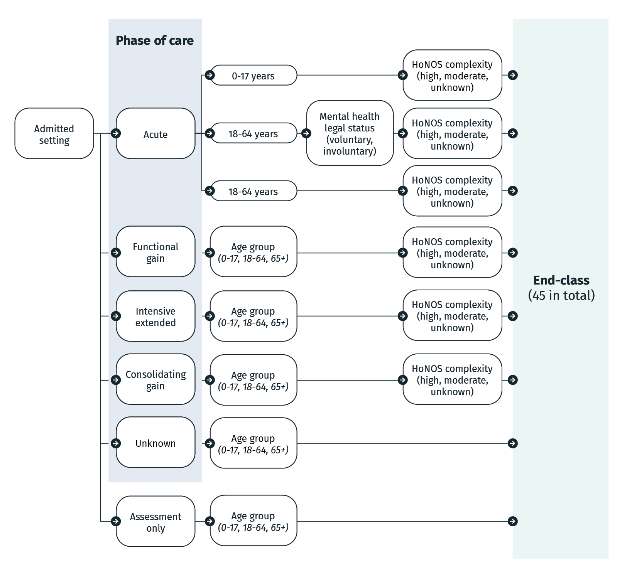 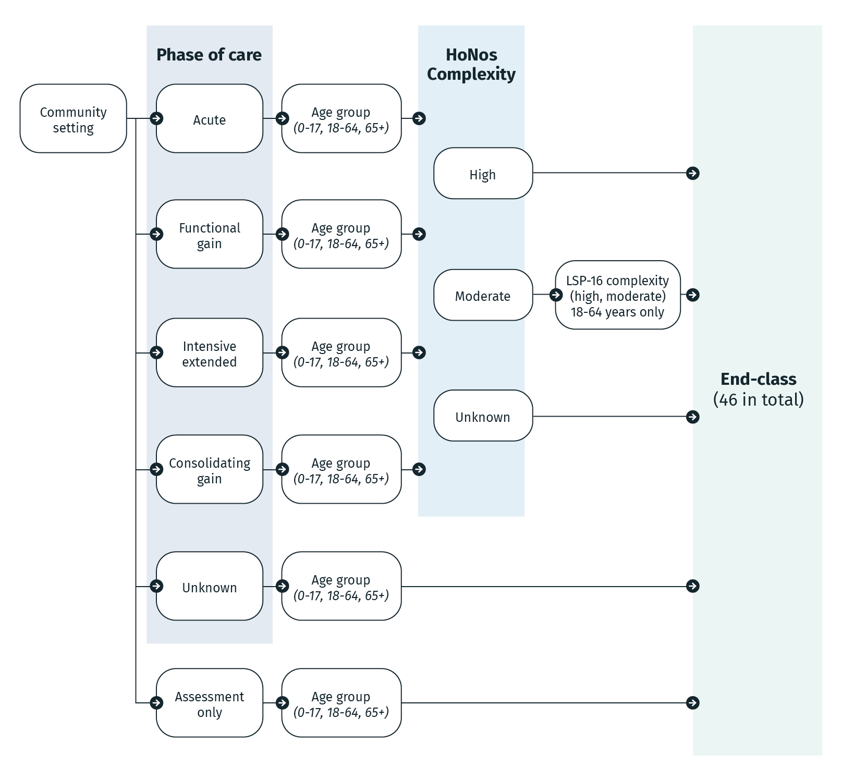

## The AMHCC complexity variables

The AMHCC V1.0 accounts for complexity using the following clinical measures: the HoNOS, the Health of the Nation Outcome Scale Children and Adolescents (HoNOSCA), the Health of the Nation Outcome Scale 65+ (HoNOS 65+) and the LSP-16. The description of each clinical instrument including definition and purpose are outlined in **Table 1**.

Table 1. Description of AMHCC complexity variables

|  |  |
| --- | --- |
| **Complexity variables** | **Description** |
| HoNOS | HoNOS is a clinical outcomes measure that captures the symptoms and functioning of the consumer at key points within an episode of mental health care. It is a clinician-rated measure that consists of 12 items that assess the various aspects of consumers’ mental health.  Each item is rated on a four-point scale ranging from 0 to 4 with high scores indicating higher severity. |
| HoNOSCA | HoNOS is adapted as the HoNOSCA for the 0 to 17 years age group. HoNOSCA is a 15-item instrument to measure the outcomes of emotional and behavioural disorders in children and adolescents. Only the first 13 items of the HoNOSCA are used in AMHCC V1.0 and are rated by the same severity measure format as the HoNOS. |
| HoNOS 65+ | HoNOS 65+ is a 12-item instrument to measure particular physical and cognitive problems affecting older people. The primary goal of the HoNOS 65+ is to measure specific mental health issues that occur in older people such as agitation and restlessness, delusions occurring in the presence of dementia, the phenomenology of depression and incontinence. The 12 items are rated by the same severity measure format as the HoNOS. |
| LSP-16 | LSP-16 is a clinical outcomes measure that assess the level of functioning for mental health consumers living in the community. It consists of 16 items that address issues faced when adapting to life in the community and only applies to community setting for 18 to 64 years age group with moderate HoNOS complexity.  Each item is rated on a three-point scale ranging from 0 to 3 with high scores indicating higher severity, resulting in individual item scores, subscale scores and a total score. |

## The AMHCC complexity model

The AMHCC V1.0 complexity model determines the weights, rescaling factors and complexity split thresholds used to assign HoNOS and/or LSP-16 complexity groups.

The first component of the AMHCC complexity model constructs linear regression models of phase cost, using the items from the HoNOS array as explanatory variables. The HoNOS array consists of 13 HoNOS items for the 0-17 age group and 12 HoNOS items for the 18-64 years and 65+ years age groups. One linear regression model is constructed for each unique combination of episode setting, MHPoC, and age group (also known as a segment), giving rise to a set of weights specific to each segment. Rescaling factors are also calculated at this step to ensure the complexity scores fall between 0-52 (inclusive) for the 0-17 years age group and 0-48 (inclusive) for the 18-64 years and 65+ years age groups.

The second component of the AMHCC complexity model determines the value of the complexity split threshold for each segment using the entire distribution of complexity scores for that segment. This complexity split threshold separates phase records in the same segment into High or Moderate complexity groups for both HoNOS and LSP-16. Where the complexity score is greater than or equal to the complexity split threshold, it is assigned to the High complexity group, otherwise it is assigned to the Moderate complexity group. Any records with missing or invalid LSP-16 item scores are assigned to the Moderate LSP-16 complexity group.

# Australian Mental Health Care Classification refinement

## Overview

In 2021, The Independent Health and Aged Care Pricing Authority (IHACPA) identified the need to update the Australian Mental Health Care Classification (AMHCC) Version 1.0 (V1.0) due to annual improvements in data volume, quality and coverage as the existing complexity model was derived from the 2014 costing study, which made use of data from 26 mental health services collected over six months.

IHACPA engaged Taylor Fry in April 2021 to undertake exploratory analysis of national mental health care episode and phase level activity and cost data collections to provide recommendations on future classification refinement. The objectives of the AMHCC V1.0 exploratory analysis included assessing the overall performance, identifying gaps and areas for improvements, reviewing and updating Health of the Nation Outcome Scale (HoNOS) weights and thresholds to ensure complexity scores remain current and fit-for-purpose. The outcomes concluded that the AMHCC V1.0 performs well when accounting for clinical complexity and cost. However, the explanatory power of the AMHCC model can be improved within its current structure through a review of the treatment of HoNOS and Abbreviated Life Skills Profile (LSP-16) as well as consideration of new variables such as diagnosis.

In 2022, IHACPA, in consultation with specialist stakeholders and jurisdictions, developed a new methodology for the AMHCC complexity model, based on the Taylor Fry methodology developed the year prior.

## Objectives and scope

The AMHCC V1.1 refinement objectives were based on the recommendations from the 2021 exploratory analysis and in consultation with IHACPA’s working groups and advisory committees.

The objectives of the AMHCC V1.1 refinement includes:

* using national mental health data to recalibrate HoNOS weights and complexity split thresholds, and LSP-16 complexity split thresholds
* allowing phases with up to two missing HoNOS items to receive a valid complexity score and a High or Moderate complexity grouping.

The scope of the AMHCC V1.1 refinement includes both the admitted and community branches. However, due to insufficient volume and quality of residential data at the commencement of the AMHCC V1.1 refinement, the residential setting was deemed out of scope. Additionally, to adhere to refinement objectives, only the HoNOS and LSP-16 complexity stages of the AMHCC structure are impacted and therefore there are no other classification hierarchy changes between Version 1.0 and V1.1 as shown in **Figure 2**.

Figure 2. Impacted areas of the classification hierarchy under AMHCC V1.1

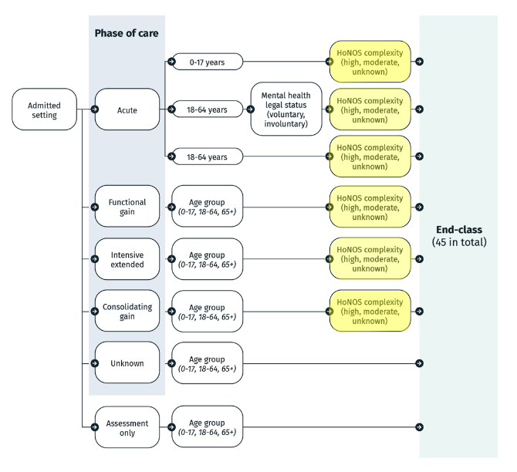 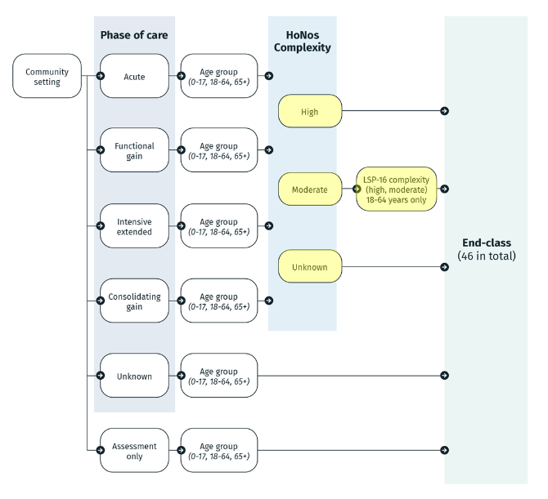

## Governance and consultation

IHACPA relies on a comprehensive committee framework to provide expert advice during classification development and refinement. The main advisory group for mental health care classification work is IHACPA’s Mental Health Working Group, a group of expert representatives from each Australian jurisdiction, the private sector, mental health consumer representatives, and mental health care clinicians and clinical bodies. The list of members is provided at **Appendix A**.

Throughout the AMHCC V1.1 refinement, consultation with the following IHACPA committees has also occurred:

* Clinical Advisory Committee
* Technical Advisory Committee
* Jurisdictional Advisory Committee.

## Data

### Data sets

To develop the AMHCC V1.1, IHACPA has used consumer activity and cost data from the following collections:

* Admitted Patient Care National Minimum Data Sets (APC NMDS)
* Activity Based Funding: Mental Health Care National Best Endeavours Data Sets (ABF MHC NBEDS)
* National Hospital Cost Data Collection (NHCDC).

The APC NMDS and ABF MHC NBEDS capture mental health care activity at the service contact (ASC), phase (MHCP) and episode (MHCE) level. The NHCDC captures the costs associated with the activity conducted during the year. Activity and cost data collections were merged at the phase and episode level for the 2018–19, 2019–20 and 2020–21 data years.

### Data preparation

IHACPA applied several steps to prepare a quality data set for the AMHCC V1.1 refinement. This involved excluding or ‘trimming’ the following data from the refinement data set:

1. records trimmed due to unusable data
2. records trimmed because they are out of scope for the AMHCC
3. records trimmed because they are irrelevant to the AMHCC V1.1 update.

**Table 2** details the trimming stages and criteria applied to create the data set for the AMHCC V1.1 refinement.

Table 2. AMHCC V1.1 data preparation trimming criteria

|  |  |
| --- | --- |
| **Trimming criteria** | **Description** |
| **Category 1: Records trimmed due to unusable data** | |
| Age less than zero | Filters out records where there was successful data linking, however the phase start date was before the birth date OR there was a missing birth date at the episode (MHCE) level.  Filters out records where there was no successful data linking (i.e. MHCP did not link to MHCE/APC) and therefore age could not be calculated. |
| Unknown length of stay | Filters out records where there are missing phase start dates or end dates. |
| High per diem cost outlier | Filters out records with a per diem phase cost above the 99th percentile among all phases. |
| Missing costs | Filters out episode or phase activity that does not link to NHCDC costs. |
| Missing activity | Filters out NHCDC costs that do not link to episode or phase level activity. |
| Zero costs | Filters out records with missing or negative in-scope cost (i.e. sum of the relevant cost buckets being 0 or less). |
| **Category 2: Records trimmed because they are out of scope for AMHCC** | |
| Residential setting | Filters out records in the residential setting because they remain out of scope for AMHCC V1.1 due to insufficient volume and quality of data collected. |
| **Category 3: Records trimmed because they are irrelevant to the AMHCC V1.1 update** | |
| Unknown MHPoC | Filters out records with an unknown MHPoC because this branch is not stratified by complexity in the AMHCC. |
| Assessment Only episodes | Filters out records flagged as Assessment Only because this branch is not stratified by complexity in the AMHCC. |

**Table 3** summarises the trimming stages and the number of episodes trimmed at each stage.

Table 3. Summary of AMHCC V1.1 trimmed records by data year

|  |  |  |  |  |  |  |
| --- | --- | --- | --- | --- | --- | --- |
| **Trim stage and category** | | **Number of trimmed records** | | | | |
| **2018-19** | **2019-20** | **2020-21** | **Total** |
| **Initial number of episode/phase-activity and costs of mental health care records** | | **1,381,111** | **1,349,582** | **1,844,001** | **4,574,694** |
| **LESS: Trimmed records** | | **1,183,417** | **1,052,279** | **1,568,685** | **3,804,381** |
| Records trimmed due to unusable data | | 900,087 | 773,830 | 1,323,450 | 2,997,367 |
| 1A | Age less than zero (phase start date before birth date OR missing birth date) | 1 | 230,048 | 205,756 | 435,805 |
| 1B | Age less than zero (age could not be calculated) | - | 126,075 | 585,356 | 711,431 |
| 2 | Unknown length of stay | - | 25 | 50 | 75 |
| 3 | High per diem cost outlier | 8,210 | 12,971 | 17,151 | 38,332 |
| 4 | Activity not matched to cost | 871,666 | 393,098 | 509,271 | 1,774,035 |
| 5 | Episode level cost not matched to activity | 340 | - | - | 340 |
| 6 | Phase level cost not matched to activity | 3,063 | - | - | 3,063 |
| 7 | Zero cost record | 16,807 | 11,613 | 5,866 | 34,286 |
| Records trimmed because they are out of scope for AMHCC | | 542 | 1,628 | 1,840 | 4,010 |
| 8 | Residential setting | 542 | 1,628 | 1,840 | 4,010 |
| Records trimmed because they are irrelevant to the AMHCC V1.1 update | | 282,788 | 276,821 | 243,395 | 803,004 |
| 9 | Assessment Only | 20,453 | 118,647 | 92,061 | 231,161 |
| 10 | Unknown phase | 262,335 | 158,174 | 151,334 | 571,843 |
| **Records retained for AMHCC V1.1 development** | | **197,694** | **297,303** | **275,316** | **770,313** |

Additionally, IHACPA considered the potential impact of coronavirus disease 2019 (COVID-19) by comparing average phase cost and analysing the distribution of key classification variables across data years. Due to minimal impacts observed, the COVID-19 impacted data was retained for the AMHCC V1.1 refinement. **Appendix B** provides detailed cost per phase and variable distribution analysis.

## Methodology

The AMHCC V1.1 complexity model seeks to minimise the volatility of weights arising due to small sample sizes by initially pooling data at the setting-age group level (for example, admitted consumers, aged 18-64 years), before modifying the weights to capture different cost and HoNOS relationships for each phase group. Comparatively, the methodology for the AMHCC V1.0 calculates HoNOS weights directly at the setting-phase-age group level. While there were changes to how the HoNOS weight values are determined under the AMHCC V1.1, the way in which these weights are applied in calculating the HoNOS complexity score remains the same. Similarly, the calculation of the LSP-16 complexity score also remains the same between classification versions.

### Determining weights and rescaling factors

In the AMHCC V1.1, a weight is calculated for each individual item within the HoNOS, HoNOSCA and HoNOS 65+ instruments. The magnitude of a HoNOS item’s weight represents its relative contribution to the HoNOS complexity of a phase (as measured by its cost).

Additionally, the AMHCC V1.1 calculates a single HoNOS rescaling factor for each segment. These rescaling factors only serve to ensure that the maximum possible HoNOS score is the same in each segment and do not impact the performance of the model.

Comparatively, there are no weights calculated for the LSP-16 in AMHCC V1.1. This results in all LSP-16 individual items given equal weighting and the complexity model assumes that all 16 items impact the LSP-16 complexity of a phase (as measured by cost) to the same degree.

### Selecting complexity split thresholds

The AMHCC V1.1 utilises a set of principles to improve the cost differentiation between complexity groupings and seeks to produce a classification that is less vulnerable to fluctuations in cost and volume of activities. The principles were largely based on those currently used in other classification development processes such as that of the Australian Refined Diagnosis Related Groups classification.

The AMHCC V1.1 complexity split thresholds are selected based on the following principles:

* the average cost for high complexity phases is greater than that of moderate complexity phases within the same segment
* the number of phases having a high complexity is lower than the number having a moderate complexity within the same segment
* the number of phases in each complexity group is at least 10 per cent of the total phases in the segment.

If there is more than one value that satisfies the above principles, then the one which produces the greatest reduction in mean squared error is selected as the complexity split threshold value for that segment. These principles are applied in the selection of both HoNOS/HoNOSCA/HoNOS 65+ and LSP-16 complexity split thresholds.

### Treatment of records with missing HoNOS item scores

Under the AMHCC V1.0, phase records with any incomplete HoNOS/HoNOSCA/HoNOS 65+ items do not receive a valid complexity score and default to the unknown HoNOS complexity group. Conversely, the National Outcomes and Casemix Collection (NOCC) rules currently allow for up to two missing HoNOS items for the overall HoNOS rating to still be considered valid.

IHACPA considered two options to increase the tolerance of the AMHCC V1.1 complexity model. The first option was to allow records with one or two missing HoNOS scores to feed into the AMHCC complexity model (specifically, the linear regression models of phase cost). This meant that these additional records would directly impact the determination of the weights and rescaling factors.

To assess whether the first option was appropriate, IHACPA undertook the following analysis:

1. Whether the profile of records with one or two missing HoNOS items was similar to the profile of records with no missing HoNOS items
2. The impact on model performance when records with one or two missing HoNOS items are included or excluded from the AMHCC complexity model.

The second option was to only use records with no missing HoNOS scores for the AMHCC complexity model and change the data validation rules for AMHCC V1.1 to allow records with one or two missing HoNOS scores to receive a valid complexity score. This meant that the records with one or two missing HoNOS scores would not influence the determination of weights and rescaling factors.

# Australian Mental Health Care Classification Version 1.1

## Overview

The Australian Mental Health Care Classification Version (AMHCC) Version 1.1 (V1.1) is a modest refinement to AMHCC V1.0. The full list of AMHCC V1.1 end classes can be found at **Appendix C**.

**Table 4** summarises the key similarities and difference between AMHCC Version 1.0 (V1.0) and AMHCC V1.1.

Table 4. Comparing AMHCC V1.0 and AMHCC V1.1

| **Feature** | **Summary of AMHCC V1.1 changes from AMHCC V1.0** |
| --- | --- |
| Number of classification variables | No change. |
| Number of end classes | No change.  However, two end classes will be inactive in AMHCC V1.1 including:   1. Admitted, Consolidating gain, 0-17 years, High Health of the Nation Outcome Scale (HoNOS) complexity 2. Admitted, Consolidating gain, 0-17 years, Moderate HoNOS complexity.   This means that the AMHCC V1.1 grouper will not assign any phase records to these two end classes. |
| Number of HoNOS complexity split thresholds | AMHCC V1.1 will have different complexity split thresholds for each Mental Health Legal Status (MHLS) value (involuntary and voluntary) for the Admitted, Acute Mental Health Phase of Care (MHPoC) and 18-64 years branch.  There will be no complexity split threshold for the Admitted, Consolidating gain MHPoC and 0-17 years branch. |
| HoNOS complexity split threshold values | The HoNOS complexity split threshold values will be different under AMHCC V1.0 and AMHCC V1.1. Split threshold values have been recalibrated using national mental health care data for AMHCC V1.1. |
| Number of Abbreviated Life Skills Profile (LSP-16) complexity split thresholds | No change. |
| LSP-16 complexity split threshold values | The LSP-16 complexity split threshold values will be different under AMHCC V1.0 and AMHCC V1.1. Split threshold values have been recalibrated using national mental health care data for AMHCC V1.1. |
| The application of the LSP-16 complexity split is limited to the community setting, 18-64 years age group with Moderate HoNOS complexity | No change. |
| Calculation of HoNOS complexity score | No change. |
| Calculation of LSP-16 complexity score | No change. |
| Methodology to assign HoNOS or LSP-16 complexity grouping | No change. |
| Treatment of records with missing HoNOS scores | Under AMHCC V1.1, records with one or two missing HoNOS items will receive a valid complexity score and a High or Moderate HoNOS complexity grouping. |
| Treatment of records with missing LSP-16 scores | No change. |

## Weights and threshold refinement

### HoNOS weights

In the AMHCC V1.1 there are 13 HoNOS weights for 0-17 years branches and 12 HoNOS items for the 18-64 years and 65+ years branches. There is a total of 24 rescaling factors, one for each unique combination of setting, phase and age group.

The number of HoNOS/ Health of the Nation Outcome Scale Children and Adolescents (HoNOSCA)/HoNOS 65+ weights and rescaling factors and the absence of LSP-16 weights has not changed between AMHCC V1.0 and V1.1. The AMHCC V1.1 weights are provided in **Appendix D**.

### HoNOS complexity split thresholds

#### Admitted setting, Acute MHPoC, 18-64 years age group, involuntary and voluntary MHLS branches

In the AMHCC V1.0 the same HoNOS complexity threshold is applied across the involuntary and voluntary branches of the Admitted Acute MHPoC, aged 18-64 years segment. Episodes with an involuntary MHLS generally have a higher HoNOS complexity score than those with a voluntary MHLS. Consequently, most phases with involuntary MHLS group to the High HoNOS complexity group and most phases with voluntary MHLS group to the Moderate HoNOS complexity group. The AMHCC V1.1 seeks to better differentiate complexity within the two MHLS groups by introducing different complexity split thresholds for each MHLS value.

**Figure 3** is a case example showing the implications of the split threshold change for AMHCC V1.1.

Figure 3. Case example showing the impact of the change to the split threshold for the Admitted setting, Acute MHPoC, 18-64 years age group, Involuntary and Voluntary branches

|  |  |  |  |  |  |
| --- | --- | --- | --- | --- | --- |
| ***Two consumers are both aged between 18-64 years with an acute phase in the admitted setting and the same HoNOS complexity score of 17. One consumer has an involuntary MHLS while the other has a voluntary MHLS.***  Under AMHCC V1.0, both consumers would group to the High HoNOS complexity end class. | | | | | |
|  | **MHLS** | **AMHCC V1.0 split threshold** | **Complexity score** | **HoNOS complexity group** |  |
|  | Involuntary | 14 | 17 | High |  |
|  | Voluntary | 14 | 17 | High |  |
|  |  |  |  |  |  |
| Under the proposed AMHCC V1.1, the involuntary consumer would group to the Moderate HoNOS complexity end class while the voluntary consumer would group to the High HoNOS complexity end class. | | | | | |
|  | **MHLS** | **AMHCC V1.1 split threshold** | **Complexity score** | **HoNOS complexity group** |  |
|  | Involuntary | 20 | 17 | Moderate |  |
|  | Voluntary | 9 | 17 | High |  |
|  |  |  |  |  |  |

#### Admitted setting, Consolidating gain MHPoC, 0-17 years age group

In the AMHCC V1.0 there is a complexity split threshold for the Admitted Consolidating Gain 0-17 years segment which separates phases into High and Moderate HoNOS complexity.

The AMHCC V1.1 does not apply a split threshold for the Admitted Consolidating Gain 0-17 years segment. Nationally, there are fewer than 20 costed records with fully populated HoNOS items for this segment across three years of data. This results in high variability in phase cost and no suitable value which meets the split threshold principles for AMHCC V1.1 discussed in Section 3.5.2.

**Figure 4** shows the available end classes for the Admitted setting, Consolidating Gain MHPoC and 0-17 years age group. Under AMHCC V1.0, records with missing HoNOS items would default to the Unknown HoNOS complexity (141Z). Records with fully populated HoNOS items would be assigned to the High (141A) or Moderate Complexity (141B) end class based on the complexity split threshold. Under AMHCC V1.1, all records will group to a single end class (141Z). The 141A and 141B end classes are inactive and whilst will not be used, are retained within AMHCC V1.1.

Figure 4. Refinement to Admitted, Consolidating Gain 0-17 years branch

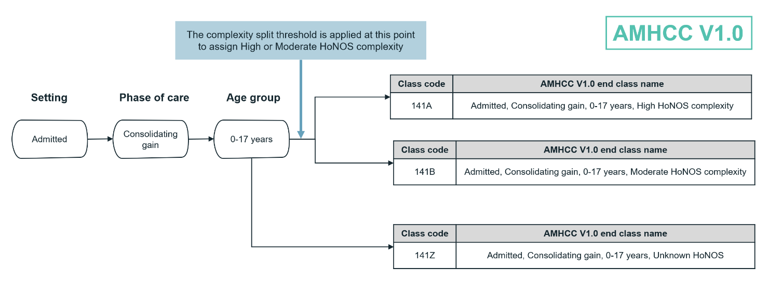

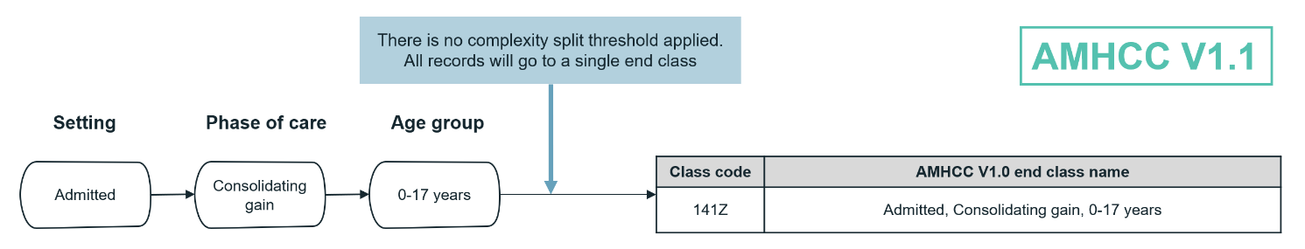

The AMHCC V1.1 additionally updates the description of the 141Z end class to remove the words “Unknown HoNOS.” **Table 5** summarises the changes to the end classes between AMHCC V1.0 and V1.1.

Table 5. AMHCC V1.0 and V1.1 end class change for Admitted, Consolidating Gain, 0-17 years branch

|  |  |  |  |  |
| --- | --- | --- | --- | --- |
| **Class code** | **AMHCC V1.0 end class name** | **AMHCC V1.1 end class name** | **AMHCC V1.0** | **AMHCC V1.1** |
| 141A | Admitted, Consolidating gain, 0-17 years, High HoNOS complexity | Admitted, Consolidating gain, 0-17 years, High HoNOS complexity | Active | Inactive |
| 141B | Admitted, Consolidating gain, 0-17 years, Moderate HoNOS complexity | Admitted, Consolidating gain, 0-17 years, Moderate HoNOS complexity | Active | Inactive |
| 141Z | Admitted, Consolidating gain, 0-17 years, Unknown HoNOS | Admitted, Consolidating gain, 0-17 years | Active | Active |

## Treatment of records with missing HoNOS items

In the AMHCC within the same segment, records with one or two missing HoNOS item scores often had a greater proportion of scores with higher severity compared to records with no missing HoNOS scores. Further, records with one or two missing HoNOS item scores had a disproportionate number of missing scores against HoNOSCA item 13 (poor school attendance) whereas records with no missing HoNOS items often reported scores greater than zero against this item.

This analysis indicated that the HoNOS reporting profile of records with one or two missing HoNOS items was considerably different to that of records with no missing HoNOS items. This meant that the inclusion of the former data cohort into the complexity model would substantially change the modelled relationship of HoNOS items and phase cost. For example, the inclusion of phases with one or two missing HoNOSCA items would dilute the phases with a non-missing HoNOSCA item 13 and potentially cause a systematic under-estimate of the impact of this item. This would ultimately distort the resulting HoNOS weights and complexity split thresholds from the complexity model.

Therefore, records with one or two missing HoNOS scores were not used as input to the AMHCC V1.1 complexity model. Instead, AMHCC V1.1 will introduce updated data validation rules such that phases with one or two missing HoNOS scores will now receive a valid complexity score and a High or Moderate HoNOS complexity group. This treatment of records with missing HoNOS items under AMHCC V1.1 is summarised in **Table 6**.

Table 6. Treatment of records with missing HoNOS scores under AMHCC V1.1

|  |  |  |  |
| --- | --- | --- | --- |
| **Treatment** | **Number of missing HoNOS item scores** | | |
| **0** | **1-2** | **More than 2** |
| Records are used in AMHCC V1.1 complexity model | ü | û | û |
| Records receive valid complexity score and High/Moderate complexity group | ü | ü | û |

IHACPA has also undertaken additional analyses which showed that an AMHCC complexity model developed using only fully populated HoNOS records was still able to reasonably predict the cost of records with one to two missing HoNOS items, with no substantial deterioration in model performance.

# Australian Mental Health Care Classification Version 1.1 model performance

The Independent Health and Aged Care Pricing Authority (IHACPA) has evaluated the overall performance of the Australian Mental Health Care Classification (AMHCC) Version 1.1 (V1.1) model by considering the change in end class distribution, changes in Health of the Nation Outcome Scales (HoNOS) and Abbreviated Life Skills Profile (LSP-16) complexity grouping and statistical performance.

## Changes in end class distribution

The AMHCC V1.1 improves the cost differentiation between High and Moderate complexity groups across most segments. Additionally, the AMHCC V1.1 resolves the issue seen in some segments under the AMHCC Version 1.0 (V1.0) where the average cost of the High complexity group was lower than that of the Moderate complexity group within the same segment.

The distribution of phase records by end class and the average cost per phase under AMHCC V1.0 and AMHCC V1.1 are provided in **Appendix E**.

## Changes in complexity grouping

### Changes in HoNOS complexity grouping

The AMHCC V1.1 had a modest impact on the assignment of HoNOS complexity grouping for records with no missing HoNOS items when compared to AMHCC V1.0, with 31 per cent of records showing a change in HoNOS complexity grouping. **Figure 5** summarises the movement of records across HoNOS complexity groups between AMHCC V1.0 and V1.1.

In the AMHCC V1.1 for records with no missing HoNOS items, 69 per cent of overall phases remained in the same HoNOS complexity group, 24 per cent moved from Moderate to High complexity group, and 7 per cent moved from the High to Moderate complexity group between classification versions.

In the admitted setting, 76 per cent of records with no missing HoNOS items remained in the same HoNOS complexity group, 9 per cent moved from Moderate to High complexity and 15 per cent moved from High to Moderate complexity.

In the community setting, 65 per cent of records with no missing HoNOS items remained in the same HoNOS complexity group between both AMHCC versions, 34 per cent moved from Moderate to High complexity and 1 per cent moved from High to Moderate complexity.

Figure 5. Changes in HoNOS complexity group between AMHCC V1.0 and V1.1 for records with no missing HoNOS items

|  |  |  |
| --- | --- | --- |
|  |  |  |
| ◼ Complexity unchanged ◼ Moderate 🡪 High ◼ High 🡪 Moderate | | |
|  | | |

### Changes in LSP-16 complexity grouping

The AMHCC V1.1 had a modest impact on the assignment of LSP-16 complexity grouping for records with no missing LSP-16 items when compared to AMHCC V1.0, with 22 per cent of records showing a change in LSP-16 complexity grouping. **Table 7** shows the movement of phases with no missing LSP-16 items across different LSP-16 complexity groups between AMHCC V1.0 and AMHCC V1.1. This analysis was limited to phases which remained in the Moderate HoNOS complexity group between both AMHCC versions.

Table 7. Changes in LSP-16 complexity group for Community 18-64 years Moderate HoNOS complexity end classes between AMHCC V1.0 and V1.1

|  |  |  |
| --- | --- | --- |
| **Segment** | **Complexity unchanged** | **Moderate** 🡪 **High** |
| Community Acute 18-64 years | 66% | 34% |
| Community Functional gain 18-64 years | 83% | 17% |
| Community Intensive extended 18-64 years | 74% | 26% |
| Community Consolidating gain 18-64 years | 75% | 25% |
| **Overall** | **78%** | **22%** |

In the AMHCC V1.1, 78 per cent of phases with no missing LSP-16 items remained in the same LSP-16 complexity group between AMHCC V1.0 and AMHCC V1.1. The remaining 22 per cent of phases moved from the Moderate to High LSP-16 complexity group. Therefore, all phases with no missing LSP-16 items will either remain in the same LSP-16 complexity grouping or move to the High LSP-16 complexity grouping under AMHCC V1.1. Across all the Mental Health Phase of Care (MHPoC) types in the Community 18-64 years branch, the Acute MHPoC had the greatest proportion of records moving from the Moderate to High complexity group between AMHCC V1.0 and AMHCC V1.1.

## Complexity model statistical performance

The weights and thresholds from the AMHCC V1.0 and AMHCC V1.1 were applied to the three-year costed mental health data set (2018–19 to 2020–21) to compare the performance of the two AMHCC versions. Complexity model statistical performance was assessed at the complexity score level and the end class level. When applied at the complexity score level, the performance metrics evaluate the degree to which the complexity score in each AMHCC version predicts phase costs. When applied at the end class level, the performance metrics evaluate the predictive power of performing the split of each segment into its constituent AMHCC end classes.

The statistical performance is calculated using Area Under Gains ratio (AUG), R-squared and Reduction in Deviance (RID). Results presented in this section have been conducted on the three-year data set, prepared according to Section 3.4.

AUG tests how well a model ranks phases from lowest to highest cost. It does not measure the accuracy of the model’s exact cost predictions and is therefore not overly influenced by outliers. An AUG of 100 per cent represents a perfect prediction of the ranking of cost and an AUG of 0 per cent represents a random cost prediction.

R-squared provides an indication of the explanatory power of a model. A higher R-squared means that the model can better predict variation in phase costs. This measure is distinct from AUG in that it does evaluate the degree to which a model predicts the exact cost of a phase.

RID provides an indication of the explanatory power of a model. A higher RID means that a higher percentage of the cost variation is explained by the classification. Like the AUG, it does not test the exact cost prediction of the complexity model, rather it tests the degree to which the end class splits create groups which are more homogeneous than the original cohort.

**Table 8** summarises the model performance metrics for the full data set and by setting level.

Table 8. Model performance comparison between AMHCC V1.0 and AMHCC V1.1

|  |  |  |  |  |  |  |  |  |
| --- | --- | --- | --- | --- | --- | --- | --- | --- |
| **Metric** | **AUG** | | | | **R-squared** | | **RID** | |
| **Grouping** | **Complexity score** | | **End class** | | **End class** | | **End class** | |
| **AMHCC version** | **V1.0** | **V1.1** | **V1.0** | **V1.1** | **V1.0** | **V1.1** | **V1.0** | **V1.1** |
| Admitted | 14% | 25% | 32% | 34% | 12% | 14% | 12% | 14% |
| Community | 3% | 8% | 15% | 16% | 10% | 11% | 11% | 12% |
| **Overall** | **12%** | **14%** | **35%** | **36%** | **36%** | **37%** | **39%** | **40%** |

The AMHCC V1.1 performs better than the AMHCC V1.0 across both admitted and community settings. This outcome is consistent across all three measures of model performance. The improvement in model performance indicates that AMHCC V1.1 can more accurately assign high-cost mental health care phases to High complexity end classes compared to AMHCC V1.0. The modest improvement in performance is likely to be a result of the classification structure and input variables remaining unchanged between the two versions.

A breakdown of model performance metrics for both AMHCC versions for each unique combination of setting and phase group, and by segment are provided in **Appendix F**.

# Conclusion

The Australian Mental Health Care Classification (AMHCC) Version 1.1 ( V 1.1) produces recalibrated weights and complexity split thresholds which better capture national mental health activity and cost data trends using the latest three years of mental health care data. It also incorporates changes to align with National Outcomes and Casemix Collection protocols, allowing phases with up to two missing Health of the Nation Outcome Scales (HoNOS) items to receive a valid complexity score and a High or Moderate HoNOS complexity grouping. AMHCC V1.1 performs better than AMHCC Version 1.0 in being able to differentiate costs between High and Moderate complexity groupings.

At the time of writing, AMHCC V1.1 has not been used to inform prices or price weights which are determined by the Independent Health and Aged Care Pricing Authority (IHACPA) as required by the National Health Reform Agreement. IHACPA will undertake additional analysis and consultation to determine the appropriate time at which to use AMHCC V1.1 to inform these figures, and consequently to inform Commonwealth funding of public hospitals. Requirements for pricing new versions of classifications and shadow pricing considerations are outlined in the [*National Pricing Model Consultation Policy*](https://www.ihacpa.gov.au/publications/national-pricing-model-consultation-policy-v2)and the [*Shadow Pricing Guidelines*](https://www.ihacpa.gov.au/resources/shadow-pricing-guidelines-version-20).

Supporting materials, including updated technical specifications and groupers, will be developed, and released on the IHACPA website in late 2023. IHACPA continues to consult with jurisdictions, health services, peak bodies, mental health clinicians and consumers to develop and refine the AMHCC based on the most recent activity and cost data to better account for and fund mental health care services across Australia with increased transparency and greater efficiency.

# Appendix A: Mental Health Working Group

Table 9. Independent Health and Aged Care Pricing Authority – Mental Health Working Group

|  |
| --- |
| **Organisation / Jurisdiction** |
| A representative of each state and territory and the Commonwealth |
| The Deputy Chief Medical Officer for Mental Health (Commonwealth) |
| A representative of the National Mental Health Commission |
| A representative of the Mental Health Australia |
| The Chair of the Mental Health Information Strategy Standing Committee |
| Three representatives of the Royal Australian and New Zealand College of Psychiatrists to represent the specialties of child and adolescent, adult and older persons’ psychiatry |
| A representative of the Australian College of Mental Health Nurses |
| A representative of Allied Health Professions Australia |
| A representative of the Royal Australian College of General Practitioners (observer status) |
| A representative of the Australian Private Hospitals Association |
| A representative of the Private Healthcare Australia |
| A representative of Community Mental Health Australia |
| A representative of the National Disability Insurance Agency |
| Three mental health clinicians with appropriate expertise in mental health services and systems |
| A mental health consumer representative and a mental health carer representative |
| A representative of IHACPA’s Clinical Advisory Committee |

# Appendix B: Data preparation in response to COVID-19

Due to the potential impact of COVID-19 on cost and activity data, IHACPA undertook additional analysis to assess what combination of data collection years could be used in the AMHCC V1.1 refinement.

The potential impact of COVID-19 was considered by analysing:

1. the distribution of key classification variables to assess whether there was a shift in the nature and type of mental health activity being reported across the three data years
2. the average phase cost to assess if there was a change in cost per phase between the two-year and three-year periods.

The following results were calculated using three years of data (2018–19, 2019–20 and 2020–21), prepared as outlined in Section 3.4. The Northern Territory did not have any costed mental health phase records in the admitted and community setting. South Australia, Western Australia and the Australian Capital Territory did not have any costed mental health phase records in the community setting.

**Distribution of key classification variables across data years**

**Figure 6** provides a breakdown of the key classification variables by data year at the national level. The distribution of records by different episode setting, age group, MHPoC and admitted MHLS values were generally consistent across 2018–19, 2019–20 and 2020–21 nationally. This suggests that there were no substantial shifts in mental health care activity reporting over the three years.

Figure 6. Distribution of national records by setting, age group, phase and admitted MHLS

|  |  |
| --- | --- |
|  |  |
|  |  |

**Analysis of average phase cost across data years**

**Figure 7** shows the change in average phase cost between the two-year data set and three-year data set at the setting level. **Figure 8** provides the same analysis for each unique combination of setting and age (the setting-age level). The percentage values in both figures show the percentage change in average phase cost between the two-year and three-year data sets.

Nationally, there were some differences in average phase cost at the setting level and setting-age level for each data year. However, there was minimal change in the average phase cost when using two years of data (2018–19 and 2019–20) versus three years of data (2018–19 to 2020–21).

Figure 7. Change in average phase cost using two-year and three-year data sets (setting level)

Figure 8. Change in average phase cost using two-year and three-year data sets (setting-age level)

|  |  |
| --- | --- |
|  |  |

# Appendix C: AMHCC V1.1 end classes

Table 10. AMHCC V1.1 admitted setting structure and end classes

| **Phase** | **Age group** | **Mental health legal status** | **HoNOS complexity** | **LSP complexity** | **Class code** | **Class description** | **Active/Inactive for AMHCC Version 1.1** |
| --- | --- | --- | --- | --- | --- | --- | --- |
| Assessment only | 0-17 years | - | - | - | 101Z | Admitted, Assessment only, 017 years | Active |
| 18-64 years | - | - | - | 102Z | Admitted, Assessment only, 1864 years | Active |
| 65+ years | - | - | - | 103Z | Admitted, Assessment only, 65+ years | Active |
| Acute | 0-17 years | - | High | - | 111A | Admitted, Acute, 0-17 years, High HoNOS complexity | Active |
| - | Moderate | - | 111B | Admitted, Acute, 0-17 years, Moderate HoNOS complexity | Active |
| - | Unknown | - | 111Z | Admitted, Acute, 0-17 years, Unknown HoNOS | Active |
| 18-64 years | Involuntary | High | - | 1121A | Admitted, Acute, 18-64 years, Involuntary, High HoNOS complexity | Active |
| Moderate | - | 1121B | Admitted, Acute, 18-64 years, Involuntary, Moderate HoNOS complexity | Active |
| Unknown | - | 1121Z | Admitted, Acute, 18-64 years, Involuntary, Unknown HoNOS | Active |
| Voluntary | High | - | 1122A | Admitted, Acute, 18-64 years, Voluntary, High HoNOS complexity | Active |
| Moderate | - | 1122B | Admitted, Acute, 18-64 years, Voluntary, Moderate HoNOS complexity | Active |
| Unknown | - | 1122Z | Admitted, Acute, 18-64 years, Voluntary, Unknown HoNOS | Active |
| 65+ years | - | High | - | 113A | Admitted, Acute, 65+ years, High HoNOS complexity | Active |
| - | Moderate | - | 113B | Admitted, Acute, 65+ years, Moderate HoNOS complexity | Active |
| - | Unknown | - | 113Z | Admitted, Acute, 65+ years, Unknown HoNOS | Active |
| Functional gain | 0-17 years | - | High | - | 121A | Admitted, Functional gain, 0-17 years, High HoNOS complexity | Active |
| - | Moderate | - | 121B | Admitted, Functional gain, 0-17 years, Moderate HoNOS complexity | Active |
| - | Unknown | - | 121Z | Admitted, Functional gain, 0-17 years, Unknown HoNOS | Active |
| 18-64 years | - | High | - | 122A | Admitted, Functional gain, 1864 years, High HoNOS complexity | Active |
| - | Moderate | - | 122B | Admitted, Functional gain, 1864 years, Moderate HoNOS complexity | Active |
| - | Unknown | - | 122Z | Admitted, Functional gain, 1864 years, Unknown HoNOS | Active |
| 65+ years | - | High | - | 123A | Admitted, Functional gain, 65+ years, High HoNOS complexity | Active |
| - | Moderate | - | 123B | Admitted, Functional gain, 65+ years, Moderate HoNOS complexity | Active |
| - | Unknown | - | 123Z | Admitted, Functional gain, 65+ years, Unknown HoNOS | Active |
| Intensive extended | 0-17 years | - | High | - | 131A | Admitted, Intensive extended, 0-17 years, High HoNOS complexity | Active |
| - | Moderate | - | 131B | Admitted, Intensive extended, 0-17 years, Moderate HoNOS complexity | Active |
| - | Unknown | - | 131Z | Admitted, Intensive extended, 0-17 years, Unknown HoNOS | Active |
| 18-64 years | - | High | - | 132A | Admitted, Intensive extended, 18-64 years, High HoNOS complexity | Active |
| - | Moderate | - | 132B | Admitted, Intensive extended, 18-64 years, Moderate HoNOS complexity | Active |
| - | Unknown | - | 132Z | Admitted, Intensive extended, 18-64 years, Unknown HoNOS | Active |
| 65+ years | - | High | - | 133A | Admitted, Intensive extended, 65+ years, High HoNOS complexity | Active |
| - | Moderate | - | 133B | Admitted, Intensive extended, 65+ years, Moderate HoNOS complexity | Active |
| - | Unknown | - | 133Z | Admitted, Intensive extended, 65+ years, Unknown HoNOS | Active |
| Consolidating gain | 0-17 years | - | High | - | 141A | Admitted, Consolidating gain, 0-17 years, High HoNOS complexity | Inactive |
| - | Moderate | - | 141B | Admitted, Consolidating gain, 0-17 years, Moderate HoNOS complexity | Inactive |
| - | Unknown | - | 141Z | Admitted, Consolidating gain, 0-17 years | Active |
| 18-64 years | - | High | - | 142A | Admitted, Consolidating gain, 18-64 years, High HoNOS complexity | Active |
| - | Moderate | - | 142B | Admitted, Consolidating gain, 18-64 years, Moderate HoNOS complexity | Active |
| - | Unknown | - | 142Z | Admitted, Consolidating gain, 18-64 years, Unknown HoNOS | Active |
| 65+ years | - | High | - | 143A | Admitted, Consolidating gain, 65+ years, High HoNOS complexity | Active |
| - | Moderate | - | 143B | Admitted, Consolidating gain, 65+ years, Moderate HoNOS complexity | Active |
| - | Unknown | - | 143Z | Admitted, Consolidating gain, 65+ years, Unknown HoNOS | Active |
| Unknown | 0-17 years | - | - | - | 191Z | Admitted, Unknown phase, 017 years | Active |
| 18-64 years | - | - | - | 192Z | Admitted, Unknown phase, 1864 years | Active |
| 65+ years | - | - | - | 193Z | Admitted, Unknown phase, 65+ years | Active |

Table 11. AMHCC V1.1 community setting structure and end classes

| **Phase** | **Age group** | **Mental health legal status** | **HoNOS complexity** | **LSP complexity** | **Class code** | **Class description** | **Active/Inactive for AMHCC Version 1.1** |
| --- | --- | --- | --- | --- | --- | --- | --- |
| Assessment only | 0-17 years | - | - | - | 201Z | Community, Assessment only, 0-17 years | Active |
| 18-64 years | - | - | - | 202Z | Community, Assessment only, 18-64 years | Active |
| 65+ years | - | - | - | 203Z | Community, Assessment only, 65+ years | Active |
| Acute | 0-17 years | - | High | - | 211A | Community, Acute, 0-17 years, High HoNOS complexity | Active |
| Moderate | - | 211B | Community, Acute, 0-17 years, Moderate HoNOS complexity | Active |
| Unknown | - | 211Z | Community, Acute, 0-17 years, Unknown HoNOS | Active |
| 18-64 years | - | High | - | 212A | Community, Acute, 18-64 years, High HoNOS complexity | Active |
| Moderate | High | 212B1 | Community, Acute, 18-64 years, Moderate HoNOS complexity with High LSP complexity | Active |
| Moderate | 212B2 | Community, Acute, 18-64 years, Moderate HoNOS complexity with Moderate LSP complexity | Active |
| Unknown | - | 212Z | Community, Acute, 18-64 years, Unknown HoNOS | Active |
| 65+ years | - | High | - | 213A | Community, Acute, 65+ years, High HoNOS complexity | Active |
| Moderate | - | 213B | Community, Acute, 65+ years, Moderate HoNOS complexity | Active |
| Unknown | - | 213Z | Community, Acute, 65+ years, Unknown HoNOS | Active |
| Functional gain | 0-17 years | - | High | - | 221A | Community, Functional gain, 0-17 years, High HoNOS complexity | Active |
| Moderate | - | 221B | Community, Functional gain, 0-17 years, Moderate HoNOS complexity | Active |
| Unknown | - | 221Z | Community, Functional gain, 0-17 years, Unknown HoNOS | Active |
| 18-64 years | - | High | - | 222A | Community, Functional gain, 18-64 years, High HoNOS complexity | Active |
| Moderate | High | 222B1 | Community, Functional gain, 18-64 years, Moderate HoNOS complexity with High LSP complexity | Active |
| Moderate | 222B2 | Community, Functional gain, 18-64 years, Moderate HoNOS complexity with Moderate LSP complexity | Active |
| Unknown | - | 222Z | Community, Functional gain, 18-64 years, Unknown HoNOS | Active |
| 65+ years | - | High | - | 223A | Community, Functional gain, 65+ years, High HoNOS complexity | Active |
| Moderate | - | 223B | Community, Functional gain, 65+ years, Moderate HoNOS complexity | Active |
| Unknown | - | 223Z | Community, Functional gain, 65+ years, Unknown HoNOS | Active |
| Intensive extended | 0-17 years | - | High | - | 231A | Community, Intensive extended, 0-17 years, High HoNOS complexity | Active |
| Moderate | - | 231B | Community, Intensive extended, 0-17 years, Moderate HoNOS complexity | Active |
| Unknown | - | 231Z | Community, Intensive extended, 0-17 years, Unknown HoNOS | Active |
| 18-64 years | - | High | - | 232A | Community, Intensive extended, 18-64 years, High HoNOS complexity | Active |
| Moderate | High | 232B1 | Community, Intensive extended, 18-64 years, Moderate HoNOS complexity with High LSP complexity | Active |
| Moderate | 232B2 | Community, Intensive extended, 18-64 years, Moderate HoNOS complexity with Moderate LSP complexity | Active |
| Unknown | - | 232Z | Community, Intensive extended, 18-64 years, Unknown HoNOS | Active |
| 65+ years | - | High | - | 233A | Community, Intensive extended, 65+ years, High HoNOS complexity | Active |
| Moderate | - | 233B | Community, Intensive extended, 65+ years, Moderate HoNOS complexity | Active |
| Unknown | - | 233Z | Community, Intensive extended, 65+ years, Unknown HoNOS | Active |
| Consolidating gain | 0-17 years | - | High | - | 241A | Community, Consolidating gain, 0-17 years, High HoNOS complexity | Active |
| Moderate | - | 241B | Community, Consolidating gain, 0-17 years, Moderate HoNOS complexity | Active |
| Unknown | - | 241Z | Community, Consolidating gain, 0-17 years, Unknown HoNOS | Active |
| 18-64 years | - | High | - | 242A | Community, Consolidating gain, 18-64 years, High HoNOS complexity | Active |
| Moderate | High | 242B1 | Community, Consolidating gain, 18-64 years, Moderate HoNOS complexity with High LSP complexity | Active |
| Moderate | 242B2 | Community, Consolidating gain, 18-64 years, Moderate HoNOS complexity with Moderate LSP complexity | Active |
| Unknown | - | 242Z | Community, Consolidating gain, 18-64 years, Unknown HoNOS | Active |
| 65+ years | - | High | - | 243A | Community, Consolidating gain, 65+ years, High HoNOS complexity | Active |
| Moderate | - | 243B | Community, Consolidating gain, 65+ years, Moderate HoNOS complexity | Active |
| Unknown | - | 243Z | Community, Consolidating gain, 65+ years, Unknown HoNOS | Active |
| Unknown | 0-17 years | - | - | - | 291Z | Community, Unknown phase, 0-17 years | Active |
| 18-64 years | - | - | - | 292Z | Community, Unknown phase, 18-64 years | Active |
| 65+ years | - | - | - | 293Z | Community, Unknown phase, 65+ years | Active |

# Appendix D: AMHCC V1.1 weights and complexity split thresholds

Table 12. AMHCC V1.1 weights and complexity split thresholds

|  |  |  |  |  |  |  |  |  |  |  |  |  |  |  |  |  |  |  |
| --- | --- | --- | --- | --- | --- | --- | --- | --- | --- | --- | --- | --- | --- | --- | --- | --- | --- | --- |
| **Setting** | **MHPoC** | **Age group** | **HoNOS weights** | | | | | | | | | | | | | **Weighted HoNOS rescaling factor** | **Weighted HoNOS threshold** | **LSP threshold** |
| **W1** | **W2** | **W3** | **W4** | **W5** | **W6** | **W7** | **W8** | **W9** | **W10** | **W11** | **W12** | **W13** |
| Admitted | Acute | 0-17 | 0.1 | 0.1 | 0.1 | 0.1 | 0.1 | 3.1 | 5.9 | 3.4 | 0.1 | 0.1 | 0.1 | 0.1 | 0.1 | 0.9701 | 20 | - |
| 18-64 | 0.1 | 0.1 | 0.1 | 2.5 | 0.8 | 9.4 | 0.1 | 0.1 | 0.1 | 1.2 | 0.2 | 0.4 |  | 0.7947 | Involuntary = 20 | - |
| Voluntary = 9 | - |
| 65+ | 0.5 | 0.1 | 0.1 | 2.7 | 0.1 | 5.2 | 0.1 | 0.1 | 0.1 | 4.3 | 0.1 | 0.4 |  | 0.8696 | 16 | - |
| Functional gain | 0-17 | 0.1 | 0.1 | 0.1 | 0.1 | 0.5 | 2 | 8 | 3.5 | 0.1 | 2.1 | 0.1 | 2 | 1.5 | 0.6436 | 15 | - |
| 18-64 | 0.1 | 0.1 | 0.1 | 4.4 | 0.9 | 8.2 | 0.1 | 0.1 | 0.1 | 1.8 | 3.3 | 0.1 |  | 0.6218 | 11 | - |
| 65+ | 1.2 | 0.1 | 0.1 | 2.5 | 0.1 | 8.9 | 3.6 | 4.6 | 0.1 | 0.1 | 0.2 | 0.1 |  | 0.5556 | 15 | - |
| Intensive extended | 0-17 | 0.1 | 0.1 | 1 | 0.1 | 0.1 | 3 | 6.8 | 3.4 | 0.8 | 0.5 | 0.4 | 0.1 | 0.1 | 0.7879 | 17 | - |
| 18-64 | 0.1 | 0.1 | 0.1 | 0.1 | 0.1 | 5 | 0.1 | 0.1 | 0.1 | 0.1 | 8.4 | 3.9 |  | 0.6593 | 26 | - |
| 65+ | 0.1 | 0.1 | 0.1 | 2.3 | 0.1 | 4.9 | 0.1 | 0.1 | 0.1 | 4.1 | 0.2 | 0.3 |  | 0.9600 | 19 | - |
| Consolidating gain | 0-17 | 0.1 | 0.1 | 0.1 | 0.1 | 0.1 | 3.1 | 5.9 | 3.4 | 0.1 | 0.1 | 0.1 | 0.1 | 0.1 | 0.9701 | - | - |
| 18-64 | 0.1 | 0.1 | 0.1 | 0.6 | 0.1 | 3.1 | 0.1 | 0.1 | 0.1 | 2 | 0.1 | 0.1 |  | 1.8182 | 17 | - |
| 65+ | 0.1 | 0.1 | 0.1 | 1.7 | 0.1 | 4.6 | 1.5 | 0.6 | 0.1 | 3.1 | 0.1 | 0.4 |  | 0.9600 | 20 | - |
| Community | Acute | 0-17 | 0.1 | 1.8 | 0.1 | 0.1 | 1.6 | 0.6 | 0.1 | 4.3 | 5.1 | 1.6 | 0.1 | 1.6 | 1.1 | 0.7143 | 21 | - |
| 18-64 | 0.1 | 0.1 | 0.1 | 0.9 | 0.5 | 4.7 | 0.3 | 0.5 | 1.2 | 2.3 | 0.1 | 0.1 |  | 1.1009 | 8 | 6 |
| 65+ | 0.1 | 0.1 | 0.1 | 0.1 | 0.1 | 1.3 | 0.3 | 0.4 | 0.1 | 0.1 | 0.1 | 0.1 |  | 4.1379 | 11 | - |
| Functional gain | 0-17 | 0.4 | 2.1 | 0.1 | 0.1 | 1.3 | 1.2 | 3.1 | 1.5 | 3.9 | 3.5 | 0.1 | 2.6 | 1.1 | 0.6190 | 19 | - |
| 18-64 | 0.1 | 0.1 | 0.1 | 3.9 | 0.9 | 5.3 | 0.1 | 0.1 | 0.2 | 2.7 | 0.1 | 0.1 |  | 0.8759 | 9 | 8 |
| 65+ | 0.1 | 0.1 | 1 | 0.1 | 0.1 | 5.1 | 0.3 | 2 | 0.1 | 0.1 | 0.9 | 0.8 |  | 1.1215 | 7 | - |
| Intensive extended | 0-17 | 0.3 | 1 | 0.1 | 0.6 | 1.2 | 1.3 | 1.8 | 0.1 | 4 | 2.8 | 0.1 | 2.5 | 1.1 | 0.7692 | 22 | - |
| 18-64 | 0.1 | 0.1 | 0.5 | 3.7 | 1.2 | 4.3 | 0.1 | 0.1 | 0.9 | 3.9 | 0.1 | 0.1 |  | 0.7947 | 12 | 9 |
| 65+ | 0.1 | 0.1 | 2 | 0.1 | 0.1 | 5.8 | 0.6 | 1.7 | 1.3 | 0.1 | 2.4 | 0.1 |  | 0.8333 | 11 | - |
| Consolidating gain | 0-17 | 0.1 | 0.1 | 0.1 | 0.9 | 0.4 | 1.1 | 0.4 | 0.1 | 0.1 | 1.7 | 0.1 | 0.6 | 0.4 | 2.1311 | 15 | - |
| 18-64 | 0.1 | 0.1 | 0.1 | 3.4 | 0.7 | 3.3 | 0.1 | 0.1 | 0.1 | 0.6 | 0.1 | 0.1 |  | 1.3636 | 8 | 7 |
| 65+ | 0.1 | 0.1 | 0.1 | 0.1 | 0.1 | 4.9 | 0.1 | 0.1 | 0.1 | 0.1 | 1.4 | 0.1 |  | 1.6438 | 8 | - |

# Appendix E: Record breakdown by end class for AMHCC V1.0 and AMHCC V1.1

**Table 13** provides a breakdown of the three-year data set (2018–19 to 2020–21), showing the movement of records across end classes between AMHCC V1.0 and AMHCC V1.1. It additionally provides the average phase cost by end class for the two AMHCC versions.

Positive values for “Raw Change” and “% Change” indicate that more records have moved into than out of that end class in the transition from AMHCC V1.0 to AMHCC V1.1. Negative values for “Raw Change” and “% Change” indicate that more records have moved out of than into that end class in the transition from AMHCC V1.0 to AMHCC V1.1.

**Table 13** excludes the end classes for Unknown MHPoC and Assessment Only as no phases will move into or out of these end classes in the transition between AMHCC V1.0 and AMHCC V1.1.

Under AMHCC V1.1, the 141Z end class captures all records in the Admitted, Consolidating gain phase, age 0-17 years. In practice, most of these records would have Unknown HoNOS and therefore, the impact of the proposed classification update has been displayed against the 'Unknown HoNOS' class.

Table 13. Record breakdown by end class for AMHCC V1.0 and AMHCC V1.1

| **Class** | **Description** | **Number of records** | | | | **Average cost** | |
| --- | --- | --- | --- | --- | --- | --- | --- |
| **AMHCC V1.0** | **AMHCC V1.1** | **Raw Change** | **% Change** | **AMHCC V1.0** | **AMHCC V1.1** |
|
| 111A | Admitted, Acute, 0-17 years, High HoNOS Complexity | 5,255 | 1,675 | -3,580 | -68% | $20,328 | $32,391 |
| 111B | Admitted, Acute, 0-17 years, Moderate HoNOS Complexity | 4,616 | 9,109 | 4,493 | 97% | $18,291 | $16,791 |
| 111Z | Admitted, Acute, 0-17 years, Unknown HoNOS | 4,324 | 3,411 | -913 | -21% | $17,408 | $17,390 |
| 1121A | Admitted, Acute, 18-64 years, Involuntary, High HoNOS Complexity | 41,460 | 40,094 | -1,366 | -3% | $27,963 | $29,545 |
| 1121B | Admitted, Acute, 18-64 years, Involuntary, Moderate HoNOS Complexity | 28,948 | 40,141 | 11,193 | 39% | $23,041 | $22,388 |
| 1121Z | Admitted, Acute, 18-64 years, Involuntary, Unknown HoNOS | 18,147 | 8,320 | -9,827 | -54% | $26,066 | $25,975 |
| 1122A | Admitted, Acute, 18-64 years, Voluntary, High HoNOS Complexity | 28,131 | 33,160 | 5,029 | 18% | $14,271 | $15,530 |
| 1122B | Admitted, Acute, 18-64 years, Voluntary, Moderate HoNOS Complexity | 43,067 | 44,893 | 1,826 | 4% | $12,313 | $11,231 |
| 1122Z | Admitted, Acute, 18-64 years, Voluntary, Unknown HoNOS | 13,663 | 6,808 | -6,855 | -50% | $13,512 | $14,275 |
| 113A | Admitted, Acute, 65+ years, High HoNOS Complexity | 5,405 | 6,023 | 618 | 11% | $46,254 | $49,373 |
| 113B | Admitted, Acute, 65+ years, Moderate HoNOS Complexity | 5,620 | 6,495 | 875 | 16% | $37,794 | $35,561 |
| 113Z | Admitted, Acute, 65+ years, Unknown HoNOS | 4,632 | 3,139 | -1,493 | -32% | $35,091 | $30,774 |
| 121A | Admitted, Functional Gain, 0-17 years, High HoNOS Complexity | 143 | 68 | -75 | -52% | $31,401 | $38,002 |
| 121B | Admitted, Functional Gain, 0-17 years, Moderate HoNOS Complexity | 70 | 175 | 105 | 150% | $20,796 | $23,490 |
| 121Z | Admitted, Functional Gain, 0-17 years, Unknown HoNOS | 116 | 86 | -30 | -26% | $19,066 | $17,009 |
| 122A | Admitted, Functional Gain, 18-64 years, High HoNOS Complexity | 2,781 | 2,506 | -275 | -10% | $45,689 | $54,809 |
| 122B | Admitted, Functional Gain, 18-64 years, Moderate HoNOS Complexity | 3,526 | 4,229 | 703 | 20% | $33,819 | $29,363 |
| 122Z | Admitted, Functional Gain, 18-64 years, Unknown HoNOS | 1,064 | 636 | -428 | -40% | $31,124 | $28,135 |
| 123A | Admitted, Functional Gain, 65+ years, High HoNOS Complexity | 534 | 485 | -49 | -9% | $40,237 | $43,425 |
| 123B | Admitted, Functional Gain, 65+ years, Moderate HoNOS Complexity | 394 | 524 | 130 | 33% | $26,494 | $25,882 |
| 123Z | Admitted, Functional Gain, 65+ years, Unknown HoNOS | 272 | 191 | -81 | -30% | $35,195 | $35,996 |
| 131A | Admitted, Intensive Extended, 0-17 years, High HoNOS Complexity | 49 | 28 | -21 | -43% | $141,935 | $161,204 |
| 131B | Admitted, Intensive Extended, 0-17 years, Moderate HoNOS Complexity | 9 | 31 | 22 | 244% | $53,326 | $95,086 |
| 131Z | Admitted, Intensive Extended, 0-17 years, Unknown HoNOS | 18 | 17 | -1 | -6% | $53,829 | $55,430 |
| 132A | Admitted, Intensive Extended, 18-64 years, High HoNOS Complexity | 547 | 220 | -327 | -60% | $67,718 | $100,351 |
| 132B | Admitted, Intensive Extended, 18-64 years, Moderate HoNOS Complexity | 389 | 788 | 399 | 103% | $41,442 | $45,886 |
| 132Z | Admitted, Intensive Extended, 18-64 years, Unknown HoNOS | 201 | 129 | -72 | -36% | $53,797 | $44,502 |
| 133A | Admitted, Intensive Extended, 65+ years, High HoNOS Complexity | 154 | 115 | -39 | -25% | $47,641 | $48,642 |
| 133B | Admitted, Intensive Extended, 65+ years, Moderate HoNOS Complexity | 61 | 130 | 69 | 113% | $45,540 | $40,428 |
| 133Z | Admitted, Intensive Extended, 65+ years, Unknown HoNOS | 62 | 32 | -30 | -48% | $25,842 | $27,110 |
| 141A | Admitted, Consolidating Gain, 0-17 years, High HoNOS Complexity | 10 | - | -10 | -100% | $16,787 | $0 |
| 141B | Admitted, Consolidating Gain, 0-17 years, Moderate HoNOS Complexity | 6 | - | -6 | -100% | $21,537 | $0 |
| 141Z | Admitted, Consolidating Gain, 0-17 years, Unknown HoNOS | 17 | 33 | 16 | 94% | $18,639 | $18,605 |
| 142A | Admitted, Consolidating Gain, 18-64 years, High HoNOS Complexity | 3,440 | 2,079 | -1,361 | -40% | $24,186 | $26,269 |
| 142B | Admitted, Consolidating Gain, 18-64 years, Moderate HoNOS Complexity | 832 | 2,718 | 1,886 | 227% | $29,040 | $24,634 |
| 142Z | Admitted, Consolidating Gain, 18-64 years, Unknown HoNOS | 1,405 | 880 | -525 | -37% | $26,126 | $25,565 |
| 143A | Admitted, Consolidating Gain, 65+ years, High HoNOS Complexity | 1,269 | 758 | -511 | -40% | $36,887 | $38,979 |
| 143B | Admitted, Consolidating Gain, 65+ years, Moderate HoNOS Complexity | 143 | 819 | 676 | 473% | $32,552 | $33,714 |
| 143Z | Admitted, Consolidating Gain, 65+ years, Unknown HoNOS | 323 | 158 | -165 | -51% | $35,081 | $35,688 |
| 211A | Community, Acute, 0-17 years, High HoNOS Complexity | 1,389 | 9,725 | 8,336 | 600% | $6,331 | $5,449 |
| 211B | Community, Acute, 0-17 years, Moderate HoNOS Complexity | 18,683 | 11,333 | -7,350 | -39% | $4,321 | $3,639 |
| 211Z | Community, Acute, 0-17 years, Unknown HoNOS | 5,506 | 4,520 | -986 | -18% | $2,757 | $2,313 |
| 212A | Community, Acute, 18-64 years, High HoNOS Complexity | 12,870 | 49,088 | 36,218 | 281% | $3,582 | $3,500 |
| 212B1 | Community, Acute, 18-64 years, Moderate HoNOS Complexity with High LSP Complexity | 1,635 | 1,489 | -146 | -9% | $7,127 | $5,301 |
| 212B2 | Community, Acute, 18-64 years, Moderate HoNOS Complexity with Moderate LSP Complexity | 79,783 | 48,769 | -31,014 | -39% | $2,834 | $2,469 |
| 212Z | Community, Acute, 18-64 years, Unknown HoNOS | 36,612 | 31,554 | -5,058 | -14% | $2,457 | $2,336 |
| 213A | Community, Acute, 65+ years, High HoNOS Complexity | 2,117 | 5,310 | 3,193 | 151% | $3,243 | $3,625 |
| 213B | Community, Acute, 65+ years, Moderate HoNOS Complexity | 8,188 | 5,672 | -2,516 | -31% | $3,512 | $3,331 |
| 213Z | Community, Acute, 65+ years, Unknown HoNOS | 5,461 | 4,784 | -677 | -12% | $2,392 | $2,203 |
| 221A | Community, Functional Gain, 0-17 years, High HoNOS Complexity | 1,997 | 8,576 | 6,579 | 329% | $9,772 | $8,328 |
| 221B | Community, Functional Gain, 0-17 years, Moderate HoNOS Complexity | 14,423 | 8,633 | -5,790 | -40% | $6,767 | $5,953 |
| 221Z | Community, Functional Gain, 0-17 years, Unknown HoNOS (221Z) | 10,217 | 9,428 | -789 | -8% | $4,121 | $3,861 |
| 222A | Community, Functional Gain, 18-64 years, High HoNOS Complexity | 7,145 | 28,413 | 21,268 | 298% | $7,635 | $7,695 |
| 222B1 | Community, Functional Gain, 18-64 years, Moderate HoNOS Complexity with High LSP Complexity | 9,251 | 6,366 | -2,885 | -31% | $10,342 | $9,253 |
| 222B2 | Community, Functional Gain, 18-64 years, Moderate HoNOS Complexity with Moderate LSP Complexity | 42,346 | 27,455 | -14,891 | -35% | $5,537 | $4,802 |
| 222Z | Community, Functional Gain, 18-64 years, Unknown HoNOS | 31,621 | 28,129 | -3,492 | -11% | $4,208 | $3,853 |
| 223A | Community, Functional Gain, 65+ years, High HoNOS Complexity | 2,124 | 4,838 | 2,714 | 128% | $4,426 | $4,891 |
| 223B | Community, Functional Gain, 65+ years, Moderate HoNOS Complexity | 7,549 | 5,313 | -2,236 | -30% | $4,399 | $4,061 |
| 223Z | Community, Functional Gain, 65+ years, Unknown HoNOS | 4,047 | 3,569 | -478 | -12% | $3,091 | $2,767 |
| 231A | Community, Intensive Extended, 0-17 years, High HoNOS Complexity | 365 | 1,992 | 1,627 | 446% | $10,282 | $8,922 |
| 231B | Community, Intensive Extended, 0-17 years, Moderate HoNOS Complexity | 3,670 | 2,196 | -1,474 | -40% | $6,917 | $5,808 |
| 231Z | Community, Intensive Extended, 0-17 years, Unknown HoNOS | 1,118 | 965 | -153 | -14% | $5,164 | $4,545 |
| 232A | Community, Intensive Extended, 18-64 years, High HoNOS Complexity | 2,947 | 9,475 | 6,528 | 222% | $9,499 | $9,430 |
| 232B1 | Community, Intensive Extended, 18-64 years, Moderate HoNOS Complexity with High LSP Complexity | 2,557 | 1,858 | -699 | -27% | $12,627 | $10,258 |
| 232B2 | Community, Intensive Extended, 18-64 years, Moderate HoNOS Complexity with Moderate LSP Complexity | 13,475 | 8,659 | -4,816 | -36% | $6,408 | $5,280 |
| 232Z | Community, Intensive Extended, 18-64 years, Unknown HoNOS | 9,014 | 8,001 | -1,013 | -11% | $4,904 | $4,588 |
| 233A | Community, Intensive Extended, 65+ years, High HoNOS Complexity | 1,366 | 1,570 | 204 | 15% | $4,717 | $6,128 |
| 233B | Community, Intensive Extended, 65+ years, Moderate HoNOS Complexity | 3,191 | 3,130 | -61 | -2% | $4,835 | $4,196 |
| 233Z | Community, Intensive Extended, 65+ years, Unknown HoNOS | 2,791 | 2,648 | -143 | -5% | $3,638 | $3,501 |
| 241A | Community, Consolidating Gain, 0-17 years, High HoNOS Complexity | 1,323 | 4,575 | 3,252 | 246% | $3,800 | $3,780 |
| 241B | Community, Consolidating Gain, 0-17 years, Moderate HoNOS Complexity | 7,786 | 5,076 | -2,710 | -35% | $3,607 | $3,452 |
| 241Z | Community, Consolidating Gain, 0-17 years, Unknown HoNOS | 30,164 | 29,622 | -542 | -2% | $2,691 | $2,682 |
| 242A | Community, Consolidating Gain, 18-64 years, High HoNOS Complexity | 6,325 | 17,667 | 11,342 | 179% | $5,029 | $6,298 |
| 242B1 | Community, Consolidating Gain, 18-64 years, Moderate HoNOS Complexity with High LSP Complexity | 4,141 | 4,226 | 85 | 2% | $9,500 | $7,783 |
| 242B2 | Community, Consolidating Gain, 18-64 years, Moderate HoNOS Complexity with Moderate LSP Complexity | 26,460 | 17,458 | -9,002 | -34% | $5,047 | $4,198 |
| 242Z | Community, Consolidating Gain, 18-64 years, Unknown HoNOS | 103,562 | 101,137 | -2,425 | -2% | $2,448 | $2,380 |
| 243A | Community, Consolidating Gain, 65+ years, High HoNOS Complexity | 852 | 3,235 | 2,383 | 280% | $3,618 | $5,046 |
| 243B | Community, Consolidating Gain, 65+ years, Moderate HoNOS Complexity | 8,263 | 6,296 | -1,967 | -24% | $4,162 | $3,658 |
| 243Z | Community, Consolidating Gain, 65+ years, Unknown HoNOS | 16,639 | 16,223 | -416 | -3% | $2,160 | $2,100 |

# Appendix F: Comparison of model performance between AMHCC V1.0 and AMHCC V1.1

**Table 14** compares the model performance of AMHCC V1.0 and AMHCC V1.1. The green-highlighted columns show where AMHCC V1.1 performance is the same or improved in comparison to AMHCC V1.0.

Model performance was assessed at the complexity score level and the end class level. When applied at the complexity score level, the performance metrics evaluate the degree to which the complexity score in each AMHCC version predicts phase costs. When applied at the end class level, the performance metrics evaluate the predictive power of performing the split of each segment into its constituent AMHCC end classes. If no complexity split is performed on a given segment, then there is no 'End class' to be assessed; these cells have been highlighted in grey.

Phases with unknown or assessment only phase type were excluded from this analysis as the AMHCC V1.1 update will not impact these phases. Phases with a residential episode setting were excluded because these are not within the scope of the AMHCC.

Table 14. Model performance comparison between AMHCC V1.0 and AMHCC V1.1

| **Metric** | **Area under gains ratio** | | | | | | **R-squared** | | | **RID** | | |
| --- | --- | --- | --- | --- | --- | --- | --- | --- | --- | --- | --- | --- |
| **Grouping** | **Complexity score** | | **End class** | | | | **End class** | | | **End class** | | |
| **AMHCC version** | **V1.0** | **V1.1** | **V1.0** | | **V1.1** | | **V1.0** | **V1.1** | | **V1.0** | | **V1.1** |
| Overall | 17.4% | 21.2% | 59.3% | | 60.2% | | 36.5% | 37.2% | | 38.9% | | 39.7% |
| Admitted | 15.7% | 27.1% | 34.9% | | 37.5% | | 12.0% | 13.7% | | 12.5% | | 14.0% |
| Community | 5.0% | 13.3% | 30.8% | | 32.5% | | 9.7% | 10.6% | | 10.8% | | 11.9% |
| **By setting and phase group** |  |  |  | |  | |  |  | |  | |  |
| **Admitted** |  |  |  | |  | |  |  | |  | |  |
| Acute | 17.3% | 28.1% | 34.6% | | 37.0% | | 11.8% | 13.4% | | 11.5% | | 12.9% |
| Functional gain | 9.7% | 23.8% | 8.7% | | 19.3% | | 1.1% | 4.5% | | 2.2% | | 6.1% |
| Intensive extended | 13.1% | 25.6% | 13.6% | | 22.5% | | 3.0% | 7.0% | | 5.5% | | 7.9% |
| Consolidating gain | 8.7% | 17.5% | 16.0% | | 19.0% | | 3.1% | 4.0% | | 3.1% | | 2.9% |
| **Community** |  |  |  | |  | |  |  | |  | |  |
| Acute | 10.5% | 16.0% | 16.3% | | 19.9% | | 3.0% | 4.3% | | 3.1% | | 4.3% |
| Functional gain | 10.0% | 15.8% | 20.9% | | 24.4% | | 4.8% | 5.9% | | 5.8% | | 7.2% |
| Intensive extended | 11.4% | 18.5% | 21.7% | | 25.1% | | 5.2% | 6.3% | | 6.1% | | 7.7% |
| Consolidating gain | -5.5% | 6.6% | 21.7% | | 23.3% | | 6.6% | 7.2% | | 7.6% | | 8.4% |
| **By setting phase and age group** | | | |  | |  | | |  | |  | |
| **Admitted** |  |  |  | |  | |  |  | |  | |  |
| Acute 0-17 years | 4.0% | 17.0% | 6.9% | | 10.0% | | 0.5% | 2.2% | | 0.4% | | 4.2% |
| Acute 18-64 years | 18.3% | 28.9% | 32.5% | | 35.5% | | 10.7% | 12.3% | | 9.6% | | 10.9% |
| Acute 65+ years | 15.8% | 23.5% | 11.6% | | 18.4% | | 1.6% | 3.8% | | 1.1% | | 3.1% |
| Functional gain 0-17 years | 15.1% | 27.6% | 20.4% | | 27.0% | | 4.5% | 8.4% | | 4.5% | | 6.3% |
| Functional gain 18-64 years | 6.9% | 22.3% | 4.4% | | 16.9% | | 0.2% | 3.7% | | 1.6% | | 5.9% |
| Functional gain 65+ years | 28.3% | 35.4% | 20.4% | | 26.1% | | 4.6% | 8.0% | | 2.7% | | 4.7% |
| Intensive extended 0-17 years | 11.9% | 37.4% | 26.1% | | 34.5% | | 8.8% | 12.8% | | 10.9% | | 8.8% |
| Intensive extended 18-64 years | 12.2% | 25.2% | 9.2% | | 18.8% | | 1.2% | 5.9% | | 2.5% | | 5.9% |
| Intensive extended 65+ years | 2.6% | 10.7% | 10.9% | | 12.1% | | 2.1% | 1.7% | | 4.8% | | 2.5% |
| Consolidating gain 0-17 years | -1.5% | 10.8% | 3.8% | |  | | 0.2% |  | | 0.8% | |  |
| Consolidating gain 18-64 years | 3.2% | 12.6% | 5.8% | | 11.3% | | 0.4% | 1.4% | | 0.5% | | 0.1% |
| Consolidating gain 65+ years | 11.7% | 18.7% | 10.1% | | 14.9% | | 1.8% | 2.5% | | 0.1% | | 0.5% |
| **Community** |  |  |  | |  | |  |  | |  | |  |
| Acute 0-17 years | 15.3% | 19.0% | 13.4% | | 22.6% | | 3.0% | 5.8% | | 2.8% | | 5.6% |
| Acute 18-64 years | 9.4% | 13.7% | 12.1% | | 17.0% | | 2.2% | 3.2% | | 1.8% | | 2.6% |
| Acute 65+ years | -3.1% | 2.0% | 15.2% | | 16.1% | | 2.8% | 3.4% | | 2.1% | | 2.9% |
| Functional gain 0-17 years | 17.8% | 19.3% | 19.2% | | 23.8% | | 4.2% | 5.7% | | 4.9% | | 6.2% |
| Functional gain 18-64 years | 7.9% | 15.5% | 18.8% | | 22.6% | | 4.6% | 5.5% | | 5.6% | | 7.0% |
| Functional gain 65+ years | 6.6% | 13.6% | 14.7% | | 20.8% | | 3.0% | 4.9% | | 1.8% | | 3.4% |
| Intensive extended 0-17 years | 14.4% | 17.1% | 9.8% | | 17.6% | | 1.5% | 3.3% | | 1.9% | | 4.5% |
| Intensive extended 18-64 years | 13.1% | 18.7% | 20.8% | | 24.0% | | 5.2% | 6.1% | | 5.7% | | 7.0% |
| Intensive extended 65+ years | 5.0% | 16.0% | 9.1% | | 14.3% | | 1.1% | 2.4% | | 1.2% | | 3.1% |
| Consolidating gain 0-17 years | 3.7% | 6.1% | 11.1% | | 11.8% | | 2.1% | 2.3% | | 1.1% | | 1.2% |
| Consolidating gain 18-64 years | -5.4% | 8.6% | 21.7% | | 23.5% | | 7.9% | 8.5% | | 9.2% | | 10.1% |
| Consolidating gain 65+ years | -0.5% | 8.7% | 20.4% | | 22.6% | | 5.7% | 6.6% | | 6.1% | | 7.3% |



Independent Health and Aged Care Pricing Authority

Eora Nation, Level 12, 1 Oxford Street  
Sydney NSW 2000

Phone 02 8215 1100  
Email [enquiries.ihacpa@ihacpa.gov.au](mailto:enquiries.ihacpa@ihacpa.gov.au)

[www.ihacpa.gov.au](http://www.ihacpa.gov.au/)