
Annual Report 2022—23
Independent Health and Aged Care Pricing Authority

Acknowledgement of Country
We, the Independent Health and Aged Care Pricing Authority, acknowledge the Traditional Owners and Custodians of Country throughout Australia. We acknowledge and respect the Traditional Custodians, the Gadigal people, whose ancestral lands are where our offices are located in the Eora Nation. We recognise their continuing connection to land, water and culture and pay our respect to Elders today and those who walk in spirit.

Introduction
In 2022, the Independent Hospital Pricing Authority commenced a formal transition, as its functions were expanded to include the provision of costing and pricing advice on aged care services to the Australian Government.
Amendments to the National Health Reform Act 2011 that saw the agency’s name change to the Independent Health and Aged Care Pricing Authority came into effect during the reporting period of this annual report, on 12 August 2022.

Contact
If you have any queries about this annual report, please contact:
Independent Health and Aged Care Pricing Authority
Communications and Media Section
Eora Nation, PO Box 483
Darlinghurst NSW 1300
Email communications.ihacpa@ihacpa.gov.au
Phone 02 8215 1100
ABN 27 598 959 960
Website ihacpa.gov.au
Connect
 LinkedIn — Independent Health and Aged Care Pricing Authority
 Twitter  YouTube  SoundCloud @IHACPA

About this report
This annual report describes the operations and performance of the Independent Health and Aged Care Pricing Authority (IHACPA) during 2022–23. The report was prepared in accordance with legislated reporting requirements under the Public Governance, Performance and Accountability Act 2013.
Online version
An online version of this annual report can be accessed at:
ihacpa.gov.au/ihacpa-annual-report-2022-23
Attribution
We request that use of all or part of this report include the following attribution: Independent Health and Aged Care Pricing Authority Annual Report 2022–23.
Cover design
The design of the front cover reflects IHACPA’s visual identity with the use of its corporate logo and branded elements. These elements appear on the cover design and throughout the report.
Copyright
Online ISSN: 2981–8575
Print ISSN: 2981–8567
© Independent Health and Aged Care Pricing Authority 2023

With the exception of the IHACPA logo, photos and signatures and where otherwise noted, all material presented in this document is provided under a Creative Commons Attribution 3.0 Australia licence.
The details of the relevant licence conditions are available on the Creative Commons website (creativecommons.org/licenses/by/3.0/au), as is the full legal code for the CC BY 3 AU licence.
Document control
This document is maintained in electronic form and is uncontrolled in printed form. It is the responsibility of the user to verify that this copy is the latest revision.

Pricing Authority Chair’s welcome

I am pleased to present the Independent Health and Aged Care Pricing Authority’s (IHACPA) Annual Report for 2022–23.
The agency delivered yet another substantial work program amid historic reform of the health and aged care sectors.

Significant growth and change
This has been a year of great change for the agency. In February 2023, IHACPA was pleased to welcome Professor Michael Pervan as Chief Executive Officer. Michael has a wealth of senior executive experience in legislative, policy and operational strategy implementation across the health and human services sectors. I look forward to continuing to work with Michael to deliver our important work program.
In response to the Royal Commission into Aged Care Quality and Safety, IHACPA’s functions were expanded in August 2022 to provide costing and pricing advice on aged care to the Australian Government.
As a result, the agency increased in size and transitioned from the Independent Hospital Pricing Authority (IHPA) to the renamed Independent Health and Aged Care Pricing Authority (IHACPA).
Our offices and organisational structure also evolved to reflect our new functions.
The decision to expand the agency recognises the importance of responsive pricing in achieving sustainability in the health and aged care sectors.

National Efficient Price Determination
Coronavirus disease 2019 (COVID-19) has resulted in significant and potentially long-lasting changes to models of care and service delivery in Australian public hospitals.
IHACPA’s National Efficient Price (NEP)Determination 2023–24, released in March 2023, reflected the impact of COVID-19 on the pricing of public hospital services.
In response to analysis and extensive consultation, IHACPA introduced a COVID-19 treatment adjustment for relevant Australian Refined Diagnosis Related Groups (AR-DRGs). This aims to account for the expected additional costs associated with treating admitted patients for COVID-19 in 2023–24.
We will continue to consider these issues during the development of the NEP Determination for 2024–25, in consultation with stakeholders.

Residential aged care pricing advice
In April 2023, IHACPA provided the government with its first advice on the pricing of residential aged care services for older Australians.
The Residential Aged Care Pricing Advice 2023–24 (RACPA23) is one of the key elements that will inform the new Australian National Aged Care Classification (AN-ACC) residential aged care funding model, which is administered by the Department of Health and Aged Care (the department). The new AN-ACC price was implemented from 1 July 2023.
IHACPA has a long history of providing the government with evidence-based pricing and costing for public hospital services. While we recognise the significant differences between hospitals and aged care, our established expertise in activity based funding and analytical rigour have provided a strong foundation for the development of aged care advice.
With the introduction of a new funding model for aged care, I am confident the expertise within the agency, and with the support of our advisory committees, working groups and stakeholders, will lead to greater alignment between the actual cost of delivering aged care services and funding in Australia for the long term.

Prostheses List
IHACPA continued work to support the department’s reforms to the Prostheses List arrangements.
In December 2022, following work with stakeholders and a public consultation, IHACPA provided the department with advice on bundling arrangements for General Use Items on the Prostheses List.
This is intended to support the private health sector in establishing alternative arrangements for the payment of benefits for these items once they are removed from the Prostheses List.

Commendations
I would like to extend my thanks to Joanne Fitzgerald who very capably filled the position of Acting Chief Executive Officer from June 2022 to January 2023. Joanne skilfully managed the agency’s expansion ahead of Michael’s arrival.
I would like to highlight the contributions made by our Clinical Advisory Committee and Jurisdictional Advisory Committee whose expert guidance and advice is essential to the decisions we make.
I thank and acknowledge the outstanding work of all the Pricing Authority members. Each has contributed their considerable expertise, wisdom and judgement.

The Pricing Authority this year farewelled Dr Kate Taylor. Kate was appointed as a member of the Pricing Authority in 2017 and provided invaluable contributions during her tenure.
This year, we welcomed Dr Stephen Judd AM to the Pricing Authority. Stephen brings considerable experience in health and aged care service delivery and design to the Pricing Authority.
I also acknowledge and thank IHACPA staff for their continued commitment to the delivery of a successful program of work this year.
In the year ahead, the agency is looking forward to delivering a wide-ranging work program. This will include balancing a variety of strategic objectives for public hospitals and aged care.
I am confident that we will continue to build upon our solid foundation of evidence-based pricing, and deliver with our ongoing commitment to transparency and accountability.

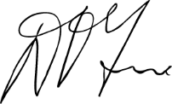
Mr David Tune AO PSM
Chair, Independent Health and Aged Care Pricing Authority

Letter of transmittal
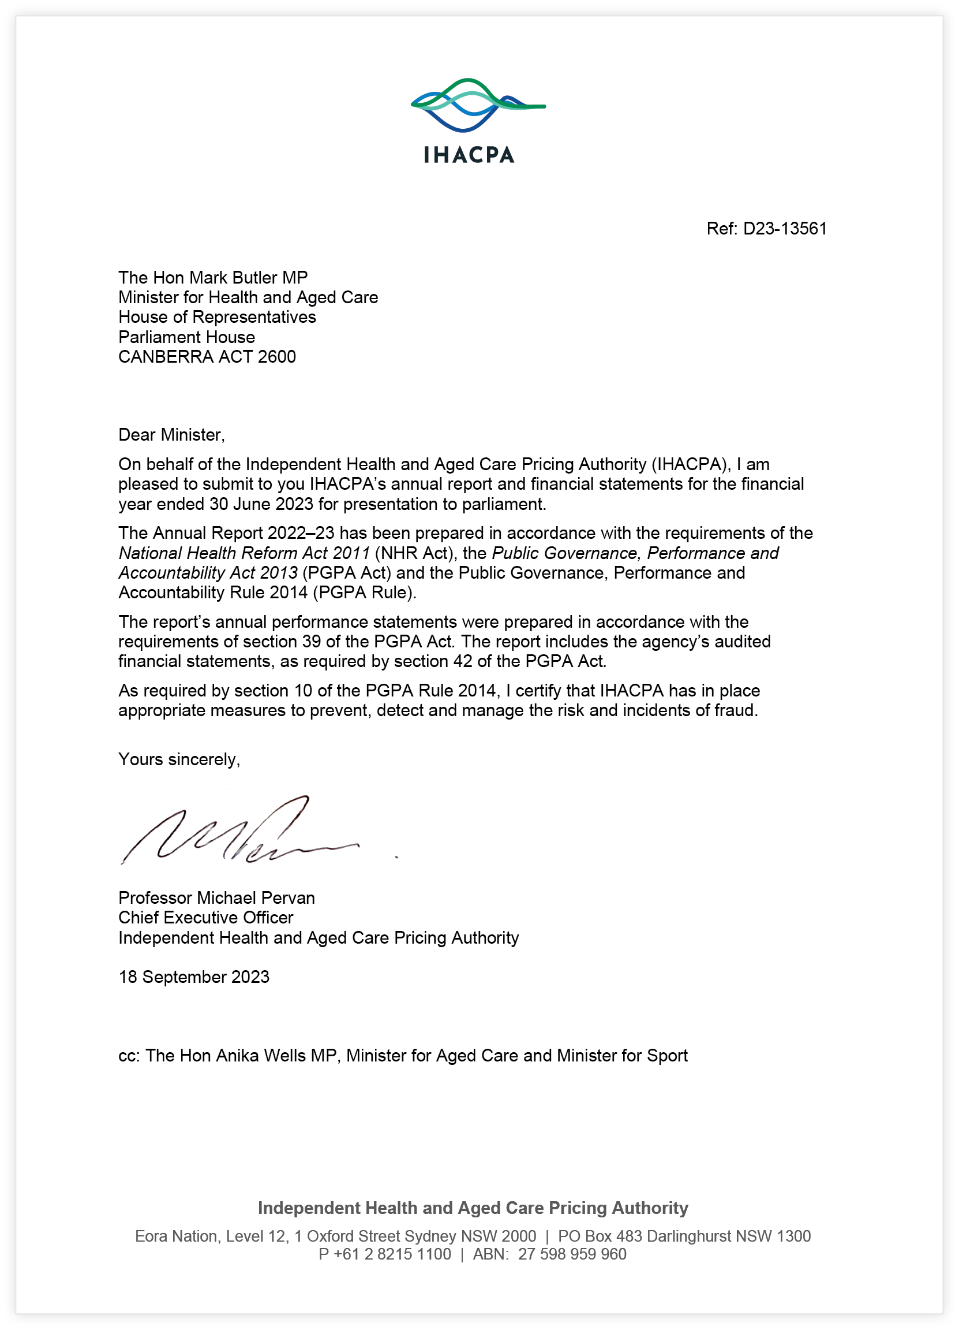

Contents
Pricing Authority Chair’s welcome ii
Letter of transmittal v
Approval by accountable authority viii
- About IHACPA 1
1.1 Legislation 2
1.3 What we do 6
1.4 Responsible Minister 13
1.5 Ministerial directions and government policy orders 13
1.6 Organisational structure 14
1.7 Committees and working groups 15
- Pricing Authority 21
2.1 About the Pricing Authority 22
2.2 Meetings of the Pricing Authority 2022—23 32
- IHACPA 2022–23 overview 35
3.1 CEO’s year in review 36
3.2 2022—23 highlights 38
- Clinical Advisory Committee 41
4.1 Letter from the Chair 42
4.2 About the Clinical Advisory Committee 44
- Aged Care 47
5.1 Aged Care Advisory Committee letter 48
5.2 IHACPA’s accommodation performance summary 12 August 2022 to 30 June 2023 49

- Annual performance statements 55
6.1 Introductory statement 56
6.2 Performance in 2022—23 — Portfolio Budget Statements 56
6.3 Strategic Objective One: Perform pricing functions 58
6.4 Strategic Objective Two: Refine and develop hospital activity classification systems 65
6.5 Strategic Objective Three: Refine and improve hospital and aged care costing 71
6.6 Strategic Objective Four: Determine data requirements and collect data 75
6.7 Strategic Objective Five: Resolve disputes on cost‑shifting and cross‑border issues 80
6.8 Strategic Objective Six: Conduct independent and transparent decision-making and engage with stakeholders 82
- Management and accountability 87
7.1 Key corporate governance practices 88
7.2 Management of human resources 92
- Financial management 101
8.1 Financial statements 102
- Appendices 131
Appendix A — Aged Care Pricing Commissioner’s Annual Report 132
Appendix B — Figures and tables 135
Appendix C — Acronyms and abbreviations 136
Appendix D — Glossary 137
Appendix E — Compliance index 141
Appendix F — Index 146

Approval by accountable authority
The Independent Health and Aged Care Pricing Authority is a corporate Commonwealth entity. This report has been prepared in accordance with the requirements of sections 17BA to 17BF of the Public Governance, Performance and Accountability Rule 2014. This report also contains information required under other applicable legislation, including the Work Health and Safety Act 2011.
As the accountable authority for the purposes of the Public Governance, Performance and Accountability Act 2013, I am responsible for preparing this annual report and providing a copy to the responsible Minister.


Professor Michael Pervan
Chief Executive Officer
Independent Health and Aged Care Pricing Authority
18 September 2023



Table 1: Details of accountable authority during the reporting period current report period (2022–23)
Professor Michael Pervan
 | Position title  Chief Executive Officer  Qualifications of the accountable authority  Bachelor of Arts (Honours) UWA 1987  Cert. Legal Studies ECU 1998  Churchill Fellow 1998  Experience of the accountable authority  Professor Michael Pervan was appointed as Chief Executive Officer of IHACPA on 1 February 2023. Prior to this, Michael was Secretary of the Department of Natural Resources and Environment Tasmania, the Department of Communities Tasmania and the Department of Health where for nearly a decade he was responsible for designing and implementing major health sector and organisational reforms.  Michael has represented Western Australia and Tasmania at the Australian Health Ministers Advisory Council and at Council of Australian Governments working groups on system reform, health workforce and mental health over a number of years. | Date of commencement  1 February 2023  Date of cessation  31 January 2028  Number of meetings of the Pricing Authority attended  5  Executive member / Non‑executive member  Executive

Ms Joanne Fitzgerald
 | Position title  Acting Chief Executive Officer  Qualifications of the accountable authority  Bachelor of Applied Science (Health Information Management)  Experience of the accountable authority  Ms Joanne Fitzgerald has worked at IHACPA since 2012 and was Acting Chief Executive Officer from 23 June 2022 to 31 January 2023. Joanne currently holds the position of Executive Director, Hospital Policy and Classification, and prior to this, she was Director, Australian Refined Diagnosis Related Group (AR-DRG)Development and was responsible for developing and managing the AR‑DRG classification system.  Joanne has more than 20 years’ experience as a health information manager working with health classifications in both the public and private health sectors. Joanne has worked as a clinical coder, manager of medical record departments and at the NSW Ministry of Health. | Date of commencement  23 June 2022  Date of cessation  31 January 2023  Number of meetings of the Pricing Authority as CEO  5  Executive member / Non‑executive member  Executive



01

About IHACPA

1.1 Legislation

The Independent Health and Aged Care Pricing Authority (IHACPA) is a corporate Commonwealth entity under the Public Governance, Performance and Accountability Act 2013.
On 12 August 2022, the Aged Care and Other Legislation Amendment (Royal Commission Response) Act 2022 and the Aged Care Legislation Amendment (Independent Health and Aged Care Pricing Authority) Instrument 2022 amended the National Health Reform Act 2011, Aged Care Act 1997 and Fees and Payment Principles 2014 (No. 2) and in so doing expanded IHACPA’s remit. The changes also transferred the functions of the former Office of the Aged Care Pricing Commissioner to IHACPA.
Under these amendments, the Independent Hospital Pricing Authority was renamed the Independent Health and Aged Care Pricing Authority. In addition to its original functions, IHACPA is now required to:
- provide annual advice to the Australian Government on pricing and costing of aged care matters annually
- provide annual advice to the Australian Government on health care pricing or costing matters upon request
- approve higher maximum accommodation payment amounts and extra service fees as set out under section 52G–4 and 35–1 of the Aged Care Act 1997.

National Health Reform Agreement
IHACPA was established under the National Health Reform Act 2011, giving effect to the National Health Reform Agreement signed by the Australian Government and all states and territories in August 2011.
The National Health Reform Agreement sets out the intention of all Australian governments to work together to improve health outcomes for every Australian.

2020–25 Addendum to the National Health Reform Agreement
On 29 May 2020, all Australian governments signed the Addendum to the National Health Reform Agreement 2020–25.
The Addendum to the National Health Reform Agreement:
- maintains a commitment to activity based funding
- reaffirms the independence and functions of the national agencies such as the Independent Health and Aged Care Pricing Authority, the National Health Funding Body and the Australian Commission on Safety and Quality in Health Care

- retains the 45 per cent Commonwealth funding contribution in growth and the 6.5 per cent national growth cap
- continues to integrate safety and quality reforms into the pricing and funding of public hospital services, including the current arrangements for sentinel events and hospital acquired complications.
Key changes to current arrangements introduced in the Addendum include:
- IHACPA is required to develop an updated methodology for pricing private patients in public hospitals that accounts for all hospital revenues. This is to ensure funding models are financially neutral for all patients, regardless of whether they elect to be private or public patients.
- IHACPA is required to develop a pricing model for avoidable hospital readmissions for implementation from 1 July 2021, following approval from the Council of Australian Governments (COAG) Health Council.
- IHACPA is required to shadow price for a period of two years, or a shorter period if agreed by the Commonwealth and the majority of states and territories, prior to the implementation of new classifications or costing rules to mitigate the need for retrospective adjustments to the national funding model.
- High-cost, highly specialised therapies will attract 50 per cent Commonwealth funding under the new nationally cohesive health technology assessment process. These will be considered outside of the 6.5 per cent national growth cap for a period of two years.
- IHACPA is required to develop a funding methodology that does not penalise states undertaking trials of innovative models of care for the COAG Health Council to approve by April 2021.

National Partnership on COVID–19 Response
On 13 March 2020, the Australian and all state and territory governments signed the National Partnership on COVID-19 Response, to provide financial assistance for the additional costs incurred by health services in responding to the coronavirus disease (COVID-19) pandemic.
On 20 March 2021, the Australian Government announced it would extend the National Partnership on COVID-19 Response with the states and territories until 30 September 2022, to support the health system’s capacity to respond to the ongoing COVID-19 challenges.

In June 2022, the Australian Government further extended the National Partnership on COVID-19 Response for another three months to 31 December 2022, in recognition of the pressures in the health and hospital system exacerbated by the COVID-19 pandemic.
The Australian Government concluded the National Partnership on COVID-19 Response on 31 December 2022.
IHACPA has worked closely with the Administrator of the National Health Funding Pool to provide assistance for the implementation of the National Partnership on the COVID-19 Response.

1.2 Who we are

The Independent Health and Aged Care Pricing Authority (IHACPA) is an independent government agency that assists the Australian Government to fund hospital and aged care services more efficiently by providing evidence‑based price determinations and pricing advice.
IHACPA delivers its annual program of work through consultation and collaboration with Australian, state and territory governments, advisory committees, key stakeholders and the public.
It is comprised of a board, the Pricing Authority, which provides advice to the government. The CEO of IHACPA is responsible for its management.
IHACPA’s organisational values shape its culture and stakeholder engagement.
Our core values are:
- We act with independence, transparency, fairness, respect, accuracy and accountability.
- We value collaboration and demonstrate our values in the way we interact internally, with our stakeholders and the broader community.
- We value the work, talent and contribution of our staff, and create organisation-wide development strategies to maintain and grow expertise and intellectual capital.
- Our staff act ethically, support a collaborative culture and take pride in their work.

1.3 What we do

Functions
The Independent Health and Aged Care Pricing Authority (IHACPA) was established in 2011 under the National Health Reform Act 2011 (the NHR Act) to promote improved efficiency in, and access to, public hospital services through the provision of independently determined pricing advice to all Australian governments.
In 2022, the Aged Care and Other Legislation Amendment (Royal Commission Response) Act 2022 amended the NHR Act, the Aged Care Act 1997 (the Aged Care Act) and the Quality and Safety Commission Act 2018.
Under the NHR Act, IHACPA’s main functions in relation to public hospitals and health care pricing and costing are:
- to determine the national efficient price for health care services provided by public hospitals where the services are funded on an activity basis;
- to determine the efficient cost for health care services provided by public hospitals where the services are block funded;
- to publish this, and other information, for the purpose of informing decision makers in relation to the funding of public hospitals;
- if requested by the Minister or the Secretary, to advise the Commonwealth in relation to certain health care pricing and costing matters.
Also under the NHR Act, IHACPA’s main functions in relation to aged care are:
- to provide advice about certain aged care pricing and costing matters to each relevant Commonwealth Minister;
- to perform such functions as are conferred on the Independent Health and Aged Care Pricing Authority by the Aged Care Act.
On 12 August 2022, the Aged Care and Other Legislation Amendment (Royal Commission Response) Act 2022 and the Aged Care Legislation Amendment (Independent Health and Aged Care Pricing Authority) Instrument 2022 came into effect amending the National Health Reform Act 2011, Aged Care Act 1997 and Fees and Payment Principles 2014 (No. 2). These legislative changes increased IHACPA’s remit and transferred across the functions of the former Office of the Aged Care Pricing Commissioner. IHACPA now has the authority to approve higher maximum accommodation payment amounts and extra service fees as set out under section 52G–4 and 35–1 of the Aged Care Act 1997.

Figure 1: Key agency functions
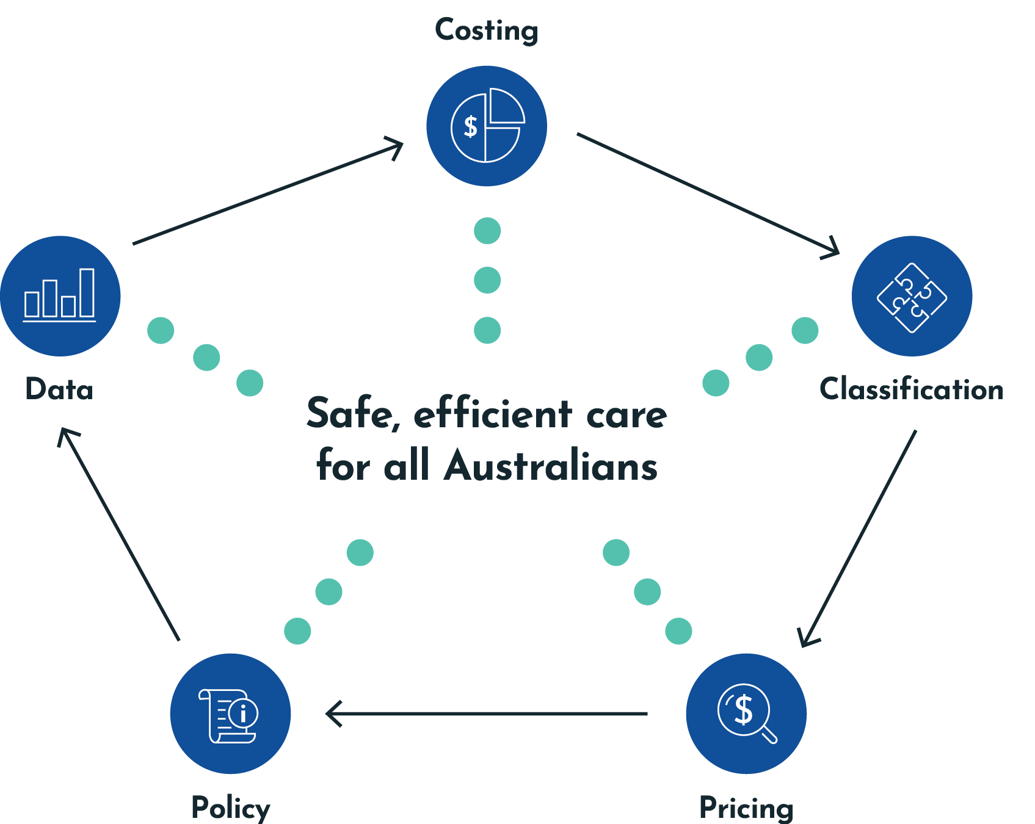

National efficient price (hospitals)
The national efficient price is based on the average cost of a hospital admission across Australia and is a determinant, along with the volume of services delivered, of the government’s funding contribution to public hospitals.
As required under the National Health Reform Agreement (clause A40), IHACPA back-casts the national efficient price whenever significant changes to the methodology or underlying data occur, to enable the fair calculation of the government’s growth funding.

National efficient cost (hospitals)
The national efficient cost represents the average cost of government funding contributions for services that are not suitable for activity based funding, such as small rural and regional hospitals.
The fixed-plus-variable structure enables changes in activity delivered in small rural hospitals to be reflected in funding and ensures there is no disincentive for states to provide services in rural areas.

Sustainable growth in hospital costs
The national weighted activity unit is a measure of health service activity expressed as a common unit, against which the national efficient price is determined. Figure 2 indicates a significant reduction in the growth rate of costs since 2011–12, to an average annual growth rate of 2.2 per cent.
Figure 2: Change in cost per national weighted activity unit
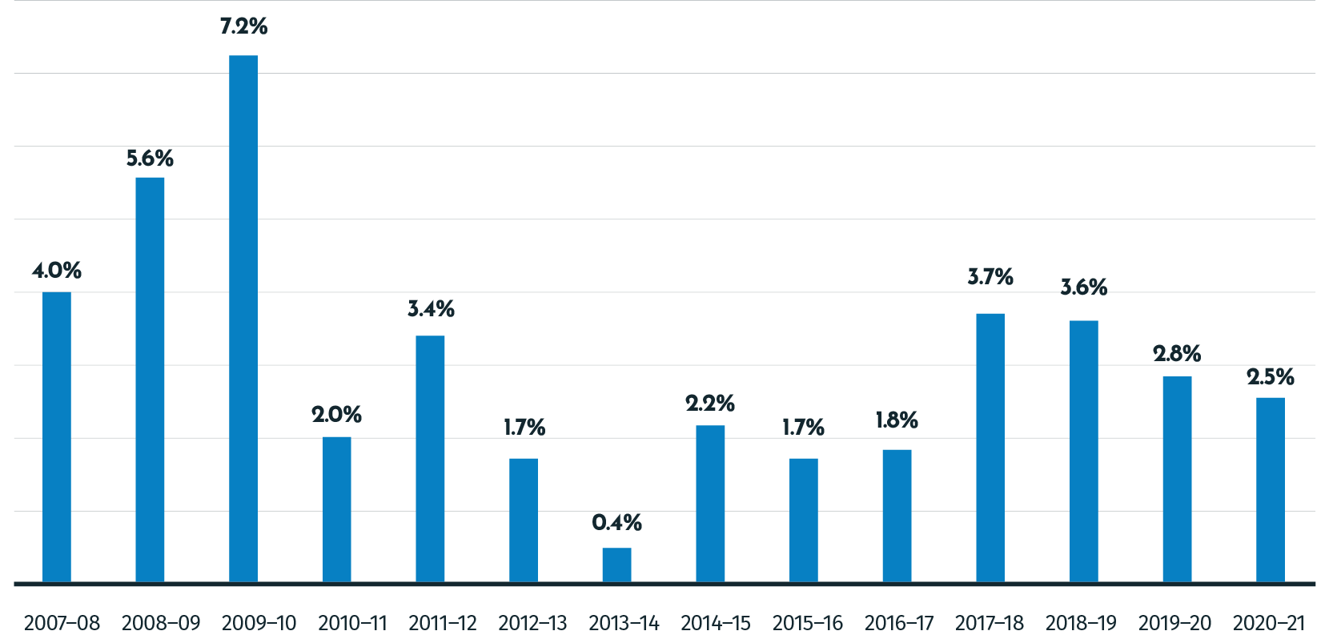

Safety and quality reforms in hospitals
The program of work for pricing and funding for safety and quality stems from the Council of Australian Governments Health Council Heads of Agreement on Public Hospital Funding in April 2016.
In 2017, all Australian governments signed an Addendum to the National Health Reform Agreement (NHRA). With the Addendum, parties committed to develop and implement reforms to improve health outcomes for all Australians through funding and pricing. These reforms were designed to improve patient outcomes in the public health system and decrease avoidable demand for public hospital services.
In addition, these pricing and funding approaches were intended to complement existing strategies to improve safety and quality in public health care.
IHACPA works together with the Australian Commission on Safety and Quality in Health Care to incorporate safety and quality measures into the determination of the national efficient price.
Under the 2017–20 Addendum to the NHRA, IHACPA advised on options for a comprehensive and risk-adjusted model to determine how funding and pricing can be used to improve patient outcomes across three key areas: sentinel events, hospital acquired complications and avoidable hospital readmissions.
Under the 2020–25 Addendum to the NHRA, IHACPA is required to continue reforms to integrate safety and quality into the pricing and funding approaches for public hospital services, to further improve the health outcomes of patients and decrease avoidable demand for public hospital services.

The implementation of pricing and funding for safety and quality has been rolled out in stages as follows:

Sentinel events
- Sentinel events are a subset of adverse patient safety events that are preventable and result in serious harm to, or death of, a patient.
- Since 1 July 2017, no government funding has been provided for any public hospital episode that includes a sentinel event. This approach applies to both activity based and block‑funded hospitals.

Hospital acquired complications
- A hospital acquired complication refers to a complication for which clinical risk mitigation strategies may reduce (but not necessarily eliminate) the risk of that complication occurring. IHACPA has worked with the Australian Commission on Safety and Quality in Health Care and other stakeholders to develop an agreed list of hospital acquired complications.
- From 1 July 2018, funding has been reduced for any episode of admitted acute care where hospital acquired complications such as falls, infections or pressure injuries occur during a hospital stay.

Avoidable hospital readmissions
- An avoidable hospital readmission occurs when a patient has been discharged from hospital (index admission), and has a subsequent unplanned admission that is related to the index admission and was potentially preventable.
- From 1 July 2021, a risk‑adjusted reduction has been applied to the funding for the index admission, based on the total price of the associated readmission.

Evaluation of safety and quality reforms
- The 2020–25 Addendum to the NHRA stipulates that IHACPA will work with the Administrator of the National Health Funding Pool and the Australian Commission on Safety and Quality in Health Care (the national bodies) to develop an evaluation framework to evaluate the implemented reforms for sentinel events, hospital acquired complications and avoidable hospital readmissions.
- IHACPA led the development of a proposed approach to evaluate the implemented safety and quality reforms, which was provided to the Health Ministers’ Meeting for consideration in October 2021, as part of the joint advice from the national bodies.

Avoidable and preventable hospitalisations
- Under the 2020–25 Addendum to the NHRA, IHACPA is required to provide joint advice with the national bodies on options for the further development of safety and quality‑related reforms, including examining ways that avoidable and preventable hospitalisations can be reduced.
- IHACPA contributed to the development of advice on options for further safety and quality-related reforms, and will consider feedback and directives from the Health Ministers’ Meeting prior to progressing this program of work.

Supporting aged care reform

Residential aged care pricing and costing advice
IHACPA provides the government with residential aged care pricing advice, with the first delivered in April 2023.
IHACPA will undertake regular costing studies and use other available datasets and information to refine the pricing framework and methodology over time. IHACPA will conduct its first Residential Aged Care Costing Study in 2023. The results of the study will inform recommendations for updated national weighted activity units (NWAU) values, including a review of the Base Care Tariff, for the Australian National Aged Care Classification (AN-ACC), for use from 1 July 2024.
As system reforms and the AN-ACC funding model become embedded across the aged care sector, costing data is acquired and technical models are refined, greater focus will be given to efficiency in developing a national residential aged care price.

Support at Home
IHACPA will conduct consultation, policy development and costing and pricing studies to provide advice to inform government decisions on the Support at Home Program pricing from 1 July 2025.

Refundable accommodation deposit approvals
Residential aged care providers seeking to charge a resident more than $550,000 as a refundable accommodation deposit (RAD) or equivalent daily amount must apply to IHACPA for approval. An approval is valid for four years.
A RAD is the lump-sum payment for a room (or part of a room) in an aged care home. The price is for residents who are not eligible for Australian Government assistance.

Extra service fee approvals
Residential aged care providers with extra service status who are seeking to charge a resident an increase to the extra service fee must apply to IHACPA for approval. Extra service status is granted by the Australian Government to charge a fee for significantly higher standards of food, entertainment options, enhanced personal services, specific products and/or organised outings. An increase to the extra service fee once approved does not expire.

1.4 Responsible Minister

The Independent Health and Aged Care Pricing Authority sits within the Department of Health and Aged Care portfolio.
The Ministers responsible for this reporting period were the Hon Mark Butler MP, Minister for Health and Aged Care and the Hon Anika Wells MP, Minister for Aged Care and Minister for Sport.

1.5 Ministerial directions and government policy orders
IHACPA did not receive any Ministerial directions in 2022–23.
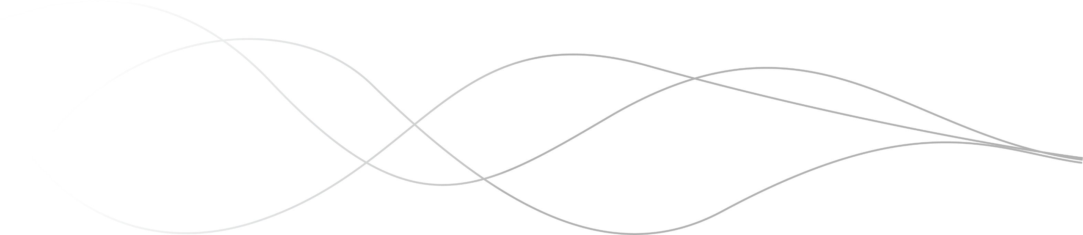

1.6 Organisational structure
Figure 3: IHACPA’s organisational structure as at 30 June 2023
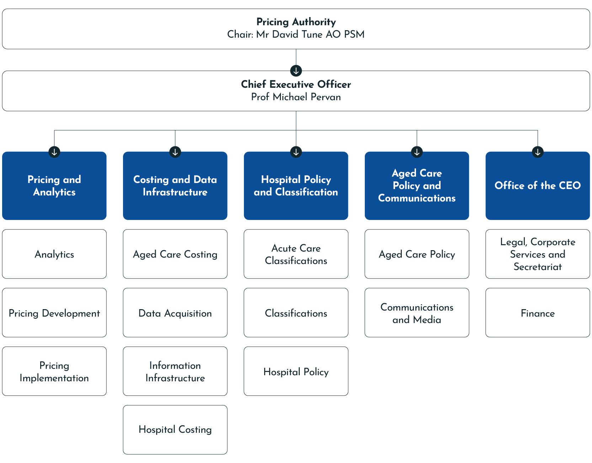

The Independent Health and Aged Care Pricing Authority (IHACPA) is a corporate Commonwealth entity consisting of a Chair, Deputy Chair (Hospital Pricing), Deputy Chair (Aged Care Pricing), and up to six other members. See page 22 for more information.
The Chief Executive Officer is responsible for the management of IHACPA and its staff. Under section 163(4) of the National Health Reform Act 2011, the Chief Executive Officer is the accountable authority of
IHACPA for the purposes of the Public Governance, Performance and Accountability Act 2013 and therefore for the purposes of this annual report.
To achieve its annual program of work, IHACPA consults and collaborates with the Australian, state and territory governments, advisory committees, key stakeholders and the public.
IHACPA’s only facility is its office in Sydney, where all its major activities are conducted.

1.7 Committees and working groups

The Independent Health and Aged Care Pricing Authority (IHACPA) has developed a comprehensive committee framework to assist in providing IHACPA with expert advice and to ensure transparency in the delivery of its work program.
IHACPA’s statutory committees comprise the Clinical Advisory Committee, the Aged Care Advisory Committee and the Jurisdictional Advisory Committee, established under Parts 4.10, 4.11A and 4.11 of the National Health Reform Act 2011 (the NHR Act) respectively.
Other advisory committees and working groups have been established to assist IHACPA in the delivery of its work program, pursuant to Part 4.12 of the NHR Act. These include:
- Activity Based Funding Technical Advisory Committee
- Audit, Risk and Compliance Committee (internal)
- Classifications Clinical Advisory Group
- Data Governance Steering Committee (internal)
- Diagnosis Related Groups Technical Group
- Emergency Care Advisory Working Group
- Interim Aged Care Working Group
- International Classification of Diseases Technical Group
- Mental Health Working Group
- National Hospital Cost Data Collection Advisory Committee
- Non-Admitted Care Advisory Working Group
- Private Sector National Hospital Cost Data Collection Working Group
- Small Rural Hospitals Working Group
- Stakeholder Advisory Committee
- Subacute Care Working Group
- Teaching, Training and Research Working Group
- Work Health and Safety Committee (internal).
Committees and working groups are structured in a way that enhances IHACPA’s statutory functions. Some committees and working groups may also have sub-committees to assist in the delivery of IHACPA’s work program. All committees and working groups have Terms of Reference setting out their role, function, membership and reporting relationship.

Figure 4: IHACPA’s management, committees and working groups
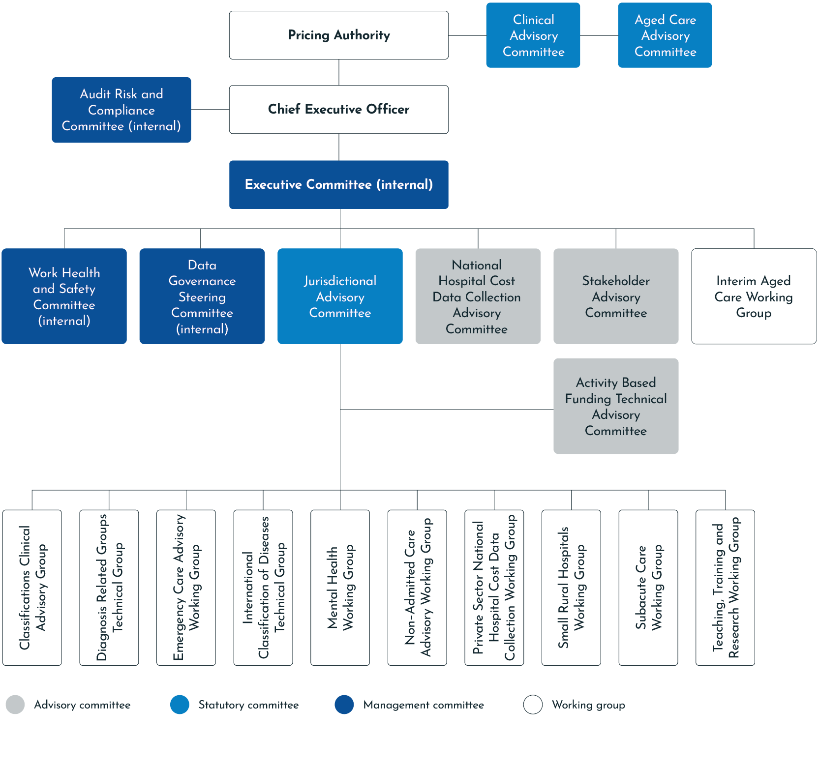

Jurisdictional Advisory Committee
The Jurisdictional Advisory Committee was established under section 195 of the NHR Act. It consists of a Chair, appointed by the Pricing Authority and nine other members (one to represent each state and territory, and one representing the Australian Government).
Committee members are appointed by the head of the health department of the jurisdiction they represent.
The Jurisdictional Advisory Committee met on 8 occasions between 1 July 2022 and 30 June 2023.
Jurisdictional Advisory Committee members as of 30 June 2023:
- Prof Michael Pervan (Chair)
- Mr Rob Anderson (Western Australia)
- Ms Fifine Cahill (Australian Government)
- Mr Michael Culhane (Australian Capital Territory)
- Ms Toni Cunningham (Queensland)
- Ms Denise Ferrier (Victoria)
- Dr Sonĵ Hall (Tasmania)
- Ms Julienne TePohe (South Australia)
- Mr Stathi Tsangaris (Northern Territory)
- Ms Deborah Willcox (New South Wales).
During the reporting period, there were changes to the Chair, Australian Government, New South Wales, South Australia and Tasmania memberships.

Audit, Risk and Compliance Committee
The IHACPA Audit, Risk and Compliance Committee provides independent advice to the Chief Executive Officer on managing IHACPA’s financial and business risk.
The Audit, Risk and Compliance Committee Charter is available at:
ihacpa.gov.au/audit-risk-and-compliance-committee.
During the reporting period, members of the Audit, Risk and Compliance Committee comprised:
- Ms Angela Diamond, Chair and independent member
- Mr Glenn Appleyard, member, Pricing Authority
- Mr John Lenarduzzi, independent member
- Ms Joanna Stone, independent member.

Table 2: Details of Audit, Risk and Compliance Committee during the reporting period (2022–23)
The IHACPA Audit, Risk and Compliance Committee met on four occasions between 1 July 2022 and 30 June 2023. During this period, Ms Joanne Fitzgerald attended two of those meetings whilst acting as IHACPA’s CEO and Prof Michael Pervan attended the latter two meetings, once appointed as IHACPA CEO.
Member name | Qualifications, knowledge, skills and experience | Number of meetings attended/ total number of meetings eligible | Total annual remuneration | Additional information
Ms Angela Diamond | Ms Angela Diamond has held several senior finance positions within the public service and is currently the Chief Financial Officer at Services Australia.  Angela has a Bachelor of Commerce from the Australian National University and is a Certified Practising Accountant. | 3/4 | Nil – employed by a Cth entity | Chair and independent member
Mr Glenn Appleyard | Mr Glenn Appleyard was a member of the Australian Accounting Standards Board from 1 January 2003 to 31 December 2011.  Glenn has held several senior positions within the public service including Deputy Secretary in the Tasmanian and Victorian Departments of Treasury and Finance, and Regional Director for the Australian Bureau of Statistics in Tasmania.  He was a member of the Commonwealth Grants Commission for 11 years and was Chair of the Tasmanian Economic Regulator.  Glenn has been a member of the Independent Health and Aged Care Pricing Authority since his appointment in 2012.  Glenn has a Bachelor of Economics from the University of Tasmania. | 3/4 | $6,924 | Pricing Authority member
Mr John Lenarduzzi | Mr John Lenarduzzi has over 20 years’ experience working in technology and security environments and spent seven years as a senior executive in Australia’s National Intelligence Community. John is currently the Director of Managed Security Operations (Global and Commercial) at CyberCX.  John has a Bachelor of Electrical and Electronic Engineering (Flinders University) and a Masters of Business Administration (Deakin). He completed the Senior Executives in National Security Program at Harvard Kennedy School in 2017 and sits as an independent member on two audit and risk committee boards. | 4/4 | $8,840 | Independent member
Ms Joanna Stone | Ms Joanna Stone has substantial public and private sector management experience and extensive experience across several audit committees as a member and previously as a Chair. Joanna holds formal qualifications in finance. | 4/4 | Nil – employed by a Cth entity | Independent member

02

Pricing Authority

2.1 About the Pricing Authority

IHACPA’s board — the Pricing Authority — provides independent and transparent advice to the Australian Government in relation to funding for public hospitals and residential aged care services.
Pricing Authority members are appointed for a period of up to five years and can be reappointed. The Chair and the Deputy Chair (Aged Care Pricing) are appointed by the Commonwealth Minister for Health and Aged Care. The Deputy Chair (Hospital Pricing) is appointed with the agreement of First Ministers of all states and territories. The remaining Pricing Authority members are appointed with the agreement of the Prime Minister and First Ministers of the states and territories.
Members of the Pricing Authority bring significant and varied expertise to their roles, including substantial experience and knowledge of the health industry, healthcare needs, the aged care industry, and the provision of health care in regional and rural areas.
The Pricing Authority is supported by a Chief Executive Officer, who is responsible for the running of IHACPA. All Pricing Authority members are non‑executive.




Mr David Tune AO PSM, Chair
Mr David Tune AO PSM was appointed Chair of the Pricing Authority with effect from 1 February 2022.
He was formerly Chair of the Aged Care Sector Committee that provided advice to the Commonwealth Government on aged care from early 2015 to July 2021.
He has undertaken many reviews for the Commonwealth and state governments, including the Legislative Review of Aged Care in 2016.
Mr Tune was Secretary of the Commonwealth Department of Finance from 2009 until 2014.




Mr Jennifer Williams AM, Deputy Chair, Hospital Pricing
Ms Jennifer Williams AM is a non‑executive director and holds a number of board positions, including Chair of Northern Health and Chair of Yooralla.
Her other board appointments are with Barwon Health and the Victorian Health Building Authority Advisory Board.
Ms Williams has previously held the positions of Chief Executive of the Australian Red Cross Blood Service, Chief Executive of Alfred Health and Chief Executive of Austin Health.
She has considerable experience in the health sector over several decades, working across the hospital, aged care and community sectors.



Dr Stephen Judd AM, Deputy Chair, Aged Care Pricing
Dr Stephen Judd was Chief Executive of health and aged care services provider, HammondCare, from 1995–2020. When he stepped down, HammondCare had grown to provide care and services to more than 25,000 clients.
Dr Judd has written and contributed to books on dementia care, aged care design and the role of charities in contemporary Australian society. He has served on numerous government and industry committees and, until 2020, was a member of the Advisory Council of the Australian Aged Care Quality Agency.
He has served as a Senior Visiting Fellow at the School of Population Health, UNSW Medicine, University of New South Wales and as the inaugural Fellow, Council on the Ageing, a peak consumer advocacy group, until the end of 2022.



Mr Glen Appleyard
Mr Glenn Appleyard was a member of the Australian Accounting Standards Board from 1 January 2003 to 31 December 2011.
Mr Appleyard has held several senior positions within the public service, including Deputy Secretary in the Tasmanian and Victorian Departments of Treasury and Finance, and Regional Director for the Australian Bureau of Statistics in Tasmania.
He was a member of the Commonwealth Grants Commission for 11 years and was the Chair of the Tasmanian Economic Regulator.



Ms Prudence Ford
Ms Prudence Ford is a member of the Health Consumers’ Council of Western Australia. She was an inaugural member of the Medical Board of Australia, and was previously a member of the National Blood Authority, the National Health and Medical Research Council, the Brightwater Care Group Board (a provider of aged and disability care services) and the Western Australian Medical Board.
Ms Ford has had 30 years’ experience in the public service at Commonwealth and state levels. She has held senior executive positions in the (then) Commonwealth departments of Community Services and Health, Finance, and the Attorney General, and in the Western Australian Departments of Health and Premier and Cabinet.




Dr Adam Coltzau
Dr Adam Coltzau is the Director of Medical Services at St George Hospital in rural Queensland.
Dr Coltzau is a rural generalist with advanced skills in obstetrics and anaesthetics. He is a Fellow of both the Royal Australian College of General Practitioners and Australian College of Rural and Remote Medicine, with extensive experience in hospital management and aged care.
He is a senior clinical lecturer at the University of Queensland Rural Clinical School and General Practitioner Training Supervisor.
Dr Coltzau was the 2017 Queensland General Practitioner of the Year. He is a former president and has served on the boards of the Rural Doctors Association of Queensland and the Rural Doctors Association of Australia.
Additionally, he has served as the inaugural Chair of the Board of the Rural Doctors Foundation, a charity he helped set up to improve health services in rural Australia.




Distinguished Professor Jane Hall AO
Professor Jane Hall AO is a Distinguished Professor of Health Economics at the University of Technology Sydney. She received the National Health and Medical Research Council Outstanding Contribution Award in 2017. She was named as one of Australian Financial Review/Westpac 100 Women of Influence in 2016.
She has been a board member of the NSW Bureau of Health Information, the Australian Cancer Society and the NSW Cancer Council.
Professor Hall is a Fellow of the Academy of Social Sciences in Australia (and its immediate Past President) and of the Australian Academy of Health and Medical Sciences.
She has worked across many areas of health economics; her current research is focussed on funding and financing issues and payment reform.



Ms Jenny Richter AM
Ms Jenny Richter AM is a non-executive director, and holds board positions with the South Australian Health and Medical Research Institute, Cancer Council SA (Deputy Chair) to March 2023, Cancer Council Australia (Deputy Chair) and the Southern Adelaide Local Health Network (Deputy Chair), where she also chairs the Finance and Performance Board Sub‑Committee.
Ms Richter has previously held a number of executive roles, including Deputy Chief Executive for SA Department of Health and Wellbeing, and Chief Executive Officer of Central Adelaide Local Health Network. She is also a past board member of ECH, a South Australian aged care support at home provider.



Dr Kate Taylor
Dr Kate Taylor is the Vice President of Eye Care Solutions for Revenio Group Oyj, the global leader in ophthalmic equipment and solutions that acquired Oculo, where she was the Founder and Chief Executive Officer. Oculo is a cloud‑based clinical platform connecting eye care professionals and their patients. Before Oculo, Dr Taylor built the Global Health Initiative at the World Economic Forum and worked with McKinsey & Co. Her initial training was in medicine and public health.
Dr Taylor also serves as a member of the Australian Digital Health Agency’s Clinical and Technical Advisory Committee. Previously, she was involved with the Board of the Mental Health Cooperative Research Centre in Australia, which researches early detection and treatment for dementia, and internationally with the boards of Roll Back Malaria, Stop TB, and the GAVI Alliance.

2.2 Meetings of the Pricing Authority 2022—23
Table 3: Meetings of the Pricing Authority 2022–23
The Pricing Authority met on 11 occasions between 1 July 2022 and 30 June 2023. The Chief Executive Officer, Prof Michael Pervan, as the accountable authority, attended 5 meetings.
Member | Meetings eligible | Meetings attended
Mr David Tune AO PSM, Chair | 11 | 10
Dr Stephen Judd AM, Deputy Chair, Aged Care Pricing | 3 | 3
Mr Glenn Appleyard | 11 | 8
Ms Prudence Ford | 11 | 10
Dr Adam Coltzau | 11 | 10
Distinguished Professor Jane Hall AO | 11 | 10
Ms Jenny Richter AM | 11 | 11
Dr Kate Taylor | 8 | 7
Dr Stephen Judd AM, Deputy Chair, Aged Care Pricing | 3 | 3



03

IHACPA 2022–23 overview

3.1 CEO’s year in review

It has been a significant year for the Independent Health and Aged Care Pricing Authority (IHACPA).
After a decade of determining prices for Australian public hospital services, our functions were expanded to include aged care services. To deliver on this part of the government’s aged care reform agenda, our team doubled in size and the National Health Reform Act 2011 was amended to see us renamed to IHACPA.
In a fast-moving environment, we delivered a significant work program, and contributed to the reform of aged care funding models.
As with any organisation, our success was made possible by our people — their skills, dedication, agility and values supporting products of international standing. A hallmark of our agency is the seamless collaboration across every function, to support our work program and tasks assigned to us by the Australian Government.
Since joining IHACPA in February 2023, I have been proud to witness those same values demonstrated in the increased engagement with the states and territories, as well as the aged care sector, in working together to better understand the cost and activity data generated by the delivery of health and aged care in Australia.

Innovation and change
Australia’s health and aged care landscape has changed significantly since the agency was established in 2011, presenting new challenges for costing and pricing.
Amid these changes, IHACPA has continued to deliver, innovate and adapt.
In 2022–23, we launched the National Benchmarking Portal. This website-based application was designed to provide access to insights on public hospital cost and activity data collected by IHACPA. Its focus areas include cost per national weighted activity unit (NWAU), safety and quality measures of hospital‑acquired complications, and avoidable hospital readmissions. With open access to data alongside appropriate privacy protections, this valuable resource will enhance policy decisions and improve patient outcomes.
To support the new functions of providing costing and pricing advice on aged care services to the government, as well as those of the Aged Care Pricing Commissioner, our work program expanded to include a residential aged care costing pilot study followed by an extensive public consultation. This resulted in the Pricing Authority providing Residential Aged Care Pricing Advice to the government for the first time and releasing the Pricing Framework for Australian Residential Aged Care Services 2023–24. A new Deputy Chair for Aged Care Pricing was also appointed to the Pricing Authority in December 2022.

In addition, the Tier 2 Non‑Admitted Services Classification Version 8.0 was released in March 2023, for implementation in the National Efficient Price Determination 2023–24.
To support jurisdictions, clinicians and consumers to understand the use and application of the Australian Mental Health Care Classification and the Mental Health Phase of Care, a suite of informational and educational online resources was also released.
As part of our continuing support of the government’s Prostheses List reforms, IHACPA delivered Advice on Alternative Bundling Arrangements for General Use Items on the Prostheses List. This evidence-based advice included information on the composition of bundles and their benefits. The advice was developed by incorporating feedback received from public consultation and supported by the Prostheses List Reform Working Group.
Over the next 12 months, IHACPA will focus on the strategic objectives set out in our Work Program and Corporate Plan 2023–24.

Thank you
What we do would not be possible without the guidance of the Pricing Authority and the expertise of our working groups and committees, as well as our strong relationships with state and territory governments, agencies and stakeholders.
We are particularly grateful to the members of our advisory groups for their contributions, which enable us to improve the products we provide governments and the health and aged care systems.
To Joanne Fitzgerald, I offer my personal thanks and gratitude for stepping in as Acting Chief Executive Officer in June 2022 to lead the agency until my commencement. Joanne expertly oversaw the agency’s transition from the Independent Hospital Pricing Authority to IHACPA and the expansion into aged care.
Finally, I extend my thanks to all IHACPA staff for their support, commitment and dedication to the agency’s vision, particularly as it continues to grow and change.
I am honoured to be part of an organisation that is instrumental in national reforms of the health and aged care systems, making them fairer and more accessible for all Australians.

Professor Michael Pervan
Chief Executive Officer
Independent Health and Aged Care Pricing Authority

3.2 2022—23 highlights
Some of the key achievements from IHACPA’s Work Program for 2022–23 include:

2022
July | - National Benchmarking Portal launched.  - NHCDC 2019–20 Private Sector Cost Report published.  - ICD-10-AM/ACHI/ACS Twelfth Edition implemented in all Australian hospitals.  - AR-DRG Version 11.0 Definitions Manuals released, and education materials distributed.
August | - Legislation establishing the expanded IHACPA passed, and the agency’s name changed from IHPA.  - Transition of the function of the Aged Care Pricing Commissioner.  - Towards an Aged Care Pricing Framework Consultation Paper released.  - Consultation Paper on Bundling Arrangements for General Use Items on the Prostheses List released.
October | - Federal Budget incorporating IHACPA’s role in Support at Home aged care measures delivered.  - The National Benchmarking Portal wins the Celebrating Smart Uses of Public Data award at the 2022 Qlik ANZ Health & Public Sector Digital Transformation Awards.
December | - Advice on Alternative Bundling Arrangements for General Use Items being removed from the Prostheses List delivered to the Department of Health and Aged Care.  - Pricing Framework for Australian Public Hospital Services 2023–24 published.  - Australian Mental Health Care Classification education materials released.


2023
February | - IHACPA Chief Executive Officer, Prof Michael Pervan, appointed.
March | - National Efficient Price and National Efficient Cost Determination 2023–24 released.  - Version 8.0 of the Tier 2 Non-Admitted Services Classification released.
April | - Residential Aged Care Pricing Advice 2023–24 delivered to Australian Government.
May | - Residential Aged Care Pricing Advice 2023–24 published.  - Supplementary Advice on Bundling Arrangements for General Use Items on the Prostheses List provided to the Department of Health and Aged Care.  - General Use Items Bundling Tool Version 2.0 released.  - Tranche 2 of the National Benchmarking Portal launched with new safety and quality dashboards and additional data released.  - The first Residential Aged Care Pricing Advice and the Residential Aged Care Pricing Framework 2023–24 released.
June | - Consultation Paper on the Pricing Framework for Australian Public Hospital Services 2024–25 released.

04

Clinical Advisory Committee

4.1 Letter from the Chair

It is a privilege to report on a year of significant progress shaping hospital pricing programs to reflect contemporary clinical practices and improve health outcomes for all Australians.
During 2022–23, the sector has continued to experience challenges that have placed pressure on health professionals of all disciplines and at all levels.
While the Independent Health and Aged Care Pricing Authority’s (IHACPA’s) operational environment has evolved over the past year to include a growing work program, the commitment of the Clinical Advisory Committee to the provision of support to the Pricing Authority, and in turn the healthcare sector, has remained constant.
I am proud to work alongside a group of multidisciplinary members whose dedication, expert knowledge and collaborative efforts have enabled us to tackle complex issues.
I would like to acknowledge our many stakeholders, who, despite being faced with resourcing impacts due to the coronavirus disease 2019 (COVID-19) response and other pressures, have continued to engage with IHACPA and provide their valuable feedback.
The committee has worked closely with jurisdictions to ensure the pricing model reflects changes to healthcare delivery, and accounting for the impact of the pandemic has remained one of the committee’s highest priorities. This includes considering increased costs, alternative models and costs of care, differences in experiences across states and territories, ongoing workforce impacts and variations in reporting.
The committee will continue to focus on monitoring data pre, during and post‑COVID-19, with the aim of establishing a resilient network of public hospitals.
I would like to take this opportunity to thank my fellow committee members for their unwavering commitment to driving meaningful change in the sector.
This year, we welcomed Prof Jenny Deague, Prof Ruth Hubbard, Dr Richard Phoon, Ms Erin Garner and A/Prof Susan Moloney as new appointees to the committee.
We also farewelled Dr Elaine Pretorius and A/Prof Melinda Truesdale in 2022–23. I would like to recognise and thank them for their greatly valued expertise and contributions.

On behalf of the Clinical Advisory Committee, I acknowledge and commend the Pricing Authority and IHACPA staff for achieving such an extensive program of work in 2022–23.
I look forward to continuing to lead the work of the Clinical Advisory Committee in the coming year and welcome the opportunity to support the agency to drive its strategic agenda.

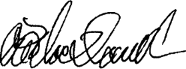
Associate Professor Alasdair MacDonald
Chair, Clinical Advisory Committee



4.2 About the Clinical Advisory Committee

The Clinical Advisory Committee is a statutory committee established under section 176 of the National Health Reform Act 2011. The functions of the committee are prescribed under section 177 as:
- to advise the Pricing Authority in relation to developing and specifying classification systems for health care and other services provided by public hospitals
- to advise the Pricing Authority in relation to matters that:
  - relate to the functions of the Pricing Authority
  - are referred to the Clinical Advisory Committee by the Pricing Authority
- to do anything incidental to, or conducive to, the performance of the above functions.
Clinical Advisory Committee members provide high-level technical and clinical advice to the Pricing Authority on a range of issues, such as activity based funding, classification development and policy development, to inform the annual determination of the national efficient price and national efficient cost.
As at 30 June 2023, the Clinical Advisory Committee consisted of 20 members.
The Clinical Advisory Committee is required to report on its work annually. The details of the committee’s membership and meetings are shown in table 4.

Membership
Clinical Advisory Committee members are appointed by the Commonwealth Minister for Health and Aged Care. Members are drawn from a range of clinical specialties and backgrounds, to ensure the committee represents a wide range of clinical expertise.
The Chair of the committee, Associate Professor Alasdair MacDonald, reports to the Commonwealth Minister for Health and Aged Care and is supported by the IHACPA secretariat.

Table 4: Membership and meetings of the Clinical Advisory Committee in 2022–23
Name | Position | Specialty | Meetings eligible | Meetings attended
A/Prof Alasdair MacDonald | Chair | Internal medicine | 3 | 3
Prof Gerard Carroll | Member | Cardiology/rural | 3 | 1
Ms Nicole Harwood | Member | Nursing | 3 | 0
Mr Christopher O’Donnell | Member | Nursing | 3 | 0
A/Prof Nicole Phillips | Member | Administration/anaesthesia and pain management | 3 | 3
A/Prof Virginia Plummer | Member | Nursing | 3 | 1
Ms Amber Polles | Member | Pharmacy | 3 | 3
Dr Elaine Pretorius | Member | Administration | 2 | 0
Ms Elizabeth Prowse | Member | Mental health | 3 | 1
Dr Tracy Smith | Member | Respiratory and palliative care | 3 | 3
Ms Monica Taylor | Member | Mental health | 3 | 3
A/Prof Melinda Truesdale | Member | Emergency medicine | 3 | 2
A/Prof Andrew Wei | Member | Haematology | 3 | 1
Dr Jo Wright | Member | Rural medical practice | 3 | 2
Dr Kathryn Zeitz | Member | Nursing | 3 | 1
Clinical Prof Jenny Deague | Member | Cardiology | 2 | 2
A/Prof Susan Moloney | Member | Paediatrics | 2 | 1
Dr Richard Phoon | Member | Nephrology | 2 | 1
Ms Erin Garner | Member | Allied health | 2 | 1
Prof Ruth Hubbard | Member | Geriatrics | 2 | 2

Clinical Advisory Committee meetings 2022–23
17 August 2022
20 October 2022
24 May 2023

05

Aged Care

5.1 Aged Care Advisory Committee letter

As Deputy Chair, Aged Care of the Pricing Authority and Chair of the Aged Care Advisory Committee, it is a privilege to write this inaugural letter introducing the new Aged Care Advisory Committee.
Established under section 204A of the National Health Reform Act 2011, the Aged Care Advisory Committee will play a vital role in advising the Pricing Authority on functions related to aged care pricing advice and other referred functions. The committee was appointed in late June 2023 and did not convene prior to the end of the financial year.
I am joined by members appointed by the Minister for Health and Aged Care:
- Ms Rowan Cockerell
- Ms Prudence Ford
- Dr Martin Laverty
- Mr Nicolas Mersiades
- Professor Julie Ratcliffe
- Professor Michael Woods.
Our committee members bring extensive skills and expertise during this time of reform for the aged care sector in Australia.
The Aged Care Advisory Committee will be supported by IHACPA and commence meetings in the new financial year.
I look forward to the year ahead and the important contribution the committee will make to the Pricing Authority’s aged care advice.


Dr Stephen Judd AM FAICD
Deputy Chair Aged Care Pricing

5.2 IHACPA’s accommodation performance summary 12 August 2022 to 30 June 2023
On 12 August 2022, the functions of the Aged Care Pricing Commissioner transferred to the expanded Independent Health and Aged Care Pricing Authority (IHACPA). IHACPA has continued to assess valid applications from approved providers seeking:
- approval to charge a refundable accommodation deposit (RAD) higher than the maximum as determined by the Minister of Health and Aged Care; and
- approval to charge an increase to the extra service fee.
Table 5: Refundable accommodation deposit data (1 July 2022 to 30 June 2023)
Time period* | Received | Approved | Withdrawn | Reframed | Refused
01 July 2022– 30 June 2023 | 697 | 656 | 101 | 133 | 0
* During this period, the function was also completed by the Aged Care Pricing Commissioner.
Table 6: Refundable accommodation deposit data (12 August 2022 to 30 June 2023)
Time period* | Received | Approved | Withdrawn | Reframed | Refused
12 August 2022– 30 June 2023 | 538 | 471 | 98 | 58 | 0
The above table outlines the number of accommodation groups assessed within the applications submitted by approved providers. At the transfer of the function from the Aged Care Pricing Commissioner to IHACPA there were 33 applications awaiting assessment, IHACPA received 175 applications and approved 189. Note that each application may consist of a number of accommodation groups. The 175 applications received by IHACPA contained 538 accommodation groups. An accommodation group is a group of rooms with similar offerings at the same priced point. A single submission by a provider will generally have between one and 10 accommodation groups. An accommodation group may have from one to all of the rooms in a service included within it.

The 2022–23 financial year saw the largest number of applications received and approved by the Aged Care Pricing Commissioner and IHACPA collectively. In addition to the decisions approved in this period, 101 applications were withdrawn. Applications may be withdrawn when insufficient information was received from the approved provider or for reasons specific to the approved provider. Those applications withdrawn may be resubmitted with amendments by the provider at any time.
IHACPA completed all decisions within the legislated 60-day period as outlined within the Fees and Payments Principles 2014 (No. 2) noting that this timeframe does not include any period during which IHACPA formally requested further information to assess the application.
Table 7: Approved applications by providers, services and rooms
 | As at 30 June 2022* | As at 30 June 2023**
Residential aged care provider | 102 | 107
Residential aged care services | 166 | 207
Residential aged care rooms | 10,469 | 13,377
* During this period, the function was completed by the Aged Care Pricing Commissioner.
** Between 1 July 2022 and 11 August 2022, the function was completed by the Aged Care Pricing Commissioner.
Table 7 outlines the approvals for the financial year 2022–23, which includes the six weeks whereby the function was still undertaken by the Aged Care Pricing Commissioner.
The figures demonstrate a continued increase in the number of rooms approved from the previous financial year.

Table 8: Approved rooms by price range (12 August 2022 to 30 June 2023)
Price range | Number of rooms approved | Percentage of total approvals
$ 550,001 to < $650,000 | 1,731 | 17.30%
$ 650,000 to < $750,000 | 3,282 | 31.60%
$ 750,000 to < $850,000 | 2,866 | 28.64%
$ 850,000 to < $950,000 | 1,116 | 11.15%
$ 950,000 to < $1,050,000 | 690 | 6.90%
$ 1,050,000 to < $1,150,000 | 127 | 0.79%
$ 1,150,000 to < $1,250,000 | 116 | 0.93%
$ 1,250,000 to < $1,350,000 | 63 | 0.63%
$ 1,350,000 to < $1,450,000 | 74 | 0.74%
$ 1,450,000 to < $1,550,000 | 18 | 0.18%
$ 1,550,000 to < $1,650,000 | 26 | 0.26%
$ 1,650,000 to < $1,750,000 | 22 | 0.22%
$ 1,750,000 to < $1,850,000 | 4 | 0.04%
$ 1,850,000 to < $1,950,000 | 0 | 0.00%
$ 1,950,000 to < $2,050,000 | 5 | 0.05%
$ 2,050,000 and over | 58 | 0.58%
Total | 10,198 | 100%
IHACPA has approved 10,198 rooms between 12 August 2022 and 30 June 2023. Table 8 demonstrates that 88 per cent of all rooms approved by IHACPA during this period were priced between $550,001 and $850,000 with 4 per cent approved above $1,000,000.

Table 9: Rooms approved by state/territory (12 August 2022 to 30 June 2023)
Jurisdiction | Number of approved rooms 2022–23 | Percentage of total rooms approved nationally 2022–23
ACT | 224 | 2.24%
NSW | 3,009 | 29.06%
QLD | 1,835 | 18.34%
SA | 565 | 4.75%
TAS | 0 | 0.00%
VIC | 3,932 | 39.29%
WA | 6,33 | 6.33%
NT | 0 | 0.00%
Total | 10,198 | 100%
Table 9 demonstrates that from 12 August 2022 to 30 June 2023, Victoria had the largest portion of the approved rooms at 39 per cent when compared with the other states and territories, followed by New South Wales with 29 per cent and then Queensland with 18 per cent. The most populous states in Australia account for the largest portion of approved rooms in residential aged care services.

Extra service fees
Table 10: Extra service fee data (12 August 2022 to 30 June 2023)
Time period* | Received | Approved | Withdrawn | Refused
12 August 2022 – 30 June 2023 | 18 | 10 | 2 | 0
IHACPA received 18 applications to increase extra service fees with 10 approved since 12 August 2022. There are six applications received within the 2022–23 financial year for extra service fees still under assessment by IHACPA for a decision due within the next financial year. It should be noted that this extra service fee relates to a provider who has been granted extra service status by the Australian Government who seeks to charge a fee for significantly higher standards of accommodation, food, entertainment options and personal services on offer to care recipients.



06

Annual performance statements

6.1 Introductory statement

I, Prof Michael Pervan, as the accountable authority of the Independent Health and Aged Care Pricing Authority (IHACPA), present the 2022–23 annual performance statements of IHACPA, as required under paragraph 39(1)(a) of the Public Governance, Performance and Accountability Act 2013 (PGPA Act).
In my opinion, these annual performance statements are based on properly maintained records, accurately reflect the performance of the entity, and comply with sub-section 39(2) of the PGPA Act (section 16F of the PGPA Rule).

6.2 Performance in 2022—23 — Portfolio Budget Statements

This year, IHACPA made significant contributions towards improving the efficiency of health and aged care services by meeting its performance criteria and deliverables outlined in the Work Program and Corporate Plan 2022–23.
The IHACPA Work Program and Corporate Plan provides a more detailed account of the objectives and deliverables to those included in the Portfolio Budget Statements. It is developed each year through a consultative process with government and health and aged care sector stakeholders and is published on the IHACPA website at ihacpa.gov.au/publications.

Figure 5: Relationship between the sources of reporting for the Annual Report 2022–23 Performance Statement

Portfolio Budget Statements

Outcome
Support public hospitals and aged care services to improve efficiency in, and access to, services through the provision of independent pricing determinations and advice and designing pricing systems that promote sustainable and high-quality care.
Program 1.1 Development of Pricing Advice and Annual Determinations
IHACPA promotes improved efficiency in, and access to, public hospital and aged care services by providing independent advice to the Australian and state and territory governments regarding pricing of healthcare and aged care services, and by developing and implementing robust systems to support activity based funding for those services.
IHACPA Work Program and Corporate Plan
Strategic Objective One
Perform pricing functions
Strategic Objective Two
Refine and develop hospital and aged care activity classification systems
Strategic Objective Three
Refine and improve hospital and aged care costing
Strategic Objective Four
Determine data requirements and collect data
Strategic Objective Five
Investigate and make recommendations concerning cost‑shifting and cross‑border disputes
Strategic Objective Six
Conduct independent and transparent decision-making and engage with stakeholders

6.3 Strategic Objective One: Perform pricing functions

IHACPA’s primary functions are to produce the National Efficient Price (NEP) Determination and the National Efficient Cost (NEC) Determination as well as aged care pricing advice each year.
The Pricing Framework for Australian Public Hospital Services (the Hospital Pricing Framework) forms the policy basis for the determinations. The Hospital Pricing Framework outlines the principles, scope and methodology used by IHACPA in determining the NEP and NEC for public hospital services in the upcoming financial year.
In refining the national pricing model for the National Efficient Price and National Efficient Cost Determinations 2023–24, IHACPA sought to be responsive to the impacts of coronavirus disease 2019 (COVID-19) and price inflation in the Australian and global economy, on the Australian healthcare system.
During 2022–23, IHACPA undertook significant technical developments to improve the price setting process and continued to refine the models used to determine the NEP and NEC. Some of these refinements were driven by the continuing changes to models of care and service delivery in Australian public hospitals due to COVID-19.
IHACPA conducted extensive analysis and continued to work closely with jurisdictions to assess and account for the impact of COVID-19 on cost and activity data, and the expected changes to public hospital activity, costs and models of care in 2023–24.
IHACPA commenced providing aged care advice in 2022, following the expansion of its functions in August 2022. The Pricing Framework for Residential Aged Care Services forms the policy basis for the Residential Aged Care Pricing Advice 2023–24 (RACPA23). The RACPA23 was developed with consideration of aged care reforms as implemented by the government, including care minute requirements and incorporating the Fair Work Commission wage case decision in relation to nursing and other staff in aged care facilities once handed down.
IHACPA commenced assessment of applications for higher maximum accommodation payment amounts and extra service fees as set out under section 52G–4 and 35–1 of the Aged Care Act 1997.
IHACPA committed to engaging with the aged care sector and its stakeholders to ensure a transparent, evidenced-based approach in the development of advice to the government. The implementation of pricing will be a multi-year process.
IHACPA will continue to work with stakeholders to build collections of data and evidence that will support hospital and aged care advice over the coming years.

Results

The reporting of key activities in this annual report refers to the deliverables of Strategic Objective One in the IHACPA Work Program and Corporate Plan 2022–23, as part of Program 1.1 of the Portfolio Budget Statements.
Table 11: Summary of performance for Strategic Objective One in 2022–23
Deliverables | Timeframe | Outcome
- Completion of public submission process for the Pricing Framework for Australian Public Hospital Services 2023–24. | Jul 2022 | Delivered
- Provision of the draft Pricing Framework for Australian Public Hospital Services 2023–24 to health ministers for a 45-day comment period. | Sep 2022 | Delivered
- Publication of the final Pricing Framework for Australian Public Hospital Services 2023–24 on the IHACPA website. | Dec 2022 | Delivered
- Finalise decisions on the General List of In-Scope Public Hospital Services for additional or altered in-scope services for 2023–24. | Dec 2022 | Delivered
- Finalise decisions on jurisdictional submissions for legitimate and unavoidable cost variations to determine whether adjustments are required for the National Efficient Price Determination 2023−24. | Dec 2022 | Delivered
- Provide the draft National Efficient Price Determination and National Efficient Cost Determination 2023–24 to health ministers for a 45-day comment period. | Dec 2022 | Delivered
- Publication of the National Efficient Price Determination and National Efficient Cost Determination 2023–24 on the IHACPA website. | Mar 2023 | Delivered
- Investigation of options to reduce avoidable and preventable hospitalisations. | Jun 2023 | Ongoing
- Provide confidential national efficient price forecast for future years to jurisdictions. | Dec 2022 | Delivered
- Publish the National Efficient Cost Supplementary Determination 2022–23. | Dec 2022 | Delivered
- Investigate opportunities to harmonise prices across similar same‑day services. | Ongoing | Ongoing
- Provide advice and supplementary advice on bundling general use Prostheses List items. | Apr 2023 | Delivered
- Complete the public consultation process for the Pricing Framework for Australian Residential Aged Care Services 2023–24. | Oct 2022 | Delivered
- Provide the draft Pricing Framework for Australian Residential Aged Care Services 2023–24 to the Commonwealth Minister for Health and Aged Care. | Dec 2022 | Delivered
- Publish the final Pricing Framework for Australian Residential Aged Care Services 2023–24 on the IHACPA website. | Early 2023 | Delivered
- Provide pricing advice to inform Australian Government decisions on residential aged care and respite care funding for 2023–24. | Apr 2023 | Delivered
- Assess applications for increases to extra service fees under section 35–1(2) of the Aged Care Act 1997. | Ongoing | Delivered
- Assess applications for refundable accommodation deposit amounts above the Minister’s maximum under section 52G–4(5) of the Aged Care Act 1997. | Ongoing | Delivered

Performance criteria
- Completion of public submission process for the Pricing Framework for Australian Public Hospital Services 2023–24 by July 2022.
- Provision of the draft Pricing Framework for Australian Public Hospital Services 2023–24 to health ministers for a 45-day comment period by September 2022.
- Publication of the final Pricing Framework for Australian Public Hospital Services 2023–24 by December 2022 on the IHACPA website.
- Finalise decisions on the General List of In-Scope Public Hospital Services for additional or altered in-scope services for 2023–24 by December 2022.
Results against performance criteria
The Consultation Paper on the Pricing Framework for Australian Public Hospital Services 2023–24 was released for public consultation on 8 June 2022, with the public consultation period closing on 8 July 2022.
The draft Pricing Framework for Australian Public Hospital Services 2023–24 was released to health ministers on 13 September 2022.
The final Pricing Framework for Australian Public Hospital Services 2023–24 was published on 7 December 2022.
IHACPA assessed requests for in-scope public hospital services as per the annual General List of In-Scope Public Hospital Services process. The outcome was published in the draft National Efficient Price Determination 2023−24 and released to health ministers on 6 December 2022.

Performance criteria
- Finalise decisions on jurisdictional submissions for legitimate and unavoidable cost variations to determine whether adjustments are required for the National Efficient Price Determination 2023−24 by December 2022.
- Provide the draft National Efficient Price Determination and National Efficient Cost Determination 2023–24 to health ministers for a 45-day comment period by December 2022.
- Publication of the National Efficient Price Determination and National Efficient Cost Determination 2023–24 on the IHACPA website by March 2023.
- Investigation of options to reduce avoidable and preventable hospitalisations by June 2023.
- Provide confidential national efficient price forecast for future years to jurisdictions by December 2022.
- Publish the Supplementary National Efficient Cost Determination 2022–23 by December 2022.
- Investigate opportunities to harmonise prices across similar services.
Results against performance criteria
IHACPA assessed requests for adjustments to the national pricing model as per its annual assessment of legitimate and unavoidable cost variations process. The outcome was published in the draft National Efficient Price Determination 2023−24 and released to health ministers on 6 December 2022.
The draft National Efficient Price Determination 2023–24 and National Efficient Cost Determination 2023–24 were provided to health ministers on 6 December 2022.
The National Efficient Price Determination 2023–24 and National Efficient Cost Determination 2023–24 were published on 6 March 2023.
IHACPA contributed to the development of joint advice from the national bodies on options to reduce avoidable and preventable hospitalisations. The advice was provided to the Health Ministers’ Meeting for consideration in October 2021.
The confidential national efficient price forecast was provided to First Ministers on 6 March 2023.
The National Efficient Cost Supplementary Determination 2022–23 was published on 6 December 2022.
In 2021–22, 2022–23 and 2023–24, IHACPA deferred consideration of pricing model refinements, such as price harmonisation across similar services, to prioritise accounting for the impact of COVID-19 on the delivery of public hospital cost and activity.

Performance criteria
- Provide advice on bundling general use items on the Prostheses List 2023
- Complete the public consultation process for the Pricing Framework for Australian Residential Aged Care Services 2023–24
- Provide the draft Pricing Framework for Australian Residential Aged Care Services 2023–24 to the Commonwealth Minister.
- Publish the final Pricing Framework for Australian Residential Aged Care Services 2023–24 on the IHACPA website.
- Provide pricing advice to inform Australian Government decisions on residential aged care and respite care funding for 2023–24.
- Assess applications for increases to extra service fees under section 35–1(2) of the Aged Care Act 1997.
- Assess applications for refundable accommodation deposit amounts above the Minister’s maximum under section 52G–4(5) of the Aged Care Act 1997.
Results against performance criteria
Following public consultations, IHACPA developed bundling advice for general use items that are scheduled to be removed from the Prostheses List. The advice was delivered and made publicly available in December 2022. In April 2023, supplementary advice was provided to the Department of Health and Aged Care (the department) to reflect changes made to the general use items currently on the Prostheses List.
The consultation for the Pricing Framework for Australian Residential Aged Care Services commenced on 16 August 2022 and closed on 14 October 2022.
The draft Pricing Framework for Australian Residential Aged Care Services 2023–24 was provided to the Minister in December 2022.
The Pricing Framework for Australian Residential Aged Care Services 2023–24 was published on 26 May 2023.
The Pricing Authority provided the Minister with pricing advice to inform the budget process on 22 April 2023.
IHACPA has assessed applications since the transition of function from the Aged Care Pricing Commissioner to IHACPA on 12 August 2022.
IHACPA has assessed applications since the transition of function from the Aged Care Pricing Commissioner to IHACPA on 12 August 2022.

Analysis

Ahead of the release of the annual Determinations, IHACPA conducted extensive consultation with the healthcare community and the general public to inform its policy approach and ensure that the national pricing model accurately reflected variations in costs, activity, and how patients access public hospital services. The Pricing Framework for Australian Public Hospital Services 2023–24 was published in December 2022.
Following the consultation period and analysis of stakeholder feedback, IHACPA prioritised the assessment and accounting for the impact of COVID-19 on public hospital activity in 2022–23.
COVID-19 has resulted in significant and potentially long-term changes to models of care and service delivery in Australian public hospitals. NEP23 uses 2020–21 activity data and the 2020–21 National Hospital Cost Data Collection (NHCDC), which was the first full financial year of data impacted by the COVID-19 pandemic.
In developing NEP23, IHACPA, in consultation with the Australian Government, states and territories, undertook extensive analysis to understand the impact of COVID-19 on the 2020–21 activity and NHCDC data, to be responsive to those issues and their impact on pricing model development.
IHACPA’s analysis indicated that patients being treated for COVID-19 had longer lengths of stay and increased costs, when compared to non-COVID-19 patients within the same Australian Refined Diagnosis Related Group (AR-DRG) end-classes.
To address this finding, IHACPA introduced a COVID-19 treatment adjustment for relevant AR-DRGs. This was to account for the additional costs associated with treating admitted patients for COVID-19, to mitigate the risk of under-pricing the treatment of COVID-19 patients and any subsequent price distortion.
Published in March 2023, the National Efficient Price Determination 2023–24 (NEP23) and the National Efficient Cost Determination 2023–24 reflected increased costs with the year-on-year rate of growth in costs per national weighted activity unit at 2.5 per cent. While this is higher than the long-term average annual growth rate of 2.2 per cent since 2011–12, it is down from the previous year’s 2.8 per cent.
In December 2022, IHACPA provided its Advice on Bundling Arrangements for General Use Items on the Prostheses List to the department, which was followed by its Supplementary Advice on Bundling Arrangements for General Use Items on the Prostheses List in April 2023.
IHACPA commenced its expanded aged care functions on 12 August 2022, guided by amendments to the National Health Reform Act 2011, the Aged Care Act 1997 (the Aged Care Act) and ministerial correspondence.

In providing pricing advice to the government, IHACPA released the Towards an Aged Care Pricing Framework Consultation Paper and consulted with stakeholders between 16 August and 14 October 2022. The Pricing Framework for Australian Residential Aged Care Services 2023–24 was subsequently developed to underpin IHACPA’s pricing advice.

In addition, IHACPA managed the transfer of all functions from the former Aged Care Pricing Commissioner. This included the determination under section 52G–4(5) and 35‑1(2) of the Aged Care Act and the assessment of applications from approved providers seeking approval for accommodation payment amounts higher than the maximum allowed amount of accommodation payment, as determined by the Minister for Health and Aged Care under section 52G–3 of the Aged Care Act. All decisions made by IHACPA for increases to the accommodation payment amount have been completed within legislated timeframes.
IHACPA has continued to assess the applications made by approved providers with Extra Service Status who are seeking an increase to their extra service fee.


6.4 Strategic Objective Two: Refine and develop hospital activity classification systems

Activity based funding requires a robust classification system on which pricing can be based.
Classifications provide the health care sector with a nationally consistent method of classifying all types of patients, their treatment and associated costs, to provide better management, measurement and funding of high-quality and efficient health care services.
IHACPA has developed the national classification systems for admitted acute care, admitted subacute and non-acute care, emergency care, non-admitted care, mental health care, and teaching and training.
Classifications are reviewed regularly, and updated periodically, to ensure they classify episodes into clinically coherent groups that have similar costs. Classification refinement is based on robust statistical analysis in consultation with expert clinical advice and stakeholders.
During 2022–23, IHACPA continued its program of work to review and refine classifications.
Furthermore, from 1 October 2022, the Australian National Aged Care Classification (AN-ACC) residential care funding model was implemented by the Australian Government. IHACPA will review AN‑ACC and provide annual advice on the classification and funding model.

Results

The reporting of key activities in this annual report refers to the deliverables of Strategic Objective Two in the IHACPA Work Program and Corporate Plan 2022–23, as part of Section 1.1 of the Portfolio Budget Statements.
Table 12: Summary of performance for Strategic Objective Two in 2022–23
Deliverables | Timeframe | Outcome
- Implement the International Statistical Classification of Diseases and Related Health Problems, Tenth Revision, Australian Modification, Australian Classification of Health Interventions and Australian Coding Standards Twelfth Edition. | Jul 2022 | Delivered
- Release the Australian Refined Diagnosis Related Groups Version 11.0. | Jul 2022 | Delivered
- Price community mental health care services using the Australian Mental Health Care Classification Version 1.0 for the National Efficient Price Determination 2023–24. | Mar 2023 | Ongoing
- Refine the Australian Mental Health Care Classification. | Ongoing | Ongoing
- Price admitted subacute and non-acute care using the Australian National Subacute and Non‑Acute Patient Classification Version 5.0 for the National Efficient Price Determination 2023–24. | Mar 2023 | Ongoing
- Continue to maintain the Tier 2 Non‑Admitted Services Classification while undertaking development work for the Australian Non-Admitted Care Classification. | Ongoing | Ongoing
- Continue to explore recommencing a costing study to support development of the Australian Non-Admitted Care Classification. | Ongoing | Ongoing
- Refine the Australian Emergency Care Classification Version 1.0. | Ongoing | Ongoing
- Continue to work with jurisdictions to implement the Australian Teaching and Training Classification. | Ongoing | Ongoing
- Management of the international sales of the ICD-10-AM/ACHI/ACS and Australian Refined Diagnosis Related Groups (AR-DRG) classification system. | Ongoing | Ongoing
- Update the Impact of New Health Technology Framework to streamline the process for assessing and incorporating new health technologies into the patient classification systems and the national pricing model. | Jul 2022 | Delivered
- Finalise the review of new health technologies based on reports received from jurisdictions, advisory bodies and other stakeholders. | May 2023 | Ongoing
- Recommend refinements to the Australian National Aged Care Classification. | Oct 2022 | Delivered

Performance criteria
- Implement the International Statistical Classification of Diseases and Related Health Problems, Tenth Revision, Australian Modification, Australian Classification of Health Interventions and Australian Coding Standards Twelfth Edition by July 2022.
- Release the Australian Refined Diagnosis Related Groups (AR-DRG) Version 11.0 by July 2022.
- Price community mental health care services using the Australian Mental Health Care Classification Version 1.0 for the National Efficient Price Determination 2023–24 by March 2023.
- Refine the Australian Mental Health Care Classification (AMHCC).
- Price admitted subacute and non‑acute care using the Australian National Subacute and Non‑Acute Patient Classification Version 5.0 for the National Efficient Price Determination 2023–24 by March 2023.
Results against performance criteria
IHACPA released ICD-10-AM/ACHI/ACS Twelfth Edition in March 2022, which was implemented on 1 July 2022. IHACPA maintained the self-paced online education program to assist health professionals to understand the key changes in ICD-10-AM/ACHI/ACS Twelfth Edition.
IHACPA released AR-DRG Version 11.0 in July 2022. IHACPA also released a self-paced online education program in July 2022 to assist health professionals understand AR-DRG fundamentals and the key changes in AR-DRG Version 11.0.
IHACPA’s analysis of the available community mental health care activity and cost data indicated that, although data collections and model performance showed improvements, an additional year of shadow pricing would enable better understanding of the impact of transitioning to activity based funding for community mental health care. IHACPA will continue to work with jurisdictions to improve data collection and jurisdictional readiness to progress to pricing community mental health care for the National Efficient Price Determination 2024–25.
In 2022–23, IHACPA commenced work to develop AMHCC Version 1.1, including updates to the Health of the Nation Outcome Scales weights and thresholds and the Life Skills Profile thresholds, based on the most recently available national mental health activity and cost data.
Following a review of jurisdictional feedback, for the National Efficient Price Determination 2023–24, a further year of shadow pricing for admitted subacute and non-acute services using AN-SNAP Version 5.0 was approved.

Performance criteria
- Continue to maintain the Tier 2 Non‑Admitted Services Classification while undertaking development work for the Australian Non-Admitted Care Classification.
- Continue to explore recommencing a costing study to support development of the Australian Non-Admitted Care Classification.
- Refine the Australian Emergency Care Classification (AECC) Version 1.0.
- Continue to work with jurisdictions to implement the Australian Teaching and Training Classification (ATTC).
- Management of international sales of the ICD-10-AM/ACHI/ACS and AR-DRG classification system.
- Update the Impact of New Health Technology Framework to streamline the process for assessing and incorporating new health technologies into patient classification systems and the national pricing model, by July 2022.

Results against performance criteria
IHACPA continues to maintain and update the Tier 2 Non-Admitted Services Classification based on stakeholder feedback, while undertaking work to develop a new non-admitted care classification. The Tier 2 Non-Admitted Services Classification Version 8.0 was released in March 2023.
The Non-Admitted Care Costing Study was suspended in September 2020 due to the impact of COVID-19. In 2022–23, the work to develop a new non-admitted care classification recommenced through the Australian Non-Admitted Patient Classification Project.
IHACPA continues to undertake analysis to refine the AECC, including progressing work to update the AECC complexity model, undertaking a review of diagnosis mapping to Emergency Care Diagnosis Groups, better accounting for paediatric complexity, and investigating the collection of intervention data in national data collections.
ATTC Version 1.0 was released in July 2018. IHACPA continues to work with jurisdictions to encourage the reporting of teaching and training activity and cost data, to transition from block funding to activity based funding under the ATTC.
IHACPA continues to effectively administer the international sales of the ICD-10-AM/ACHI/ACS and AR-DRG classification system.
IHACPA released the New Health Technology Policy, previously named the Impact of New Health Technology Framework, in December 2022. The updated policy incorporates a more streamlined and timely process for assessing new health technologies for inclusion into the activity based funding system.

Performance criteria
- Finalise the review of new health technologies based on reports received from jurisdictions, advisory bodies and other stakeholders.
- Recommend refinements to the Australian National Aged Care Classification.

Results against performance criteria
Under the updated New Health Technology Policy, IHACPA will accept submissions from jurisdictions, advisory bodies and other stakeholders on an ongoing basis, to facilitate the timely identification of new health technology and reduce duplication of processes.
In 2022–23, IHACPA continued to monitor and review the impact of new health technologies on the existing classifications.
As cost and resident data is collected and improved, IHACPA will review and recommend refinements to the Australian National Aged Care Classification as required, in consultation with its advisory committees, working groups and stakeholder engagement.

Analysis

IHACPA continued its program of work to develop and refine classification systems during 2022–23.
ICD-10-AM/ACHI/ACS Twelfth Edition was implemented and used to price admitted acute care from 1 July 2022. A program of work to develop ICD-10-AM/ACHI/ACS Thirteenth Edition commenced in 2022 and is ongoing. In 2023, IHACPA also commenced a project to map ICD-10-AM to the Eleventh Revision of the International Statistical Classification of Diseases and Related Health Problems (ICD-11), to inform a decision on a potential future implementation.
In July 2022, IHACPA released AR-DRG Version 11.0 to be used to price admitted acute care from 1 July 2023. Also in July, a self-paced online education program was released to help health professionals better understand AR-DRG fundamentals and the key changes in AR-DRG Version 11.0. This is the first time IHACPA has provided education material in relation to the AR-DRG classification. A program of work to develop AR-DRG Version 12.0 also commenced in 2022 and is ongoing in 2022–23.
IHACPA used AMHCC Version 1.0 to continue to shadow price community mental health care for the National Efficient Price Determination 2023–24 (NEP23), with the intention of progressing to pricing community mental health care using AMHCC Version 1.0 for 2024–25. Progression to activity based funding for community mental health care will enable IHACPA to better identify the costs of providing these services, and drive improvements in data collection and pricing.
AN-SNAP Version 5.0 was developed through detailed statistical analysis and consultation with jurisdictions, clinical experts and other subacute and non-acute care stakeholders. AN-SNAP Version 5.0 introduces a new variable to recognise frailty as a cost driver for geriatric evaluation and management, and non-acute episodes of care. AN-SNAP Version 5.0 was shadow priced for a second year for the NEP23. IHACPA will use AN-SNAP Version 5.0 to price admitted subacute and non-acute services for the National Efficient Price Determination 2024–25 (NEP24).
IHACPA recommenced work to develop a new non-admitted care classification through the Australian Non-Admitted Patient Classification Project.
The Australian Non-Admitted Patient Classification Project will assess the feasibility of using existing data available from state and territory electronic medical record systems, and other information systems, to develop a comprehensive activity and cost data set. These data collections will underpin the development of a final hierarchy and end‑classes for the new non-admitted care classification and the associated non‑admitted data sets.

6.5 Strategic Objective Three: Refine and improve hospital and aged care costing

Hospital costing focuses on the cost and mix of resources used to deliver patient care, performing a vital role in activity based funding. Costing informs the development of the activity based funding classification systems and provides valuable information for pricing purposes.

A key output for IHACPA is to coordinate the annual National Hospital Cost Data Collection (NHCDC), which is one of the primary inputs into the determination of the national efficient price. This includes the development of national costing standards and data collection, validation, quality assurance, analysis, reporting and benchmarking.
The NHCDC is undertaken in conjunction with the states and territories.
The delivery of aged care pricing advice to government will be supported by the collection and development of data on the delivery of care in residential aged care facilities. Data collections through the Residential Aged Care Costing Study will inform the development of the Australian Aged Care Costing Standards.

Results

The reporting of key activities in this annual report refers to the deliverables of Strategic Objective Three in the IHACPA Work Program and Corporate Plan 2022–23, as part of Section 1.1 of the Portfolio Budget Statements.
Table 13: Summary of performance for Strategic Objective Three in 2022–23
Deliverables | Timeframe | Outcome
- Release the Australian Hospital Patient Costing Standards Version 4.2. | Aug 2022 | Ongoing
- Release 2020–21 National Hospital Cost Data Collection public sector report. | Mar 2023 | Delivered
- Release 2020–21 National Hospital Cost Data Collection private sector report. | Mar 2023 | Ongoing
- Release 2020–21 National Hospital Cost Data Collection Independent Financial Review. | Mar 2023 | Delivered
- Continue to work towards phasing out the private patient correction factor for all jurisdictions for the National Efficient Price Determination 2023–24. | Mar 2023 | Ongoing
- Investigation of organ donation, retrieval and transplantation costs. | Dec 2022 | Ongoing
- Undertake the Residential Aged Care Costing Study. | Dec 2023 | Ongoing
- Develop the Australian Aged Care Costing Standards. | Jun 2024 | Ongoing


Performance criteria
- Release the Australian Hospital Patient Costing Standards Version 4.2 by August 2022.
- Release 2021–21 National Hospital Cost Data Collection public sector report by June 2023.
- Release 2021–21 National Hospital Cost Data Collection private sector report by July 2023.
- Release 2021–21 National Hospital Cost Data Collection Independent Financial Review by March 2023.
- Continue to work towards phasing out the private patient correction factor for all jurisdictions for the National Efficient Price Determination 2023–24 (NEP23).
- Investigation of organ donation, retrieval and transplantation costs.
- Undertake the Residential Aged Care Costing Study.
- Develop the Australian Aged Care Costing Standards.
Results against performance criteria
Following consultation with IHACPA’s advisory committees and jurisdictions, a new version of the Australian Hospital Patient Costing Standards, Version 4.2, will be published in August 2023.
The 2020–21 NHCDC report for the public sector was published on IHACPA’s website in June 2023.
The delivery of the 2020–21 NHCDC report for the private sector was published on IHACPA’s website in July 2023.
The 2020–21 NHCDC Independent Financial Review was published on IHACPA’s website in March 2023.
IHACPA progressed phasing out the private patient correction factor for the NEP23. IHACPA will continue to work with the remaining three state and territory jurisdictions to phase out the private patient correction factor in future Determinations.
In December 2022, IHACPA presented the Jurisdictional Advisory Committee with a proposed approach to improve activity and cost data collections. This is to also inform refinements to the national pricing model to more accurately reflect organ donation, retrieval and transplantation costs.
Since December 2022 IHACPA has continued to engage with residential aged care facilities to collect activity and cost data.
IHACPA will continue to evaluate the requirement for aged care costing standards through the Residential Aged Care Costing Study.

Analysis

During 2022–23, IHACPA collected the 2020–21 NHCDC and delivered the report for the public sector in June 2023. The release of the 2020–21 NHCDC report concluded the collection and analysis of submitted cost data from 680 unique Australian public hospitals.
Through this process, IHACPA ensures the effective collection and reporting of costing information to support activity based funding outcomes. Alongside the release of the 2020–21 NHCDC, IHACPA reviewed and enhanced the report and the associated infographics, to combine and streamline content for stakeholders referencing the information.
To ensure the NHCDC data is robust and fit-for-purpose, IHACPA commissioned an independent financial review of the 2020–21 NHCDC to assess whether participating jurisdictions have prepared submissions in line with the Australian Hospital Patient Costing Standards (AHPCS) version 4.1, including and allocating in scope costs to patient activity. Following the assessment, the 2020–21 Independent Financial Review Report was published in March 2023.
Following consultation with IHACPA’s advisory committees and jurisdictions, an updated version of the AHPCS, Version 4.2, is being prepared and will be published in August 2023.
IHACPA has continued to collect NHDC from private hospitals and uses this data to prepare the Private Sector NHCDC 2020–21 report.
In 2022–23, IHACPA undertook a review of the current activity reporting and costing arrangements for organ donation, retrieval and transplantation and non-admitted pre and post-organ transplantation care. This review focussed on supporting the ongoing investigation of organ donation, retrieval and transplantation costs.
IHACPA will continue to work with jurisdictions to progress this work, to ensure activity and cost data sets appropriately reflect the volume and costs associated with organ donation, retrieval and transplantation.
During the 2022–23 period, IHACPA completed the Residential Aged Care Costing Pilot Study and commenced the Residential Aged Care Costing Study. Through engaging with the residential aged care sector and development of the time-based data collection, IHACPA will increase data holdings to inform development of aged care pricing advice.
IHACPA also commenced a support at home costing study to collect information to inform future pricing advice to government on in home aged care services.

6.6 Strategic Objective Four: Determine data requirements and collect data

Timely, accurate and reliable public hospital data is vital for both the development of activity based funding classifications for hospital services and the determination of the national efficient price for those services.
IHACPA has developed a rolling Three Year Data Plan to communicate the data requirements, data standards and timelines that will be used to collect data over the coming three years, to the Australian Government and the states and territories.

IHACPA publishes data compliance reports on a quarterly basis, which indicate jurisdictional compliance with the specifications in the Three Year Data Plan.
Through the commencement of aged care costing studies and provision of Residential Aged Care Pricing Advice 2022–23, IHACPA identified relevant cost and activity data elements required to inform development of future costing and pricing advice. IHACPA will continue to work with key stakeholders to develop data request specifications for aged care.

Results

The reporting of key activities in this annual report refers to the deliverables of Strategic Objective Four in the IHACPA Work Program and Corporate Plan 2022–23, as part of Section 1.1 of the Portfolio Budget Statements.
Table 14: Summary of performance for Strategic Objective Four in 2022–23
Deliverables | Timeframe | Outcome
- Publish the Three Year Data Plan 2023–24 to 2025–26. | Jun 2023 | Delivered
- Complete the annual review of activity based funding National Best Endeavours Data Sets and National Minimum Data Sets. | Dec 2022 | Delivered
- Implement the Individual Healthcare Identifier into national health data sets. | Jul 2022 | Delivered
- Further develop the Secure Data Management System functionality. | Ongoing | Ongoing
- Collect jurisdictional submissions for March quarter 2022 activity based funding activity data. | Jun 2022 | Delivered
- Collect jurisdictional submissions for June quarter 2022 activity based funding activity data. | Sep 2022 | Delivered
- Collect jurisdictional submissions for September quarter 2022 activity based funding activity data. | Dec 2022 | Delivered
- Collect jurisdictional submissions for December quarter 2022 activity based funding activity data. | Mar 2023 | Delivered
- Publish data compliance report for March quarter 2022. | Sep 2022 | Delivered
- Publish data compliance report for June quarter 2022. | Dec 2022 | Delivered
- Publish data compliance report for September quarter 2022. | Mar 2023 | Delivered
- Publish data compliance report for December quarter 2022. | Jun 2023 | Delivered
- Continue to expand access to the National Benchmarking Portal. | Jul 2022 | Delivered

Performance criteria
- Publish the Three Year Data Plan 2023–24 to 2025–26 by June 2023.
- Complete the annual review of Activity Based Funding National Best Endeavours Data Sets and National Minimum Data Sets by December 2022.
- Implement the Individual Healthcare Identifier into national health data sets by July 2022.
- Further develop the Secure Data Management System functionality.
- Collect jurisdictional submissions for March quarter 2022 activity based funding activity data.
- Collect jurisdictional submissions for June quarter 2022 activity based funding activity data.
- Collect jurisdictional submissions for September quarter 2022 activity based funding activity data.
- Collect jurisdictional submissions for December quarter 2022 activity based funding activity data.
Results against performance criteria
The Three Year Data Plan 2023–24 to 2025–26 was published on 23 June 2023.
IHACPA continues to support the development and refinement of the activity based funding data set specifications annually. The National Best Endeavours Data Sets and the National Minimum Data Sets for the 2023–24 reporting period were finalised in December 2022 and published in February 2023.
IHACPA worked with jurisdictions and the Australian Institute of Health and Welfare to develop the Individual Healthcare Identifier National Best Endeavours Data Set for reporting from 1 July 2022.
IHACPA will continue to develop the Secure Data Management System to support its core technical functions, while ensuring the current high standards of data security are followed and maintained.
IHACPA collected activity based funding activity data for March quarter 2022 in line with the Three Year Data Plan 2021–22 to 2023–24.
IHACPA collected activity based funding activity data for June quarter 2022 in line with the Three Year Data Plan 2021–22 to 2023–24.
IHACPA collected activity based funding activity data for September quarter 2022 in line with the Three Year Data Plan 2021–22 to 2023–24.
IHACPA collected activity based funding activity data for December quarter 2022 in line with the Three Year Data Plan 2021–22 to 2023–24.

Performance criteria
- Publish data compliance report for March quarter 2022
- Publish data compliance report for June quarter 2022.
- Publish data compliance report for September quarter 2022.
- Publish data compliance report for December quarter 2022.
- Continue to expand access to the National Benchmarking Portal.

Results against performance criteria
Data compliance reports were published for the March quarter 2022 in September 2022.
Data compliance reports were published for the June quarter 2022 in December 2022.
Data compliance reports were published for the September quarter 2022 in March 2023.
Data compliance reports were published for the December quarter 2022 in June 2023.
The National Benchmarking Portal provides access to activity based funding datasets to the general public, alongside user guides, technical specifications and educational videos. The portal was released on 26 July 2022 and updated with additional dashboards and data on 30 May 2023.

Analysis

Throughout 2022–23, IHACPA continued to work with the jurisdictions and national bodies to ensure cost and activity data was received from jurisdictions in a timely manner and adhered to data standards, to support IHACPA in undertaking its core determinative functions.
This was done through the publication of the rolling Three Year Data Plan 2023–24 to 2025–26, which was published in June 2023. The Three Year Data Plan specifies the data requirements and timelines that IHACPA will use to collect data over the following three years, and the reporting commitments from the Australian, state and territory governments.
IHACPA’s Three Year Data Plan 2023–24 to 2025–26 is the first to include information about the aged care data that IHACPA will need to collect to facilitate the provision of advice on aged care costing and pricing.
IHACPA collected activity data for all activity streams on a quarterly basis throughout 2022–23. IHACPA also prepared and published, following ministerial consultation, compliance reports reflecting each jurisdiction’s provision of data on a quarterly basis.
IHACPA continues to support jurisdictions to improve the collection of the Individual Healthcare Identifier (IHI) to provide greater transparency of the patient journey and to support implementation of new funding models. The IHI was implemented on a best endeavours basis into national activity based funding data sets from 1 July 2022.
Following consultation with jurisdictions and stakeholders, IHACPA began the development of a National Benchmarking Portal (NBP) to be made available to the public.
The release of the NBP occurred in two phases. The first phase of the launch, which included dashboards that focus on cost and activity data for the years 2017–18, 2018–19 and 2019–20, was released in July 2022.
Phase two of the NBP launch, released in May 2023, expanded the data accessible to the public to include safety and quality indicator rates and an additional year of data for 2020–21.

6.7 Strategic Objective Five: Resolve disputes on cost‑shifting and cross‑border issues
Under the National Health Reform Act 2011, IHACPA has a role to investigate and make recommendations concerning cross-border disputes between states and territories and to assess cost-shifting disputes.

Results
The reporting of key activities in this annual report refers to the deliverables of Strategic Objective Five in the IHACPA Work Program and Corporate Plan 2022–23, as part of Section 1.1 of the Portfolio Budget Statements.
Table 15: Summary of performance for Strategic Objective Five in 2022–23
Deliverable | Timeframe | Outcome
Conduct annual review of the Cost-Shifting and Cross-Border Dispute Resolution Policy. | Jun 2023 | Delivered

Performance criteria
- Conduct an annual review of the Cost‑Shifting and Cross-Border Dispute Resolution Policy.
- Investigation of cost-shifting or cross-border disputes and provision of recommendations or assessment within six months of receipt of the request.

Results against performance criteria
An updated Cost-Shifting and Cross‑Border Dispute Resolution Policy, Version 6.0, was published on 7 July 2023.
IHACPA received a submission from South Australia in March 2022 under section 138 and 140 of the National Health Reform Act 2011. The assessment and investigation of this cross-border dispute was finalised in November 2022.

Analysis
IHACPA follows the process outlined in the Cost-Shifting and Cross-Border Dispute Resolution Policy to investigate cost-shifting and cross-border disputes, to ensure they are managed in a timely, equitable and transparent manner.
Following a review of the Cost-Shifting and Cross-Border Dispute Resolution Policy, in consultation with jurisdictions, an updated version of the policy (Version 6.0) was published in July 2023.
IHACPA received a submission from South Australia in March 2022 under section 138 and 140 of the National Health Reform Act 2011. The assessment and investigation of this cross-border dispute was finalised in November 2022.

6.8 Strategic Objective Six: Conduct independent and transparent decision-making and engage with stakeholders

IHACPA works in partnership with Australian, state and territory governments and other stakeholders. IHACPA conducts its work independently from governments, which allows the agency to deliver impartial, evidence‑based decisions. IHACPA is transparent in its decision‑making processes and consults extensively across the health and aged care sectors.

Extensive consultation with governments and stakeholders informs the methodology that underpins IHACPA’s decisions and work program. IHACPA has a formal consultation framework in place to ensure it draws on an extensive range of expertise in undertaking its functions.

Results

The reporting of key activities in this annual report refers to the deliverables of Strategic Objective Six in the IHACPA Work Program and Corporate Plan 2022–23, as part of Section 1.1 of the Portfolio Budget Statements.
Table 16: Summary of Performance for Strategic Objective Six in 2022–23
Deliverables | Timeframe | Outcome
- Provide quarterly activity based funding activity data reports to the Pricing Authority and Jurisdictional Advisory Committee. | Ongoing | Ongoing
- Publish evidence-based activity based funding related research and analysis. | Ongoing | Ongoing
- Development of a funding methodology for innovative funding models. | Ongoing | Ongoing
- Implementation of strategies, tools and working papers to ensure IHACPA is providing information that will support its stakeholders. | Ongoing | Ongoing
- Deliver the IHACPA Annual Conference. | Aug 2023 | Ongoing
- Deliver an educational webinar series. | Ongoing | Ongoing

Performance criteria
- Provide quarterly activity based funding activity data reports to the Pricing Authority and Jurisdictional Advisory Committee.
- Publish evidence-based activity based funding-related research and analysis.
Results against performance criteria
IHACPA provided quarterly activity based funding activity data reports to the Pricing Authority, Jurisdictional Advisory Committee and Technical Advisory Committee.
IHACPA continued to develop evidence‑based activity based funding‑related research and analysis in 2022–23. IHACPA recognises that access to high-quality, nationally consistent health data is essential for conducting research and analysis, and to inform the development of policies for improving health outcomes for all Australians. IHACPA’s Data Access and Release Policy governs the process regarding release of IHACPA data to researchers.
In 2022–23, IHACPA received 8 requests for data, which were processed according to the Data Access and Release Policy.

Performance criteria
- Development of a funding methodology for innovative funding models
- Implementation of strategies, tools and working papers to ensure that IHACPA is providing information that will support its stakeholders.
- Deliver the IHACPA Annual Conference by August 2023.
- Deliver an educational webinar series.
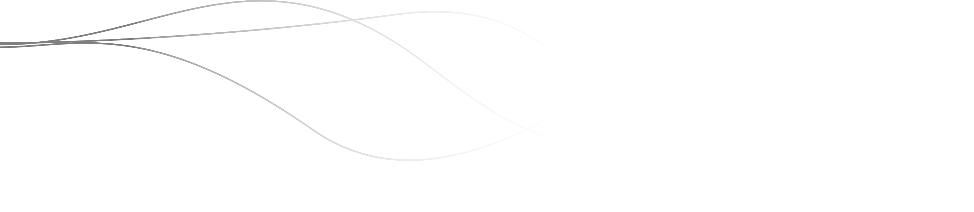
Results against performance criteria
IHACPA continued to engage with jurisdictions on innovative funding methods and to develop draft guidelines for trialling innovative funding models.
IHACPA continued to prepare committee papers, policy documents and technical specifications to support communication of the work program to stakeholders.
Following the Activity Based Funding Conference in May 2022, there was no conference held during the 2022–23 financial year. The 2023 conference will be held in August 2023.
Educational needs were assessed, and webinars were delivered as required, including on Prostheses List reforms. IHACPA also participated in a Department of Health and Aged Care webinar on Residential Aged Care Funding Reforms. IHACPA will continue to evaluate its education program for external stakeholders.

Analysis

IHACPA continued to provide a transparent account of its decision‑making through its committees and working groups, public consultations and the release of detailed policies, outlining the processes IHACPA used to undertake its key functions during 2022–23. During the reporting period, this included four public consultations that received 136 responses from stakeholders.
IHACPA publishes public submissions to its completed consultations on its website. In addition, IHACPA releases a ‘Consultation Report’ alongside the release of its key strategic policy documents, including the Pricing Framework for Australian Public Hospital Services and the Pricing Framework for Australian Residential Aged Care Services. These frameworks detail feedback received during public consultations and IHACPA’s rationale behind its policy decisions and pricing advice.
One of the requirements under the 2020–25 Addendum to the National Health Reform Agreement (NHRA) was the development of a funding methodology that supports states and territories in undertaking trials of innovative models of care.
IHACPA is in the process of developing project parameters and business rules to facilitate piloting state and territory-nominated innovative models of care and services and will continue to work with jurisdictions and stakeholders to investigate options for further developing, trialling and implementing alternate funding models.
In August 2023, IHACPA will host the IHACPA Conference 2023: The Future of Funding. The conference will continue IHACPA’s commitment to education as it delivers speakers and content across both the health and aged care sectors.
In addition, during 2022–23, IHACPA continued to provide accessible information to stakeholders using educational webinars. IHACPA has hosted numerous sessions, including on the Prostheses List reform, and participated in webinars hosted by stakeholders. These events aim to increase the understanding of IHACPA’s work and enhance transparency.

07

Management and accountability

7.1 Key corporate governance practices

Risk management
The Independent Health and Aged Care Pricing Authority’s (IHACPA’s) enterprise-wide approach to risk management remains at the forefront of all its activities. It administers its risks using tools that address the strategic and tactical risks of all significant decisions. IHACPA’s risk management framework, including its risk appetite statement and risk register, is reviewed annually.
Strategic risks are identified with reference to current business and environmental issues facing IHACPA. These risks fall into three major risk categories:
- reputational risks
- data and information governance risks
- corporate risks.
IHACPA’s strategic risks are actively managed through audits, assurance and internal control processes. Where new risks emerge, resources are assigned to understand and manage those risks. Potential risks are reviewed biannually or more frequently, as required. Tactical risks are managed through a decision-based risk management tool, which requires recording of the risk and a formal decision on the managed likelihood and consequence of the risk.

The assessment tool forms part of any major decision, ensuring that the final decision‑maker is fully informed and aware of managed risk outcomes during the decision-making process. IHACPA’s Privacy Threshold Assessment tool allows IHACPA to determine whether there is a risk to personal information, and therefore a need to undertake a Privacy Impact Assessment. As with the Tactical Risk Tool, the Privacy Threshold Assessment tool forms part of any decision that may impact privacy.
IHACPA has a mature enterprise risk management framework in place. Risk management is considered a business-as-usual activity for all IHACPA staff.
Additionally, IHACPA continues to maintain a shared Strategic Risk Register with the National Health Funding Body, which has identified joint risks that the agencies manage together. Currently those risks are:
- incorrect calculation of Commonwealth funding entitlements
- changes to models that have not been effectively modelled or implemented.

Compliance
IHACPA has a broad range of compliance obligations, including key statutory obligations set out in the National Health Reform Act 2011, the Aged Care Act 1997, the National Health Reform Agreement, the Public Governance, Performance and Accountability Act 2013, and the Public Governance, Performance and Accountability Rule 2014.
Other legal and compliance obligations include work health and safety, privacy, freedom of information, intellectual property, public interest disclosure, the Protective Security Policy Framework, website accessibility and records management.
The Chief Executive Officer (CEO), as the accountable authority, receives management assurances on IHACPA’s compliance obligations through an organised system of controls and special exercises. This includes substantive testing, monthly reports, exception notifications and compliance audits undertaken by an independent internal auditor and reviewed by IHACPA’s Audit Risk and Compliance Committee.

Compliance achievements
IHACPA’s internal compliance audits during the year show that:
- information and communication technology systems continued to appropriately address the top risks defined by the Australian Signals Directorate
- no compliance issues arising from IHACPA’s administration of relevant sections of the National Health Reform Act 2011.

Financial authorisation
As a corporate Commonwealth agency, IHACPA is not required to adhere to the Commonwealth Procurement Rules, however, it chooses to do so as a matter of best practice. All of IHACPA’s procurement decisions are made in accordance with the Commonwealth Procurement Rules. Line managers have value and purchase class limits, in accordance with the delegation of financial authorities that are approved and reviewed regularly by the accountable authority.

Fraud control plan
IHACPA’s fraud control plan is recognised as a critical internal tool used to mitigate the act and consequences of unauthorised use of IHACPA data and financial resources. The plan encourages ethical behaviour by using business processes designed to prevent deceptive activities. These processes are supported by monitoring controls to detect fraud and deter offending behaviour and are reviewed annually or earlier if required.

Inter-agency financial activity
During the 2022–23 financial year, IHACPA received shared services resourcing from the Department of Health and Aged Care (the department). The department charged IHACPA $723,000 to provide these services, covering treasury, processing of financial transactions, information and communication desktop services and parliamentary support.

Ecologically sustainable development and environmental performance
IHACPA does not undertake any substantive work that is covered by section 516A of the Environment Protection and Biodiversity Conservation Act 1999 (EPBC Act).

Australian Public Service Net Zero 2030
As part of the reporting requirements under section 516A of the EPBC Act, and in line with the Government’s APS Net Zero 2030 policy, all non-corporate Commonwealth entities and corporate Commonwealth entities are required to publicly report on the emissions from their operations.
The greenhouse gas emissions inventory presents greenhouse gas emissions over the 2022–2023 period. Results are presented on the basis of Carbon Dioxide Equivalent (CO₂-e) emissions. Greenhouse gas emissions reporting has been developed with methodology that is consistent with the whole of Australian Government approach as part of the APS Net Zero 2030 policy.

Table 17: Greenhouse gas emissions inventory ­— location-based method 2022–2023
Emission source | Scope 1 kg  CO2-e | Scope 2 kg  CO2-e | Scope 3 kg  CO2-e | Total kg  CO2-e
Electricity (Location Based Method) | - | 29,667 | 2,438 | 32,105
Natural gas | - | - | - | -
Fleet vehicles | - | - | - | -
Domestic flights | - | - | 20,600 | 20,600
Other energy | - | - | - | -
Total kg CO2-e | - | 29,667 | 23,038 | 52,705
Notes:
- The table above presents emissions related to electricity usage using the location‑based accounting method. CO₂-e = Carbon Dioxide Equivalent.
- Scope 1 emissions are emissions made directly (eg. running a fleet of vehicles). IHACPA had no scope 1 emissions.
- Scope 2 emissions are indirect emissions from the generation of purchased energy, from a utility provider and relate to electricity usage at IHACPA’s office space. Electricity transmission and distribution losses are included in scope 3.
- Scope 3 emissions are all indirect emissions not included in scope 2 that occur in the value chain including both upstream and downstream emissions. IHACPA’s scope 3 emissions primarily represent domestic flight emissions relating to the IHACPA CEO and Pricing Authority. Domestic flight emissions relating to staff seconded to IHACPA from the Department of Health and Aged Care are included in the department’s emissions disclosure.

7.2 Management of human resources

The Chief Executive Officer (CEO) is IHACPA’s only employee and is based in Sydney, New South Wales. All other staff are seconded from the Department of Health and Aged Care to IHACPA. IHACPA staff report to the CEO under a Memorandum of Understanding with the department.
IHACPA continues to place great value in creating a more productive and inclusive workplace, primarily by attracting and retaining high calibre, talented and engaged staff. All staff can optimise their work-life balance by using the generous flexible working arrangements offered by IHACPA. This includes effective technological support to make these flexible working arrangements seamless.
IHACPA is committed to the recruitment and retention of a diverse workforce (for example, in gender, age, cultural and linguistic background, disability, indigeneity and LGBTQI+) and actively promotes an inclusive workplace culture.
The 2023 Australian Public Service (APS) Employee Census was conducted from 8 May to 9 June 2023. IHACPA employees are invited to participate and provide their views. The purpose of the census is to understand the views and experience of employees working at IHACPA and the broader APS.

Ongoing and non‑ongoing employees
The department reports on IHACPA’s seconded workforce. However, to ensure transparency and comply with mandatory reporting requirements, IHACPA provides the following staffing tables.

Table 18: Ongoing seconded employees 2023
 | Man/Male |  |  | Woman/Female |  |  | Non-binary |  |  | Prefers not to answer
Classification | Full-time | Part-time | Total | Full-time | Part-time | Total | Full-time | Part-time | Total | Full-time | Part-time | Total | Total
Senior Executive Service | 0 | 1 | 1 | 3 | 0 | 3 | 0 | 0 | 0 | 0 | 0 | 0 | 4
Executive Level 2 | 9 | 0 | 9 | 11 | 0 | 11 | 0 | 0 | 0 | 0 | 0 | 0 | 20
Executive Level 1 | 11 | 0 | 11 | 27 | 1 | 28 | 0 | 0 | 0 | 0 | 0 | 0 | 39
APS Level 6 | 7 | 0 | 7 | 10 | 2 | 12 | 0 | 0 | 0 | 0 | 0 | 0 | 19
APS Level 5 | 0 | 0 | 0 | 0 | 0 | 0 | 0 | 0 | 0 | 0 | 0 | 0 | 0
Total | 27 | 1 | 28 | 51 | 3 | 54 | 0 | 0 | 0 | 0 | 0 | 0 | 82

Table 19: Ongoing seconded employees 2022
 | Man/Male |  |  | Woman/Female |  |  | Non-binary |  |  | Prefers not to answer
Classification | Full-time | Part-time | Total | Full-time | Part-time | Total | Full-time | Part-time | Total | Full-time | Part-time | Total | Total
Senior Executive Service | 0 | 1 | 1 | 2 | 0 | 2 | 0 | 0 | 0 | 0 | 0 | 0 | 3
Executive Level 2 | 6 | 0 | 6 | 8 | 0 | 8 | 0 | 0 | 0 | 0 | 0 | 0 | 14
Executive Level 1 | 6 | 1 | 7 | 18 | 2 | 20 | 0 | 0 | 0 | 0 | 0 | 0 | 27
APS Level 6 | 5 | 0 | 5 | 6 | 3 | 9 | 0 | 0 | 0 | 0 | 0 | 0 | 14
APS Level 5 | 0 | 0 | 0 | 0 | 0 | 0 | 0 | 0 | 0 | 0 | 0 | 0 | 0
Total | 17 | 2 | 19 | 34 | 5 | 39 | 0 | 0 | 0 | 0 | 0 | 0 | 58

Table 20: Non-ongoing seconded employees 2023
 | Man/Male |  |  | Woman/Female |  |  | Non-binary |  |  | Prefers not to answer
Classification | Full-time | Part-time | Total | Full-time | Part-time | Total | Full-time | Part-time | Total | Full-time | Part-time | Total | Total
Senior Executive Service | 0 | 0 | 0 | 0 | 0 | 0 | 0 | 0 | 0 | 0 | 0 | 0 | 0
Executive Level 2 | 0 | 0 | 0 | 1 | 0 | 1 | 0 | 0 | 0 | 0 | 0 | 0 | 1
Executive Level 1 | 0 | 0 | 0 | 6 | 1 | 7 | 0 | 0 | 0 | 0 | 0 | 0 | 7
APS Level 6 | 0 | 0 | 0 | 3 | 0 | 3 | 0 | 0 | 0 | 0 | 0 | 0 | 3
APS Level 5 | 0 | 0 | 0 | 0 | 0 | 0 | 0 | 0 | 0 | 0 | 0 | 0 | 0
Total | 0 | 0 | 0 | 10 | 1 | 11 | 0 | 0 | 0 | 0 | 0 | 0 | 11

Table 21: Non-ongoing seconded employees 2022
 | Man/Male |  |  | Woman/Female |  |  | Non-binary |  |  | Prefers not to answer
Classification | Full-time | Part-time | Total | Full-time | Part-time | Total | Full-time | Part-time | Total | Full-time | Part-time | Total | Total
Senior Executive Service | 0 | 0 | 0 | 0 | 0 | 0 | 0 | 0 | 0 | 0 | 0 | 0 | 0
Executive Level 2 | 1 | 0 | 1 | 0 | 0 | 0 | 0 | 0 | 0 | 0 | 0 | 0 | 1
Executive Level 1 | 1 | 0 | 1 | 3 | 0 | 3 | 0 | 0 | 0 | 0 | 0 | 0 | 4
APS Level 6 | 0 | 0 | 0 | 0 | 0 | 0 | 0 | 0 | 0 | 0 | 0 | 0 | 0
APS Level 5 | 0 | 0 | 0 | 0 | 0 | 0 | 0 | 0 | 0 | 0 | 0 | 0 | 0
Total | 2 | 0 | 2 | 3 | 0 | 3 | 0 | 0 | 0 | 0 | 0 | 0 | 5

Key management personnel
Table 22: Information about remuneration for key management personnel
 |  | Short term benefits |  |  | Post-employment | Other long‑term benefits
Name | Position title | Base  salary  $ | Bonuses  S | Other benefit and allowances  $ | Superannuation  contribution  $ | Long  service  leave  $ | Other  long-term  benefits  $ | Termination  benefits  $ | Total remuneration  $
Mr Glenn Appleyard | Pricing Authority member | 32,606 | - | - | 5,021 | - | - | - | 37,627
Dr Adam Coltzau | Pricing Authority member | 32,606 | - | - | 3,424 | - | - | - | 36,030
Dr Stephen Judd AM | Pricing Authority member: Deputy Chair (Aged Care Pricing) | 9,053 | - | - | 951 | - | - | - | 10,003
Ms Joanne Fitzgerald | Acting Chief Executive Officer | 238,691 | - | 15,267 | 37,108 | 4,411 | - | - | 295,476
Ms Prudence Ford | Pricing Authority member: Acting Deputy Chair (Aged Care Pricing) | 32,606 | - | - | 3,424 | - | - | - | 36,030
Distinguished Prof Jane Hall AO | Pricing Authority member | 32,606 | - | - | 3,424 | - | - | - | 36,030
Prof Michael Pervan | Chief Executive Officer | 207,879 | - | 46,231 | 10,473 | 2,982 | - | - | 267,565
Ms Jenny Richter AM | Pricing Authority member | 32,606 | - | - | 3,424 | - | - | - | 36,030
Dr Kate Taylor | Pricing Authority member | 25,256 | - | - | 2,652 | - | - | - | 27,908
Mr David Tune AO PSM | Pricing Authority member: Chair | 87,956 | - | - | 9,235 | - | - | - | 97,191
Ms Jennifer Williams AM | Pricing Authority member: Deputy Chair (Hospital Pricing) | 32,606 | - | - | 3,424 | - | - | - | 36,030
Total |  | 764,471 | - | 61,498 | 82,559 | 7,393 | - | - | 915,920
Key management personnel are those persons having authority and responsibility for planning, directing and controlling the activities of the entity, directly or indirectly. IHACPA has determined the key management personnel to be the Chief Executive Officer and the Pricing Authority members. The disaggregated KMP remuneration information in the table above is in accordance with the Public Governance, Performance and Accountability Rule 2014 (PGPA Rule).

Staff development
IHACPA cultivates, values and supports staff by developing their skills and capabilities to meet their work requirements, as well as to achieve their full potential. IHACPA also promotes a culture where people work within and across teams to broaden their expertise.
Training was provided on a programmed basis to management and a needs basis to individual staff. Additionally, mid-level and senior management staff undertook a program of leadership capability training. IHACPA supported individuals to attend conferences and training events that assisted staff to acquire and develop skills used in their work. In 2022–23, IHACPA’s training investment averaged $1,678 per staff member.

Education and review processes
During the reporting period, the Acting CEO, who acted for the period from 23 June 2022 to 31 January 2023 and the CEO, who was appointed on 1 February 2023, enhanced their skills through attendance at international and domestic activity based funding events and received regular performance feedback from the Pricing Authority at each Pricing Authority meeting.

Work health and safety
In 2022–23, IHACPA’s Work Health and Safety Committee continued to manage work health and safety matters in accordance with the Work Health and Safety Act 2011.
The committee met 6 times during the year and dealt with a range of work health and safety matters.
IHACPA maintained its ongoing practice of providing workplace assessments for all new staff and as required for existing staff. IHACPA also provides additional support to staff working from home.
In 2022–23, no notifiable incidents were identified with regard to work health and safety.
IHACPA has only one employee, the CEO of IHACPA. Neither the Acting CEO nor the CEO suffered an injury during the reporting period. Reporting of employees of the department seconded to IHACPA and a Memorandum of Understanding will be reported on in the department’s annual report.
There were no investigations conducted during the year relating to businesses or undertakings conducted by the entity.

Advertising and market research
In 2022–23, IHACPA commissioned no advertising that must be reported under section 311A of the Commonwealth Electoral Act 1918.



08

Financial management

8.1 Financial statements
Independent auditor’s report 103
Statement by the Chief Executive Officer and Chief Financial Officer 105
Primary financial statements 106
Statement of comprehensive income 106
Statement of financial position 107
Statement of changes in equity 108
Cash flow statement 109
Overview 110
Notes to the financial statements 113
Financial performance 113
1.1 Expenses 113
1.2 Own-source revenue and gains 115
Financial position 117
2.1 Financial Assets 117
2.2 Non-Financial Assets 118
2.3 Payables 121
2.4 Interest bearing liabilities 121
People and relationships 122
3.1 Employee provisions 122
3.2 Key management personnel remuneration 123
3.3 Related party disclosures 123
Managing uncertainties 124
4.1 Contingent assets and liabilities 124
4.2 Financial instruments 125
4.3 Fair value measurement 127
Other Information 128
5.1 Current/non-current distinction for assets and liabilities 128

Independent auditor’s report
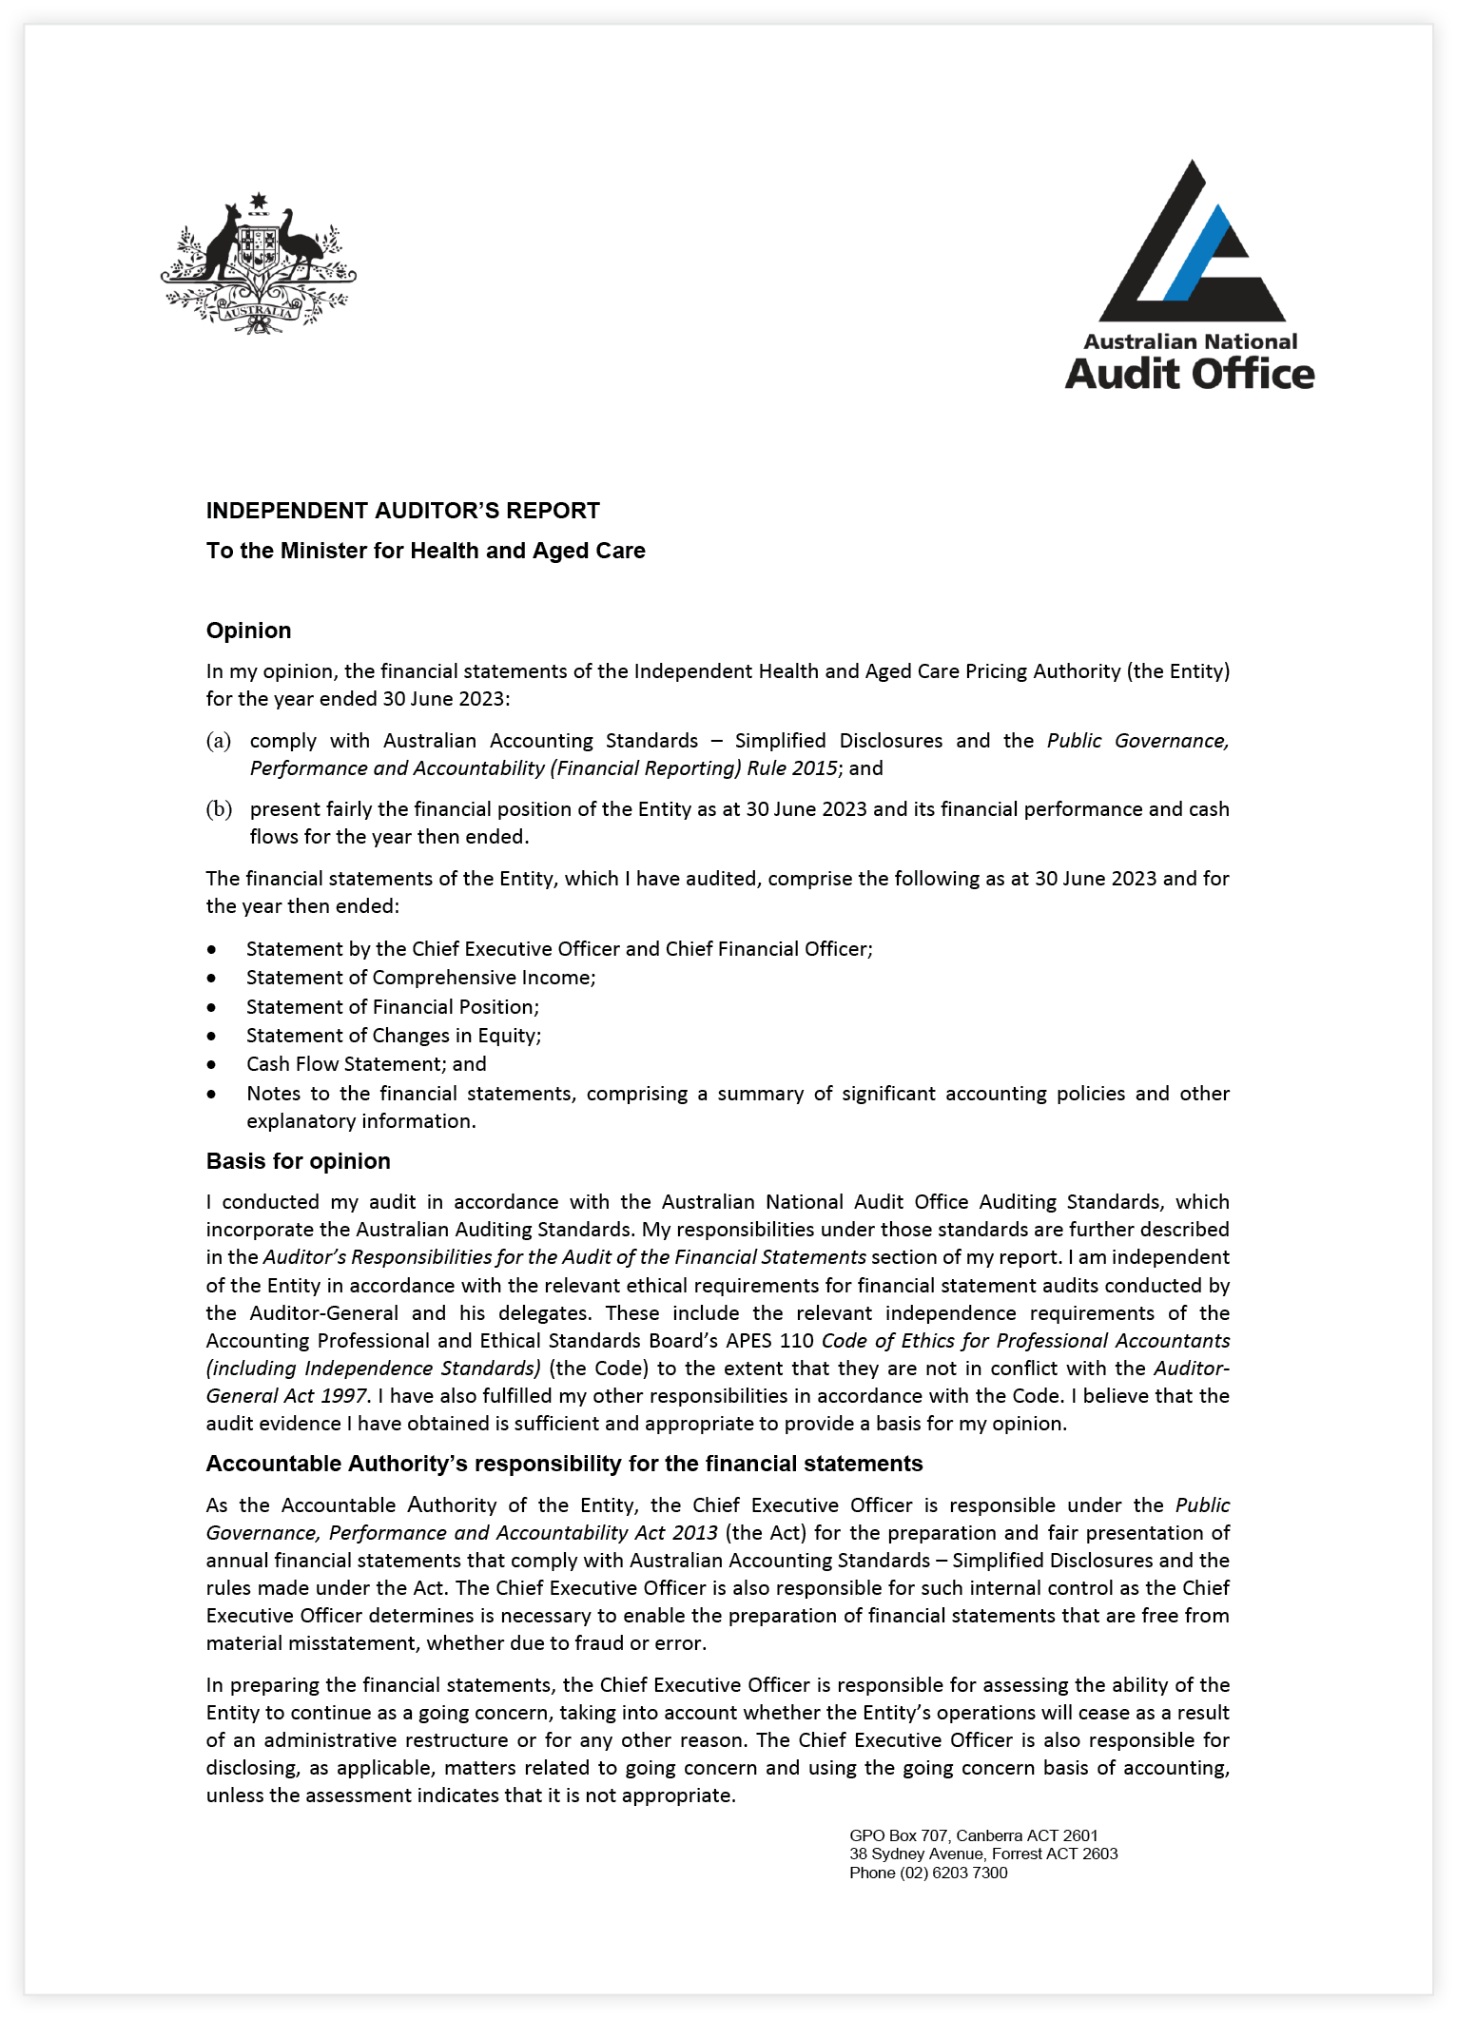

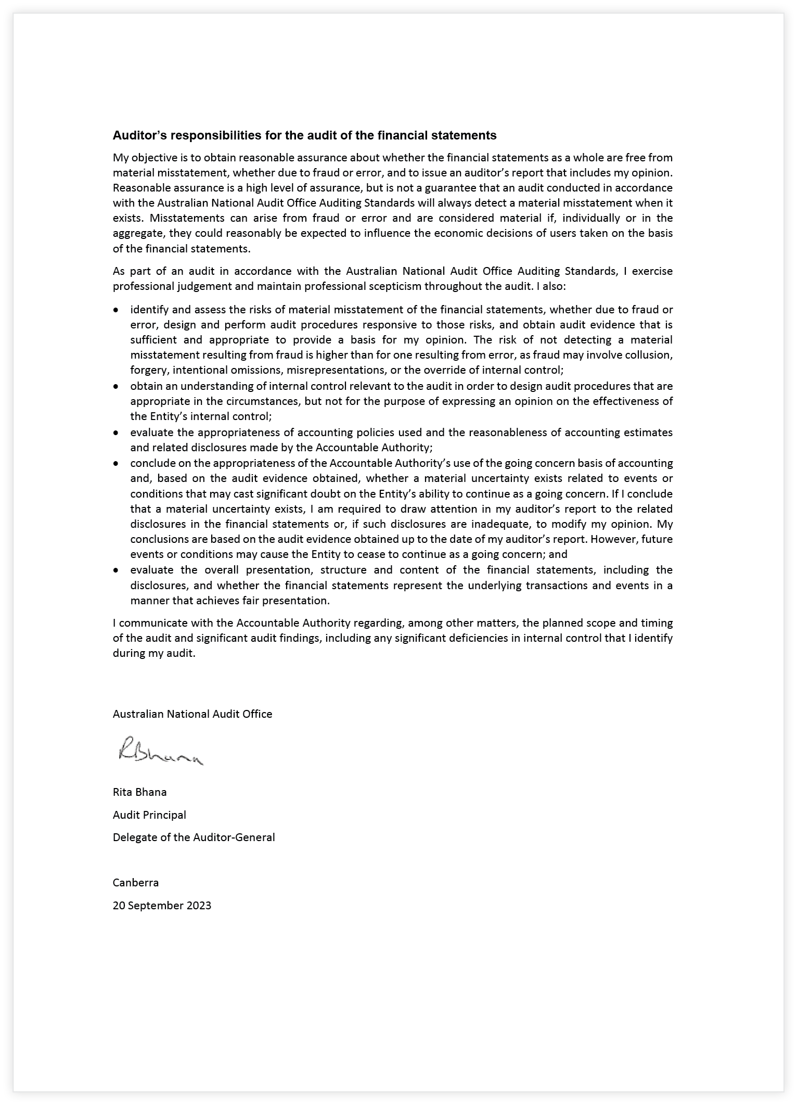

Statement by the Chief Executive Officer and Chief Financial Officer
In our opinion, the attached financial statements for the year ended 30 June 2023 comply with subsection 42(2) of the Public Governance, Performance and Accountability Act 2013 (PGPA Act), and are based on properly maintained financial records as per subsection 41(2) of the PGPA Act.
In our opinion, at the date of this statement, there are reasonable grounds to believe that the Independent Health and Aged Care Pricing Authority will be able to pay its debts as and when they fall due.

Professor Michael Pervan
Chief Executive Officer
18 September 2023


Chris Miljak
Chief Financial Officer
18 September 2023

Primary financial statements

Statement of comprehensive income
for the period ended 30 June 2023
 | Notes | 2023  $’000 | 2022  $’000 | Original Budget $’000
NET COST OF SERVICES
EXPENSES
Employee benefits | 1.1A | 12,229 | 8,864 | 14,900
Suppliers | 1.1B | 22,928 | 16,695 | 34,891
Depreciation and amortisation | 2.2A | 1,579 | 1,301 | 1,631
Finance costs | 1.1C | 175 | 61 | 175
Losses from the disposal of assets | 2.2A | - | 738 | -
Total expenses |  | 36,911 | 27,659 | 51,597
OWN-SOURCE INCOME
Own-source revenue
Revenue from contracts with customers | 1.2A | 1,660 | 1,034 | 800
Resources received free of charge | 1.2B | 12,311 | 8,514 | 14,399
Interest |  | 657 | 6 | 150
Total own-source revenue |  | 14,628 | 9,554 | 15,349
Other gains | 1.2C | - | 270 | -
Total gains |  | - | 270 | -
Total own-source income |  | 14,628 | 9,824 | 15,349
Net cost of services |  | 22,283 | 17,835 | 36,248
Revenue from Government | 1.2D | 36,516 | 18,359 | 35,802
Surplus / (Deficit) |  | 14,233 | 524 | (446)
Total comprehensive surplus / (deficit) |  | 14,233 | 524 | (446)
The above statement should be read in conjunction with the accompanying notes.

Budget Variances Commentary

Statement of Comprehensive Income
Total expenses of $36.911m were $14.686m less than budget primarily due to lower supplier expenses of $11.963m and employee benefits expenses of $2.671m.
Supplier and employee benefit expenses were lower primarily due to procurement and recruitment delays relating to the implementation of the in-home aged care program noting that the policy implementation date was extended subsequent to the October 2022–23 budget.
Total own source income of $14.628m was $0.721m less than budget primarily due to lower resources received free of charge as a result of lower employee benefits expenses partially offset by higher interest, and revenue from contracts with customers.
Revenue from Government of $36.516m was $0.714m higher than budgeted amount primarily due to a current year funding increase included in the May 2023 budget relating to the aged care accommodation measure.

Statement of financial position
as at 30 June 2023
 | Notes | 2023  $’000 | 2022  $’000 | Original Budget $’000
ASSETS
Financial assets
Cash and cash equivalents | 2.1A | 30,742 | 16,079 | 15,145
Trade and other receivables | 2.1B | 1,066 | 529 | 529
Total financial assets |  | 31,808 | 16,608 | 15,674
Non-financial assets
Buildings (right-of-use assets) | 2.2A | 11,095 | 12,375 | 11,093
Leasehold improvement | 2.2A | 2,175 | 2,398 | 2,152
Computer software | 2.2A | 1,380 | 61 | 958
Other - prepayments |  | 405 | 308 | 308
Total non-financial assets |  | 15,055 | 15,142 | 14,511
Total assets |  | 46,863 | 31,750 | 30,185
LIABILITIES
Payables
Suppliers | 2.3A | 4,534 | 2,623 | 2,328
Other payables | 2.3B | 17 | 235 | 235
Total payables |  | 4,551 | 2,858 | 2,563
Interest bearing liabilities
Lease liabilities | 2.4A | 11,698 | 12,532 | 11,698
Total interest bearing liabilities |  | 11,698 | 12,532 | 11,698
Provisions
Employee provisions | 3.1A | 21 | - | 10
Total provisions |  | 21 | - | 10
Total liabilities |  | 16,270 | 15,390 | 14,271
Net assets |  | 30,593 | 16,360 | 15,914
EQUITY
Contributed equity |  | 400 | 400 | 400
Retained surplus |  | 30,193 | 15,960 | 15,514
Total equity |  | 30,593 | 16,360 | 15,914
The above statement should be read in conjunction with the accompanying notes.

Budget Variances Commentary

Statement of Financial Position
Total assets of $46.863m were $16.678m higher than budget primarily due to the increase in cash holdings from retained surpluses.
Total liabilities of $16.270m were $1.999m above than budget primarily due to higher supplier payables.
Total equity of $30.593m was $14.679m higher than the budget primarily due to retained surpluses.

Statement of changes in equity
for the period ended 30 June 2023
 | Notes | 2023  $’000 | 2022  $’000 | Original Budget $’000
CONTRIBUTED EQUITY
Opening balance
Balance carried forward from previous period |  | 400 | 400 | 400
Closing balance as at 30 June |  | 400 | 400 | 400
RETAINED EARNINGS
Opening balance
Balance carried forward from previous period |  | 15,960 | 15,436 | 12,999
Comprehensive income
Surplus / (deficit) for the period |  | 14,233 | 524 | (446)
Closing balance as at 30 June |  | 30,193 | 15,960 | 12,553
TOTAL EQUITY
Opening balance
Balance carried forward from previous period |  | 16,360 | 15,836 | 13,399
Equity movements during the period
Surplus for the period |  | 14,233 | 524 | (54)
Closing balance as at 30 June |  | 30,593 | 16,360 | 13,345
The above statement should be read in conjunction with the accompanying notes.

Budget Variances Commentary

Statement of Changes in Equity
Total equity of $30.593m was $17.248m higher than the budget amount primarily due to retained surpluses.

Cash flow statement
for the period ended 30 June 2023
 | Notes | 2023  $’000 | 2022  $’000 | Original Budget $’000
OPERATING ACTIVITIES
Cash received
Receipts from government |  | 36,516 | 18,359 | 35,802
Sale of goods and rendering of services |  | 1,802 | 954 | 860
Interest |  | 554 | - | 150
Net GST received |  | 1,690 | 1,689 | 1,960
Total cash received |  | 40,562 | 21,002 | 38,772
Cash used
Employees |  | (1,136) | (833) | (3,104)
Suppliers |  | (23,340) | (17,014) | (34,593)
Interest payments on lease liabilities |  | (175) | (61) | (175)
Total cash used |  | (24,651) | (17,908) | (37,872)
Net cash from /(used by) operating activities |  | 15,911 | 3,094 | 900
INVESTING ACTIVITIES
Cash used
Purchase of computer software |  | (386) | - | (1,000)
Purchase of leasehold improvements |  | (27) | (2,481) | -
Total cash used |  | (413) | (2,481) | (1,000)
Net cash from /(used by) investing activities |  | (413) | (2,481) | (1,000)
FINANCING ACTIVITIES
Cash used
Principal payments of lease liabilities |  | (835) | (785) | (834)
Total cash used |  | (835) | (785) | (834)
Net cash from/(used by) financing activities |  | (835) | (785) | (834)
Net increase / (decrease) in cash held |  | 14,663 | (172) | (934)
Cash and cash equivalents at the beginning of the reporting period |  | 16,079 | 16,251 | 16,079
Cash and cash equivalents at the end of the reporting period | 2.1A | 30,742 | 16,079 | 15,145
The above statement should be read in conjunction with the accompanying notes.

Budget Variances Commentary

Statement of Changes in Cash Flow
The closing cash balance of $30.742m was $15.597m higher than the budget primarily due to retained surpluses noting that the budget is derived on a break-even assumption.

Overview

Objectives of the Independent Health and Aged Care Pricing Authority
The Independent Health and Aged Care Pricing Authority (IHACPA) is a corporate Commonwealth entity under the Public Governance, Performance and Accountability Act 2013 (PGPA Act) with its principal place of business located at Level 12, 1 Oxford Street, Sydney NSW.
IHACPA’s role and functions are set out in the National Health Reform Act 2011, the Aged Care Act 1997 and the Aged Care Quality and Safety Commission Act 2018. IHACPA’s role and functions include the:
- determination of the National Efficient Price and National Efficient Cost for public hospital services
- development of national classifications for activity based funding
- resolution of disputes on cost-shifting and cross-border issues
- provision of advice on healthcare pricing and costing matters
- provision of advice on aged care pricing and costing matters
- performance of certain functions conferred by the Aged Care Act 1997.
The continued existence of the entity in its present form, and with its present programs, is dependent on government policy and on continuing funding by parliament for the entity’s administration and programs.

The basis of preparation
The financial statements are general purpose financial statements and are required by section 42 of the PGPA Act.
The financial statements have been prepared in accordance with the:
Public Governance, Performance and Accountability (Financial Reporting) Rule 2015 (FRR)
Australian Accounting Standards and Interpretations — including simplified disclosures for Tier 2 Entities under AASB 1060 issued by the Australian Accounting Standards Board (AASB) that apply for the reporting period.
The financial statements have been prepared on an accrual basis and in accordance with the historical cost convention, except for certain assets and liabilities at fair value. Except where stated, no allowance is made for the effect of changing prices on the results or the financial position. The financial statements are presented in Australian dollars and values are rounded to the nearest thousand dollars, unless otherwise specified.

Significant changes affecting IHACPA during 2022–23
Commencing 12 August 2022, schedule 8 of the Aged Care and Other Legislation Amendment (Royal Commission Response) Act 2022 (Cwlth) amended the National Health Reform Act 2011, the Aged Care Act 1997 and the Aged Care Quality and Safety Commission Act 2018 to expand the functions of a renamed IHACPA to include the:
provision of advice on healthcare pricing and costing matters
provision of advice on aged care pricing and costing matters
performance of certain functions conferred by the Aged Care Act 1997.
IHACPA commenced providing advice to inform Commonwealth Government decisions on the costing and pricing of aged care services from 1 July 2023.
No other significant changes affecting IHACPA have occurred in this reporting period.

New Accounting Standards
IHACPA has adopted all new, revised and amending standards and interpretations that were issued by the Australian Accounting Standards Board (AASB) prior to the sign-off date and which are applicable to the current reporting period.
The following new, revised and amending standards and interpretations were issued by the AASB prior to the signing of the statement by the Chief Executive Officer and Chief Financial Officer:
Standard/  Interpretation | Expected impact
AASB 2021-2 Amendments to Australian Accounting Standards ­— Disclosure of Accounting Policies and Definition of Accounting Estimates (AASB 2021-2) | This amending standard is not expected to have a material impact on the financial statements for the current reporting period or future reporting periods.
AASB 2021-6 Amendments to Australian Accounting Standards ­— Disclosure of Accounting Policies: Tier 2 and Other Australian Accounting Standards (AASB 2021‑6) | This amending standard is not expected to have a material impact on the financial statements for the current reporting period or future reporting periods.

Significant accounting judgements and estimates
Except where specifically identified and disclosed, IHACPA has determined that no accounting assumptions and estimates have a significant risk of causing a material adjustment to carrying amounts of assets and liabilities within the next accounting period.

Comparative figures
Note that the comparative figures relating to the maturity analysis of leases in note 2.4A have been adjusted as a result of correcting a prior period error. No other notes are impacted by this change. Refer to note 2.4A for details.

Taxation
IHACPA is exempt from all forms of taxation, except Fringe Benefits Tax (FBT) and the Goods and Services Tax (GST).

Events after the reporting period
No events have occurred since the reporting date which have had a material impact on the financial statements.

Notes to the financial statements

Financial performance
This section analyses the financial performance of IHACPA for the year ended 30 June 2023.
Note 1.1 Expenses
 | 2023  $’000 | 2022  $’000
Note 1.1A: Employee Benefits
Wages and salaries | 529 | 528
Superannuation — Defined contribution plans | 87 | 63
Leave and other entitlements | 323 | 353
Wages and salaries for staff provided by Department of Health and Aged Care | 11,290 | 7,920
Total employee benefits | 12,229 | 8,864

Accounting Policy

Employee Benefits
Accounting policies for employee benefits is contained in the People and Relationships section.

 | 2023  $’000 | 2022  $’000
Note 1.1B: Suppliers
Goods and services supplied or rendered | 8,984 | 3,842
Consultants | 6,198 | 5,986
Contractors | 5,881 | 5,081
IT services | 231 | 100
Travel | 122 | 89
Training | 263 | 464
Publishing materials | 157 | 279
Legal and audit expenses | 534 | 234
Conferences and seminars | 556 | 618
Other | 22,926 | 16,693
Total goods and services supplied or rendered | 8,984 | 3,842
Goods supplied | 316 | 649
Services rendered | 22,610 | 16,044
Total goods and services supplied or rendered | 22,926 | 16,693
Other suppliers
Workers’ compensation expenses | 2 | 2
Total other suppliers | 2 | 2
Total suppliers | 22,928 | 16,695

Note 1.1C: Finance Costs:
Interest on lease liabilities (office space lease) | 175 | 61
Total finance costs | 175 | 61
The above lease disclosures should be read in conjunction with the accompanying notes 2.2A and 2.4A.


Note 1.2 Own-source revenue and gains
 | 2023  $’000 | 2022  $’000
Own-Source Revenue
Note 1.2A: Revenue from contracts with customers
Sale of goods | 1,660 | 1,034
Total revenue from contracts with customers | 1,660 | 1,034
Sales of goods are from sales of intellectual property relating to the Australian Refined Diagnosis Related Groups (AR-DRG) classification systems.

Accounting Policy

Revenue from contracts with customers
Revenue from the sale of goods is recognised when control has been transferred to the buyer.
In relation to AASB 15, IHACPA has considered each revenue stream to identify the existence of an enforceable contract that requires the completion of sufficiently specific performance obligations in exchange for relevant consideration. Revenue is recognised either over time or at a point in time as performance obligations are completed and IHACPA has an enforceable right to payment for the performance completed to date.
Receivables for goods and services, which have 30 day terms, are recognised at the nominal amounts due less any impairment allowance account. Collectability of debts is reviewed at the end of the reporting period. Allowances are made when collectability of the debt is no longer considered probable.

 | 2023  $’000 | 2022  $’000
Note 1.2B: Resources received free of charge
Departmental contribution received free of charge | 12,246 | 8,449
Resources received free of charge ­— Remuneration of auditors | 65 | 65
Total other revenue | 12,311 | 8,514

Accounting Policy

Resources received free of charge
Resources received free of charge are recognised as revenue when, and only when, a fair value can be reliably determined and the services would have been purchased if they had not been donated. Use of those resources is recognised as an expense. Resources received free of charge are recorded as revenue.

 | 2023  $’000 | 2022  $’000
Note 1.2C: Other gains
Gain on lease modification | - | 270
Total other gains | - | 270

Note 1.2D: Revenue from Government
Amounts from Department of Health and Aged Care | 36,516 | 18,359
Total revenue from Government | 36,516 | 18,359

Accounting Policy

Revenue from Government
Funding received or receivable from non-corporate Commonwealth entities is recognised as Revenue from Government by IHACPA unless the funding is in the nature of an equity injection or a loan.


Financial position
This section analyses the IHACPA’s assets used to conduct its operations and the operating liabilities incurred as a result. Employee-related information is disclosed in the People and Relationships section.
Note 2.1 Financial Assets
 | 2023  $’000 | 2022  $’000
Note 2.1A: Cash and cash equivalents
Cash on deposit | 30,742 | 16,079
Total cash and cash equivalents | 30,742 | 16,079

Accounting Policy

Cash and cash equivalents
Cash is recognised at its nominal amount. Cash and cash equivalents includes:
- cash on hand, and
- demand deposits in bank accounts with an original maturity of three months or less that are readily convertible to known amounts of cash and subject to insignificant risk of changes in value.

 | 2023  $’000 | 2022  $’000
Note 2.1B: Trade and other receivables
Other receivables
GST receivable from the Australian Taxation Office | 859 | 382
Other amounts receivable | 207 | 147
Total other receivables | 1,066 | 529
Total trade and other receivables (gross) | 1,066 | 529
Less expected credit loss allowance | - | -
Total trade and other receivables (net) | 1,066 | 529
No amounts receivable are overdue.

Accounting Policy

Trade and other receivables
IHACPA’s financial assets are comprised of trade receivables and other receivables that are held for the purpose of collecting the contractual cash flows. All of IHACPA’s financial assets are measured, and carried, at amortised cost.

Impairment
All assets were assessed for impairment as at 30 June 2023. Where indications of impairment exist, the asset’s recoverable amount is estimated and an impairment adjustment made if the asset’s recoverable amount is less than its carrying amount.

Note 2.2 Non-Financial Assets
Note 2.2A: Reconciliation of the Opening and Closing Balances of Property, Plant and Equipment, and Intangibles
 | Buildings  $’000 | Leasehold improvement  $’000 | Computer Software  $’000 | Total  $’000
As at 1 July 2022
Gross book value | 12,802 | 2,481 | 777 | 16,060
Accumulated depreciation, amortisation and impairment | (427) | (83) | (716) | (1,226)
Total as at 1 July 2022 | 12,375 | 2,398 | 61 | 14,834
Additions
Purchase or internally developed | - | 27 | - | 27
Under construction (work in progress) | - | - | 1,367 | 1,367
Depreciation and amortisation | - | (250) | (48) | (298)
Depreciation on right-of-use assets | (1,280) | - | - | (1,280)
Total as at 30 June 2023 | 11,095 | 2,175 | 1,380 | 14,650
Total as at 30 June 2023 represented by
Gross book value | 12,802 | 2,508 | 2,144 | 17,454
Accumulated depreciation, amortisation and impairment | (1,707) | (333) | (764) | (2,804)
Total as at 30 June 2023 represented by | 11,095 | 2,175 | 1,380 | 14,650
Carrying amount of right-of-use assets | 11,095 | - | - | 11,095
No indicators of impairment were found for property, plant and equipment or intangibles.

Summary of asset transactions:
The lease for IHACPA’s office space at level 12, 1 Oxford Street Sydney commenced on 1 March 2022 for a term of 5 years (with a 5-year extension option), with a right-of-use-asset of $12.802m and office fit-out costs of $2.481m were recognised. During the period, $0.027m of additional office fit-out costs and $1.367m for internally developed software were incurred.

Accounting Policy

Property, plant and equipment, and intangibles
Assets are recorded at cost on acquisition except as stated below. The cost on acquisition includes the fair value of assets transferred in exchange and liabilities undertaken. Financial assets are initially measured at their fair value plus transaction costs where appropriate.
Assets acquired at no cost, or for nominal consideration, are initially recognised as assets and income at their fair value at the date of acquisition, unless acquired as a consequence of restructuring of administrative arrangements. In the latter case, assets are initially recognised as contributions by owners at the amounts at which they were recognised in the transferor’s accounts immediately prior to the restructuring.

Asset recognition threshold
Purchases of property, plant and equipment are recognised initially at cost in the statement of financial position, except for purchases costing less than $5,000, which are expensed in the year of acquisition (other than where they form part of a group of similar items which are significant in total).

Lease right-of-use (ROU) assets
Leased ROU assets are capitalised at the commencement date of the lease and comprise of the initial lease liability amount, initial direct costs incurred when entering into the lease less any lease incentives received. These assets are accounted for by Commonwealth lessees as separate asset classes to corresponding assets owned outright, but included in the same column as where the corresponding underlying assets would be presented if they were owned. Lease ROU assets continue to be measured at cost after initial recognition.

Revaluations
Following initial recognition at cost, property, plant and equipment (excluding ROU assets) are carried at fair value less subsequent accumulated depreciation and accumulated impairment losses. Valuations are conducted with sufficient frequency to ensure that the carrying amounts of assets did not differ materially from the assets’ fair values as at the reporting date. The regularity of independent valuations depended upon the volatility of movements in market values for the relevant assets.
Revaluation adjustments are made on a class basis. Any revaluation increment is credited to equity under the heading of asset revaluation reserve except to the extent that it reversed a previous revaluation decrement of the same asset class that was previously recognised in the surplus/deficit. Revaluation decrements for a class of assets are recognised directly in the surplus/deficit except to the extent that they reversed a previous revaluation increment for that class.
Any accumulated depreciation as at the revaluation date is eliminated against the gross carrying amount of the asset and the asset restated to the revalued amount.

Depreciation
Depreciable property, plant and equipment assets are written-off to their estimated residual values over their estimated useful lives to the entity using, in all cases, the straight-line method of depreciation. Depreciation rates (useful lives), residual values and methods are reviewed at each reporting date and necessary adjustments are recognised in the current, or current and future reporting periods, as appropriate.
Depreciation rates applying to each class of depreciable asset are based on the following useful lives:
 | 2023 | 2022
Leasehold improvements | Lease terms | Lease terms
Plant and equipment | 3 to 6 years | 3 to 6 years

Impairment
All assets were assessed for impairment at 30 June 2023. Where indications of impairment exist, the assets recoverable amount is estimated and an impairment adjustment made if the asset’s recoverable amount is less than its carrying amount.
The recoverable amount of an asset is the higher of its fair value less costs of disposal and its value in use. Value in use is the present value of the future cash flows expected to be derived from the asset. Where the future economic benefit of an asset is not primarily dependent on the asset’s ability to generate future cash flows, and the asset would be replaced if the entity were deprived of the asset, its value in use is taken to be its depreciated replacement cost.

Derecognition
An item of property, plant and equipment is derecognised upon disposal or when no further future economic benefits are expected from its use or disposal.

Intangibles
The entity’s intangibles comprise internally developed software for internal use. These assets are carried at cost less accumulated amortisation and accumulated impairment losses.
Software is amortised on a straight-line basis over its anticipated useful life. The useful lives of the entity’s software are 1 to 6 years (2022: 1 to 6 years). All software assets were assessed for indications of impairment as at 30 June 2023.

Note 2.3 Payables
 | 2023  $’000 | 2022  $’000
Note 2.3A: Suppliers
Trade creditors and accruals | 4,463 | 2,623
Contract liabilities from contracts with customers | 71 | -
Total suppliers | 4,534 | 2,623
Trade creditors settlement terms are 30 days.
The contract liabilities from contracts with customers are associated with prepaid conference revenue.
Note 2.3B: Other Payables
Salaries and wages | 17 | 35
Leave entitlements payable | - | 200
Total other payables | 17 | 235
Note 2.4 Interest bearing liabilities
 | 2023  $’000 | 2022  $’000
Note 2.4A: Lease liabilities
Lease liability (office space) | 11,698 | 12,532
Total lease liabilities | 11,698 | 12,532
Total cash outflow for leases for the year ended 30 June 2023 was $1.009m (2022: $0.848m)
Maturity analysis — contractual undiscounted cash flows
Within 1 year | 1,058 | 1,009
Between 1 to 5 years | 5,175 | 4,644
More than 5 years | 6,304 | 7,894
Total undiscounted leases | 12,537 | 13,547
Prior period error:
Comparative figures in the maturity analysis above have been adjusted due to applying a discounted methodology instead of an undiscounted cash flows approach. The error resulted in an increase of $1.015m to the comparative total value of undiscounted leases over the maturity period (from $12.532m to $13.547m). No other notes are impacted by this change.
The lease for IHACPA’s office space at Level 12, 1 Oxford Street Sydney commenced on 1 March 2022 for a term of 5 years (with a 5 year extension option).

People and relationships
This section describes a range of employment and post-employment benefits provided to our people and our relationships with other key people.
Note 3.1 Employee provisions
 | 2023  $’000 | 2022  $’000
Note 3.1A: Employee provisions
Leave | 21 | -
Total employee provisions | 21 | -

Accounting Policy

Employee provisions
Liabilities for short-term employee benefits and termination benefits expected within 12 months of the end of reporting period are measured at their nominal amounts.
Other long-term employee benefits are measured as net total of the present value of the defined benefit obligation at the end of the reporting period, minus the fair value at the end of the reporting period of plan assets (if any), out of which the obligations are to be settled directly.

Leave
The liability for employee benefits includes provision for annual leave and long service leave.
The leave liabilities are calculated on the basis of employees’ remuneration at the estimated salary rates that will be applied at the time the leave is taken, including the entity’s employer superannuation contribution rates to the extent that the leave is likely to be taken during service rather than paid out on termination. The estimate of the present value of the liability takes into account attrition rates, and pay increases through promotion and inflation.

Superannuation
The entity’s staff are members of the Commonwealth Superannuation Scheme (CSS), the Public Sector Superannuation Scheme (PSS), or the PSS accumulation plan (PSSap), or other superannuation funds held outside the Australian Government. The CSS and PSS are defined benefit schemes for the Australian Government. The PSSap is a defined contribution scheme.
The liability for defined benefits is recognised in the financial statements of the Australian Government and is settled by the Australian Government in due course. This liability is reported in the Department of Finance’s administered schedules and notes.
The entity makes employer contributions to the employees’ defined benefit superannuation scheme at rates determined by an actuary to be sufficient to meet the current cost to the Australian Government. The entity accounts for the contributions as if they were contributions to defined contribution plans.
The liability for superannuation recognised as at 30 June represents outstanding contributions.

Note 3.2 Key management personnel remuneration
Key management personnel are those persons having authority and responsibility for planning, directing and controlling the activities of the entity, directly or indirectly, including any Pricing Authority member. The entity has determined the key management personnel to be the Chief Executive Officer and the Pricing Authority members.

Key management personnel remuneration is reported in the table below:
 | 2023  $’000 | 2022  $’000
Short-term employee benefits | 826 | 723
Post-employment benefits | 83 | 52
Other long-term benefits | 7 | 73
Termination benefits | - | -
Total key management personnel remuneration expenses | 916 | 848
The total number of key management personnel that are included in the above table is 11 (2022: 12).
The above key management personnel remuneration excludes the remuneration and other benefits of the Portfolio Ministers whose remuneration and other benefits are set by the Remuneration Tribunal and are not paid by the entity.
Note 3.3 Related party disclosures

Related party relationships
IHACPA is an Australian Government controlled entity. Related parties to this entity are the key management personnel (as per Note 3.2) and other Australian Government entities.

Transactions with related parties
Given the breadth of government activities, related parties may transact with the government sector in the same capacity as ordinary citizens. Such transactions include the payment or refund of taxes, receipt of a Medicare rebate or higher education loans. These transactions have not been separately disclosed in this note.
Giving consideration to relationships with related entities, and transactions entered into during the reporting period by IHACPA, it has been determined that there are no related party transactions to be separately disclosed for 2023. In the 2022 prior period, Mr Glenn Appleyard and A/Prof Bruce Chater provided advice to IHACPA when they were not Pricing Authority members or key management personnel. Mr Glenn Appleyard was paid $19,245 and A/Prof Bruce Chater was paid $13,969. These amounts include superannuation.

Managing uncertainties
This section analyses how IHACPA manages financial risks within its operating environment.
Note 4.1 Contingent assets and liabilities

Quantifiable contingencies
There were no quantifiable contingent assets or liabilities in this reporting period (2022: nil).

Unquantifiable contingencies
There were no unquantifiable contingent assets or liabilities in this reporting period (2022: nil).

Significant remote contingencies
There were no significant remote contingent assets or liabilities in this reporting period (2022: nil).

Accounting Policy

Contingent asset and liabilities
Contingent liabilities and contingent assets are not recognised in the statement of financial position but are reported in the notes. They may arise from uncertainty as to the existence of a liability or asset, or represent an asset or liability in respect of which the amount cannot be reliably measured. Contingent assets are disclosed when settlement is probable but not virtually certain, and contingent liabilities are disclosed when settlement is greater than remote.

Note 4.2 Financial instruments
 | 2023  $’000 | 2022  $’000
Note 4.2A: Financial instruments (assets)
Financial assets at amortised cost
Cash and cash equivalents | 30,742 | 16,079
Trade and other receivables | 207 | 147
Total financial assets at amortised cost | 30,949 | 16,226

Note 4.2B: Financial instruments (liabilities)
Financial liabilities measured at amortised cost
Trade creditors and accruals | 4,463 | 2,623
Contract liabilities from contracts with customers | 71 | -
Total financial liabilities measured at amortised cost | 4,534 | 2,623

Accounting Policy

Cash and cash equivalents
Cash is recognised at its nominal amount. Cash and cash equivalents includes:
- cash on hand, and
- demand deposits in bank accounts with an original maturity of three months or less that are readily convertible to known amounts of cash and subject to insignificant risk of changes in value.

Classification and measurement
The classification and measurement of IHACPA’s financial assets under AASB 9 is determined by its business model for managing its financial assets and the contractual cash flow characteristics of those assets.

Financial assets
IHACPA’s financial assets are comprised of trade receivables and other receivables that are held for the purpose of collecting the contractual cash flows. All of IHACPA’s financial assets are measured, and carried, at amortised cost.

Financial liabilities
IHACPA’s financial liabilities are measured, and carried, at amortised cost. Supplier and other payables are recognised to the extent that the goods or services have been received, irrespective of having been invoiced. Lease liabilities are measured using the effective interest method.

Impairment
AASB 9 requires IHACPA to impair its financial assets by applying the ‘expected credit losses’ (ECL) model. IHACPA has taken advantage of the practical expedient which allows the use of a Provision Matrix to calculate expected credit losses on trade receivables. IHACPA has assessed the loss allowance for its financial assets at an amount equal to lifetime expected credit losses.
Due to the nature of IHACPA’s receivables, a nil loss allowance has been calculated. There is no impairment of IHACPA’s financial assets as at 30 June 2023.

Note 4.3 Fair value measurement

Accounting Policy
As allowed for by AASB 13 Fair Value Measurement, quantitative information on significant unobservable inputs used in determining fair value is not disclosed.
Assets held at fair value include leasehold improvements and property, plant and equipment. Assets not held at fair value include computer software and Right-of-Use (ROU) assets.
IHACPA tests the procedures of the valuation model as an internal management review at least once every 12 months (with a formal revaluation undertaken once every three years). An independent revaluation was undertaken by Jones Lang LaSalle Public Sector Valuations Pty Ltd in June 2022 consistent with the valuation methodologies described below with no revaluation adjustments required. If a particular asset class experiences significant and volatile changes in fair value (that is, where indicators suggest that the value of the class has changed materially since the previous reporting period), that class is subject to specific valuation in the reporting period, where practicable, regardless of the timing of the last specific valuation.
The categories of fair value measurement are:
- Level 1: quoted prices (unadjusted) in active markets for identical assets that the entity can access at measurement date.
- Level 2: inputs other than quoted prices included within Level 1 that are observable for the asset, either directly or indirectly.
- Level 3: unobservable inputs.
IHACPA’s assets are held at fair value and are measured at category Levels 2 or 3 with no fair values measured at category Level 1.
Leasehold improvements are measured at category Level 3 and the valuation methodology used is Depreciated Replacement Cost (DRC). Under DRC the estimated cost to replace the asset is calculated, with reference to new replacement price per square metre, and then adjusted to take into account its consumed economic benefit (accumulated depreciation). The consumed economic benefit has been determined based on the professional judgement with regard to physical, economic and external obsolescence factors.
Property, plant and equipment is measured at either category Level 2 or 3. The valuation methodology is either market approach or DRC, based on replacement cost for a new equivalent asset. The significant unobservable inputs used in the fair value measurement of property, plant and equipment assets are the market demand and professional judgement.

Other Information
Note 5.1 Current/non-current distinction for assets and liabilities
 | 2023  $’000 | 2022  $’000
Note 5.1A Current/non-current distinction for assets and liabilities
Assets expected to be recovered in:
No more than 12 months
Cash and cash equivalents | 30,742 | 16,079
Trade and other receivables | 1,066 | 529
Prepayments | 405 | 292
Total no more than 12 months | 32,213 | 16,900
More than 12 months
Buildings | 11,095 | 12,375
Leasehold improvements | 2,175 | 2,398
Computer software | 1,380 | 61
Prepayments | - | 16
Total more than 12 months | 14,650 | 14,850
Total assets | 46,863 | 31,750
Liabilities expected to be settled in:
No more than 12 months
Suppliers | 4,534 | 2,623
Leases | 895 | 834
Other payables | 17 | 235
Employee provisions | 18 | -
Total no more than 12 months | 5,464 | 3,692
More than 12 months
Leases | 10,803 | 11,698
Employee provisions | 3 | -
Total more than 12 months | 10,806 | 11,698
Total liabilities | 16,270 | 15,390



09

Appendices

Appendix A — Aged Care Pricing Commissioner’s Annual Report
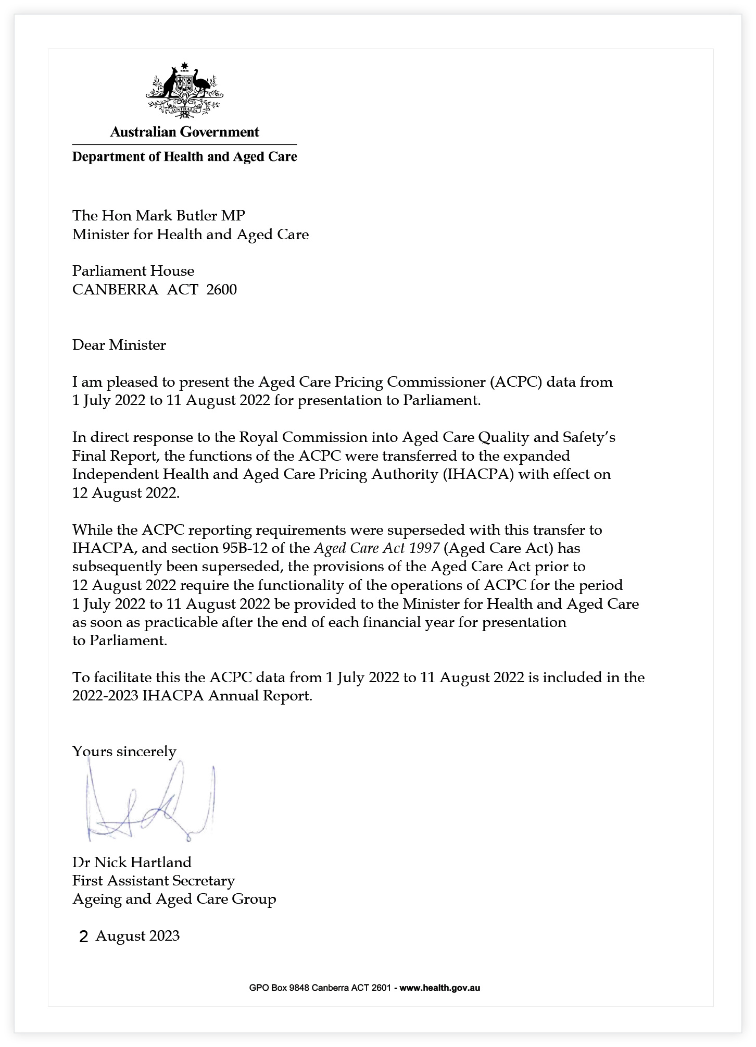

Aged Care Pricing Commissioner’s Annual Report (01 July 2022 — 11 August 2022)
The former Aged Care Pricing Commissioner, Mr David Weiss, was appointed from 21 May 2021 until the Aged Care Pricing Commissioner (ACPC) function was abolished on 11 August 2022. During his tenure as the Pricing Commissioner, and in addition to his other duties as Pricing Commissioner, Mr Weiss oversaw the transfer of the ACPC function to the expanded Independent Health and Aged Care Pricing Authority (IHACPA).
This transfer of function was in direct response to the Royal Commission into Aged Care Quality and Safety’s Final Report and took effect on 12 August 2022.
While the ACPC reporting requirements were superseded with this transfer to IHACPA, and section 95B–12 of the Aged Care Act 1997 (Aged Care Act) has subsequently been superseded, the provisions of the Aged Care Act prior to 12 August 2022 require the functionality of the operations of ACPC for the period 1 July 2022 to 11 August 2022 be provided to the Minister for Health and Aged Care as soon as practicable after the end of each financial year for presentation to Parliament. To streamline this reporting process, the ACPC data from 1 July 2022 to 11 August 2022 has been included in the 2022–2023 IHACPA Annual Report and endorsed by Dr Nicholas Hartland, First Assistant Secretary, Department of Health and Aged Care.

Functions of the Aged Care Pricing Commissioner
The main statutory functions of the ACPC were to:
- review and approve proposed accommodation payments that are higher than the maximum amount of $550,000 (as determined by the Minister); and
- review and approve applications for changes in extra service fees.
In carrying out these functions, the ACPC strived to contribute in a positive way to improve transparency in the pricing of residential aged care accommodation, so that prices for residents were set objectively and fairly and were in no way determined by a resident’s ability to pay.
The ACPC was required to include the following information in the Annual Report:
- The number of applications that were made to the ACPC during the financial year for the approval to charge an accommodation payment higher that the maximum amount of accommodation payment determined by the Minister under section 52G–3 of the Aged Care Act,
- The number of such applications approved, rejected/refused, or withdrawn during the financial year,
- The number of applications that were made for approval to charge an extra service fee, and
- Any other information required by the Commissioner Principles to be included in the report.

1 July 2022 to 11 August 2022 performance summary

Accommodation Payments
Previously, the ACPC Annual Reports provided additional analysis of the approved applications for higher accommodation payments that included presenting information by state/territory, value, and distance from the CBD. Due to the compressed reporting period, however, this additional analysis is not feasible. As such, the aggregate applications are presented in table 1.
Table 23: Applications for higher Accommodation Payments
Time period | Received | Approved | Withdrawn | Reframed | Refused
01 July – 11 August 2022 | 159 | 185 | 3 | 75 | 0

Importantly, when the ACPC function transferred to IHACPA, 33 applications for higher accommodation payments and 0 extra service fee (ESF) increases were transferred and subsequently processed by IHACPA.
Following the transfer of this function, IHACPA have noted that the data captured in table 1 indicates that the ACPC counted the number of accommodation groups across all applications and not by the number of applications received. Noting that an accommodation group is a group of rooms with similar offerings at the same priced point, while a single submission by a provider will generally have between one and ten accommodation groups. This means that an accommodation group may have from one to all of the rooms in a facility included within it. As such, the different methodology of counting accommodation payment applications between the former ACPC and IHACPA will result in a change to how this information will be presented in the future.

Extra Service Fees
The ACPC received four applications for changes to extra service fees (ESFs) and approved all four, between 1 July 2022 and 11 August 2022.
An ESF application relates to a provider with extra service status who seeks to charge a fee for significantly higher standards of accommodation, food and personal services on offer to the care recipient. A provider with extra service status can apply every 12 months to change the extra service fee. The fee can be increased by a maximum of 20% plus CPI. In considering an application to increase extra service fees, the ACPC looks at several factors, including food options, entertainment options, enhanced personal services, specific products offered and organised activities.
While approved providers may make an application at any time, the ACPC cannot decide to approve a proposed extra service fee until at least 12 months has elapsed since the date on which the last approval took effect.

Appendix B —
Figures and tables
Table 1: Details of accountable authority during the reporting period current report period (2022–23) ix
Figure 1: Key agency functions 7
Figure 2: Change in cost per national weighted activity unit 8
Figure 3: IHACPA’s organisational structure as at 30 June 2023 14
Figure 4: IHACPA’s management, committees and working groups 16
Table 2: Details of Audit, Risk and Compliance Committee during the reporting period (2022–23) 18
Table 3: Meetings of the Pricing Authority 2022–23 32
Table 4: Membership and meetings of the Clinical Advisory Committee in 2022–23 45
Table 5: Refundable accommodation deposit data (1 July 2022 to 30 June 2023) 49
Table 6: Refundable accommodation deposit data (12 August 2022 to 30 June 2023) 49
Table 7: Approved applications by providers, services and rooms 50
Table 8: Approved rooms by price range (12 August 2022 to 30 June 2023) 51
Table 9: Rooms approved by state/territory (12 August 2022 to 30 June 2023) 52
Table 10: Extra service fee data (12 August 2022 to 30 June 2023) 52
Figure 5: Relationship between the sources of reporting for the Annual Report 2022–23 Performance Statement 57
Table 11: Summary of performance for Strategic Objective One in 2022–23 59
Table 12: Summary of performance for Strategic Objective Two in 2022–23 66
Table 13: Summary of performance for Strategic Objective Three in 2022–23 72
Table 14: Summary of performance for Strategic Objective Four in 2022–23 76
Table 15: Summary of performance for Strategic Objective Five in 2022–23 80
Table 16: Summary of Performance for Strategic Objective Six in 2022–23 83
Table 17: Greenhouse gas emissions inventory ­— location-based method 2022–2023 91
Table 18: Ongoing seconded employees 2023 93
Table 19: Ongoing seconded employees 2022 94
Table 20: Non-ongoing seconded employees 2023 95
Table 21: Non-ongoing seconded employees 2022 96
Table 22: Information about remuneration for key management personnel 97
Table 23: Applications for higher Accommodation Payments 134

Appendix C — Acronyms and abbreviations
AN-ACC – Australian National Aged Care Classification
ANAO – Australian National Audit Office
AR-DRG – Australian Refined Diagnosis Related Groups
COAG – Council of Australian Governments
IHACPA – Independent Health and Aged Care Pricing Authority
IHPA – Independent Hospital Pricing Authority
NHCDC – National Hospital Cost Data Collection
NWAU – National weighted activity unit
PGPA – Public Governance, Performance and Accountability Act 2013
RAD – Refundable accommodation deposit

Appendix D — Glossary

Activity based funding
A system for funding public hospital services based on the actual number of services provided to patients and the efficient cost of delivering those services. Activity based funding uses national classifications, cost weights and the national efficient price to determine the amount of funding for each activity or service.

Australian Refined Diagnosis Related Groups
Australian Refined Diagnosis Related Groups are an Australian admitted patient classification system, which provides a clinically meaningful way of relating a hospital’s casemix to the resources required by the hospital. Each Australian Refined Diagnosis Related Group represents a class of patients with similar clinical conditions requiring similar hospital services. The classification categorises acute admitted patient episodes of care into groups with similar conditions and similar usage of hospital resources, using information in the hospital morbidity record such as the diagnoses, procedures and demographic characteristics of the patient.

Avoidable hospital readmissions
An avoidable hospital readmission occurs when a patient who has been discharged from hospital (index admission) is admitted again within a certain time interval, and the readmission:
- is clinically related to the index admission, and
- has the potential to be avoided through improved clinical management and/or appropriate discharge planning in the index admission.
The Australian Commission on Safety and Quality in Health Care is tasked with developing and maintaining a list of clinical conditions considered to be avoidable hospital readmissions.

Back-casting
The process by which the effect of significant changes to the activity based funding classification systems or costing methodologies are reflected in the pricing model the year prior to implementation, for the calculation of Commonwealth Government funding for each activity based funding service category.

Block funding
A system of funding public hospital functions and services as a fixed amount based on population and previous funding.

Corporate Plan
The primary strategic planning document of a Commonwealth Government entity. It sets out the objectives, capabilities and intended results over a 4‑year period, in accordance with the entity’s stated purposes. The Corporate Plan should provide a clear line of sight with the relevant annual performance statement, Portfolio Budget Statement and Annual Report.

Council of Australian Governments
The Council of Australian Governments (COAG) was the peak intergovernmental forum in Australia.
The members included the prime minister, state and territory premiers and chief ministers, and the president of the Australian Local Government Association. The role of COAG was to promote policy reforms that were of national significance, or which needed coordinated action by all Australian governments.
COAG was dissolved as of 29 May 2020. The Health Ministers’ Meeting has been established to consider matters previously brought to the COAG Health Council.

Health Ministers’ Meeting
Following the dissolution of COAG and its supporting mechanisms, matters previously considered by COAG Health Council will now be considered by health ministers through the Health Ministers’ Meeting.

Hospital acquired complication
A complication that occurs during a hospital stay such as falls, infections or pressure injuries. Clinical risk mitigation strategies may reduce (but not necessarily eliminate) the risk of that complication occurring. The Australian Commission on Safety and Quality in Health Care maintains the list of hospital acquired complications.

National efficient cost
IHACPA determines a national efficient cost for services that are not suitable for activity based funding, such as small rural hospitals. The national efficient cost determines the Australian Government contribution to block funded hospitals.

National efficient price
A base price calculated by IHACPA as a benchmark to guide governments about the level of funding that would meet the average cost of providing acute care (admitted, emergency and outpatient) services in public hospitals across Australia. The national efficient price is based on the projected average cost of a national weighted activity unit after the deduction of specified Commonwealth Government funded programs.

National Health Reform Act 2011
IHACPA was established under the National Health Reform Act 2011. The National Health Reform Act 2011 gave effect to the National Health Reform Agreement signed by the Australian Government and all states and territories in August 2011.

National Health Reform Agreement
The National Health Reform Agreement outlines the funding, governance and performance arrangements for the delivery of public hospital services in Australia.
The agreement was entered into by the Australian Government and all states and territories in August 2011.
On 29 May 2020 all Australian governments signed a new addendum, which amended the National Health Reform Agreement for the period from 1 July 2020 to 30 June 2025.

National weighted activity unit
A national weighted activity unit (NWAU) is a measure of health service activity expressed as a common unit, against which the national efficient price is paid. It provides a way of comparing and valuing each public hospital service (whether it is an admission, emergency department presentation or outpatient episode), by weighting it for its clinical complexity.
The average hospital service is worth one NWAU. The most intensive and expensive activities are worth multiple NWAUs, and the simplest and least expensive are worth fractions of an NWAU.

Protective Security Policy Framework
The Protective Security Policy Framework provides policy, guidance and better practice advice for governance, personnel, physical and information security. The 36 mandatory requirements assist agency heads to identify their responsibilities to manage security risks to their people, information and assets.

Public Governance, Performance and Accountability Act 2013
The Public Governance, Performance and Accountability Act 2013 (PGPA Act) establishes a coherent system of governance and accountability for public resources, with an emphasis on planning, performance and reporting. The PGPA Act applies to all Commonwealth Government entities and companies.

Sentinel event
A sentinel event is a subset of adverse events that result in death or serious harm to the patient, such as surgical procedures involving the wrong body part or medication errors leading to death.

Shadow pricing
Shadow pricing is the indicative or likely cost of services.
Clause A40 of the National Health Reform Agreement requires IHACPA to consider transitional arrangements when developing new activity based funding classification systems or costing methodologies.

This includes shadowing the pricing of new classifications, costing methodologies or adjustments, when appropriate. Shadow pricing enables states and territories to understand and assess the impact of a new approach on the level and distribution of funding to local hospital networks.

Work Program
Each year, IHACPA consults on and publishes a work program for the year ahead. As prescribed in section 225 of the National Health Reform Act 2011, the objectives of the IHACPA Work Program set out IHACPA’s program of work for the coming year and invite interested persons (including states and territories) to make submissions to the Pricing Authority about the work program up to 30 days after publication. IHACPA work programs are available at ihacpa.gov.au/publications.

Appendix E — Compliance index
The Independent Health and Aged Care Pricing Authority, as a corporate Commonwealth entity, has prepared this annual report under section 17BA of the Public Governance, Performance and Accountability Rule 2014, and section 46 of the Public Governance, Performance and Accountability Act 2013 (the Act).
PGPA Rule Reference | Part of Report | Page |  | Requirement
17BE |  | Contents of annual report
17BE(a) | Legislation | 2 | Details of the legislation establishing the body. | Mandatory
17BE(b)(i) | What we do | 6 | A summary of the objects and functions of the entity as set out in legislation. | Mandatory
17BE(b)(ii) | What we do | 6 | The purposes of the entity as included in the entity’s corporate plan for the reporting period. | Mandatory
17BE(c) | Responsible Minister | 13 | The names of the persons holding the position of responsible Minister or responsible ministers during the reporting period, and the titles of those responsible ministers. | Mandatory
17BE(d) | Ministerial directions and government policy orders | 13 | Directions given to the entity by the Minister under an Act or instrument during the reporting period. | If applicable, mandatory
17BE(e) | Ministerial directions and government policy orders | 13 | Any government policy order that applied in relation to the entity during the reporting period under section 22 of the Act. | If applicable, mandatory
17BE(f) | N/A |  | Particulars of non-compliance with:  - a direction given to the entity by the Minister under an Act or instrument during the reporting period; or  - a government policy order that applied in relation to the entity during the reporting period under section 22 of the Act. | If applicable, mandatory
17BE(g) | Annual performance statements | 55–85 | Annual performance statements in accordance with paragraph 39(1)(b) of the Act and section 16F of the rule. | Mandatory
17BE(h), 17BE(i) | N/A |  | A statement of significant issues reported to the Minister under paragraph 19(1)(e) of the Act that relates to non-compliance with finance law and action taken to remedy non-compliance. | If applicable, mandatory
17BE(j) | Approval by accountable authority | viii | Information on the accountable authority, or each member of the accountable authority, of the entity during the reporting period. | Mandatory
17BE(k) | Organisational structure | 14 | Outline of the organisational structure of the entity (including any subsidiaries of the entity). | Mandatory
17BE(ka) | Ongoing and non-ongoing employees | 92–96 | Statistics on the entity’s employees on an ongoing and non-ongoing basis, including the following:  - statistics on full-time employees;  - statistics on part-time employees;  - statistics on gender;  - statistics on staff location. | Mandatory
17BE(l) | Organisational structure | 14 | Outline of the location (whether or not in Australia) of major activities or facilities of the entity. | Mandatory
17BE(m) | Key corporate governance practices | 88–91 | Information relating to the main corporate governance practices used by the entity during the reporting period. | Mandatory
17BE(n), 17BE(o) | N/A |  | For transactions with a related Commonwealth entity or related company where the value of the transaction, or if there is more than one transaction, the aggregate of those transactions, is more than $10,000 (inclusive of GST):  - the decision-making process undertaken by the accountable authority to approve the entity paying for a good or service from, or providing a grant to, the related Commonwealth entity or related company; and  - the value of the transaction, or if there is more than one transaction, the number of transactions and the aggregate of value of the transactions. | If applicable, mandatory
17BE(p) | Legislation | 2–3 | Any significant activities and changes that affected the operation or structure of the entity during the reporting period. | If applicable, mandatory
17BE(q) | N/A |  | Particulars of judicial decisions or decisions of administrative tribunals that may have a significant effect on the operations of the entity. | If applicable, mandatory
17BE(r) | N/A |  | Particulars of any reports on the entity given by:  - the Auditor-General (other than a report under section 43 of the Act); or  - a Parliamentary Committee; or  - the Commonwealth Ombudsman; or  - the Office of the Australian Information Commissioner. | If applicable, mandatory
17BE(s) | N/A |  | An explanation of information not obtained from a subsidiary of the entity and the effect of not having the information on the annual report. | If applicable, mandatory
17BE(t) | N/A |  | Details of any indemnity that applied during the reporting period to the accountable authority, any member of the accountable authority or officer of the entity against a liability (including premiums paid, or agreed to be paid, for insurance against the authority, member or officer’s liability for legal costs). | If applicable, mandatory
17BE(taa) | Audit, Risk and Compliance Committee | 17–19 | The following information about the audit committee for the entity:  - a direct electronic address of the charter determining the functions of the audit committee;  - the name of each member of the audit committee;  - the qualifications, knowledge, skills or experience of each member of the audit committee;  - information about each member’s attendance at meetings of the audit committee;  - the remuneration of each member of the audit committee. | Mandatory
17BE(ta) | Key management personnel | 97 | Information about executive remuneration. | Mandatory
17BF |  | Disclosure requirements for government business enterprises
17BF(1)(a)(i) | N/A |  | An assessment of significant changes in the entity’s overall financial structure and financial conditions. | If applicable, mandatory
17BF(1)(a)(ii) | N/A |  | An assessment of any events or risks that could cause financial information that is reported not to be indicative of future operations or financial conditions. | If applicable, mandatory
17BF(1)(b) | N/A |  | Information on dividends paid or recommended. | If applicable, mandatory
17BF(1)(c) | N/A |  | Details of any community service obligations the government business enterprise has including:  - an outline of actions taken to fulfil those obligations; and  - an assessment of the cost of fulfilling those obligations. | If applicable, mandatory
17BF(2) | N/A |  | A statement regarding the exclusion of information on the grounds that the information is commercially sensitive and would be likely to result in unreasonable commercial prejudice to the government business enterprise. | If applicable, mandatory

Appendix F — Index

2020–21 National Hospital Cost Data Collection Independent Financial Review, 72, 73, 74
A
accommodation groups, 49, 134
accommodation payments, 6, 133–134
see also refundable accommodation deposits (RAD)
accommodation performance summary, 49–52
accountable authority, viii–x, 14, 56, 89
acknowledgement of country, inside front cover
acronyms and abbreviations, 136
activity based funding
classifications for, 65
costing for, 71
data collection, 75
definition, 137
reports to committees, 83
Addendum to the National Health Reform Agreement 2017–20, 9
Addendum to the National Health Reform Agreement 2020–25, 2–3, 9, 11, 85, 139
Administrator of the National Health Funding Pool, 4, 11
admitted care classifications, 65–70
advertising and market research, 98
Advice on Bundling Arrangements for General Use Items on the Prostheses List, 37, 63
Aged Care Act 1997, 2, 6, 58, 63, 89, 133
Aged Care Advisory Committee, 15, 48
Aged Care and Other Legislation Amendment (Royal Commission Response) Act 2022, 2, 6
Aged Care Legislation Amendment (Independent Health and Aged Care Pricing Authority) Instrument 2022, 2, 6
Aged Care Pricing Commissioner, 6, 36, 49–50, 64
annual report, 132–134
aged care reform, 12, 36
see also residential aged care pricing advice
ANAO report, 103–104
annual performance statements
introduction, 56
Portfolio Budget Statements, 56–57
Strategic Objective One: Perform pricing functions, 58–64
Strategic Objective Two: Refine and develop hospital activity classification systems, 65–70
Strategic Objective Three: Refine and improve hospital and aged care costing, 71–74
Strategic Objective Four: Determine data requirements and collect data, 75–79

Strategic Objective Five: Resolve disputes on cost-shifting and cross-border issues, 80–81
Strategic Objective Six: Conduct independent and transparent decision-making and engage with stakeholders, 82–85
Appleyard, Glenn, 18, 26
APS Employee Census, 92
APS Net Zero 2030, 90
Audit, Risk and Compliance Committee, 16–17, 89
audits
independent auditor’s report, 103–104
internal compliance, 89
Australian Aged Care Costing Standards, 71, 72, 73
Australian Classification of Health Interventions (ACHI), 66, 67, 68, 70
Australian Coding Standards (ACS) Twelfth Edition, 66, 67, 68, 70
Australian Commission on Safety and Quality in Health Care, 2, 9, 10, 11, 138
Australian Emergency Care Classification, 66, 68
Australian Hospital Patient Costing Standards, 72, 73, 74
Australian Institute of Health and Welfare, 77
Australian Mental Health Care Classification, 37, 66, 67, 70
Australian National Aged Care Classification (AN-ACC), iii, 12, 65, 66, 69
Australian National Audit Office (ANAO) report, 103–104
Australian National Subacute and Non‑Acute Patient (AN-SNAP) Classification, 66, 67, 70
Australian Non-Admitted Care Classification, 66, 68
Australian Non-Admitted Patient Classification Project, 68, 70
Australian Refined Diagnosis Related Groups (AR-DRGs), ii, 63, 66, 67, 68, 70, 137
Australian Signals Directorate, 89
Australian Teaching and Training Classification, 66, 68
avoidable and preventable hospitalisations, 11, 59, 61
avoidable hospital readmissions, 3, 10, 36, 137
B
back-casting, 137
Base Care Tariff, 12
block funding, 138
Butler, Mark, 13

C
Chair, Pricing Authority, 22
Chair’s welcome, ii–iv
Chief Executive Officer, ii, 92
accountable authority, viii–x, 14, 56, 89
financial statements, 105
meetings attended, 18, 32
responsibilities, 14, 22
skills development, 98
year in review, 36–37
Chief Financial Officer, 105
classification systems, 65–70
Clinical Advisory Committee
Chair’s letter, 42–43
functions, 44
membership and meetings, 44–45
statutory committee, iii, 15
COAG Health Council, 9
Coltzou, Adam, 28
committees and working groups, 15–19, 98
Commonwealth Electoral Act 1918, 98
Commonwealth Procurement Rules, 89
compliance, 89
compliance index, 141–144
conferences, 83, 84, 85
Consultation Report, 85
contact details, inside front cover
corporate governance, 88–91
Corporate Plan, 56–57, 138
Cost-Shifting and Cross-Border Dispute Resolution Policy, 80–81
Council of Australian Governments (COAG)
definition, 138
Health Council Heads of Agreement on Public Hospital Funding, 9
COVID-19
adjustment for AR-DRGs, ii, 63
impacts of, 42, 58, 61
National Partnership on COVID-19 Response, 4
cross-border disputes, 80–81
D
Data Access and Release Policy, 83
data collection and analysis, 36, 75–79
decision-making processes, 82–85
Department of Health and Aged Care, 13, 90, 92
Deputy Chair (Aged Care Pricing), 14, 22, 25, 37, 48
Deputy Chair (Hospital Pricing), 14, 22, 24
Diamond, Angela, 18
dispute resolution, 80–81

E
ecologically sustainable development, 90–91
educational webinars, 83, 84, 85
emergency care classification, 65, 66, 68
Emergency Care Diagnosis Groups, 68
Environment Protection and Biodiversity Conservation Act 1999, 90
environmental performance, 90–91
extra service fees, 6, 12, 52, 58, 60, 62, 64, 133–134
F
Fair Work Commission wage case decision, 58
Fees and Payments Principles 2014 (No. 2), 2, 6, 50
financial authorisation, 89
financial statements, 102–128
Fitzgerald, Joanne, iii, x, 18, 37
Ford, Prudence, 27
frailty, 70
fraud control plan, 90
functions of IHACPA, 6–7
funding methodology, 83, 84, 85
G
General List of In-Scope Public Hospital Services, 59, 60
glossary, 137–140
government policy orders, 13
greenhouse gas emissions, 90–91
H
Hall, Jane, 29
Hartland, Nicholas, 133
Health Ministers’ Meeting, 11, 138
Health of the Nation Outcome Scales, 67
health technologies, 66, 68–69
hospital acquired complications, 10, 36, 138
hospital activity classification systems, 65–70
hospital costing, 71–74
hospital costs, 8
see also national weighted activity units (NWAU)
Hospital Pricing Framework, 58–64, 85
human resources
diversity of staff, 92
flexible working arrangements, 92
key management personnel, 97
non-ongoing seconded employees, 95–96
ongoing seconded employees, 93–94
remuneration, 97
staff development, 98
work health and safety, 98

I
IHACPA
about, 5
core values, 5
functions, 6–7
highlights, 38–39
introduction, inside front cover
organisational structure, 14
overview, 36–39
transition from IHPA, inside front cover, ii, 2, 36, 133
IHACPA Annual Conference, 83, 84, 85
Impact of New Health Technology Framework, 66, 68–69
independent auditor’s report, 103–104
Individual Healthcare Identifier, 76, 77, 79
Individual Healthcare Identifier National Best Endeavours Data Set, 77
in-home aged care services, 12, 74
innovative models of care, 3, 83, 84, 85
inter-agency financial activity, 90
International Statistical Classification of Diseases and Related Health Problems, Tenth Revision, Australian Modification (ICD-10-AM), 66, 67, 68, 70
International Statistical Classification of Diseases and Related Health Problems, Eleventh Revision (ICD-11), 70
J
Judd, Stephen, iv, 25, 48
Jurisdictional Advisory Committee, iii, 15, 16, 83
L
legislation, 2–4
legitimate and unavoidable cost variations, 59, 61
Lenarduzzi, John, 19
letter of transmittal, v
Life Skills Profile thresholds, 67
M
MacDonald, Alasdair, 42–45
management and accountability, 88–98
mental health care, 65, 66, 67, 70
Mental Health Phase of Care, 37
Miljak, Chris, 105
Minister responsible, 13
Ministerial directions, 13

N
National Benchmarking Portal, 36, 76, 78, 79
National Best Endeavours Data Sets, 76, 77
national efficient cost, 8, 138
National Efficient Cost Determination 2023–24, 58–64
National Efficient Cost Supplementary Determination 2022–23, 59, 61
national efficient price, 8, 139
National Efficient Price Determination 2023–24, ii, 37, 58–64
national efficient price forecast, 61
National Health Funding Body, 2, 88
National Health Funding Pool, 4, 11
National Health Reform Act 2011, 2, 6, 14, 15, 36, 44, 48, 63, 80, 89, 139, 140
National Health Reform Agreement, 2, 8, 89, 139
National Hospital Cost Data Collection (NHCDC), 63, 71–74
National Minimum Data Sets, 76, 77
National Partnership on COVID-19 Response, 4
national weighted activity units (NWAU), 8, 12, 36, 139
New Health Technology Policy, 66, 68–69
non-admitted care classification, 65, 66, 68, 70
Non-Admitted Care Costing Study, 68
notifiable incidents, 98
O
Office of the Aged Care Pricing Commissioner, 6
organ donation, 72, 73, 74
organisational structure, 14
organisational values, 5
P
Pervan, Michael, see Chief Executive Officer
Portfolio Budget Statements, 56–57
price harmonisation, 59, 61
Pricing Authority (board), 5, 14, 83
meetings, 32
members, 23–32
roles and functions, 22
Pricing Framework for Australian Public Hospital Services, 58–64, 85
Pricing Framework for Australian Residential Aged Care Services, 36–37, 58, 59, 62, 64, 85
pricing functions, 58–64
Privacy Threshold Assessment, 88
private patients pricing methodology, 3, 72, 73
procurement, 89
Program 1.1 Development of Pricing Advice and Annual Determinations, 57
Prostheses List, iii, 37, 59, 62, 63, 84, 85
Protective Security Policy Framework, 89, 139
Public Governance, Performance and Accountability Act 2013, 2, 14, 56, 89, 105, 139
Public Governance, Performance and Accountability Rule 2014, 89

Q
Quality and Safety Commission Act 2018, 6
R
refundable accommodation deposits (RAD), 12, 49–52, 58, 60, 62, 64
see also accommodation payments
research and analysis, 83
Residential Aged Care Costing Study, 12, 71–74
Residential Aged Care Pricing Advice, iii, 36, 58, 75
residential aged care pricing advice, 12, 58, 60, 62, 64, 71, 74, 133–134
responsible Minister, 13
Richter, Jenny, 30
risk management, 88
Royal Commission into Aged Care Quality and Safety, ii, 133
rural and regional hospitals, 8
S
safety and quality in hospitals, 9–11
Secure Data Management System, 76, 77
sentinel events, 10, 140
shadow pricing, 3, 140
shared services, 90
specialised therapies, 3
staff, see human resources
stakeholder engagement, 82–85
Stone, Joanna, 19
strategic objectives, see annual performance statements
Strategic Risk Register, 88
Supplementary Advice on Bundling Arrangements for General Use Items on the Prostheses List, 63
Support at Home Program, 12, 74
T
Tactical Risk Tool, 88
Taylor, Kate, iv, 31
teaching and training classification, 65, 66, 68
Technical Advisory Committee, 83
Three Year Data Plan, 75, 76, 77, 79
Tier 2 Non-Admitted Services Classification, 37, 66, 68
Towards an Aged Care Pricing Framework Consultation Paper, 64
transition from IHPA, inside front cover, ii, 2, 36, 133
Tune, David, ii–iv, 14, 23

V
values of IHACPA, 5
W
wage case decisions, 58
webinars, 83, 84, 85
Weiss, David, 133
Wells, Anika, 13
Williams, Jennifer, 24
Work Health and Safety Act 2011, 98
Work Health and Safety Committee, 98
Work Program
definition, 140
highlights, 38–39
Work Program and Corporate Plan 2022–23, 56–57
working groups and committees, 15–19, 98



Independent Health and Aged Care Pricing Authority
Eora Nation, Level 12, 1 Oxford Street
Sydney NSW 2000
02 8215 1100
enquiries.ihacpa@ihacpa.gov.au

Dr Stephen Judd AM: appointed as Deputy Chair (Aged Care Pricing) from 13 March 2023.
Ms Joanne Fitzgerald: appointment as Acting CEO expired on 31 January 2023. Other benefits and allowances relate to motor vehicle allowance.
Ms Prudence Ford: in addition to serving as a Pricing Authority member, appointed Acting Deputy Chair (Aged Care Pricing) from 14 November 2022 to 12 March 2023.
Prof Michael Pervan: appointed as CEO from 1 February 2023. Other benefits and allowances relate to relocation expenses.
Dr Kate Taylor: appointment expired on 31 March 2023.
Ms Jennifer Williams AM: the Pricing Authority Deputy Chair’s title changed to Deputy Chair (Hospital Pricing) from 12 August 2022.
IHACPA notes that the Council of Australian Governments has been dissolved and the Health Ministers’ Meetings has been established to consider matters previously brought to the Council of Australian Governments Health Council.

