

Governance framework for the development of the admitted care classifications

ICD-10-AM/ACHI/ACS Thirteenth Edition and AR-DRG Version 12.0

**Governance framework for the development of the admitted care classifications—   
ICD-10-AM/ACHI/ACS Thirteenth Edition   
and AR-DRG Version 12.0**

© Independent Health and Aged Care Pricing Authority 2022

This publication is available for your use under a Creative Commons BY Attribution 3.0 Australia licence, with the exception of the Independent Health and Aged Care Pricing Authority logo, photographs, images, signatures and where otherwise stated. The full licence terms are available from the Creative Commons website.



Use of Independent Health and Aged Care Pricing Authority material under a Creative Commons BY Attribution 3.0 Australia licence requires you to attribute the work (but not in any way that suggests that the Independent Health and Aged Care Pricing Authority endorses you or your use of the work).

Independent Health and Aged Care Pricing Authority material used 'as supplied'.

Provided you have not modified or transformed Independent Health and Aged Care Pricing Authority material in any way including, for example, by changing Independent Health and Aged Care Pricing Authority text – then the Independent Health and Aged Care Pricing Authority prefers the following attribution:

Source: The Independent Health and Aged Care Pricing Authority

**Table of Contents**

Abbreviations 4

1. Purpose 5

2. Background 6

2.1 Classification systems for admitted patient care 6

2.2 Requests for classification development 7

2.3 Requests for classification guidance 7

2.4 Licensing arrangements for the classifications 8

3. Principles-based development 9

3.1 Process principles 9

3.1.1 Transparency 10

3.1.2 Respect of process 10

3.1.3 Evidence-based 10

3.1.4 Stability 10

3.2 ICD-10-AM/ACHI/ACS principles 11

3.2.1 Decision principles 11

3.2.2 Prioritisation principles 11

3.2.3 Development principles 12

3.3 AR-DRG principles 18

3.3.1 Decision principles 18

3.3.2 Prioritisation principles 18

3.3.3 Development principles 19

4. Classification development process 23

4.1 Development cycle timelines and milestones 23

4.2 Technical and clinical advisory groups 24

4.3 Consultation and endorsement committees 24

4.4 Approval by the Pricing Authority 25

4.5 Outcomes of the classification development cycle 26

5. Development cycle outputs 27

5.1 Classification products 27

5.1.1 ICD-10-AM/ACHI/ACS products 27

5.1.2 AR-DRG products 28

5.2 New edition education 29

# Abbreviations

|  |  |
| --- | --- |
| **Abbreviation** | **Full term** |
| **ABF** | Activity based funding |
| **ACE** | Australian Classification Exchange |
| **ADRG** | Adjacent Diagnosis Related Group |
| **APC NMDS** | Admitted Patient Care National Minimum Data Set |
| **AR-DRGs** | Australian Refined Diagnosis Related Groups |
| **CCAG** | Classifications Clinical Advisory Group |
| **CHADx** | Classification of Hospital Acquired Diagnoses |
| **ECC** | Episode Clinical Complexity |
| **ECCS** | Episode Clinical Complexity Score |
| **ECL** | Electronic code list |
| **DCL** | Diagnosis Complexity Level |
| **DRG** | Diagnosis Related Group |
| **DTG** | Diagnosis Related Groups Technical Group |
| **HAC** | Hospital Acquired Complications |
| **ICD-10** | International Statistical Classification of Diseases and Related Health Problems, Tenth Revision |
| **ICD-10-AM/ACHI/ACS** | International Statistical Classification of Diseases and Related Health Problems, Tenth Revision, Australian Modification (ICD-10-AM)/Australian Classification of Health Interventions (ACHI)/Australian Coding Standards (ACS) |
| **ICD-11** | International Classification of Diseases, Eleventh Revision |
| **ICD-O** | International Classification of Diseases for Oncology |
| **ICHI** | International Classification of Health Interventions |
| **IHACPA** | Independent Health and Aged Care Pricing Authority |
| **ITG** | International Classification of Diseases Technical Group |
| **MBS** | Medicare Benefits Schedule |
| **MDC** | Major Diagnostic Category |
| **NHDISC** | National Health Data and Information Standards Committee |
| **NHRA** | National Health Reform Agreement |
| **WHO** | World Health Organization |

# Purpose

The Independent Health and Aged Care Pricing Authority (IHACPA) undertakes the development of classifications, data standards and metadata for admitted patient care. In Australia, the admitted care classifications, used for admitted patient care, comprise the following:

* + International Statistical Classification of Diseases and Related Health Problems, Tenth Revision, Australian Modification (ICD-10-AM)
  + Australian Classification of Health Interventions (ACHI)
  + Australian Coding Standards (ACS); collectively ICD-10-AM/ACHI/ACS
  + Australian Refined Diagnosis Related Groups (AR-DRGs).

The *Governance framework for the development of the admitted care classifications* (the Framework) outlines the classification development and approval process, the guiding principles and classification outputs that are the result of the classification development cycle.

The Framework is updated with each new classification development cycle to ensure it, and the classifications that it governs, remain fit for purpose and relevant to the Australian healthcare system.

The governance arrangements outlined in this Framework are applicable for the development of:

* + ICD-10-AM/ACHI/ACS Thirteenth Edition
  + AR-DRG Version 12.0 (AR-DRG V12.0).

# Background

## 2.1 Classification systems for admitted patient care

In Australia, the classifications and standards used for admitted patient care are:

* + ICD-10-AM/ACHI/ACS that captures certain clinical activity in the admitted patient setting
  + AR-DRGs that group admitted acute episodes of care, into clinical and resource homogenous groups.

These classifications are interrelated but have different use cases as illustrated in   
**Figure 1**.

Figure 1. ICD-10-AM/ACHI/ACS, used for admitted patient care, underpins AR-DRGs.

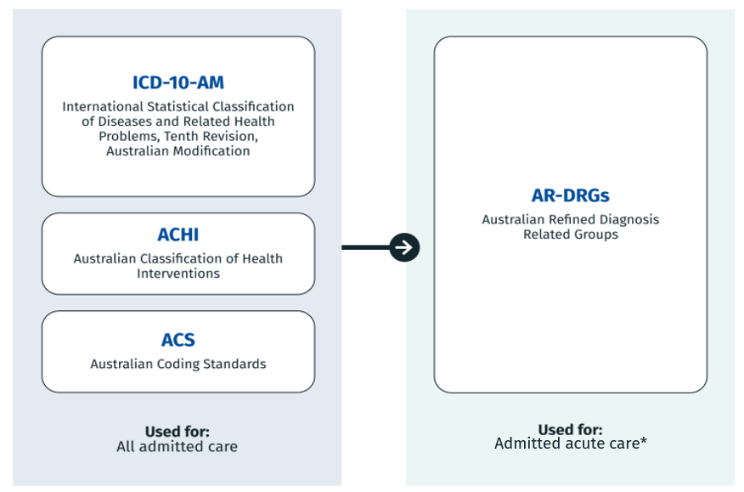

*Admitted acute care includes newborn care

ICD-10-AM is based on the World Health Organization’s (WHO) International Statistical Classification of Diseases and Related Health Problems, Tenth Revision (ICD-10) and classifies diseases, injuries and health related problems.

ACHI classifies surgeries, therapies and other health interventions and maintains alignment with the Medical Benefits Scheme (MBS).

The ACS are a set of instructions that are applied in assigning ICD-10-AM and ACHI codes to promote consistency in the classification of admitted episodes of care. Collectively known as the ICD-10-AM/ACHI/ACS classification system, it captures clinical activity for admitted patient care, and has a number of purposes, including:

* + identifying patterns and disease trends
  + clinical research and management
  + research into the quality of healthcare and patient safety.

The AR-DRG classification uses data coded using the ICD-10-AM/ACHI/ACS classification system along with other routinely collected data to classify episodes of admitted acute care in public and private hospitals across Australia. AR-DRGs provide a clinically meaningful way of relating the number and types of acute admitted patients to the resources required in treatment.

AR-DRGs are used for a number of purposes, including:

* + benchmarking
  + epidemiology
  + facilitation of payment of services in the private healthcare sector
  + health service planning
  + performance management.

AR-DRGs capture admitted acute activity and are utilised in calculating the national efficient price for public hospital activity based funding (ABF).

## 2.2 Requests for classification development

Requests for classification development are progressed through a **public submission** lodged on the [Australian Classification Exchange (ACE) portal](https://ace.ihacpa.gov.au/Ace/) and apply to both ICD-10-AM/ACHI/ACS and AR-DRGs. Public submissions may be used to inform classification development after meeting the respective classification development principles for each classification.

There is no restriction on who may submit a public submission.

## 2.3 Requests for classification guidance

Requests for classification guidance are progressed through a **query submission** lodged on the ACE portal and apply only to ICD-10-AM/ACHI/ACS. Query submissions may be progressed as a Coding Rule or frequently asked question and published as [National Coding Advice](https://www.ihacpa.gov.au/resources/national-coding-advice).

Query submissions are restricted to the jurisdictional coding advisory committees.

Further information on this process, including the activation of ACHI placeholder codes, is available on the [IHACPA website](https://www.ihacpa.gov.au/resources/national-coding-advice).

## 2.4 Licensing arrangements for the classifications

Australian users may purchase the finalised classifications from IHACPA’s publishing partner [Lane Print](https://ar-drg.laneprint.com.au/). The use of the admitted care classifications in other countries are subject to licence arrangements and depend on the country.

External software vendors may also provide products that relate to the admitted care classifications. For further information on these products, and country license arrangements, the following avenues are available:

Website: www.ihacpa.gov.au/health-care/products-and-licenses

Email: Classification.Licensing@ihacpa.gov.au

Phone: (02) 8215 1100

# Principle-based development

The admitted care classifications are developed using a principle-based approach. Four principles are used across the development cycle to ensure that the classifications are fit for purpose. These principles are illustrated in **Figure 2**.

Figure 2. Four types of principles guiding the classification development cycle.

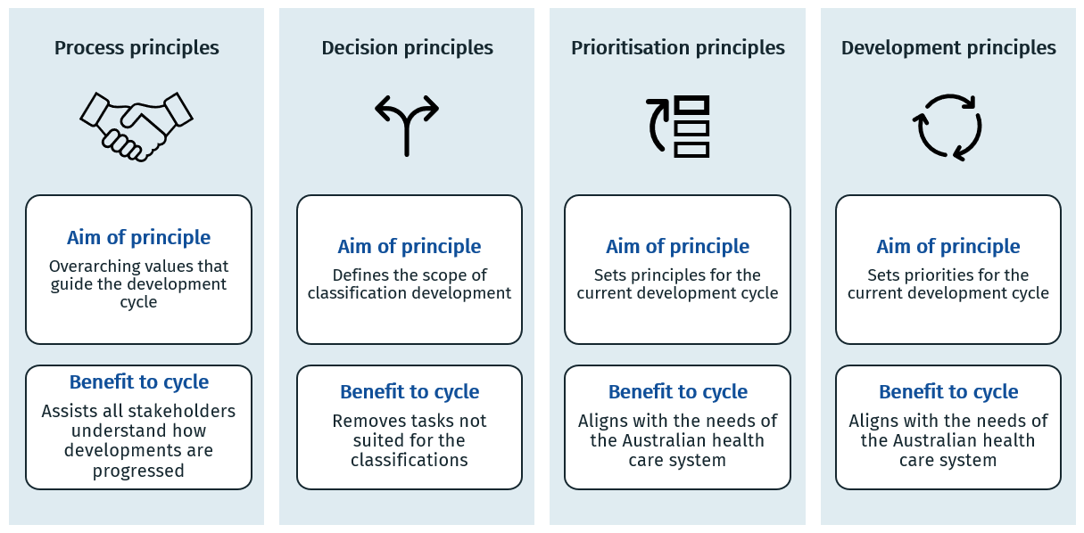

The process principles apply across all aspects of the ICD-10-AM/ACHI/ACS and AR-DRG classification development cycle.

The decision principles, prioritisation principles and development principles are specific to the development of each classification system.

## 3.1 Process principles

The process principles identify the overarching values strived for, and the steps taken to achieve these values, during the process of reviewing and developing refinements to the admitted care classifications.

### 3.1.1 Transparency

* + The work program and principles outlined in the Framework are updated for each new development cycle following consultation.
  + Updates to the classification systems will be made following consultation and then documented for future reference.
  + Final decisions will be shared with the relevant advisory group members. Subsequent amendments arising from quality assurance processes will be shared prior to the publication of the classifications.
  + Public submission outcomes will be made available via the Australian Classification Exchange (ACE) portal.
  + Public consultation will seek feedback on the major changes to the classifications (such as new codes or end classes) and flag any significant changes to the classification products.

### 3.1.2 Respect of process

* + Advisory group members will have appropriate opportunity to review meeting papers and provide feedback to IHACPA.
  + IHACPA will make a final decision, considering all factors informing the development process (i.e. development principles, advisory group feedback and clinical input) to support the national interest in the use of the classifications.

### 3.1.3 Evidence-based

* + Classification development will follow an evidence-based approach based on the decision, prioritisation and development principles to ensure the classifications are fit for purpose for their many uses.
  + Clinical input will be sought from the Classifications Clinical Advisory Group (CCAG), or a more specialised clinical authority, where indicated.
  + International classifications will be considered in the development process.

### 3.1.4 Stability

* + Classification development will consider consistency and timing of changes for the purposes of maintaining data stability. Stability will be balanced with the ability of the classifications to remain agile by including the issuing of National Coding Advice to utilise emergency use codes (ICD-10-AM) and provisional use codes (ACHI).
  + The admitted care classifications will be developed to ensure integration across  
    ICD-10-AM/ACHI/ACS and AR-DRGs.

## 3.2 ICD-10-AM/ACHI/ACS principles

### 3.2.1 Decision principles

The decision principles identify submissions that are in scope for classification development. IHACPA will seek advice from the CCAG or the appropriate advisory group where required. Where CCAG determines that a public submission is clinically incoherent, it will not proceed for classification development.

Concepts identified as out of scope may be better addressed elsewhere than in the development of the admitted care classifications, such as jurisdictional admission policies or the development process for related classification systems.

**In-scope:**

* Changes related to ensuring ACHI is fit for purpose
* Changes related to ensuring the ACS are fit for purpose
* Changes related to reducing the National Coding Advice or public submissions
* Changes related to incorporating instructions from the WHO
* Minor changes to ICD-10-AM that support the above.

**Out of scope:**

* Changes related to the Classification of Hospital Acquired Diagnoses (CHADx)
* Changes related to the specifications of the Hospital Acquired Complications (HAC) list
* Changes related to the structure or content of IHACPA’s other ABF classifications
* Changes related to policies that do not apply nationally (e.g. admission policies, data quality audit programs)
* Changes that may lead to significant instability in admitted patient care data
* Changes that are not supported by CCAG or not incorporated in an equivalent classification published by the WHO.

### 3.2.2 Prioritisation principles

The following classification development tasks are considered standard refinements for the   
ICD-10-AM/ACHI/ACS work program:

* Amendments arising from the errata identified in the previous edition
* Amendments that correct other issues identified by the classification developer
* Review of the introduction content for each classification volume, including the conventions
* Review of the use of the emergency use codes (ICD-10-AM) and provisional use codes (ACHI) for potential incorporation into the main chapters of each classification.

All remaining in-scope development submissions will be assessed against the prioritisation principles.

A development submission will be assigned a priority level if it meets at least one of the criteria defined within that priority level (**Table 1**). Where a development submission meets criteria from more than one priority level it will be assigned to the higher level.

IHACPA will seek advice from CCAG and/or the appropriate advisory group to determine if the priority level of a development task requires review.

Table 1. Priority criteria **for ICD-10-AM/ACHI/ACS development tasks**

| **Priority** | **Criteria for priority level** |
| --- | --- |
| **High priority** | * Updates related to refining problematic ACS * Updates related to the Medicare Benefits Schedule (MBS) * Updates related to the Australian Schedule of Dental Services and Glossary * Updates related to ACHI and ICD-10-AM where the current edition does not reflect contemporary clinical practice (i.e. gaps in ACHI and ICD-10-AM) * Updates that support the implementation of initiatives under the National Health Reform Agreement (NHRA) * Concepts identified by IHACPA in a previous development cycle as a priority * Updates that support national strategies or significant public health issues, as agreed by ITG Members * Referrals from AR-DRG development that also add value to ICD-10-AM/ACHI/ACS |
| **Medium priority** | * Updates to ACS that are the subject of multiple guidelines in the National Coding Advice * Updates that support jurisdictional strategies * Changes to edits on classification codes * Updates that address conflicting or missing classification conventions that may restrict or cause unnecessary code assignment. |
| **Low priority** | * A development proposal is assigned as low priority if it does not meet any of the principles in high or medium priority. |

### 3.2.3 Development principles

The development principles identify the rules applied during the refinement and development process of the ICD-10-AM/ACHI/ACS classification system. The development principles for   
ICD-10-AM/ACHI/ACS align with the relevant hardcopy volume (**Tables 2**, **3**, **4**, **5** and **6**) and include the conventions of the electronic code lists (ECL) with the Tabular List conventions. Development principles do not account for conventions used solely in the introduction section of the Alphabetic Indices or Tabular Lists for navigation purposes – this includes the use of punctuation, typeface and annotations.

The most recent five years of activity data available at the commencement of the development cycle is used to inform the development of the ICD-10-AM/ACHI/ACS classification system and is taken from public and private hospital data collections. Specific areas of classification development may require more recent data than is available at commencement of the development cycle, these refinements may be initiated later in the development cycle with more recently available data.

Table 2. Development conventions for the ICD-10-AM Tabular List and ICD-10-AM ECL attributes

| **Convention** | **Principles** |
| --- | --- |
| **Code** | * Between 3 and 5 characters long * Utilise a dash to indicate a third, fourth or fifth character code in the Tabular List is required |
| **Description** | * Spelling of terms are consistent with similar terms in the block range or chapter * Terminology to align with ICD-11 * No use of apostrophes with eponyms * Limited use of special characters * Preference to use scientific terminology over eponyms * ‘and’ implies ‘and/or’ * ‘due to’ implies causal relationship between conditions |
| **ECL description** | * Uses the same principles as Description, unless additional terms from the hierarchy are required for context |
| **ECL short description** | * Uses the same principles as the Description, unless the character count is  over 40 * All abbreviated and truncated words are listed in the ECL dictionary |
| **Age edits** | * An age edit is used when the concept has an expected age range for which the condition frequently occurs. |
| **Sex flag** | * Codes using ‘male’ refer to the biological characteristics of the male reproductive system * Codes using ‘female’ refer to the biological characteristics of the female reproductive system |
| **Rare use flag** | * Rare diagnosis codes relate to rare and/or notifiable diseases; applied to  ICD-10-AM Chapters 1 to 21 * Emergency use codes relate to whether a code is provisionally activated; applied to ICD-10-AM Chapter 22 *Codes for special purposes* |
| **Unacceptable diagnosis flag** | * Unacceptable principal diagnosis codes align with  ACS 0050 *Unacceptable principal diagnosis codes* * Unacceptable diagnosis codes align with ACS 0049 *Disease codes that must never be assigned* |
| **Inclusion terms** | * Uses the same principles as Description, except eponyms may be used as *Inclusion* terms * *Inclusion* terms must appear in the Alphabetic Index |
| **Instructional notes/terms** | Listed in the following order, then in alphabetic order within each *Instructional* note:   * *Glossary description/definition* * *Includes* * *Note* * *See* * *Code first* * *Code also/Use additional code* * *Excludes*   Other:   * Subdivisions only apply to the specified code range. Site subclassifications may apply to multiple specified categories * *Excludes* notes are placed at the broader concept to redirect users to more specific concepts, if applicable. *Excludes* notes should not be duplicated at both codes/blocks. |
| **Special signs/Annotations** | * Dagger symbol applied to an aetiology code concept subject to dagger/asterisk dual classification, denoting a full-time dagger * Asterisk symbol applied next to the code of a manifestation concept, subject to dagger/asterisk dual classification * ACS symbol is applied to codes/categories/ranges/chapters that are specifically mentioned in the ACS. |
| **Residual codes** | For new fourth character level codes:   * specific conditions – use characters 0 to 7 * specific conditions that are not classified elsewhere (‘other’) – use character 8 * unspecified conditions (‘NOS’) – use character 9   For new fifth character level codes:   * specific conditions – use characters 1 to 8 * specific conditions that are not classified elsewhere (‘other’) – use character 9 * unspecified conditions (‘NOS’) – use character 0   Specific conditions that are not elsewhere classified are reviewed for candidacy to become a specific condition category using frequency data. |

Table 3. Development conventions for the ICD-10-AM Alphabetic Index

|  |  |
| --- | --- |
| **Convention** | **Principles** |
| **Cross references** | * Cross references are used rather than duplicating the same subterms at a different lead term * *See* is used for the preferred alternative indexing term; a code is never provided at a *See* cross reference * *See also* is used for an alternative indexing term where subterms provide more specificity * *See condition* is used where an alternative index pathway is required; a code is never provided at a *See condition* cross reference * *Code to* is used for a code range where the same fourth or fifth character codes may be applied, and the three character category is defined within that code range; a code range and a fourth or fifth character is provided at a *Code to* reference |
| **Structure** | Essential Modifiers:   * Listed in alphabetic order * No use of apostrophes with eponyms * List prepositional terms (including those in parentheses) in alphabetic order, then remaining terms in alphabetic order   Nonessential Modifiers:   * Must not appear as essential modifier at the same level under a lead term |
| **Lead terms** | * Listed in alphabetic order |
| **Subterms** | * in (due to) indicates a causal link |

Table 4. Development conventions for the ACHI Tabular List and ACHI ECL attributes

| **Convention** | **Principles** |
| --- | --- |
| **Chapter** | * The structure of the intervention classification is based on anatomy rather than surgical specialty. * Chapters generally align with the chapter headings of ICD‑10-AM to maintain parity with the disease classification. |
| **Block** | * Nonsurgical interventions are listed separately from surgical interventions * Codes are listed from most to least invasive within the block |
| **Code** | * Seven characters in length * First five characters (the stem) should be used for similar concepts, with more specific intervention concepts differentiated with distinct codes for the final two characters (the extension) * Extension of ‘XX’ is used for an ACHI code where a two character extension code is provided in detail in the Tabular List * Provider neutral, where possible * Diagnostic terms are avoided, where possible * For new codes, the following basic concepts apply:   + Insertion/Implantation, Adjustment and Removal/Excision   + Unilateral, or single interventions performed (e.g. code applied per session) * For enhancing existing codes, frequency data may be used to refine concepts to include:   + Revision/Replacement   + Bilateral, or ranges of interventions performed (e.g. less than 10 sessions, 11-20 sessions) * Clinical advice is required to determine if a new code should pre-coordinate open or endoscopic approaches |
| **Description** | * Spelling of terms are consistent with similar terms in the block range or chapter * No use of apostrophes with eponyms * Preference to use scientific terminology over eponyms * ‘and’ implies ‘and’; ‘or’ implies ‘or’ |
| **ECL description** | * Uses the same principles as Description, unless additional terms from the hierarchy are required for context |
| **ECL short description** | * Uses the same principles as the Description, unless the character count is over 40 * All abbreviated and truncated words are listed in the ECL dictionary |
| **Age edits** | * An age edit is required when the code can only be used for a specific age range. |
| **Sex flag** | * Codes using ‘male’ refer to the biological characteristics of the male reproductive system * Codes using ‘female’ refer to the biological characteristics of the female reproductive system |
| **Rare use flag** | * Provisional use codes relate to whether a code is provisionally activated; applied to ACHI Chapter 21 *Codes for special purposes* |
| **Inclusion terms** | * Uses the same principles as Description, except eponyms may be used as *Inclusion* terms * *Inclusion* terms must appear in the Alphabetic Index |
| **Instructional notes/terms** | Listed in the following order, then in block number order within each *Instructional* note:   * *Glossary description/definition* * *Includes* * *Note* * *Code also when performed* (*Code also*, *Code first*) * *Excludes*   Other:   * Extensions only apply to the specified code range. Site extensions may apply to multiple specified blocks. * Diagnostic terms are located in the *Note* * *Excludes* notes are located at the broader concept to redirect users to more specific concepts, if applicable. *Excludes* notes should not be duplicated at both codes/blocks. |
| **Residual codes** | Specific interventions that are not elsewhere classified are reviewed for candidacy to become a specific intervention category using frequency data. |

Table 5. Development conventions for the ACHI Alphabetic Index

|  |  |
| --- | --- |
| **Convention** | **Principles** |
| **Cross references** | * *See* is used for the preferred alternative indexing term; a code is never provided at a *See* cross reference * *See also* is used for an alternative indexing term where subterms provide more specificity * *See block* is used where the code assigned may be selected from the Instructional notes within the ACHI Tabular List * *Code specific procedure performed* is used where an alternative index pathway is required; a code is never provided at this cross reference * *Omit code* is used to indicate a code should not be assigned as it may represent an intervention component; a code is never provided at this cross reference * Cross references are used rather than duplicating the same subterms at a different lead term |
| **Structure** | Essential Modifiers:   * Listed in alphabetic order * No use of apostrophes with eponyms * Lists prepositional terms in alphabetic order, then remaining terms in alphabetic order   Nonessential Modifiers:   * Must not appear as essential modifier at the same level under a lead term * Well-known product names may be used, where applicable * Well-known abbreviations are adjacent to the applicable code |
| **Lead terms** | * Listed in alphabetic order |

Table 6. Development conventions for the ACS

|  |  |
| --- | --- |
| **Convention** | **Principles** |
| **Coding standard number** | * Reference for an ACS is four digits, with the first two digits representing the chapter to which the ACS belongs (general standards have the first two digits of 00) |
| **Coding standard content** | * Coding standards must contain advice that cannot be covered by classification convention alone * Existing ACS may be retired with the advice converted into classification convention or content in the Alphabetic Index or Tabular List as required * Information in the ACS must prioritise classification advice over clinical information that may become out of date * Title must have the expanded concept with any common abbreviation included in parentheses * ACS and relevant sub-sections must be indexed in the *ACS Standards Index* |
| **Examples** | * Scenarios or examples may be described to provide context to the classification guidelines. The examples are not a complete representation of an entire episode of care and should not be inferred to have meaning beyond the specific guidelines * Examples are provided where necessary to illustrate coding directives and include a rationale as to why relevant codes are applied * Details not immediately relevant to applying the guidelines in that ACS are generally not included in examples to focus the example and rationale * Code titles use the electronic code list description |
| **Appendices** | * Coding guidelines are not included in the appendices but support the application of the ACS |
| **Glossary** | * Terms must be specific to the application of the ACS * Does not include clinical terms or definitions |

## 3.3 AR-DRG principles

### 3.3.1 Decision principles

The decision principles identify development proposals that are in-scope for AR-DRG classification development. IHACPA will seek advice from the CCAG or another appropriate advisory group where required. Where CCAG determines that a development proposal is clinically incoherent, it will not proceed for classification development.

**In-scope:**

Development proposals must address issues that are:

* + related to improving the performance of AR-DRGs in classifying admitted acute episodes of care
  + based on data elements that reflect the clinical or demographic characteristics of admitted acute episodes of care, rather than characteristics of service providers
  + measurable using hospital activity and cost data that are accessible by IHACPA.

**Out of scope:**

Development proposals are out of scope if they address issues that are:

* + related to care types not classified using AR-DRGs under ABF arrangements, such as mental health care and subacute care
  + not classifiable using data elements based on clinical or demographic characteristics of admitted acute episodes of care
  + related to pricing rather than AR-DRGs, such as hospital acquired complications (HACs)
  + coding issues in the underpinning disease and intervention classification
  + unique to an AR-DRG version no longer supported by IHACPA[1], i.e. Version 7.0 and prior.
  + grouping anomalies that affect a limited number of episodes.

### 3.3.2 Prioritisation principles

The following classification development tasks are considered standard refinements for new versions of AR-DRGs:

* + Review and refinement of the Episode Clinical Complexity (ECC) Model to maintain clinical currency and cost homogeneity, including:
  + review of codes in-scope for receiving a Diagnosis Complexity Level (DCL)
  + recalibration of the DCLs using cost and activity data
  + review of splitting thresholds for end classes.
  + Review of the intervention hierarchy using cost and activity data
  + Integration of changes emanating from the underpinning ICD-10-AM/ACHI/ACS classification system
  + Review of issues related to ADRG 801 *General Interventions Unrelated to Principal Diagnosis* that affect a relatively high number of episodes[2].

All remaining in-scope development proposals will be assessed against the prioritisation principles.

A development proposal will be assigned a high priority level if it meets at least one of the criteria defined within the high priority level (**Table 7**).

IHACPA will seek advice from CCAG and/or the appropriate advisory group to determine if the priority level of a development task requires review.

Table 7. Priority principles for AR-DRG development tasks

| **Priority** | **Criteria for priority level** |
| --- | --- |
| **High priority** | * + Issues that demonstrate significant material impact on the classification as measured by episodes affected or costs involved[3]   + Issues that affect a wide range of MDCs/ADRGs   + Issues related to changes in clinical practice and technology that can be assessed using sufficient, available data * Areas that may warrant review due to the length of elapsed time from previous review and a review is timely due to clinical advances. |
| **Low priority** | A development proposal is assigned as low priority if it does not meet any of the principles in high priority. |

Throughout the development cycle, classification development tasks may be added to the work program where they meet the high priority criteria. Consequently, lower priority classification development tasks may be held over for completion in a future development cycle.

### 3.3.3 Development principles

Cost and activity data used for the development of AR-DRGs uses the most recently available data at the commencement of the development cycle.

The development principles identify the rules applied during the refinement and development process for the AR-DRG classification system, as follows:

#### Primary principles

* + Clinical coherence: The AR-DRG classification must ensure that episodes within a class have similar characteristics with respect to diagnoses (both principal and additional diagnoses), interventions and treatment administered.
  + Resource homogeneity: The AR-DRG classification must ensure episodes have a similar level of resource utilisation within a class, and a large variation in resource utilisation between classes.
  + Classification soundness: The AR-DRG classification must have a manageable, balanced number of classes that are statistically robust and relatively stable over time.
  + Statistical soundness: The statistical performance of the AR-DRG classes must be sound according to various statistical measures.
  + Evidence based: Changes to the AR-DRG classification must be supported by hospital activity and cost data that can be accessed by IHACPA.
  + Integration with underpinning disease and intervention classification: The AR-DRG classification must be integrated with the underpinning ICD-10-AM/ACHI/ACS classification system, for example, there must be consistency between the admitted care classifications in relation to unacceptable principal diagnoses, sex and other demographic edits.

#### Pre Major Diagnostic Category (Pre MDC) principles

A Pre MDC class must meet both of the following criteria:

* + Episodes are clinically considered to be more appropriately classified according to treatment provided than principal diagnosis
  + There is an inherent high cost in the treatment provided.

#### Major Diagnostic Category (MDC) principles

* + An MDC requires a balance of clinical coherence and resource homogeneity
  + All episodes can be grouped into an MDC based on its principal diagnosis
  + The majority of episodes within an MDC should be grouped to specific ADRGs rather than non-specific ADRGs (e.g. ADRG 801 *General Interventions (GIs) Unrelated to Principal Diagnosis* and residual, non-specific ADRGs).

#### Adjacent Diagnosis Related Group (ADRG) principles

* + An ADRG requires a balance of clinical coherence and resource homogeneity
  + An ADRG should contain at least 200 episodes per year, except for those designed to contain rare and high cost episodes[4]
  + For development proposals requesting new ADRGs, appropriate placement within a current ADRG must be considered in the first instance.

#### ADRG hierarchy principles

The intervention hierarchy is based on the following criteria:

* + Intervention ADRGs must be sorted from high to low cost with decisions based on both mean and median cost
  + Intervention ADRGs must be sorted from specific to non-specific ADRGs and before ADRG 801 *General Interventions (GIs) Unrelated to Principal Diagnosis*. This criterion may override the cost criterion[5]
  + Intervention ADRGs must be sorted from the initial definitive intervention, to follow-up and supportive interventions and from major to minor or other interventions. This criterion may override the cost criterion
  + Intervention ADRGs must be sorted from treatment to diagnostic interventions. This criterion may override the cost criterion.

#### Diagnosis Related Group (DRG) principles

The following principles inform appropriate splitting into DRG end classes. In certain circumstances, the specific principles may be relaxed to cater for special case ADRGs. An example includes high volume ADRGs such as O60 *Vaginal delivery*.

* A DRG must have at least 200 episodes per year, except for those within an ADRG with a limited number of episodes
* A DRG must have a minimum total cost of $1 million per year
* A DRG must have at least 10 per cent of episodes within the ADRG
* The absolute change in mean cost between consecutive DRGs must be at least $3,700
* The relative change in mean cost between consecutive DRGs should be at least 2 times
* There should be an inverse trend between the number of episodes in a DRG and the complexity level of the DRG.

#### Principles for diagnosis exclusions from the complexity model

Codes are out of scope within the complexity model and excluded if they:

* + represent undefined or ill-specified conditions
  + represent symptoms and findings or transient conditions
  + provide additional or contextual information only
  + most unacceptable principal diagnosis codes
  + represent asymptomatic or sub-clinical conditions
  + represent markers of other diseases
  + represent minor conditions that do not generally result in admitted acute episodes of care
  + represent an underlying cause of disease.

#### Principles for new edition ICD-10-AM codes that are deemed in-scope within the complexity model

As data for codes created in a new edition of ICD-10-AM will only be available after implementation, new edition ICD-10-AM codes that are deemed in-scope within the complexity model cannot have an accurate DCL assigned due to the absence of data from which a DCL can be derived.

The new in-scope codes will receive the same DCLs as their logical backward maps in the previous edition of ICD-10-AM. In rare circumstances when a new ICD-10-AM code backward maps to a code in the previous edition that is, or becomes, excluded from the complexity model, that new code will receive a DCL of zero in the new AR-DRG version even though it is, in principle, in-scope for DCL calculation.

In future AR-DRG versions, the new in-scope codes will receive their own DCLs calculated from the most recent activity and cost data associated with the new code.

# Classification development process

## 4.1 Development cycle timelines and milestones

The development cycle of the ICD-10-AM/ACHI/ACS and AR-DRG classification systems is a three-year cycle. This approach balances clinical currency against data stability and reduces the administrative burden in implementing new releases of the classifications. **Figure 3** provides an illustration of the three-year cycle from 2022–23 to 2025–26.

Figure 3. Anticipated timelines for ICD-10-AM/ACHI/ACS Thirteenth Edition and AR-DRG Version 12.0. 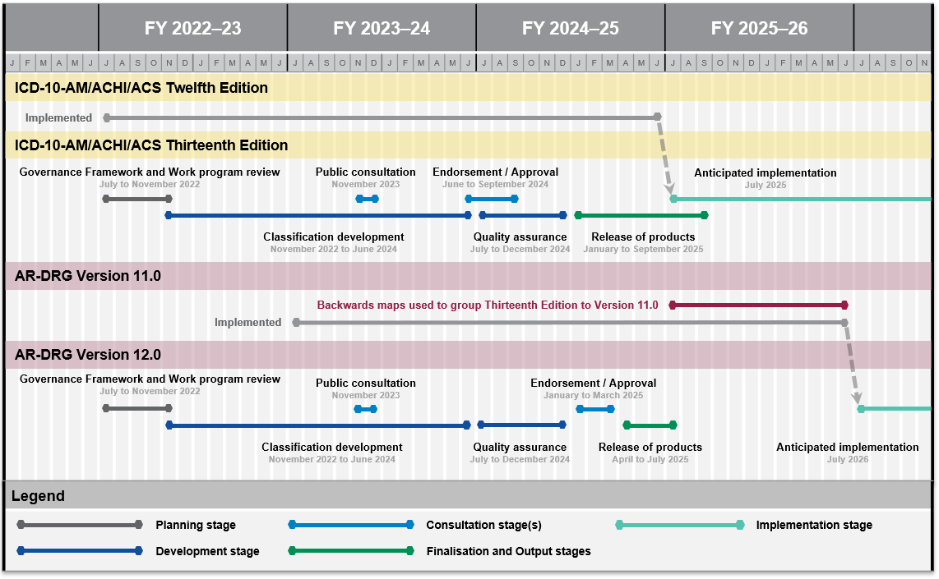

There are key dependencies between the ICD-10-AM/ACHI/ACS and AR-DRG classification systems and both are developed concurrently to ensure these dependencies are maintained.   
ICD-10-AM/ACHI/ACS is released several months prior to the AR-DRG classification implementation is staggered one year after ICD-10-AM/ACHI/ACS.

## 4.2 Technical and clinical advisory groups

IHACPA’s advisory groups listed in **Table 8** are responsible for providing expert technical and clinical advice throughout the development cycle. Advisory groups use their networks to ensure comprehensive input is received on changes to the classification in the development stage of the cycle.

Table 8. Advisory groups involved in the development stage

| **Group** | **Description** | **Role in development cycle** |
| --- | --- | --- |
| **Classifications Clinical Advisory Group (CCAG)**  [Further information on CCAG](https://www.ihacpa.gov.au/about-ihacpa/what-we-do/committees-and-working-groups/classifications-clinical-advisory-group). | **Advisory group.**  **Membership includes representation from IHACPA’s Clinical Advisory Committee as well as medical, nursing and allied health professions with significant knowledge of the classification.** | **Provides expert clinical advice on classification development proposals.**  **Assists IHACPA in applying development principles (see Sections 3.2.3 and 3.3.3).** |
| **ICD Technical Group (ITG)**  [Further information on ITG](https://www.ihacpa.gov.au/about-ihacpa/what-we-do/committees-and-working-groups/international-classification-diseases-technical-group). | **Advisory group.**  **Membership includes representatives from all jurisdictions, public and private healthcare organisations, Australian health sector organisations and peak bodies.** | **Provides expert classification advice and technical input on ICD-10-AM/ACHI/ACS development by providing feedback on technical development tasks.**  **Assists IHACPA in applying development principles (see Section 3.2.3).** |
| **DRG Technical Group (DTG)**  [Further information on DTG](https://www.ihacpa.gov.au/about-ihacpa/what-we-do/committees-and-working-groups/diagnosis-related-groups-technical-group). | **Advisory group.**  **Membership includes representatives from all jurisdictions, public and private healthcare organisations, Australian health sector organisations and peak bodies.** | **Provides technical input on AR-DRG development by providing feedback on technical development tasks.**  **Assists IHACPA in applying development principles (see Section 3.3.3).** |

## 4.3 Consultation and endorsement committees

IHACPA’s consultation and endorsement committees are listed in **Table 9** and provide strategic advice in the consultation stage of the development cycle.

The public consultation process is conducted prior to finalising the admitted care classifications to ensure the broadest possible consultation across the public and private health sector. Stakeholders may opt in to receive updates about the public consultation process by [subscribing to alerts](https://www.ihacpa.gov.au/subscribe) on the IHACPA website.

A draft final report for both ICD-10-AM/ACHI/ACS and AR-DRGs outlines key areas of change proposed for interested stakeholders and members of the public to provide feedback on new editions/versions of the classifications.

IHACPA uses feedback from the public consultation process to refine the classifications and, where necessary, seeks advice from the advisory groups before progressing the classifications through the endorsement committees and finally to the [Pricing Authority](https://www.ihacpa.gov.au/about-ihacpa/who-we-are/pricing-authority) (IHACPA’s Board) for approval.

Table 9. Consultation and endorsement committees involved in the consultation stage

| **Group** | **Description** | **Role in development cycle** |
| --- | --- | --- |
| **Technical Advisory Committee (TAC)**  Further information on [TAC](https://www.ihacpa.gov.au/about-ihacpa/what-we-do/committees-and-working-groups/activity-based-funding-technical-advisory-committee). | Endorsement committee.  Membership includes representatives from all jurisdictions with expertise in clinical costing, classification, data processing and modelling that underpins the development of ABF. | Provides technical input on classification and data standards that underpin classification development. |
| **Jurisdictional Advisory Committee (JAC)**  Further information on [JAC](https://www.ihacpa.gov.au/about-ihacpa/what-we-do/committees-and-working-groups/jurisdictional-advisory-committee). | Endorsement committee.  Membership includes representatives from all jurisdictions | Reviews and endorses the classifications. |
| **Clinical Advisory Committee (CAC)**  Further information on [CAC](https://www.ihacpa.gov.au/about-ihacpa/what-we-do/committees-and-working-groups/clinical-advisory-committee). | Endorsement committee.  Membership consists of specialists that are appointed by the Australian Government Minister for Health, and are drawn from a range of clinical specialties and backgrounds to ensure a wide range of clinical expertise | Provides clinical input on classification and data standards that underpin development of the classifications.  Reviews and endorses the classifications. |

The National Health Data and Information Standards Committee (NHDISC) is a national committee run by the [Australian Institute of Health and Welfare](https://www.aihw.gov.au/about-us/committees) with technical and working knowledge of health classification and data standards. They are an endorsement committee for the metadata and data standards that relate to data coded using ICD-10-AM/ACHI/ACS in the various health data collections, including the Admitted Patient Care NMDS (APC NMDS).

## 4.4 Approval by the Pricing Authority

Following the public consultation on major classification changes, IHACPA seeks endorsement of the finalised classifications from its technical and advisory groups. The final step is to seek approval from the Pricing Authority. The Pricing Authority oversees IHACPA’s function and work and has ultimate responsibility to finalise and implement classifications under the *National Health Reform Agreement*.

**Figure 4** illustrates the stages in the classification development cycle with key governance groups identified and the role of the Pricing Authority in the finalisation stage.

Figure 4. Overview of the stages in the classification development process.

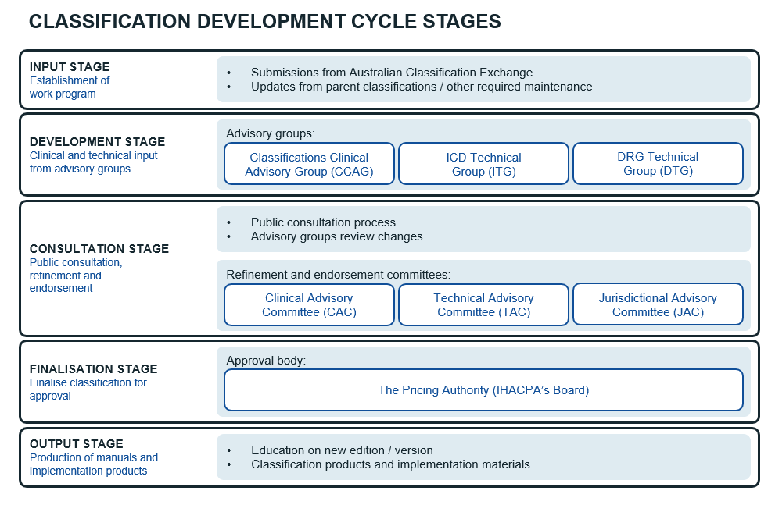

## 4.5 Outcomes of the classification development cycle

The outcomes of the classification development cycle are provided as classification products. Public submissions that have informed the development of the classification are outlined in the Summary of Updates publication (See *section 5.1.1*).

# Development cycle outputs

## 5.1 Classification products

The ICD-10-AM/ACHI/ACS and AR-DRG classification systems are licensed products. There are no restrictions for purchasing the classification products if you are located within Australia, however users from other countries require a license agreement.

Further information can be found on IHACPA’s website:   
<https://www.ihacpa.gov.au/health-care/products-and-licenses>

Details of what is included in each product is summarised below. Further details on how to use these products or their technical outputs are provided in the introduction content or accompanying user guide as applicable.

### 5.1.1 ICD-10-AM/ACHI/ACS products

The following classification products were produced for ICD-10-AM/ACHI/ACS Twelfth Edition:

* **ICD-10-AM Alphabetic Index** is used to locate diagnostic terms to be coded. The ICD‑10-AM Alphabetic Index contains diagnostic terms that do not appear in the ICD-10-AM Tabular List. The ICD-10-AM Alphabetic Index contains three sections:
  + - * Section I: Alphabetic index of diseases and nature of injury
      * Section II: External causes of injury
      * Section III: Table of drugs and chemicals.
* **ICD-10-AM Tabular List** contains the disease classification itself at the three, four and five character levels. A listing of the three character categories is also included.
* **ACHI Alphabetic Index** is used to locate procedural terms to be coded. The ACHI Alphabetic Index contains procedural terms which do not appear in the ACHI Tabular List.
* **ACHI Tabular List** contains the procedure classification itself and includes details of the axes by which the classification is structured. **ACS** contains the Australian standards that provide guidance in the application of the ICD-10-AM and the ACHI codes.
* **Mapping tables for ICD-10-AM and ACHI** are licensed material that demonstrate the relationship between the codes in two concurrent editions of the ICD-10-AM/ACHI. The mapping tables provide a means of interpreting data using codes from either of the two concurrent editions of the classification with:
  + - backward maps providing equivalent codes for codes created in the newer edition
    - forward maps providing equivalent codes for codes deleted in the newer edition.

Both of these types of maps provide an equivalent code that best matches the concept from a clinical perspective in a tabulated form.

Mapping tables are also available between ICD-10-AM and the parent classification ICD-10, as well as a map between ACHI and the Medicare Benefits Schedule.

* **Electronic code lists (ECLs) for ICD-10-AM and ACHI** are licensed electronic files that are used in the development of software or are integrated into existing patient software using the ICD-10-AM and ACHI codes for private or commercial purposes.
* The **Chronicle** is a reference tool to document changes between editions of   
  ICD-10-AM/ACHI/ACS and aims to improve the understanding about changes made to the   
  ICD-10-AM/ACHI/ACS, and reasons for changes. The Chronicle is updated with each new edition of ICD-10-AM/ACHI/ACS.
* **Summary of Updates** summarises the changes, such as the codes created, amended and deleted for the classifications, and summarises the public submissions that were assessed for the development of that edition.
* **Reference to Changes** details the changes, such as the updates to the Alphabetic Index, Tabular List and ACS, across ICD-10-AM/ACHI/ACS made for that edition.
* **Electronic appendices** are electronic files that lists unacceptable diagnosis codes and the special tabulation lists for mortality and morbidity.

### 5.1.2 AR-DRG products

The following classification products are produced for each new version of AR-DRGs:

* + **Final Report** outlines the changes made for the new version of AR-DRGs and details the refinement process and rationale for changes.
  + **Technical Specifications** details the methodology and technical specifications used in the development of the new AR-DRG version, including:
  + data preparation and modification
  + ADRG intervention hierarchy review
  + derivation of the Episode Clinical Complexity Score (ECCS)
  + ADRG splitting review.
  + **Definitions Manual** provides a high level understanding of DRG grouping logic and assists with the identification of likely DRG assignments for individual episodes of care. The Definitions Manual comprise three volumes:
  + Volume One: DRGs A13A–I80Z
  + Volume Two: DRGs J01A–Z66Z
  + Volume Three: Appendices.

Appendices found in volume three are also provided in Excel format. As there is no DCL information within the Definitions Manual, users are unable to identify the resulting DRG that requires the Episode Clinical Complexity Score splits, therefore, it is not intended to serve as a substitute for the grouper.

* + **Descriptions** provide a full listing of long and short descriptions for MDCs, ADRGs and DRGs displayed in an Excel format and are available on the IHACPA website.
  + **AR-DRG grouper specifications** facilitate commercial development of AR-DRG groupers by licensed software vendors.

## 5.2 New edition education

Education is released with each new edition of ICD-10-AM/ACHI/ACS and AR-DRGs to familiarise users with the changes being implemented. The education is designed to highlight major changes in a comprehensive and accessible manner and may be provided in varying formats. Education is also supplemented by several accompanying documents that support implementation.



Independent Health and Aged Care Pricing Authority

Eora Nation, Level 12, 1 Oxford Street  
Sydney NSW 2000

Phone 02 8215 1100  
Email [enquiries.ihacpa@ihacpa.gov.au](mailto:enquiries.ihacpa@ihacpa.gov.au)  
Twitter @IHACPAnews

www.ihacpa.gov.au

1. Please refer to [*Revision of ICD-10-AM/ACHI/ACS and AR-DRG Cycles*](https://www.health.gov.au/news/phi-circulars/phi-5421-revision-of-icd-10-amachiacs-and-ar-drg-cycles) for more information on phase out of old AR-DRG versions.
2. The issues related to ADRG 801 *General Interventions Unrelated to Principal Diagnosis* that affect more episodes will be prioritised when capacity is limited. Those affecting fewer episodes may be held over for a future development cycle.
3. IHACPA will rank and select development proposals based on their material impact on the classification and progress classification development accordingly.
4. This principle applies to the data used for AR-DRG development, that currently includes public hospital data only.
5. Specific ADRGs are ADRGs designed for one or more specific interventions. Non-specific ADRGs are residual ADRGs designed to catch episodes not grouped to specific ADRGs but have interventions related to the principal diagnoses. Non-specific ADRGs normally start with the word ‘Other’. For example. ADRG C02 *Enucleations and Orbital Interventions* is a specific ADRG, while ADRG C14 *Other Eye Interventions* is a non-specific ADRG. Non-specific ADRGs are normally at the bottom of the intervention hierarchy but before ADRG 801 *General Interventions* (*GIs) Unrelated to Principal Diagnosis*.