Independent Hospital Pricing Authority
Emergency care costing and classification project
Cost report

Version
Version 2.0, October 2017

Suggested citation
Health Policy Analysis 2017, Cost report, Independent Hospital Pricing Authority, Sydney.

Disclaimer
In accordance with Health Policy Analysis’ policy, we are obliged to advise that neither Health Policy Analysis nor any employee nor sub-contractor undertakes responsibility in any way whatsoever to any person or organisation (other than the Independent Hospital Pricing Authority) in respect of information set out in this report, including any errors or omissions therein, arising through negligence or otherwise however caused.

Health Policy Analysis Pty Ltd
Suite 101, 30 Atchison Street, St Leonards 2065
ABN: 54 105 830 920
Phone: +61 2 8065 6491
Fax: +61 2 8905 9151

Table of contents
Executive summary 1
Summary of results 2
Considerations for classification 6
Conclusion and next steps 7
1. Introduction 8
Sampling frame and participating sites 8
Time line 9
Terminology 10
Data collection 11
1. Additional patient and stay characteristics 12
2. Clinician time 13
3. Costed activity 13
2. Results 16
Emergency department stays for which data was reported 16
Overall cost characteristics 17
Patient demographics 20
General characteristics of the emergency department stays 24
Diagnosis modifiers 28
Emergency department diagnoses 30
Emergency department presenting problems 36
Movements between treatment areas 37
Procedures and other clinical activities 38
Comparison of times for activities and procedures with the consensus study of clinician times 41
Investigations 46
3. Considerations for the classification 47
4. Conclusion and next steps 50
References 51
Appendix 1: Activities and procedures 52

Executive summary
The Independent Hospital Pricing Authority (IHPA) is developing a new classification system for emergency care services for Australia, for the purposes of activity based funding. The project is referred to as the Emergency care costing and classification project, and is being undertaken by a consortium led by Health Policy Analysis.
The objectives of the project are to:
- Undertake a targeted prospective costing study to further investigate the impact of drivers of cost in providing emergency care at the patient level, and thereby aid in the development of a new emergency care classification system.

- Develop a new classification system for emergency care services for activity based funding purposes, based on a structure agreed by IHPA. This will include data specification for new data elements introduced in relation to the proposed classification system.
The costing study component included 10 hospitals from four states and territories: New South Wales, Western Australia, South Australia and the Northern Territory. It involved the collaboration of and significant efforts by staff from the participating the hospitals and health authorities. The sites, by study strata, are shown in Table 1.
Table 1 – Hospitals by study strata

Hospital name | Stratum
Sydney Children’s | Specialist paediatric (SP)
Royal Prince Alfred | Major city: large (MCL)
Sir Charles Gairdner | Major city: large (MCL)
Armadale Kelmscott | Major city: large (MCL)
Lyell McEwin | Major city: large (MCL)
Royal Darwin | Regional: large (ReL)
Blacktown | Major city: other (MCOt)
Port Macquarie | Regional: other (ReOt)
Mount Gambier | Regional: other (ReOt)
Alice Springs | Remote (Rem)

Study documents were developed to assist hospitals and health authorities in undertaking the study. These included a site implementation plan, costing methodology and data request specification. Other study resources were also developed to assist with data management and training of hospital staff.
The costing study involved a four-week data collection period. Within this, two weeks involved collection, by clinical staff, of the time associated with patient care and the procedures provided to the patient. In this report this is referred to as ‘Period A’. For the other two weeks, data on patient characteristics was collected, additional to the data routinely collected through emergency department information systems. In this report, this is referred to as ‘Period B’. The total of Period A and Period B is the four-week data collection period. Participating hospitals were also required to submit routinely collected data for the remainder of the 2015-16 financial year (referred to as ‘the rest of year’ in this report).
Following the collection and submission of the additional patient and stay characteristics and clinician time data, study sites were required to undertake costing of emergency care. The results of this were also submitted as part of the study. A whole-of-hospital costing study was undertaken by each hospital for the entire 2015-16 financial year. This was important so that all costs relating to the financial year could be allocated, and costs specifically relating to the emergency department were not over- or under-estimated. As part of the costing methodology, Health Policy Analysis developed relative value units using the clinician time data for sites to allocate clinical staff costs to patients. Relative value units specify, in relative terms, the costs (in this case nursing and medical salaries and wages) that should be allocated to each patient. Relative value units used to allocate clinical staffing costs in routine costing studies of emergency care have tended to be based on triage category and episode end status, either directly (e.g. local judgment of relative utilisation of resources based on these data elements), or indirectly (e.g. using Urgency Related Group relativities, which are based on these data elements) (Health Policy Analysis 2014b). The relative value units developed and used in this study represent a significant enhancement to this. Using clinical time as a basis for allocating costs to patients allows the exploration of a range of patient and stay characteristics as drivers of cost for the classification, which will be undertaken in the next stage of the project.
In addition to the costing study data collection, an Emergency care clinician time consensus study (the ‘consensus study’) was undertaken as part of the project. The consensus study sought to obtain time estimates for the same set of procedures/ activities collected in the Emergency care costing study. These estimates were provided by clinicians through a Delphi process. The purpose of the consensus study was to validate the results of the costing study, as well as fill any gaps (i.e. due to low number of observations for any specific procedure/ activity during the study period). However, there were sufficient volumes of most procedures represented in the costing study. The small number of procedures for which the consensus data was used to obtain time estimates included pacing wire insertion, oesophagoscopy/ gastroscopy, sigmoidoscopy/ colonoscopy, laryngoscopy, and pleural aspiration.
This report summarises the results of the costing study, and provides further considerations for classification development. It also compares the times that clinicians recorded for specific activities and procedures with those estimated in the consensus study.

Summary of results
A total of 43,175 presentations were captured by hospitals during the four-week data collection period (Period A and B), with 21,765 of these attributed to Period A. Approximately 83% of the presentations in Period A had at least one procedure or activity recorded. When multiple clinicians were involved in delivering a single procedure to a patient, there were several counts of the procedure. Removing the effects of this (i.e. counting each procedure/ activity delivered by more than one clinician only once), there were a total of 182,098 procedures/ activities recorded. This equates to 8.4 procedures/ activities per emergency department stay.
The overall mean cost for the study period was $696, and the median $578. This is shown in Table 2. There is considerable variability in costs. The variation between mean and median costs suggests that the distribution of costs is skewed. This is displayed clearly in Figure 1. It is of a density plot, which shows the estimated proportion of stays at different levels of cost. There is a long tail (skew) to the right, and the peak of the density distribution lies to the left of the mean cost.
Table 2 – Overall cost characteristics

Measure | Total | Locationª |  | Size^{b}
 |  | MC | RegR | Large | Other
Mean cost $ | 696 | 704 | 679 | 707 | 722
Median $ | 578 | 588 | 547 | 598 | 588
n | 43,175 | 28,154 | 15,021 | 28,666 | 11,505
ªMC: Major city, including large, other and specialist paediatric; RegR: Regional & remote including large & other.
^{b}Large: >=50,000 stays per annum; Other: <50,000 stays per annum (excl. Specialist paediatric).
Figure 1 – Distribution of costs (density)
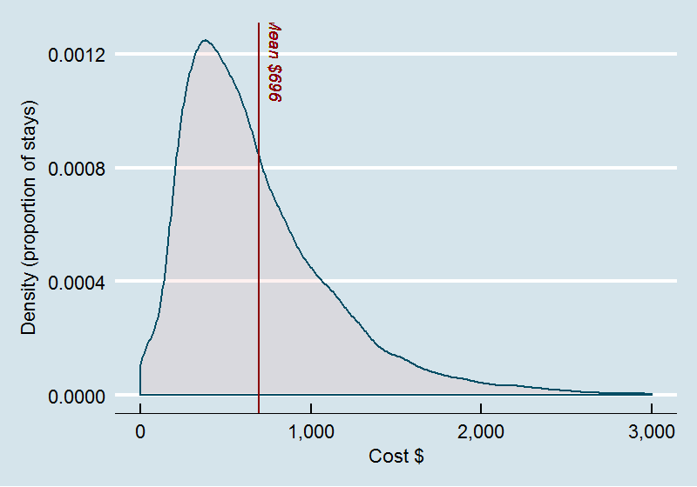
The analysis also showed that the cost distributions vary between hospitals, and hence hospital level effects are likely to be important.
Medical and nursing costs were by far the largest components of the overall cost. On average, they contributed 26% and 24% of the direct costs respectively, accounting for 50% of the total costs.
The analysis on demographic features of patients and stays showed the following:
- The mean age of patients was 38, and median 36.
- In general costs increases with age, although this does not account for the interaction with other characteristics of the stays. For example, the relationship between age and cost applies to stays with an end status of admission or discharge. However, costs are in general lower for stays in which the patient is discharged directly from the emergency department.
- Indigenous patients accounted for 13.6% of the emergency department stays in the study period. This is higher than for the full population of patients attending emergency departments, to some extent related to the nature of the hospitals in the sample. In further analyses the sample will be weighted to reflect the characteristics of the full population of emergency care activity.
- Emergency department stays for Indigenous patients had higher costs compared with other patients ($728 versus $692). Subsequent analysis will need to consider the interaction with other factors (such as age), which may result in a larger difference in estimated mean costs.
- There are variations in the mean costs associated with country of birth, although the influence of other factors will need to be considered.
- Stays in which patients arrive by ambulance, air/helicopter account for around 26.8% of the sample, while stays in which the mode of arrival is police/corrections account for around 1.4% of the sample.
- Costs of emergency department stays in which the mode of arrival is ambulance, air/helicopter are higher than those involving police/corrections, which are in turn higher than for other emergency department stays.
- Stays in which the visit type is an Emergency presentation account for 99% of the sample.
- Costs for stays in which the visit type is an Emergency presentation are generally higher than other visit types.
- The most common triage category overall is category 4 (Semi-urgent) (39.1%) followed by category 3 (Urgent) (38.2%). These categories account for close to 80% of emergency department stays in the sample.
- There is a correlation between costs and triage categories, with the highest mean costs observed for patients assigned to category 1 ($1,518) and lowest for patients assigned to category 5 ($364).
- There is also a correlation between the treatment time in emergency department and triage categories, although the median treatment time for patients assigned to triage category 1 is generally lower than that for category 2.
- The episode end status’ of ‘admitted’ and ‘departed’ accounted for around 90% of emergency department stays. The next most common category relates to patients who ‘did not wait’.
- There is a large difference in mean costs observed for patients who are admitted compared with those where the episode was completed and the patient departed. There are higher costs for patients referred to another hospital and patients who die in the emergency department, although both dispositions are relatively infrequent. The mean cost for patients who ‘did not wait’ was higher than expected. This partly related to the costs allocated to these patients based on treatment time and/or actual procedures reported. This was unexpected as the national definition of ‘did not wait’ generally implies that no treatment has commenced for these patients (other than triage assignment). However, it became evident this is not how this episode end status is interpreted for some emergency departments.
‘Diagnosis modifiers’ were collected specifically for this study, and are defined as conditions or states that contribute to a patient being more complex than expected given their presenting condition, and are hypothesised to result in higher costs of care. They include factors that the Investigative review of classification systems for emergency care (Health Policy Analysis, 2014a) identified as potentially driving costs of patients. The list is as follows (the parentheses indicating the abbreviation used in Figure 2, if different from the label in the list):
- unconscious
- body mass index greater than or equal to 40 (BMI >=40)
- homeless
- involuntary mental health legal status (MH legal status)
- intellectual disability
- severe mental health disorder (severe MH disorder)
- child at risk
- chronic substance/alcohol dependence or abuse (chronic dependence/ abuse)
- unable to self-care
- unable to communicate in English
- distress/ confusion/ agitation requiring one-on-one nursing (distress/ confusion/ agitation)
- patient is a residential care resident (residential care).

Each of the diagnosis modifiers was defined in the Data request specification that was developed for the study.
Overall, the analysis suggests that the presence of diagnosis modifiers is associated with increased costs, although interactions with other characteristics are yet to be examined. This is shown in Figure 2. The proportion of stays for which any one of the diagnosis modifiers was present ranged from below 1% to just over 10.5%.
Figure 2 – Costs by presence of diagnosis modifiers (DM)
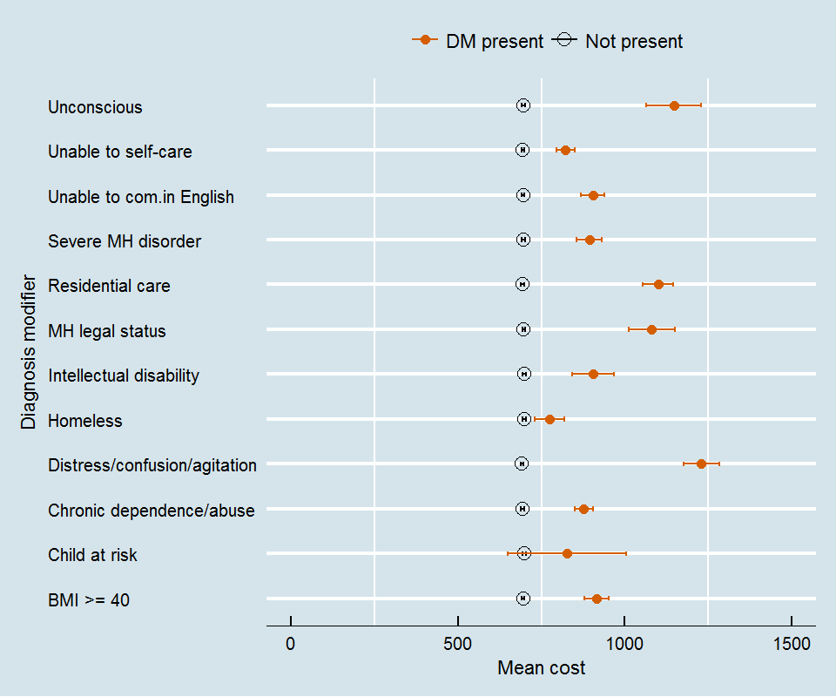

The following were also investigated and reported on in this document:
- The diagnoses and presenting problems of patients in the study, and associated mean costs.
- The activities and procedures recorded by clinicians in providing care to patients and associated times, and comparisons with the time estimates from the consensus study.
- Investigations undertaken (including laboratory and imaging).
- Patterns of patients’ movements between treatment areas.

Considerations for classification
The Investigative review of classification systems for emergency care (Health Policy Analysis 2014a) proposed a basic structure of a classification system in the medium term. A principle in the development of the classification is that any new data elements introduced into the national data sets for emergency care should be a by-product of clinical care, and only introduced where:
- there is clear evidence that they add material value in explaining cost variation in emergency care
- they can support other uses (e.g. quality improvement, clinical redesign and process flow, operational management of the emergency department)
- the data element might also be useful in other classifications (e.g. inpatient. ambulatory care)
- the benefits to be derived from the implementation of the new data justify the costs (which should include clinician time in capturing any new data).
The diagnosis modifiers collected in this study will be assessed against the above criteria.
Also, as part of the costing study, a survey of clinicians involved in the data collection was undertaken once the data collection activities concluded, to capture any further reflections that they may have about patient complexity following their participation in the study. The survey asked clinicians to draw on their clinical judgment, and experience of participating in the study, to assess whether the additional patient characteristics collected as part of the study added to complexity of care and/ or resource intensity of treatment. The survey results confirmed that the diagnosis modifiers collected as part of the study were ones that clinicians believe have an impact on patient complexity and/ or resource use (and thus should be considered for the classification of emergency care in development). Additional conditions or other characteristics impacting on patient complexity and/ or resource use (i.e. in addition to those already collected through the study) were also identified by clinicians.
Clinicians also listed a range of specific diagnoses that are likely to be high complexity and/ or cost, which can be statistically tested in the classification phase of the project.

Conclusion and next steps
The results of the costing study are being presented to sites as part of a review and validation process. So far clinicians have supported the study results. Where there have been shifts in costs compared with results based on existing routine costing processes of emergency care, clinicians have fed back that the shifts seem reasonable and appropriate.
Based on the above and the results presented in this report, the conclusion is that the data obtained from the study is good quality, and sufficient to support further analysis to develop a classification for emergency care. There is evidence from the univariate analysis that several of the variables collected through this study are correlated with higher costs.
The next stage of the project will be to examine the combined impact of these variables, and how these can be incorporated into a classification that provides an appropriate basis for predicting costs, as well as being meaningful to clinicians, managers and planners.
The outcomes of this report and further analyses of variables will form the basis of consultations with stakeholders for the development of the new classification system.

- Introduction
The Independent Hospital Pricing Authority (IHPA) is developing a new classification system for emergency care services for Australia, for the purposes of activity based funding. The project is referred to as the Emergency care costing and classification project, and is being undertaken by a consortium led by Health Policy Analysis.
The objectives of the project are to:
- Undertake a targeted prospective costing study to further investigate the impact of drivers of cost in providing emergency care at the patient level, and thereby aid in the development of a new emergency care classification system.

- Develop a new classification system for emergency care services for activity based funding purposes, based on a structure agreed by IHPA. This will include data specification for new data elements introduced in relation to the proposed classification system.
The prospective costing study component of the overall project is referred to as the Emergency care costing study.

Sampling frame and participating sites
The Emergency care costing study was conducted in a sample of emergency departments across Australia. States and territories were asked to nominate hospitals to participate in the study. The final sample was made up of 10 sites representative of the different sizes and roles of emergency departments, as shown in Table 3 below. The Table also shows the strata used within the sampling frame for the study. In some strata, only one hospital participated in the study. To avoid reporting detailed data on individual hospitals in this report most tables have grouped hospitals based on location and size. The analysis by location groups grouped hospitals into those located in major cities and those located in regional and remote areas (using the remoteness structure of the Australian Statistical Geography Standard (ASGS)). The groupings based on size reflect hospitals with more than 50,000 emergency department stays per annum (‘large’) and those with less than 50,000 (‘other’). The specialist paediatric hospital (Sydney Children’s) has been excluded from the grouping based on size to ensure the individual hospital’s data is not identifiable. Many of the tables in the report use the grouping of hospitals based on location and size, in addition to reporting on the total of study hospitals. Additional analyses have been undertaken of stays involving paediatric patients.
Table 3 – Hospitals by study strata, location and size

Hospital name | Stratum | Location | Size
Sydney Children’s | Specialist paediatric (SP) | Major city (MC) | Excludedª
Royal Prince Alfred | Major city: large (MCL) | Major city (MC) | Large
Sir Charles Gairdner | Major city: large (MCL) | Major city (MC) | Large
Armadale Kelmscott | Major city: large (MCL) | Major city (MC) | Large
Lyell McEwin | Major city: large (MCL) | Major city (MC) | Large
Royal Darwin | Regional: large (ReL) | Regional/remote (RegR) | Large
Blacktown | Major city: other (MCOt) | Major city (MC) | Other
Port Macquarie | Regional: other (ReOt) | Regional/remote (RegR) | Other
Mount Gambier | Regional: other (ReOt) | Regional/remote (RegR) | Other
Alice Springs | Remote (Rem) | Regional/remote (RegR) | Other
ª Sydney Children’s Hospital has been excluded in analyses of size only; else included in other analyses.

Time line
The time line for the Emergency care costing study is shown in Figure 3.
Figure 3 – Costing study time line
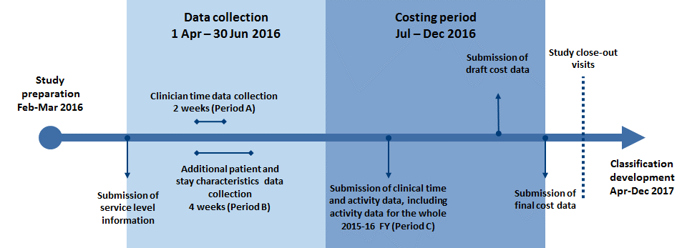

The study involved a four-week data collection period. Within this, two weeks involved collection, by clinical staff, of the time associated with patient care and the procedures provided to the patient. In this report this is referred to as ‘Period A’. For the other two weeks, data was collected on patient characteristics, additional to the data routinely collected through patient administration systems. In this report, this is referred to as ‘Period B’. As such, the total of Period A and Period B is the four-week data collection period. Participating hospitals were also required to submit routinely collected data for the remainder of the 2015 16 financial year.
Table 4 – Hospitals by study strata

Hospital | Period A start date | Period A end date | Study start date | Study end date
Sydney Children’s | 01-04-2016 | 15-04-2016 | 01-04-2016 | 29-04-2016
Royal Prince Alfred | 01-06-2016 | 16-06-2016 | 01-06-2016 | 29-06-2016
Sir Charles Gairdner | 16-05-2016 | 30-05-2016 | 01-05-2016 | 30-05-2016
Armadale Kelmscott | 16-05-2016 | 29-05-2016 | 01-05-2016 | 29-05-2016
Lyell McEwin | 14-06-2016 | 30-06-2016 | 01-06-2016 | 30-06-2016
Royal Darwin | 12-05-2016 | 26-05-2016 | 12-05-2016 | 16-06-2016
Blacktown | 02-05-2016 | 16-05-2016 | 02-05-2016 | 30-05-2016
Port Macquarie | 01-06-2016 | 16-06-2016 | 01-06-2016 | 29-06-2016
Mount Gambier | 14-06-2016 | 29-06-2016 | 31-05-2016 | 29-06-2016
Alice Springs | 09-05-2016 | 23-05-2016 | 09-05-2016 | 09-06-2016

Terminology
National reporting of emergency department activity occurs through the Non-Admitted Patient Emergency Department Care (NAPEDC) National Minimum Data Set (NMDS). The statistical unit describing service/ care events in emergency departments in this NMDS is an ‘emergency department stay’. It is defined as the period between when a patient presents to an emergency department and when that person is recorded as having physically departed the emergency department. Other terms used in the names of data elements relating to care in the emergency department in national data standards are ‘episode’ and ‘service episode’. In some states and territories, the term ‘presentation’ is used.
Several date/time data items are reported within the NAPEDC NMDS, including:
- presentation date and time (METeOR identifiers 471886 and 471889)
- triage date and time (METeOR identifiers 474189 and 474193)
- clinical care commencement date and time (METeOR identifiers 474116 and 474118)
- episode end date and time (METeOR identifiers 474138 and 474169)
- physical departure date and time (METeOR identifiers 474436 and 474438).
Note that some of the data elements in the NMDSs use ‘episode’ in the title, for example, ‘episode end status’.
Components of the emergency department stay are defined by differences between these date/time data items including:
- Waiting time, which is the time between presentation and commencement of clinical care.
- Treatment time, which is the time between commencement of clinical care and episode end.
- The period between the episode end and physical departure.
These are shown in Figure 4.
Figure 4 – Components of an emergency department stay
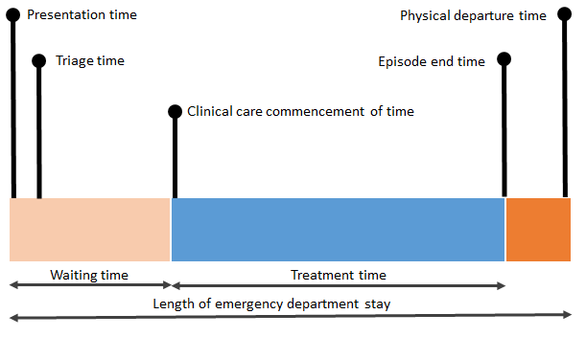
In parallel to these date/time data items, most emergency departments record movements of patients between treatment areas. For this study data on patient movements between treatment areas was also reviewed. Emergency departments commonly identify treatment areas associated with:
- short stay units within the emergency department
- resuscitation treatment area
- acute treatment area
- ‘fast track’ treatment area
- specialised mental health emergency units
- procedure rooms/areas
- waiting room
- ambulance bay.
In most instances, patients admitted to short stay units are classified as ‘admitted’ patients, and were not directly included in the study and/or analysis. In the next stage of this project further analysis will be undertaken of admitted patient episodes that follow an emergency department stay. This also appears to be the case for patients transferred to specialised mental health emergency units, although further analysis of these units will be undertaken in the next stage of this project.
As noted above, many emergency departments have a designated area in which procedures are undertaken. However, several emergency departments reported that movements of patients into these procedure rooms in not always recorded. This appears to be the case from analysis of the data.
Analysis of the data suggests some emergency departments have models of care in which clinical care commences while the patient is still within the waiting room. Clinical care commencement is not the same as triage. These models may involve nursing, and in some instances, medical staff examining the patient in the waiting room and initiating procedures that may be required in subsequent treatment. We also found cases where the whole treatment time occurred in the waiting room itself.
Another feature of the reported data, is that, for some emergency departments, a clinical care commencement date/time was reported for some patients who had a reported episode end status of ‘did not wait to be attended by a health care professional’. This appears inconsistent with the national definitions, as in the circumstance a patient leaves after clinical care commencement, an episode end status of ’Left at own risk after being attended by a health care professional but before the non-admitted patient emergency department service episode was completed’ would be more appropriate. This issue will be further explored in subsequent analysis.

Data collection
Data collection for the Emergency care costing study consisted of the following:
- Patient and stay characteristics additional to those routinely collected.
- Clinician time in relation to individual patients (including the procedure/ activity being undertaken).
- Costed activity, using the clinician time collection information.
These are described below.

1. Additional patient and stay characteristics
Through the study more detailed patient and emergency stay characteristics than those available through routine NMDSs were collected over a four-week period, which occurred between 1 April and 30 June 2016. Additional patient/ stay characteristics requested for the study included some that are already collected locally and/ or reported to NMDSs, and some that were specifically developed for this study. These were as follows:
- Presenting problem. Routinely collected by most sites but not reported through the NMDSs.
- Diagnosis. Routinely collected by most sites and reported through the NMDSs.
- Additional diagnoses. Most sites have a capacity to collect these, and there is provision to report up to five through the NMDSs. However, in practice, recording and reporting of additional diagnoses is limited.
- Diagnosis modifiers. These were developed and collected specifically for the study.
- Procedures. Some sites routinely collect a subset of procedures performed in the emergency department. These are not reported through the NMDSs.
- Investigations. These include imaging, pathology and diagnostic procedures performed in the emergency department. These are not including in the NMDSs. Most costing processes involve linking of imaging and pathology orders/ results to the emergency department stay data at a local level.
‘Diagnosis modifiers’ were defined as conditions or states that contribute to a patient being more complex than expected given their presenting condition, and are hypothesised to result in higher costs of care. They include factors that the Investigative review of classification systems for emergency care (Health Policy Analysis, 2014a) identified as potentially driving costs of patients. The list is as follows:
- unconscious
- body mass index greater than or equal to 40
- homeless
- involuntary mental health legal status
- intellectual disability
- severe mental health disorder
- child at risk
- chronic substance/alcohol dependence or abuse
- unable to self-care
- unable to communicate in English
- distress/ confusion/ agitation requiring one-on-one nursing
- patient is a residential care resident.
Several sites also collected data on additional locally-defined diagnosis modifiers.

2. Clinician time
To aid the costing aspect of the study, information was also collected by sites on the time clinicians spend in providing care and treatment to individual patients, and in undertaking activities associated with patient care. Sites collected this data for a two-week period (Period A), which was within the four-week period during which the additional patient characteristics were collected (see above). Sites implemented barcode scanning technology to collect this information, and some supplemented this with observers. These data were used to develop relative value units for use in costing the four-week period.

3. Costed activity
Costing was for the entire 2015-16 financial year, and was in the context of a whole-of-hospital study for each participating site. These were important so that all costs relating to the financial year could be allocated, and costs specifically relating to the emergency department were not over- or under-estimated. The costing process involved five broad steps, as follows:
- Step 1: Development of final allocation statistics for clinical staff and other resource categories based on data on clinician time allocated to individual patients and/ or in undertaking specific procedures/ activities over a two-week period.
- Step 2: Assignment of cost centres in the general ledger to appropriate final cost centre types (reflecting product categories wherever possible, including the specific emergency care product categories) and indirect (overhead) cost centre types. Mapping of cost line items to National Hospital Cost Data Collection (NHCDC) line items.
- Step 3: Allocation of costs from indirect (overhead) cost centres to direct cost centres.
- Step 4: Allocation of costs accumulated in final cost centres to product categories.
- Step 5: Allocation of costs to patients within product categories, including the emergency department product category.
Steps 1 and 5 were particularly emphasised in this study. In relation to Step 1, relative value units were developed by Health Policy Analysis for the study sites to undertake costing. Relative value units specify, in relative terms, the costs that should be allocated to each patient stay. The relative value units developed for this study involved the following:
- For patients within the two-week period for clinical time data collection (Period A), relative value units were based on reported clinical time. There were effectively three sources of data related to the activities/procedures undertaken for patients in this period: the clinical time related data (this was submission B3 in the Data request specification developed for this study), the reported procedures (submission C3), and the data on investigations (submission C4). These were analysed to determine, for each stay, the activities/procedures reported by medical, nursing or allied health staff. See discussion of the approach to analysing reported procedures/ activities in Chapter 2 Results, in the section Procedures and other clinical activities (p. 38), for an explanation of how duplicate procedures/ activities within an emergency department stay were handled.
- After analysis of these sources, additional procedures/ activities were imputed where they would normally be expected to have occurred, but were not reported. Procedures/ activities were imputed only for patients who had a clinical time commencement date/time recorded (which excludes most patients with an episode end status of ‘did not wait’). The clinical procedures/ activities imputed are listed below, with the activity number from the Data request specification referenced (see Appendix 1 for a list of the procedures/ activities):
  - Initial treating clinician bedside evaluation (Medical activity 111).
  - Treating clinician summation and disposition (Medical activity 121).
  - Initial senior assessment (only for patients spending time in resuscitation and acute treatment areas) (Medical activity 117).
  - Senior review verbal only (only for patients spending time in resuscitation and acute treatment areas) (Medical activity 118).
  - Ordering of diagnostic test (only for patients with a recorded pathology or imaging service) (Medical activity 80).
  - Imaging ordering with a radiology consult (only for patients with CT/MRI/nuclear Medicine service or any other imaging) (Medical activity 81).
  - Other point of care diagnostic tests, measure or investigation (patients with a recorded investigation of 90 Other specified investigations not elsewhere classified) (Medical activity 89).
  - Triage (Nursing activity 130).
  - Initial nursing assessment (Nursing activity 131).
  - Nursing summation and disposition assessment (Nursing activity 135).
  - Clinical observations (only for patients spending time in resuscitation and acute treatment areas) (Nursing activity 132).
  - Other bedside nursing care and documentation (only for patients spending time in resuscitation and acute treatment areas) (Nursing activity 136).
  - Blood specimen collection (only for patients with a recorded pathology service) (Nursing activity 82).
  - Nursing escort to investigation procedure or on disposition (only for patients with a recorded imaging service) (Nursing activity 60).
- Overall, there were 97,309 procedures/ activities imputed, accounting for 30.1% of the total procedures/ activities used for costing. Of these, 54,442 were ones that are typically undertaken by medical clinicians, and 42,867 by nursing clinicians.
- Clinical time data (data submission B3) was used to estimate the clinical time associated with activities/procedures where no clinical time was reported. These estimates were based on the mean clinical time for patients within the treatment area.
- Overall medical and nursing time was then calculated for each stay within the two-week period (Period A). This value was then used as a basis for the relative value unit for these patients.
- For patients in the remaining two weeks of the study period (Period B), regression models were developed to estimate the level of clinical time consumed for each patient, using the Period A data. The parameters included in the regression model varied between hospital, depending on the level of information available for stays in Period B (i.e. the predictors available for the model). These predictors included:
- The highest intensity treatment area (i.e. in terms of clinical staffing) in which a patient spent time during their stay.
- The number of minutes within each treatment area (excluding waiting room/ambulance bay).
- Indicators of whether pathology or imaging were ordered for the patient during the stay.
- Estimated number of nursing shifts across which the patient was in the emergency department (selected hospitals).
- The procedures reported for the patient (selected hospitals).
- For patients outside of the four-week study period (i.e. those presenting to the emergency department the ‘rest of the year’) predictors that reflect the service utilisation indicators available across the full 2015-16 financial year were used in the model. These included all the indicators that were used for Period B above, except the procedures reported for the patient (which were not available for the rest of the year). Instead, the patient’s diagnosis was used.
- For this study, salaries and wages of nurse practitioners were allocated to patients in the same way as medical salaries and wages (i.e. using the same relative value units for both groups). This is because where there were such personnel, employed by the emergency department they tended to be a substitute for a medical practitioner for patients for whom this was appropriate, rather than a substitute for nursing.
- Data for the relative value units was provided to hospitals and then incorporated into the costing process by costing coordinators. Exceptions to this were the two SA hospitals, where the costing for the study data was undertaken by Health Policy Analysis.
- A similar process for allied health staff involved with emergency care was not feasible. Allied health staff data were only collected for a subset of the participating emergency departments, and in these, activity was only reported for a small number of patients. These data will be further analysed in the next stages of this project. As such, costing coordinators used routine local methods for allocating allied health staff costs to patients. In some instances, data feeds from allied health patient systems are available and used.
- For imaging and pathology, the sites generally had good systems to enable costs for tests to be traced to the patients that used them. For other cost components, specifically, non-clinical staff salaries and wages and goods and services, costing coordinators made judgments about the best approach, based on local circumstances.
The relative value units developed and used in this study represent a significant enhancement to the ones used in routine costing studies of emergency department care amongst hospitals. The latter have tended to be based on triage category and episode end status, either directly (e.g. local judgment of relative utilisation of resources based on these data elements), or indirectly (e.g. using Urgency Related Group relativities, which are based on these data elements) (Health Policy Analysis 2014b). This limits the use of these data to explore a range of patient and stay characteristics as drivers of cost. This study has made these data available, and will be used to inform the classification to be developed in the next stage of the project.
- Results

Emergency department stays for which data was reported
The following tables provide details of the number of emergency department stays reported for hospitals participating in the study. Table 5 shows numbers of stays by Period A, Period B and the rest of the year. The total for the study period (Period A plus Period B) is also shown. Most of the following tables and charts relate to the study period (that is the total of Period A plus Period B). Overall there were 43,175 emergency department stays managed by these hospitals during the study period.
Table 5 – Emergency department stays by hospital

Measure | Hospital* |  |  |  |  |  |  |  |  |  | Total
 | 2SCH | 2RPA | 6SIR | 6ARM | 5LMH | 8RDH | 2BLT | 2PMB | 5MTG | 8ASH
Emergency department stays (n)
Period A | 1,584 | 3,226 | 2,646 | 2,312 | 3,347 | 2,889 | 1,771 | 1,311 | 855 | 1,824 | 21,765
Period B | 1,420 | 2,622 | 2,793 | 2,329 | 2,449 | 4,053 | 1,655 | 1,155 | 732 | 2,202 | 21,410
Rest of year | 34,878 | 68,705 | 64,552 | 54,814 | 61,894 | 61,446 | 40,353 | 29,816 | 18,033 | 41,112 | 475,603
Emergency department stays - study period (A&B) only
n | 3,004 | 5,848 | 5,439 | 4,641 | 5,796 | 6,942 | 3,426 | 2,466 | 1,587 | 4,026 | 43,175
* 2SCH is Sydney Children’s; 2RPA is Royal Prince Alfred; 6SIR is Sir Charles Gairdner; 6ARM is Armadale Kelmscott; 5LMH is Lyell McEwin; 8RDH is Royal Darwin; 2BLT is Blacktown; 2PMB is Port Macquarie; 5MTG is Mount Gambier; 8ASH is Alice Springs. Differences in the proportion of stays in Period A and Period B by hospital largely reflect the number of days for Period A (which varies slightly between the sites), the number of days in the month, and other factors influencing demand. For example, for Lyell McEwin, Period A was 17 days out of 30 days in June 2016. Thus, the higher proportion stays in Period A reflects the higher number of days in Period A for this Hospital compared with the others. For Royal Darwin, Period A was 14 days out of 31 days in May 2016. Therefore, the lower proportion stays in Period A reflects the lower number of days in Period A compared with the other hospitals (in addition to the other factors identified above).
Table 6 shows the number of hospitals and total number of stays for each of the study strata. Cost data has not been included for two hospitals, as these data have only just been received. (The data for these hospitals will be included in the next version of this report.)
Table 6 – Emergency department stays by study strata

Measure | Total | Stratum
 |  | MCL | MCOt | ReL | ReOt | Rem | SP
Hospitals (n)
Full study | 10 | 4 | 1 | 1 | 2 | 1 | 1
Reporting costs | 10 | 4 | 1 | 1 | 2 | 1 | 1
Emergency department stays (n)
Period A | 21,765 | 11,531 | 1,771 | 2,889 | 2,166 | 1,824 | 1,584
Period B | 21,410 | 10,193 | 1,655 | 4,053 | 1,887 | 2,202 | 1,420
Rest of year | 475,603 | 249,965 | 40,353 | 61,446 | 47,849 | 41,112 | 34,878
Emergency department stays - study period (A&B) only
n | 43,175 | 21,724 | 3,426 | 6,942 | 4,053 | 4,026 | 3,004
MCL is Major city, large; MCOt is Major city, other; ReL is Regional, large; ReOt is Regional, other; Rem is Remote; SP is Specialist paediatric.

Table 7 shows the number of hospitals and total number of stays for the total of study hospitals and the sub-groups of hospitals based on location and size.
Table 7 – Emergency department stays by grouped strata

Measure |  | Locationª |  | Size^{b}
 | Total | MC | RegR | Large | Other
Hospitals (n)
Full study | 10 | 6 | 4 | 5 | 4
Reporting costs | 10 | 6 | 4 | 5 | 4
Emergency department stays (n)
Period A | 21,765 | 14,886 | 6,879 | 14,420 | 5,761
Period B | 21,410 | 13,268 | 8,142 | 14,246 | 5,744
Rest of year | 475,603 | 325,196 | 150,407 | 311,411 | 129,314
Emergency department stays - study period (A&B) only
n | 43,175 | 28,154 | 15,021 | 28,666 | 11,505
ªMC: Major city, including large, other and specialist paediatric; RegR: Regional & remote including large & other.
^{b}Large: >=50,000 stays per annum; Other: <50,000 stays per annum (excl. Specialist paediatric).

Overall cost characteristics
This section provides an overview of the characteristics and distribution of stay level costs reported for the study period. The following sections present information on how costs vary across different characteristics of the patient and stays. Table 8 shows the overall mean cost and median cost for the study period. There is considerable variability in the costs. The difference between the mean and median cost suggests that the distribution is skewed. This is common in cost distributions, which often have long tails involving observations with costs well above the mean cost.
Table 8 – Overall cost characteristics

Measure | Total | Locationª |  | Size^{b}
 |  | MC | RegR | Large | Other
Mean cost $ | 696 | 704 | 679 | 707 | 722
Median $ | 578 | 588 | 547 | 589 | 588
n | 43,175 | 28,154 | 15,021 | 28,666 | 11,505
ªMC: Major city, including large, other and specialist paediatric; RegR: Regional & remote including large & other.
^{b}Large: >=50,000 stays per annum; Other: <50,000 stays per annum (excl. Specialist paediatric).
The overall distribution can be visualised using a density plot (Figure 5). The density plot shows the estimated proportion of stays at different levels of cost. In Figure 5, the mean cost overall is shown with a vertical line. The plots indicate that the peak of the density distribution lies to the left of the mean cost.
Figure 5 – Distribution of costs (density)
Figure 6 and Figure 7 provide additional perspectives on the overall distribution of costs. In Figure 6 the density plots for each of the participating sites have been overlayed. The box plots in Figure 7 show the variation within each of the hospitals. These show how median costs vary between hospitals and the shape of distribution. Both Figure 6 and Figure 7 suggest that cost distributions vary between hospitals and hence hospital level effects are likely to be important. Therefore, these should be accounted for in analysing the results.
Figure 6 – Distribution of costs (density) by hospital
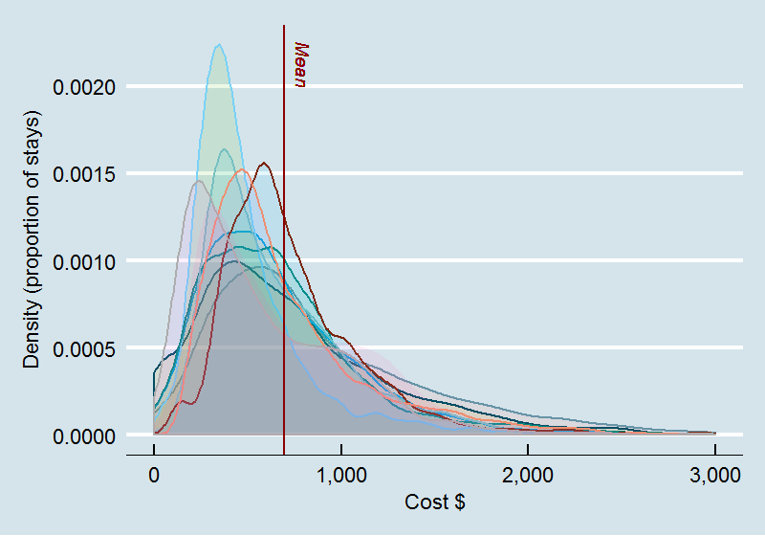

Figure 7 – Distribution of costs by hospital (box plot)
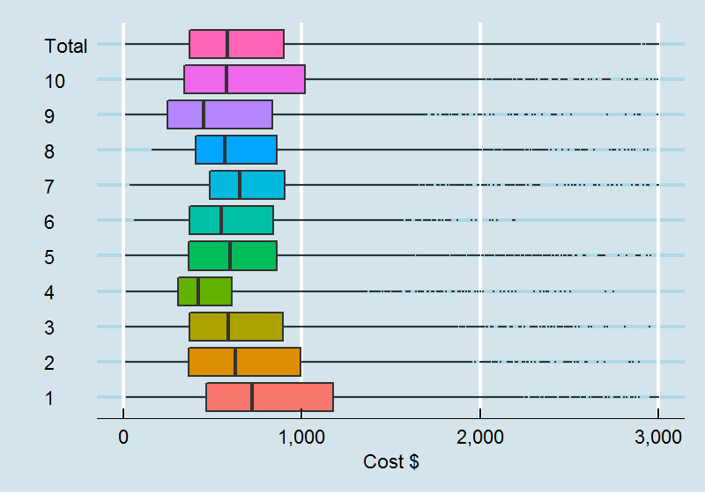

Table 9 provides information on the breakup of estimated costs in the sample, based on assignment to ‘cost buckets’. Cost buckets combine the cost centre group from which a cost is incurred (e.g. allied health services, critical care, imaging department, pathology department) and line items (e.g. salaries and wages, goods and services). Line items are groups of general ledger expenditure account codes that define the resources being used by a cost centre. Cost buckets reflect the intermediate products involved in the production of a clinical service such as an episode of care. The standard way of representing cost buckets in the NHCDC is to assign most costs associated with emergency care cost centres to an emergency department cost bucket. To present the costs for this study, a slightly modified approach was adopted, in which what would previously have been allocated to the emergency department cost bucket has been split into ward medical, ward nursing, and non-clinical salaries. Table 10 shows the costs by line item.
The proportion of direct and indirect costs varied across sites, with some having a higher proportion of direct costs, and others a higher proportion of indirect costs. This is due to whether expenditure is recorded against direct or indirect cost centres, and reflects the different general ledger/ cost centre structures amongst the sites and jurisdictions. Also, non-clinical salaries are higher in the cost bucket analysis (Table 9) compared with the cost line item analysis (Table 10) because in some instances, clinician salaries are recorded against ‘non-clinical’ cost centres. In their assignment to cost buckets, they are reallocated to non-clinical salaries.
Table 9 – Mean costs per stay by cost bucket

Cost bucket | Mean cost ($) |  |  | Percentage
 | Direct | Indirect | Total | Direct | Indirect | Total
Total | 543.7 | 152 | 695.7 | 100.0% | 100.0% | 100.0%
Ward medical | 145.5 | 5.6 | 151.1 | 26.0% | 3.6% | 21.1%
Ward nursing | 134.4 | 7.9 | 142.3 | 24.0% | 5.0% | 19.9%
Allied | 10.0 | 3.1 | 13.1 | 1.8% | 2.0% | 1.8%
Non-clinical salaries | 68.8 | 35.3 | 104.1 | 12.3% | 22.5% | 14.5%
Oncosts | 34.7 | 12.6 | 47.3 | 6.2% | 8.0% | 6.6%
Pathology | 47.1 | 6.6 | 53.7 | 8.4% | 4.2% | 7.5%
Imaging | 59.7 | 10.2 | 69.9 | 10.7% | 6.5% | 9.8%
Pharmacy | 7.6 | 0.3 | 8.0 | 1.4% | 0.2% | 1.1%
Operating room | 0.1 | 0.0 | 0.1 | 0.0% | 0.0% | 0.0%
Special procedure suites | 0.0 | 0.0 | 0.0 | 0.0% | 0.0% | 0.0%
Ward supplies | 24.2 | 43.6 | 67.8 | 4.3% | 27.8% | 9.5%
Prostheses | 0.5 | 0.0 | 0.5 | 0.1% | 0.0% | 0.1%
Hotel | 5.9 | 8.8 | 14.7 | 1.1% | 5.6% | 2.1%
Depreciation | 4.0 | 18.0 | 22.0 | 0.7% | 11.5% | 3.1%
Excluded | 16.5 | 4.8 | 21.4 | 3.0% | 3.1% | 3.0%

Table 10 – Mean costs per stay by cost line item

Cost line item | Mean cost ($) |  |  | Percentage
 | Direct | Indirect | Total | Direct | Indirect* | Total
Total | 543.7 | 152 | 695.7 | 100.0% | 100.0% | 100.0%
Ward medical | 158.7 | 6.2 | 164.9 | 32.2% | 4.2% | 25.7%
Ward nursing | 137.6 | 8.5 | 146.1 | 27.9% | 5.7% | 22.7%
Non-clinical salaries | 26.2 | 37.9 | 64.1 | 5.3% | 25.4% | 10.0%
Pathology | 3.4 | 0.0 | 3.4 | 0.7% | 0.0% | 0.5%
Imaging | 4.3 | 0.0 | 4.3 | 0.9% | 0.0% | 0.7%
Allied | 27.6 | 2.5 | 30 | 5.6% | 1.7% | 4.7%
Pharmacy | 7.6 | 0.2 | 7.8 | 1.5% | 0.1% | 1.2%
Supplies MS | 16.6 | 0.4 | 16.9 | 3.4% | 0.2% | 2.6%
Supplies GS | 54.5 | 41.5 | 96.0 | 11.0% | 27.8% | 14.9%
Prostheses | 0.5 | 0.0 | 0.5 | 0.1% | 0.0% | 0.1%
Oncosts | 34.7 | 12.6 | 47.3 | 7.0% | 8.4% | 7.4%
Hotel | 5.9 | 8.8 | 14.7 | 1.2% | 5.9% | 2.3%
Depreciation | 4.0 | 18.0 | 22.0 | 0.8% | 12.1% | 3.4%
Corp | 0.0 | 12.1 | 12.1 | 0.0% | 8.1% | 1.9%
Other | 11.9 | 0.5 | 12.4 | 2.4% | 0.3% | 1.9%

The following sections present analyses that explore the relationship between various patient and emergency department stay characteristics and costs. In most instances these are presented as univariate analyses. That is, the analyses examine how costs vary with respect to a single characteristic. The next stage of this project will further consider the combined effects of these characteristics of costs. That is, models of costs that include more than one single characteristic. This will be undertaken using approaches such as multiple regression (in which several variables are introduced into the model to explain how costs vary), and regression trees. Regression trees use machine learning algorithms to explore ways in which the available explanatory variables may be split/grouped and combined to explain/predict variation in costs.
Most of the characteristics considered in the analyses presented are categorical variables rather than continuous variable. The main exception to this is the age variable. In some instances, the categorical variables have an order (e.g. triage category). In the tables below for each characteristic, information is presented on the proportion of stays reported for each category (level) of a variable, and the mean reported costs for that category. At this stage, we have avoided presenting measures of statistical significance within the tables themselves (such as p-values). One reason for this is that until the effect of clustering within hospitals is taken into account, measures of significance are likely to be misleading. Confidence intervals have been included within most of the charts presented, which provide some sense of the level of confidence around specific estimates. However, for the reasons outlined above, these should be treated with caution, until models controlling for hospital level effects have been estimated.

Patient demographics
The tables and charts in this section show the demographic features of patients from the study period. Table 11 provides information on age and sex of patients. Across the hospitals, 49.6% of patients were female. There is a small difference in cost between emergency department stays for females compared with males.
The analysis by age group shows:
- The mean age of patients was 38, and median was 36.
- In general costs increase with age, although this does not account for the interaction with other characteristics of the stays.
The relationship between cost and age is shown in Figure 8.
Table 11 – Patient demographics part 1

Measure | Total | Locationª |  | Size^{b}
 |  | MC | RegR | Large | Other
Study period (A&B)
Mean cost $ | 696 | 704 | 679 | 707 | 722
Median | 578 | 588 | 547 | 598 | 588
n | 43,175 | 28,154 | 15,021 | 28,666 | 11,505
Sex (percent)
Female | 49.6% | 49.4% | 50.1% | 49.4% | 52.4%
Male | 50.3% | 50.6% | 49.9% | 50.6% | 47.6%
Sex (mean cost $)
Female | 706 | 716 | 685 | 715 | 729
Male | 686 | 692 | 673 | 699 | 714
Age
Mean | 38 | 38 | 38 | 41 | 41
Median | 36 | 35 | 37 | 38 | 39
Standard deviation | 46 | 55 | 24 | 54 | 25
Age group (percent)
00-04 | 11.9% | 13.3% | 9.2% | 8.6% | 8.2%
05-14 | 9.4% | 9.5% | 9.2% | 6.9% | 7.9%
15-24 | 12.9% | 12.8% | 13.1% | 13.5% | 13.6%
25-34 | 14.5% | 14.1% | 15.2% | 15.8% | 14.9%
35-44 | 11.8% | 10.6% | 14.0% | 12.7% | 12.4%
45-54 | 11.1% | 9.7% | 13.7% | 11.6% | 12.7%
55-64 | 9.0% | 8.6% | 9.8% | 9.6% | 10.0%
65-74 | 8.2% | 8.2% | 8.0% | 8.9% | 8.4%
75-84 | 6.6% | 7.5% | 4.9% | 7.1% | 7.1%
85+ | 4.7% | 5.6% | 2.9% | 5.2% | 4.7%
Age group (mean cost $)
00-04 | 486 | 493 | 464 | 505 | 441
05-14 | 503 | 510 | 488 | 522 | 452
15-24 | 582 | 594 | 561 | 588 | 565
25-34 | 623 | 624 | 621 | 627 | 611
35-44 | 692 | 689 | 695 | 691 | 693
45-54 | 736 | 745 | 724 | 733 | 744
55-64 | 797 | 808 | 779 | 776 | 845
65-74 | 900 | 915 | 871 | 882 | 947
75-84 | 1,019 | 1,027 | 996 | 977 | 1,119
85+ | 1,063 | 1,062 | 1,068 | 1,022 | 1,170
ªMC: Major city, including large, other and specialist paediatric; RegR: Regional & remote including large & other.
^{b}Large: >=50,000 stays per annum; Other: <50,000 stays per annum (excl. Specialist paediatric).
Figure 8 – Mean cost by age group
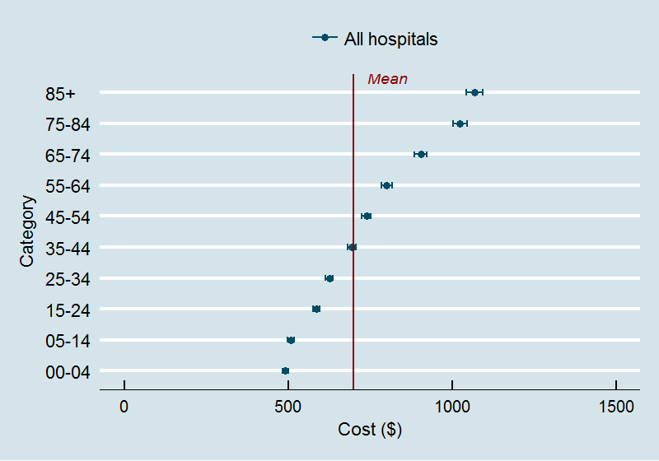

Figure 9 and Figure 10 provide further information on this relationship between age and sex, showing differences between emergency department stays by episode end status. In these figures, each observation is plotted as a point. This reveals the relative frequency of observations across the age and cost dimensions.
It can be seen for stays with an end status of admission or discharge, the relationship between age and cost applies (Figure 9). However, costs are in general lower for stays in which the patient is discharged from the emergency department directly. There is also a wide distribution of costs observed at each age, which tends to be broader for very young patients. Figure 10 suggests that the age cost relationship is not as strong for patients referred to another hospital, and there is an inverse relationship where the episode end status is died in emergency department.
Overall, age is an important factor, but it is clear there are a range of interactions with other factors. Figure 9 and Figure 10 explore only one of these interactions. The next stage of this project will involve a more detailed investigation of these interactions.
Figure 9 – Cost by age: selected disposition categories | Figure 10 – Cost by age: selected disposition categories
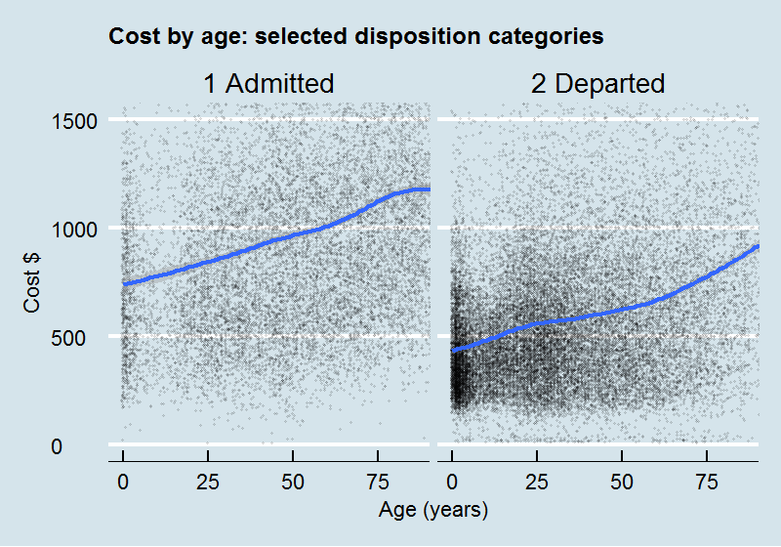 | 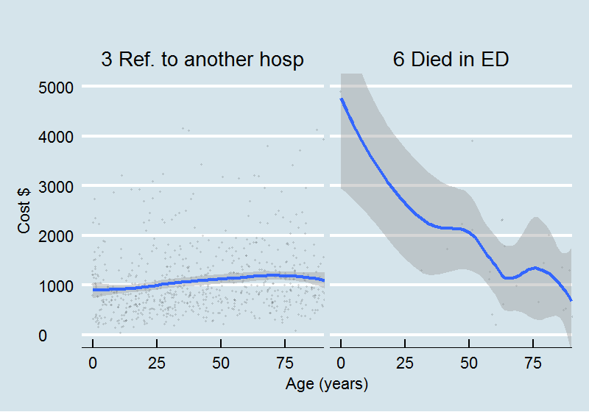
Table 12 provides information on Indigenous status, country of birth, compensation status and DVA eligible patients. Points of interest with these analyses are:
- Indigenous patients accounted for 13.6% of the emergency department stays in the study period. This is higher than for the full population of patients attending emergency departments, to some extent related to the nature of the hospitals in the sample. In further analyses the sample will be weighted to reflect the characteristics of the full population of emergency care activity.
- Emergency department stays for Indigenous patients had higher costs compared with other patients ($728 versus $692, see also Figure 11 and Figure 12). Subsequent analysis will need to consider the interaction with other factors (such as age), which may result in a larger difference in estimated mean costs.
- Country of birth is the main indicator of Cultural and Linguistic Diversity (CALD) within the sample, but is acknowledged as only one of the indicators of CALD.
- There are variations in the mean costs associated with country of birth, although the influence of other factors will need to be considered.
- Compensable emergency department stays accounted for 6.1% overall, but were significantly higher for some hospitals. Overall compensable stays had a slightly lower cost compared with other stays.
- Emergency department stays associated with DVA eligible patients accounted for slightly less than 1% of emergency department stays in the sample. There was a significant difference in cost for DVA compared with other patients, although other factors (such as age) may impact this difference.
Table 12 – Patient demographics part 2 and stay characteristics

Measure | Total | Locationª |  | Size^{b}
 |  | MC | RegR | Large | Other
Study period (A&B)
Mean cost $ | 696 | 704 | 679 | 707 | 722
Median | 578 | 588 | 547 | 598 | 588
n | 43,175 | 28,154 | 15,021 | 28,666 | 11,505
Indigenous status (Percent)
Indigenous | 13.6% | 4.5% | 30.7% | 11.2% | 22.7%
Non-Indigenous | 85.6% | 94.5% | 69.1% | 87.8% | 77.1%
Not stated/Missing | 0.7% | 1.0% | 0.2% | 1.0% | 0.2%
Indigenous status (Mean cost $)
Indigenous | 728 | 740 | 725 | 800 | 645
Non-Indigenous | 692 | 704 | 660 | 697 | 743
Not stated/Missing | 561 | 544 | 687 | 536 | 860
Country of birth (Percent)
Americas | 1.2% | 1.5% | 0.7% | 1.3% | 1.0%
Australia | 81.1% | 77.4% | 87.5% | 77.6% | 86.1%
North-east Asia | 1.3% | 1.8% | 0.5% | 1.6% | 0.6%
North-west Europe | 8.6% | 10.4% | 5.6% | 10.8% | 5.3%
Oceania (ex.Aust) | 3.5% | 4.0% | 2.6% | 3.6% | 4.0%
South-east Asia | 2.7% | 3.0% | 2.0% | 3.1% | 2.1%
Sub-Saharan Africa | 1.5% | 1.9% | 1.0% | 1.9% | 0.9%
Country of birth (Mean cost $)
Americas | 634 | 650 | 575 | 639 | 689
Australia | 672 | 669 | 678 | 688 | 692
North-east Asia | 658 | 642 | 750 | 656 | 801
North-west Europe | 812 | 829 | 755 | 807 | 867
Oceania (ex.Aust) | 735 | 778 | 614 | 721 | 767
South-east Asia | 715 | 735 | 668 | 708 | 766
Sub-Saharan Africa | 688 | 710 | 617 | 676 | 752
Compensation status (Percent)
1 Compensable | 6.1% | 2.2% | 13.3% | 2.7% | 15.9%
2 Non-compensable | 93.9% | 97.8% | 86.7% | 97.3% | 84.1%
9 Not stated/not known | 0.0% | 0.0% | 0.0% | 0.0% | 0.0%
Compensation status (Mean cost $)
1 Compensable | 659 | 699 | 646 | 655 | 659
2 Non-compensable | 699 | 704 | 687 | 708 | 738
9 Not stated/not known | 269 | 764 | 33 | 832 | 40
DVA eligible patients (Percent)
1 Yes | 0.9% | 1.0% | 0.8% | 1.1% | 0.8%
2 No | 99.1% | 99.0% | 99.2% | 98.9% | 99.2%
9 Not stated/unknown | 0.0% | 0.0% | 0.0% | 0.0% | 0.0%
DVA eligible patients (Mean cost $)
1 Yes | 1,077 | 1,088 | 1,057 | 1,063 | 1,111
2 No | 694 | 705 | 678 | 708 | 721
9 Not stated/unknown | 269 | 764 | 33 | 832 | 40
ªMC: Major city, including large, other and specialist paediatric; RegR: Regional & remote including large & other.
^{b}Large: >=50,000 stays per annum; Other: <50,000 stays per annum (excl. Specialist paediatric).

Figure 11 – Mean cost by Indigenous status
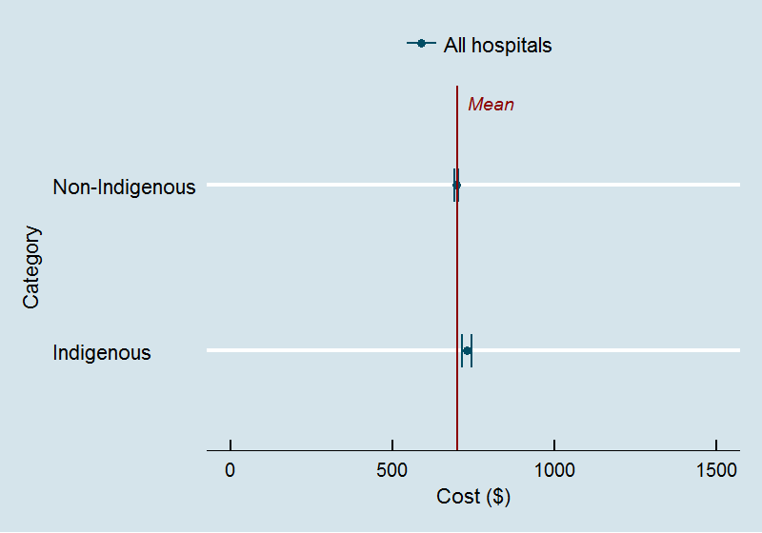

Figure 12 – Density plot for costs by Indigenous status
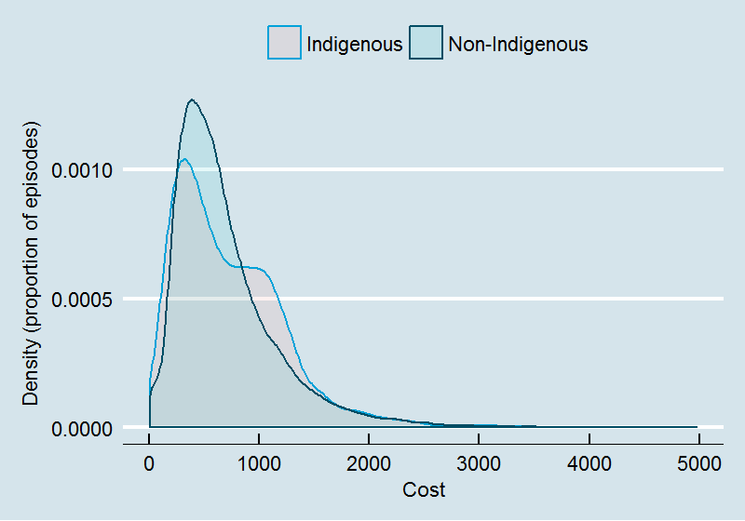

General characteristics of the emergency department stays
This section explores the relationship between some of the more general characteristics of emergency department stays (mode of arrival, visit type, triage category and episode end status) and cost. Table 13, Figure 13 and Figure 14 present analyses of mode of arrival and visit type. These analyses suggest:
- Stays in which patients arrive by ambulance, air/helicopter account for around 26.8% of the sample, while stays in which the mode of arrival is police/corrections account for around 1.4% of the sample.
- Costs of emergency department stays in which the mode of arrival is ambulance, air/helicopter are higher than those involving police/corrections, which are in turn higher than for other emergency department stays.
- Stays in which the visit type is an Emergency presentation account for 99% of the sample.
- Costs for stays in which the visit type is an Emergency presentation are generally higher than other visit types.
Table 13 – Emergency department stay characteristics part A

Measure | Total | Locationª |  | Size^{b}
 |  | MC | RegR | Large | Other
Study period (A&B)
n | 43,175 | 28,154 | 15,021 | 28,666 | 11,505
Mode of arrival (Percent)
1 Ambulance, air/helicopter | 26.8% | 27.4% | 25.8% | 28.9% | 26.3%
2 Police/corrections | 1.4% | 0.8% | 2.5% | 1.4% | 1.8%
8 Other | 71.8% | 71.8% | 71.7% | 69.7% | 71.9%
9 Not stated/unknown | 0.0% | 0.0% | 0.0% | 0.0% | 0.0%
Mode of arrival (Mean cost $)
1 Ambulance, air/helicopter | 1,029 | 965 | 1,155 | 1,006 | 1,118
2 Police/corrections | 590 | 807 | 453 | 626 | 520
8 Other | 574 | 606 | 513 | 586 | 580
9 Not stated/unknown | 478 | 686 | 270 | 14 | 526
Visit type (Percent)
1 Emergency presentation | 99.0% | 98.9% | 99.1% | 98.9% | 99.2%
2 Return Visit, planned | 0.7% | 0.7% | 0.6% | 0.6% | 0.5%
3 Pre-arranged admission | 0.2% | 0.1% | 0.2% | 0.1% | 0.3%
5 Dead on arrival | 0.2% | 0.3% | 0.0% | 0.3% | 0.0%
Visit type (Mean cost $)
1 Emergency presentation | 699 | 708 | 681 | 710 | 724
2 Return Visit, planned | 471 | 475 | 462 | 487 | 485
3 Pre-arranged admission | 500 | 302 | 730 | 293 | 721
5 Dead on arrival | 130 | 137 | 12 | 137 | 12
Visit type (Median time†(mins))
1 Emergency presentation | 125 | 139 | 100 | 128 | 125
2 Return Visit, planned | 67 | 70 | 53 | 72 | 56
3 Pre-arranged admission | 36 | 15 | 124 | 15 | 122
5 Dead on arrival | 12 | 12 | N.A. | 12 | N.A.
ªMC: Major city, including large, other and specialist paediatric; RegR: Regional &
remote including large & other.
^{b}Large: >=50,000 stays per annum; Other: <50,000 stays per annum (excl. Specialist paediatric).
†Time from service commencement to stay end. Does not including waiting time.
Figure 13 – Costs by mode of arrival
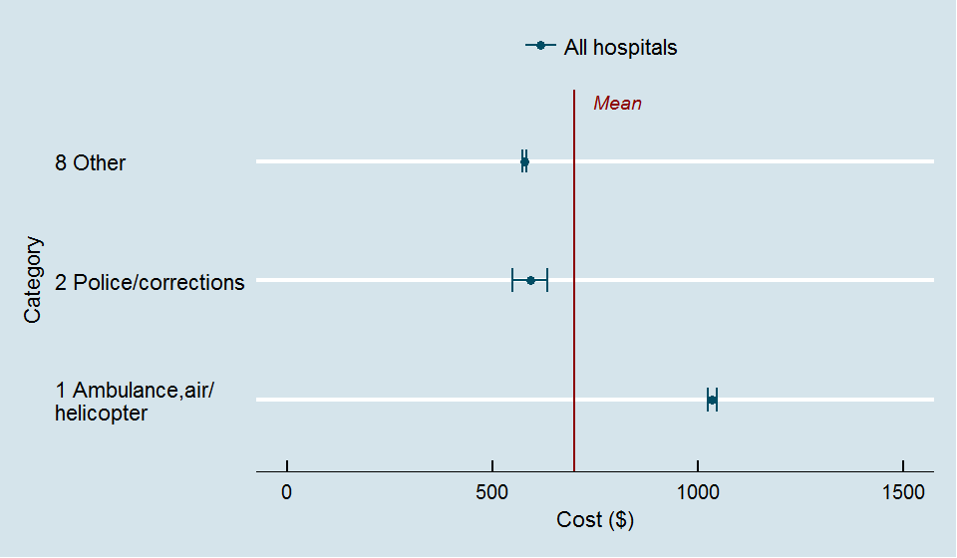

Figure 14 – Costs by emergency department visit type
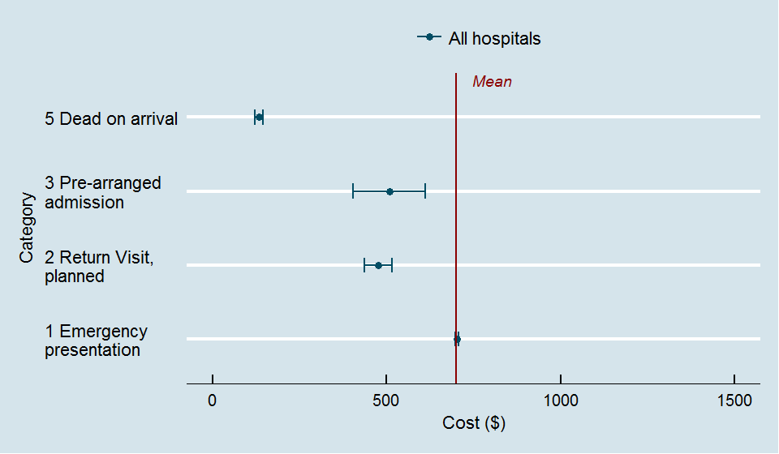

Table 14, Figure 15 and Figure 16 present analyses of triage category and episode end status (disposition). In these analyses we have also included the median treatment time for these characteristics. These analyses suggest:
- The most common triage category overall is category 4 (Semi-urgent) (39.1%) followed by category 3 (Urgent) (38.2%). These categories account for close to 80% of emergency department stays in the sample.
- There is a correlation between costs and triage categories, with the highest mean costs observed for patients assigned to category 1 ($1,518) and lowest for patients assigned to category 5 ($364).
- There is also a correlation between the treatment time in emergency department and triage categories, although the median treatment time for patients assigned to triage category 1 is generally lower than that for category 2.
- The episode end status’ of ‘admitted’ and ‘departed’ account for around 90% of emergency department stays. The next most common category relates to patients who ‘did not wait’.
- There is a large difference in mean costs observed for patients admitted compared with those who departed. There are higher costs for patients referred to another hospital and patient who die in the emergency department, although both dispositions are relatively infrequent. The mean cost for patients who ‘did not wait’ was higher than expected. This partly related to the costs allocated to these patients based on treatment time and/or actual procedures reported. This was unexpected as the national definition of ‘did not wait’ generally implies that no treatment has commenced for these patients (other than triage assignment). However, it became evident this is not how episode end status is interpreted for some emergency departments.
Triage category and episode end status form the core dimensions of the URG and UDG classification. The preliminary evidence from the study suggests that these characteristics have a strong correlation with costs. As discussed in the Investigative review of classification systems for emergency care (Health Policy Analysis 2014a), the development of a new classification needs to consider other dimensions and should consider whether a reduction in the importance of triage and episode end status in the revised classification is warranted.
Table 14 – Emergency department stay characteristics part B

Measure | Total | Locationª |  | Size^{b}
 |  | MC | RegR | Large | Other
Study period (A&B)
Mean cost $ | 696 | 704 | 679 | 707 | 722
Median | 578 | 588 | 547 | 598 | 588
n | 43,175 | 28,154 | 15,021 | 28,666 | 11,505
Triage category (Percent)
1 Resuscitation | 1.1% | 1.3% | 0.7% | 1.2% | 0.7%
2 Emergency | 16.6% | 18.1% | 13.7% | 17.7% | 16.8%
3 Urgent | 38.2% | 40.7% | 33.5% | 41.2% | 35.8%
4 Semi-urgent | 39.1% | 34.7% | 47.2% | 34.7% | 41.2%
5 Non-urgent | 5.1% | 5.2% | 4.9% | 5.2% | 5.5%
Triage category (Mean cost $)
1 Resuscitation | 1,518 | 1,526 | 1,487 | 1,480 | 1,854
2 Emergency | 1,011 | 1,016 | 998 | 982 | 1,105
3 Urgent | 769 | 750 | 813 | 755 | 816
4 Semi-urgent | 512 | 510 | 515 | 533 | 510
5 Non-urgent | 364 | 379 | 333 | 373 | 346
Triage category (Median time† mins)
1 Resuscitation | 150 | 173 | 101 | 138 | 194
2 Emergency | 177 | 191 | 138 | 177 | 177
3 Urgent | 148 | 158 | 125 | 148 | 147
4 Semi-urgent | 89 | 95 | 81 | 92 | 92
5 Non-urgent | 52 | 55 | 47 | 54 | 47
Episode end status (Percent)
1 Admitted | 32.6% | 32.1% | 33.5% | 34.2% | 33.3%
2 Departed | 59.8% | 59.9% | 59.4% | 57.7% | 59.4%
3 Ref. to another hosp | 1.7% | 2.4% | 0.4% | 2.1% | 1.2%
4 Did not wait | 4.4% | 3.7% | 5.8% | 4.4% | 4.7%
5 Left at own risk | 1.3% | 1.5% | 0.8% | 1.3% | 1.4%
6 Died in ED | 0.1% | 0.1% | 0.0% | 0.1% | 0.1%
7 Dead on arrival | 0.2% | 0.3% | 0.1% | 0.3% | 0.0%
Episode end status (Mean cost $)
1 Admitted | 971 | 977 | 960 | 948 | 1,047
2 Departed | 573 | 584 | 550 | 594 | 562
3 Ref. to another hosp | 1,059 | 1,066 | 989 | 1,032 | 1,186
4 Did not wait | 243 | 150 | 352 | 229 | 297
5 Left at own risk | 575 | 522 | 766 | 540 | 698
6 Died in ED | 1,532 | 1,532 | N.A. | 1,385 | 1,951
7 Dead on arrival | 175 | 143 | 498 | 184 | 12
Episode end status (Median time† mins)
1 Admitted | 163 | 188 | 111 | 161 | 165
2 Departed | 107 | 114 | 94 | 112 | 106
3 Ref. to another hosp | 206 | 210 | 184 | 212 | 194
4 Did not wait | 78 | 58 | 95 | 75 | 87
5 Left at own risk | 129 | 120 | 146 | 126 | 154
6 Died in ED | 91 | 82 | 391 | 31 | 222
7 Dead on arrival | 11 | 10 | 259 | 11 | N.A.
ªMC: Major city, including large, other and specialist paediatric; RegR: Regional & remote including large & other.
^{b}Large: >=50,000 stays per annum; Other: <50,000 stays per annum (excl. Specialist paediatric).
†Time from service commencement to stay end. Does not including waiting time.

Figure 15 – Costs by triage category
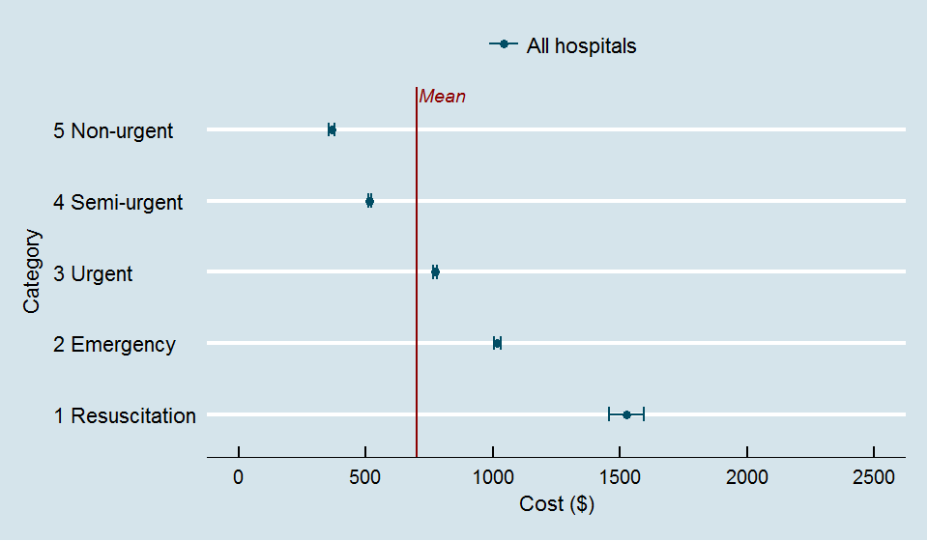

Figure 16 – Costs by episode end status (disposition)
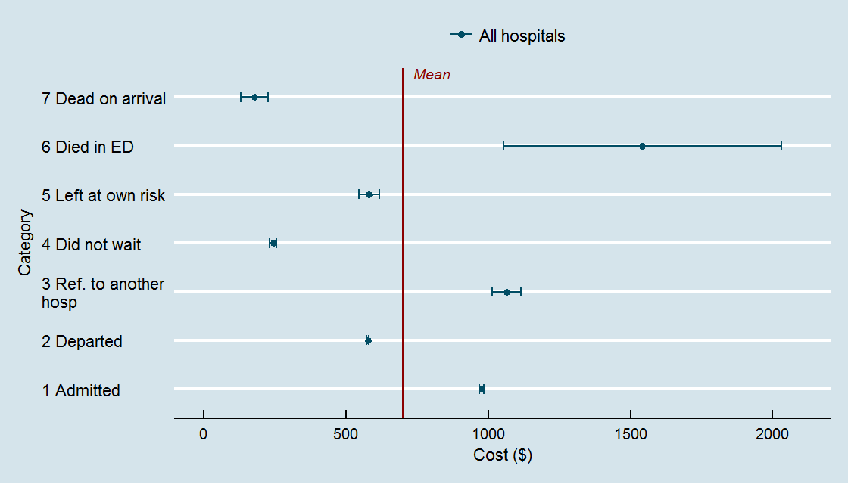

Diagnosis modifiers
This section explores the relationship between diagnosis modifiers that were collected specifically for this study and costs. Table 15 and Figure 17 present comparisons of mean costs for emergency department stays in which the diagnosis modifiers were present, and stays in which the they were not (or not reported). Table 15 also shows the percentage of stays for which the diagnosis modifier was reported. Stays in which the episode end status was ‘4 Did not wait’, ‘7 Dead on arrival’ or ‘6 Died in emergency department’ have been excluded from this analysis.
Overall, the analysis suggests that the presence of diagnosis modifiers is associated with increased costs, although interactions with other characteristics are yet to be examined. The proportion of stays for which any one of the diagnosis modifiers was present ranged from below 1% to just over 10.5%.

Table 15 – Diagnosis modifiers

Diagnosis modifier | Total | Locationª |  | Size^{b}
 |  | MC | RegR | Large | Other
Study period (A&B)
n | 43,175 | 28,154 | 15,021 | 28,666 | 11,505
Unconscious†
Mean cost DM not present $ | 758 | 758 | 759 | 775 | 802
Mean cost DM present $ | 1,144 | 1,133 | 1,178 | 1,090 | 1,500
Percent of cases DM reported % | 1.8% | 1.9% | 1.4% | 2.5% | 0.8%
BMI >= 40
Mean cost DM not present $ | 758 | 761 | 750 | 778 | 797
Mean cost DM present $ | 915 | 906 | 924 | 889 | 956
Percent of cases DM reported % | 4.9% | 3.3% | 8.4% | 4.8% | 6.5%
Homeless
Mean cost DM not present $ | 765 | 764 | 767 | 780 | 815
Mean cost DM present $ | 774 | 869 | 742 | 846 | 509
Percent of cases DM reported % | 3.2% | 1.1% | 8.1% | 4.1% | 2.5%
Severe MH disorder
Mean cost DM not present $ | 759 | 758 | 761 | 774 | 807
Mean cost DM present $ | 889 | 899 | 856 | 898 | 836
Percent of cases DM reported % | 4.9% | 5.4% | 3.7% | 6.9% | 2.2%
Chronic substance/alcohol depend./abuse
Mean cost DM not present $ | 756 | 755 | 758 | 770 | 809
Mean cost DM present $ | 874 | 914 | 818 | 905 | 789
Percent of cases DM reported % | 8.3% | 6.9% | 11.6% | 9.8% | 7.8%
Involuntary mental health legal status
Mean cost DM not present $ | 760 | 759 | 761 | 775 | 806
Mean cost DM present $ | 1,074 | 1,084 | 1,046 | 1,163 | 869
Percent of cases DM reported % | 1.8% | 1.9% | 1.5% | 2.0% | 1.8%
Intellectual disability
Mean cost DM not present $ | 763 | 763 | 761 | 781 | 805
Mean cost DM present $ | 902 | 885 | 932 | 900 | 923
Percent of cases DM reported % | 1.9% | 1.8% | 2.3% | 1.9% | 2.3%
Distress/confusion/agitation††
Mean cost DM not present $ | 749 | 752 | 742 | 767 | 788
Mean cost DM present $ | 1,225 | 1,226 | 1,223 | 1,212 | 1,250
Percent of cases DM reported % | 3.5% | 2.9% | 4.9% | 3.7% | 4.2%
Residential care resident
Mean cost DM not present $ | 753 | 751 | 756 | 769 | 797
Mean cost DM present $ | 1,096 | 1,095 | 1,098 | 1,083 | 1,138
Percent of cases DM reported % | 3.6% | 4.1% | 2.5% | 4.5% | 2.9%
Unable to self-care
Mean cost DM not present $ | 759 | 745 | 800 | 770 | 827
Mean cost DM present $ | 820 | 1,086 | 628 | 902 | 685
Percent of cases DM reported % | 10.5% | 6.0% | 20.8% | 10.2% | 14.5%
Unable to communicate in English
Mean cost DM not present $ | 757 | 758 | 755 | 775 | 802
Mean cost DM present $ | 902 | 962 | 850 | 899 | 914
Percent of cases DM reported % | 5.7% | 3.6% | 10.5% | 6.7% | 5.2%

Diagnosis modifier | Total | Locationª |  | Size^{b}
 |  | MC | RegR | Large | Other
Child at risk
Mean cost DM not present $ | 765 | 765 | 766 | 782 | 808
Mean cost DM present $ | 824 | 938 | 608 | 908 | 622
Percent of cases DM reported % | 0.4% | 0.4% | 0.5% | 0.5% | 0.3%
ª MC: Major city, including large, other and specialist paediatric; RegR: Regional &
remote including large & other.
^{b} Large: >=50,000 stays per annum; Other: <50,000 stays per annum (excl. Specialist paediatric).
† Includes somnolence, stupor, coma.
†† Requiring one-on-one nursing.
Figure 17 – Costs by presence of diagnosis modifiers (DM)

Emergency department diagnoses
This section explores the nature of diagnoses reported by participating emergency departments. The systems for recording and reporting diagnoses vary across states/territories and across hospitals within states/territories. In Australia, emergency departments record diagnoses using systems based on SNOMED-CT or ICD (the clear majority based on ICD-10-AM). Some states and territories have implemented short lists of diagnoses. It is important to note that within states and territories there are often local variants of systems, for example, with preferred short lists/codes used.
Table 16 provides a description of the systems used by participating hospitals, together with an analysis of the distinct number of diagnosis codes being used in each hospital. For this analysis, data from the full 2015-16 years was used. The analysis shows that the number of diagnosis codes used in the participating hospitals ranges from 674 to 2,730. Hospitals using SNOMED-CT used a greater number of codes (ranging from 1,340 to 2,730). Across the financial year, many codes were used only once, or two to five times. A small number of codes are used frequently. For example, when codes that were used more than 100 times in the year are considered, there are between 38 and 168 codes used.
Table 16 – Diagnoses codes used for reporting, full year*

 | SNOMED-CT |  |  |  | ICD-10-AM
 |  |  |  |  | 6th ed |  | 8th ed | 9th ed
 | A | B | C | D | E | F | G | H | I | J
Distinct diagnosis codes
1 | 739 | 717 | 648 | 575 | 254 | 217 | 225 | 227 | 248 | 209
2-5 | 728 | 733 | 854 | 563 | 355 | 363 | 168 | 371 | 402 | 390
6-20 | 486 | 488 | 683 | 418 | 317 | 344 | 135 | 391 | 379 | 410
21-40 | 139 | 126 | 212 | 111 | 142 | 163 | 59 | 154 | 132 | 184
41-60 | 68 | 51 | 91 | 52 | 71 | 77 | 28 | 80 | 55 | 77
61-80 | 29 | 22 | 55 | 30 | 37 | 50 | 13 | 42 | 39 | 41
81-100 | 22 | 22 | 43 | 16 | 22 | 32 | 8 | 40 | 23 | 34
100+ | 90 | 58 | 144 | 59 | 142 | 168 | 38 | 129 | 90 | 146
Total | 2,301 | 2,217 | 2,730 | 1,824 | 1,340 | 1,414 | 674 | 1,434 | 1,368 | 1,491
Proportion of episodes
1 | 1.7% | 2.4% | 0.9% | 1.6% | 0.4% | 0.3% | 1.1% | 0.3% | 0.5% | 0.3%
2-5 | 5.2% | 7.6% | 3.7% | 4.7% | 1.8% | 1.6% | 2.7% | 1.8% | 2.7% | 1.9%
6-20 | 12.2% | 17.2% | 10.3% | 12.2% | 6.1% | 5.4% | 7.0% | 6.5% | 9.5% | 6.6%
21-40 | 9.3% | 12.1% | 8.5% | 8.6% | 6.9% | 6.8% | 8.6% | 6.5% | 8.7% | 7.7%
41-60 | 7.8% | 8.6% | 6.3% | 6.9% | 6.0% | 5.4% | 7.2% | 5.9% | 6.0% | 5.6%
61-80 | 4.7% | 5.0% | 5.3% | 5.6% | 4.5% | 5.0% | 4.6% | 4.3% | 6.0% | 4.2%
81-100 | 4.6% | 6.7% | 5.3% | 3.9% | 3.4% | 4.1% | 3.8% | 5.3% | 4.5% | 4.6%
100+ | 54.6% | 40.5% | 59.7% | 56.5% | 70.8% | 71.4% | 65.0% | 69.4% | 62.0% | 69.3%
Total | 100.0% | 100.0% | 100.0% | 100.0% | 100.0% | 100.0% | 100.0% | 100.0% | 100.0% | 100.0%
* Reflects the distinctive number of codes used for recording diagnoses.
The most commonly used codes/terms were further investigated. Table 17 shows the 20 most common SNOMED-CT terms used for the four emergency departments using this system. The Table shows the rank for these terms across all four of these hospitals, and for each of the hospitals. It also shows the percent of emergency department stays for which the term was reported. The most common terms are:
- 21522001 Abdominal pain (finding)
- 29857009 Chest pain (finding)
- 34014006 Viral disease (disorder)
- 281794004 Viral upper respiratory tract infection (disorder).
Table 17 – Most common diagnoses reported by hospitals using SNOMED*

SNOMED diagnosis | Rank |  |  |  |  | ED stays (%)
 | A | B | C | D | Total
21522001 Abdominal pain (finding) | 2 | 1 | 1 | 3 | 1 | 3.9%
29857009 Chest pain (finding) | 1 | 2 | 2 | 35 | 2 | 2.9%
34014006 Viral disease (disorder) | 5 | 9 | 9 | 1 | 3 | 1.7%
281794004 Viral upper respiratory tract infection (disorder) | 20 | 7 | 11 | 2 | 4 | 1.4%
82271004 Injury of head (disorder) | 9 | 10 | 5 | 6 | 5 | 1.4%
422400008 Vomiting (disorder) | 20 | 9 | 8 | 7 | 6 | 1.2%
25374005 Gastroenteritis (disorder) | 4 | 15 | 16 | 8 | 7 | 1.1%
386661006 Fever (finding) | 17 | 16 | 12 | 5 | 7 | 1.1%
25064002 Headache (finding) | 7 | 5 | 7 | 19 | 8 | 1.1%
71186008 Croup (disorder) | 29 | 12 | 21 | 4 | 9 | 1.1%
271594007 Syncope (disorder) | 14 | 8 | 4 | 33 | 10 | 1.0%
161891005 Backache (finding) | 9 | 4 | 8 | 35 | 11 | 0.9%
68566005 Urinary tract infectious disease (disorder) | 10 | 11 | 10 | 19 | 12 | 0.9%
267036007 Dyspnea (finding) | 12 | 5 | 8 |  | 13 | 0.8%
56018004 Wheezing (finding) | 31 | 24 | 42 | 4 | 14 | 0.8%
161898004 Falls (finding) | 8 | 8 | 11 |  | 15 | 0.8%
233604007 Pneumonia (disorder) | 13 | 21 | 13 | 13 | 16 | 0.8%
44465007 Sprain of ankle (disorder) | 20 | 14 | 12 | 19 | 17 | 0.7%
314212008 Abdominal pain - cause unknown (finding) | 16 | 3 | 30 | 18 | 18 | 0.7%
63238001 Dead on arrival at hospital (finding) |  | 24 | 3 |  | 19 | 0.7%
312608009 Laceration - injury (disorder) | 23 | 23 | 6 | 32 | 20 | 0.7%
* Emergency department stays with a reported diagnosis.
Table 18 shows the 20 most common ICD codes used for the six emergency departments using this system. The Table shows the rank for these terms across all six of these hospitals, and for each of the hospitals. It also shows the percent of emergency department stays for which the code was reported. The most common codes are:
- R10.4 Other and unspecified abdominal pain
- R07.4 Chest pain unspecified
- B34.9 Viral infection unspecified
- F10.0 Ment & beh disrd dt alcohol use ac intox.
Table 18 – Most common diagnoses reported by hospitals using ICD*

ICD diagnosis | Rank |  |  |  |  |  |  | ED stays (%)
 | E | F | G | H | I | J | Total
R10.4 Other and unspecified abdominal pain | 1 | 15 | 1 | 1 | 2 | 2 | 1 | 3.6%
R07.4 Chest pain unspecified | 2 | 5 | 3 | 2 | 5 | 1 | 2 | 3.4%
B34.9 Viral infection unspecified | 3 | 18 | 2 | 13 | 6 | 3 | 3 | 2.0%
F10.0 Ment & beh disrd dt alcohol use ac intox | 28 | 19 | 32 | 9 | 1 | 5 | 4 | 1.2%
N39.0 Urinary tract infection site not spec | 14 | 8 | 7 | 9 | 10 | 8 | 5 | 1.2%
J06.9 Acute URTI unspecified | 10 | 15 | 9 | 34 | 4 | 8 | 6 | 1.2%
R55 Syncope and collapse | 11 | 13 | 25 | 4 | 23 | 12 | 7 | 1.1%
Z53.2 Proc not done pt decn oth & unsp reason | 2 |  |  |  |  |  | 8 | 1.0%
S09.9 Unspecified injury of head | 9 | 12 | 24 | 36 | 20 | 4 | 9 | 1.0%
R07.3 Other chest pain | 15 | 15 | 17 | 8 | 20 | 18 | 10 | 0.9%
S93.40 Sprain and strain of ankle part unsp | 21 | 26 | 6 | 17 | 13 | 16 | 11 | 0.9%
J45.9 Asthma unspecified | 4 | 20 | 46 | 49 | 11 | 12 | 12 | 0.9%
R51 Headache | 22 | 15 | 31 | 11 | 19 | 13 | 13 | 0.9%
R50.9 Fever unspecified | 25 | 9 | 30 | 25 | 15 | 6 | 14 | 0.8%
R11 Nausea and vomiting | 22 | 14 | 24 | 20 | 18 | 12 | 15 | 0.8%
R42 Dizziness and giddiness | 20 | 14 | 20 | 10 | 31 | 25 | 16 | 0.8%
Z04.3 Exam & observation foll oth acdt | 54 | 31 | 21 | 3 | 33 | 12 | 17 | 0.8%
L03.11 Cellulitis of lower limb |  |  | 21 | 19 | 11 | 7 | 18 | 0.7%
J21.9 Acute bronchiolitis unspecified | 6 | 21 | 21 |  | 17 | 35 | 19 | 0.7%
J05.0 Acute obstructive laryngitis [croup] | 14 | 22 | 5 |  | 29 | 41 | 20 | 0.6%
Z53.9 Procedure not carried out unsp reason |  |  | 4 | 6 |  |  | 20 | 0.6%
* Emergency department stays with a reported diagnosis.

SNOMED-CT terms were mapped to ICD-10-AM and the results analysed across all 10 hospitals in the study. Table 19 shows the 20 most common codes across all 10 hospitals and the rank of that code within each hospital. The Table also shows the mean cost estimated for each of these diagnoses.
Table 19 – Most common diagnoses reported by hospitals mapped
to three-digit ICD-AM codes*

Three-digit ICD-10-AM codes | Rank
 | A | B | C | D | E | F | G | H | I | J | Total | Mean cost ($)
R07 Pain in throat and chest | 1 | 2 | 2 | 33 | 1 | 4 | 2 | 1 | 2 | 1 | 1 | 850
R10 Abdominal and pelvic pain | 2 | 1 | 1 | 2 | 2 | 3 | 1 | 2 | 3 | 3 | 2 | 813
B34 Viral infection of unspecified site | 17 | 16 | 19 | 3 | 4 | 19 | 3 | 19 | 8 | 7 | 3 | 515
M25 Other joint disorders, not elsewhere classified | 4 | 6 | 10 | 23 | 28 | 30 | 15 | 18 | 4 | 2 | 4 | 600
L03 Cellulitis | 13 | 10 | 11 | 27 | 20 | 20 | 6 | 9 | 1 | 4 | 5 | 661
M54 Dorsalgia | 5 | 4 | 4 | 31 | 23 | 17 | 18 | 11 | 9 | 5 | 6 | 698
J06 Acute upper respiratory infections of multiple and unspecified sites | 25 | 8 | 12 | 1 | 9 | 14 | 15 | 44 | 7 | 15 | 7 | 467
S01 Open wound of head | 29 | 10 | 18 | 5 | 12 | 30 | 8 | 9 | 14 | 6 | 8 | 514
S09 Other and unspecified injuries of head | 10 | 11 | 5 | 4 | 12 | 11 | 29 | 46 | 26 | 9 | 9 | 561
Z53 Persons encountering health services for specific procedures, not carried out | 3 | 27 | 65 |  | 3 |  | 7 | 8 |  |  | 10 | 199
S52 Fracture of forearm | 7 | 10 | 24 | 13 | 10 | 28 | 13 | 33 | 17 | 8 | 11 | 646
S62 Fracture at wrist and hand level | 15 | 11 | 20 | 14 | 19 | 27 | 4 | 13 | 24 | 11 | 12 | 509
R55 Syncope and collapse | 22 | 8 | 6 | 36 | 14 | 12 | 32 | 4 | 28 | 18 | 13 | 891
T14 Injury of unspecified body region | 8 | 5 | 3 | 8 | 45 | 19 | 37 | 43 | 31 | 43 | 14 | 600
R06 Abnormalities of breathing | 22 | 7 | 11 | 6 | 16 | 27 | 33 | 21 | 28 | 25 | 15 | 823
N39 Other disorders of urinary system | 20 | 19 | 21 | 29 | 18 | 6 | 14 | 12 | 14 | 16 | 16 | 780
F10 Mental and behavioural disorders due to use of alcohol | 38 | 27 | 22 |  | 29 | 20 | 35 | 7 | 5 | 9 | 17 | 769
S93 Dislocation, sprain and strain of joints and ligaments at ankle and foot level | 37 | 22 | 23 | 26 | 15 | 27 | 9 | 15 | 11 | 13 | 18 | 475
A09 Other gastroenteritis and colitis of infectious and unspecified origin | 6 | 9 | 7 | 11 | 24 | 16 | 22 | 48 | 32 | 34 | 19 | 708
R11 Nausea and vomiting | 32 | 8 | 13 | 12 | 25 | 13 | 31 | 28 | 25 | 18 | 20 | 627
* Emergency department stays with a reported diagnosis.
In preliminary work for this project a set of diagnoses grouping were developed based on the groupings used for assignment of acute episodes to adjacent diagnosis groups in the AR-DRG classification. These assignments were expanded in certain areas (such as injuries) to provide further detail for diagnoses that are most frequent in the emergency department setting. A major diagnostic category grouping was also developed based on this preliminary classification. Table 20 shows the 20 most common categories using this preliminary classification, across all 10 hospitals, the rank of that code within each hospital and the mean cost for each of these codes.
Table 21 shows the 20 most common categories using the ICD-10-AM chapters, across all 10 hospitals, the rank of that code within each hospital and the mean cost for each of these codes.

Table 20 – Most common diagnoses reported by hospitals, mapped to diagnosis groupings*

Emergency department diagnosis grouping | Rank |  |  |  |  |  |  |  |  |  |  | % | Mean cost  ($)
 | A | B | C | D | E | F | G | H | I | J | Total
Z641 Other factors influencing | 3 | 6 | 4 | 18 | 1 | 9 | 2 | 1 | 1 | 2 | 1 | 6 | 545
I881 Injury to Forearm, Wrist, | 4 | 2 | 1 | 2 | 6 | 2 | 3 | 7 | 5 | 6 | 2 | 5 | 517
G66 Abdominal Pain or Mesenter | 2 | 1 | 2 | 7 | 3 | 4 | 6 | 6 | 7 | 7 | 3 | 4.7 | 810
F74 Chest Pain | 1 | 3 | 3 | 34 | 2 | 5 | 9 | 2 | 8 | 3 | 4 | 4.6 | 855
E99 Other respiratory disorder | 6 | 4 | 5 | 1 | 3 | 3 | 7 | 19 | 2 | 9 | 5 | 4.4 | 673
I884 Injuries, Other | 9 | 7 | 6 | 3 | 5 | 8 | 11 | 8 | 4 | 1 | 6 | 4.1 | 574
G712 Other diseases of digesti | 5 | 8 | 7 | 10 | 4 | 15 | 5 | 4 | 12 | 8 | 7 | 3.6 | 770
I883 Other Injury to Skin, Sub | 28 | 11 | 22 | 6 | 7 | 15 | 1 | 3 | 10 | 10 | 8 | 3.4 | 562
J641 Cellulitis | 7 | 16 | 12 | 20 | 12 | 16 | 10 | 18 | 3 | 4 | 9 | 2.7 | 630
T631 Other Viral Illness | 18 | 19 | 20 | 5 | 8 | 22 | 8 | 22 | 13 | 12 | 10 | 2.3 | 510
I841A Sprains, Strains and Dis | 35 | 26 | 37 | 16 | 9 | 22 | 4 | 5 | 16 | 22 | 11 | 2.1 | 646
I693 Bone Diseases and Arthrop | 12 | 13 | 21 | 22 | 35 | 33 | 18 | 27 | 9 | 5 | 12 | 1.9 | 597
J68A Other Skin Disorders | 21 | 20 | 15 | 12 | 13 | 11 | 12 | 25 | 11 | 12 | 12 | 1.9 | 494
E95 Other upper respiratory in | 26 | 15 | 17 | 4 | 14 | 19 | 16 | 41 | 10 | 25 | 13 | 1.8 | 482
I681 Non-surgical Spinal Disor | 13 | 10 | 9 | 29 | 26 | 20 | 18 | 20 | 14 | 11 | 14 | 1.8 | 685
G67 Oesophagitis and Gastroent | 14 | 18 | 11 | 9 | 17 | 15 | 13 | 28 | 17 | 24 | 15 | 1.7 | 651
F752 Other Circulatory System | 8 | 9 | 18 | 43 | 15 | 19 | 19 | 9 | 18 | 20 | 16 | 1.7 | 951
B81 Other Disorders of the Ner | 10 | 5 | 8 | 24 | 21 | 13 | 24 | 11 | 24 | 35 | 17 | 1.7 | 1009
I711 Other Musculotendinous Di | 11 | 12 | 10 | 16 | 22 | 30 | 29 | 23 | 15 | 18 | 18 | 1.6 | 632
Z61 Signs and Symptoms | 22 | 28 | 14 | 33 | 27 | 1 | 43 | 36 | 37 | 28 | 19 | 1.5 | 726
G703 Selected digestive system | 25 | 13 | 19 | 13 | 21 | 10 | 17 | 24 | 23 | 23 | 20 | 1.5 | 673
* Emergency department stays with a reported diagnosis.
Table 21 – Most common diagnoses reported by hospitals mapped to ICD chapters*

ICD chapter | Rank |  |  |  |  |  |  |  |  |  |  | % | Mean cost  ($)
 | A | B | C | D | E | F | G | H | I | J | Total
21.1 Injuries | 1 | 1 | 1 | 1 | 1 | 1 | 1 | 1 | 1 | 1 | 1 | 22.8 | 602
04 Diseases and disorders of the respiratory system | 4 | 4 | 4 | 2 | 2 | 3 | 3 | 4 | 2 | 5 | 2 | 10.8 | 745
06 Diseases and disorders of the digestive system | 3 | 3 | 2 | 4 | 3 | 4 | 2 | 3 | 3 | 2 | 3 | 10.8 | 761
05 Diseases and disorders of the circulatory system | 2 | 2 | 3 | 11 | 4 | 5 | 4 | 2 | 7 | 3 | 4 | 9.9 | 904
23 Factors influencing health status and other contacts with health services | 6 | 8 | 8 | 9 | 5 | 12 | 5 | 6 | 6 | 7 | 5 | 6 | 545
18 Infectious and parasitic diseases | 8 | 7 | 7 | 3 | 6 | 6 | 6 | 11 | 8 | 8 | 6 | 5.4 | 660
08 Diseases and disorders of the musculoskeletal system and connective tissue | 5 | 6 | 6 | 6 | 10 | 15 | 8 | 8 | 5 | 4 | 7 | 5.2 | 638
01 Diseases and disorders of the nervous system | 7 | 5 | 5 | 7 | 7 | 7 | 8 | 5 | 11 | 9 | 8 | 4.8 | 984
09 Diseases and disorders of the skin, subcutaneous tissue and breast | 9 | 9 | 9 | 5 | 8 | 8 | 7 | 12 | 4 | 6 | 9 | 4.6 | 574
11 Diseases and disorders of the kidney and urinary tract | 10 | 10 | 10 | 10 | 11 | 10 | 10 | 9 | 12 | 10 | 10 | 3 | 825
19 Mental diseases and disorders | 11 | 12 | 11 | 17 | 9 | 13 | 9 | 7 | 14 | 12 | 11 | 2.7 | 770
23 Poising, toxic effects, alcohol/drug use and alcohol/drug effect | 13 | 16 | 12 | 19 | 12 | 14 | 11 | 10 | 10 | 11 | 12 | 2.2 | 816
03 Diseases and disorders of the ear, nose, mouth and throat | 16 | 11 | 13 | 8 | 13 | 11 | 13 | 13 | 13 | 15 | 13 | 2 | 623
24 Symptoms, Signs and Abnormal Clinical and Laboratory Findings NEC | 17 | 17 | 15 | 18 | 16 | 2 | 19 | 16 | 19 | 17 | 14 | 1.5 | 726
10 Endocrine, nutritional and metabolic diseases and disorders | 18 | 14 | 19 | 16 | 15 | 16 | 14 | 15 | 9 | 15 | 15 | 1.5 | 908
02 Diseases and disorders of the eye | 20 | 13 | 17 | 13 | 18 | 17 | 15 | 13 | 15 | 13 | 16 | 1.4 | 474
14 Pregnancy, childbirth and the puerperium | 12 | 19 | 14 | 23 | 19 | 9 | 12 | 22 | 18 | 18 | 17 | 1.1 | 613
07 Diseases and disorders of the hepatobiliary system and pancreas | 15 | 15 | 18 | 20 | 14 | 17 | 17 | 14 | 17 | 16 | 18 | 1.1 | 907
13 Diseases and disorders of the female reproductive system | 14 | 19 | 16 | 22 | 17 | 18 | 16 | 20 | 16 | 14 | 19 | 1 | 706
22 Burns | 22 | 19 | 21 | 15 | 19 | 16 | 15 | 19 | 20 | 19 | 20 | 0.6 | 574
* Emergency department stays with a reported diagnosis.
Table 22 shows the underlying diagnoses that contributed to the four most common MDCs from the previous Table.
Table 22 – Diagnoses within the most common emergency department MDCs*

 | ED stay (%) | Mean cost ($) | Rank diagnosis | Rank MDC
21.1 Injuries
I881 Injury to Forearm, Wrist, | 5.0 | 517 | 2 | 1
I884 Injuries, Other | 4.1 | 574 | 6 | 1
I883 Other Injury to Skin, Sub | 3.4 | 562 | 8 | 1
I841A Sprains, Strains and Dis | 2.1 | 646 | 11 | 1
I893 Injuries, Complications o | 1.5 | 560 | 21 | 1
I836 Fracture, forearm | 1.3 | 648 | 25 | 1
I802 Intracranial Injury, Skul | 0.8 | 932 | 38 | 1
I862 Trauma to the Eye, Other | 0.8 | 340 | 39 | 1
I833 Fracture, lower leg | 0.7 | 734 | 41 | 1
I835 Fracture, ankle and foot | 0.6 | 558 | 48 | 1
I834 Fracture, shoulder and up | 0.6 | 757 | 51 | 1
I832A Fractures of Neck of Fem | 0.5 | 1,262 | 53 | 1
I882 Injury to Shoulder, Arm, | 0.5 | 517 | 55 | 1
I851 Nasal Trauma and Deformit | 0.3 | 517 | 69 | 1
I871 Foreign body in other res | 0.3 | 558 | 75 | 1
I801 Concussion without loss o | 0.2 | 619 | 83 | 1
I821A Injuries, internal organ | 0.1 | 1,424 | 84 | 1
04 Diseases and disorders of the respiratory system
E99 Other respiratory disorder | 4.4 | 673 | 5 | 2
E95 Other upper respiratory in | 1.8 | 482 | 13 | 2
E62 Respiratory Infections/Inf | 1.4 | 985 | 22 | 2
E671 Respiratory Signs and Sym | 1.1 | 826 | 28 | 2
E692 Asthma | 1.1 | 705 | 30 | 2
E65 Chronic Obstructive Airway | 0.7 | 1,104 | 44 | 2
E61A Pulmonary Embolism, Pulmo | 0.3 | 1,299 | 73 | 2
06 Diseases and disorders of the digestive system
G66 Abdominal Pain or Mesenter | 4.7 | 810 | 3 | 3
G712 Other diseases of digesti | 3.6 | 770 | 7 | 3
G703 Selected digestive system | 1.5 | 673 | 20 | 3
D45 Disorders of teeth and sup | 0.4 | 390 | 60 | 3
G65 GI Obstruction | 0.3 | 1,152 | 70 | 3
C76 Other disorders of eye and | 0.2 | 547 | 78 | 3
D662 Other Ear, Nose, Mouth an | 0.2 | 518 | 82 | 3
05 Diseases and disorders of the circulatory system
F74 Chest Pain | 4.6 | 855 | 4 | 4
F752 Other Circulatory System | 1.7 | 951 | 16 | 4
F73 Syncope and Collapse | 1.2 | 891 | 27 | 4
F76 Arrhythmia, Cardiac Arrest | 0.9 | 974 | 33 | 4
F69 Valvular Disorders, Abnorm | 0.6 | 757 | 50 | 4
F62 Heart Failure and Shock | 0.5 | 1,194 | 52 | 4
F60 Circulatory Disorders W AM | 0.4 | 999 | 58 | 4
* Emergency department stays with a reported diagnosis.

Emergency department presenting problems
Table 23 shows the 20 most common presenting problems across all 10 hospitals and the rank of that presenting problem within each hospital. The Table also shows the mean cost estimated for each of these of these presenting problems.
Table 23 – Most common presenting problems reported by hospital*

Presenting problem | Rank |  |  |  |  |  |  |  |  |  |  | Cost ($)
Hospital: | A | B | C | D | E | F | G | H | I | J | Total | Mean
252 Abdominal pain | 1 | 2 | 1 | 4 | 1 | 2 | 1 | 1 | 3 | 2 | 1 | 786
102 Chest pain | 2 | 4 | 4 | 28 | 2 | 3 | 3 | 2 | 5 | 4 | 2 | 910
908 Other specified problem not elsewhere classified | 37 | 35 | 28 | 18 | 35 | 10 | 9 | 3 | 1 | 1 | 3 | 696
552 Pain Limb lower/hip | 7 | 5 | 7 | 10 |  |  | 12 | 7 | 2 | 3 | 4 | 609
909 Review/medical assessment requested (incl. medical certificate) | 6 | 1 | 2 | 16 | 12 | 4 | 15 | 38 | 10 | 8 | 5 | 536
464 Injury other | 4 | 3 | 3 | 1 | 6 | 32 |  |  | 50 | 46 | 6 | 628
903 Fever | 18 | 14 | 10 | 2 | 11 |  | 22 | 24 | 9 | 7 | 7 | 647
461 Injury limb upper/shoulder | 8 | 12 | 8 |  | 5 | 7 | 2 | 5 | 48 | 44 | 8 | 558
460 Injury limb lower/hip | 9 | 10 | 9 |  | 8 | 17 | 4 | 8 | 46 | 10 | 9 | 597
759 Shortness of breath |  |  |  | 18 | 3 | 1 | 10 | 4 | 8 | 5 | 10 | 911
911 Unwell | 3 | 8 | 5 | 12 | 27 | 6 | 32 | 26 |  |  | 11 | 849
752 Breathing problem | 5 | 6 | 6 | 3 | 7 | 30 | 27 | 34 | 51 | 60 | 12 | 883
755 Cough | 22 | 11 | 17 | 5 | 10 |  | 5 | 20 | 4 | 16 | 13 | 593
263 Vomiting | 14 | 11 | 16 | 6 | 9 | 13 | 11 | 19 |  |  | 14 | 651
551 Pain Back | 16 | 11 | 14 | 33 | 23 | 11 | 6 | 6 | 12 | 17 | 15 | 687
606 Headache | 17 | 13 | 15 | 21 | 13 | 20 | 15 | 10 | 15 | 15 | 16 | 705
459 Injury head | 20 | 15 | 12 | 7 | 16 | 30 | 8 | 13 | 28 | 11 | 17 | 643
859 Laceration |  |  | 58 |  |  | 8 | 7 | 9 | 11 | 9 | 18 | 524
553 Pain Limb upper/shoulder | 15 | 7 | 13 | 8 |  |  | 19 | 11 | 37 | 50 | 19 | 536
451 Assault - alleged, including sexual |  |  | 58 | 39 |  |  | 19 | 15 | 6 | 6 | 20 | 730
* Emergency department stays with a reported diagnosis.

Movements between treatment areas
Information on movements between treatment areas within the emergency department was obtained and analysed. Table 24 shows these results. For this analysis treatment areas were grouped into six main categories: Resus, Acute, Mixed, Fast Track, Waiting room and Other. Most emergency departments had Resus and Acute treatment areas. Many had the equivalent of a ‘Fast Track’ treatment area. The ‘Mixed’ category was used to capture a range of diverse treatment areas. Most emergency departments had treatment areas for Waiting Room and the Ambulance Bay (which have been grouped for this analysis). Many emergency departments also had ‘Other’ treatment areas which were an administrative convenience that allowed the emergency department stay to remain open while clinicians recorded information or followed up related matters after patients have left the emergency department. As patients often move between treatment areas, to assist analysis, patients were assigned to a hierarchy of treatment areas. The hierarchy reflected the treatment area with the highest intensity/level of staffing in which a patient had spent time during the emergency department stay. For example, in the Table, 4,579 patients spent some time in a resus treatment area. Of these, 1,873 patients also spent time in an acute treatment area, and 1,253 patients also spent time in a treatment area assigned to the ‘Mixed’ category.
Table 24 also shows the mean time per patient (per stay) in each treatment area, and the mean time overall for each area (i.e. including all stays). For Mean time in treatment area, the column Total stays refers to mean treatment time overall for that area. Note that this is not the same as ‘treatment time’ within the context of an emergency department stay, which is the time between commencement of clinical care and episode end (see Figure 3). In this Table, the mean time in the treatment area is the time between when the patient is recorded to have been physically moved to the area and when they leave that area.
Table 24 – Emergency department stays and mean time by treatment area

Treatment area hierarchy | Total stays | Patients spending any time in:
 |  | Resus | Acute | Mixed | Fast Track | Waiting | Other
Number of episodes
Resus | 4,579 | 4,579 | 1,873 | 1,253 | 197 | 1,860 | 1,904
Acute | 14,741 |  | 14,725 | 4,084 | 642 | 8,918 | 4,721
Mixed | 9,794 |  |  | 9,792 | 941 | 7,485 | 2,082
Fast Track | 7,399 |  |  |  | 7,274 | 5,343 | 2,170
Waiting Room/Other | 5,363 |  |  |  |  | 5,318 | 1,134
Not assigned | 1,299
Percentage
Resus | 100% | 100% | 41% | 27% | 4% | 41% | 42%
Acute | 100% |  | 100% | 28% | 4% | 60% | 32%
Mixed | 100% |  |  | 100% | 10% | 76% | 21%
Fast Track | 100% |  |  |  | 98% | 72% | 29%
Waiting Room/Other | 100% |  |  |  |  | 99% | 21%
Not assigned | 100%
Mean time in treatment area (mins)
Resus | 245 | 187 | 106 | 75 | 5 | 13 | 46
Acute | 198 |  | 261 | 94 | 5 | 37 | 55
Mixed | 144 |  |  | 233 | 14 | 67 | 58
Fast Track | 120 |  |  |  | 143 | 67 | 82
Waiting Room/Other | 97 |  |  |  |  | 426 | 38
Not assigned | 145

Procedures and other clinical activities
A key feature of the Emergency care costing study was recording of activities and procedures by clinicians (in Period A). Times associated with activities and procedures were also recorded. This section shows the frequencies of procedures and activities by study strata. The next section presents the times associated with these.
Table 25 presents summary data on the procedures and activities reported during Period A. The study procedures could be recorded in either Submission B3 (Staff time allocated to individual patients and/or procedures/activities) or Submission C3 (Procedures). However, there were differences between these submissions as follows:
- For Submission B3 the list of procedures included a range of medical, nursing and allied health ‘activities’, which were not captured in Submission C3. This is one of the contributing factors to the number of procedures reported in Submission B3 compared with C3.
- Within B3, procedures and activities were reported against a specific clinician, and could be allocated to the discipline of the clinician. The allocation across the major disciplines is shown in rows 1-4 of Table 25. When multiple clinicians were involved with a single procedure, there were several counts of the procedure in Submission B3 compared with one count in Submission C3, which is also contributing factor to the number of procedures reported for Submission B3 compared with C3.
- The data collection structure for submission B3 allowed a clinician to record multiple procedures/ activities in one data entry, against a time block. Consequently, in B3, the number of procedures/ activities recorded exceed the number of data entries (whereas for C3 the number of procedures recorded was equal to the number of data entries), as can be seen in the columns for data entries and procedures in Table 25.
Table 25 – Reporting of procedures and activities during Period A*

Data source | Staff group | Data entries | Procedures/ activities | Procedures/ activities  (duplicates removed) | Emergency department stays | Procedures/ activities per stay
B3 submission | 1 Medical | 99,773 | 139,197 | 67,004 | 21,765 | 3.08
B3 submission | 2 Nursing | 165,393 | 231,830 | 88,767 | 21,765 | 4.08
B3 submission | 2A Nurse practitioner | 3,106 | 10,878 | 2,415 | 21,765 | 0.11
B3 submission | 3 Allied health/other | 3,613 | 6,385 | 2,923 | 21,765 | 0.13
B3 submission | All groups | 271,885 | 388,290 | 152,852 | 21,765 | 7.02
C3 submission | All groups | 182,576 | 182,576 | 92,375 | 21,765 | 4.24
Combined B3/C3 | All groups |  | 570,866 | 182,098 | 21,765 | 8.37
Excluding DNW/DOA** | All groups |  |  |  | 20,741 | 8.68
* Reflects all episodes, including those with episode end status’ of ‘did not wait’ and ‘dead on arrival’. Locally defined procedures have been included. Counts in the column ‘Procedures/ activities’ include those that were not attached to a specific emergency department stay. The column `Procedures/ activities (duplicates removed)` counts a procedure/activity code only once during an emergency department stay. The total for the row ‘Combined B3/C3 - All groups’ in the column `Procedures/ activities (duplicates removed)` further removes duplicates between the B3 and the C3 submissions, and thus is not the sum of the previous two rows: ‘B3 submission - All Groups’ and ‘C3 submission - All Groups’.
** DNW = Did not wait; DOA = Dead on arrival.
In the analysis presented in Table 25, the duplicate reported procedures and activities within each emergency department stay have been removed. That is, if a procedure/ activity code is reported more than once within a single emergency department stay, then it is counted only once. The tables below present frequencies based on the counts with duplicates removed, using data from both the B3 and C3 submissions. On this basis, there was a total of 182,098 procedures reported during Period A, which equates to an overall average of 8.37 procedures/activities per stay. This is against stays that had at least one procedure/ activity recorded and those with no procedure/ activity recorded. Approximately 83% of the presentations in Period A had at least one procedure or activity recorded.
The tables presented below have focussed on emergency department stays in which the episode end status was not ‘did not wait’ and ‘dead on arrival’. The expectation is that a stay with an end status of ‘did not wait’ would have only one activity reported (for Triage), but as discussed elsewhere, this was not always the case for some hospitals. The frequency of procedures/activities for stays with an end status of ‘dead on arrival’ will depend on administrative arrangements at each hospital.
Table 26 shows the number of emergency department stays where at least one procedure/ activity was recorded within a high-level grouping of procedures and activities, and the percentage of episodes that this represents. These are presented by the study strata. More detail showing the frequencies of emergency department stays are provided Table 29 in Appendix 1.
Of all activities and procedures specified for collection, additional medical (20) and additional nursing (21) activities were most commonly recorded. These included activities such as bedside evaluation, and synthesis and documentation. Diagnostics were also frequently recorded.
Sites could add locally defined procedures/ activities for collection. These are in the category ‘23 Locally defined medical/ nursing’. The actual procedures/ activities are listed in Appendix 1. Examples are bed management/patient flow, urinalysis and needle decompression. The category ’22 Other medical and nursing’ was used to record a standard set of activities that could be provided by both medical and nursing clinicians, such as family conference and end of life discussion patient and/or family. The full list of these is also shown in Appendix 1.
Allied health activities tended to be less commonly reported. This was partly due to allied health clinicians not being represented in all emergency departments, and partly due to not participating in the study (i.e. in many instances allied health staff were not staff of the emergency department even though they provided services to emergency department patients).
Table 26 – Number and percentage of emergency department stays with at least one procedure/activity in the high-level procedure/activity group by study strata

High-level procedure/activity group | Stratum**
 | MCL | MCOt | ReL | Rem | ReOt | SP
Number of emergency department stays in which at least one high level procedure/activity was reported*
11 Life support/respiratory | 85 | 31 | 10 | 4 | 21 | 2
12 Anaesthetic | 164 | 13 | 53 | 43 | 27 | 22
13 Cardiovascular | 4,656 | 858 | 1,025 | 682 | 625 | 163
14 Regional procedures | 1,679 | 176 | 563 | 408 | 229 | 223
15 Patient mobility and positioning | 1,456 | 385 | 53 | 120 | 262 | 37
16 Manage. acute behavioural disturbances | 443 | 23 | 20 | 50 | 24 | 2
17 Diagnostics | 5,930 | 844 | 776 | 899 | 836 | 507
18 Medication administration | 5,071 | 1,017 | 1,449 | 1,170 | 826 | 685
19 Referrals | 1,626 | 104 | 73 | 208 | 144 | 120
20 Additional medical | 8,139 | 1,183 | 327 | 1,318 | 1,100 | 1,282
21 Additional nursing | 8,670 | 1,451 | 293 | 1,483 | 1,441 | 1,389
22 Other medical/ nursing | 4,935 | 563 | 206 | 861 | 543 | 694
23 Locally defined medical/nursing | 5,989 | 1,190 | 365 | 545 | 518 | 769
30 Physiotherapy | 348 | 61 | 54 | 2 | 17 | 0
31 Occupational therapy | 164 | 0 | 29 | 1 | 0 | 0
32 Psychology | 42 | 2 | 0 | 0 | 0 | 0
33 Social work | 120 | 7 | 25 | 18 | 1 | 1
34 Clinical pharmacy | 23 | 119 | 70 | 1 | 0 | 104
35 Dietetics | 32 | 0 | 0 | 11 | 0 | 0
36 Speech pathology | 11 | 3 | 1 | 3 | 0 | 50
37 Orthotics & prosthetics | 44 | 8 | 0 | 0 | 0 | 0
99 Locally defined allied health | 0 | 336 | 0 | 0 | 0 | 84
99 Other allied health | 200 | 200 | 170 | 0 | 49 | 0
Percentage of emergency department stays in which at least one high level procedure/activity was reported*
11 Life support/respiratory | 0.8% | 1.8% | 0.4% | 0.2% | 1.0% | 0.1%
12 Anaesthetic | 1.5% | 0.7% | 2.0% | 2.6% | 1.3% | 1.4%
13 Cardiovascular | 42.4% | 49.8% | 37.9% | 40.6% | 29.8% | 10.6%
14 Regional procedures | 15.3% | 10.2% | 20.8% | 24.3% | 10.9% | 14.5%
15 Patient mobility and positioning | 13.3% | 22.3% | 2.0% | 7.1% | 12.5% | 2.4%
16 Manage. acute behavioural disturbances | 4.0% | 1.3% | 0.7% | 3.0% | 1.1% | 0.1%
17 Diagnostics | 54.0% | 49.0% | 28.7% | 53.5% | 39.8% | 33.0%
18 Medication administration | 46.2% | 59.0% | 53.5% | 69.7% | 39.3% | 44.6%
19 Referrals | 14.8% | 6.0% | 2.7% | 12.4% | 6.9% | 7.8%
20 Additional medical | 74.1% | 68.6% | 12.1% | 78.5% | 52.4% | 83.5%
21 Additional nursing | 79.0% | 84.2% | 10.8% | 88.3% | 68.6% | 90.5%
22 Other medical/ nursing | 44.9% | 32.7% | 7.6% | 51.3% | 25.9% | 45.2%
23 Locally defined medical/nursing | 54.5% | 69.0% | 13.5% | 32.5% | 24.7% | 50.1%
30 Physiotherapy | 3.17% | 3.5% | 2.0% | 0.1% | 0.8% | 0.0%
31 Occupational therapy | 1.5% | 0.0% | 1.1% | 0.1% | 0.0% | 0.0%
32 Psychology | 0.4% | 0.1% | 0.0% | 0.0% | 0.0% | 0.0%
33 Social work | 1.1% | 0.4% | 0.9% | 1.1% | 0.0% | 0.1%
34 Clinical pharmacy | 0.2% | 6.9% | 2.6% | 0.1% | 0.0% | 6.8%
35 Dietetics | 0.3% | 0.0% | 0.0% | 0.7% | 0.0% | 0.0%
36 Speech pathology | 0.1% | 0.2% | 0.0% | 0.2% | 0.0% | 3.3%
37 Orthotics & prosthetics | 0.4% | 0.5% | 0.0% | 0.0% | 0.0% | 0.0%
99 Locally defined allied health | 0.0% | 19.5% | 0.0% | 0.0% | 0.0% | 5.5%
99 Other allied health | 1.8% | 11.6% | 6.3% | 0.0% | 2.3% | 0.0%
* Based on B3 (Staff time allocated to procedures/activities) or C3 (Procedures) submissions which were specified in the Data request specification developed for the project. Reflects number of episodes in which procedure occurred rather than number of procedures. Excludes episode end status’ of did not wait and dead on arrival.
** MCL is Major city, large; MCOt is Major city, other; ReL is Regional, large; ReOt is Regional, other; Rem is Remote; SP is Specialist paediatric.

Comparison of times for activities and procedures with the consensus study of clinician times
A consensus study of clinicians of times to undertake specific activities and procedures was also undertaken as part of the broader Emergency care costing and classification project. The project was known as the Emergency care clinician time consensus study (the ‘consensus study’).
The consensus study sought to obtain time estimations for the same set of procedures/ activities collected in the costing study, adjusted (where relevant) for the different categories of patients receiving those procedures/ activities. These estimates were provided by clinicians through a Delphi consultation process. The purpose of the consensus study was to validate the results of the costing study, as well as fill any gaps (i.e. due to low number of observations for any specific procedure/ activity during the study period). However, there were sufficient volumes of most procedures represented in the costing study. The small number of procedures for which the consensus data was used to supplement time estimates for costing purposes included pacing wire insertion, oesophagoscopy/ gastroscopy, sigmoidoscopy/ colonoscopy, laryngoscopy, and pleural aspiration.
The results from the 10 sites in the costing study have been used for the comparison. Also, only medical and nursing times have been compared, as there was a low number of allied health observations in both the costing study and the consensus study.
Figure 18 compares five nursing standard workflow activities for which there were high volumes of data reported in the costing study. In the consensus study, estimates for nursing times were obtained for a range of case types including ‘simple’, ‘complex illness’ and ‘complex injury’. The estimates from the consensus study are shown in the Figure as coloured circles representing the four case types. The bars through the circles represent the interquartile ranges (IQR) of the reported times. The mean values of the observations from the costing study and confidence intervals for these are shown in black.
For four of the activities, the consensus estimates were higher than the values observed in the costing study, although in most instances only slightly higher, except for 135 Nursing summation and disposition. This might be because summation and disposition-related activities do not necessarily take place at the patient’s bedside, and thus in the costing study, it is likely that only the component of the activity occurring at the bedside was captured. In the case of 131 Initial nursing assessment, the observed values are at the upper range of the consensus estimates. 130 Triage had slightly lower values in the consensus study compared with costing study, although the consensus values shown were adjusted (down) by nursing stakeholders following the review of the times reported by individual nurses.

Figure 18 – Mean times of nursing activities, comparison between the costing study and the Emergency care clinician time consensus study
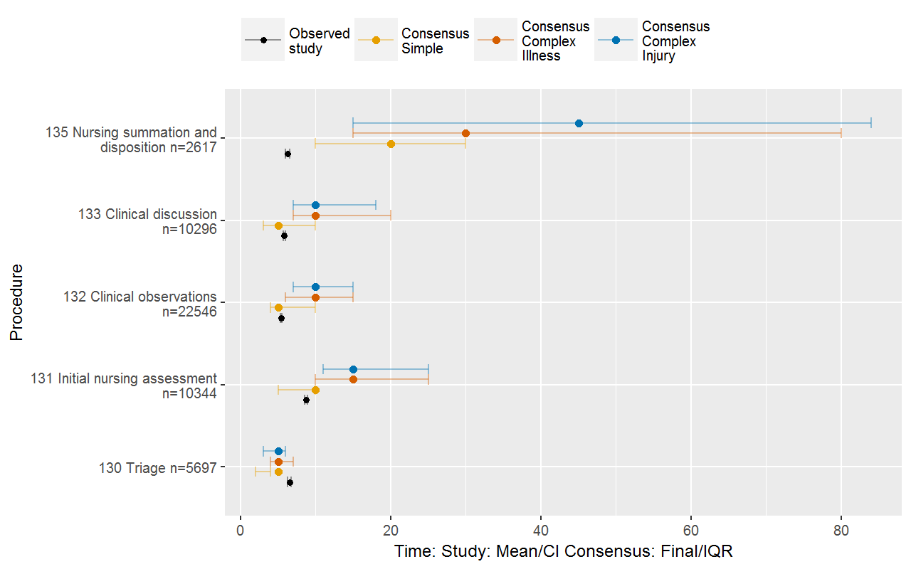

Figure 19 compares procedures for which there were at least 10 observations reported in the costing study across the 10 hospitals. For these procedures, the median value of the consensus estimates (i.e. across the case types) was used, and the IQRs are also shown. The procedures are presented in descending order by the mean times from the consensus study.
There was overlap between both sets of times in most instances. A large difference between the two sources was seen for 32 Fracture/ dislocation reduction (with the consensus study estimate being much higher). Where there are differences, it is potentially the times relating to complex patients that the nurses are recalling when estimating times in the consensus study.

Figure 19 – Mean times of nursing procedures, comparison between the costing study and the Emergency care clinician time consensus study
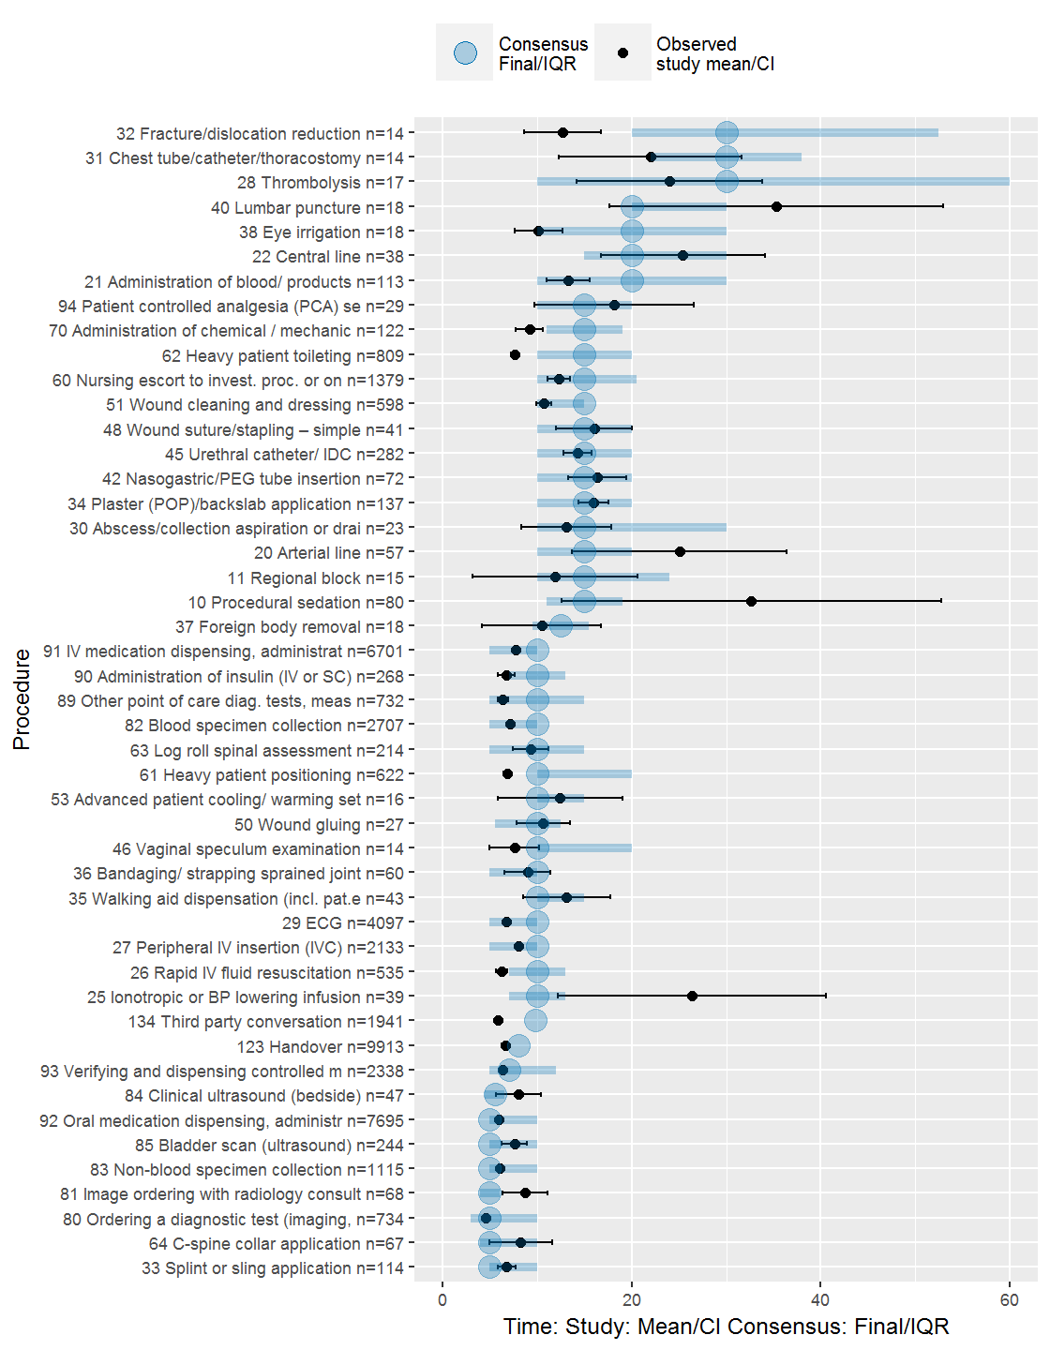

Figure 20 compares nine medical standard workflow activities. As for nursing, in the medical component of the consensus study, estimates were obtained for a range of case types, including ‘simple’, ‘complex illness’ and ‘complex injury’. The estimates from the consensus study are shown in the Figure as coloured circles representing the four case types. The bars through the circles represent the interquartile ranges (IQR) of the reported times. The mean of the observations from the costing study and confidence intervals are shown in black and confidence intervals are also shown (represented by the straight line).
Overall the results varied; some observed values from the costing study closely resembled the consensus estimates, whereas others were different. For activities 110 Initial treating bedside evaluation, 111 Initial treating clinician synthesis and documentation, 117 Initial senior assessment and 118 Senior review - verbal only (advice to treating clinician), the values from the costing study are close to the consensus estimates for simple cases. This is expected, as simple cases tend to dominate the case types seen in emergency departments.
For activities 112 Additional treating clinician bedside evaluation, 113 Additional treating clinician synthesis and documentation, 115 External clinician phone consultation and 119 Senior review patient examined, the observed values from the costing study are in the range of the consensus estimates, between the simple cases and complex injury cases. It is potentially the case that in busy emergency departments, additional treating clinician activities and senior review are more often undertaken in relation to complex patients.
For activity 121 Treating clinician summation and disposition, the costing study values are below the consensus estimates (although, still within the consensus study range). Similar to the observation in relation to nursing, this might be due to that fact that in the costing study, summation and disposition-related activities are not necessarily taking place at the patient’s bedside, and thus only part of the time for the activity is being captured.
Figure 20 – Mean times of medical activities, comparison between the costing study and the Emergency care clinician time consensus study
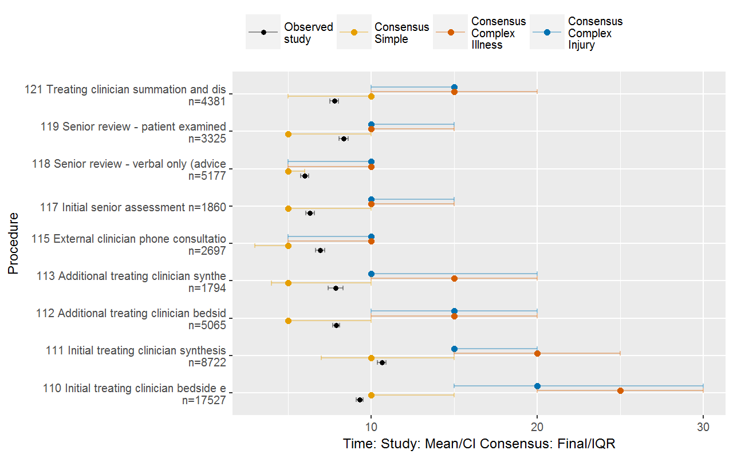
Figure 21 compares the times for procedures. It is presented in descending order by the mean times from the consensus study, and only shows procedures where there were more than 10 observations recorded in the costing study across the 10 hospitals. The median (i.e. across all case types) of the consensus estimates is presented, as well as the IQR. From the costing study, the mean and the confidence intervals are presented. The confidence intervals for lower frequency procedures are generally wider.
The consensus estimates tended to be lower than the times observed in the costing study, except for the following procedures, where the median values from the consensus study were higher, and there was no overlap of the IQR of the consensus study results and the confidence intervals around the mean time observed from the costing study:
- 32 Fracture/ dislocation reduction
- 120 Medical escort to and from imaging
- 70 Administration of chemical/ mechanical restraint
- 116 External clinician in-person consult
- 125 End of life discussion – patient and family.
Most of these procedures are ones that are likely to take a long time with a complex patient, and it is potentially these times that doctors are recalling when estimating times in the consensus study.
Figure 21 – Mean times of medical procedures, comparison between the costing study and the Emergency care clinician time consensus study
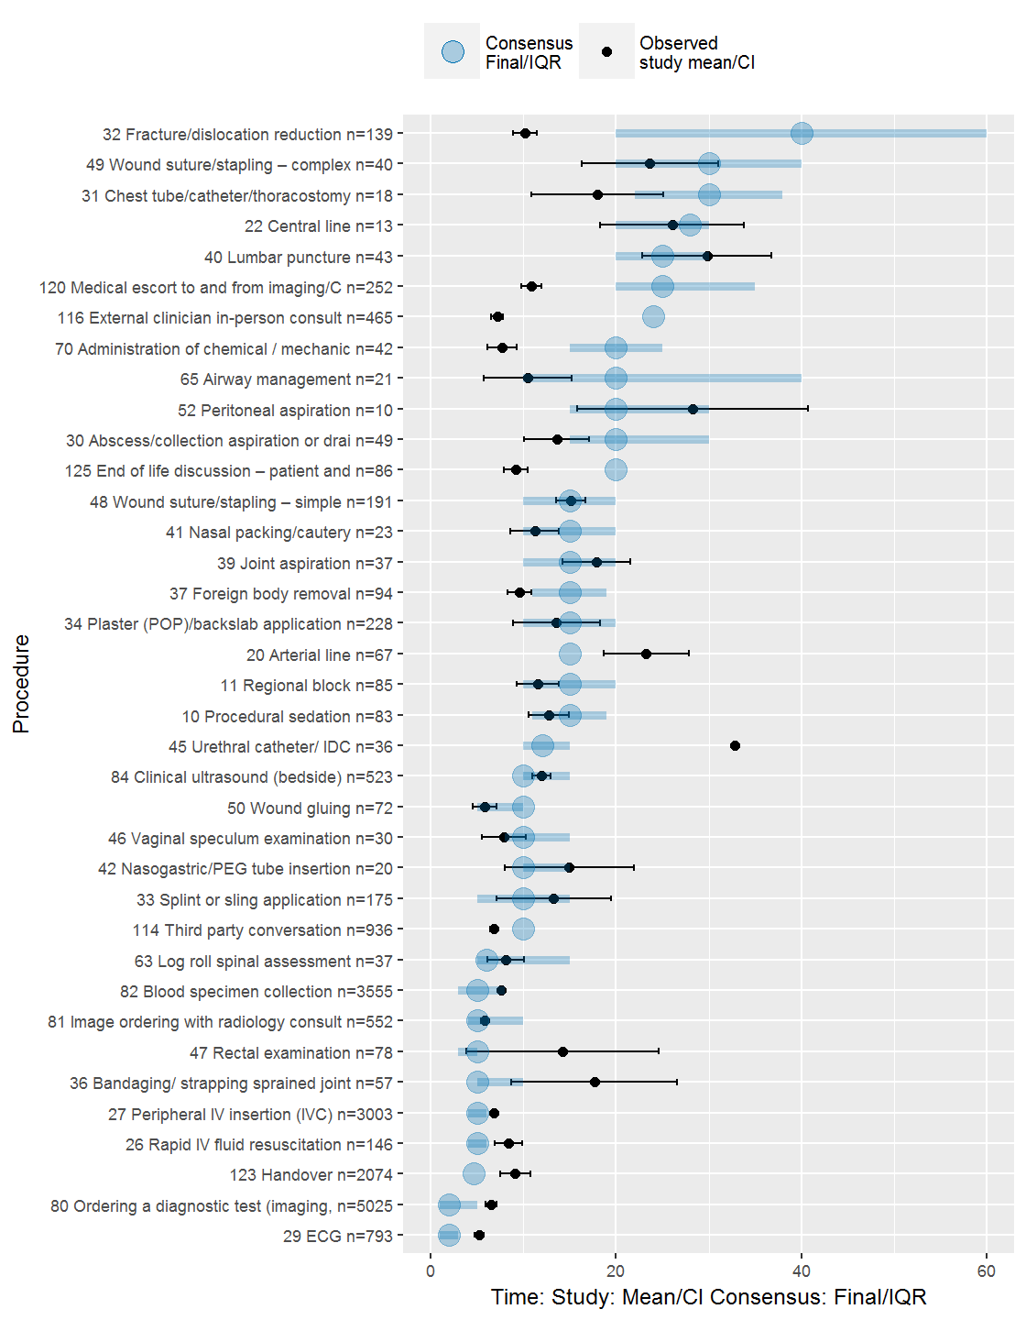

Investigations
The data collected for the Emergency care costing study included investigations undertaken for patients in the emergency department. Table 27 shows the results of this.
The most commonly reported investigation was basic panel blood testing (item 21). This was followed by directed investigations (item 22), which was in turn followed by plain x-ray of a single region (item 31).
Table 27 – Episodes with investigations reported, by study strata

Investigation | Stratum**
 | MCL | MCOt | ReL | Rem | ReOt | SP
Number of emergency department stays in which at least one investigation was reported*
21 Basic panel¹ | 8,366 | 2,163 | 522 | 317 | 696 | 335
22 Directed investigation² | 6,813 | 2,173 | 982 | 955 | 456 | 370
23 Complex investigation³ | 3,369 | 842 | 43 | 37 | 95 | 63
31 Plain X-ray - single region | 5,910 | 1,380 | 66 | 725 | 1,069 | 477
32 Plain X-ray - multiple regions | 83 | 3 | 6 | 68 | 87 | 56
33 Ultrasound - radiology department | 116 | 247 | 6 | 158 | 80 | 57
34 CT - single region, with or without contrast | 1,410 | 452 | 3 | 165 | 334 | 28
35 CT - multiple regions, with or without contrast | 192 | 134 | 0 | 26 | 151 | 3
36 Nuclear medicine scan | 51 | 0 | 0 | 0 | 0 | 0
37 MRI with or without contrast | 49 | 6 | 0 | 7 | 27 | 10
90 Other specified investigations not elsewhere classified | 2,673 | 0 | 0 | 42 | 15 | 18
Percentage of emergency department stays in which at least one investigation was reported
21 Basic panel¹ | 51.4% | 65.0% | 8.0% | 8.5% | 17.8% | 11.5%
22 Directed investigation² | 41.8% | 65.3% | 15.1% | 25.6% | 11.7% | 12.7%
23 Complex investigation³ | 20.7% | 25.3% | 0.7% | 1.0% | 2.4% | 2.2%
31 Plain X-ray - single region | 36.3% | 41.5% | 1.0% | 19.4% | 27.4% | 16.4%
32 Plain X-ray - multiple regions | 0.5% | 0.1% | 0.1% | 1.8% | 2.2% | 1.9%
33 Ultrasound - radiology department | 0.7% | 7.4% | 0.1% | 4.2% | 2.0% | 2.0%
34 CT - single region, with or without contrast | 8.7% | 13.6% | 0.0% | 4.4% | 8.6% | 1.0%
35 CT - multiple regions, with or without contrast | 1.2% | 4.0% | 0.0% | 0.7% | 3.9% | 0.1%
36 Nuclear medicine scan | 0.3% | 0.0% | 0.0% | 0.0% | 0.0% | 0.0%
37 MRI with or without contrast | 0.3% | 0.2% | 0.0% | 0.2% | 0.7% | 0.3%
90 Other specified investigations not elsewhere classified | 16.4% | 0.0% | 0.0% | 1.1% | 0.4% | 0.6%
Notes:
¹ 21 Basic panel: Tests include any of: FBP, U+E, BSL, VBG, CRP, ESR, BAL, BetaHCG, Group and screen, MSU for MC&S. ² 22 Directed investigation: Tests include any of: of D-Dimer/Coagulation profile, Troponin/Cardiac enzymes, LFTS, Lipase, Ca, PO4, Mg, ABG, lactate, Paracetamol, Anticonvulsant, Lithium, Specimen MC+S, Hepatitis serology, HIV serology, Influenza, Pap Smear, CSF (xanthochromia, cells, chemistry), Malaria, EBV/Monospot, Cross match.
³ 23 Complex investigation: If any other laboratory tests are ordered, irrespective of number or type (e.g. drug/toxin levels, autoimmune studies, iron studies etc.)
* Based on C4 (Emergency department laboratory and imaging investigations) submission, which was specified in the Data request specification developed for the project. Reflects number of episodes in which investigation was reported rather than number of investigations. Excludes episode end status’ of did not wait and dead on arrival. Excludes Armadale Kelmscott hospital due to data issues.
** MCL is Major city, large; MCOt is Major city, other; ReL is Regional, large; ReOt is Regional, other; Rem is Remote; SP is Specialist paediatric.
Mean costs of investigations, separately for pathology and imaging, are shown in Table 9 (by cost ‘bucket’) and in Table 10 (by line item) earlier in this report. At this stage, analysis has not been undertaken on the costs contributed by individual investigations. This will be undertaken in the classification stage of the project, accounting for the various indications for conducting an investigation.
- Considerations for the classification
The Investigative review of classification systems for emergency care (Health Policy Analysis 2014a) proposed a basic structure of a classification system for emergency care in the medium term as follows:
- In the first tier of the classification, stays would be separated into those requiring emergency care and a small set of other final classes (non-emergency care, did not wait and dead on arrival). It is possible for the non-emergency stays to be handled through the non-admitted classification, but this needs to be tested empirically.
- In the second tier of the classification, emergency stays would be grouped into clinically meaningful groups using emergency department diagnosis (perhaps enhanced by presenting problem and/or procedure in the long term). The groups need to reflect emergency care (i.e. the major categories of diagnoses managed in emergency care). This will be slightly different to admitted acute care, but may look like the medical Adjacent Australian-Refined Diagnosis Related Groups (AR-DRGs).
- Where there is an empirical basis, these diagnosis groups would then be split to reflect different levels of severity and/or complexity (consequently also reflecting resource use). Not all classes will need to be split beyond diagnosis group. In the medium term, these splits would be based on age, disposition and triage. In the longer term, the splits could be based on additional diagnoses (which may include functional/ dependency factors), procedure, age, and possibly disposition. Rather than using these variables to create separate splits for each class, a ‘patient emergency care clinical complexity score’ could be applied (like that used in AR-DRGs). It would summarise relevant information across the variables used to assess overall severity/ complexity of the patient.
The broad structure of the classification would be settled in the medium term, and the longer term would be focussed on developing a better approach to the third level splits in the classification. Figure 22 depicts the broad approach emerging from the Investigative review.

Figure 22 – Emergency care classification structure recommended by the Investigative review of classification systems for emergency care (Health Policy Analysis 2014a)
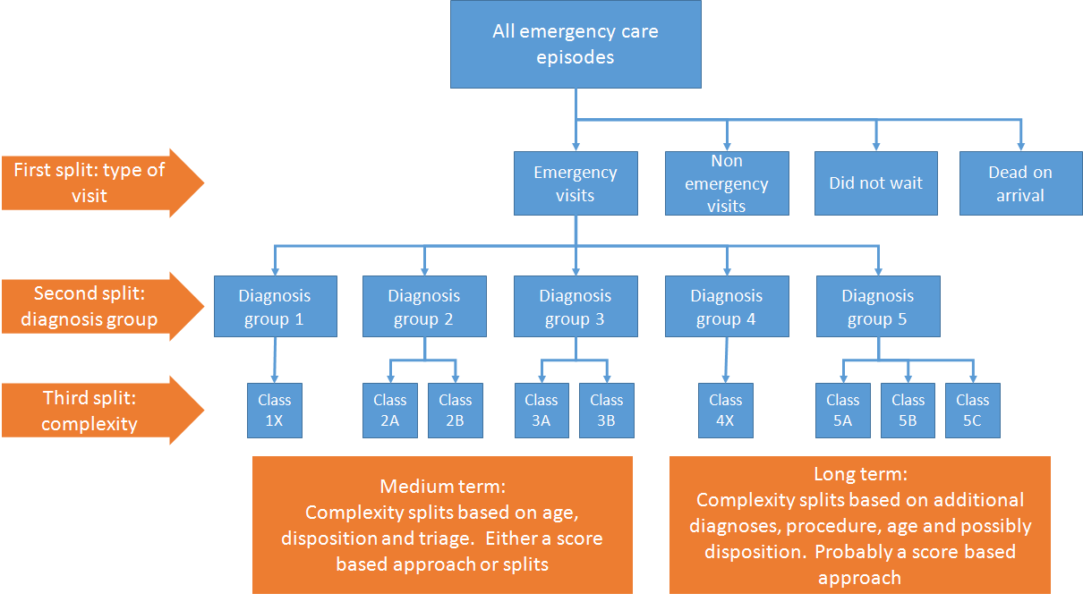

A principle in the development of the classification is that any new data elements introduced into the national data sets for emergency care should be a by-product of clinical care, and only introduced where:
- there is clear evidence that they add material value in explaining cost variation in emergency care
- they can support other uses (e.g. quality improvement, clinical redesign and process flow, operational management of the emergency department)
- the data element might also be useful in other classifications (e.g. inpatient. ambulatory care)
- the benefits to be derived from the implementation of the new data justify the costs (which should include clinician time in capturing any new data).
The diagnosis modifiers collected in this study will be assessed against the above criteria.
In the current study, a survey of clinicians involved in the data collection was undertaken once the data collection activities concluded, to capture any further reflections that they may have about patient complexity following their participation in the study. The survey asked clinicians to draw on their clinical judgment, and experience of participating in the study, to assess whether the additional patient characteristics collected as part of the study added to complexity of care and/ or resource intensity of treatment. Clinicians were also encouraged to provide any other patient characteristic they believed impacted patient complexity and resource use.
This survey was distributed in June 2016 and closed in July 2016, with 171 responses received online and on paper. The number of responses by clinical designation are shown in Table 28.

Table 28 – Respondents to the Emergency care costing study post data collection clinician survey

Designation | Responses
Nursing | 97
Medical | 66
Allied health | 4
No designation listed | 4
Total | 171

The survey results confirmed that the diagnosis modifiers collected as part of the study were ones that clinicians believe have an impact on patient complexity and/ or resource use (and thus should be considered for the classification of emergency care in development). In the free text question, clinicians qualified that:
- Complexity increases with multiple diagnosis modifiers present in any one patient.
- Complexity increases when the emergency department clinicians attempt to resolve a patient’s issues to send them home versus admitting them. This is contrary to the higher weights for subsequently admitted patients in the current URG classification, and is a theme that has been consistent in the consultations with clinicians in relation to this project.
- The National Emergency Access Target (NEAT) of 90% of patients to leave the emergency department within four hours of presentation also has an impact on how much resource goes into treating a patient. Additional resources go into treating patients that might not make the target.
- A patient that is a resident of an aged care facility may result in less resource use, as living in residential care makes discharge easier.
Additional conditions or other characteristics impacting on patient complexity and/ or resource use (i.e. in addition to those already collected through the study) identified by clinicians were as follows:
- Age less than 1 year or 75 years plus
- Patients on more than three medications
- Aboriginal and/ or Torres Strait Islander status
- Arrival by ambulance
- Lack of mobility
- Low compliance with treatment/ refusal of care
- Patients travelling long distances for treatment
- At risk of falls
- Domestic violence/ sexual assault.
Clinicians also listed a range of specific diagnoses that are likely to be high complexity and/ or cost, which can be statistically tested in the classification phase of the project.

- Conclusion and next steps
The results of the costing study are being presented to sites as part of a review and validation process. So far clinicians have supported the study results. Where there have been shifts in costs compared with results based on existing routine costing processes of emergency care, clinicians have fed back that the shifts seem reasonable and appropriate.
A key theme arising from the site consultations, and evident in the analysis shown in this report, is the varying infrastructure and practices at the hospitals that impact on cost. For example, it was shown in the analysis in this report that patients assigned an episode end status of ‘did not wait’ in some instances were seen by a clinician. Examples of variation in practice were also identified by the study sites for patients that are ‘dead on arrival’, those that die in the emergency department, and those that are transferred to another hospital for treatment. These variations are mostly hospital-specific. Others are due to the role of the emergency department (i.e. level and specialist role such as emergency mental health role) and the location (i.e. rural versus metropolitan). While hospital-level effects (including those relating to role level/specialisation and location) are important to understand, they need to be controlled for in the analysis to develop the classification. Role level/specialisation and location factors will be explored in the next stage of the analysis, and may be considered in the pricing model to be developed for emergency care.
Based on the above and the results presented in this report, the conclusion is that the data obtained from the study is good quality, and sufficient to support further analysis to develop a classification for emergency care. There is evidence from the univariate analysis that several of the variables collected through this study are correlated with higher costs.
The next stage of the project will be to examine the combined impact of these variables, and how these can be incorporated into a classification that provides an appropriate basis for predicting costs, as well as being meaningful to clinicians, managers and planners.
The outcomes of this report and further analyses of variables will form the basis of consultations with stakeholders for the development of the new classification system.

References
Health Policy Analysis 2014a, Investigative review of classification systems for emergency care – Final report, Independent Hospital Pricing Authority, Sydney.
Health Policy Analysis 2014b, Investigative review of classification systems for emergency care – Supplementary data analysis, Independent Hospital Pricing Authority, Sydney.

Appendix 1: Activities and procedures

Table 29 – Percentage of emergency department stays with at least one procedure/activity recorded*, by study strata

Procedure/activity |  |  | Stratum**
 |  |  | MCL | MCOt | ReL | Rem | ReOt |  | SP
11 Life support/respiratory
 | P0001 Assisted ventilation |  | 0.40% | 0.70% | 0.15% | 0.12% | 0.38% |  | 0.13%
 | P0002 Basic life support (CPR) |  | 0.07% | 0.17% | 0.04% | 0.00% | 0.00% |  | 0.00%
 | P0003 Cardioversion/defibrillation |  | 0.15% | 0.06% | 0.15% | 0.00% | 0.05% |  | 0.00%
 | P0004 Endotracheal intubation |  | 0.17% | 0.46% | 0.07% | 0.00% | 0.10% |  | 0.07%
 | P0005 Endotracheal extubation |  | 0.01% | 0.12% | 0.00% | 0.00% | 0.00% |  | 0.00%
 | P0007 Initiation/ management of CPAP/BIPAP |  | 0.36% | 1.10% | 0.11% | 0.18% | 0.81% |  | 0.00%
 | P0008 Management of intubated patient |  | 0.12% | 0.35% | 0.07% | 0.00% | 0.19% |  | 0.07%
12 Anaesthetic
 | P0010 Procedural sedation |  | 0.65% | 0.52% | 0.74% | 1.0% | 0.52% |  | 1.37%
 | P0011 Regional block |  | 0.87% | 0.29% | 0.78% | 1.7% | 0.81% |  | 0.13%
 | P0012 Ischaemic (Biers) blocks |  | 0.06% | 0.00% | 0.44% | 0.0% | 0.00% |  | 0.00%
13 Cardiovascular
 | P0020 Arterial line |  | 0.44% | 1.10% | 0.22% | 0.36% | 0.33% |  | 0.00%
 | P0021 Administration of blood/ products |  | 0.59% | 0.70% | 0.48% | 0.00% | 0.43% |  | 0.20%
 | P0022 Central line |  | 0.12% | 0.35% | 0.18% | 0.60% | 0.14% |  | 0.46%
 | P0023 External cardiac pacing |  | 0.13% | 0.00% | 0.07% | 0.24% | 0.05% |  | 0.13%
 | P0024 Pacing wire insertion |  | 0.01% | 0.00% | 0.00% | 0.12% | 0.00% |  | 0.00%
 | P0025 Ionotropic or BP lowering infusion |  | 0.23% | 0.35% | 0.18% | 0.24% | 0.24% |  | 0.00%
 | P0026 Rapid IV fluid resuscitation |  | 3.12% | 13.23% | 5.43% | 6.73% | 1.19% |  | 0.33%
 | P0027 Peripheral IV insertion (IVC) |  | 32.48% | 30.16% | 33.91% | 33.47% | 19.34% |  | 8.86%
 | P0028 Thrombolysis |  | 0.11% | 0.17% | 0.48% | 0.00% | 0.19% |  | 0.00%
 | P0029 ECG |  | 22.72% | 30.45% | 19.62% | 23.05% | 20.58% |  | 1.17%
14 Regional procedures
 | P0030 Abscess/collection aspiration or drainage |  | 0.40% | 0.29% | 1.03% | 1.25% | 0.10% |  | 0.20%
 | P0031 Chest tube/catheter/thoracostomy |  | 0.07% | 0.23% | 0.04% | 0.30% | 0.29% |  | 0.20%
 | P0032 Fracture/dislocation reduction |  | 0.86% | 0.70% | 1.29% | 0.95% | 0.33% |  | 0.59%
 | P0033 Splint or sling application |  | 2.42% | 1.91% | 3.32% | 3.75% | 1.10% |  | 2.21%
 | P0034 Plaster (POP)/backslab application |  | 2.07% | 1.22% | 3.03% | 2.98% | 1.29% |  | 3.52%
 | P0035 Walking aid dispensation (incl. pat.ed. |  | 0.93% | 0.23% | 2.14% | 2.32% | 0.05% |  | 0.65%
 | P0036 Bandaging/ strapping sprained joint |  | 0.81% | 0.58% | 1.92% | 0.00% | 0.76% |  | 2.21%
 | P0037 Foreign body removal |  | 0.79% | 0.29% | 0.70% | 1.13% | 0.33% |  | 0.78%
 | P0038 Eye irrigation |  | 0.36% | 0.17% | 0.81% | 0.24% | 0.10% |  | 0.20%
 | P0039 Joint aspiration |  | 0.18% | 0.23% | 0.11% | 0.66% | 0.05% |  | 0.00%
 | P0040 Lumbar puncture |  | 0.20% | 0.17% | 0.11% | 0.30% | 0.14% |  | 0.59%
 | P0041 Nasal packing/cautery |  | 0.36% | 0.06% | 0.04% | 0.18% | 0.05% |  | 0.00%
 | P0042 Nasogastric/PEG tube insertion |  | 0.37% | 0.23% | 0.37% | 0.18% | 0.57% |  | 0.85%
 | P0043 Pleural aspiration |  | 0.05% | 0.17% | 0.00% | 0.00% | 0.00% |  | 0.13%
 | P0044 Suprapubic catheter |  | 0.10% | 0.00% | 0.11% | 0.30% | 0.00% |  | 0.33%
 | P0045 Urethral catheter/ IDC |  | 1.83% | 1.80% | 1.07% | 1.31% | 1.48% |  | 0.33%
 | P0046 Vaginal speculum examination |  | 0.30% | 0.29% | 0.92% | 1.13% | 0.14% |  | 0.07%
 | P0047 Rectal examination |  | 0.75% | 0.35% | 1.00% | 0.95% | 0.76% |  | 0.07%
 | P0048 Wound suture/stapling simple |  | 2.03% | 0.70% | 2.22% | 0.00% | 0.71% |  | 0.98%
 | P0049 Wound suture/stapling complex |  | 0.32% | 0.23% | 0.41% | 0.00% | 0.10% |  | 0.26%
 | P0050 Wound gluing |  | 0.66% | 0.46% | 1.18% | 1.19% | 0.38% |  | 0.85%
 | P0051 Wound cleaning and dressing |  | 5.16% | 2.38% | 8.94% | 13.58% | 4.53% |  | 3.52%
 | P0052 Peritoneal aspiration |  | 0.06% | 0.17% | 0.07% | 0.00% | 0.00% |  | 0.00%
 | P0053 Advanced patient cooling/ warming setup |  | 0.14% | 0.06% | 0.00% | 0.00% | 0.05% |  | 0.00%
15 Patient mobility and positioning
 | P0060 Nursing escort to invest. proc. or on disposition |  | 7.23% | 19.32% | 0.18% | 2.62% | 9.00% |  | 1.43%
 | P0061 Heavy patient positioning |  | 3.35% | 1.91% | 0.22% | 2.26% | 2.10% |  | 0.07%
 | P0062 Heavy patient toileting |  | 4.24% | 2.15% | 0.15% | 1.49% | 1.95% |  | 0.00%
 | P0063 Log roll spinal assessment |  | 0.90% | 0.99% | 1.11% | 1.01% | 0.76% |  | 0.98%
 | P0064 C-spine collar application |  | 0.45% | 0.87% | 1.18% | 0.77% | 0.62% |  | 0.39%
 | P0065 Airway management |  | 1.13% | 0.64% | 0.07% | 1.25% | 0.86% |  | 0.26%
 | P0066 Positioning of patient to avoid pressure injury |  | 1.83% | 2.61% | 0.18% | 1.85% | 1.72% |  | 0.00%
16 Management of acute behavioural disturbances
 | P0070 Administration of chemical / mechanical restraint |  | 1.2% | 0.75% | 0.18% | 0% | 0.24% |  | 0.00%
 | P0071 1-to-1 nursing for distressed/confused/ agitated |  | 3.4% | 0.99% | 0.66% | 3% | 0.95% |  | 0.13%
17 Diagnostics
 | P0080 Ordering a diagnostic test (imaging, pathology) |  | 33.42% | 27.84% | 2.88% | 21.0% | 23.44% |  | 20.65%
 | P0081 Image ordering with radiology consult |  | 4.92% | 6.38% | 13.34% | 16.1% | 1.91% |  | 1.82%
 | P0082 Blood specimen collection |  | 31.72% | 28.89% | 3.03% | 28.2% | 21.39% |  | 8.27%
 | P0083 Non-blood specimen collection |  | 8.89% | 3.02% | 0.78% | 11.5% | 9.62% |  | 9.51%
 | P0084 Clinical ultrasound (bedside) |  | 2.97% | 1.91% | 2.62% | 5.0% | 2.62% |  | 0.52%
 | P0085 Bladder scan (ultrasound) |  | 1.87% | 0.64% | 1.07% | 1.5% | 0.67% |  | 0.59%
 | P0086 Laryngoscopy (flexible or rigid) |  | 0.02% | 0.00% | 0.11% | 0.3% | 0.00% |  | 0.00%
 | P0087 Oesophagoscopy/gastroscopy (flexible or rigid) |  | 0.08% | 0.00% | 0.00% | 0.0% | 0.00% |  | 0.00%
 | P0088 Sigmoidoscopy/colonoscopy (flexible or rigid) |  | 0.05% | 0.00% | 0.00% | 0.3% | 0.00% |  | 0.00%
 | P0089 Other point of care diag. tests, measures |  | 18.08% | 7.08% | 14.52% | 24.7% | 21.49% |  | 6.38%
18 Medication administration
 | P0090 Administration of insulin (IV or SC) |  | 1.76% | 1.22% | 1.11% | 2.32% | 0.81% |  | 0.07%
 | P0091 IV medication dispensing, administration, check |  | 23.26% | 36.19% | 22.98% | 28.11% | 19.77% |  | 10.88%
 | P0092 Oral medication dispensing, administration |  | 33.44% | 45.71% | 48.13% | 65.10% | 31.16% |  | 40.85%
 | P0093 Verifying and dispensing controlled meds |  | 11.86% | 12.06% | 13.26% | 20.85% | 7.19% |  | 2.74%
 | P0094 Patient controlled analgesia (PCA) set-up |  | 0.23% | 0.29% | 0.15% | 0.54% | 0.19% |  | 0.20%
19 Referrals
 | P0100 Referral for mental health legal status assess |  | 1.23% | 2.78% | 1.4% | 1.7% | 0.33% |  | 0.07%
 | P0101 Referral aged care assessment |  | 0.32% | 0.35% | 0.0% | 0.0% | 3.29% |  | 0.39%
 | P0109 Referral other |  | 13.70% | 3.13% | 1.4% | 11.1% | 4.29% |  | 7.43%
20 Additional medical
 | P0110 Initial treating clinician bedside evaluation | 58.1% |  | 58.6% | 8.09% | 63.2% | 45.69% | 67.04%
 | P0111 Initial treating clinician synthesis & doc. | 48.1% |  | 37.5% | 7.06% | 49.9% | 33.59% | 50.81%
 | P0112 Additional treating clinician bedside eval. | 20.7% |  | 23.7% | 1.22% | 16.0% | 28.35% | 15.77%
 | P0113 Additional treating clinician synthesis & doc. | 7.8% |  | 0.0% | 1.15% | 13.8% | 3.24% | 24.63%
 | P0114 Third party conversation | 5.9% |  | 9.7% | 1.40% | 10.0% | 9.39% | 3.26%
 | P0115 External clinician phone consultation | 13.6% |  | 17.6% | 0.30% | 7.7% | 10.15% | 19.09%
 | P0116 External clinician in-person consultation | 3.0% |  | 6.2% | 0.37% | 4.6% | 3.19% | 0.00%
 | P0117 Initial senior assessment | 13.3% |  | 9.7% | 0.59% | 4.8% | 0.48% | 7.75%
 | P0118 Senior review - verbal only (advice to treating) | 24.4% |  | 12.9% | 3.92% | 30.7% | 19.34% | 29.12%
 | P0119 Senior review - patient examined | 19.1% |  | 17.2% | 2.51% | 23.0% | 7.10% | 13.94%
 | P0120 Medical escort to and from imaging/CT/ward | 1.5% |  | 2.1% | 0.26% | 2.1% | 1.24% | 0.91%
 | P0121 Treating clinician summation and disposition | 22.0% |  | 11.2% | 4.80% | 39.4% | 17.20% | 34.07%
21 Additional nursing
 | P0130 Triage | 31.6% |  | 44.1% | 0.07% | 48.6% | 33.06% | 38.83%
 | P0131 Initial nursing assessment | 49.6% |  | 30.4% | 6.46% | 39.4% | 42.26% | 15.57%
 | P0132 Clinical observations | 62.8% |  | 57.9% | 5.80% | 81.5% | 45.40% | 37.59%
 | P0133 Clinical discussion | 41.3% |  | 50.8% | 2.55% | 48.0% | 24.44% | 45.15%
 | P0134 Third party conversation | 11.1% |  | 9.7% | 0.48% | 21.0% | 12.48% | 0.13%
 | P0135 Nursing summation and disposition | 17.4% |  | 10.4% | 0.30% | 16.1% | 5.96% | 3.71%
 | P0136 Other bedside nursing care and doc. | 53.7% |  | 61.6% | 4.77% | 46.3% | 39.45% | 71.07%
 | P0137 Nurse chaperone | 2.4% |  | 3.9% | 0.22% | 8.2% | 0.62% | 0.72%
22 Other medical/ nursing
 | P0122 Family conference | 5.4% |  | 5.0% | 0.52% | 3% | 4.76% | 33.75%
 | P0123 Handover | 39.7% |  | 28.0% | 6.43% | 51% | 21.06% | 17.26%
 | P0124 Supervision/ teaching | 10.2% |  | 5.3% | 0.81% | 0% | 6.24% | 10.42%
 | P0125 End of life discussion patient and/or family/ | 0.9% |  | 0.0% | 0.18% | 0% | 0.81% | 0.46%
 | P0200 Other specified procedure NEC | 52.4% |  | 69.03% | 13% | 32% | 24.49% | 50.10%
23 Locally defined medical/nursing
 | P0202 Bed Management/patient flow | 21.2% |  | 14.62% | - | - | 4.42% | 3.71%
 | P0203 Allocate nursing staff | 22.4% |  | 0.64% | - | - | - | -
 | P0204 Human resource management (replacing sick leave/shortages) | 8.1% |  | 0.12% | - | - | 0.08% | 0.26%
 | P0205 Administering of oxygen therapy | - |  | - | - | - | - | 0.52%
 | P0205 Equipment search | 6.5% |  | 14.27% | - | - | 4.65% | -
 | P0206 Room or Bed Search | 3.3% |  | - | - | - | - | -
 | P0207 Nursing conference - bed huddles | 6.5% |  | 2.03% | - | - | - | -
 | P0208 IIMS Documentation | 6.5% |  | 2.03% | - | - | 0.15% | 2.08%
 | P0209 Consult with referring hospital | - |  | - | - | - | - | 0.13%
 | P0210 NETS consultation | - |  | - | - | - | - | 0.00%
 | P0211 Diagnostic Review | - |  | - | - | - | - | 21.17%
 | P0212 ICU Admission | - |  | - | - | - | 0.00% | -
 | P0213 Nursing transfer to ward | - |  | - | - | - | - | 3.13%
 | P0214 Urinalysis | 13.7% |  | 19.49% | - | - | 0.15% | -
 | P0216 Needle decompression | 35.3% |  | - | - | - | - | 0.07%
 | P0217 IO Access | - |  | - | - | - | - | 0.07%
 | P0218 Isolation cleaning | - |  | - | - | - | - | 0.13%
 | P0219 Ordering medication | - |  | 4.99% | - | - | - | -
 | P0220 Restocking | - |  | - | - | - | 2.25% | -
 | P0221 Security | 13.7% |  | - | - | - | - | -
 | P0222 Other locally defined medical/ nursing procedures/activities | 10.0% |  | - | - | - | 2.40% | -
* Based on B3 (Staff time allocated to procedures/activities) or C3 (Procedures) submissions which were specified in the Data request specification developed for the project. Reflects number of episodes in which procedure occurred rather than number of procedures. Excludes episode end status’ of did not wait and dead on arrival. Sites could also add locally defined procedures for collection. Where they did so, these are not shown.
** MCL is Major city, large; MCOt is Major city, other; ReL is Regional, large; ReOt is Regional, other; Rem is Remote; SP is Specialist paediatric.

