

Annual

Report
2020–21
Independent Hospital Pricing Authority

Contact
If you have any queries about this annual report please contact:
Independent Hospital Pricing Authority
Communication and Media Section
Eora Nation, PO Box 483
Darlinghurst NSW 1300
Email communications.ihpa@ihpa.gov.au
Telephone 02 8215 1100
ABN 27 598 959 960
Website www.ihpa.gov.au
Online version
An online version of this annual report can be accessed at:
www.ihpa.gov.au/ihpa-annual-report-2020-21
Follow us
LinkedIn linkedin.com/company/independent-hospital-pricing-authority
Twitter twitter.com/IHPAnews
YouTube youtube.com/IHPAGovAu
SoundCloud soundcloud.com/IHPA
Suggested citation: Independent Hospital Pricing Authority Annual Report 2020–21
Online ISSN: 2201–1862
Print ISSN: 2201–0718
© Independent Hospital Pricing Authority 2021

With the exception of the IHPA logo, photos and signatures and where otherwise noted, all material presented in this document is provided under a Creative Commons Attribution 3.0 Australia licence.
The details of the relevant licence conditions are available on the Creative Commons website, (www.creativecommons.org/licenses/by/3.0/au) as is the full legal code for the CC BY 3 AU licence.

Chair’s welcome


I am pleased to present the Independent Hospital Pricing Authority’s (IHPA) Annual Report for 2020–21.
As the Chair of IHPA, it was a pleasure to lead the agency to deliver yet another substantial work program in the preceding year.
Addendum to the Health Reform Agreement 2020–25
In May 2020, all Australian governments signed the 2020–25 Addendum to the National Health Reform Agreement. This Addendum reaffirmed each party’s commitment to improving health outcomes for all Australians and reducing the demand for avoidable public hospital services.
This year IHPA made significant progress on addressing key changes required by the new Agreement—including an updated methodology to achieve financial neutrality for pricing private patients in public hospitals and adjustments to reduce avoidable hospital readmissions.
For 2021–22, the release of the annual Pricing Framework for Australian Public Hospital Services (Pricing Framework) took place alongside the release of the National Efficient Price and National Efficient Cost Determinations 2021–22.
This was to ensure that IHPA’s consultation on the development of the Pricing Framework included feedback on the Addendum to the National Health Reform Agreement 2020–25.
I believe the approach the agency has taken in the past year is already helping to shape the strategies that are making positive steps towards improving health outcomes for all Australians.
Response to COVID-19
The National Partnership on Coronavirus Disease 2019 (COVID-19) Response was signed in March 2020, ensuring additional health service funding for the national response to the pandemic.
In order to implement the measures under the Agreement, IHPA updated the national classifications and data reporting guidelines and published rules for coding and costing COVID-19 episodes of care. This ensured these changes were promptly and adequately accounted for in the national pricing model to support states and territories in their response to the pandemic. IHPA has continued to update the national classifications to reflect changes to the COVID-19 response, such as the vaccination roll out.
The adjusted timeline for the release of the Pricing Framework 2021–22 also allowed IHPA to conduct early consultation on the emerging issues resulting from COVID-19 to understand the potential continuing changes to models of care and service delivery in Australian public hospitals.
Stable and sustainable rate of growth
In March 2021, IHPA published its tenth National Efficient Price Determination and ninth National Efficient Cost Determination for public hospital services in 2020–21, following extensive consultation with jurisdictions and stakeholders.
The Pricing Framework and Determinations are critical in deciding the Commonwealth funding contribution to public hospital services. They also provide a benchmark for the efficient cost of providing these services and enable a stable and sustainable rate of growth in public hospital costs (see Figure 5).
Delivering safe, high-quality and efficient health care
IHPA continues to work with the Australian Commission on Safety and Quality in Health Care and other stakeholders to include safety and quality measures in its pricing and funding approaches. For 2020–21, our common goal to improve health outcomes and decrease avoidable demand for public hospital services led us to conclude the two-year shadow-pricing period of funding options for reducing avoidable hospital readmissions on 30 June 2021. The new pricing model is set to commence on 1 July 2021.

Valuable stakeholder partnerships and collaboration
IHPA continues to build many strategic and trusted partnerships with all Australian governments, peak bodies and associations. Engaging with, and listening to, our key stakeholders is a critical part of how we fulfil our statutory functions.
I would like to highlight the contributions made by our Clinical Advisory Committee. Their advice is essential to the decisions we make.
As I come to the end of my second tour of duty at IHPA, I thank and acknowledge the outstanding work of all of the Pricing Authority members, past and present. Each has contributed their considerable insights, wisdom and judgement over the last ten years to deliver balanced determinations for the Australian Government. Their diligence has contributed positively to major reform of the funding of Australian public hospitals.
On behalf of the Pricing Authority, I commend Mr James Downie, Chief Executive Officer, for his outstanding performance and leadership. All of IHPA’s achievements have only been possible because of our Chief Executive Officer’s skills and leadership qualities. He has serviced the Board with impeccable professionalism and it has been a pleasure working as a team with James over the last ten years. I also acknowledge IHPA staff for their continued commitment to the delivery of a successful program of work this year, despite the challenges faced with the pandemic.

Looking ahead
In the year ahead, the Pricing Authority looks forward to contributing further to creating incentives for efficient and high-quality public hospital services across Australia.
There are exciting new challenges ahead that build on the activity based funding foundations.
The new Agreement signalled the need to support innovation by states and territories. In response, IHPA has analysed which services might be better funded through different models, such as bundled payments and casemix adjusted capitation payments. IHPA has published a roadmap to lead national discussion on the future funding models. The aim is to shift the focus of funding models away from only rewarding activity and admission to hospital, and move towards more incentives for continuity of care, preventing avoidable hospitalisation and substituting the best care option to achieve optimum outcomes and value for Australians.
Delivered on 11 May 2021, the Federal Budget 2021–22 includes two measures whereby IHPA’s remit will be expanded to inform Australian Government decisions on the pricing of aged care services and prostheses reforms from 1 July 2023.
I am confident the agency’s expanded role will make a positive impact on residential aged care, home aged care pricing and the cost and access to medical devices in the private health sector, as we have seen with the sustainability achieved in the hospital sector.
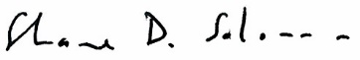
Mr Shane Solomon
Chair
Independent Hospital Pricing Authority
30 August 2021

Letter of transmittal
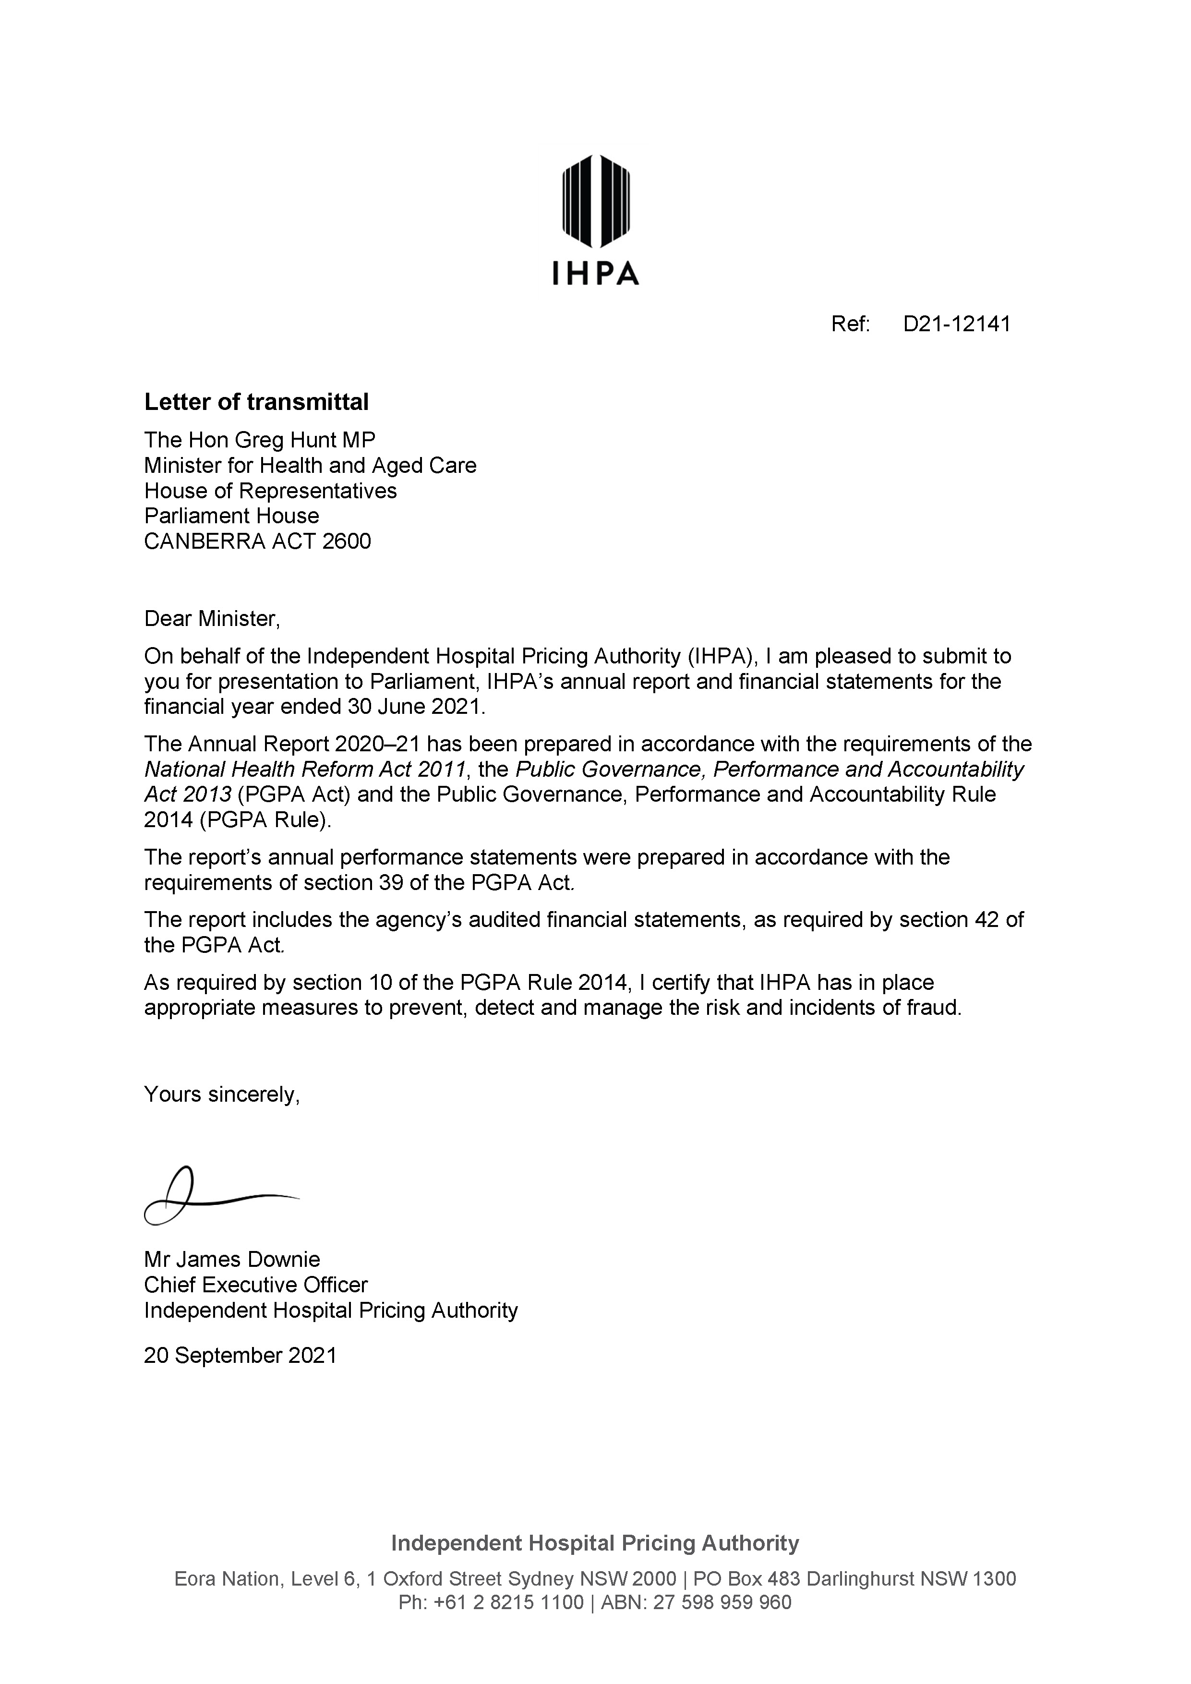

Contents
Chair’s welcome i
Letter of transmittal iv
Contents v
Approval by the accountable authority 1
- About IHPA 3
Legislation 4
Who we are 6
Pricing and funding for safety and quality 8
Responsible Minister 10
Ministerial directions and government policy orders 11
Pricing for public hospital services 12
Organisational structure 16
Committees and working groups 17
- Pricing Authority 21
About the Pricing Authority 23
Meetings of the Pricing Authority 2020–21 26
- IHPA 2020–21 overview 27
CEO’s year in review 28
2020–21 highlights 30
- Clinical Advisory Committee 31
Letter from the Chair 32
About the Clinical Advisory Committee 34
2020–21 highlights 36
- Annual performance statements 37
Introductory statement 38
Performance in 2020–21 39
Activities 40
- Management and accountability 63
Key corporate governance practices 64
Management of human resources 69
- Financial management 77
Financial statements 78
- Appendices 103
Appendix A: Figures and tables 104
Appendix B: Acronyms and abbreviations 105
Appendix C: Glossary 106
Appendix D: Compliance index 109
Index 112



Approval by the accountable authority
I present the annual report of the Independent Hospital Pricing Authority for the financial year ended 30 June 2021, in accordance with the National Health Reform Act 2011 and pursuant to section 46 of the Public Governance, Performance and Accountability Act 2013.
The Independent Hospital Pricing Authority is a corporate Commonwealth entity. This report has been prepared in accordance with the requirements of sections 17BA to 17BF of the Public Governance, Performance and Accountability Rule 2014. This report also contains information required under other applicable legislation, including the Work Health and Safety Act 2011.
As the accountable authority for the purposes of the Public Governance, Performance and Accountability Act 2013, I am responsible for preparing this annual report and providing a copy to the responsible Minister.

Mr James Downie
Chief Executive Officer
Independent Hospital Pricing Authority
20 September 2021


About IHPA


Legislation
The Independent Hospital Pricing Authority (IHPA) is a corporate Commonwealth entity under the Public Governance, Performance and Accountability Act 2013.
National Health Reform Agreement
IHPA was established under the National Health Reform Act 2011, giving effect to the National Health Reform Agreement signed by the Commonwealth Government and all states and territories in August 2011.
The National Health Reform Agreement sets out the intention of all Australian governments to work together to improve health outcomes for every Australian.
National Partnership on COVID-19 Response
On 13 March 2020, the Commonwealth and all state and territory governments signed the National Partnership on Coronavirus Disease 2019 (COVID-19) Response, to provide financial assistance for the additional costs incurred by health services in responding to the COVID-‍19 pandemic.
IHPA has worked closely with the Administrator of the National Health Funding Pool to provide assistance for the implementation of the National Partnership Agreement on the COVID-19 Response.
In order to implement the measures under this Agreement, IHPA developed the national classification systems for reporting COVID-19 in Australian hospitals within admitted care, emergency care and non-admitted care settings.
Comprehensive guidelines were published on the IHPA website and updated regularly to support hospitals in classifying and reporting COVID-19 related episodes of care.
The activity based funding classifications have been updated regularly to ensure that COVID-19 testing, treatment and vaccination can be accurately reported and tracked.
The associated national costing and pricing guidelines that were published ensure that the costs of responding to the pandemic, and in turn the evolving needs of the health system, are appropriately and consistently captured across the country.
Addendum to the National Health Reform Agreement 2020–25
On 29 May 2020 all Australian governments signed a new Addendum, which amended the National Health Reform Agreement for the period from 1 July 2020 to 30 June 2025.
The Addendum to the National Health Reform Agreement:
- maintains a commitment to activity based funding
- reaffirms the independence and functions of the national agencies such as the Independent Hospital Pricing Authority, the National Health Funding Body and the Australian Commission on Safety and Quality in Health Care
- retains the 45 per cent Commonwealth funding contribution and the 6.5 per cent national growth cap
- continues to integrate safety and quality reforms into the pricing and funding of public hospital services, including the current arrangements for sentinel events and hospital acquired complications.
Key changes to current arrangements introduced in the Addendum include:
- IHPA is required to develop an updated methodology for pricing private patients in public hospitals that accounts for all hospital revenues. This is to ensure funding models are financially neutral with respect to all patients, regardless of whether patients elect to be private or public.
- IHPA is required to develop a pricing model for avoidable hospital readmissions for implementation from 1 July 2021, following approval from the Council of Australian Governments (COAG) Health Council0F0F.
- IHPA is required to shadow price for a period of two years, or a shorter period if agreed by the Commonwealth and the majority of states and territories, prior to the implementation of new classifications or costing rules to mitigate the need for retrospective adjustments to the national funding model.
- High-cost, highly specialised therapies will attract 50 per cent Commonwealth funding under the new nationally cohesive health technology assessment process. These will be considered outside of the 6.5 per cent national growth cap for a period of two years.
- IHPA is required to develop a funding methodology that does not penalise states undertaking trials of innovative models of care for the COAG Health Council1F to approve by April 2021.
Federal Budget 2021–22
The Federal Budget 2021–22 was delivered on 11 May 2021 and contains two measures that impact IHPA’s current role of pricing for public hospital services.
The first measure is in response to the Royal Commission into Aged Care Quality and Safety.
Under this measure, IHPA will inform Australian Government decisions on annual funding increases in residential aged care from 1 July 2023. IHPA will also have a role in providing pricing advice for home-based aged care from 1 July 2023.
The second measure involves working with the Department of Health and key stakeholders to support reform to the Prostheses List, to reduce the cost of medical devices used in the private health sector and to streamline access to new medical devices.

Who we are
The Independent Hospital Pricing Authority (IHPA) is an independent government agency established by the Commonwealth as part of the National Health Reform Act 2011 to contribute to significant reforms to improve Australian public hospitals.
Vision
To design pricing systems that promote safe, efficient public hospital care for all Australians.
Purpose
To promote improved efficiency in, and access to, safe and high-quality public hospital services, primarily through setting the national efficient price and levels of block funding for public hospital activities.
Organisational values
IHPA’s organisational values shape the culture of the agency and form the basis for stakeholder engagement to achieve our vision. Our core values are as follows:
- We act with independence, transparency, fairness, respect, accuracy and accountability.
- We value collaboration and demonstrate our values in the way we interact internally, with our stakeholders and the broader community.
- We value the work, talent and contribution of our staff, and create organisation‑wide development strategies to maintain and grow expertise and intellectual capital.
Our staff act ethically, support a collaborative culture and take pride in their work.
Functions
Pursuant to the National Health Reform Act 2011, the primary functions of IHPA are as follows:
- to determine the national efficient price for healthcare services provided by public hospitals where the services are funded on an activity basis
- to determine the national efficient cost for healthcare services provided by public hospitals where the services are block funded
to publish the national efficient price, national efficient cost and other information each year for the purpose of informing decision‑makers in relation to the funding of public hospitals.
IHPA was established to promote improved efficiency in, and access to, public hospital services through the provision of independent advice to Australian governments.
IHPA achieves this by developing and implementing robust systems to support activity based funding for those services (see ‘Pricing for public hospital funding’, p12).
In undertaking its work, IHPA is required to consider the actual cost of delivering public hospital services in as wide a range of hospitals as practicable. It is also required to take into account any legitimate and unavoidable variations in costs due to hospital characteristics and patient complexity.
IHPA balances a range of national policy objectives, which are guided by principles contained in the National Health Reform Agreement and its amendments.

Pricing and funding for safety and quality
The program of work for pricing and funding for safety and quality originated from the April 2016 Council of Australian Governments Health Council2F Heads of Agreement on Public Hospital Funding.
In 2017, all Australian governments signed an Addendum to the National Health Reform Agreement. Through this Agreement, parties committed to develop and implement reforms to improve health outcomes of Australians through funding and pricing approaches to safety and quality. These reforms are designed to improve patient outcomes in the public health system and decrease avoidable demand for public hospital services.
These pricing and funding approaches intend to complement existing strategies to improve safety and quality in public health care.
The Independent Hospital Pricing Authority (IHPA) works together with the Australian Commission on Safety and Quality in Health Care to incorporate safety and quality measures into the determination of the national efficient price.
Under the Addendum 2017–20, IHPA is required to advise on options for a comprehensive and risk‑adjusted model to determine how funding and pricing is used to improve patient outcomes across three key areas: sentinel events, hospital acquired complications and avoidable hospital readmissions.
Under the Addendum 2020–25, IHPA is required to continue reforms to integrate safety and quality into the pricing and funding approaches for public hospital services to further improve the health outcomes of patients and decrease avoidable demand for public hospital services.
The implementation of pricing and funding for safety and quality has been rolled out in stages as follows.
- Sentinel events: Sentinel events are a subset of adverse patient safety events that are wholly preventable and result in serious harm to, or the death of, a patient.
Since 1 July 2017, no Commonwealth funding has been provided for any public hospital episode that includes a sentinel event. This policy applies to both activity based and block-funded hospitals.
- Hospital acquired complications: A hospital acquired complication refers to a complication for which clinical risk mitigation strategies may reduce (but not necessarily eliminate) the risk of that complication occurring. IHPA has worked with the Australian Commission on Safety and Quality in Health Care and other stakeholders to develop an agreed list of hospital acquired complications.
From 1 July 2018, funding has been reduced for any episode of admitted acute care where hospital acquired complications such as falls, infections or pressure injuries occur during a hospital stay.
- Avoidable hospital readmissions: Unplanned hospital readmissions are a measure of potential issues with the quality, continuity and integration of care provided to patients during or subsequent to their original hospital stay.
The 2017–20 Addendum required that IHPA develop pricing and funding adjustments to target avoidable hospital readmissions, which arise from complications of the management of the patient’s original hospital admission.
A key feature of the 2020–25 Addendum was the agreement by all jurisdictions to implement the third tranche of pricing measures to support continued safety and quality improvements in Australia’s public hospital system.
IHPA commenced an analysis of three funding options intended to assist in reducing avoidable hospital readmissions for two years from 1 July 2019.
The analysis period allowed IHPA to assess the impacts of the proposed funding options based on cost and activity data, while providing the states and territories with a transitional arrangement prior to any decision on the introduction of the adjustment.
From 1 July 2021, the national pricing model will include measures associated with avoidable readmissions, in addition to previously introduced measures for sentinel events and hospital acquired complications.

Responsible Minister
The Independent Hospital Pricing Authority sits within the Department of Health portfolio.
The Minister responsible for this reporting period is the Hon Greg Hunt MP, Minister for Health and Aged Care.

Ministerial directions and government policy orders
On 29 January 2020, the Independent Hospital Pricing Authority (IHPA) received a Ministerial Direction from the Hon Greg Hunt MP, under section 226(1) of the National Health Reform Act 2011.
The direction required that IHPA study existing and projected costs for Nationally Funded Centres by 31 January 2021, recommending options regarding:
- whether Nationally Funded Centres, individually and collectively, are more appropriately funded via activity based funding or block-funding arrangements under the National Health Reform Agreement.
- the development and operation of cost models and pricing models for the Nationally Funded Centres, covering both existing and potential future services delivered under the program. In issuing this direction, the Minister consulted with the COAG Health Council1F.
In compliance with the direction, IHPA has prepared an interim report for consideration of the Australian Health Ministers Advisory Council, which was delivered on 10 December 2020.
IHPA did not receive any Ministerial Directions in 2020–21.

Pricing for public hospital services
Under the National Health Reform Agreement, the Independent Hospital Pricing Authority (IHPA) was established to contribute to significant reforms to improve the efficiency and transparency of public hospital funding.
A vital component of these reforms is the implementation of activity based funding for Australian public hospital services.
IHPA designs the pricing systems that underpin the activity based funding approaches.
Activity based funding
Activity based funding describes the system by which hospitals are paid based on the number and complexity of patients they treat.
If a hospital treats more patients, it receives more funding. Activity based funding takes into account the fact that some patients are more complicated to treat than others.
Funding for public hospital services is based on the number of weighted services provided to patients and the price to be paid for delivering those services.
Activity based funding enables efficiency comparisons to be made between hospitals and allows system and hospital managers to identify inefficient practices, manage costs and optimise resource allocation. It is a useful tool to measure hospital performance and to establish appropriate benchmarks.
The national efficient price underpins the implementation of activity based funding.
Each financial year, IHPA releases the National Efficient Price and National Efficient Cost Determinations.
These Determinations, in conjunction with data regarding the actual volume and type of hospital services provided by states and territories, are used by the Administrator of the National Health Funding Pool to calculate the Commonwealth funding contribution to public hospitals.
In 2020–21, national classifications were used to fund the following service categories on an activity basis:
- admitted acute services
- admitted mental health services
- subacute and non-acute services
- emergency department services
non-admitted services.
Figure 1: National efficient price 2021–22
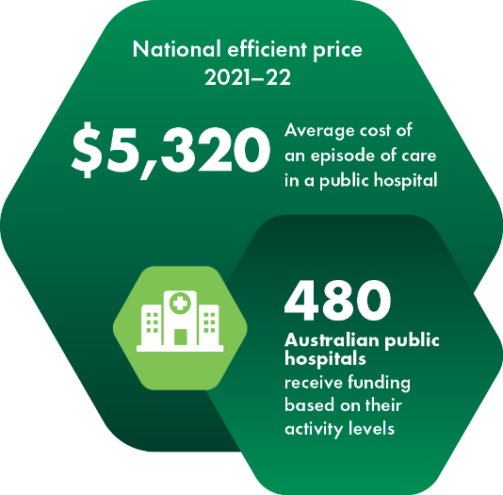

Activity based funding timeline
 | Activity based funding becomes a requirement of Commonwealth funding for public hospitals.
 | National Health Reform Agreement signed by all Australian governments; this agreement outlines the establishment of IHPA.
 | First national efficient price was established at $4,808.
 | First national efficient cost was established at $4.738 million.
 | From 2017, no Commonwealth funding has been provided for any public hospital episode that includes a sentinel event.
 | From 2018, funding has been reduced for any episode of admitted acute care where hospital acquired complications occur during a hospital stay.
 | Refined national efficient cost model introduced under fixed-plus-variable model.
 | Tenth national efficient price was established at $5,597.  - Ninth national efficient cost was established at $2.99 million fixed cost and $5,762 variable cost.  From 2021, IHPA will implement a funding adjustment to apply where there is an avoidable hospital readmission to any hospital within the same jurisdiction.

Building blocks for an activity based funding system
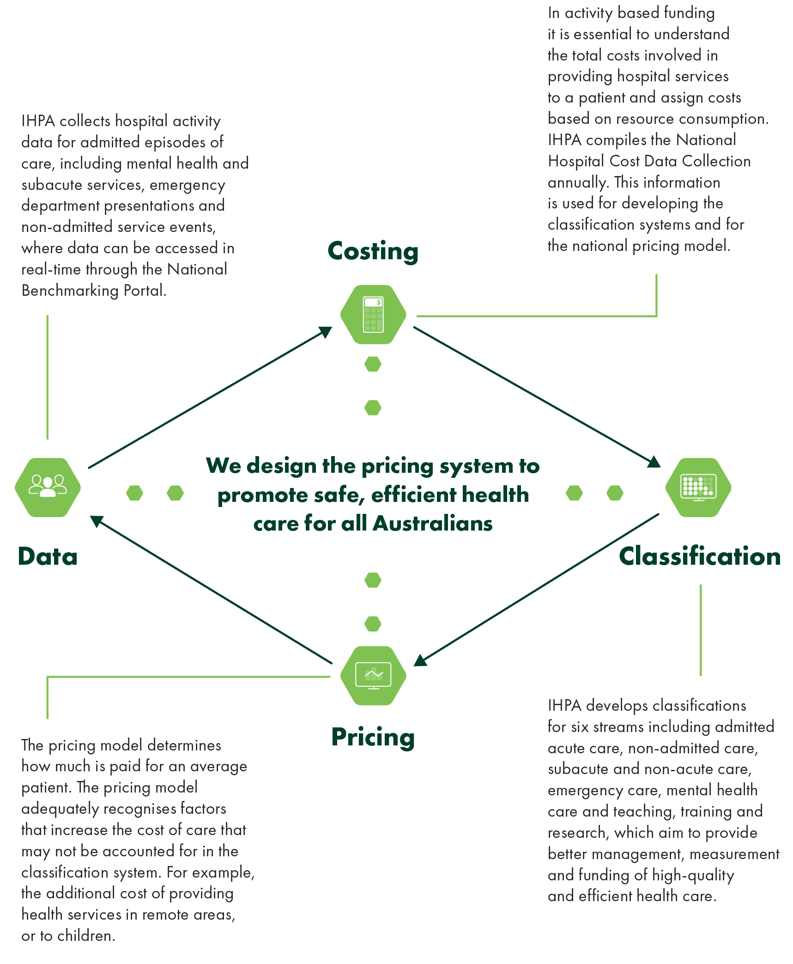

Further details on activity based funding, are available at www.ihpa.gov.au/what‑we‑do.
Block funding
The national efficient cost underpins funding for services that are not suitable for activity based funding, such as:
- small rural and regional hospitals
- teaching, training and research in public hospitals
- non-admitted mental health care.
The national efficient cost represents the average cost of Commonwealth funding contribution on a block grant basis for small rural hospitals.
The national efficient cost is determined using the in‑scope activity and expenditure data for hospitals to be block funded.
For the 2020–21 national efficient cost, a new cost model based on a fixed-plus-variable structure was introduced in consultation with states and territories.
This new model has a more sophisticated approach in calculating block funding to better reflect the changes in activity delivered in small rural hospitals and it ensures there is no disincentive for states to provide services in rural areas.
Figure 2: National efficient cost 2021–22
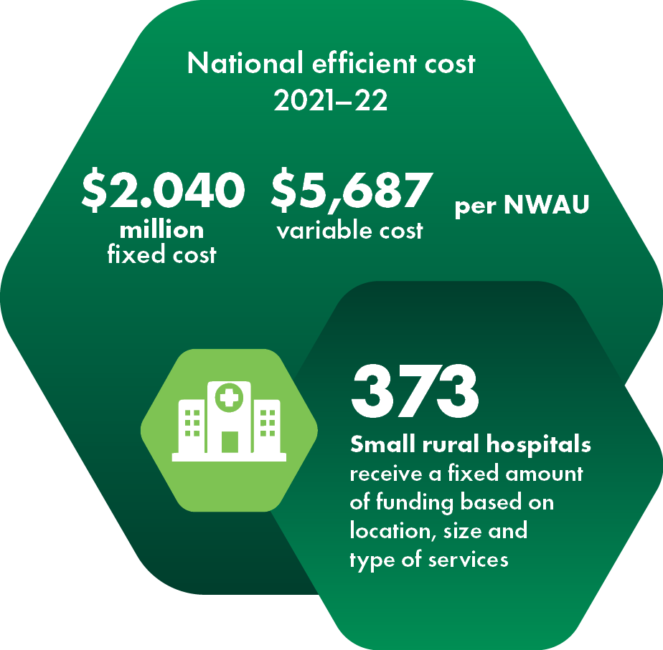

Organisational structure
Figure 3: IHPA’s organisational structure as at 30 June 2021
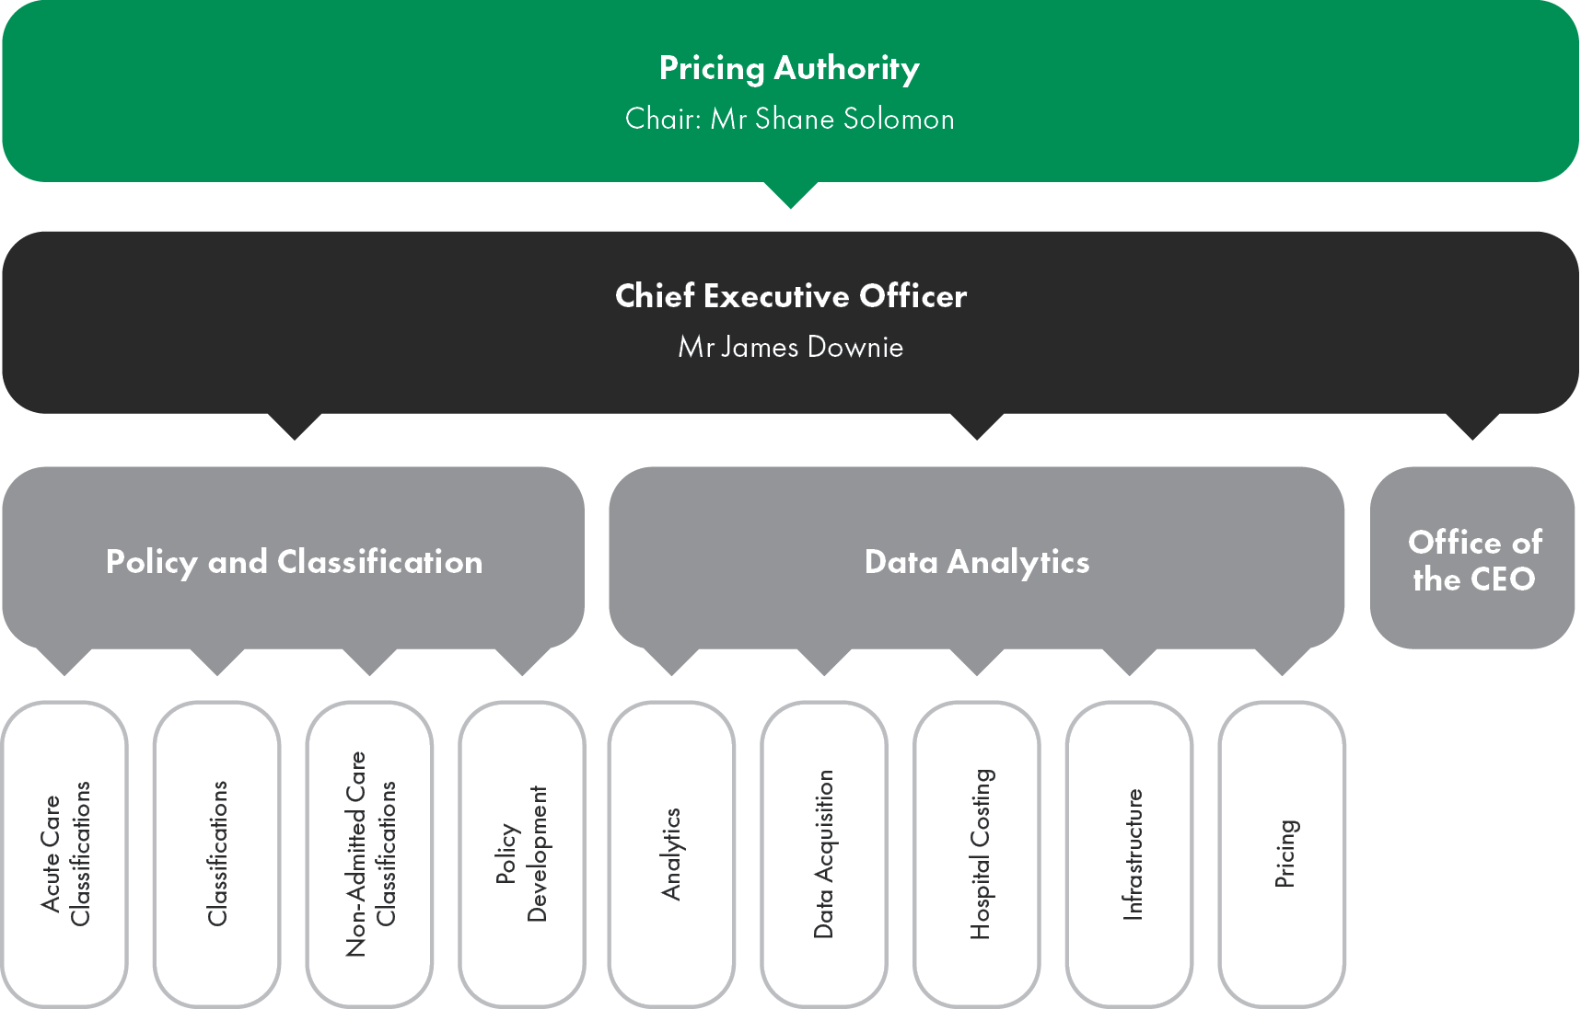
The Independent Hospital Pricing Authority (IHPA) is a corporate Commonwealth entity consisting of a Chair, Deputy Chair and up to seven other members. See p23 for more information.
The Chief Executive Officer is responsible for the day‑to‑day management of IHPA and its staff. Under section163(4) of the National Health Reform Act 2011, the Chief Executive Officer is the accountable authority of IHPA for the purposes of the Public Governance, Performance and Accountability Act 2013 and therefore for the purposes of this annual report.
To achieve its annual program of work, IHPA consults and collaborates with the Commonwealth, state and territory governments, advisory committees, key stakeholders and the public.
IHPA’s only facility is its office in Sydney where all its major activities are conducted.

Committees and working groups
The Independent Hospital Pricing Authority (IHPA) has developed a committee framework to assist in providing expert advice and to ensure transparency in the delivery of its work program.
IHPA’s statutory committees comprise of the Clinical Advisory Committee and the Jurisdictional Advisory Committee, established under Parts 4.10 and 4.11 of the National Health Reform Act 2011 respectively.
Other advisory committees and working groups have been established to assist IHPA in the delivery of its work program, pursuant to Part 4.12 of the National Health Reform Act 2011. These include:
- Activity Based Funding Technical Advisory Committee
- Audit, Risk and Compliance Committee (internal)
- Classifications Clinical Advisory Group
- Data Governance Steering Committee (internal)
- Diagnosis Related Groups Technical Group
- Emergency Care Advisory Working Group
- International Classification of Diseases Technical Group
- Mental Health Working Group
- National Hospital Cost Data Collection Advisory Committee
- Non-Admitted Care Advisory Working Group
- Small Rural Hospitals Working Group
- Stakeholder Advisory Committee
- Subacute Care Working Group
- Teaching, Training and Research Working Group
- Work Health and Safety Committee (internal).
Committees and working groups are structured to enhance IHPA’s statutory functions. Some committees and working groups may also have sub-committees to assist in the delivery of IHPA’s work program. All committees and working groups have Terms of Reference setting out their role, function, membership and reporting relationship, which are regularly updated.

Figure 4: IHPA’s management, committees and working groups
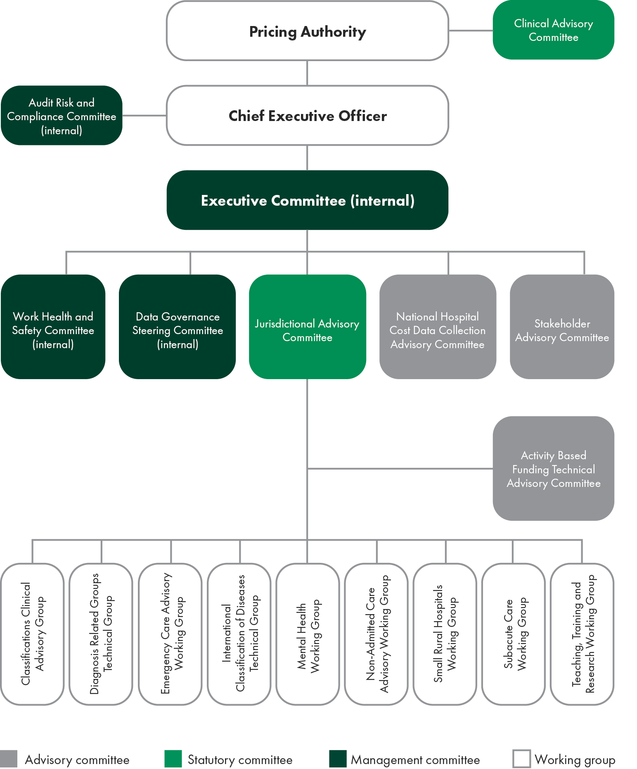

Clinical Advisory Committee
The Clinical Advisory Committee was established under section 176 of the National Health Reform Act 2011. Its functions include:
- advising the Pricing Authority on developing and specifying classification systems for health care and other services provided by public hospitals
- advising the Pricing Authority in relation to:
  - matters related to the functions of the Pricing Authority
  - matters referred to it by the Pricing Authority.
Committee members are appointed by the Australian Government Minister for Health. At 30 June 2021, the Clinical Advisory Committee consisted of 22 members.
The Clinical Advisory Committee is required to report on its work annually. The Clinical Advisory Committee Annual Report, including details of its membership and meetings, sits within the IHPA Annual Report, at p31.
Jurisdictional Advisory Committee
The Jurisdictional Advisory Committee was established under section 195 of the National Health Reform Act 2011. It consists of a Chair, appointed by the Pricing Authority and nine other members (one to represent each state and territory, and one representing the Commonwealth Government).
Committee members are appointed by written instrument by the head of the health department of the jurisdiction they represent.
The Jurisdictional Advisory Committee met on 10 occasions between 1 July 2020 and 30 June 2021.
Jurisdictional Advisory Committee members as of 30 June 2021:
- Mr James Downie (Chair)
- Mr Rob Anderson (Western Australia)
- Ms Lynne Cowan (South Australia)
- Ms Toni Cunningham (Queensland)
- Ms Denise Ferrier (Victoria)
- Ms Bronwyn Field (Commonwealth Government)
- Dr Nigel Lyons (New South Wales)
- Mr Peter O’Halloran (Australian Capital Territory)
- Mr Ross Smith (Tasmania)
- Mr Stathi Tsangaris (Northern Territory).
During the reporting period, there was one change to the Commonwealth membership.


Pricing Authority


Sustainable growth in hospital costs
Growth in cost per National Weighted Activity Unit
The National Weighted Activity Unit is a measure of health service activity expressed as a common unit, against which the national efficient price is determined. Figure 5 indicates a significant reduction in the rate of growth in costs since 2011–12, to a sustained growth rate of 2.1 per cent.
Figure 5: Cost per National Weighted Activity Unit
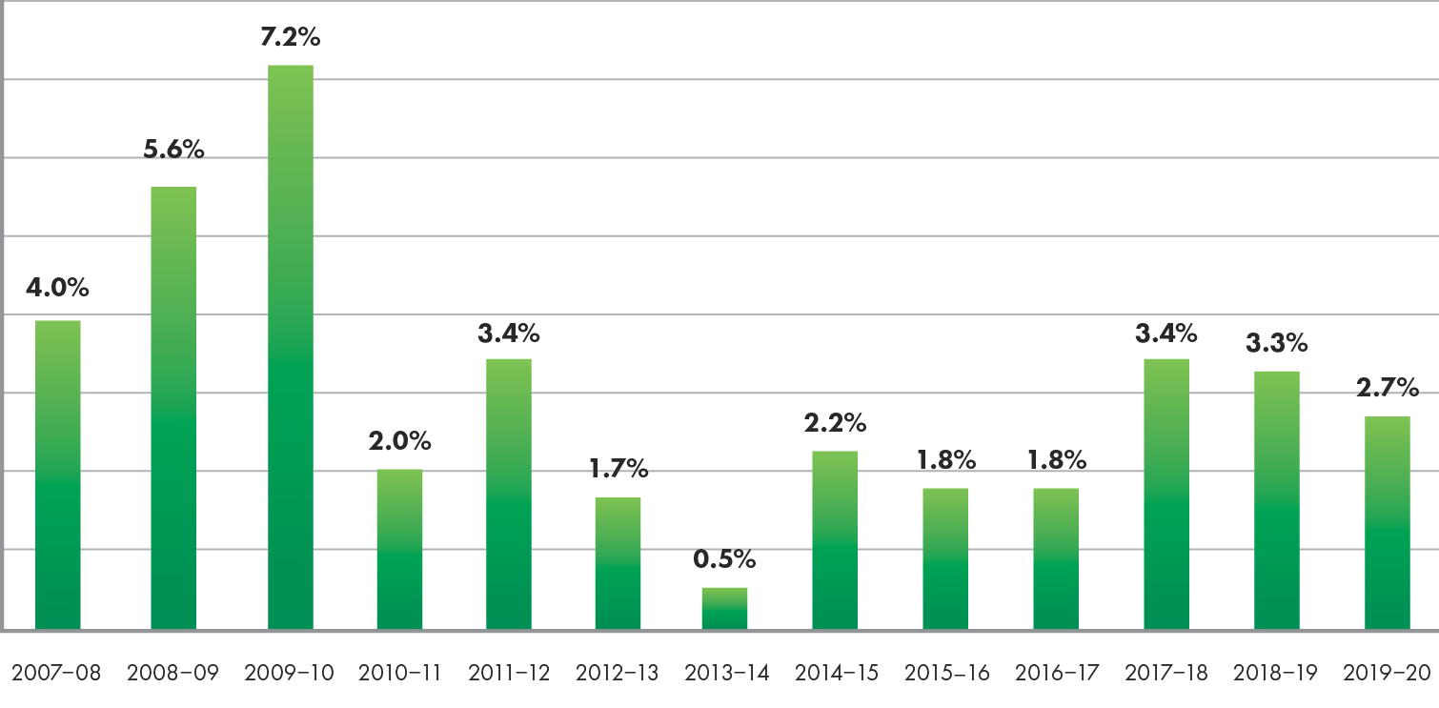
National efficient price
The national efficient price represents the average cost of a hospital admission across Australia and is a determinant (along with the volume of services delivered) of the Commonwealth’s funding contribution to public hospitals.
As required under the National Health Reform Agreement (clause A40), IHPA back-casts the national efficient price whenever significant changes to the methodology or underlying data occur, to enable the fair calculation of the Commonwealth’s growth funding.

About the Pricing Authority
The Pricing Authority is responsible for promoting improved efficiency in, and access to, public hospital services. This is achieved by providing independent advice to Australian governments in relation to the efficient costs of services and developing and implementing robust systems to promote activity based funding for these services.
The Pricing Authority consists of a Chair, a Deputy Chair and up to seven other members.
Pricing Authority members are appointed for a period of up to five years. The Chair is appointed by the Australian Government Minister for Health, the Deputy Chair is appointed with the agreement of First Ministers of all states and territories and the remaining Pricing Authority members are appointed with the agreement of the Prime Minister and First Ministers of the states and territories.
Members of the Pricing Authority bring significant and varied expertise to their role, including substantial experience and knowledge of the health industry, healthcare needs and the provision of health care in regional and rural areas.
The Pricing Authority is supported by a Chief Executive Officer, who is responsible for the day-to-day running of IHPA.
All Pricing Authority members are non-executive.

Mr Shane Solomon (Chair)
Shane Solomon has over 30 years’ of international and national healthcare management expertise. Shane currently provides health strategy and advisory services and holds non‑executive director roles. Prior to this role, he was the founding Managing Director of Telstra Health, an e-health business within Telstra.
Previously, Shane was KPMG’s Partner in Charge, Healthcare. In this role, he worked with state and Australian governments, along with private sector health organisations.
Shane was the Chief Executive of the Hong Kong Hospital Authority, managing Hong Kong’s 57,000 public hospital staff. During his five-year tenure, he implemented significant funding and service quality reforms, including a casemix pay‑for‑performance model and the ongoing development of a comprehensive integrated e-health system.
In Victoria, Shane was Under-Secretary of Health at the Department of Human Services (as it then was), where he was responsible for managing the funding system (including casemix) for Victoria, and performance and governance of Melbourne metropolitan health services. He was responsible for developing the Hospital Admission Risk Program and implementing governance reforms in Victoria’s public hospital system.
Ms Jennifer Williams (Deputy Chair)
Jennifer Williams is a non-executive director and holds a number of board positions including Chair of Northern Health and Chair of Yooralla.
Her other board appointments are with the Australian Medical Research Advisory Board, Barwon Health and the Victorian Health Building Authority Advisory Board. She has previously held the positions of Chief Executive of the Australian Red Cross Blood Service, Chief Executive of Alfred Health and Chief Executive of Austin Health.
Mr Glenn Appleyard
Glenn Appleyard was a member of the Australian Accounting Standards Board from 1 January 2003 to 31 December 2011.
Glenn has held several senior positions within the public service including Deputy Secretary in the Tasmanian and Victorian Departments of Treasury and Finance and Regional Director for the Australian Bureau of Statistics in Tasmania.
He was a member of the Commonwealth Grants Commission for 11 years and was the Chair of the Tasmanian Economic Regulator.
Associate Professor Bruce Chater
Associate Professor Bruce Chater is Head of the Mayne Academy of Rural and Remote Medicine at the University of Queensland. He performs these tasks from his rural base of Theodore, Queensland, where he continues as a practising rural doctor.
Bruce has been involved in ensuring that rural health services provide high-quality and professional services to rural communities. He was the founding convener of the Rural Doctors Association of Queensland and Australia, founding Chair of the National Rural Health Alliance, Chair of the Rural Working Party of the World Organization of Family Doctors and served as President of the Australian College of Rural and Remote Medicine.
Ms Prudence Ford
Prudence Ford is a member of the Health Consumers’ Council of WA. She was an inaugural member of the Medical Board of Australia, and was previously a member of the National Blood Authority, the National Health and Medical Research Council, the Brightwater Care Group Board and the Western Australian Medical Board.
Prudence has had 30 years’ experience in the public service at Commonwealth and state levels. She has held senior executive positions in the (then) Commonwealth Departments of Community Services and Health, Finance, and the Attorney General and in the Western Australian Departments of Health and the Premier and Cabinet.
Professor Jane Hall
Professor Jane Hall is Distinguished Professor of Health Economics in the Business School at the University of Technology, Sydney. She is a Fellow of the Academy of Social Sciences in Australia and a Fellow of the Australian Academy of Health and Medical Sciences.
Jane has worked across many areas of health economics, including health technology assessment, measurement of quality of life, end-of-life care, health workforce, economics of primary care and funding and financing issues.
Jane established the Centre for Health Economics Research and Evaluation in 1990 and she remains in the Centre as Director, Strategy. She is engaged in health policy issues internationally through her involvement with the Commonwealth Fund International Program in Health Policy and Practice.
Ms Jenny Richter
Jenny Richter is a non-executive director, and holds directorships with the South Australian Health and Medical Research Institute, Cancer Council SA (Deputy Chair), Cancer Council Australia (Deputy Chair) and the Southern Adelaide Local Health Network, where she also chairs the Clinical Governance Board Sub-Committee.
Jenny Richter has previously held a number of executive roles, including five years as Deputy Chief Executive for SA Health, and more recently as Chief Executive Officer of Central Adelaide Local Health Network.
Jenny’s experience in the health sector commenced as a registered nurse, following which she gained significant leadership experience in areas of hospital and health service planning and performance both in Australia and the United Kingdom.
Dr Kate Taylor
Dr Kate Taylor is the Director of Eye Care Solutions for Revenio Group Oyj, the global leader in ophthalmic equipment and solutions that acquired Oculo, of which Kate was the Founder and Chief Executive Officer. Oculo is an online platform to connect eye care professionals and their patients. Kate is a member of the Australian Digital Health Agency’s Clinical and Technical Advisory Committee.
She was previously involved with the Board of the Mental Health Cooperative Research Centre in Australia, and internationally with the Boards of Roll Back Malaria, Stop TB, and the GAVI Alliance.

Meetings of the Pricing Authority 2020–21
Table 1: Meetings of the Pricing Authority 2020–21
The Pricing Authority met on 10 occasions between 1 July 2020 and 30 June 2021. The Chief Executive Officer, Mr James Downie, as the accountable authority, attended all 10 meetings.
.  Member | Meetings eligible | Meetings attended
Mr Shane Solomon (Chair) | 10 | 10
Ms Jennifer Williams (Deputy Chair) | 10 | 10
Mr Glenn Appleyard | 10 | 9
A/Prof Bruce Chater | 10 | 10
Ms Prudence Ford | 10 | 10
Prof Jane Hall | 10 | 10
Dr Kate Taylor | 10 | 10
Ms Jenny Richter | 10 | 10


IHPA 2020–21 overview


CEO’s year in review
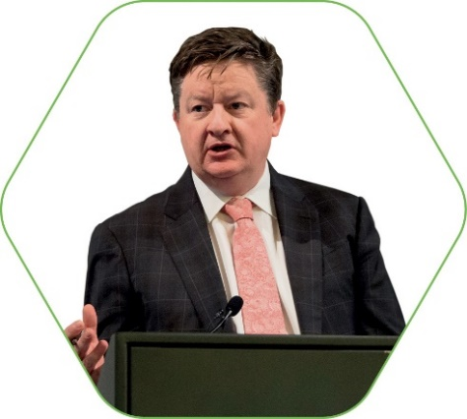
In 2020–21, the Independent Hospital Pricing Authority (IHPA) delivered another full program of work, in addition to its swift response to the challenges presented by Coronavirus Disease 2019 (COVID-19) throughout the year.
These priorities guided the strategic direction for our work as we continued to design the pricing systems to deliver high-quality, efficient and safe public hospital services for all Australians.
Responding to COVID-19
IHPA has worked closely with the Administrator of the National Health Funding Pool to provide assistance in implementing the National Partnership Agreement for COVID-19 Response.
In the early stages of the outbreak, IHPA released emergency use codes to ensure critical information on COVID-19 patients was available in a timely manner. We also provided guidance to states and territories and public hospitals on how the costs of treating COVID-19 patients should be captured.
The ongoing collaboration that took place in relation to submitting this cost and activity data has and will continue to be incredibly valuable as we consider the impact of the pandemic on the delivery of all public hospital services in the short and long-term.
Key highlights
The Addendum to the National Health Reform Agreement 2020–25 maintains a commitment to activity based funding and reaffirms the role of IHPA. Our work program for 2020–21 continued reforms for improving health outcomes of patients, including reducing avoidable hospital admissions, and working for the provision of safe, high-quality care across the Australian public hospital system, as mandated by the safety and quality measures agreed upon by all Australian governments in 2017.
In March 2021 we released the National Efficient Price and National Efficient Cost Determinations, alongside the Pricing Framework for Australian Public Hospital Services for 2021–22.
In 2020–21, work was undertaken to introduce the first version of the Australian Emergency Care Classification to price emergency department services from 1 July 2021. Shadow pricing of community mental health care using the first version of the Australian Mental Health Care Classification also commenced from 1 July 2021.
Development of the new versions of the subacute and non-acute and admitted care classifications also continued. These were informed by consultations with our stakeholders and the public on the proposed refinements to ensure they were clinically accurate and meaningful prior to being incorporated into the national pricing model.
In 2021 we finalised the 24-month shadow period to assess three funding options to reduce avoidable hospital readmissions.
In addition to our regular work program, this year we also produced a pricing and costing study for the Nationally Funded Centres Program, which supports access to a small number of high-cost and highly specialised, low-volume procedures for Australian patients.
Investing in partnerships
As we pursued our many priorities for the preceding year, our partnership with stakeholders also grew and IHPA’s achievements throughout 2020–21 would not have been possible without their input and collaboration to drive improvements in all areas of our work.
Despite the pandemic, we held our eighth Activity Based Funding Conference, which was held in May 2021. It was a pleasure to host the virtual event for a record number of delegates–delivering valuable education for 2,171 professionals from across the world.
Commendation
I take this opportunity to acknowledge the expert advice and guidance of the Pricing Authority.
I also wish to thank the Clinical Advisory Committee, and all of our committees and working groups, for their dedication in providing ongoing expert guidance to deliver a clinically-relevant annual program of work. I particularly want to thank the members of the committee whose terms expired during 2021, Dr Philip Hoyle, Mrs Jan Erven, A/Prof Louis Irving, Prof Daryl Williams, Dr Ruth Vine and Dr Amanda Ling, all of whom have made significant contributions to IHPA’s success over the past 10 years.
My sincere thanks to all of the staff at IHPA for their support and commitment once again, especially during the challenging times we have faced throughout the COVID-19 pandemic. I am proud to be leading an agency with such a diverse and highly-skilled team.
Year ahead
IHPA will continue to work closely with all jurisdictions and the national agencies to progress the implementation of the long-term, key principles outlined in the 2020–21 Addendum, and continue to support funding arrangements under the National Partnership Agreement on COVID-19 Response.
In the year ahead, we look forward to expanding this important work in the fields of aged care and prostheses, following the announcements outlined in the Federal Budget 2021–22.

Mr James Downie
Chief Executive Officer
Independent Hospital Pricing Authority
30 August 2021

2020–21 highlights
Some of the key achievements from IHPA’s Work Program for 2020–21 include:
 | - Implementation of Australian Refined-Diagnosis Related Groups Version 10.0 for pricing admitted acute care.  - Implementation of the new clauses under the Addendum to the National Health Reform Agreement 2020–25.
 | Completion of the consultation and end-to-end review of the Australian Refined-Diagnosis Related Groups Version and ICD-10-AM/ACHI/ACS classification systems.
 | - Governance framework for the development of the admitted care classifications published.  - Completion of Nationally Funded Centres Program pricing and costing study.
 | National Hospital Cost Data Collection, Round 23, Public Sector Report released.
 | - Publication of Pricing Framework for Australian Public Hospital Services 2021–22.  - Release of the National Efficient Price and National Efficient Cost Determinations for 2021–‍22.  - Rules for coding and reporting COVID-19 episodes of care Version 2.0 published.
 | - Consultation paper on the development of the Australian National Subacute and Non-Acute Patient Classification Version 5.0 released.  - National Hospital Cost Data Collection, Round 23, Private Sector Report released.
 | - Activity Based Funding Conference 2021 held under the theme ‘Activity based funding into the future: Responsive. Relevant. Reliable.’  - Consultation paper on the development of updated versions of the admitted care classifications released.
 | - Completion of the two-year shadow period to assess the impact of three funding options to measure avoidable hospital readmissions.  - Three Year Data Plan 2021–22 to 2023–24 published.  - Consultation Paper on Pricing Framework for Australian Public Hospital Services 2022–23 released.  - IHPA’s Work Program and Corporate Plan for 2021–‍22 published.


Clinical Advisory Committee


Letter from the Chair

It is a privilege to Chair the Clinical Advisory Committee and to present our Annual Report for 2020–21.
The Clinical Advisory Committee is a multidisciplinary group whose members have extensive clinical knowledge and skills across a wide range of areas in the health sector.
The committee draws on this expertise and experience to provide advice in relation to the Independent Hospital Pricing Authority’s (IHPA) program of work.
This year we played a critical role in providing clinical input relating to the options for pricing and funding for the safety and quality reforms reaffirmed in the 2020–25 Addendum to the National Health Reform Agreement.
The committee provided clinical advice on IHPA’s three proposed funding options for reducing avoidable hospital readmissions. The committee will continue to advise IHPA in this area, as the agency concludes its analysis and commences the implementation period from 1 July 2021.
The committee provided ongoing input to the Pricing Framework for Australian Public Hospital Services for 2021–22, ensuring the framework’s policies remained clinically relevant. We also provided advice on the determination of the national efficient price and national efficient cost, to allow IHPA to ensure they were fit-for-purpose.
The Clinical Advisory Committee continued its work advising on classification systems. For 2020–21, this included contributing to the development of the new version of the Australian Refined Diagnosis Related Groups classification. The new editions of the disease and intervention classifications for admitted acute care for the agency’s public consultation paper were released in May 2020. Input was also provided for Version 5.0 of the Australian National Subacute and Non-Acute Patient Classification, which was consulted on in April 2021.
Under the National Partnership on Coronavirus Disease 2019 (COVID-19) Response, committee members provided feedback on the national activity based funding classifications and the updates to the coding and classification systems for reporting COVID-19 in Australian public hospitals, including admitted care, emergency and non-admitted care.
I would like to express my sincere thanks to my fellow committee members for their meaningful contribution and thoughtful consideration of the complex, and at times highly technical, issues over the past year. I deeply appreciate their commitment to improving efficiency, accountability and transparency across the public healthcare system.
There were a few changes to the membership of the committee over this past year. I would like to thank Dr Philip Hoyle, Mrs Jan Erven, A/Prof Louis Irving, Prof Daryl Williams, Dr Ruth Vine and Dr Amanda Ling for many years of greatly valued service. I welcome A/Prof Virginia Plummer, Dr Phil Sargent, Ms Nicole Harwood and Mr Christopher O’Donnell as new appointees to the committee.
On behalf of the Clinical Advisory Committee, I acknowledge and commend the Pricing Authority, the Chief Executive Officer and IHPA staff for delivering a successful program of work
in 2020–21.
I look forward to continuing to lead the work of the Clinical Advisory Committee in the coming year and welcome the opportunity to support the agency to drive its strategic agenda in the year ahead.
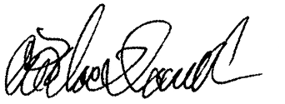
Associate Professor
Alasdair MacDonald
Chair, Clinical Advisory Committee
18 August 2021

About the Clinical Advisory Committee
Clinical Advisory Committee members provide high-level technical and clinical advice to the Pricing Authority on a range of issues, such as activity based funding, classification development and policy development to inform the annual determination of the national efficient price and national efficient cost.
The Clinical Advisory Committee is a statutory committee established under Part 4.10 of the National Health Reform Act 2011.
The functions of the committee are described in section177:
- to advise the Pricing Authority in relation to developing and specifying classification systems for health care and other services provided by public hospitals
- to advise the Pricing Authority in relation to matters that:
  - relate to the functions of the Pricing Authority
  - are referred to the Clinical Advisory Committee by the Pricing Authority
- to do anything incidental to, or conducive to, the performance of the above functions.
Membership
The members of the committee are appointed by the Australian Government Minister for Health, and are drawn from a range of clinical specialties and backgrounds to ensure the committee represents a wide range of clinical expertise.
Appointments are based on individual expertise rather than as a representation of any organisation, peak body or jurisdiction. The Remuneration Tribunal determines remuneration.
The Chair of the committee, Associate Professor Alasdair MacDonald, reports to the Australian Government Minister for Health and is supported by IHPA staff.

Table 2: Membership and meetings of the Clinical Advisory Committee in 2020–212F
Name | Position | Specialty | Meetings eligible | Meetings attended
A/Prof Alasdair MacDonald | Chair | Internal medicine | 3 | 3
Prof Gerard Carroll | Member | Cardiology/rural | 3 | 0
Ms Jan Erven | Member | Occupational therapy | 3 | 3
Mr Anthony Graham Fish | Member | Allied health | 3 | 3
Prof Leon Flicker | Member | Geriatrics/Indigenous health | 3 | 2
Ms Nicole Harwood | Member | Nursing | 2 | 2
Dr Philip Hoyle | Member | Administration | 3 | 0
A/Prof Louis Irving | Member | Respiratory/Indigenous health | 3 | 2
Dr Amod Karnik | Member | Intensive care medicine | 3 | 2
Dr Amanda Ling | Member | Administration | 3 | 2
Mr Christopher O’Donnell | Member | Nursing | 2 | 1
A/Prof Virginia Plummer | Member | Nursing | 3 | 3
Ms Amber Polles | Member | Pharmacy | 3 | 2
Dr Phil Sargent | Member | Paediatrics | 3 | 3
A/Prof Melinda Truesdale | Member | Emergency medicine | 3 | 2
A/Prof Paul Varghese | Member | Geriatrics/rehabilitation | 3 | 3
Dr Ruth Vine | Member | Psychiatry | 3 | 1
A/Prof Andrew Wei | Member | Haematology | 3 | 3
A/Prof Bernard Whitfield | Member | Ear nose and throat surgery/ injuries/trauma | 3 | 2
A/Prof Daryl Williams | Member | Anaesthesia and pain management | 3 | 0
Dr Jo Wright | Member | Rural medical practice | 3 | 3
Dr Kathryn Zeitz | Member | Nursing | 3 | 2

Clinical Advisory Committee meetings 2020–21
18 August 2020
3 February 2021
19 May 2021

2020–21 highlights
In 2020–21, the Clinical Advisory Committee supported IHPA’s work program to deliver the following key achievements:
 | Advice on the assessment of new health technologies to ensure pricing of public hospital services responds to the introduction of new evidence-based technology and innovations in the models of care in a timely manner.
 | - Advice on the Pricing Framework for Australian Public Hospital Services 2021–22.  - Input to inform the National Efficient Price and National Efficient Cost Determinations for 2021–22.  - Input to the COVID-19 Response—Rules for coding and reporting COVID-19 episodes of care.  - Advice on price harmonisation to ensure consistent pricing of similar same-day services across different settings of care, specifically investigating chemotherapy and renal dialysis.  Investigations into alternative funding models to activity based funding for the future, including bundled payments and capitation models.
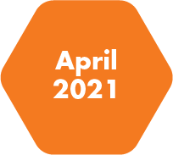 | Advice on the development of the Australian National Subacute and Non-Acute Patient Classification Version 5.0.
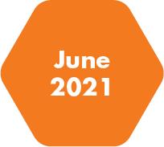 | Consultation on the development of the AR-DRG and ICD-10-AM/ACHI/ACS classification systems.


Annual performance statements


Introductory statement
I, Mr James Downie, as the accountable authority of the Independent Hospital Pricing Authority (IHPA), present the 2020–21 annual performance statements of IHPA, as required under paragraph 39(1)(a) of the Public Governance, Performance and Accountability Act 2013 (PGPA Act).
In my opinion, these annual performance statements are based on properly maintained records, accurately reflect the performance of the entity, and comply with subsection 39(2) of the PGPA Act.

Performance in 2020–21
This year the Independent Hospital Pricing Authority (IHPA) made significant steps in driving improvements of the efficiency of public hospital services by meeting its performance criteria and deliverables outlined in its Work Program 2020–21 and its requirements as part of the National Partnership on (Coronavirus Disease 2019) COVID-‍19 Response.
The IHPA Work Program 2020–21 provides a more detailed account of the objectives and deliverables to those included in the Portfolio Budget Statements and IHPA’s Corporate Plan. It is developed each year through a consultative process with government and health sector stakeholders and is published on the IHPA website (see www.ihpa.gov.au/publications).
Figure 6: Relationship between the sources of reporting for the Annual Report 2020–21 Performance Statement
Portfolio Budget Statements 2020–21
Outcome  Promote improved efficiency in, and access to, public hospital services primarily through setting efficient national prices and levels of block funding for hospital activities. |  | Work Program 2020–21 |  | Strategic objective 1 Perform IHPA pricing functions Activity 1: Perform IHPA pricing functions  Strategic objective 2 Refine and develop hospital activity classification systems Activity 2: Refine and develop national classification systems  Strategic objective 3 Refine and improve hospital costing Activity 3: Refine and improve hospital costing  Strategic objective 4 Determine data requirements and collect data Activity 4: Develop hospital data requirements and collect data  Strategic objective 5 Resolve disputes on cost-shifting and cross-border issues Activity 5: Resolve disputes on cost-shifting and cross-border issues  Strategic objective 6 Independent and transparent decision-making and engagement with stakeholders Activity 6: Independent and transparent decision-making and engagement with stakeholders
 |  | Corporate Plan 2020–21
Program 1.1 Public Hospital Price Determinations
IHPA promotes improved efficiency in, and access to, public hospital services by providing independent advice to the Australian Government and state and territory governments regarding the efficient price of healthcare services, and by developing and implementing robust systems to support activity based funding for those services.

Activities
Activity 1: Perform IHPA pricing functions
IHPA’s primary function is to produce the National Efficient Price Determination and the National Efficient Cost Determination each year. The Pricing Framework for Australian Public Hospital Services (Pricing Framework) forms the policy basis for the Determinations. The Pricing Framework outlines the principles, scope and methodology to be adopted by IHPA in the setting of the national efficient price and national efficient cost for public hospital services in the next financial year.
During 2020–21, IHPA undertook further technical development to improve the price-setting process and continued to refine the models used to determine the national efficient price and national efficient cost.
Figure 7: Relationship between sources for reporting of Activity 1
Sources of reporting for the Annual Report 2020–21 Performance Statement
Portfolio Budget Statements 2020–21
Outcome 1  Promote improved efficiency in, and access to, public hospital services primarily through setting efficient national prices and levels of block funding for hospital activities. |  | Work Program 2020–21 |  | Strategic objective 1 Perform IHPA pricing functions Activity 1: Perform IHPA pricing functions
 |  | Corporate Plan 2020–21 |  | Strategic objective 1 Perform IHPA pricing functions Activity 1: Perform IHPA pricing functions
Program 1.1 Public Hospital Price Determinations
IHPA promotes improved efficiency in, and access to, public hospital services by providing independent advice to the Australian Government and state and territory governments regarding the efficient price of healthcare services, and by developing and implementing robust systems to support activity based funding for those services.

Results
Table 3: Summary of Performance for Activity 1 in 2020–21
Summary of Performance for Activity 1: Perform IHPA pricing functions
Publish the Pricing Framework for Australian Public Hospital Services 2021–22 by December 20203 | Delivered
Completion of Nationally Funded Centres Program pricing and costing study by January 2021 | Delivered
Finalise decisions on the General List of In-Scope Public Hospital Services for additional or altered in-scope services for 2021–22 by December 2020 | Delivered
Finalise decisions on the legitimate and unavoidable cost variations to assess  changes or adjustments to the National Efficient Price Determination 2021−22 by December 2020 | Delivered
Publish the National Efficient Price and National Efficient Cost Determinations 2021–22 by March 2021 | Delivered
Complete review of the recommendations provided in the Fundamental Review by March 2021 | Ongoing
Completion of the shadow period to assess the impact of three funding options to measure avoidable hospital readmissions by June 2021 | Delivered
Development of a software tool to track avoidable hospital readmissions – Version1.0 by December 2021 | Ongoing
Provide confidential national efficient price forecast for future years to jurisdictions by December 2020 | Delivered
Publish the Supplementary National Efficient Cost Determination 2020–21 by December 2020 | Delivered
Investigate opportunities to harmonise prices across similar same-day services | Delivered

Performance criteria |  | Results against performance criteria
- Publish the Pricing Framework for Australian Public Hospital Services 2021–22 by December 2020. |  | The Pricing Framework for Australian Public Hospital Services 2021–22 was published on 2 March 2021, after being postponed to allow for consultation on the implementation of the new clauses under the Addendum to the National Health Reform Agreement 2020–25 and the response to COVID-19.
- Completion of the Nationally Funded Centres Program pricing and costing study by January 2021. |  | In response to the Ministerial Direction received from the Hon Greg Hunt MP under section 226(1) of the National Health Reform Act 2011 in January 2021, IHPA completed the Nationally Funded Centres Program pricing and costing study in December 2020.
- Finalise decisions on the General List of In-Scope Public Hospital Services for additional or altered in-scope services for 2021–22 by December 2020. |  | IHPA assessed requests for in-scope public hospital services as per its annual assessment of General List of In-Scope Public Hospital Services process.
- Finalise decisions on the legitimate and unavoidable cost variations to assess changes or adjustments to the National Efficient Price Determination 2021−22 by December 2020. |  | IHPA assessed changes and requests for adjustments to the national pricing model as per its annual assessment of legitimate and unavoidable cost variations process.
- Publish the National Efficient Price and National Efficient Cost Determinations by March 2021. |  | The National Efficient Price and National Efficient Cost Determinations 2021–22 were published on 2 March 2021.
- Reduce the number of local hospital networks that record costs per National Weighted Activity Unit significantly above the national efficient price. |  | The range between the 50th and 90th percentile cost per National Weighted Activity Unit by local hospital network decreased from $840 in 2017–18 to $798 in 2018–19, representing a reduction of $42.
- Completion of the shadow period to assess the impact of three funding options to measure avoidable hospital readmissions by June 2021. |  | IHPA commenced an analysis of three funding options intended to assist in reducing avoidable hospital readmissions for two years from 1 July 2019. From 1 July 2021, the national pricing model will include measures associated with avoidable hospital readmissions, in addition to previously introduced measures for sentinel events and hospital acquired complications.

Performance criteria |  | Results against performance criteria
- Provide a further increase in the proportion of funding for public services using activity based funding as reported by the Administrator of the National Health Funding Pool. |  | As at June 2021, 82.18 per cent of funding for public services paid by the Administrator of the National Health Funding Pool was based on activity based funding. This is a decrease of 0.45 per cent compared to the 2019–20 financial year.
- Investigate opportunities to harmonise prices across similar same-day services. |  | In 2020–21, IHPA investigated additional opportunities for the harmonisation of price weights for haemodialysis and chemotherapy in the admitted and non-admitted care settings. The aim of price harmonisation is to ensure that similar services are priced consistently across settings.

Analysis
This year, the Pricing Framework for Australian Public Hospital Services 2021–22 (Pricing Framework) was released alongside the National Efficient Price and National Efficient Cost Determinations 2021–22. While this was a delay to its usual release in December 2020, this ensured that the Pricing Framework included feedback on the new clauses under the 2020–25 Addendum to the National Health Reform Agreement and allowed for early consultation on emerging issues associated with the COVID-19 pandemic.
IHPA’s work towards pricing and funding for safety and quality, as per the 2017–20 and 2020–25 Addendum to the National Health Reform Agreement, continued in 2020–21. This included completing the final year of the analysis of three funding options for reducing avoidable hospital readmissions, which was undertaken from July 2019 for 24-months. Following extensive consultation with stakeholders, the healthcare community and the general public, IHPA’s approach to incorporate the measures aiming to improve quality, continuity and integration of care was presented in the Pricing Framework 2021–22.
IHPA also monitored the changes reported by jurisdictions as a result of the response to the COVID-19 pandemic to ensure pricing responds accordingly. Changes reported by jurisdictions included a significant growth in the use of telemedicine, a reduction in hospital admissions nationally and longer term changes to service delivery required to implement COVID-19 safety measures.
Published in March 2021, the National Efficient Price and National Efficient Cost Determinations 2021–22 continue to demonstrate the benefits of activity based funding in reducing costs. This is demonstrated in both the significant reduction in the rate of growth in costs per National Weighted Activity Unit since 2011–12, to a sustained growth rate of 2.1 per cent, and the reduction of local hospital networks in the 50th and 90th percentile range of costs per National Weighted Activity Unit.
IHPA’s work to progress the pricing of mental health care services continued in 2020–21 in consultation with jurisdictions. This included shadow pricing admitted mental health care, as outlined in the Australian Mental Health Care Classification Pricing Feasibility Report. IHPA also outlined its intention to shadow price community mental health care using the Australian Mental Health Care Classification from 2021–22 through its Consultation Paper on the Pricing Framework 2021–22.

Activity 2: Refine and develop national classification systems
Activity based funding requires robust classification systems on which pricing can be based. Classifications aim to provide the healthcare sector with a nationally consistent method of classifying all types of patients, their treatment and associated costs. IHPA has determined the national classification systems for public hospital services, including admitted acute, non‑admitted, emergency, admitted subacute and non-acute mental health care and teaching, training and research.
Classifications are reviewed regularly and updated periodically to ensure that they remain clinically relevant and resource homogeneous within a service category. Such modifications are based on robust statistical analysis and are overlaid by expert clinical advice.
During 2020–21, IHPA continued its work program to review and refine the classifications.
Figure 8: Relationship between sources for reporting of Activity 2
Sources of reporting for the Annual Report 2020–21 Performance Statement
Portfolio Budget Statements 2020–21
Outcome 1  Promote improved efficiency in, and access to, public hospital services primarily through setting efficient national prices and levels of block funding for hospital activities. |  | Work Program 2020–21 |  | Strategic objective 2 Refine and develop hospital activity classification systems Activity 2: Refine and develop national classification systems
 |  | Corporate Plan 2020–21 |  | Strategic objective 2 Refine and develop hospital activity classification systems Activity 2: Refine and develop national classification systems
Program 1.1 Public Hospital Price Determinations
IHPA promotes improved efficiency in, and access to, public hospital services by providing independent advice to the Australian Government and state and territory governments regarding the efficient price of healthcare services, and by developing and implementing robust systems to support activity based funding for those services.

Results
Table 4: Summary of Performance for Activity 2 in 2020–21
Summary of Performance for Activity 2: Refine and develop hospital activity classification systems
Finalise the refinement of ICD-10-AM/ACHI/ACS Twelfth Edition | Ongoing
Finalise the development of AR-DRG Version 11.0 | Ongoing
Refine the Australian Mental Health Phase of Care as part of the Australian Mental Health Care Classification development | Delivered
Price mental health care services using the Australian Mental Health Care Classification for the National Efficient Price Determination 2021–22 | Ongoing
Consult on the draft Australian National Subacute and Non-Acute Patient Classification Version 5.0 | Delivered
Continue to maintain the Tier 2 Non-Admitted Services Classification while undertaking development work for the Australian National Subacute and Non-Acute Classification | Ongoing
Complete the non-admitted care costing study, including activity and cost data for the Australian Non‑Admitted Care Classification | On hold
Refine the Australian Emergency Care Classification Version 1.0 | Ongoing
Continue to work with jurisdictions to implement Australian Teaching and Training Classification | Ongoing
Continue collecting activity and cost data for the Australian Teaching and Training Classification | Ongoing
Management of the international sales of the Australian Refined Diagnosis Related Groups system | Ongoing
Finalise the review of new health technologies based on reports received from government agencies and advisory bodies | Delivered
Review the process for assessing the impact of new health technologies on patient classification systems | Ongoing

Performance criteria |  | Results against performance criteria
- Finalise  ICD-10-AM/ACHI/ACS Twelfth Edition for implementation from 1 July 2022 and use in the National Efficient Price Determination 2022–23. |  | In May 2021, IHPA undertook a public consultation seeking feedback on major changes proposed for the Twelfth Edition of ICD-10-AM/ACHI/ACS.
- Finalise AR-DRG Version 11.0 for release on 1 July 2022 for use in the National Efficient Price Determination 2023–24. |  | In May 2021, IHPA undertook a public consultation seeking feedback on major changes proposed for AR-DRG Versions 11.0.
- Refine the Mental Health Phase of Care as part of the Australian Mental Health Care Classification (AMHCC) development. |  | In 2020–21, IHPA concluded the Mental Health Phase of Care Clinical Refinement Testing Project to understand how proposed refinements to the phase of care performed as part of the AMHCC.
- Consult on the draft Australian National Subacute and Non-Acute Patient Classification (AN-SNAP) Version 5.0. |  | In April 2021, IHPA released a draft of the AN-SNAP Version 5.0 for public consultation.
- Continue to maintain the Tier 2 Non-Admitted Services Classification (Tier 2) while undertaking development work for the new non-admitted care classification. |  | IHPA continues to maintain and update Tier 2 based on stakeholder feedback while a new non-admitted care classification is developed. Additional Tier 2 classes were developed and implemented to reflect COVID-19 consultation, diagnostics and vaccinations.
- Complete the non-admitted care costing study, including activity and cost data for the new non-admitted care classification. |  | In March 2020, the non-admitted care costing study was put on hold and then formally suspended due to the COVID-19 pandemic.
- Refine the Australian Emergency Care Classification (AECC) Version 1.0. |  | The AECC Version 1.0 will be used for pricing emergency department episodes from 1 July 2021. Work on further refinements of AECC Version 1.0 commenced in 2020.

Performance criteria |  | Results against performance criteria
- Continue to work with jurisdictions to implement Australian Teaching and Training Classification (ATTC). |  | ATTC Version 1.0 was released in 2018–19. IHPA continues to work with jurisdictions to implement ATTC, however, teaching and training activity continues to be block funded with limited progress due to the available data.
- Continue collecting activity and cost data for the ATTC. |  | IHPA continues to collect activity and cost data that is submitted by jurisdictions to seek alternative solutions to block funding for teaching, training and research.
- Management of the international sales of the ICD-10-AM/ACHI/ACS and AR-DRG classification systems. |  | IHPA continues to effectively administer the international sales of the ICD-10-AM/ACHI/ACS and AR-DRG classification systems.
- Finalise the review of new health technologies based on reports received from government agencies and advisory bodies. |  | IHPA released its consultation on the Assessment of New Health Technology in October 2020 to ensure pricing of public hospital services responds to introduction of evidence-based, effective new technology and innovations in the models of care that improve patient outcomes in a timely way. Final decisions on new health technologies prioritised for classification development occurred in May 2021.
- Review the process for assessing the impact of new health technologies on patient classification systems. |  | IHPA reviewed the Impact of New Health Technology Framework in May 2020 to assess the impact of incorporating new high-cost, highly specialised treatments into the classification systems and the national pricing model. IHPA included expenditure amounts for Kymriah®, Yescarta®, Qarziba® and Luxturna™ in the National Efficient Cost Determination 2021–22 on the advice of states and territories.

Analysis
IHPA continued its work to develop and refine classification systems that accurately capture the resources required to treat different types of patients and undertook two public consultations in 2020–21. This included development of the new versions of the classifications used for admitted care and subacute and non-acute care; ICD-10-AM/ACHI/ACS Twelfth Edition, AR-DRG Version 11.0 and AN-SNAP Version 5.0 respectively.
IHPA worked closely with the Administrator of the National Health Funding Pool to provide assistance in implementation of the National Partnership Agreement for COVID-19 Response.
A key part of this has been to develop classification, costing and pricing guidelines relating to COVID-19 and ensuring stakeholders are directly informed on any new advice, as required, in order to respond to the evolving nature of the clinical requirements of recording and classifying episodes of care across the country.
IHPA implemented emergency use codes for COVID-19 in ICD-10-AM and in the Emergency Department Short List, which are used to classify admitted and emergency care respectively. Additional classes were also created for COVID-19 activity in the non-admitted care classification. This year a new class was created in Tier 2 to account for COVID-19 vaccination data.
IHPA commenced pricing emergency department services using the Australian Emergency Care Classification Version 1.0 and shadow pricing community mental health care using the Australian Mental Health Care Classification Version 1.0 for the first time in the National Efficient Price Determination 2021–22.
The non-admitted care costing study was suspended in 2020 due to the impact of COVID-19. The development of a new non-admitted care classification to replace Tier 2 has therefore been delayed. IHPA is seeking feedback on readiness to recommence the non-admitted care costing study.
With the assistance of the Clinical Advisory Committee, IHPA has commenced a review of the process for assessing the impact of new health technologies on patient classification systems.

Activity 3: Refine and improve hospital costing
Hospital costing focuses on the cost and mix of resources used to deliver patient care and plays a vital role in activity based funding. Costing informs the development of activity based funding classification systems and provides valuable information for pricing purposes.
A key output for IHPA is to coordinate the annual National Hospital Cost Data Collection (NHCDC), which is the primary input into the national efficient price. This includes the development of national costing standards, collection, validation, quality assurance, analysis, reporting, and benchmarking. The cost collection is undertaken in conjunction with states and territories, and private hospitals.
Figure 9: Relationship between sources for reporting of Activity 3
Sources of reporting for the Annual Report 2020–21 Performance Statement
Portfolio Budget Statements 2020–21
Outcome 1  Promote improved efficiency in, and access to, public hospital services primarily through setting efficient national prices and levels of block funding for hospital activities. |  | Work Program 2020–21 |  | Strategic objective 3 Refine and improve hospital costing Activity 3: Refine and improve hospital costing
 |  | Corporate Plan 2020–21 |  | Strategic objective 3 Refine and improve hospital costing Activity 3: Refine and improve hospital costing
Program 1.1 Public Hospital Price Determinations
IHPA promotes improved efficiency in, and access to, public hospital services by providing independent advice to the Australian Government and state and territory governments regarding the efficient price of healthcare services, and by developing and implementing robust systems to support activity based funding for those services.

Results
Table 5: Summary of Performance for Activity 3 in 2020–21
Summary of Performance for Activity 3: Refine and improve hospital costing
Evaluate compliance with new aspects of the Australian Hospital Patient Costing Standards Version 4.0 | Delivered
Release Round 23 National Hospital Cost Data Collection public sector report | Delivered
Release Round 23 National Hospital Cost Data Collection cost weight tables for private hospitals | Delivered
Release the National Hospital Cost Data Collection Round 23 Independent Financial Review | Not delivered
IHPA will work towards phasing out the private patient correction factor for the National Efficient Price Determination 2021−22 | Ongoing

Performance criteria |  | Results against performance criteria
- Evaluate compliance with new aspects of the Australian Hospital Patient Costing Standards Version (AHPCS) Version 4.0. |  | IHPA evaluates compliance to the AHPCS Version 4.0 through its annual NHCDC Independent Financial Review, which was cancelled for 2021 due to the impact of COVID-19 on jurisdictions and health services. To ensure compliance with the AHPCS Version 4.0, IHPA requested jurisdictions to confirm their compliance in their Data Quality Statement Release Round 23 NHCDC public sector report.
- Release Round 23 NHCDC public sector report. |  | The Round 23 NHCDC report for the public sector was published on the IHPA website in February 2021. In 2020– 21, IHPA continued to adapt the NHCDC report into a consolidated infographics and thematic article designed to support jurisdictions and to broaden the understanding of its use among a wider audience.
- Release Round 23 NHCDC cost weight tables for private hospitals. |  | Round 23 cost weight tables for private hospitals were published on the IHPA website in April 2021.
- Release the NHCDC Round 23 Independent Financial Review. |  | The Round 23 Independent Financial Review was cancelled due to the impact of COVID-19 on jurisdictions and health services.
- IHPA will work towards phasing out the private patient correction factor for National Efficient Pricing Determination 2021–22. |  | IHPA will work towards phasing out the private patient correction factor for the National Efficient Price Determination 2021–22 and will continue to work towards phasing out the private patient correction factor in future Determinations.

Analysis
In 2020–21, IHPA maintained its annual NHCDC and delivered the report for the public sector in February 2021. Through this report, IHPA ensures the effective collection and reporting of costing information to support activity based funding outcomes.
In 2021, IHPA reviewed and enhanced the report. In response to stakeholder feedback, results were also made clearer by IHPA through its infographics. IHPA redeveloped the infographics to combine and streamline content for the ease of stakeholders’ reference.
Due to the impact of COVID-19, the Independent Financial Review of the NHCDC Round 23 (financial year 2018–19) was cancelled in consideration of jurisdictions’ capacity to participate as they responded to the pandemic.
In the absence of the Independent Financial Review, IHPA updated the data quality statements to include questions on the compliance with the AHPCS by jurisdictions. In July 2020, IHPA commenced reviewing the AHPCS to ensure the standards remained up-to-date and still served the purpose for costing patient episodes in the current setting in public hospitals.
In 2020, the Australian Accounting Standards Board accounting standard 16 (AASB16) was implemented and the AHPCS were subsequently reviewed to ensure that they were in line with AASB. The review of the standards assessed the impact of the new accounting standards, as well as other areas in the standards as raised by jurisdictions.
In addition to the public sector NHCDC, IHPA delivers the NHCDC for the private sector, which was delivered in April 2021.
Activity 4: Develop hospital data requirements and collect data
Timely, accurate and reliable public hospital data is vital to both the development of activity based funding classifications for hospital services and in determining the national efficient price of those services.
IHPA has developed a rolling Three Year Data Plan to communicate to the Australian Government and states and territories the data requirements, data standards and timelines that IHPA will use to collect data over the coming three years.
To ensure greater transparency, IHPA publishes data compliance reports on a quarterly basis, which indicate jurisdictional compliance with the specifications in the Three Year Data Plan.
Figure 10: Relationship between sources for reporting of Activity 4
Sources of reporting for the Annual Report 2020–21 Performance Statement
Portfolio Budget Statements 2020–21
Outcome 1  Promote improved efficiency in, and access to, public hospital services primarily through setting efficient national prices and levels of block funding for hospital activities. |  | Work Program 2020–21 |  | Strategic objective 4 Determine data requirements and collect data Activity 4: Develop hospital data requirements and collect data
 |  | Corporate Plan 2020–21 |  | Strategic objective 4 Determine data requirements and collect data Activity 4: Develop hospital data requirements and collect data
Program 1.1 Public Hospital Price Determinations
IHPA promotes improved efficiency in, and access to, public hospital services by providing independent advice to the Australian Government and state and territory governments regarding the efficient price of healthcare services, and by developing and implementing robust systems to support activity based funding for those services.

Results
Table 6: Summary of Performance for Activity 4 in 2020–21
Summary of Performance for Activity 4: Develop hospital data requirements and collect data
Publish the Three Year Data Plan 2021–22 to 2023–24 | Delivered
Complete phasing out aggregate non-admitted data for activity based funding reporting | Delivered
Complete the annual review of Activity Based Funding National Best Endeavours Data Sets and National Minimum Data Sets | Delivered
Develop the process for the collection of Individual Healthcare Identifiers as part of national data sets | Ongoing
Further develop the secure data management system functionality | Ongoing
Collect jurisdictional submissions for 2020 activity based funding activity data on a quarterly basis | Delivered
Publish data compliance report for each quarter in 2020 | Delivered
Continue to expand access to the National Benchmarking Portal | Ongoing
Performance criteria |  | Results against performance criteria
- Update Three Year Data Plan annually and publish on the IHPA website by June 2021. |  | The Three Year Data Plan was updated and published in June 2021.
- Complete phasing out aggregate non-admitted data for activity based funding reporting. |  | IHPA continues to develop activity based funding data specifications on an annual basis, or as required, in alignment with the Three Year Data Plan. Data specifications are developed with regard to published data standards. IHPA will only accept non-admitted care patient level data from July 2021.
- Develop appropriate data specifications and ensure information provided for decision-making meets those specifications. |  | Activity based funding data submissions were assessed based on the published data standards.
- Develop the process for the collection of Individual Healthcare Identifiers as part of national data sets. |  | IHPA established a process and engaged with some states and territories to undertake pilot collection of the Individual Healthcare Identifier as part of national data submission.

Performance criteria |  | Results against performance criteria
- Further develop the secure data management system functionality. |  | IHPA will continue to develop the secure data management system to support its core technical functions, while ensuring the current high standards of data security are maintained.
- Collect jurisdictional submissions for 2020 activity based funding activity data on a quarterly basis. |  | IHPA collected the 2020 activity based funding activity data submissions from state and territory health departments for each quarter.
- Publish a report on a quarterly rolling basis, outlining compliance with the data requirements and data standards specified in the rolling Three Year Data Plan. |  | The quarterly data compliance reports were developed in consultation with jurisdictions and were published on the IHPA website. The IHPA Data Compliance Policy was used to assess jurisdictional compliance ratings.
- Develop a process to expand the current access to National Benchmarking Portal. |  | IHPA consulted with stakeholders to work out a feasible pathway to expand access to the National Benchmarking Portal to the public by December 2021, while ensuring sufficient context and privacy protections are in place.

Analysis
In June 2021, IHPA published its eighth rolling Three Year Data Plan, covering the period 2021–22 to 2023–‍24. The plan specifies the data requirements and timelines that IHPA will use to collect data over the next three years. Following the Administrator of the National Health Funding Pool’s decision to phase out aggregate non-admitted activity reporting for funding and reconciliation purposes from 1 July 2021, IHPA will only accept non-admitted care patient level data from that date.
Through the Pricing Framework for Australian Public Hospital Services 2021–22, IHPA continues to advocate for the routine collection of the Individual Healthcare Identifier to provide greater transparency of the patient journey and to support implementation of new funding models. IHPA is working with jurisdictions to undertake a pilot collection of the Individual Healthcare Identifier as part of national data submissions. The pilot is set to commence in 2021 to support jurisdictions in addressing implementation issues. The pilot will consider data specifications and data submission processes.
IHPA has worked with jurisdictions and other stakeholders in order to make the National Benchmarking Portal publicly available in December 2021. Throughout 2020–21, this has included continuing work to ensure the appropriate privacy protections are in place for its release to the public, which will enhance policy decisions and improve patient outcomes. This is also supplemented by the development of the new secure data management system, which is set to continue over 2021–22.
IHPA has collected jurisdictional activity data submissions for 2020–21 on a quarterly basis and has published the associated data compliance reports for each quarter on its website in accordance with the IHPA Data Compliance Policy.

Activity 5: Resolve disputes on cost‑shifting and cross‑border issues
IHPA has a role to investigate and make recommendations concerning cross-border disputes between states and territories and to make assessments of cost‑shifting disputes.
Figure 11: Relationship between sources for reporting of Activity 5
Sources of reporting for the Annual Report 2020–21 Performance Statement
Portfolio Budget Statements 2020–21
Outcome 1  Promote improved efficiency in, and access to, public hospital services primarily through setting efficient national prices and levels of block funding for hospital activities. |  | Work Program 2020–21 |  | Strategic objective 5 Resolve disputes on cost‑shifting and cross‑border issues Activity 5: Resolve disputes on cost‑shifting and cross‑border issues
 |  | Corporate Plan 2020–21 |  | Strategic objective 5 Resolve disputes on cost‑shifting and cross‑border issues Activity 5: Resolve disputes on cost‑shifting and cross‑border issues
Program 1.1 Public Hospital Price Determinations
IHPA promotes improved efficiency in, and access to, public hospital services by providing independent advice to the Australian Government and state and territory governments regarding the efficient price of healthcare services, and by developing and implementing robust systems to support activity based funding for those services.

Results
Table 7: Summary of Performance for Activity 5 in 2020–21
Summary of Performance for Activity 5: Resolve disputes on cost‑shifting and cross‑border issues
Publish an updated Cost-Shifting and Cross-Border Dispute Resolution Framework | Delivered

Performance criteria |  | Results against performance criteria
- Review and publication of updated Cost-Shifting and Cross-Border Dispute Resolution Framework. |  | An updated Cost-Shifting and Cross-Border Dispute Resolution Framework (Version 4.0) was published in April 2021.
- Investigation of cost-shifting or cross-border disputes and provision of recommendations or assessment within six months of receipt of the request. |  | IHPA received a submission from Queensland in October 2020 under section 138 and 140 of the National Health Reform Act 2011. Terms were agreed between Queensland and New South Wales and no recommendation was required from IHPA.

Analysis
As part of IHPA’s role to deliver fair funding for hospitals across the country through the setting of the national efficient price for public hospital services, the agency is required to manage cost-shifting and cross-border disputes under section 138 of the National Health Reform Act 2011 and clauses A110 to A126 of the Addendum to the National Health Reform Agreement 2020–25.
IHPA follows the process outlined in the Cost-Shifting and Cross-Border Dispute Resolution Framework (the Framework) to investigate cross-border disputes to ensure they are managed in a timely, equitable and transparent manner.
The Pricing Authority and Chief Executive Officer of IHPA review the Framework, including associated documentation, annually or as required. The Framework was last reviewed in April 2021.
In October 2020, IHPA received a submission from Queensland with regards to cross-border funding contributions for New South Wales residents treated in Queensland hospitals. Through the Framework, IHPA employs six key stages in order to make recommendations to resolve a dispute. In following this process, terms were agreed by the jurisdictions and no recommendation was required by IHPA.
Activity 6: Independent and transparent decision‑making and engagement with stakeholders
IHPA works in partnership with the Australian Government, state and territory governments and other stakeholders. IHPA conducts its work independently from governments, which allows the agency to deliver impartial, evidence‑based decisions. IHPA is transparent in its decision‑making processes and consults extensively across the health industry.
Extensive consultation with governments and stakeholders informs the methodology that underpins IHPA’s decisions and work program. IHPA has a formal consultation framework in place to ensure that it draws on an extensive range of expertise in undertaking its functions. Input from stakeholders, through IHPA’s multiple committees and working groups, ensures that IHPA’s work is informed by expert clinical advice, which helps to maintain IHPA’s credibility throughout the industry.
Figure 12: Relationship between sources for reporting of Activity 6
Sources of reporting for the Annual Report 2020–21 Performance Statement
Portfolio Budget Statements 2020–21
Outcome 1  Promote improved efficiency in, and access to, public hospital services primarily through setting efficient national prices and levels of block funding for hospital activities. |  | Work Program 2020–21 |  | Strategic objective 6 Independent and transparent decision-making and engagement with stakeholders Activity 6: Independent and transparent decision-making and engagement with stakeholders
 |  | Corporate Plan 2020–21 |  | Strategic objective 6 Independent and transparent decision-making and engagement with stakeholders Activity 6: Independent and transparent decision-making and engagement with stakeholders
Program 1.1 Public Hospital Price Determinations
IHPA promotes improved efficiency in, and access to, public hospital services by providing independent advice to the Australian Government and state and territory governments regarding the efficient price of healthcare services, and by developing and implementing robust systems to support activity based funding for those services.

Results
Table 8: Summary of Performance for Activity 6 in 2020–21
Summary of Performance for Activity 6: Independent and transparent decision-making and engagement with stakeholders
Provide quarterly activity based funding activity data reports to the Pricing Authority and Jurisdictional Advisory Committee | Delivered
Publish evidence-based activity based funding related research and analysis | Ongoing
Progress investigation of bundled payments for stroke, and hip and knee replacements | Ongoing
Develop a capitation model for hospital avoidance programs | Ongoing
Implementation of strategies, tools and working papers to ensure that IHPA is providing information that will inform its stakeholders | Ongoing
Activity Based Funding Conference 2021 | Delivered

Performance criteria |  | Results against performance criteria
- Provide quarterly activity based funding activity data reports to the Pricing Authority and Jurisdictional Advisory Committee. |  | IHPA provides quarterly activity based funding activity data reports to the Pricing Authority, Jurisdictional Advisory Committee and Technical Advisory Committee.
- Publish evidence-based activity based funding related research and analysis. |  | IHPA continued to develop evidence-based activity based funding related research and analysis in 2020–21; this included the delivery of presentations delivered as part of the Activity Based Funding Conference 2021 scientific program.  IHPA recognises that access to high-quality, nationally consistent health data is essential for conducting research and analysis, and to inform the development of policies for improving health outcomes for all Australians. IHPA’s Data Access and Release Policy governs the process regarding release of IHPA data to researchers. In 2020–21, IHPA received 11 requests for data, which were processed according to the Data Access and Release Policy.

Performance criteria |  | Results against performance criteria
- Progress investigation of bundled payments for stroke, and hip and knee replacements. |  | In 2020–21, IHPA commenced investigations into alternative funding models to activity based funding, which included bundled payments. The Pricing Framework for Australian Public Hospital 2021–22 identifies the main criteria where bundled payments may be appropriate, that is, where there are well-defined care pathways that span multiple care settings, such as maternity care, stroke or hip replacements.
- Develop a capitation model for hospital avoidance programs. |  | IHPA conducted analysis of linked activity and cost data to identify a patient cohort that may be suitable to funding through a capitation model. Chronic conditions were found to be key drivers of hospital utilisation. IHPA will continue to work with jurisdictions to develop a funding methodology that supports innovative funding models.
- Appropriate committees and working groups maintained to support IHPA’s functions. |  | In 2020–21 IHPA maintained up to 18 committees and working groups, to provide expert advice and to ensure the transparency and integrity of the organisation. During the reporting period, IHPA held 67 meetings with the various committees and working groups.
- Public consultation processes conducted in accordance with the National Health Reform Act 2011. |  | IHPA conducted five public consultation processes in 2020–21, each in accordance with the National Health Reform Act 2011. This included:  - Pricing Framework for Australian Public Hospital Services 2021–22 (September 2020)  - Assessment of New Health Technologies for 2020–21 (October 2020)  - IHPA Work Program and Corporate Plan  2021–22 (April 2021)  - Draft Australian National Subacute and Non-Acute Patient Classification Version 5.0 (May 2021)  - Development of the ICD-10-AM/ACHI/ACS Twelfth Edition and AR-DRG Version 11.0 (May 2021).

Performance criteria |  | Results against performance criteria
- All stakeholder input is appropriately considered. |  | All submissions received by IHPA, as part of consultation processes, are presented to the Pricing Authority for consideration and published on the IHPA website.
- Inbox enquiries responded to within a two‑week timeframe. |  | IHPA received 253 inbox enquiries during the reporting period. IHPA responded to 92 per cent within two weeks, and to 37 per cent of those on the day of receipt.
- Deliver the biennial Activity Based Funding Conference hosted for a broad audience in the health industry. |  | IHPA hosted its Activity Based Funding Conference 2021 from 5 to 7 May 2021. The conference was held as a virtual event and provided education to 2,171 delegates from across Australia and around the world. The three-day scientific program featured 47 speakers who shared their technical expertise, insights and personal experiences in the healthcare sector under the conference theme: ‘Activity based funding into the future: Responsive. Relevant. Reliable.’

Analysis
Throughout 2020–21, IHPA continued to provide a transparent account of its decision-making through its committees and working groups, public consultations and the release of the detailed policies outlining the processes IHPA employs to undertake its key functions.
During the reporting period, this included five public consultations, which is an increase of three consultations from the previous year. This included a ‘Consultation Report’ alongside the Pricing Framework for Australian Public Hospital Services, which details the feedback received during the public consultation and IHPA’s rationale behind its policy decisions.
From July 2020, IHPA commenced implementing the new clauses of the 2020–25 Addendum to the National Health Reform Agreement. One of the requirements under this Agreement included the development of a funding methodology that supports states and territories in undertaking trials of innovative models of care. Investigations into alternative funding models to activity based funding continued in relation to bundled payments and capitation models to support the delivery of integrated care with a focus on hospital avoidance.
As part of this work, IHPA developed a roadmap in consultation with its key advisory committees. This is outlined in the Pricing Framework for Australian Public Hospital Services 2020–21, which sets out different funding models and their applicability to different conditions and care pathways. IHPA also continues to advocate for the inclusion of the Individual Healthcare Identifier in data sets, which would be a key facilitator for the incorporation of funding models with different pathways for medical treatment.
IHPA provided valuable education with greater accessibility for its stakeholders throughout 2020–21. This included the delivery of the agency’s eighth Activity Based Funding Conference. Due to the uncertainty of COVID-19, for 2021 the conference was offered to local and international delegates for free for the first time, which saw a 395.6 per cent increase in attendance to the conference of the year prior, with 66 per cent of delegates attending for the first time.
Following the success of the 2021 event, preparations have begun for the next Activity Based Funding Conference, which will be held as a hybrid event (with a virtual and live component) in Brisbane, Australia in May 2022. In addition, IHPA has also introduced an inaugural digital webinar series to complement the agency’s educational offering and to provide continuing opportunities for health professionals between holding its flagship conference. Through this webinar series, attendees may engage directly with IHPA’s senior leaders, technical advisors and industry experts on the practical application of the core themes relating to activity based funding processes to support their understanding of how their roles and the underlying processes and systems support pricing and funding of public hospital services.


Management and accountability


Key corporate governance practices

Since the agency’s formation in 2011, the Independent Hospital Pricing Authority’s (IHPA) accountable authority has established a robust system of risk management and controls to assist in the governance of the agency.
The Pricing Authority delivers the functions defined in the National Health Reform Act 2011. The Pricing Authority approves IHPA’s core business activities—most notably, the determination of the national efficient price and the national efficient cost for public hospital services annually, and building national classification systems for all hospital services. The Chief Executive Officer, as the accountable authority, is responsible for IHPA’s day-to-day administration.
Risk management
IHPA’s enterprise-wide approach to risk management remains at the forefront of all of its activities. It administers its risks using tools that address the strategic and tactical risks of all significant decisions. IHPA updated its risk management framework in 2019 and reviews it annually. It has also developed a detailed risk appetite statement, linked to its risk register, which it reviews annually.
Strategic risks are identified with reference to current business and environmental issues facing IHPA. These risks fall into three major risk categories:
- reputational risks
- data and information governance risks
- corporate risks.
IHPA’s strategic risks are actively managed through audits, assurance and internal control processes. Where new risks emerge, resources are assigned to understand and manage those risks. They are reviewed biannually or as required.
Tactical risks are managed through a decision-based risk management tool, which requires recording of the risk and a formal decision on the managed likelihood and consequence of the risk. The assessment tool forms part of any major decision, ensuring that the final decision maker is fully informed and cognisant of managed risk outcomes during the decision‑making process.
This year that tool was enhanced to include a Privacy Threshold Assessment, allowing IHPA to determine whether there is a risk to personal information, and therefore a need to undertake a Privacy Impact Assessment.
IHPA has a mature enterprise risk management framework in place and risk management is considered a business‑as‑usual activity for all IHPA staff.
During the period of this annual report, IHPA closely monitored and managed the operational and technical risks associated with the Coronavirus Disease 2019
(COVID-19) pandemic.

Additionally, IHPA continues to maintain a shared Strategic Risk Register with the National Health Funding Body, which has identified joint risks that the agencies manage together. Currently those risks are:
- incorrect calculation of Commonwealth funding entitlements
- changes to models that have not been effectively modelled ‍or implemented.
IHPA’s business continuity plan ensured an effective and seamless transition to working from home during the entire lockdown period required by the COVID-19 pandemic.
Compliance
IHPA has a broad range of compliance obligations including key statutory obligations set out in the National Health Reform Act 2011, the National Health Reform Agreement, the Public Governance Performance and Accountability Act 2013 and the Public Governance Performance and Accountability Rule 2014.
Other legal and compliance obligations include: work health and safety, privacy, freedom of information, intellectual property, the Protective Security Policy Framework, website accessibility and records management.
The Chief Executive Officer, as the accountable authority, receives management assurances on IHPA’s compliance obligations through an organised system of controls and special exercises, including substantive testing, monthly reports, exception notifications and compliance audits undertaken by an independent internal auditor.
Compliance achievements
IHPA’s internal compliance audits during the year show that:
- information and communication technology systems continued to appropriately address the top risks defined by the Australian Signals Directorate
- no compliance issues arising from IHPA’s administration of relevant sections of the National Health Reform Act 2011
- no material compliance issues emanating from the Public Governance Performance and Accountability Act 2013.

Financial authorisation
As a corporate Commonwealth Agency, IHPA is not required to adhere to the Commonwealth Procurement Rules, but chooses to do so as a matter of best practice. All of IHPA’s procurement decisions are made in accordance with the Commonwealth Procurement Rules. Line managers have value and purchase class limits, in accordance with the delegation of financial authorities that are approved and reviewed regularly by the Chief Executive Officer, as the accountable authority.
Audit, Risk and Compliance Committee5F
The IHPA Audit, Risk and Compliance Committee provides independent advice to the Chief Executive Officer on managing IHPA’s financial and business risk.
The Audit, Risk and Compliance Committee Charter is available at: www.ihpa.gov.au/audit-risk-and-compliance-committee.
During the reporting period, members of the Audit, Risk and Compliance Committee comprised:
- Mr Glenn Appleyard, member, Pricing Authority
- Mr Alan Bansemer, independent member
- Ms Angela Diamond, Chair and independent member
- Mr John Lenarduzzi, independent member
- Ms Joanna Stone, independent member.

Table 9: Details of Audit, Risk and Compliance Committee during the reporting period (2020–21)
The IHPA Audit, Risk and Compliance Committee met on four occasions between 1 July 2020 and 30 June 2021. The Chief Executive Officer, Mr James Downie, as the accountable authority, attended three meetings.
Member name | Qualifications, knowledge, skills and experience | Number of meetings attended/  total number of meetings eligible | Total annual remuneration
Mr Glenn Appleyard | Mr Glenn Appleyard was a member of the Australian Accounting Standards Board from 1 January 2003 to 31 December 2011.  Glenn has held several senior positions within the public service including Deputy Secretary in the Tasmanian and Victorian Departments of Treasury and Finance and Regional Director for the Australian Bureau of Statistics in Tasmania.  He was a member of the Commonwealth Grants Commission for 11 years and was the Chair of the Tasmanian Economic Regulator.  Glenn has been a member of the Independent Hospital Pricing Authority since 2012.  Glenn has a Bachelor of Economics from the University of Tasmania. | 4/4 | $9,232
Mr Alan Bansemer | Mr Alan Bansemer has over 35 years’ experience in the health sector, including six years as the West Australian Health Commissioner and eight years as the Deputy Secretary to the Commonwealth Department of Human Services and Health (as it then was).  Alan has chaired a number of committees including the Medicare Schedule Review Board and General Practice Consultative Committee. In addition, he has served as a member of numerous health advisory committees including the Australian Health Ministers’ Advisory Council, Health Insurance Commission (now Medicare Australia) and the Australian Institute of Health and Welfare.  Alan has a bachelor’s degree in economics from the University of Adelaide and postgraduate diploma in business administration from the South Australian Institute of Technology. | 1/4 | $2,000
Ms Angela Diamond | Ms Angela Diamond has held several senior finance positions within the public service including First Assistant Secretary Financial Performance and Management at the Department of Defence and is currently the Chief Financial Officer for Services Australia.  Angela has a Bachelor of Commerce from the Australian National University and is a Certified Practising Accountant. | 4/4 | Nil – employed by a Cwth entity

Member name | Qualifications, knowledge, skills and experience | Number of meetings attended/  total number of meetings eligible | Total annual remuneration
Mr John Lenarduzzi | Mr John Lenarduzzi has over 20 years’ experience working in technology and security environments and spent seven years as a senior executive in Australia’s National Intelligence Community. Having started his career as an electronic engineer in Adelaide, he moved to Canberra in 2001 where he worked in a range of roles to deliver transformational change nationally and internationally through strategic planning, organisational change, capability development and operations. John took a role in the private sector in 2020 and is currently the Director of Managed Security Operations (Global and Commercial) at CyberCX with leadership responsibilities across Australia, New Zealand, the United Kingdom and the United States.  John has a Bachelor of Electrical and Electronic Engineering (Flinders University) and a Masters of Business Administration (Deakin). He completed the Senior Executives in National Security Program at Harvard Kennedy School in 2017 and sits as an independent member on two audit and risk committee boards. | 3/3 | $6,570
Ms Joanna Stone | Ms Joanna Stone has substantial public and private sector management experience and extensive experience across several audit committees as Chair and as a member. Joanna holds formal qualifications in finance. | 1/1 | Nil –employed by a Cwth entity

Fraud control plan
IHPA’s fraud control plan is recognised as a critical internal tool used to mitigate the act and consequences of authorised use of IHPA data and financial resources. The plan encourages ethical behaviour through the use of business processes designed to prevent deceptive activities, supported by monitoring controls to detect fraud and deter offending behaviour and is reviewed annually or as required.
Inter-agency financial activity
During the 2020–21 financial year, IHPA received shared services resourcing from the Department of Health.
The Department of Health charged IHPA $351,000 to provide these services covering treasury, processing of financial transactions, information and communication desktop services and parliamentary support.
Ecologically sustainable development and environmental performance
IHPA does not undertake any substantive work that is covered by section 516A of the Environment Protection Act 1999.

Management of human resources

The Chief Executive Officer is the Independent Hospital Pricing Authority’s (IHPA) only employee and is based in Sydney, New South Wales. All other staff are seconded from the Department of Health to IHPA and report to the Chief Executive Officer.
IHPA continues to place great value in creating a more productive and inclusive workplace— primarily by attracting and retaining high-calibre, talented and engaged staff. The agency supports a flexible work environment and will continue to support all staff to optimise their work-life balance, as well as providing technological support critical to achieving their required work performance.
IHPA is committed to the recruitment and retention of a diverse (for example, in gender, age, cultural and linguistic background, disability, Indigenous, and LGBTI+) workforce and actively promotes an inclusive workplace culture.
Ongoing and non-ongoing employees
The Chief Executive Officer is IHPA’s only employee and is based in Sydney, New South Wales (no change from prior year).
All other staff are seconded from the Department of Health and report to the Chief Executive Officer. Although the Department of Health reports on seconded IHPA staff as part of its mandatory reporting requirements, to ensure transparency, IHPA has provided the following staffing tables.

Table 10: Ongoing seconded employees 2021
 | Male |  |  | Female
Classification | Full-time | Part-time | Total | Full-time | Part-time | Total | Total
Senior Executive Service | 0 | 0 | 0 | 2 | 0 | 2 | 2
Executive Level 2 | 5 | 0 | 5 | 7 | 0 | 7 | 12
Executive Level 1 | 10 | 0 | 10 | 9 | 2 | 11 | 21
APS Level 6 | 2 | 0 | 2 | 3 | 2 | 5 | 7
APS Level 5 | 0 | 0 | 0 | 1 | 0 | 1 | 1
Total | 17 | 0 | 17 | 22 | 4 | 26 | 43

Table 11: Ongoing seconded employees 2020
 | Male |  |  | Female
Classification | Full-time | Part-time | Total | Full-time | Part-time | Total | Total
Senior Executive Service | 0 | 0 | 0 | 2 | 0 | 2 | 2
Executive Level 2 | 7 | 0 | 7 | 5 | 2 | 7 | 14
Executive Level 1 | 8 | 0 | 8 | 8 | 2 | 10 | 18
APS Level 6 | 5 | 0 | 5 | 7 | 2 | 9 | 14
APS Level 5 | 0 | 0 | 0 | 1 | 0 | 1 | 1
Total | 20 | 0 | 20 | 23 | 6 | 29 | 49

Table 12: Non-ongoing seconded employees 2021
 | Male |  |  | Female
Classification | Full-time | Part-time | Total | Full-time | Part-time | Total | Total
Senior Executive Service | 0 | 0 | 0 | 0 | 0 | 0 | 0
Executive Level 2 | 0 | 0 | 0 | 0 | 1 | 1 | 1
Executive Level 1 | 1 | 0 | 1 | 2 | 0 | 2 | 3
APS Level 6 | 0 | 0 | 0 | 0 | 0 | 0 | 0
APS Level 5 | 0 | 0 | 0 | 0 | 0 | 0 | 0
Total | 1 | 0 | 1 | 2 | 1 | 3 | 4

Table 13: Non-ongoing seconded employees 2020
 | Male |  |  | Female
Classification | Full-time | Part-time | Total | Full-time | Part-time | Total | Total
Senior Executive Service | 0 | 0 | 0 | 0 | 0 | 0 | 0
Executive Level 2 | 0 | 0 | 0 | 0 | 0 | 0 | 0
Executive Level 1 | 0 | 0 | 0 | 2 | 0 | 2 | 2
APS Level 6 | 0 | 0 | 0 | 1 | 0 | 1 | 1
APS Level 5 | 0 | 0 | 0 | 0 | 0 | 0 | 0
Total | 0 | 0 | 0 | 3 | 0 | 3 | 3

Key management personnel
Table 14: Information about remuneration for key management personnel
72 IHPA Annual Report 2020–21
 |  | Short-term benefits |  |  | Post-employment benefits | Other long-term benefits
Name | Position title | Base salary  $ | Bonuses  $ | Other  benefits and allowances $ | Superannuation  contributions  $ | Long service leave  $ | Other long-term benefits  $ | Termination  benefits  $ | Total  remuneration  $
Mr Glenn Appleyard6F | Pricing Authority member | 39,748 | - | - | 6,158 | - | - | - | 45,906
Mr Bruce Chater | Pricing Authority member | 31,748 | - | - | 3,016 | - | - | - | 34,764
Mr James Downie | Chief Executive Officer | 442,446 | - | - | 20,613 | 6,326 | - | - | 469,385
Ms Prudence Ford | Pricing Authority member | 31,748 | - | - | 3,016 | - | - | - | 34,764
Prof Jane Hall | Pricing Authority member | 31,748 | - | - | 3,016 | - | - | - | 34,764
Ms Jenny Richter | Pricing Authority member | 31,748 | - | - | 3,016 | - | - | - | 34,764
Mr Shane Solomon | Pricing Authority member (Chair) | 85,646 | - | - | 8,136 | - | - | - | 93,782
Dr Kate Taylor | Pricing Authority member | 31,748 | - | - | 3,016 | - | - | - | 34,764
Ms Jennifer Williams | Pricing Authority member (Deputy Chair) | 31,748 | - | - | 3,016 | - | - | - | 34,764
Total |  | 758,328 | - | - | 53,003 | 6,326 | - | - | 817,657
The above disaggregated key management personnel remuneration information is in accordance with the Public Governance, Performance and Accountability Rule 2014. Key management personnel are those persons having authority and responsibility for planning, directing and controlling the activities of the entity, directly or indirectly, including any Pricing Authority member. The entity has determined the key management personnel to be the Chief Executive Officer and the Pricing Authority members. The remuneration in the table above is based on the relevant remuneration tribunal determinations for holders of full-time and part-time public office.

Staff development
IHPA cultivates, values and supports staff by developing their skills and capabilities to meet their work requirements, as well as to achieve their full potential. IHPA promotes a culture where people work within and across teams to broaden their expertise.
Training was provided on a programmed basis to management and a needs basis to individual staff. Additionally, mid-level and senior management staff undertook a program of leadership capability training. IHPA supported individuals to attend conferences and training events that assisted them to acquire and develop skills used in their work. In 2020–21, IHPA’s training investment averaged $2,762 per staff member.
The accountable authority
Under the National Health Reform Act 2011, the Chief Executive Officer is the accountable authority.
The Chief Executive Officer is responsible for the effective delivery of IHPA’s work program and supports the Pricing Authority to fulfil its functions.

Table 15: Details of accountable authority during the reporting period current report period (2020–21)
 |  |  |  | Period as the accountable authority or member
Name | Qualifications of the accountable authority | Experience of the accountable authority | Position title | Date of commencement | Date of cessation | Number of meetings of the board of the company
Mr James Downie | Masters of Business Administration; Bachelor of Engineering, Metallurgical Engineering | Mr James Downie was appointed as the IHPA Chief Executive Officer on 1 September 2016. Prior to this, James was Executive Director, Activity Based Funding, leading the teams responsible for delivering the classification, costing and pricing functions of IHPA as well as the data acquisition activities.  He previously held roles with the Victorian Department of Health and the Royal Children’s Hospital Melbourne, and various technical and operational roles in the resources industry. | Chief Executive Officer | 1 September 2016 | 31 August 2021 | N/A

Education and review processes
During the reporting period, the Chief Executive Officer enhanced his skills through attendance at domestic and international activity based funding events and attended specialised leadership training that was also made available to IHPA mid-level and senior management staff. He receives regular performance feedback via the Pricing Authority meetings.
Work health and safety
In 2020–21, IHPA’s Work Health and Safety Committee continued to manage work health and safety matters in accordance with the Work Health and Safety Act 2011.
The committee met six times during the year and dealt with a range of work health and safety matters.
IHPA maintained its ongoing practice of providing workplace assessments for new staff, as required, and provided additional support to staff working from home during the COVID-19 pandemic.
In 2020–21, no notifiable incidents were identified in regards to work health and safety. One worker reported an injury and this worker lodged a workers’ compensation claim, which has not been determined. There were no investigations conducted during the year relating to businesses or undertakings conducted by the entity.
Advertising and market research
In 2020–21, IHPA commissioned no advertising that must be reported under section 311A of the Commonwealth Electoral Act 1918.


Financial
management


Financial statements
Independent auditor’s report 79
Statement by the Chief Executive Officer and Chief Financial Officer 81
Primary financial statements 82
Statement of comprehensive income 82
Statement of financial position 83
Statement of changes in equity 84
Cash flow statement 85
Overview 86
Notes to the financial statements 88
Financial performance 88
Note 1.1 Expenses 88
Note 1.2 Own-source revenue and gains 90
Financial position 92
Note 2.1 Financial assets 92
Note 2.2 Non-financial assets 93
Note 2.3 Payables 96
Note 2.4 Interest bearing liabilities 96
People and Relationships 97
Note 3.1 Employee provisions 97
Note 3.2 Key management personnel remuneration 98
Note 3.3 Related party disclosures 98
Managing uncertainties 99
Note 4.1 Contingent assets and liabilities 99
Note 4.2 Financial instruments 100
Note 4.3 Fair value measurement 101
Other information 102
Note 5.1 Current/non-current distinction for assets and liabilities 102

Independent auditor’s report
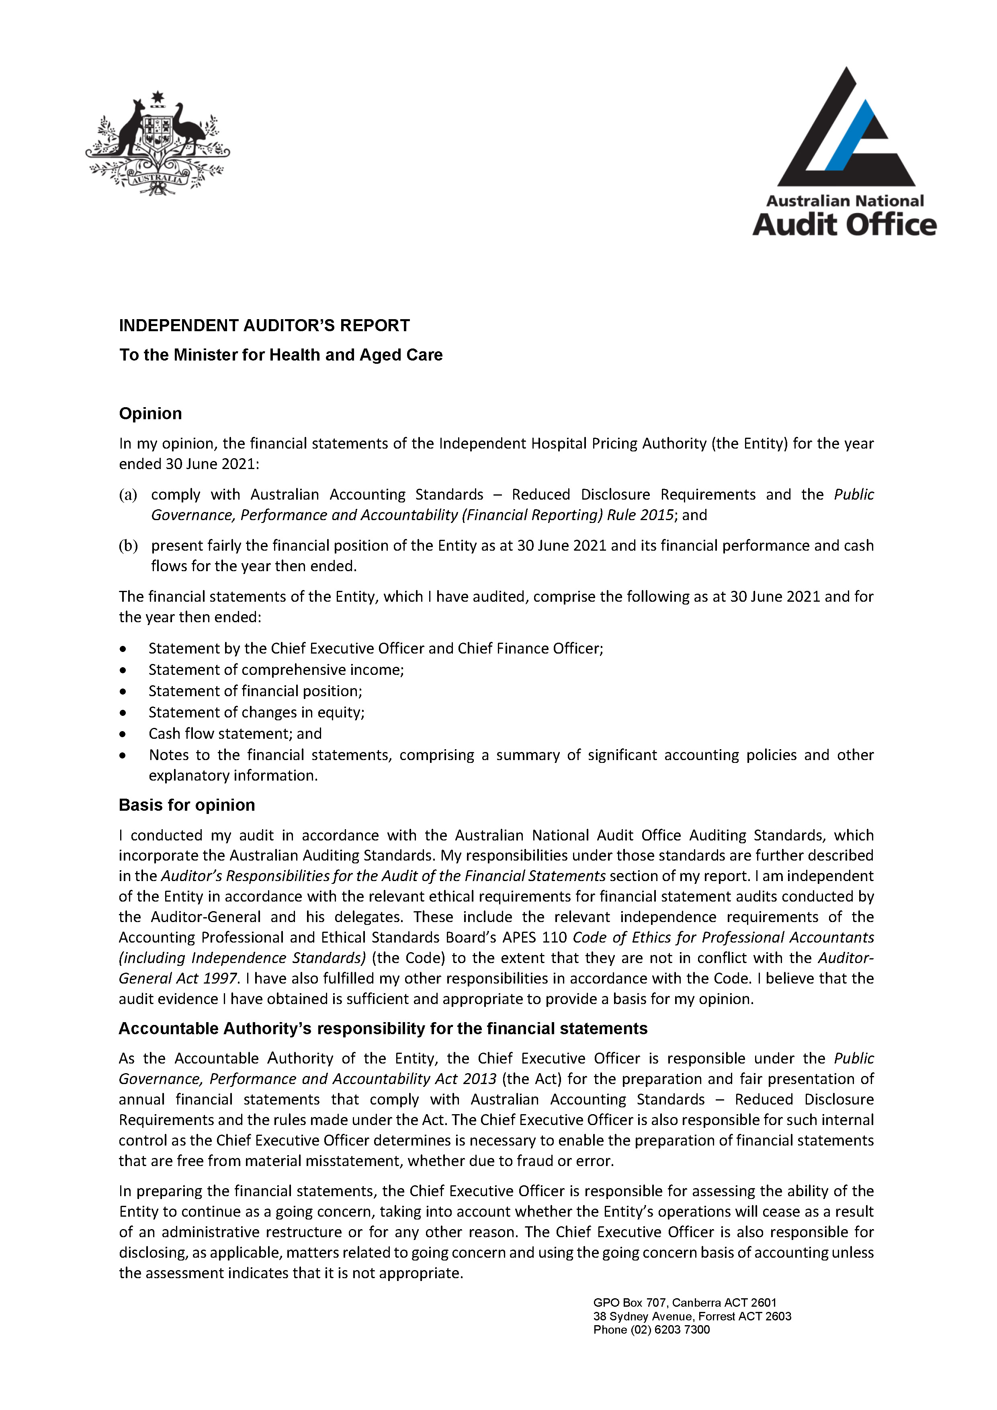

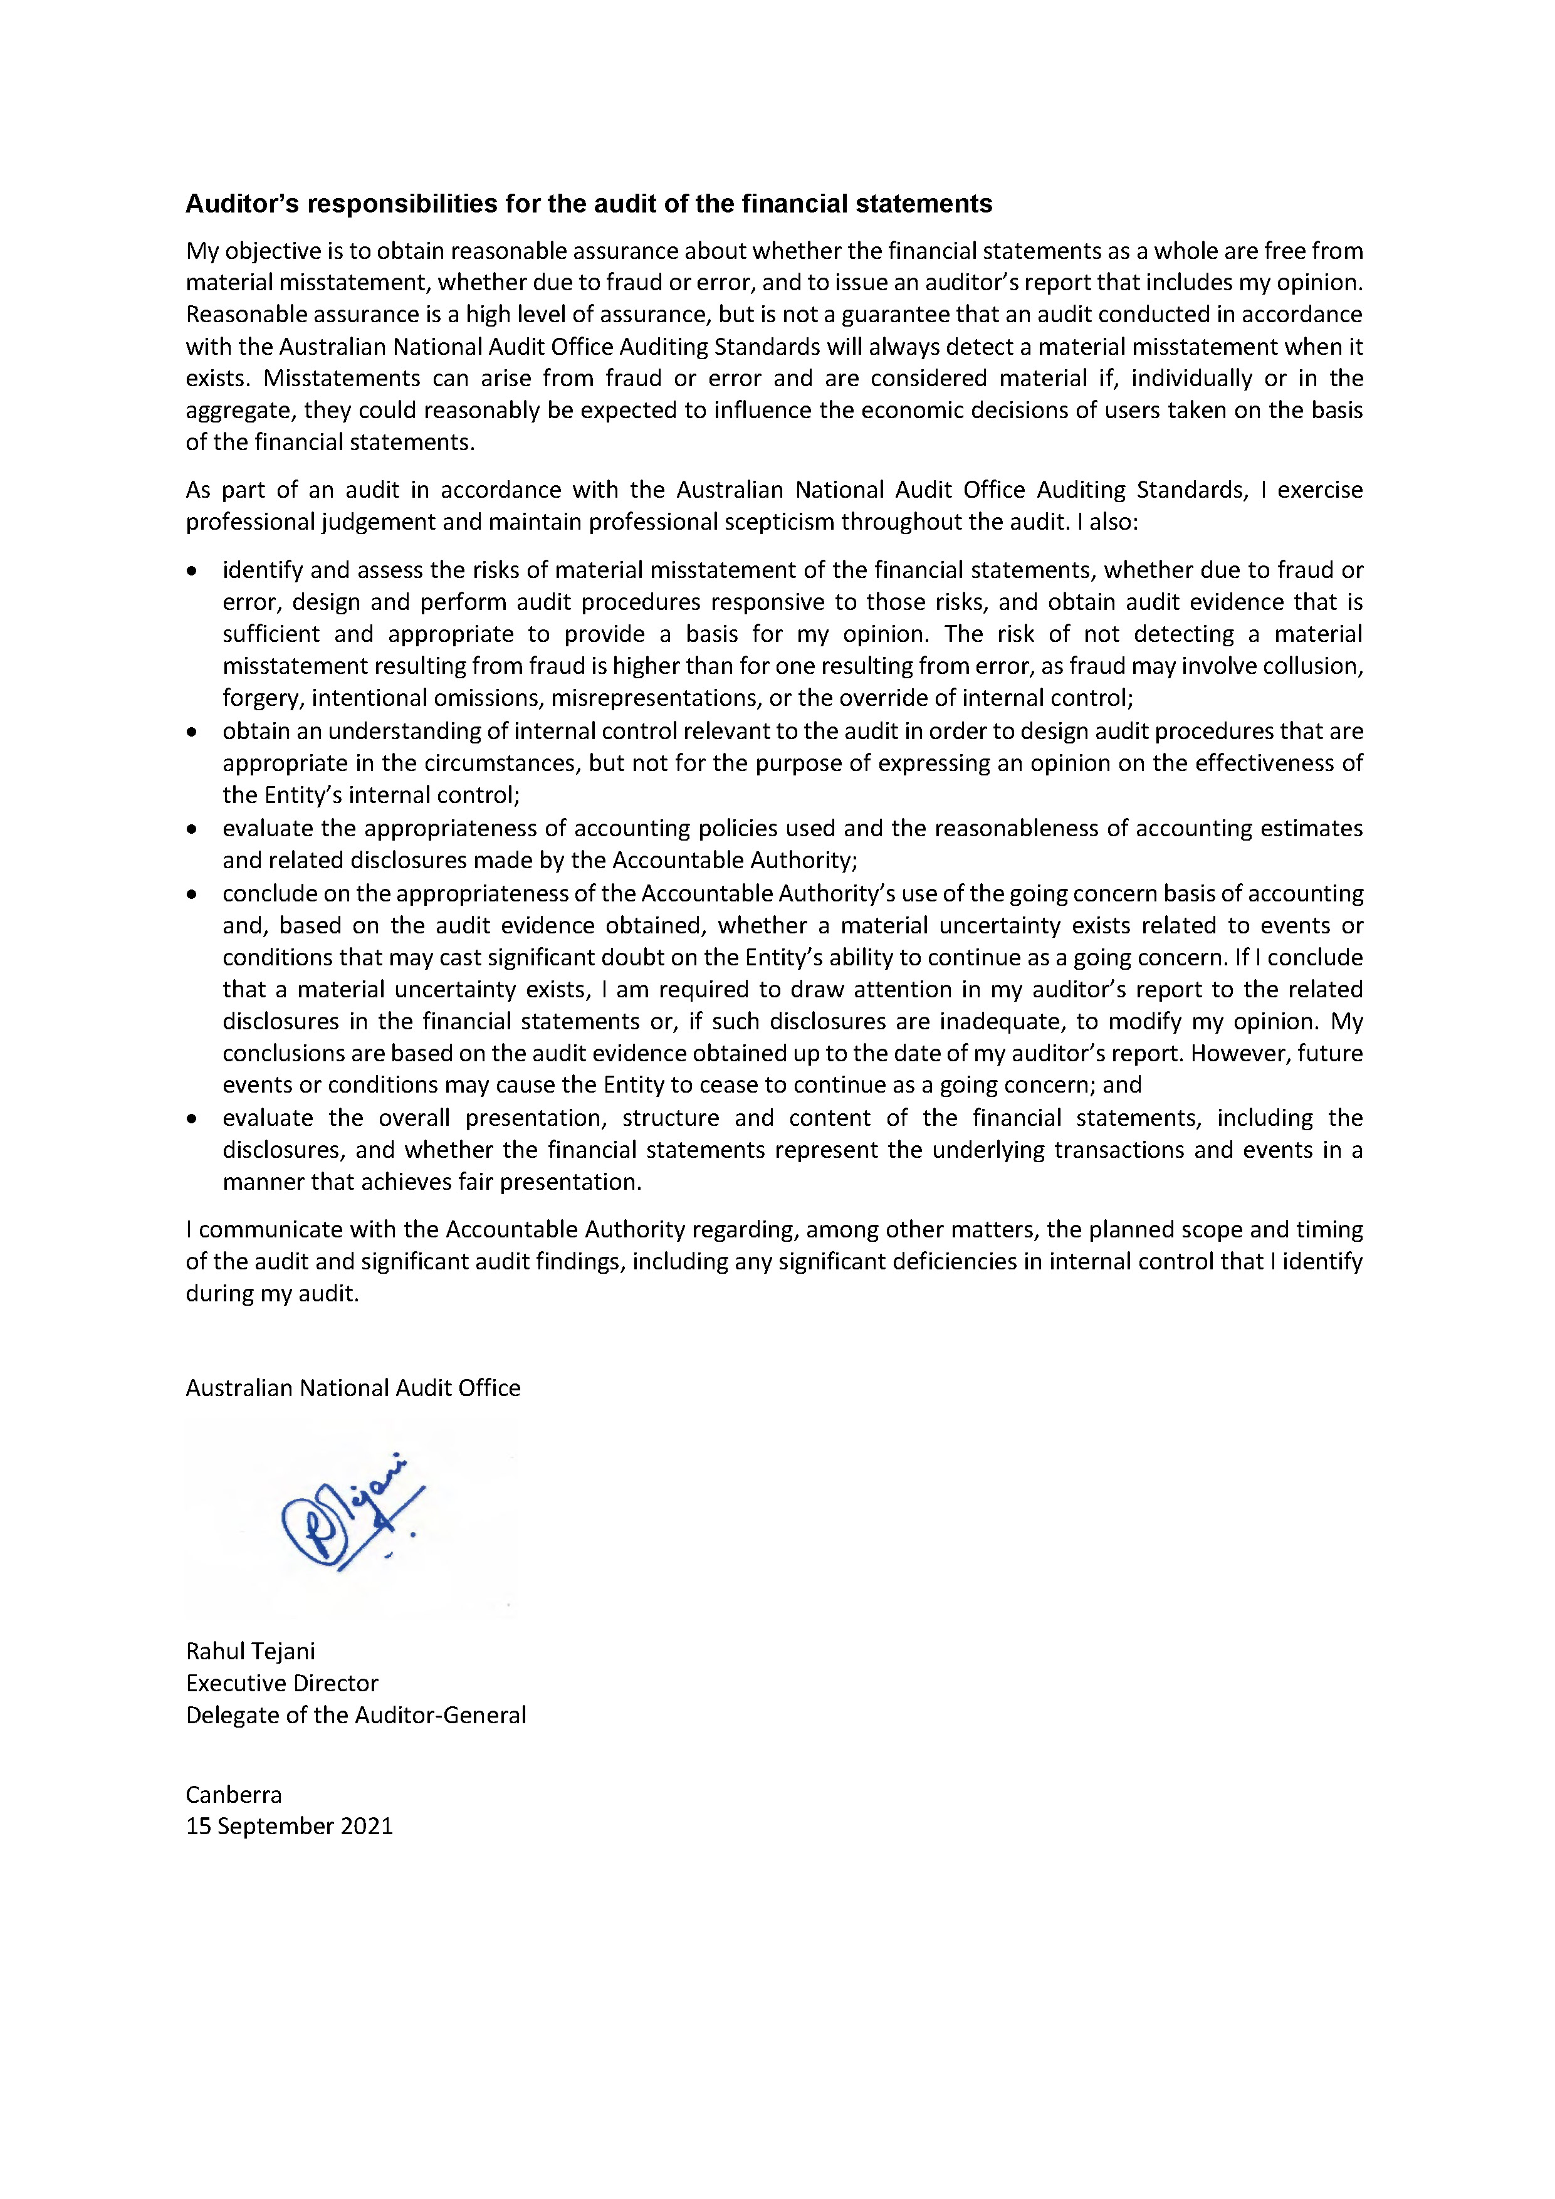

Independent Hospital Pricing Authority Financial Statements 2020–21
For the year ended 30 June 2021
Statement by the Chief Executive Officer and Chief Financial Officer
In our opinion, the attached financial statements for the year ended 30 June 2021 comply with subsection 42(2) of the Public Governance, Performance and Accountability Act 2013 (PGPA Act), and are based on properly maintained financial records as per subsection 41(2) of the PGPA Act.
In our opinion, at the date of this statement, there are reasonable grounds to believe that the Independent Hospital Pricing Authority will be able to pay its debts as and when they fall due.
Mr James Downie
Chief Executive Officer
15 September 2021

Mr Chris Miljak
Chief Financial Officer
15 September 2021

Primary financial statements
Statement of comprehensive income
for the period ended 30 June 2021
 | Notes | 2021  $’000 | 2020  $’000 | Original Budget  $’000
NET COST OF SERVICES
EXPENSES
Employee benefits | 1.1A | 7,764 | 7,983 | 7,983
Suppliers | 1.1B | 9,800 | 13,224 | 14,258
Depreciation and amortisation | 2.2A | 1,437 | 1,323 | 1,111
Finance costs | 1.1C | 63 | 75 | 68
Losses from the disposal of assets |  | - | 152 | -
Total expenses |  | 19,064 | 22,757 | 23,420
OWN-SOURCE INCOME
Own-source revenue
Revenue from contracts with customers | 1.2A | 217 | 804 | 750
Interest |  | 5 | 56 | 20
Resources received free of charge | 1.2B | 7,440 | 7,722 | 7,562
Total own-source revenue |  | 7,662 | 8,582 | 8,332
Net cost of services |  | 11,402 | 14,175 | 15,088
Revenue from Government | 1.2C | 13,744 | 15,024 | 14,993
Surplus / (Deficit) |  | 2,342 | 849 | (95)
Total comprehensive surplus / (Deficit) |  | 2,342 | 849 | (95)
The above statement should be read in conjunction with the accompanying notes.
Budget Variances Commentary
Statement of Comprehensive Income
Total expenses of $19.064m were $4.356m lower than the budgeted amount of $23.420m. The main driver was lower supplier expenses of $4.458m which were partially offset by higher depreciation and amortisation expenses of $0.326m.
Supplier expenses were lower than budget primarily due to a greater proportion of projects being managed in-house which resulted in net savings, and deferred program activity arising from state and territory hospital resources being reassigned to manage the COVID-19 pandemic.
Depreciation and amortisation expenses were higher than budget primarily due to reducing the useful life of leasehold improvement assets consistent with the reassessment of the lease term.
Total own source income of $7.662m was $0.670m less than the budgeted amount of $8.322m, primarily due to lower revenue from contracts with customers of $0.533m and lower resources received free of charge of $0.122m.
Revenue from contracts with customers were lower than budget due to fewer sales of licences relating to the Australian Refined Diagnosis Related Groups classification systems as a result of the COVID-19 pandemic.
Revenue from Government of $13.744m was also lower than budget by $1.249m as IHPA did not require the full budgeted amount from the Department of Health due to lower supplier expenses.

Statement of financial position
as at 30 June 2021
 | Notes | 2021  $’000 | 2020  $’000 | Original Budget  $’000
ASSETS
Financial assets
Cash and cash equivalents | 2.1A | 16,251 | 14,119 | 14,300
Trade and other receivables | 2.1B | 273 | 199 | 306
Total financial assets |  | 16,524 | 14,318 | 14,606
Non-financial assets
Buildings | 2.2A | 1,124 | 6,112 | 5,340
Leasehold improvement | 2.2A | 1,107 | 1,686 | 1,517
Computer software | 2.2A | 92 | 177 | 59
Plant and equipment | 2.2A | 1 | 2 | 10
Other - prepayments |  | 368 | 161 | 161
Total non-financial assets |  | 2,692 | 8,138 | 7,087
Total assets |  | 19,216 | 22,456 | 21,693
LIABILITIES
Payables
Suppliers | 2.3A | 1,737 | 2,416 | 2,426
Other payables | 2.3B | 18 | 12 | 12
Total payables |  | 1,755 | 2,428 | 2,438
Interest bearing liabilities
Lease liabilities | 2.4A | 1,519 | 6,433 | 5,756
Total interest bearing liabilities |  | 1,519 | 6,433 | 5,756
Provisions
Employee provisions | 3.1A | 106 | 101 | 100
Total provisions |  | 106 | 101 | 100
Total liabilities |  | 3,380 | 8,962 | 8,294
Net assets |  | 15,836 | 13,494 | 13,399
EQUITY
Contributed equity |  | 400 | 400 | 400
Retained surplus |  | 15,436 | 13,094 | 12,999
Total equity |  | 15,836 | 13,494 | 13,399
The above statement should be read in conjunction with the accompanying notes.
Budget Variances Commentary
Statement of Financial Position
Total assets of $19.216m were $2.477m less than the budgeted amount of $21.693m primarily due to the lower buildings (represented by right-of-use assets) of $4.216m and leasehold improvements of $0.410m, which was partially offset by a higher cash balance of $1.951m.
Right-of-use assets were lower than budget due to IHPA reassessing (shortening) the end of the lease term in accordance with AASB 16 Leases. Leasehold improvement assets were also lower than budget due to increased depreciation expense from reducing the useful life consistent with the reassessment of the lease term. Cash was higher than budget primarily due to the current year surplus.
Total liabilities of $3.380m were $4.914m lower than the budgeted amount of $8.294m primarily due to lower lease liabilities due to IHPA reassessing (shortening) the end of the lease term in accordance with AASB 16 Leases.
Total equity of $15.836m was $2.437m higher than the budgeted amount of $13.399m primarily due to the current period surplus noting that the budget is derived on a break-even assumption.

Statement of changes in equity
for the period ended 30 June 2021
 | Notes | 2021  $’000 | 2020  $’000 | Original Budget  $’000
CONTRIBUTED EQUITY
Opening balance
Balance carried forward from previous period |  | 400 | 400 | 400
Closing balance as at 30 June |  | 400 | 400 | 400
ASSET REVALUATION RESERVE
Opening balance
Balance carried forward from previous period |  | - | 74 | -
Transfer to retained earnings
From disposal of revalued assets |  | - | (74) | -
Closing balance as at 30 June |  | - | - | -
RETAINED EARNINGS
Opening balance
Balance carried forward from previous period |  | 13,094 | 12,294 | 13,094
Adjustment for changes to accounting standards
Adjustment on initial application of AASB 16 |  | - | (123) | -
Transfer from asset revaluation reserve
From disposal of revalued assets |  | - | 74 | -
Comprehensive income
Surplus / (deficit) for the period |  | 2,342 | 849 | (95)
Closing balance as at 30 June |  | 15,436 | 13,094 | 12,999
TOTAL EQUITY
Opening balance
Balance carried forward from previous period |  | 13,494 | 12,768 | 13,494
Equity movements during the period
Adjustment on initial application of AASB 16 |  | - | (123) | -
Surplus for the period |  | 2,342 | 849 | (95)
Closing balance as at 30 June |  | 15,836 | 13,494 | 13,399
The above statement should be read in conjunction with the accompanying notes.
Budget Variances Commentary
Statement of Changes in Equity
Total equity of $15.836m was $2.437m higher than the budgeted amount of $13.399m primarily due to the current period surplus noting the budget is derived on a break-even assumption.
Cash flow statement
for the period ended 30 June 2021
 | Notes | 2021  $’000 | 2020  $’000 | Original Budget  $’000
OPERATING ACTIVITIES
Cash received
Receipts from government |  | 13,744 | 15,714 | 14,993
Sale of goods and rendering of services |  | 215 | 1,025 | 750
Interest |  | 5 | 67 | 20
Net GST received |  | 1,021 | 1,681 | 1,315
Total cash received |  | 14,985 | 18,487 | 17,078
Cash used
Employees |  | (823) | (835) | (840)
Suppliers |  | (11,284) | (14,988) | (15,252)
Interest payments on lease liabilities |  | (63) | (75) | (68)
Total cash used |  | (12,170) | (15,898) | (16,160)
Net cash from /(used by) operating activities |  | 2,815 | 2,589 | 918
INVESTING ACTIVITIES
Cash used
Purchase of computer software |  | - | - | (10)
Purchase of leasehold improvements |  | - | (1,728) | (50)
Total cash used |  | - | (1,728) | (60)
Net cash from /(used by) investing activities |  | - | (1,728) | (60)
FINANCING ACTIVITIES
Cash used
Principal payments of lease liabilities |  | (683) | (638) | (677)
Total cash used |  | (683) | (638) | (677)
Net cash from/(used by) financing activities |  | (683) | (638) | (677)
Net increase in cash held |  | 2,132 | 223 | 181
Cash and cash equivalents at the beginning of the reporting period |  | 14,119 | 13,896 | 14,119
Cash and cash equivalents at the end of the reporting period | 2.1A | 16,251 | 14,119 | 14,300
The above statement should be read in conjunction with the accompanying notes.
Budget Variances Commentary
Statement of Changes in Cash Flow
The closing cash balance of $16.251m was $1.951m higher than the budgeted amount of $14.300m primarily due to the current period surplus, noting the budget is derived on a break-even assumption.

Overview
Objectives of the Independent Hospital Pricing Authority
The Independent Hospital Pricing Authority (IHPA) is a corporate Commonwealth entity under the Public Governance, Performance and Accountability Act 2013 (PGPA Act).
IHPA's role and functions are set out in the National Health Reform Act 2011.
IHPA’s functions include to:
- determine the national efficient price and national efficient cost for public hospital services
- develop national classifications for activity based funding
resolve disputes on cost-shifting and cross-border issues.
IHPA is structured to meet the following outcome: promote improved efficiency in, and access to, public hospital services primarily through setting the national efficient price and levels of block funding for hospital activities.
The continued existence of the entity in its present form, and with its present programs, is dependent on government policy and on continuing funding by Parliament for the entity's administration and programs.
The basis of preparation
The financial statements are general purpose financial statements and are required by section 42 of the PGPA Act.
The financial statements have been prepared in accordance with the:
- Public Governance, Performance and Accountability (Financial Reporting) Rule 2015 (FRR)
- Australian Accounting Standards and Interpretations — Reduced Disclosure Requirements issued by the Australian Accounting Standards Board (AASB) that apply for the reporting period.
The financial statements have been prepared on an accrual basis and in accordance with the historical cost convention, except for certain assets and liabilities at fair value. Except where stated, no allowance is made for the effect of changing prices on the results or the financial position. The financial statements are presented in Australian dollars and values are rounded to the nearest thousand dollars, unless otherwise specified.
Significant changes affecting IHPA during 2020–21
No significant changes affecting IHPA have occurred in this reporting period.
COVID-19 pandemic impacts
Due to state and territory hospital resources being reassigned to manage the COVID-19 pandemic, some forecast expenditure relating to the non-admitted costing study has been deferred until such time resources become available. There were no other financial impacts from the pandemic.
New Accounting Standards
Adoption of new Australian Accounting Standard requirements
IHPA has adopted all new, revised and amending standards and interpretations that were issued by the Australian Accounting Standards Board (AASB) prior to the sign-off date and which are applicable to the current reporting period.
The following new, revised and amending standards and interpretations were issued by the AASB prior to the signing of the statement by the Chief Executive Officer and Chief Financial Officer:
New standard | Expected impact
AASB 1059 Service Concession Arrangements: Grantors | No impact

All other new, revised and amending standards or interpretations that have been issued by the AASB prior to sign-off date that are applicable to future reporting period(s) are not expected to have a future material financial impact on IHPA's financial statements.
Significant accounting judgements and estimates
For the purposes of estimating the lease liability and the right-of-use asset in accordance with AASB 16 Leases, IHPA has reassessed the end of the lease term from 31 May 2028 to 31 May 2023. Refer to Note 2.4 ‘Interest bearing liabilities’ for further details.
IHPA has determined that no other accounting assumptions and estimates have a significant risk of causing a material adjustment to carrying amounts of assets and liabilities within the next accounting period.
Comparative figures
Comparative figures have been adjusted, where required, to conform to changes in presentation of the financial statements.
Taxation
IHPA is exempt from all forms of taxation, except Fringe Benefits Tax (FBT) and the Goods and Services Tax (GST). Revenues, expenses, assets and liabilities are recognised net of GST, except where the amount of GST incurred is not recoverable from the Australian Taxation Office.
Events after the reporting period
No events have occurred since the reporting date which have had a material impact on the financial statements.

Notes to the financial statements
Financial performance
This section analyses the financial performance of IHPA for the year ended 30 June 2021.
Note 1.1 Expenses
 | 2021  $’000 | 2020  $’000
Note 1.1A: Employee Benefits
Wages and salaries | 524 | 527
Superannuation
Defined contribution plans | 56 | 61
Leave and other entitlements | 256 | 267
Wages and salaries for staff provided by Department of Health | 6,928 | 7,128
Total employee benefits | 7,764 | 7,983

Accounting Policy
Employee benefits
Accounting policies for employee benefits is contained in the People and Relationships section.

 | 2021  $’000 | 2020  $’000
Note 1.1B: Suppliers
Goods and services supplied or rendered
Consultants | 2,793 | 4,244
Contractors | 1,999 | 3,955
IT services | 3,908 | 3,764
Travel | 53 | 211
Training | 132 | 168
Publishing materials | 202 | 293
Legal and audit expenses | 179 | 179
Conferences and seminars | 132 | 40
Other | 400 | 367
Total goods and services supplied or rendered | 9,798 | 13,221
Goods supplied | 277 | 425
Services rendered | 9,521 | 12,796
Total goods and services supplied or rendered | 9,798 | 13,221
Other suppliers
Workers’ compensation expenses | 2 | 3
Total other suppliers | 2 | 3
Total suppliers | 9,800 | 13,224

 | 2021  $’000 | 2020  $’000
Note 1.1C: Finance Costs
Interest on lease liabilities (office space lease) | 63 | 75
Total finance costs | 63 | 75
The above lease disclosures should be read in conjunction with the accompanying notes 2.4A.

Note 1.2 Own-source revenue and gains
 | 2021  $’000 | 2020  $’000
OWN-SOURCE REVENUE
Note 1.2A: Revenue from contracts with customers
Sale of goods | 217 | 683
Rendering of services | - | 121
Total revenue from contracts with customers | 217 | 804

Accounting Policy
Revenue from contracts with customers
Revenue from the sale of goods is recognised when control has been transferred to the buyer.
In relation to AASB 15, IHPA has considered each revenue stream to identify the existence of an enforceable contract that requires the completion of sufficiently specific performance obligations in exchange for relevant consideration. Revenue is recognised either over time or at a point in time as performance obligations are completed and IHPA has an enforceable right to payment for the performance completed to date.
Receivables for goods and services, which have 30 day terms, are recognised at the nominal amounts due less any impairment allowance account. Collectability of debts is reviewed at the end of the reporting period. Allowances are made when collectability of the debt is no longer probable.

 | 2021  $’000 | 2020  $’000
Note 1.2B: Resources received free of charge
Departmental contribution received free of charge | 7,375 | 7,657
Other resources received free of charge | 65 | 65
Total other revenue | 7,440 | 7,722

Accounting Policy
Resources received free of charge
Resources received free of charge are recognised as revenue when, and only when, a fair value can be reliably determined and the services would have been purchased if they had not been donated. Use of those resources is recognised as an expense. Resources received free of charge are recorded as revenue.

 | 2021  $’000 | 2020  $’000
Note 1.2C: Revenue from Government
Amounts from Department of Health | 13,744 | 15,024
Total revenue from Government | 13,744 | 15,024

Accounting Policy
Revenue from Government
Funding received or receivable from non-corporate Commonwealth entities is recognised as Revenue from Government by IHPA unless the funding is in the nature of an equity injection or a loan.

Financial position
This section analyses the IHPA's assets used to conduct its operations and the operating liabilities incurred as a result. Employee-related information is disclosed in the People and Relationships section.
Note 2.1 Financial assets
 | 2021  $’000 | 2020  $’000
Note 2.1A: Cash and cash equivalents
Cash on deposit | 16,251 | 14,119
Total cash and cash equivalents | 16,251 | 14,119

Accounting Policy
Cash and cash equivalents
Cash is recognised at its nominal amount. Cash and cash equivalents includes:
- cash on hand, and
- demand deposits in bank accounts with an original maturity of 3 months or less that are readily convertible to known amounts of cash and subject to insignificant risk of changes in value.

 | 2021  $’000 | 2020  $’000
Note 2.1B: Trade and other receivables
Other receivables
GST receivable from the Australian Taxation Office | 242 | 187
Other amounts receivable | 31 | 12
Total other receivables | 273 | 199
Total trade and other receivables (gross) | 273 | 199
Less impairment allowance | - | -
Total trade and other receivables (net) | 273 | 199
No amounts receivable are overdue.

Accounting Policy
Trade and other receivables
IHPA's financial assets are comprised of trade receivables and other receivables that are held for the purpose of collecting the contractual cash flows. All of IHPA's financial assets are measured, and carried, at amortised cost.
Impairment
All assets were assessed for impairment as at 30 June 2021. Where indications of impairment exist, the asset's recoverable amount is estimated and an impairment adjustment made if the asset's recoverable amount is less than its carrying amount.

Note 2.2 Non-financial assets
Note 2.2A: Reconciliation of the Opening and Closing Balances of Property, Plant and Equipment, and Intangibles
 | Buildings  $’000 | Leasehold improvement  $’000 | Plant and equipment  $’000 | Computer software  $’000 | Total  $’000
As at 1 July 2020
Gross book value | 6,884 | 1,847 | 6 | 787 | 9,524
Accumulated depreciation, amortisation and impairment | (772) | (161) | (4) | (610) | (1,547)
Total as at 1 July 2020 | 6,112 | 1,686 | 2 | 177 | 7,977
Additions
Internally developed | - | - | - | 16 | 16
Depreciation and amortisation | - | (578) | (1) | (102) | (681)
Depreciation on right-of-use assets | (756) | - | - | - | (756)
Adjustment to right-of-use assets from reassessing lease term | (4,231) | - | - | - | (4,231)
Total as at 30 June 2021 | 1,124 | 1,107 | 1 | 92 | 2,324
Total as at 30 June 2021 represented by
Gross book value | 2,653 | 1,846 | 6 | 803 | 5,308
Accumulated depreciation, amortisation and impairment | (1,528) | (739) | (5) | (712) | (2,984)
Total as at 30 June 2021 represented by | 1,124 | 1,107 | 1 | 92 | 2,324
Carrying amount of right-‍of-‍use assets | 1,124 | - | - | - | 1,124
No indicators of impairment were found for property, plant and equipment or intangibles.
Adjustment to right-of-use assets from reassessing lease term:
On the 1 June 2018, IHPA in its capacity as lessee entered into a 5 year lease (with 5 year extension option) for office space. On 1 June 2021, IHPA reassessed the end of the lease term from 31 May 2028 to 31 May 2023 and as a result reduced the lease liability and the right-of-use asset by $4.231m in accordance with AASB 16 Leases. IHPA is reasonably certain that the extension option will not be exercised due to a larger office space requirements to accommodate increased staff levels as a result of government decisions announced in the 2021–22 budget.

Accounting Policy
Property, plant and equipment, and intangibles
Assets are recorded at cost on acquisition except as stated below. The cost on acquisition includes the fair value of assets transferred in exchange and liabilities undertaken. Financial assets are initially measured at their fair value plus transaction costs where appropriate.
Assets acquired at no cost, or for nominal consideration, are initially recognised as assets and income at their fair value at the date of acquisition, unless acquired as a consequence of restructuring of administrative arrangements. In the latter case, assets are initially recognised as contributions by owners at the amounts at which they were recognised in the transferor’s accounts immediately prior to the restructuring.
Asset recognition threshold
Purchases of property, plant and equipment are recognised initially at cost in the statement of financial position, except for purchases costing less than $5,000, which are expensed in the year of acquisition (other than where they form part of a group of similar items which are significant in total).
Lease Right of Use (ROU) Assets
Leased ROU assets are capitalised at the commencement date of the lease and comprise of the initial lease liability amount, initial direct costs incurred when entering into the lease less any lease incentives received. These assets are accounted for by Commonwealth lessees as separate asset classes to corresponding assets owned outright, but included in the same column as where the corresponding underlying assets would be presented if they were owned. Lease ROU assets continue to be measured at cost after initial recognition.
Revaluations
Following initial recognition at cost, property, plant and equipment (excluding ROU assets) are carried at fair value less subsequent accumulated depreciation and accumulated impairment losses. Valuations are conducted with sufficient frequency to ensure that the carrying amounts of assets did not differ materially from the assets’ fair values as at the reporting date. The regularity of independent valuations depended upon the volatility of movements in market values for the relevant assets.
Revaluation adjustments are made on a class basis. Any revaluation increment is credited to equity under the heading of asset revaluation reserve except to the extent that it reversed a previous revaluation decrement of the same asset class that was previously recognised in the surplus/deficit. Revaluation decrements for a class of assets are recognised directly in the surplus/deficit except to the extent that they reversed a previous revaluation increment for that class.
Any accumulated depreciation as at the revaluation date is eliminated against the gross carrying amount of the asset and the asset restated to the revalued amount.
Depreciation
Depreciable property, plant and equipment assets are written-off to their estimated residual values over their estimated useful lives to the entity using, in all cases, the straight-line method of depreciation. Depreciation rates (useful lives), residual values and methods are reviewed at each reporting date and necessary adjustments are recognised in the current, or current and future reporting periods, as appropriate.
Depreciation rates applying to each class of depreciable asset are based on the following useful lives:
 | 2021 | 2020
Leasehold improvements | Lease terms | Lease terms
Plant and equipment | 3 to 6 years | 3 to 6 years

Impairment
All assets were assessed for impairment at 30 June 2021. Where indications of impairment exist, the assets recoverable amount is estimated and an impairment adjustment made if the asset’s recoverable amount is less than its carrying amount.
The recoverable amount of an asset is the higher of its fair value less costs of disposal and its value in use. Value in use is the present value of the future cash flows expected to be derived from the asset. Where the future economic benefit of an asset is not primarily dependent on the asset’s ability to generate future cash flows, and the asset would be replaced if the entity were deprived of the asset, its value in use is taken to be its depreciated replacement cost.
Derecognition
An item of property, plant and equipment is derecognised upon disposal or when no further future economic benefits are expected from its use or disposal.
Intangibles
The entity's intangibles comprise internally developed software for internal use. These assets are carried at cost less accumulated amortisation and accumulated impairment losses.
Software is amortised on a straight-line basis over its anticipated useful life. The useful lives of the entity's software are 1 to 6 years (2020: 1 to 4 years). All software assets were assessed for indications of impairment as at 30 June 2021.

Note 2.3 Payables
 | 2021  $’000 | 2020  $’000
Note 2.3A: Suppliers
Trade creditors and accruals | 1,737 | 2,416
Total suppliers | 1,737 | 2,416
Settlement terms are 30 days.
Note 2.3B: Other Payables
Payable to Department of Health | - | 2
Salaries and wages | 18 | 10
Total other payables | 18 | 12

Note 2.4 Interest bearing liabilities
 | 2021  $’000 | 2020  $’000
Note 2.4A: Lease liabilities
Lease liability (office space) | 1,519 | 6,433
Total lease liabilities | 1,519 | 6,433
Total cash outflow for leases for the year ended 30 June 2021 was $0.746m (2020: $0.713m)
Maturity analysis - contractual undiscounted cash flows
Within 1 year | 777 | 677
Between 1 to 5 years | 742 | 4,062
More than 5 years | - | 1,694
Total lease | 1,519 | 6,433

On the 1 June 2018, IHPA in its capacity as lessee entered into a 5 year lease (with 5 year extension option) for office space. On 1 June 2021, IHPA reassessed the end of the lease term from 31 May 2028 to 31 May 2023 and as a result reduced the lease liability and the right-of-use asset by $4.231m in accordance with AASB 16 Leases.
IHPA is reasonably certain that the extension option will not be exercised due to a larger office space requirements to accommodate increased staff levels as a result of government decisions announced in the 2021–22 budget.

People and Relationships
This section describes a range of employment and post-employment benefits provided to our people and our relationships with other key people.
Note 3.1 Employee provisions
 | 2021  $’000 | 2020  $’000
Note 3.1A: Employee provisions
Leave | 106 | 101
Total employee provisions | 106 | 101

Accounting Policy
Employee provisions
Liabilities for short-term employee benefits and termination benefits expected within 12 months of the end of reporting period are measured at their nominal amounts.
Other long-term employee benefits are measured as net total of the present value of the defined benefit obligation at the end of the reporting period, minus the fair value at the end of the reporting period of plan assets (if any), out of which the obligations are to be settled directly.
Leave
The liability for employee benefits includes provision for annual leave and long service leave.
The leave liabilities are calculated on the basis of employees’ remuneration at the estimated salary rates that will be applied at the time the leave is taken, including the entity’s employer superannuation contribution rates to the extent that the leave is likely to be taken during service rather than paid out on termination. The estimate of the present value of the liability takes into account attrition rates, and pay increases through promotion and inflation.
Superannuation
The entity's staff are members of the Commonwealth Superannuation Scheme (CSS), the Public Sector Superannuation Scheme (PSS), or the PSS accumulation plan (PSSap), or other superannuation funds held outside the Australian Government. The CSS and PSS are defined benefit schemes for the Australian Government. The PSSap is a defined contribution scheme.
The liability for defined benefits is recognised in the financial statements of the Australian Government and is settled by the Australian Government in due course. This liability is reported in the Department of Finance’s administered schedules and notes.
The entity makes employer contributions to the employees' defined benefit superannuation scheme at rates determined by an actuary to be sufficient to meet the current cost to the Government. The entity accounts for the contributions as if they were contributions to defined contribution plans.
The liability for superannuation recognised as at 30 June represents outstanding contributions.

Note 3.2 Key management personnel remuneration
Key management personnel are those persons having authority and responsibility for planning, directing and controlling the activities of the entity, directly or indirectly, including any Pricing Authority member. The entity has determined the key management personnel to be the Chief Executive Officer and the Pricing Authority members.
Key management personnel remuneration is reported in the table below:
 | 2021  $’000 | 2020  $’000
Short-term employee benefits | 758 | 774
Post-employment benefits | 53 | 53
Other long-term benefits | 7 | 9
Termination benefits | - | -
Total key management personnel remuneration expenses¹ | 818 | 836
The total number of key management personnel that are included in the above table is 9 (2020: 10).

¹The above key management personnel remuneration excludes the remuneration and other benefits of the Portfolio Ministers whose remuneration and other benefits are set by the Remuneration Tribunal and are not paid by the entity.

Note 3.3 Related party disclosures
Related party relationships:
The entity is an Australian Government controlled entity. Related parties to this entity are the key management personnel as per Note 3.2 Key Management Personnel Remuneration and other Australian Government entities.
Transactions with related parties:
Given the breadth of Government activities, related parties may transact with the Government sector in the same capacity as ordinary citizens. Such transactions include the payment or refund of taxes, receipt of a Medicare rebate or higher education loans. These transactions have not been separately disclosed in this note.
Giving consideration to relationships with related entities, and transactions entered into during the reporting period by the entity, it has been determined that there are no related party transactions to be separately disclosed.

Managing uncertainties
This section analyses how IHPA manages financial risks within its operating environment.
Note 4.1 Contingent assets and liabilities
Quantifiable contingencies
There were no quantifiable contingent assets or liabilities in this reporting period (2020: nil).
Unquantifiable contingencies
There were no unquantifiable contingent assets or liabilities in this reporting period (2020: nil)
Significant remote contingencies
There were no significant remote contingent assets or liabilities in this reporting period (2020: nil).
Accounting Policy
Contingent asset and liabilities
Contingent liabilities and contingent assets are not recognised in the statement of financial position but are reported in the notes. They may arise from uncertainty as to the existence of a liability or asset, or represent an asset or liability in respect of which the amount cannot be reliably measured. Contingent assets are disclosed when settlement is probable but not virtually certain, and contingent liabilities are disclosed when settlement is greater than remote.

Note 4.2 Financial instruments
 | 2021  $’000 | 2020  $’000
Note 4.2A: Financial instruments (assets)
Financial assets at amortised cost
Cash and cash equivalents | 16,251 | 14,119
Trade and other receivables | 31 | 12
Less: Impairment allowance | - | -
Total financial assets at amortised cost | 16,282 | 14,131
Note 4.2B: Financial instruments (liabilities)
Financial liabilities measured at amortised cost
Trade creditors and accruals | 1,737 | 2,416
Total financial liabilities measured at amortised cost | 1,737 | 2,416

Accounting Policy
Cash and cash equivalents
Cash is recognised at its nominal amount. Cash and cash equivalents includes:
- cash on hand, and
- demand deposits in bank accounts with an original maturity of 3 months or less that are readily convertible to known amounts of cash and subject to insignificant risk of changes in value.
Classification and measurement
The classification and measurement of IHPA's financial assets under AASB 9 is determined by its business model for managing its financial assets and the contractual cash flow characterisitcs of those assets.
Financial assets
IHPA's financial assets are comprised of trade receivables and other receivables that are held for the purpose of collecting the contractual cash flows. All of IHPA's financial assets are measured, and carried, at amortised cost.
Financial liabilities
IHPA's financial liabilities are measured, and carried, at amortised cost. Supplier and other payables are recognised to the extent that the goods or services have been received, irrespective of having been invoiced. Lease liabilities are measured using the effective interest method.
Impairment
AASB 9 requires IHPA to impair its financial assets by applying the 'expected credit losses' (ECL) model. IHPA has taken advantage of the practical expedient which allows the use of a Provision Matrix to calculate expected credit losses on trade receivables. IHPA has assessed the loss allowance for its financial assets at an amount equal to lifetime expected credit losses.
Due to the nature of IHPA's receivables, a nil loss allowance has been calculated. There is no impairment of IHPA's financial assets for 2020–21.

Note 4.3 Fair value measurement
Accounting Policy
As allowed for by AASB 13 Fair Value Measurement, quantitative information on significant unobservable inputs used in determining fair value is not disclosed.
Assets held at fair value include leasehold improvements and property, plant and equipment. Assets not held at fair value include computer software and Right-of-Use (ROU) assets.
IHPA tests the procedures of the valuation model as an internal management review at least once every 12 months (with a formal revaluation undertaken once every three years). If a particular asset class experiences significant and volatile changes in fair value (i.e. where indicators suggest that the value of the class has changed materially since the previous reporting period), that class is subject to specific valuation in the reporting period, where practicable, regardless of the timing of the last specific valuation.
The categories of fair value measurement are:
- Level 1: quoted prices (unadjusted) in active markets for identical assets that the entity can access at measurement date.
- Level 2: inputs other than quoted prices included within Level 1 that are observable for the asset, either directly or indirectly.
- Level 3: unobservable inputs.
IHPA's assets are held at fair value and are measured at category Levels 2 or 3 with no fair values measured at category Level 1.
Leasehold improvements are measured at category Level 3 and the valuation methodology used is Depreciated Replacement Cost (DRC). Under DRC the estimated cost to replace the asset is calculated, with reference to new replacement price per square metre, and then adjusted to take into account its consumed economic benefit (accumulated depreciation). The consumed economic benefit has been determined based on the professional judgement with regard to physical, economic and external obsolescence factors.
Property, plant and equipment is measured at either category Level 2 or 3. The valuation methodology is either market approach or DRC, based on replacement cost for a new equivalent asset. The significant unobservable inputs used in the fair value measurement of PPE assets are the market demand and professional judgement.

Other information
Note 5.1 Current/non-current distinction for assets and liabilities
 | 2021  $’000 | 2020  $’000
Note 5.1A Current/non-current distinction for assets and liabilities
Assets expected to be recovered in:
No more than 12 months
Cash and cash equivalents | 16,251 | 14,119
Trade and other receivables / prepayments | 641 | 360
Total no more than 12 months | 16,892 | 14,479
More than 12 months
Buildings | 1,124 | 6,112
Leasehold improvements | 1,107 | 1,686
Computer software | 92 | 177
Plant and equipment | 1 | 2
Total more than 12 months | 2,324 | 7,977
Total assets | 19,216 | 22,456
Liabilities expected to be settled in:
No more than 12 months
Suppliers | 1,737 | 2,416
Leases | 777 | 677
Other payables | 18 | 12
Employee provisions | 18 | 16
Total no more than 12 months | 2,550 | 3,121
More than 12 months
Leases | 742 | 5,756
Employee provisions | 88 | 85
Total more than 12 months | 830 | 5,841
Total liabilities | 3,380 | 8,962

Appendices


Appendix A: Figures and tables
Figure 1: National efficient price 2021–22 12
Figure 2: National efficient cost 2021–22 15
Figure 3: IHPA’s organisational structure as at 30 June 2021 16
Figure 4: IHPA’s management, committees and working groups 18
Figure 5: Cost per National Weighted Activity Unit 22
Table 1: Meetings of the Pricing Authority 2020–21 26
Table 2: Membership and meetings of the Clinical Advisory Committee in 2020–21 35
Figure 6: Relationship between the sources of reporting for the
Annual Report 2020–21 Performance Statement 39
Figure 7: Relationship between sources for reporting of Activity 1 40
Table 3: Summary of Performance for Activity 1 in 2020–21 41
Figure 8: Relationship between sources for reporting of Activity 2 44
Table 4: Summary of Performance for Activity 2 in 2020–21 45
Figure 9: Relationship between sources for reporting of Activity 3 49
Table 5: Summary of Performance for Activity 3 in 2020–21 50
Figure 10: Relationship between sources for reporting of Activity 4 52
Table 6: Summary of Performance for Activity 4 in 2020–21 53
Figure 11: Relationship between sources for reporting of Activity 5 55
Table 7: Summary of Performance for Activity 5 in 2020–21 56
Figure 12: Relationship between sources for reporting of Activity 6 57
Table 8: Summary of Performance for Activity 6 in 2020–21 58
Table 9: Details of Audit, Risk and Compliance Committee during the reporting period (2020–21) 67
Table 10: Ongoing seconded employees 2021 70
Table 11: Ongoing seconded employees 2020 70
Table 12: Non-ongoing seconded employees 2021 71
Table 13: Non-ongoing seconded employees 2020 71
Table 14: Information about remuneration for key management personnel 72
Table 15: Details of accountable authority during the reporting
period current report period (2020–21) 74

Appendix B: Acronyms and abbreviations
ANAO – Australian National Audit Office
COAG7F– Council of Australian Governments
IHPA – Independent Hospital Pricing Authority
MoU – Memorandum of Understanding
NHCDC – National Hospital Cost Data Collection
NWAU – National Weighted Activity Unit
PGPA – Public Governance, Performance and Accountability Act 2013

Appendix C: Glossary
Activity based funding
A system for funding public hospital services based on the actual number of services provided to patients and the efficient cost of delivering those services. Activity based funding uses national classifications, cost weights and the national efficient price to determine the amount of funding for each activity or service.
Australian Refined Diagnosis Related Groups
Australian Refined Diagnosis Related Groups are an Australian admitted patient classification system, which provides a clinically meaningful way of relating a hospital’s casemix to the resources required by the hospital. Each Australian Refined Diagnosis Related Group represents a class of patients with similar clinical conditions requiring similar hospital services. The classification categorises acute admitted patient episodes of care into groups with similar conditions and similar usage of hospital resources, using information in the hospital morbidity record such as the diagnoses, procedures and demographic characteristics of the patient.
Avoidable hospital readmissions
An avoidable hospital readmission occurs when a patient who has been discharged from hospital (index admission) is admitted again within a certain time interval, and the readmission:
- is clinically related to the index admission, and
has the potential to be avoided through improved clinical management and/or appropriate discharge planning in the index admission.
The complete list of hospital acquired complications is available on the Australian Commission for Safety and Quality in Healthcare’s website.
Back-casting
The process by which the effect of significant changes to the activity based funding classification systems or costing methodologies are reflected in the pricing model the year prior to implementation, for the calculation of Commonwealth Government funding for each activity based funding service category.
Block funding
A system of funding public hospital functions and services as a fixed amount based on population and previous funding.
Casemix
The number and type of patients treated in a hospital.

Council of Australian Governments
The Council of Australian Governments (COAG) was the peak intergovernmental forum in Australia.
The members included the Prime Minister, state and territory Premiers and Chief Ministers, and the President of the Australian Local Government Association. The role of COAG was to promote policy reforms that were of national significance, or which needed coordinated action by all Australian governments.
COAG has been dissolved as of 29 May 2020. The Health Ministers’ Meetings has been established to consider matters previously brought to the COAG Health Council.
Corporate Plan
The primary strategic planning document of a Commonwealth Government entity. It sets out the objectives, capabilities and intended results over a four‑year period, in accordance with the entity’s stated purposes. The Corporate Plan should provide a clear line of sight with the relevant annual performance statement, Portfolio Budget Statement and Annual Report.
Health Ministers’ Meeting
Following the dissolution of COAG and its supporting mechanisms, matters previously considered by COAG Health Council (CHC) will now be considered by health ministers through the Health Ministers' Meetings.
Hospital acquired complication
A complication which occurs during a hospital stay such as falls, infections or pressure injuries. Clinical risk mitigation strategies may reduce (but not necessarily eliminate) the risk of that complication occurring. The complete list of hospital acquired complications is available on the Australian Commission for Safety and Quality in Healthcare’s website.
National efficient cost
IHPA determines a national efficient cost for services that are not suitable for activity based funding, such as small rural hospitals. The national efficient cost determines the Commonwealth Government contribution to block funded hospitals.
National efficient price
A base price calculated by IHPA as a benchmark to guide governments about the level of funding that would meet the average cost of providing acute care (admitted, emergency and outpatient) services in public hospitals across Australia. The national efficient price is based on the projected average cost of a National Weighted Activity Unit (NWAU) after the deduction of specified Commonwealth Government funded programs.
National Health Reform Act 2011
IHPA was established under the National Health Reform Act 2011. The National Health Reform Act 2011 gave effect to the National Health Reform Agreement signed by the Commonwealth Government and all states and territories in August 2011.
National Health Reform Agreement
The Agreement outlines the funding, governance and performance arrangements for the delivery of public hospital services in Australia.
The Agreement was entered into by the Australian Government and all states and territories in August 2011.

National Weighted Activity Unit
A National Weighted Activity Unit (NWAU) is a measure of health service activity expressed as a common unit, against which the national efficient price is paid. It provides a way of comparing and valuing each public hospital service (whether it is an admission, emergency department presentation or outpatient episode), by weighting it for its clinical complexity.
The average hospital service is worth one NWAU. The most intensive and expensive activities are worth multiple NWAUs, and the simplest and least expensive are worth fractions of an NWAU.
Protective Security Policy Framework
The Protective Security Policy Framework provides policy, guidance and better practice advice for governance, personnel, physical and information security. The 36 mandatory requirements assist agency heads to identify their responsibilities to manage security risks to their people, information and assets.
Public Governance, Performance and Accountability Act 2013
The Public Governance, Performance and Accountability Act 2013 (PGPA Act) establishes a coherent system of governance and accountability for public resources, with an emphasis on planning, performance and reporting. The PGPA Act applies to all Commonwealth entities and Commonwealth companies.
Sentinel event
A sentinel event is a subset of adverse events that result in death or serious harm to the patient, such as surgical procedures involving the wrong body part or medication errors leading to death.
Shadow pricing
Shadow pricing is the indicative or likely cost of services.
Clause A40 of the National Health Reform Agreement requires IHPA to consider transitional arrangements when developing new activity based funding classification systems or costing methodologies.
This includes shadowing the pricing of new classifications, costing methodologies or adjustments, when appropriate. Shadow pricing enables states and territories to understand and assess the impact of a new approach on the level and distribution of funding to local hospital networks.
Work Program
Each year IHPA consults on and publishes a work program for the year ahead. As prescribed in section 225 of the National Health Reform Act 2011, the objectives of the IHPA Work Program are to: set out IHPA’s program of work for the coming year and invite interested persons (including states and territories) to make submissions to the Pricing Authority about the work program up to 30 days after publication. IHPA work programs are available at www.ihpa.gov.au/publications.

Appendix D: Compliance index
The Independent Hospital Pricing Authority, as a corporate Commonwealth entity, has prepared this annual report under section 17BA of the Public Governance, Performance and Accountability Rule 2014, and section 46 of the Public Governance, Performance and Accountability Act 2013.
PGPA Rule Reference | Part of Report |  | Description | Requirement
17BE | Contents of annual report
17BE(a) | Legislation | 4 | Details of the legislation establishing the body | Mandatory
17BE(b)(i) | Who we are | 6-7 | A summary of the objects and functions of the entity as set out in legislation | Mandatory
17BE(b)(ii) | Who we are | 6-7 | The purposes of the entity as included in the entity’s corporate plan for the reporting period | Mandatory
17BE(c) | Responsible Minister | 10 | The names of the persons holding the position of responsible Minister or responsible Ministers during the reporting period, and the titles of those responsible Ministers | Mandatory
17BE(d) | Ministerial Directions and government policy orders | 11 | Directions given to the entity by the Minister under an Act or instrument during the reporting period | If applicable, mandatory
17BE(e) | Ministerial Directions and government policy orders | 11 | Any government policy order that applied in relation to the entity during the reporting period under section 22 of the Act | If applicable, mandatory
17BE(f) | N/A |  | Particulars of non‑compliance with:  (a) a direction given to the entity by the Minister under an Act or instrument during the reporting period, or  (b) a government policy order that applied in relation to the entity during the reporting period under section 22 of the Act | If applicable, mandatory
17BE(g) | Annual performance statements | 38-61 | Annual performance statements in accordance with paragraph 39(1)(b) of the Act and section 16F of the rule | Mandatory

PGPA Rule Reference | Part of Report |  | Description | Requirement
17BE(h), 17BE(i) | N/A |  | A statement of significant issues reported to the Minister under paragraph 19(1)(e) of the Act that relates to non‑compliance with finance law and action taken to remedy non‑compliance | If applicable, mandatory
17BE(j) | The accountable authority | 74 | Information on the accountable authority, or each member of the accountable authority, of the entity during the reporting period | Mandatory
17BE(k) | Organisational structure | 16 | Outline of the organisational structure of the entity (including any subsidiaries of the entity) | Mandatory
17BE(ka) | Ongoing and non-ongoing employees | 70-71 | Statistics on the entity’s employees on an ongoing and non‑ongoing basis, including the following:  (a) statistics on full‑time employees  (b) statistics on part‑time employees  (c) statistics on gender  (d) statistics on staff location | Mandatory
17BE(l) | Organisational structure | 16 | Outline of the location (whether or not in Australia) of major activities or facilities of the entity | Mandatory
17BE(m) | Key corporate governance practices | 64-68 | Information relating to the main corporate governance practices used by the entity during the reporting period | Mandatory
17BE(n), 17BE(o) | N/A |  | For transactions with a related Commonwealth entity or related company where the value of the transaction, or if there is more than one transaction, the aggregate of those transactions, is more than $10,000 (inclusive of GST):  (a) the decision‑making process undertaken by the accountable authority to approve the entity paying for a good or service from, or providing a grant to, the related Commonwealth entity or related company, and  (b) the value of the transaction, or if there is more than one transaction, the number of transactions and the aggregate of value of the transactions | If applicable, mandatory
17BE(p) | N/A |  | Any significant activities and changes that affected the operation or structure of the entity during the reporting period | If applicable, mandatory
17BE(q) | N/A |  | Particulars of judicial decisions or decisions of administrative tribunals that may have a significant effect on the operations of the entity | If applicable, mandatory

PGPA Rule Reference | Part of Report |  | Description | Requirement
17BE(r) | N/A |  | Particulars of any reports on the entity given by:  (a) the Auditor‑General (other than a report under section 43 of the Act), or  (b) a Parliamentary Committee, or  (c) the Commonwealth Ombudsman, or  (d) the Office of the Australian Information Commissioner | If applicable, mandatory
17BE(s) | N/A |  | An explanation of information not obtained from a subsidiary of the entity and the effect of not having the information on the annual report | If applicable, mandatory
17BE(t) | N/A |  | Details of any indemnity that applied during the reporting period to the accountable authority, any member of the accountable authority or officer of the entity against a liability (including premiums paid, or agreed to be paid, for insurance against the authority, member or officer’s liability for legal costs) | If applicable, mandatory
17BE(ta) | Key management personnel | 72 | Information about executive remuneration | Mandatory
17BF | Disclosure requirements for government business enterprises
17BF(1)(a)  (‍i) | N/A |  | An assessment of significant changes in the entity’s overall financial structure and financial conditions | If applicable, mandatory
17BF(1)(a)  (ii) | N/A |  | An assessment of any events or risks that could cause financial information that is reported not to be indicative of future operations or financial conditions | If applicable, mandatory
17BF(1)(b) | N/A |  | Information on dividends paid or recommended | If applicable, mandatory
17BF(1)(c) | N/A |  | Details of any community service obligations the government business enterprise has including:  (a) an outline of actions taken to fulfil those obligations, and  (b) an assessment of the cost of fulfilling those obligations | If applicable, mandatory
17BF(2) | N/A |  | A statement regarding the exclusion of information on the grounds that the information is commercially sensitive and would be likely to result in unreasonable commercial prejudice to the government business enterprise | If applicable, mandatory

Index
A
accountability and management, 64–75
accountable authority, 1, 26, 66, 67, 73, 74
annual performance statements, 38–61
acronyms and abbreviations, 105
activity based funding (ABF), 12–14, 43
alternative funding models to, 59
analysis and research, 58
classifications for, 14, 44–48
conference, 58
data collection, 53, 54
defined, 106
research and analysis into, 58
Activity Based Funding Conference, 29, 30, 58, 60, 61
acute care classifications, 32
Addendum to the National Health Reform Agreement 2017–20, 8, 9
Addendum to the National Health Reform Agreement 2020–25, i, 4–5, 8, 28, 42, 43, 56, 61
Administrator of the National Health Funding Pool, 12, 43, 54
admitted care classifications, 28, 30, 32, 48
advertising and market research, 75
advisory committees, 17–19, 58
See also Clinical Advisory Committee
aged care service pricing, iii, 5, 29
aggregate non-admitted data collection, phasing out, 53, 54
ANAO report, 79–80
annual performance statements, 38–61
Activity 1, 40–43
Activity 2, 44–48
Activity 3, 49–51
annual performance statements, continued
Activity 4, 52–54
Activity 5, 55–56
Activity 6, 57–61
analysis, 43, 48, 51, 54, 56, 61
summary, 39
Appleyard, Glenn, 24
Assessment of New Health Technology, 47
Audit, Risk and Compliance Committee, 66–68
audits, 64, 65
independent auditor’s report, 79–80
Australian Accounting Standards, 51, 86
Australian Classification of Health Interventions, 45, 46, 47, 59
Australian Classification of Health Interventions (ACHI), 36
Australian Coding Standards (ACS), 45, 46, 47, 59
Australian Commission on Safety and Quality in Health Care, ii, 8, 9
Australian Emergency Care Classification (AECC), 28, 46, 48
Australian Health Ministers Advisory Council, 11
Australian Hospital Patient Costing Standards, 50
Australian Mental Health Care Classification, 28, 43, 46, 48
Australian National Audit Office (ANAO), 79–80
Australian National Subacute and Non-Acute Patient Classification (AN-SNAP), 30, 32, 36, 46, 48
Australian Non-Admitted Care Classification, 46, 48
Australian Refined Diagnosis Related Groups (AR-DRGs), 30, 32, 36, 46
defined, 106
Australian Teaching and Training Classification, 45, 47
avoidable hospital readmissions, 5, 9, 13, 41
defined, 106
B
back-casting, 22
defined, 106
benchmarking portal, 53, 54
block funding, 15
defined, 106
bundled payments, 58, 59, 61
business continuity plan, 65
C
capitation funding models, 58, 59, 61
Care Clinical Refinement Testing Project, 46
casemix, defined, 106
Chair’s welcome, i–iii
Chater, Bruce, 24
Chief Executive Officer, 23, 65, 69, 81
remuneration, 72
reporting requirements, 1, 81
review of year, 28–29
training, 75
Chief Financial Officer, 81
classification levels of staff, 70–71
classification systems, 28, 32, 47
for ABF, 14, 44–48
for COVID-19, 48
Clinical Advisory Committee, ii, 17, 19, 29, 32–‍36
2020–21 highlights, 36
functions, 32, 34
meetings, 35
membership, 33, 34, 35
remuneration, 34
COAG Health Council, 5, 11
committees and working groups, 17–19, 59, 66–‍69
Commonwealth Electoral Act 1918, 75
Commonwealth Procurement Rules, 66
compliance index, 109–111
compliance reports, 65
conferences, 29
consultation framework, 57
contact details, inside front cover
corporate Commonwealth entity status, 86
corporate governance, 64–68
Corporate Plan, 30
defined, 107
See also annual performance statements
cost of providing public hospital services. See public hospital pricing and funding
cost-shifting, 55–56
costing standards, 49–51
Council of Australian Governments (COAG), defined, 107
COVID-19
coding and classification of, 4, 32, 36, 46, 48
costing and pricing guidelines, 4, 28
impacts of, 43, 50, 51, 61, 86
response to, i, 28, 64, 65
cross-border disputes, 55–56
D
Data Access and Release Policy, 58
data collection, 52–54
Data Compliance Policy and reports, 54
data management systems, 54
data quality statements, 51
data release to researchers, 58
deliverables, 39
Department of Health, 10, 68, 69
Determinations (NEP and NEC), ii, 12, 30, 40–‍43, 47, 48
digital webinar series, 61
disputes on cost-shifting and cross-border issues, 55–56
diversity of staff, 69
Downie, James (CEO), ii, 1, 38, 74
See also Chief Executive Officer

E
ecologically sustainable development and environmental performance, 68
education and review processes, 75
emergency care classification, 28, 45
employees. See staff
enquiries, inbox, 60
Environmental Protection Act 1999, 68
ethical standards, 6, 68
external scrutiny, 79–80
F
Federal Budget 2021–22, 5
female staff, 70, 71
financial authorisation, 66
financial management
ANAO report, 79–80
COVID-19 pandemic impacts, i, 4, 43, 51, 80, 85
financial statements, 78–100
overview, 86–87
fixed-plus-variable cost model, 13, 15
Ford, Prudence, 25
fraud control plan, 68
full-time staff, 70, 71
functions. See roles and functions
funding adjustments, 43
funding for innovative models of care, 61
funding models, 36, 59, 61
future. See outlook
G
gender of staff, 69–71
General List of In-Scope Public Hospital Services, 41, 42
glossary, 106–108
goals, ii, 86
governance, 64–68
government policy orders, 11
growth funding, 22
H
Hall, Jane, 25
health and safety of staff, 75
Health Ministers’ Meeting, defined, 107
hospital acquired complications, 9, 13
defined, 107
hospital activity classification systems, 44–45
hospital activity data, 14
hospital avoidance programs, 58
hospital costing, 22, 49–51
hospital data requirements, 52–54
human resources. See staff
I
ICD-10-AM/ACHI/ACS, 36, 45, 46, 47, 48, 59
IHPA overview, 6, 23, 28–30
2020–21 highlights, 30
business continuity plan, 65
CEO’s review, 28–29
Chair’s welcome, i–iii
enabling legislation, 4–5
financial statements, 78–100
goals, ii
governance, 64–68
meetings, 26
members, 23

IHPA overview, continued
new roles, 5
organisational structure, 16, 18
organisational values, 6
performance statements, 38–61
Pricing Authority (board), 64
purpose, 6
roles and functions, 5, 7, 23, 40, 86
staff benefits, 72, 88, 97–98
stakeholders, ii, 29, 57–61
vision statement, 6
work program, 30, 39
Impact of New Health Technology Framework, 47
inbox enquiries, 60
Individual Healthcare Identifiers (IHI), 53, 61
infographics, 51
inter-agency financial activity, 68
internal audits, 65
International Statistical Classification of Diseases and Related Health Problems, Tenth Revision, Australian Modification (ICD-‍10-‍AM), 36, 45, 46, 47, 48, 59
internet home page, inside front cover
J
Jurisdictional Advisory Committee, 17, 19, 58
jurisdictional compliance, 53, 54
K
key management personnel, 72
remuneration, 72, 98
L
legislation, 4–5
letter of transmittal, iv
M
MacDonald, Alasdair, 32–33, 34
management and accountability, 64–75
management committees, 17, 18
medical devices. See Prosthesis List reform
meetings, 26
Audit, Risk and Compliance Committee, 67
Clinical Advisory Committee, 35
Jurisdictional Advisory Committee, 19
mental health care pricing, 43
Mental Health Phase of Care Clinical Refinement Testing Project, 46
Minister responsible, 10, 23
Ministerial directions, 11
N
National Benchmarking Portal, 14, 54
National Best Endeavours Data Sets, 53
national efficient cost, ii, 15
defined, 107
Determinations, 30, 40–43
national efficient price, ii, 12–13, 22
defined, 107
Determinations, 30, 40–43
National Health Funding Body, 65
National Health Funding Pool, 4, 12
National Health Reform Act 2011, 4, 6, 7, 64, 65, 86
accountable authority, 1, 16, 73
advisory committees, 17, 19, 34
cost-shifting and cross-border disputes, 56
defined, 107
Ministerial Directions, 11
National Health Reform Agreement, 4, 7
defined, 107

National Hospital Cost Data Collection (NHCDC), 14, 30, 49–51
National Minimum Data Sets, 53
National Partnership on Coronavirus Disease 2019 (COVID-19) Response, 4, 32, 36
National Weighted Activity Units (NWAU), 22
defined, 108
Nationally Funded Centres Program, 11, 29, 30, 41–42
new health technology assessments, 5, 36, 47, 48
NHCDC Independent Financial Review, 50
non-ABF funding models, 59
non-acute patient classification, 28
non-admitted care classification, 46, 48
non-admitted care patient level data, 53
non-admitted mental health care, 15
non-ongoing seconded employees, 69, 71
notifiable incidents, 75
O
objectives, ii, 86
occupational health and safety. See work health and safety
office location, 16
ongoing seconded employees, 69–70
online training, 61
organisational structure, 16
organisational values, 6
outlook, iii, 29
2022 conference, 61
overview, 28–30
P
pandemic response. See COVID-19
part-time staff, 70, 71
performance statements. See annual performance statements
personnel. See staff
plans and planning, conferences, 61
Portfolio Budget Statements, performance against objectives, 39
price harmonisation, 36, 41, 43
pricing and funding adjustments, 9, 13, 41, 42
Pricing Authority (board), 58, 64
Pricing Framework for Australian Public Hospital Services, i, 30, 32, 40–43, 59, 61
pricing models, 5, 58, 59, 61
Privacy Threshold Assessment, 64
private patients, 5, 50
Prosthesis List reform, iii, 5, 29
Protective Security Policy Framework, 65
defined, 108
public consultations, 59, 61
Public Governance, Performance and Accountability Act 2013, 1, 38, 65, 81, 86
defined, 108
Public Governance Performance and Accountability Rule 2014, 1, 65
public hospital pricing and funding, 8–9, 12–15
Clinical Advisory Committee input, 32
See also activity based funding (ABF); national efficient cost; national efficient price
purpose statement, 6

R
readmissions. See avoidable hospital readmissions
remuneration, 98
key management personnel, 72
reporting
Clinical Advisory Committee, 36
data compliance, 54
National Hospital Cost Data Collection, 50
response rate to enquiries, 60
responsible Minister, 10
Richter, Jenny, 25
risk management, 64–65
roles and functions, 5, 7, 23, 86
Royal Commission into Aged Care Quality and Safety, 5
rural and regional hospitals, 15
S
safety and quality, ii, 8–9
sentinel events, 9, 12
defined, 108
shadow period, 29, 30
shadow pricing, 5, 43
defined, 108
social media, inside front cover
Solomon, Shane, 24
Chair’s welcome, i–iii
staff, 69–75
benefits, 72, 88, 97–98
commendations, 29
development, 73
diversity, 69
gender, 70–71
key management personnel, 98
numbers and workforce composition, 69–71
provisions for, 97–98
remuneration, 98
response to COVID-19 restrictions, 75
staff, continued
training, 73, 75
work health and safety, 75
working from home, 65, 75
workplace assessments, 75
See also Chief Executive Officer
stakeholders, ii, 29, 57–61
statutory committees, 17, 18
statutory obligations, 65
Strategic Risk Register, 65
subacute patient classification, 28
Supplementary National Efficient Cost Determination 2020–21, 41
T
tactical risks, 64
taxation, 87
Taylor, Kate, 25
teaching and training classification, 45, 47
telemedicine, 43
Three Year Data Plan, 30, 52–54
training, staff, 73, 75
V
vision statement, 6
W
webinar series, 61
website, inside front cover
Williams, Jennifer (Deputy Chair), 24
Work, Health and Safety Committee, 75
Work Health and Safety Act 2011, 75
Work Program, 39
2020–21 highlights, 30
defined, 108
workers’ compensation claims, 75
working from home, 65, 75
working groups and committees, 17–19, 59
workplace assessments, staff, 75


Eora Nation, Level 6, 1 Oxford Street
Sydney NSW 2000
T 02 8215 1100
E enquiries.ihpa@ihpa.gov.au
@IHPAnews

IHPA notes that the Council of Australian Governments has been dissolved and the Health Ministers’ Meetings has been established to consider matters previously brought to the Council of Australian Governments Health Council.
IHPA notes that the Council of Australian Governments has been dissolved and the Health Ministers’ Meetings has been established to consider matters previously brought to the Council of Australian Governments Health Council.
Clinical Advisory Committee membership changes: Ms Nicole Harwood, and Mr Christopher O’Donnell were appointed on 1 January 2021. The appointments of Dr Philip Hoyle, Mrs Jan Erven, A/Prof Louis Irving, Prof Daryl Williams, Dr Ruth Vine and Dr Amanda Ling ended on 30 June 2021.
Delivered in March 2021
Delivered in December 2020
Mr John Lenarduzzi was appointed on 24 November 2020 and Ms Joanna Stone was appointed on 24 May 2021. The appointment of Mr Alan Bansemer ended on 30 June 2021.
Base salary includes Audit Review and Compliance Committee sitting fees
IHPA notes that the Council of Australian Governments has been dissolved and the Health Ministers’ Meetings has been established to consider matters previously brought to the Council of Australian Governments Health Council.

