  - Independent Hospital Pricing Authority

Annual Report
2015–2016
WWW.IHPA.GOV.AU

CONTENTS

Approval by the accountable authority 4
01 / About IHPA 5
Enabling legislation 6
Functions and purpose 6
Responsible minister 6
What is activity based funding? 7
Organisational structure 8
IHPA committees and working groups 10
Clinical advisory committee 12
Jurisdictional advisory committee 12

02 / Pricing Authority 13
From the Chair – Shane Solomon 14
About the Pricing Authority 17
Members of the Pricing Authority 2015–16 18
Meetings of the Pricing Authority 2015–16 20

03 / IHPA 2015–2016 overview 21
From the CEO, James Downie 22
2015–16 Snapshot 24

04 / Clinical Advisory Committee: Annual Report 25
from the Chair, Dr Alisdair Macdonald 26
About the clinical advisory committee 27
Membership 28
CAC Meetings 2015–16 30
2015–16 Snapshot 31

05 / Management and Accountability 32
Significant changes affecting IHPA 33
Key Corporate Governance Practices 34
Risk Management 34
COMPLIANCE 34
Financial Authorisation 35
Audit, Risk and Compliance Committee 35
Fraud Control Plan 35
Inter-Agency Financial Activity 36
Ecologically Sustainable Development And Environmental Performance 36
Advertising and Market Research 36
Management of Human Resources 36
Staff Training 37
The Accountable Authority — Education and Review Processes 38
Work, Health and Safety (WHS) 38

06 / Annual Performance statements 39
Introductory Statement 40
Ihpa Purpose 40
Results 40
Activity 1: Perform IHPA Pricing Functions 40
Activity 2: Develop National Classifications for Activity Based Funding 41
Activity 3: Determine Data Requirements and Data Standards 43
Activity 4: ResoLve disputes on cost-shifting and cross-border issues 44
Activity 5: Independent and Transparent Decision-Making and Engagement with Stakeholders 44
Activity 6: Manage The Business Effectively and Develop Staff 46
Analysis 47

07 / Financial Management 48
ANAO Report 49
Financial Statements 51

08 / Appendices 79
APPENDIX A: IHPA PUBLICATIONS 80
APPENDIX B: FIGURES & TABLES 80
APPENDIX C: ACRONYMS & ABBREVIATIONS 81
APPENDIX D: GLOSSARY 82
APPENDIX E: COMPLIANCE INDEX 85
Index 87

Approval by the
accountable authority
I present the annual report of the Independent Hospital Pricing Authority for the financial year ended 30 June 2016, in accordance with the National Health Reform Act 2011 and pursuant to section 46 of the Public Governance, Performance and Accountability Act 2013 (the PGPA Act).
The Independent Hospital Pricing Authority is a corporate Commonwealth entity. This report has been prepared in accordance with the requirements of sections 17BA to 17BF of the Public Governance, Performance and Accountability Rule 2014. This report also contains information as required under other applicable legislation, including the Work Health and Safety Act 2011.
As the Accountable Authority for the purposes of the PGPA Act, I am responsible for preparing this annual report and providing a copy to the responsible Minister.
James Downie
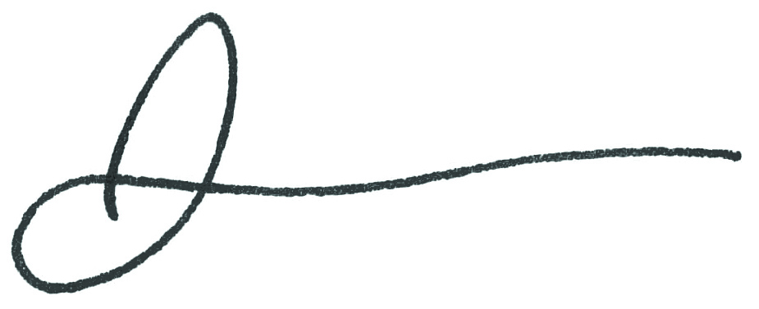
Chief Executive Officer
Independent Hospital Pricing Authority
1 October 2016


/ About IHPA


Enabling legislation
The Independent Hospital Pricing Authority (IHPA) is a Corporate Commonwealth Entity under the Public Governance, Performance and Accountability Act 2013.
IHPA was established under the National Health Reform Act 2011, giving effect to the National Health Reform Agreement signed by the Australian Government and all states
and territories in August 2011.

Functions and purpose
Pursuant to the National Health Reform Act 2011, the main functions of IHPA are:
- to determine the national efficient price for health care services provided by public hospitals where the services are funded on an activity basis;
- to determine the efficient cost for health care services provided by public hospitals where the services are block funded;
- to publish the National Efficient Price, National Efficient Cost and other information each year for the purpose of informing decision makers in relation to the funding of public hospitals.
IHPA was established to promote improved efficiency in, and access to, public hospital services through the provision of independent advice to Australian governments in relation to the efficient costs of public hospital services, and developing and implementing robust systems to support Activity Based Funding for those services. (See ‘What is Activity Based Funding?’ at p 07.)
In undertaking its work, IHPA is required to consider the actual cost of delivering public hospital services in as wide a range of hospitals as practicable. It is also required to take into account any legitimate and unavoidable variations in costs due to hospital characteristics and patient complexity. IHPA balances a range of national policy objectives, guided by principles contained in the National Health Reform Agreement.

Responsible minister
The Independent Hospital Pricing Authority sits within the Department of Health portfolio.
The responsible Minister for the duration of the reporting period was the Hon. Sussan Ley MP, Minister for Health.

What is activity based funding?
Activity Based Funding (ABF) means hospitals are paid for the number and complexity of patients they treat. If a hospital treats more patients, it receives more funding. ABF takes into account the fact that some patients are more complicated to treat than others.
ABF enables efficiency comparisons between hospitals and allows system and hospital managers to identify inefficient practices, manage costs and optimise resource allocation. ABF is a useful tool to measure hospital performance and to establish appropriate benchmarks for hospital performance.
The building blocks required for an ABF system are:

Classification
Classifications provide the health care sector with a nationally consistent method of classifying all types of patients, their treatment and associated costs in order to provide better management, measurement and funding of high quality and efficient health care services. More information about IHPA classifications and how they are developed is available at www.ihpa.gov.au/what-we-do/classifications.

Data collection
Each patient episode needs to be counted. This includes inpatient admissions, emergency department presentations and outpatient appointments as well as a range of mental health and rehabilitation services. More information about IHPA data collection is available at www.ihpa.gov.au/what-we-do/data-collection.

Costing
A representative number of patient episodes are costed. This information is used for developing the classification system and for the pricing model. More information about IHPA costing activities is available at www.ihpa.gov.au/what-we-do/costing.

Pricing
The pricing model determines how much is paid for an average patient. The pricing model needs to adequately recognise factors that increase the cost of care that may not be picked up in the classification system, for example the additional cost of providing health services in remote areas, or to children. More information about IHPA pricing activities is available at www.ihpa.gov.au/what-we-do/pricing.

Organisational structure
Figure 1: IHPA’s organisational structure at 30 June 2016
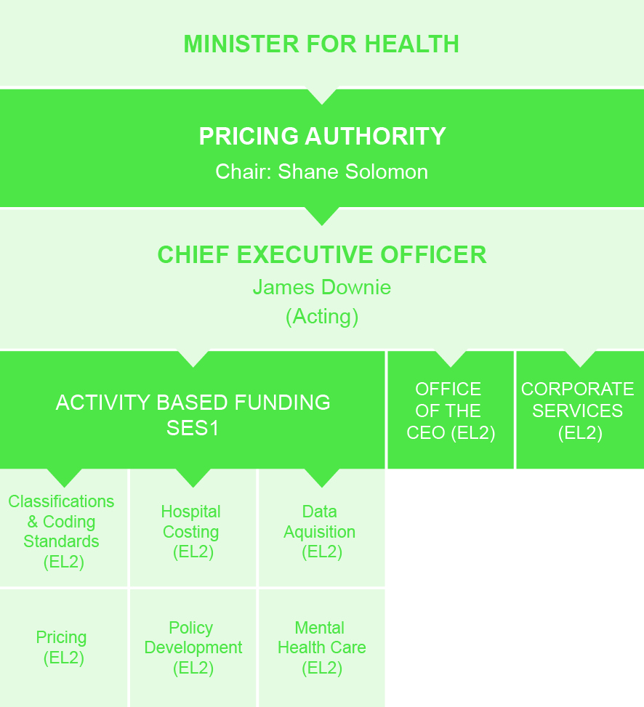

The Pricing Authority is a body corporate consisting of a Chair, Deputy Chair, and seven members. The Chair of the Pricing Authority reports directly to the Minister for Health.
For more about the Pricing Authority, see p 17.
The Chief Executive Officer is responsible for the day-to-day management of IHPA and its staff. Pursuant to s 163(4) of the National Health Reform Act 2011, the Chief Executive Officer is the Accountable Authority of IHPA for the purposes of the Public Governance, Performance and Accountability Act 2013, and therefore for the purposes of this Annual Report.
To achieve its Work Program, IHPA works in collaboration with all jurisdictions, advisory committees, key stakeholders and the public. IHPA’s statutory committees comprise the Clinical Advisory Committee (CAC) and the Jurisdictional Advisory Committee (JAC), established pursuant to Parts 4.10 and 4.11 of the National Health Reform Act 2011.
(An annual report for CAC is included within the IHPA Annual Report at p 25.)
The IHPA office in Sydney is the only facility of the entity, and IHPA’s major activities are located here.

CHIEF EXECUTIVE OFFICER, JAMES DOWNIE
James Downie was appointed CEO of the Independent Hospital Pricing Authority
in September 2016, having acted in the role since June 2015.
Prior to this James was the Executive Director, Activity Based Funding, leading the teams responsible for delivering the classification, costing and pricing functions of IHPA as well
as the data acquisition activities.
James has previously held roles with the Victorian Department of Health, the Royal Children’s Hospital Melbourne and various technical and operational roles in the
resources industry.

IHPA committees
and working groups

IHPA has developed a committee framework to assist in providing expert advice and to ensure the transparency and integrity of the organisation.
IHPA’s statutory committees comprise the Clinical Advisory Committee and the Jurisdictional Advisory Committee.
Other advisory committees and working groups have been established to assist IHPA in delivery of its Work Program, pursuant to part 4.12 of the National Health Reform Act 2011, including:
- Stakeholder Advisory Committee
- Technical Advisory Committee
- National Hospital Cost Data Collection (NHCDC) Advisory Committee
- Teaching, Training and Research Working Group
- Small Rural Hospitals Working Group
- Non-admitted Care Advisory Working Group
- Subacute Care Working Group
- Mental Health Working Group
- Emergency Care Advisory Working Group
- ABF Evaluation Steering Committee
- Bundled Pricing Advisory Group
- National Benchmarking Portal Development (NBPD) Steering Committee
Working groups and committees are structured to enhance IHPA’s statutory functions.
Some committees and working groups may also have sub-committees to assist in the delivery of IHPA’s Work Program. All committees and working groups have Terms of Reference setting out their role, function, delegated power, membership and reporting relationship.
Figure 2: IHPA’s management, committees and working groups
Work Health & Safety Committee
PRICING AUTHORITY
Audit Risk & Compliance Committee
IHPA CHIEF EXECUTIVE OFFICER
MINISTER FOR HEALTH
ABF Technical
Advisory Committee
IHPA EXECUTIVE
COMMITTEE
CLINICAL
ADVISORY COMMITTEE
Stakeholder Advisory Committee
Jurisdictional Advisory Committee
NHCDC Advisory Committee
Bundled Pricing Advisory Group
Teaching, Training and Research Working Group
Small Rural Hospitals Working Group
Non-Admitted Care Advisory Working Group
Subacute Working Group
Mental Health Working Group
Emergency Care Advisory Working Group
NBPD Steering Committee
Pricing Authority
Statutory Authority
Management Committee
Advisory Committee
Working Group

Clinical advisory committee
The Clinical Advisory Committee (CAC) is established under section 177 of the National Health Reform Act 2011 (the NHR Act). Its functions include advising the Pricing Authority on developing and specifying classification systems for health care and other services provided by public hospitals, the functions of the Pricing Authority, and matters referred to it by the Pricing Authority.
CAC members are appointed by the Australian Government Minister for Health. At 30 June 2016, the CAC consisted of 24 members.
The CAC is required to report annually. The CAC Annual Report, including details of its members and meetings, sits within the IHPA Annual Report, at p 25.

Jurisdictional advisory committee
The Jurisdictional Advisory Committee (JAC) was established under section 195 of the NHR Act. The JAC consists of a Chair appointed by the Pricing Authority and nine other members (one to represent each state, territory and the Australian Government). JAC members are appointed by written instrument by the head of the health department of each jurisdiction. The JAC met on eight occasions between 1 July 2015 and 30 June 2016.
JAC members as of 30 June 2016:

- Mr James Downie, Chair
- Ms Alanna Foster
- Ms Frances Diver
- Mr Michael Pervan
- Mr Jamin Woolcock
- Ms Elizabeth Koff
- Mr Phil Ghiradello
- Ms Toni Cunningham
- Mr Rob Anderson
- Ms Lisa Watson

During the reporting period there were several JAC membership changes, with the NT,
WA, Qld and ACT advising IHPA of changes to JAC membership by written instrument.
IHPA CEO, Mr James Downie, has been Chair of JAC since 1 June 2015.
Other members in the reporting period:
- Ms Kim Smith
- Mr Nick Steele
- Ms Janet Anderson
- Ms Allison Grieson
- Mr Beress Brooks

/ Pricing Authority


From the Chair –
Shane Solomon
It is with great pleasure that I present IHPA’s Annual Report for 2015–16.
Activity Based Funding (ABF) was introduced nationally in 2011 as a means of determining Australian Government funding to Australian public hospitals to improve transparency of public hospital funding and strengthen initiatives for efficiency. At the Council of Australian Governments (COAG) in April 2016, the Prime Minister and First Ministers signed a Heads
of Agreement which included a commitment to continue with ABF and the National Efficient Price (NEP) until 2020.
Much has been achieved since the introduction of ABF and during the reporting period, as outlined in this report. These achievements can be attributed to the collaborative and transparent environment that IHPA has created, working in partnership with the jurisdictions and a wide range of stakeholders. The NEP is now widely used by jurisdictions as an independent benchmarking tool to measure the efficiency of public hospital services in their state or territories and to assist with funding decisions.
With the delivery of its fifth round of pricing, IHPA has continued to refine and improve its pricing model and we are starting to see the impact that ABF has in regards to reducing the growth in public hospital costs. Since the publication of the first NEP in 2012, it is evident that the growth in public hospital costs per National Weighted Activity Unit has slowed (see Figure 3, opposite).
Next year will bring some new and exciting challenges to IHPA and the Pricing Authority.
An outcome of the recent COAG Heads of Agreement is a stronger focus on pricing for safety and quality. We will continue to work with the Australian Commission on Safety and Quality in Health Care in considering options for pricing safety and quality in public hospitals.
I would like to thank my fellow members of the Pricing Authority for their expertise and vision over the past financial year. I would also like to thank James Downie, Chief Executive Officer, and all IHPA staff who have contributed to the successful delivery of IHPA’s Work Program for 2015–16. The Pricing Authority has a very high regard for the work it receives from IHPA.
I look forward to leading the Pricing Authority over the coming year and continuing to contribute to all Australian governments’ commitment to an efficient and sustainable
health care system.
Shane Solomon
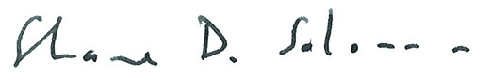
Chair, Pricing Authority
1 October 2016

Significant slowdown in costs

Cost per National Weighted Activity Unit (NWAU)
The NWAU is a measure of health service activity expressed as a common unit, against which the National Efficient Price (NEP) is determined. Figure 3 indicates a significant levelling off since the first NEP Determination in 2012, to a sustained growth rate of about 1.1% since 2011–12.
Figure 3: Cost per National Weighted Activity Unit (NWAU)

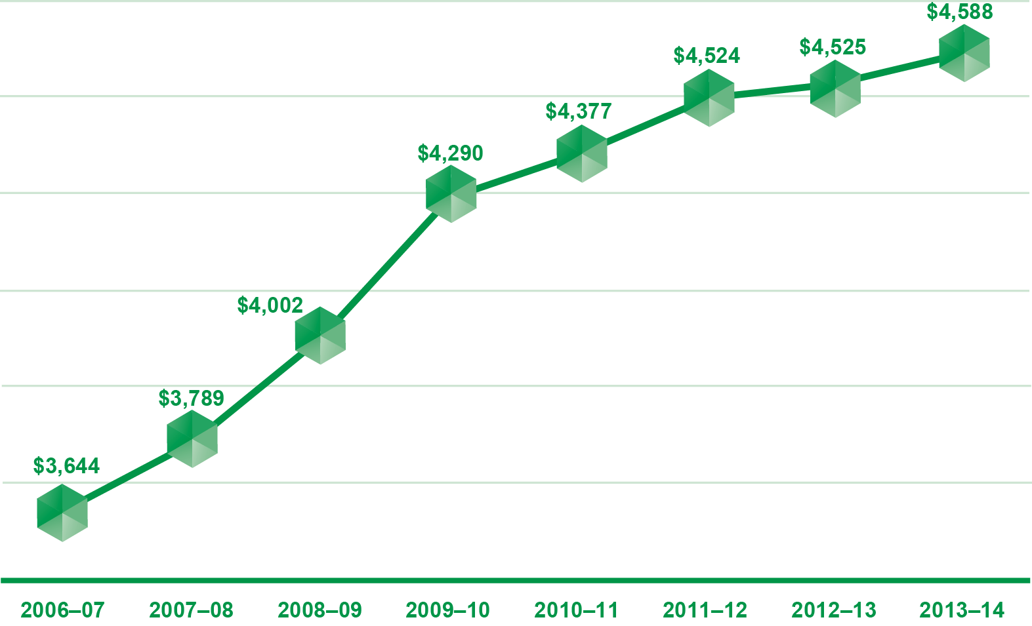

Decreasing National Efficient Price
The National Efficient Price represents the average cost of providing public hospital services across Australia. The downward trend of the NEP, as represented in Figure 4 below, is an indicator of activity based funding’s success in controlling costs.
Figure 4: Decreasing National Efficient Price 2012–2016

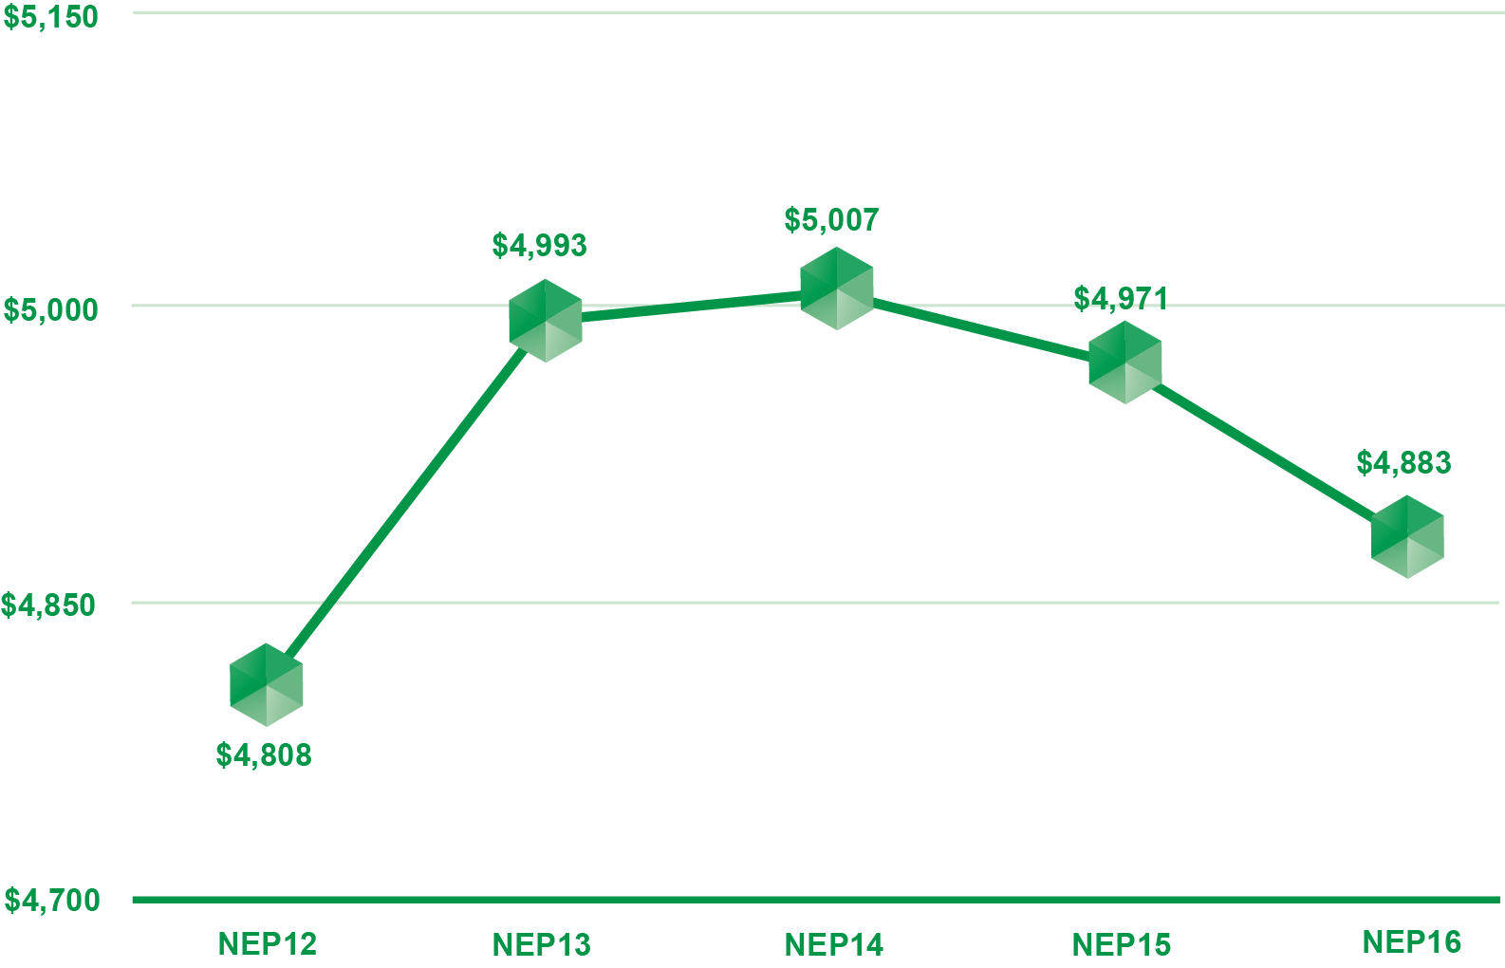

As required under the National Health Reform Agreement (cl B40), IHPA backcasts the NEP whenever significant changes to the methodology or underlying data occurs, to enable the fair calculation of Commonwealth growth funding.

About the Pricing Authority

The Pricing Authority is responsible for promoting improved efficiency and access to public hospital services by providing independent advice to government in relation to the efficient costs of services and developing and implementing robust systems to promote activity based funding for such services. The Pricing Authority consists of a Chair, a Deputy Chair and seven other members. As of 30 June 2016, one position was not filled.
Pricing Authority members are appointed for a period not greater than five years. The Chair is appointed by the Australian Government Minister for Health; the Deputy Chair is appointed with the agreement of First Ministers of all states and territories; and the Pricing Authority members are appointed with the agreement of the Prime Minister and First Ministers of the states and territories.
Members of the Pricing Authority bring significant and varied expertise to their role including: substantial experience and knowledge of the health industries, health care needs and the provision of health care in regional and rural areas. The Pricing Authority is supported by a Chief Executive Officer, who is responsible for the day-to-day running of IHPA.
The current Pricing Authority members were appointed in February 2012. All Pricing Authority members are non-executive.
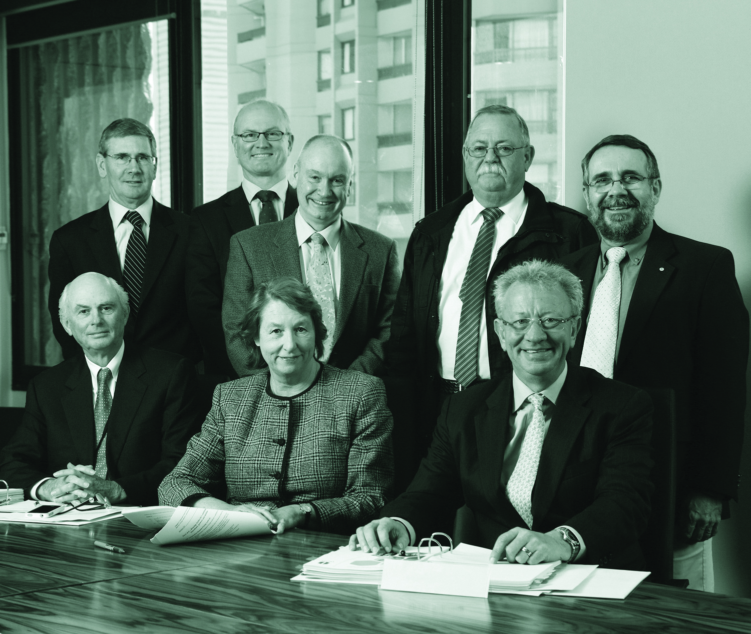
The Pricing Authority. Back row, left to right: Mr Glenn Appleyard, Mr Jim Birch, AM (Deputy Chair), Dr Michael Walsh, Mr Alan Bansemer, Associate Professor Bruce Chater, OAM. Front row, left to right: Mr Alan Morris, Professor Jane Hall, Mr Shane Solomon (Chair).

Members of the Pricing Authority 2015–16
- Mr Shane Solomon (Chair)
Shane Solomon has over 30 years of international and national healthcare management expertise. Shane is the Managing Director of Telstra Health, a new eHealth business within Telstra.
Prior to joining Telstra, Shane was KPMG’s Partner in Charge, Healthcare. In this role, he worked with state and Australian Governments, along with private sector health organisations.
Shane was the Chief Executive of the Hong Kong Hospital Authority, managing Hong Kong’s 57,000 public hospital staff. During his five-year tenure, he implemented significant funding and service quality reforms, including a casemix pay for performance model and the ongoing development of a comprehensive integrated e-health system.
In Victoria, Shane was Under-Secretary of Health at the Department of Human Services (as it then was) where he was responsible for managing the funding system (including casemix) for Victoria, and performance and governance of Melbourne metropolitan health services. He was responsible for developing the Hospital Admission Risk Program and governance reforms to Victoria’s public hospital system.
Shane was the first Group Chief Executive Officer of the integrated Sisters of Mercy Victorian hospital and aged care services group, merging public hospitals, private hospitals, aged care services, and palliative care services into a single new organisation and expanding the Sisters of Mercy mission from five entities to 12.
- Mr Jim Birch, AM (Deputy Chair)
Jim Birch lives in Adelaide, South Australia and is a board member of the Australian Red Cross Blood Service, the Australian Red Cross Society, Little Company of Mary Health Care, the Australian Digital Health Agency, Cancer Council of SA and Mary MacKillop Care SA.
Jim is a business consultant and was previously Global Health Leader of Ernst and Young, Lead Partner, Health and Human Services and Government and Public Sector Lead Partner at Ernst and Young. Jim has also held the position of Chief Executive of the Human Services and Health Department in South Australia.
- Mr Glenn Appleyard
Glenn Appleyard was a member of the Australian Accounting Standards Board from
1 January 2003 to 31 December 2011.
Glenn has held several senior positions within the public service including: Deputy Secretary in the Tasmanian and Victorian Departments of Treasury and Finance, Regional Director for the Australian Bureau of Statistics in Tasmania.
He was a member of the Commonwealth Grants Commission for 11 years and was also the Chair of the Tasmanian Economic Regulator. Glenn is currently the Chairman of PSMA Australia Ltd.
- Mr Alan Bansemer
Alan Bansemer has over 42 years’ experience in the health sector, including six years as the West Australian Health Commissioner and eight years as the Deputy Secretary to the Australian Government Department of Human Services and Health (as it then was).
He currently runs his own private consultancy group, Banscott Health Consulting Pty Ltd, providing strategic advice to health departments throughout Australia.
Alan has chaired a number of committees including the Medicare Schedule Review Board and General Practice Consultative Committee. In addition, he has served as
a member of numerous health advisory committees including the Australian Health Ministers’ Advisory Council, Health Insurance Commission and the Australian Institute
of Health and Welfare.
- Associate Professor Bruce Chater, OAM
Associate Professor Bruce Chater is Head of the Academic Discipline of Rural and Remote Medicine and Deputy Chair of the Rural Clinical School Management Committee at the University of Queensland — tasks he performs from his rural base of Theodore, Queensland where he continues as a practising rural doctor.
Bruce has been very involved in ensuring that rural health services provide high quality and professional services to rural people. He was the founding convener of the Rural Doctors’ Association of Queensland and Australia, founding Chair of the National Rural Health Alliance and served as President of the Australian College of Rural and
Remote Medicine.
- Professor Jane Hall
Professor Jane Hall is the founding Director of the Centre for Health Economics Research and Evaluation and Professor of Health Economics in the Faculty of Business at the University of Technology, Sydney. Jane is a Fellow of the Academy of Social Sciences in Australia.
She has held many advisory and board positions, and is currently a member of the board of the Bureau of Health Information. She is actively involved in policy analysis and critique, and is a regular commentator on health funding and organisational issues
in Australia.
- Mr Alan Morris
Alan Morris is the former Chair of the Commonwealth Grants Commission and also undertakes consulting and advisory work for AusAID and the World Bank.
His prior appointments have included: Executive Director for Australia, Korea, New Zealand and Egypt at the European Bank for Reconstruction and Development, London; Secretary, Department of Premier and Cabinet, Tasmania; Secretary (Chief Executive Officer) and Secretary to Cabinet, Department of the Chief Minister, Northern Territory of Australia; Assistant to Executive Director, International Monetary Fund, Washington DC; Chief Financial Officer, International Finance Section, Australian Treasury; and First Assistant Secretary, Department of Finance, Papua New Guinea.
- Dr Michael Walsh
Michael is Chief Executive of Cabrini Health, a private not for profit Catholic health service in Melbourne, Australia. He was recruited from Doha, Qatar where he was Chief Executive of the National Health Authority. Prior to this he worked in London, England as Chief Executive, South East London Strategic Health Authority. Michael has held a range of senior hospital and health department positions in Victoria and Western Australia.
He is Vice President of the Royal Australasian College of Medical Administration, a Fellow of Australasian College of Health Service Management. Michael has over 25 years’ experience in health service policy and management in both public and
private sectors.

Meetings of the Pricing Authority 2015–16
The Pricing Authority met on nine occasions between 1 July 2015 and 30 June 2016. Chief Executive Officer, James Downie, as the Accountable Authority, attended all nine meetings.
Table 1: Pricing Authority meetings and attendances 2015–16
MEMBER | MEETINGS ELIGIBLE | MEETINGS ATTENDED
Shane Solomon (Chair) | 9 | 8
Jim Birch, AM (Deputy Chair) | 9 | 8
Glenn Appleyard | 9 | 6
Alan Morris | 9 | 5
Alan Bansemer | 9 | 8
A/Prof. Bruce Chater, OAM | 9 | 9
Prof. Jane Hall | 9 | 8
Michael Walsh | 9 | 8

/ IHPA 2015–2016 overview


From the CEO,
James Downie
I am pleased to present the Independent Hospital Pricing Authority’s 2015–16
Annual Report.
In 2015–16 IHPA continued to fulfil its annual pricing functions, publishing the Pricing Framework for Australian Public Hospital Services 2016–17 in 2015, followed by the NEP and NEC determinations in February 2016. This year saw a number of methodological improvements to the pricing model such as improvement of the private patient correction and the introduction of an age adjustment for emergency care, providing a more accurate way of accounting for costs.
In 2016 IHPA completed a ground-breaking piece of work, the Australian Mental Health Care Classification. Following two consultation papers and with guidance from the Mental Health Classification Expert Reference Group, this new classification will be more clinically relevant, and will support new models of care being implemented in all states and territories. IHPA will continue to engage with the mental health care community to ensure the classification is relevant and to achieve ongoing improvement.
In 2015–16 IHPA completed a costing study for Teaching Training and Research activities
in public hospitals and will develop a classification for teaching and training by the end of the next financial year.
Building on the benchmarking opportunities that ABF provides, IHPA has developed a National Benchmarking Portal, to be released in 2016. This will allow jurisdictions and hospitals to compare health data and facilitate the benchmarking of hospital-level costs
and activity data.
In December 2015 IHPA launched its redeveloped website. With a more modern design
and better accessibility, the new website represents IHPA’s commitment to sharing its publications, research and data with the public and facilitating engagement with the Government’s health reform agenda.



The year ended on a positive note with the Heads of Agreement signed at COAG confirming that public hospital services would continue to be funded by Activity Based Funding (ABF) until 2020. This support for ABF was reflected in the energy and discussion at IHPA’s Activity Based Funding conference in Brisbane in May. Local speakers were joined by international speakers from Germany and the US to provide an interesting mix of case studies and presentations.
I would like to acknowledge the members of the Pricing Authority and the Clinical Advisory Committee for their expertise, vision and commitment. IHPA also recognises the importance of its relationships with jurisdictions and key stakeholders, who have helped guide IHPA’s Work Program and contributed to the success and national acceptance of IHPA’s work. Finally, I would like thank IHPA staff for their ongoing professionalism and hard work,
and I look forward to working with them over the year ahead.
James Downie
Chief Executive Officer, IHPA
1 October 2016

2015–16 Snapshot


OCTOBER 2015
- Tier 2 Non-admitted Services Compendium, National Index
and Definitions Manual for
2016–17 completed

MARCH 2016
- NEP and NEC Determinations 2016–17 published
- Mental Health Care Classification version 1.0 finalised
MAY 2016
- Annual review of the General
List of In-Scope Public Hospital Services published
- Consultation on the Work
Program 2016–17
- Updated Back-casting Policy
- Hosted the Activity Based Funding Conference, Brisbane

NOVEMBER 2015
- Australian Mental Health Care Classification consultation
- Pricing Framework for Australian
Public Hospital Services
2016–17 released

DECEMBER 2015
- Teaching, training and research
costing study completed
- Launch of new IHPA website
JUNE 2016
- Three Year Data Plan updated
- Publication of the IHPA Work
Program 2016–17

/ Clinical Advisory Committee: Annual Report


from the Chair,
Dr Alisdair Macdonald
I am delighted to present the Clinical Advisory Committee’s (CAC) Annual Report. I took over the role of Chair in November 2015 following the retirement of Professor Ian Gough.
Professor Gough provided the groundwork for this important advisory committee. The CAC is a multidisciplinary group comprising experts in their areas that bring a great deal of high-level knowledge not only in relation to clinical practice, but also to funding. Professor Gough led the committee in providing critical input into the first Pricing Framework for Australian Public Hospital Services ensuring clinical input and provision of advice in key areas of IHPA’s work.
I would like to thank Professor Gough for his hard work and I look forward to building on this work, ensuring that IHPA continues to deliver a clinically relevant National Efficient Price and National Efficient Cost each year.
In the reporting period, as always, the CAC provided clinically relevant advice regarding the Pricing Framework for Australian Public Hospital Services 2016–17 which informed IHPA’s determination of the NEP and NEC for 2016–17.
We progressed work as part of a joint working party with the Australian Commission for Safety and Quality in Health Care and IHPA, developing and piloting ways in which data routinely generated in Australian public hospitals can be provided to clinical teams in hospitals to promote improvements to safety and quality.
We continued to advise on the development of national classification systems for teaching, training and research and mental health care as well as evaluating a proposed approach for a new classification system for emergency care services.
The CAC also provided input into some new and exciting areas including an assessment
of the impact of new technology on hospital service delivery on future policy and pricing determinations and options for bundled pricing across care settings for future years. We also considered IHPA’s approach to best practice pricing for hip fracture care in future years.
I would like to thank my fellow CAC members for their contribution to the work outlined within this chapter and very much look forward to leading the work of the committee for the coming year. I would also like to acknowledge the IHPA Pricing Authority and staff who have once again delivered a successful Work Program in 2015–16.
Dr Alasdair MacDonald
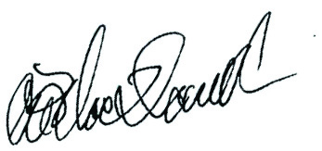
Chair, Clinical Advisory Committee
1 October 2016

About the clinical
advisory committee
The Clinical Advisory Committee (CAC) members provide high-level technical and clinical advice to the Pricing Authority on a range of issues such as activity based funding and classification development and revision to guide IHPA policy development and inform the National Efficient Price and National Efficient Cost.
The CAC is a statutory committee established under Part 4.10 of the National Health Reform Act 2011.
The functions of the CAC are described in s. 177:
- to advise the Pricing Authority in relation to developing and specifying classification systems for health care and other services provided by public hospitals;
- to advise the Pricing Authority in relation to matters that:
  - relate to the functions of the Pricing Authority; and
  - are referred to the Clinical Advisory Committee by the Pricing Authority;
- to do anything incidental to or conducive to the performance of the above functions.
The members of the CAC were appointed by the Australian Government Minister for Health and are drawn from a range of clinical specialties and backgrounds to ensure the CAC represents a wide range of clinical expertise. Appointments are based on individual expertise rather than as a representative of an organisation, peak body or jurisdiction. Remuneration is determined by the Remuneration Tribunal.
The Chair of the CAC, Dr Alasdair MacDonald, reports to the Australian Government Minister for Health and is supported by IHPA staff.

Membership
Members are appointed by the Australian Government Minister for Health and are drawn from a range of clinical specialties and backgrounds to ensure the CAC represents a wide range of clinical expertise.
Table 2: Membership and meetings of the CAC in 2015–16
NAME | POSITION | SPECIALTY | MEETING ELIGIBLE | MEETINGS ATTENDED
Prof. Ian Gough | Chair | Endocrinology/  Surgery | 2 | 2
Dr Alasdair MacDonald | Deputy Chair | Internal Medicine | 4 | 4
Prof. Gerard Carroll | Member | Cardiology/Rural | 4 | 3
Prof. Peter Macdonald | Member | Transplantation | 4 | 0
A/Prof. Paul Varghese | Member | Geriatrics/  Rehabilitation | 4 | 3
Dr Bernard Whitfield | Member | Ear Nose and  Throat Surgery/  Injuries/Trauma | 4 | 3
Prof. John Turnidge | Member | Infectious Disease | 4 | 0
Dr Philip Hoyle | Member | Administration | 4 | 2
A/Prof. Louis Irving | Member | Respiratory/  Indigenous Health | 4 | 1
A/Prof. Daryl Williams | Member | Anaesthesia  and Pain Management | 4 | 2
Footnotes:
NAME | POSITON | SPECIALITY | MEETING ELIGIBLE | MEETINGS ATTENDED
Prof. Leon Flicker | Member | Geriatrics/  Indigenous Health | 4 | 3
W/Prof. Fiona Wood | Member | Burns | 4 | 3
Dr Amanda Ling | Member | Administration | 4 | 3
A/Prof. Liza Heslop | Member | Nursing/  Pregnancy  and Childbirth | 4 | 2
Prof. Graham J Reynolds | Member | Paediatrics | 4 | 2
Prof. Geoff Donnan | Member | Neurology | 4 | 2
Ms Jan Erven | Member | Occupational  Therapist | 4 | 3
Prof. Sally Tracy | Member | Midwife | 4 | 1
Ms Amber Roberts | Member | Pharmacist | 4 | 2
Ms Alison McMillan | Member | Chief Nurse | 4 | 4
Dr Ruth Vine | Member | Psychiatrist | 4 | 4
Ms Sue Davis | Member | Nurse | 4 | 3
Ms Julie Connell | Member | Allied Health  Manager | 3 | 3
Dr Jo Wright | Member | Rural Medical  Practice | 4 | 0

Footnotes:
NAME | POSITON | SPECIALITY | MEETING ELIGIBLE | MEETINGS ATTENDED
A/Prof. Melinda  Truesdale | Member | Emergency  Medicine | 4 | 4
Dr Amod Karnik | Member | Intensive Care  Medicine | 4 | 3
Dr Andrew Wei | Member | Haematology | 2 | 2

CAC Meetings 2015–16

The CAC met on four occasions during 2015–2016:
- 3 August 2015
- 19 October 2015
- 8 February 2016
- 16 May 2016
Footnotes:

2015–16 Snapshot
In 2015–16 the Clinical Advisory Committee supported IHPA’s Work Program to deliver the following key achievements:

The Pricing Framework for Australian Public Hospital Services 2016–17
IHPA’s determination of the NEP and NEC for 2016–17
Development of national classification systems for
teaching, training and research and mental health care
Evaluation of the proposed approach for a new
classification system for emergency care services
Development work on International Statistical Classification of Diseases and Related Health Problems, Tenth Revision, Australian Modification (ICD-10-AM) Tenth edition for admitted acute care
Assessment of the impact of new technology on hospital service
delivery on future policy and pricing determinations
Investigation of options for bundled pricing across care settings for future years
Consideration of IHPA’s approach to best practice pricing
for hip fracture care in future years
Contribution to IHPA’s specialist groups including the joint working party Australian Commission on Safety and Quality in Health Care
The development of the ABF benchmarking portal with the aim
of ensuring high standards and quality in the clinical community

/ Management and Accountability

Significant changes
affecting IHPA

The Mid-Year Economic and Fiscal Outlook 2015–16 (MYEFO 2015–16) specified that the Government would achieve savings of $70 million over four years from 2015–16 by further reducing the number of government bodies in the Health Portfolio to reduce overlap and improve efficiency.
This included transferring operational functions of the Independent Hospital Pricing Authority to the Department of Health from 1 July 2016, with the Board, Chief Executive Officer and functions retained. A Memorandum of Understanding (MoU) between IHPA and the Department of Health was executed in June 2016, implementing the Machinery of Government changes announced in MYEFO 2015–16. The MoU set out the authorities, resources and management responsibilities of the parties to be applied from 1 July 2016. The IHPA CEO retains responsibility as the Accountable Authority. All other staff employed by IHPA at 30 June 2016 were transferred to the Department of Health, with 40 operational staff seconded back to IHPA under the direct control of the IHPA CEO. IHPA’s budgets have been apportioned between the Department of Health and IHPA in accordance with the MoU.
To prepare for the transfer of IHPA staff to the Department of Health by 30 June 2016 and the reduction in internal resources from a planned 59 staff to 40, IHPA completed a program of activities, such as: a review of policies, reassignment of responsibilities, redesign of controls and assurance, establishment of Health/IHPA working group, revision of the internal audit program, update of financial and human resource delegations, updated monthly control reports, and revision of funding sources.
The planning process did not identify any unsurmountable risks, however the agency will enter a period of change as the new corporate governance, control and assurance processes implied in these changes become embedded into the agency.

Key Corporate
Governance Practices

Since formation of the agency in 2011, IHPA’s Accountable Authority has established a robust system of risk management and controls to assist in the governance of the agency.
The obligations defined in the National Health Reform Act 2011 are overseen by the Pricing Authority. The Pricing Authority provides guidance and approval on IHPA’s core business activities — ABF classification development and pricing products.
IHPA places a high importance on informal and formal communications with government and non-government stakeholders.

Risk Management
IHPA’s enterprise approach to risk management is administered using tools that deal with strategic and tactical risks.
Strategic risks are developed with reference to current business and environmental issues facing IHPA. At 30 June, there were nine strategic risks under active management. These risks include: data management, maintenance of independence, classification development, compliance and corporate risks. These strategic risks are actively managed through audits, assurance and control processes. Where new risks emerge, resources are assigned to understand and manage the risks. The move of staff to the Department of Health presented a range of challenges for the agency which have been appropriately managed during the year (see above, p 33).
Tactical risks are managed through a decision based risk management tool. This is a particularly useful process in regards to procurement and ICT risks, as it enables them to be quickly documented and a position determined on the managed risk likelihood and consequence. Through this approach, management is fully cognisant of managed risk outcomes during its decision making.
IHPA has a mature enterprise risk management framework in place and risk management is considered a business-as-usual activity for all IHPA staff.

COMPLIANCE
IHPA has a broad range of compliance obligations including key statutory obligations set out in the National Health Reform Act 2011 (the NHR Act) and the National Health Reform Agreement, the Public Governance Performance and Accountability Act 2013 (the PGPA Act) and the Public Governance Performance and Accountability Rule 2014. Other legal and compliance obligations include those relating to employees, work health and safety, privacy, freedom of information, intellectual property, the Protective Security Policy Framework, website accessibility and records management.
The Accountable Authority received management assurances on IHPA’s compliance obligations through an organised system of controls and special exercises, including substantive testing, monthly reports, exception notifications and compliance audits undertaken by Crowe Horwath, the independent internal auditor.
Compliance achievements during the year include:
- ICT systems assessed as compliant with the top risks defined by Australian Signals Directorate
- IHPA confirmed to the relevant Ministers its full compliance with the Protective Security Policy Framework of the Commonwealth
- There were no compliance issues arising from IHPA’s administration of relevant sections of the NHR Act
- IHPA did not report any material compliance issues emanating from the Public Governance Performance and Accountability Act 2013
- Third-party audit by Crowe Horwath on internal governance and management of Pricing Authority protected data, with a positive result

Financial Authorisation
IHPA makes procurement decisions in accordance with the Commonwealth Procurement rules. Line managers have value and purchase class limits in accordance with a delegation of financial authorities that is approved by the Accountable Authority.

Audit, Risk and Compliance Committee
The IHPA Audit, Risk and Compliance (ARC) Committee provides independent advice
to assist the Chief Executive Officer, the Executive Committee and the Pricing Authority manage IHPA’s financial and business risk.
At 30 June 2016, members of the ARC Committee comprised:
- Robert Butterworth, Chair and Independent member
- Angela Diamond, Independent member
- Alan Bansemer, Pricing Authority member

Fraud Control Plan
IHPA’s fraud control plan is recognised as a critical internal tool used to mitigate the act
and consequences of unauthorised use of IHPA data and financial resources. The plan encourages ethical behaviour through use of business processes designed to prevent deceptive activities, supported by monitoring controls to detect fraud and deter
offending behaviour.

Inter-Agency Financial Activity
IHPA expended $1.180 million with the Australian Commission on Safety and Quality in Healthcare in a program of activity designed to develop options to incorporate activity based pricing to assist in the delivery of improved safety and quality outcomes in public hospitals.
Since establishment, IHPA has received shared services from the Department of Health. During 2015–16, the Department of Health charged IHPA $0.397 million to provide services covering treasury, processing of financial transactions, information and communication desktop services and parliamentary support.

Ecologically Sustainable Development
And Environmental Performance
IHPA does not undertake any substantive work that is covered by s 516A of the Environment Protection Act 1999.

Advertising and Market Research
IHPA did not commission any advertising or market research that requires to be reported under s311A of the Commonwealth Electoral Act 1918.

Management of
Human Resources
In 2015–16, staff demonstrated their resilience in dealing with the planned move of their positions to the Department of Health (see p 33).
Unplanned leave at 11.6 days per employee was in line with the Australian Public
Service average.
Labour turnover at 21% reflects the career advancement opportunities IHPA employment provides to staff. People in the hospital ABF sector hold the agency in high regard and this aided the attraction of suitable new staff.
Table 3: Staff numbers by classification, gender and full-time/part-time status at 30 June 2016
 | FEMALE |  |  | MALE
CLASSIFICATION | TOTAL | F/T | P/T | TOTAL | F/T | P/T | TOTAL
HOPO | 0 | 0 | 0 | 1 | 1 | 0 | 1
SES | 1 | 1 | 0 | 0 | 0 | 0 | 1
EL2 | 5 | 4 | 1 | 4 | 4 | 0 | 9
EL1 | 12 | 9 | 3 | 11 | 11 | 0 | 23
APS Level 6 | 11 | 8 | 3 | 4 | 3 | 1 | 15
APS Level 5 | 1 | 1 | 0 | 1 | 1 | 0 | 2
TOTAL | 30 | 23 | 7 | 21 | 20 | 1 | 51
Key: F/T = full time, P/T = part time
HOPO = Holder of Public Office (a statutory appointment — the CEO)
Note: Staff numbers by classification are based on actual not nominal classification.

Staff Training
Training was provided on a programmed basis to management and a needs basis to individual staff.
The CEO supported and attended programmed management training for executive level staff. Further, IHPA supported individuals to attend conferences and training events that assisted them to acquire and develop skills used in their work. In 2015–16, IHPA’s training investment averaged $4,000 per staff member.
It is anticipated that the transfer of IHPA staff to the Department of Health will further increase opportunities for staff training and development, providing them access to the Department of Health’s significant training resources.

The Accountable Authority —
Education and Review Processes
Under the NHR Act, the Chief Executive Officer is the Accountable Authority. During the reporting period the CEO enhanced his skills through attendance at domestic and international activity based funding events and attended specialised leadership training that was also made available to IHPA mid-level and senior management staff. The CEO receives regular performance feedback via the monthly Pricing Authority meetings, which the CEO also attends.

Work, Health and Safety (WHS)
In 2015–16, IHPA’s Work Health and Safety Committee continued to manage work health and safety matters in accordance with the Work Health and Safety Act 2011. The committee met three times during the year and dealt with a range of WHS matters.
IHPA maintained its ongoing practice of providing workplace assessments for new staff,
and as required. An additional WHS initiative in 2015–16 was a program to assist staff manage ergonomic desking in the workspace.
In 2015–16 no notifiable incidents were identified in regards to WHS. No workers reported injuries and no worker compensation claims were made. There were no investigations conducted during the year relating to businesses or undertakings conducted by the entity.

/ Annual
Performance statements

Introductory Statement
I, James Downie, as the Accountable Authority of the Independent Hospital Pricing Authority (IHPA), present the 2015–16 annual performance statements of IHPA, as required under paragraph 39(1)(a) of the Public Governance, Performance and Accountability Act 2013 (PGPA Act). In my opinion, these annual performance statements are based on properly maintained records, accurately reflect the performance of the entity, and comply with subsection 39(2) of the PGPA Act.

Ihpa Purpose
Under the National Health Reform Act 2011, IHPA has one purpose: providing independent advice to governments in relation to the efficient costs of public hospital services, and developing and implementing robust systems to support activity based funding for such services.
IHPA has one outcome: to promote improved efficiency in, and access to, public hospital services.

Results

Activity 1: Perform IHPA Pricing Functions
IHPA’s primary function is to produce the National Efficient Price (NEP) and the National Efficient Cost (NEC) each year. The National Pricing Framework outlines the principles, scope and methodology to be adopted by IHPA in the setting of the NEP and NEC for public hospital services in 2016–17. The Pricing Framework forms the policy basis for the NEP and NEC determinations.
During 2015–16, IHPA was to undertake further technical development to improve the price setting process, and continue to refine the models used to determine the NEP and NEC.
Criteria
- Publish the National Pricing Framework 2016–17 by 31 December 2015
- Publish the NEP and NEC Determinations by 31 March 2016
- Reduction in the range between the 50th and 90th percentile cost per NWAU when compared to 2013–14 data
- Achieve positive annual external assurance on process
- Meet 90% of the Work Program deliverables

Source
- 2015–16 Corporate Plan — Strategy 1
- 2015–16 Portfolio Budget Statement Program 1.1
Result against performance criteria
- The National Pricing Framework 2016–17 was published on time, in November 2015
- The NEP and NEC Determinations were published on time, in March 2015
- There has been no significant change in the range between the 50th and 90th percentile cost per NWAU.
- The 2013–14 cost models underpinning both the NEP and NEC were validated and quality assured by Price WaterhouseCoopers. All cost models were deemed fit for purpose.
- IHPA has met more than 90% of its Work Program deliverables relating to its pricing functions.

Activity 2: Develop National Classifications
for Activity Based Funding
ABF requires robust classification systems. Classifications aim to provide the health care sector with a nationally consistent method of classifying all types of patients, their treatment, and associated costs. IHPA has already determined the national classifications systems for public hospital services, including admitted acute, non-admitted, emergency and subacute care. Classifications are reviewed regularly and updated periodically to ensure that they remain clinically relevant and resource homogenous within a service category. Such modifications are based on robust statistical analysis and include specialist input from clinicians.
During 2015–16, IHPA aimed to further develop the classifications for admitted acute care, subacute care, non-admitted patient care as well as progress the initial design of new classifications in emergency care, teaching, training and research, and mental health care.
Criteria
- Commence development work on the new classification system for emergency care services in 2015–16
- Progress development of the Australian Mental Health Care Classification V2.0 by June 2016
- Ongoing development of the subacute care classification during 2015–16
- Completion of a teaching, training and research costing study by 1 December 2015
- Continue development work on the new classification for non-admitted care in 2015–16
- Commence development work on Australian Modification of the International Statistical Classification of Diseases 10th Edition and the Australian Refined Diagnosis Related Groups V9.0 prior to 30 June 2016
- Provide a further increase in the proportion of funding for public services using
ABF as reported by the Administrator of the National Health Funding Pool
- Meet 90% of the Work Program deliverables
Source
- 2015–16 Corporate Plan — Strategy 2
- 2015–16 Portfolio Budget Statement Program 1.1
Result against performance criteria
All criteria for this purpose were met.
- Development of the new emergency care classification commenced in 2015–16 with
a costing study to collect cost and activity data to inform classification development. Emergency departments from 10 hospitals across four jurisdictions collected patient activity and clinical data between April and June 2016. The patient activity data will be costed in the second half of 2016.
- In 2015–16 IHPA commenced work to refine the AMHCC for the next iteration, Version 2.0, with targeted consultation with the child and adolescent mental health sector to review the child and adolescent classes, and an inter-rater reliability study on the new concept of mental health phase of care.
- Development of the subacute classification continued in 2015–16, with a focus on patients receiving Geriatric Evaluation and Management (GEM) care in hospitals. IHPA commissioned a collection of patient cognitive measures and other clinical data from the medical records of GEM patients in 15 hospitals across four jurisdictions. This collection resulted in a GEM dataset containing both cost and clinical data for over 4,000 records.
- The teaching, training and research costing study was completed by December 2015. The key finding from the study was that it is possible to cost the output or ‘product’ of hospital teaching and training (i.e. a health professional who has acquired a particular
set of clinical skills), and therefore it is feasible to fund teaching and training on an activity basis. The costing study data provides an adequate starting point for the development of a teaching and training classification. Work to develop an Australian teaching and training classification will commence in the second half of 2016.
- IHPA has commenced development of the Australian Non-Admitted Care Classification (ANACC). Scoping work, data analysis and development of non-admitted classification structures and variables were underway in 2015–16 and will continue into 2016–17.
- Development of the updated versions of Australian Modification of the International Statistical Classification of Diseases and the Australian Refined Diagnosis Related Groups commenced in the reporting period, with a focus on refinements to ensure the classifications remain clinically relevant and up-to-date with clinical practice as well as adequately explaining the costs of providing admitted acute hospital care. There has been widespread consultation with clinicians, states and territories and the private
sector on the refinements. The new versions of the classifications are on schedule for completion by November 2016.

- The Administrator of the National Health Funding Pool reported a further increase in
the proportion of funding for public services using ABF during 2015–16. As of April 2016, 85% of funding paid by the Administrator was ABF. This is an increase of 2% on the 2014–15 amount.
Table 4: Proportion of funding for public services using ABF
YEAR | PERCENTAGE
2013–14 | 82.4%
2014–15 | 83%
April 2016 | 85%
- IHPA has met more than 90% of its Work Program deliverables relating to classifications.

Activity 3: Determine Data Requirements
and Data Standards
Timely, accurate and reliable public hospital data is vital to both the development of classifications for hospital services and to determine the NEP of those services. IHPA has developed a rolling Three Year Data Plan to communicate to the Australian Government and states and territories the data requirements, data standards and timelines that IHPA will use to collect data over the coming three years. To ensure greater transparency, IHPA publishes data compliance reports every six months to indicate jurisdictional compliance with the specifications in the rolling Three Year Data Plan.
Criteria
- Update rolling Three Year Data Plan and publish on IHPA website by July 2015
- Publication of a report on a six monthly rolling basis outlining compliance with the data requirements and data standards specified in the rolling Three Year Data Plan
- Internal data assessment and compliance
- Assurance from jurisdictions regarding data quality/accuracy
Source
- 2015–16 Corporate Plan — Strategy 4
- 2015–16 Portfolio Budget Statement Program 1.1
Result against performance criteria
All criteria for this purpose were met.
- The Three Year Data Plan was updated and published on the IHPA website
in June 2015.
- The biannual data compliance reports were consulted on with jurisdictions and published on the IHPA website.
- ABF data submissions were assessed based on the published data standards such as data set specification and data request specification. The 2015 IHPA Data Compliance Policy was used to assess jurisdictional compliance rating.
- Jurisdictions were required to sign off their final data submission to IHPA to ensure that data conforms as closely as is achievable in regards to its quality and accuracy.

Activity 4: ResoLve disputes on cost-shifting and
cross-border issues
IHPA has a role to investigate and make recommendations concerning cross-border disputes between states and territories and to make assessments of cost-shifting disputes.
Criteria
- Publication of updated Cost-Shifting and Cross-Border and Dispute Resolution Framework
- IHPA investigation of cost-shifting or cross-border disputes and provision of recommendations or assessment within six months of receipt of request
Source
- 2015–16 Portfolio Budget Statement Program 1.1
Result against performance criteria
All criteria for this purpose were met.
- An updated Cost-Shifting and Cross-Border and Dispute Resolution Framework
(Version 3.0) was published in March 2016.
- In 2015–16 IHPA did not receive any requests relating to this function.

Activity 5: Independent and Transparent Decision-Making and Engagement with Stakeholders
IHPA works in partnership with Commonwealth, state and territory governments and other stakeholders. IHPA conducts its work independently from governments which allows the agency to deliver impartial, evidenced based decisions. It is transparent in its decision making processes and consults extensively across the health industry.
The methodology that underpins IHPA’s decisions and Work Program is informed by extensive consultation with governments and stakeholders. IHPA has a formal consultation framework in place to ensure that it draws on an extensive range of expertise in undertaking its functions. Input from stakeholders through IHPA’s multiple committees and working groups ensures that IHPA’s work is informed by expert clinical advice which helps to establish and consolidate IHPA’s credibility throughout the industry.
Criteria
- Appropriate committees and working groups maintained to support IHPA’s functions
- Public consultation processes conducted in accordance with the National Health
Reform Act
- All stakeholder input is appropriately considered
- Inbox enquiries responded to within a two-week timeframe
- Annual national conference hosted for a wide audience in the health industry
Source
- 2015–16 Corporate Plan — Strategy 5
Results against performance criteria
- In 2015–16 IHPA maintained up to 17 committees and working groups to provide expert advice and to ensure the transparency and integrity of the organisation. During the reporting period IHPA held 79 meetings with the various committees and working groups.
- IHPA conducted six consultation processes in 2015–16, each in accordance with the National Health Reform Act 2011. These included:
- Pricing Framework for Australian Public Hospital Services 2016–17 (May–June 2016)
- IHPA Work Program (June 2016)
- Development of the Australian Mental Health Care Classification —
Public Consultation Paper 2 (November–December 2015)
- Consultation paper on the Emergency Department International Classification of Diseases 10th Revision Australian Modification (ICD-10-AM) Principal Diagnosis Short List (July 2015)
- Emergency Care Costing Study — Discussion Paper
- Emergency Care Costing Study — Project Management Survey
(January–March 2016)
- All submissions received by IHPA were presented to the Pricing Authority for consideration and published on the IHPA website.
- IHPA received 205 inbox enquiries during the reporting period. 85% were responded to within two weeks, and 42% of those were responded to on the day of receipt.
Table 5: Response rate to enquiries
TOTAL REQUESTS | SAME DAY RESPONSE | 1–7 DAYS | 7–14 DAYS | 15+ DAYS
205 | 73 | 89 | 13 | 30
- The Activity Based Funding Conference 2016, held in Brisbane, attracted 335 delegates. It comprised eight plenary sessions and one panel, 37 concurrent sessions and six workshops. Fifty-two abstracts were submitted for consideration.

Activity 6: Manage The Business Effectively
and Develop Staff
IHPA has a mature risk management framework in place which includes policies, processes and systems that enable staff to treat risks in different ways as required by the tasks performed. Processes are designed to support achievement of IHPA’s functions and activities. Positive assurance that key risks and compliance obligations are being managed is provided through a range of internal controls and ongoing assurance programs.
IHPA’s work program incorporates highly technical work which requires significant
technical workforce capability and expertise. IHPA’s workforce planning strategies emphasise technical skills as well as foundation skills required by all Australian Public Service employees, such as strategic thinking, policy development and advice, effective writing, analysis and judgement, cultural interpersonal effectiveness, team work and collaboration, working in partnership, and negotiation and relationship management. All are central to IHPA’s success and effectiveness. IHPA strengthens management and leadership teams by enhancing performance feedback and providing targeted learning and development programs.
Criteria
- Proper governance and risk management systems and controls are in place
- Satisfactory report from the ANAO as part of the annual audit
- Effective people management
Source
- 2015–16 Corporate Plan — Strategy 6
Result against performance criteria
- IHPA has appropriate governance and risk management controls in place. See Key Corporate Governance Practices at pp 34–35.
- See the ANAO report at p 49 of this Annual Report.
- IHPA demonstrates effective people management through monitoring staff turnover rates and developing staff through attendance at training events. The staff turnover rate of 21% is discussed at p 36. Staff training and development is discussed at p 37.

Analysis
The challenges presented to the agency by Machinery of Government changes during
the reporting period (see p 33) were managed well and did not significantly impact
IHPA’s performance.
IHPA has had a productive and successful year, meeting its performance criteria and more than 90% of the IHPA Work Program deliverables. The IHPA Work Program provides a more detailed set of goals and deliverables than those included in the PBS and Corporate Plan.
It is developed each year through a consultative process with government and Health Sector stakeholders and published on the IHPA website (see www.ihpa.gov.au/publications). To keep track of its Work Program deliverables, IHPA produces a fortnightly ABF Project Status Report, which covers all Work Program deliverables up to and during that period. The Status Report for the period ending 1 July 2016 indicated all relevant projects were completed, or on schedule.
The Australian Refined Diagnosis Related Groups classification continues to be well-regarded within Australia and internationally and is currently licensed for use in 17 countries around the world. The latest version of the Australian Refined Diagnosis Related Groups (AR-DRG V8.0) classification was adopted for national pricing of admitted acute hospital care in NEP 2016–17. The latest version of the Australian National Subacute and Non-acute Patient classification (AN-SNAP V4.0) was also adopted for national pricing for the first time in NEP 2016–17, for the pricing of admitted subacute and non-acute hospital care.
Over the past financial year IHPA has enhanced the existing secure data submission portal. The portal now has a data quality verification function and the data submission process has been automated. Going forward, this will reduce the work required by jurisdictions in submitting data to IHPA while ensuring high quality data is provided.
The NEP and NEC for 2016–17 illustrate the benefits of Activity Based Funding in reducing costs (see p 16). The COAG agreement in April 2016 to commit to ABF through to 2020 provides the opportunity to further mature the ABF model and processes.

/ Financial Management

ANAO Report

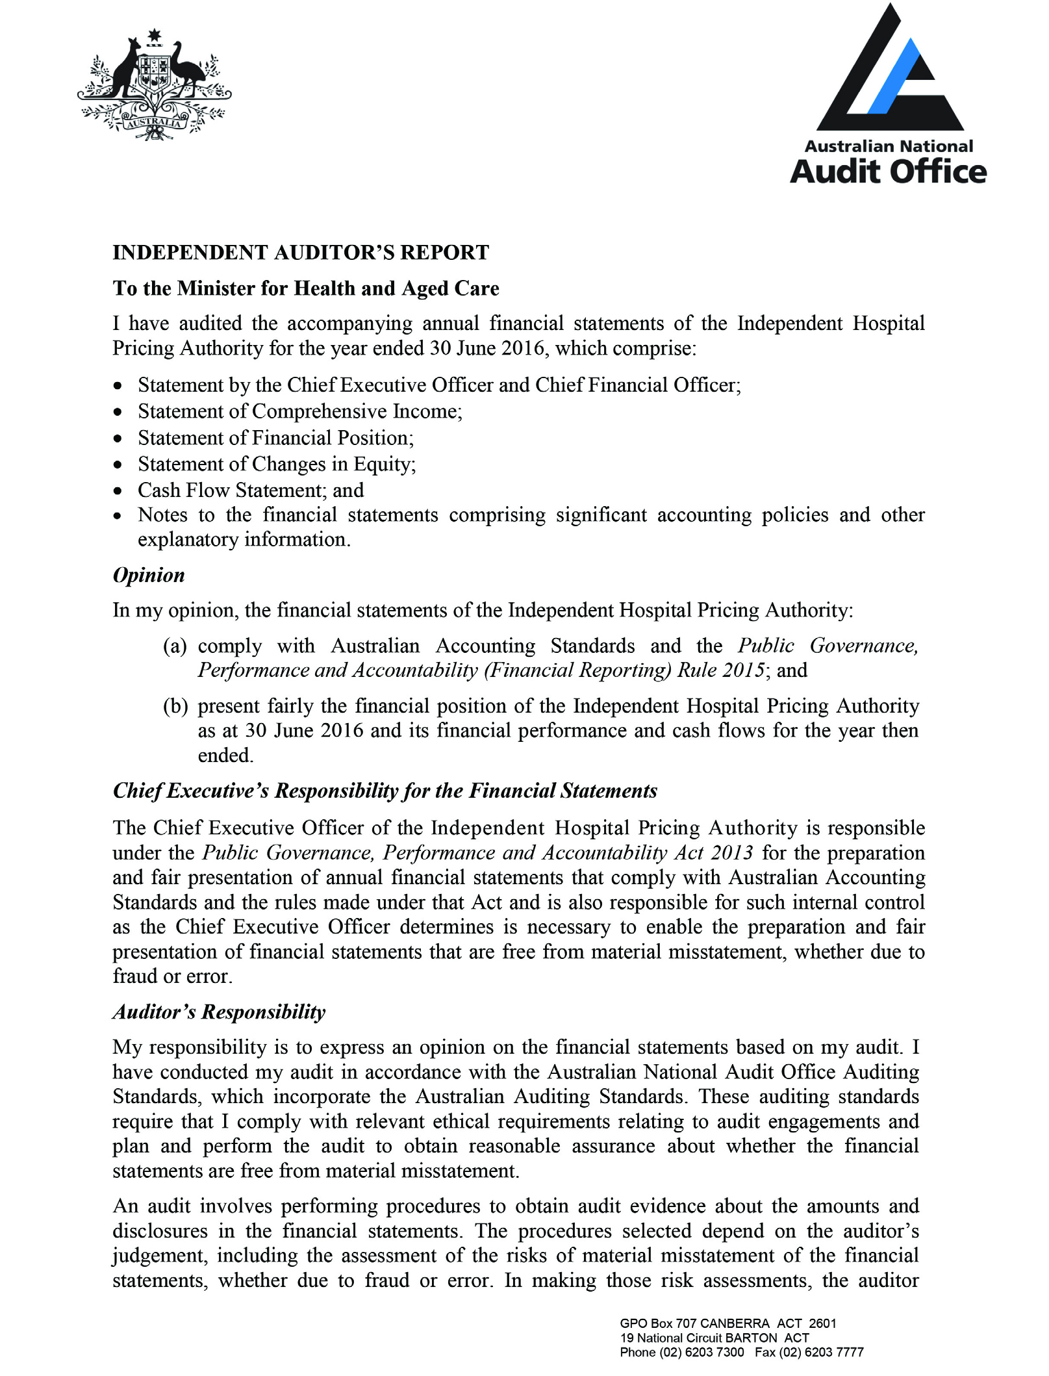
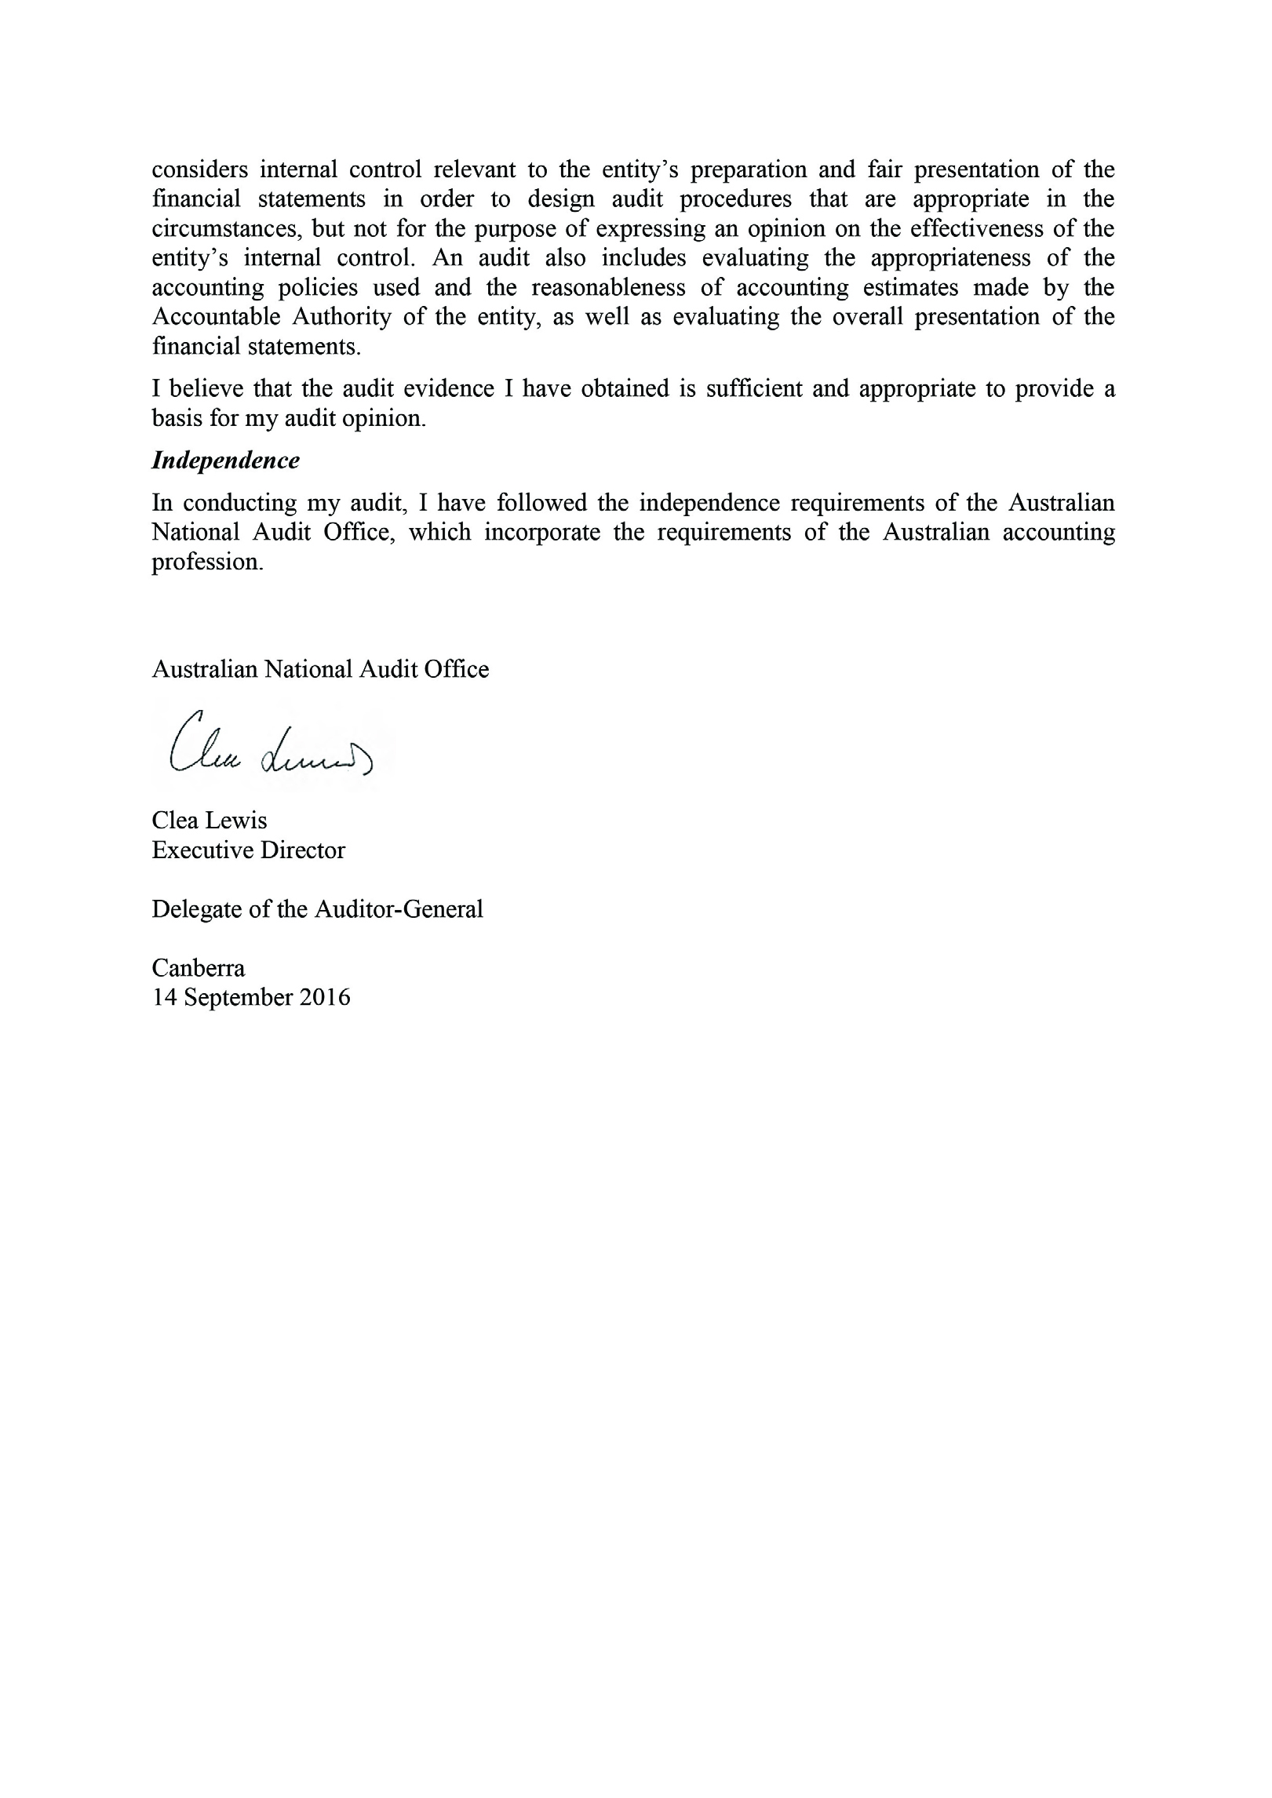

Financial Statements

Contents
Certification

Primary financial statement
Statement of Comprehensive Income
Statement of Financial Position
Statement of Changes in Equity
Cash Flow Statement
Overview

Notes to the financial statements:
1. Departmental Financial Performance
1.1 Expenses
1.2 Departmental Financial Position
2.1 Financial Assets
2.2 Non-Financial Assets
2.3 Payables
2.4 Other Provisions
3. Funding
3.1 Appropriations
3.2 Cash Flow Reconciliation
4. People and relationships
4.1 Employee Provisions
4.2 Senior Management Personnel Remuneration
5. Managing uncertainties
5.1 Contingent Assets and Liabilities
5.2 Financial Instruments
5.3 Fair Value Measurement
6. Other information
6.1 Reporting of Outcomes
Independent Hospital Pricing Authority Financial Statements 2015–16
For the year ended 30 June 2016

STATEMENT BY THE ACCOUNTABLE AUTHORITIES,
CHIEF EXECUTIVE AND CHIEF FINANCIAL OFFICER
In our opinion, the attached financial statements for the year ended 30 June 2016 comply with subsection 42(2) of the Public Governance, Performance and Accountability Act 2013 (PGPA Act), and are based on properly maintained financial records as per subsection 41(2) of the PGPA Act.
In our opinion, at the date of this statement, there are reasonable grounds to believe that
the Independent Hospital Pricing Authority will be able to pay its debts as and when they
fall due.
This statement is made in accordance with a resolution of the directors.

Signed
James Downie
Accountable Authority
Chief Financial Officer
14 September 2016
Signed
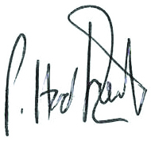
Peter Hadfield
Chief Executive Officer
14 September 2016

Statement of Comprehensive Income
for the period ended 30 June 2016
 |  | 2016 | 2015 |  | Original Budget
 | Notes | $'000 | $'000 |  | $'000
NET COST OF SERVICES
Expenses
Employee Benefits | 1.1A | 8,019 | 7,242 |  | 8,172
Suppliers | 1.1B | 14,367 | 16,423 |  | 17,004
Depreciation and amortisation | 2.2A | 671 | 567 |  | 752
Finance Costs | 1.1C | 3 | - |  | -
Write-Down and Impairment of Assets | 1.1D | - | 242 |  | -
Total expenses |  | 23,060 | 24,474 |  | 25,928
Own-Source Income
Own-source revenue
Sale of Goods and Rendering of Services | 1.2A | 867 | 2,364 |  | 245
Interest | 1.2B | 133 | 34 |  | -
Other Revenue | 1.2C | 105 | 38 |  | -
Total own-source revenue |  | 1,105 | 2,436 |  | 245
Gains
Other Gains | 1.2D | 58 | 58 |  | -
Total gains |  | 58 | 58 |  | -
Total own-source income |  | 1,163 | 2,494 |  | 245
Net (cost of)/contribution by services |  | (21,897) | (21,980) |  | (25,683)
Revenue from Government | 1.2E | 25,877 | 25,726 |  | 25,877
Surplus/(Deficit) after income tax on continuing operations |  | 3,980 | 3,746 |  | 194
Total other comprehensive income after income tax |  | 3,980 | 3,746 |  | 194

The above statement should be read in conjunction with the accompanying notes.
Budget Variances Commentary
Statement of Comprehensive Income
Supplier expenses of $14,367k were below budget by $2,637k, mainly due to IHPA taking advantage of more mature business processes that enabled a reduction in expenditure on consultants and external assurance work. Sale of goods and services of $867k were above budget by $622k due to higher than planned sales of classification support material $318k and sales of Australian Diagnosis Related Groups intellectual property to overseas sovereign clients $265k.
Statement of Financial Position
as at 30 June 2016
 |  | 2016 | 2015 |  | Original Budget
 | Notes | $’000 | $’000 |  | $’000
ASSETS
Financial assets
Cash and Cash Equivalents | 2.1A | 8,400 | 4,743 |  | 367
Trade and Other Receivables | 2.1B | 18,515 | 19,864 |  | 17,764
Total financial assets |  | 26,915 | 24,607 |  | 18,131
Non-financial assets
Buildings | 2.2A | 395 | 596 |  | 260
Plant and equipment | 2.2A | 360 | 348 |  | 231
Computer software | 2.2A | 184 | 180 |  | 212
Other intangibles | 2.2A | 172 | 230 |  | 150
Other Non-Financial Assets | 2.2B | 49 | 48 |  | 44
Total non-financial assets |  | 1,160 | 1,402 |  | 897
Total assets |  | 28,075 | 26,009 |  | 19,028
LIABILITIES
Payables
Suppliers | 2.3A | 1,931 | 3,892 |  | 2,261
Other Payables | 2.3B | 787 | 688 |  | 770
Total payables |  | 2,718 | 4,580 |  | 3,031
Provisions
Employee Provisions | 4.1 | 1,085 | 1,140 |  | 702
Other Provisions | 2.4 | 165 | 162 |  | 170
Total provisions |  | 1,250 | 1,302 |  | 872
Total liabilities |  | 3,968 | 5,882 |  | 3,903
Net assets |  | 24,107 | 20,127 |  | 15,125
EQUITY
Contributed equity |  | 400 | 400 |  | (3,251)
Reserves |  | 16 | 16 |  | 16
Retained surplus |  | 23,691 | 19,711 |  | 18,360
Total equity |  | 24,107 | 20,127 |  | 15,125

The above statement should be read in conjunction with the accompanying notes.
Budget Variances Commentary
Statement of Financial Position for not-for-profit Reporting Entities
Total financial assets of $26,915k were higher than budget by $8,784k mainly due to increased opening cash balance of $4,376k and 2015-16 surplus was over original budget
by $3,786k.
Total Non Financial Assets at $1,160k was $263k over budget mainly due to an investment in office equipment of $140k and an opening balance $171k over budget.
Total liabilities are in line with budget.
Equity of $24,107 is $8,982 above budget reflecting income statement surpluses in 2014–15 and 2015–16.
Statement of Changes in Equity
for the period ended 30 June 2016
 | 2016 | 2015 |  | Original Budget
Notes | $’000 | $’000 |  | $’000
CONTRIBUTED EQUITY
Opening balance
Balance carried forward from previous period | 400 | 400 |  | (3,251)
Adjusted opening balance | 400 | 400 |  | (3,251)
Closing balance as at 30 June | 400 | 400 |  | (3,251)
RETAINED EARNINGS
Opening balance
Balance carried forward from previous period | 19,711 | 19,102 |  | 18,166
Adjusted opening balance | 19,711 | 19,102 |  | 18,166
Comprehensive income
Surplus for the period | 3,980 | 3,746 |  | 194
Total comprehensive income | 3,980 | 3,746 |  | 194
Transfers between equity components | - | (3,137) |  | -
Closing balance as at 30 June | 23,691 | 19,711 |  | 18,360
ASSET REVALUATION RESERVE
Opening balance
Balance carried forward from previous period | 16 | 16 |  | 16
Adjusted opening balance | 16 | 16 |  | 16
Closing balance as at 30 June | 16 | 16 |  | 16
TOTAL EQUITY
Opening balance
Balance carried forward from previous period | 20,127 | 19,518 |  | 14,931
Adjusted opening balance | 20,127 | 19,518 |  | 14,931
Comprehensive income
Surplus for the period | 3,980 | 3,746 |  | 194
Total comprehensive income | 3,980 | 3,746 |  | 194
Transfers between equity components | - | (3,137) |  | -
Closing balance as at 30 June | 24,107 | 20,127 |  | 15,125
The above statement should be read in conjunction with the accompanying notes.
Accounting Policy
Equity Injections
Amounts appropriated which are designated as ‘equity injections’ for a year (less any formal reductions) and Departmental Capital Budgets (DCBs) are recognised directly in contributed equity in that year.
Budget Variances Commentary
Statement of Changes in Equity
Equity was higher than budget expectation due to the above budget income statement surplus in 2014–15 and 2015–16.
Cash Flow Statement
for the period ended 30 June 2016
 |  | 2016 | 2015 |  | Original Budget
 | Notes | $’000 | $’000 |  | $’000
OPERATING ACTIVITIES
Cash received
Appropriations |  | - | 23,641 |  | 25,771
Receipts from Government |  | 26,120 | - |  | -
Sale of goods and rendering of services |  | 1,994 | 1,316 |  | 150
Interest |  | 133 | 34 |  | -
Net GST received |  | 1,132 | 1,047 |  | 632
Other |  | 105 | 37 |  | -
Total cash received |  | 29,484 | 26,075 |  | 26,553
Cash used
Employees |  | 8,271 | 6,908 |  | 8,323
Suppliers |  | 17,020 | 14,186 |  | 17,268
Net GST paid |  | 105 | 53 |  | 545
Other |  | 1 | 3 |  | -
Total cash used |  | 25,397 | 21,150 |  | 26,136
Net cash from/(used by) operating activities | 3.2 | 4,087 | 4,925 |  | 417
INVESTING ACTIVITIES
Cash used
Purchase of property, plant and equipment |  | 199 | 174 |  | 418
Purchase of computer software |  | 231 | 594 |  | -
Total cash used |  | 430 | 768 |  | 418
Net cash from/(used by) investing activities |  | (430) | (768) |  | (418)
FINANCING ACTIVITIES
Cash received
Other |  | - | 273 |  | -
Total cash received |  | - | 273 |  | -
Net cash from/(used by) financing activities |  | - | 273 |  | -
Net increase/(decrease) in cash held |  | 3,657 | 4,430 |  | (1)
Cash and cash equivalents at the beginning of the reporting period |  | 4,743 | 313 |  | 368
Cash and cash equivalents at the end of the reporting period | 2.1A | 8,400 | 4,743 |  | 367

The above statement should be read in conjunction with the accompanying notes.
Budget Variances Commentary
Total cash received at $29,484k was $2,931 over budget, mainly due to revenue received from the sale of Intellectual property, printed materials, the 2016 Activity Based Funding conference and interest received arising from the higher than budgeted cash balances.
Cash used was broadly in line with plan.

Overview

Objectives of the Independent Hospital Pricing Authority
The Independent Hospital Pricing Authority (IHPA) is an Australian Government controlled entity. It is a not-for-profit entity.
IHPA's objective is to:
- Determine the National Efficient Price and National Efficient Cost for public hospital services;
- Develop national classifications for Activity Based Funding; and
- Resolve disputes on cost-shifting and cross-border issues.
IHPA is structured to meet the following outcome:
Outcome 1: Promote improved efficiency in, and access to, public hospital services primarily through setting efficient national prices and levels of block funding for hospital activities.
The continued existence of the entity in its present form and with its present programmes is dependent on Government policy and on continuing funding by Parliament for the entity's administration and programmes.

Basis of Preparation of the Financial Statements
The financial statements are general purpose financial statements and are required by section 42 of the Public Governance, Performance and Accountability Act 2013.
The financial statements have been prepared in accordance with:
- Public Governance, Performance and Accountability (Financial Reporting) Rule 2015 (FRR) for reporting periods ending on or after 1 July 2015; and
- Australian Accounting Standards and Interpretations issued by the Australian Accounting Standards Board (AASB) that apply for the reporting period.
The financial statements have been prepared on an accrual basis and in accordance with the historical cost convention, except for certain assets and liabilities at fair value. Except where stated, no allowance is made for the effect of changing prices on the results or the financial position. The financial statements are presented in Australian dollars and values
are rounded to the nearest thousand dollars unless otherwise specified.

New Accounting Standards
Adoption of New Australian Accounting Standard Requirements
No accounting standard has been adopted earlier than the application date as stated
in the standard.
No new standards, revised standards, amending standards or interpretations were issued prior to the signing of the statement by the accountable authority and chief financial officer, were applicable to the current reporting period and had a material impact on IHPA's
financial statements.
Future Australian Accounting Standard Requirements
New standards, revised standards and interpretations that were issued by the Australian Accounting Standards Board prior to the sign off date and are applicable to the future reporting period are not expected to have a material future impact on the Independent Hospital Pricing Authority.

Taxation
IHPA is exempt from all forms of taxation except Fringe Benefits Tax (FBT) and the Goods and Services Tax (GST).

Events After the Reporting Period
The operational functions of the Independent Hospital Pricing Authority will transfer to the Department of Health from 1 July 2016, with the Board, Chief Executive Officer and functions retained. The Pricing Authority staff salary and shared services will be received free of charge from Department of Health from 1 July 2016.
A Memorandum of Understanding (MoU) between IHPA and the Department of Health was executed in June 2016, implementing the Machinery of Government changes announced in MYEFO 2015–16. The MoU set out the authorities, resources and management responsibilities of the parties to be applied from 1 July 2016. The IHPA CEO retains responsibility as the Accountable Authority. All other staff employed by IHPA at 30 June 2016 were transferred to the Department of Health, with 40 operational staff seconded back to IHPA under the direct control of the IHPA CEO. IHPA’s budgets have been apportioned between the Department of Health and IHPA in accordance with the MoU.

Financial Performance
This section analyses the financial performance of Independent Hospital Pricing Authority for the year ended 2016.
1.1 Expenses
 | 2016 | 2015
 | $’000 | $’000
1.1A: Employee Benefits
Wages and salaries | 5,597 | 5,201
Superannuation
Defined contribution plans | 848 | 431
Defined benefit plans | 135 | 500
Leave and other entitlements | 1,176 | 1,110
Separation and redundancies | 263 | -
Total employee benefits | 8,019 | 7,242
Accounting Policy
Accounting policies for employee related expenses is contained in the People and relationships sections.
1.1B: Suppliers
Goods and services supplied or rendered
Consultants | 3,653 | 6,067
Contractors | 7,470 | 7,374
Recruitment and relocation cost | 169 | 104
Travel and training costs | 625 | 529
IT services | 813 | 622
Publishing materials | 203 | 300
Legal expenses and audit fees | 224 | 247
Other | 726 | 678
Total goods and services supplied or rendered | 13,883 | 15,921
Goods supplied | 926 | 1,107
Services rendered | 12,957 | 14,814
Total goods and services supplied or rendered | 13,883 | 15,921
Other suppliers
Operating lease rentals in connection with
Minimum lease payments | 452 | 434
Workers compensation expenses | 32 | 68
Total other suppliers | 484 | 502
Total suppliers | 14,367 | 16,423

Leasing commitments
IHPA in its capacity as lessee entered into a lease for office accommodation for the period up to 31 May 2018. The lease is subject to an annual cost increase and not able to be cancelled.
Lease incentives are recognised as liabilities and reduced on a straight line basis against rental expense over the term of the lease.
Where IHPA has a contractual obligation to undertake remedial work upon vacating a property the estimated cost is recognised as a liability.
Commitments for minimum lease payments in relation to non-cancellable  operating leases are payable as follows: | 2016  $’000 | 2015  $’000
Within 1 year | 643 | 628
Between 1 to 5 years | 605 | 1,231
More than 5 years | - | -
Total operating lease commitments | 1,248 | 1,859
Accounting Policy
Operating lease payments are expensed on a straight-line basis which is representative of the pattern of benefits derived from the leased assets.
1.1C: Finance Costs
Unwinding of discount | 3 | -
Total finance costs | 3 | -
1.1D: Write-Down and Impairment of Assets
Impairment on financial instruments | - | 242
Total write-down and impairment of assets | - | 242

1.2 Own-Source Revenue and gains
 | 2016 | 2015
 | $’000 | $’000
Own-Source Revenue
1.2A: Sale of Goods and Rendering of Services
Rendering of services | 867 | 2,364
Total sale of goods and rendering of services | 867 | 2,364

Accounting Policy
Revenue from the sale of goods is recognised when:
a. the risks and rewards of ownership have been transferred to the buyer;
b. the Pricing Authority retains no managerial involvement or effective control over the goods;
The stage of completion of contracts at the reporting date is determined by reference to the proportion that costs incurred to date bear to the estimated total costs of the transaction. Receivables for goods and services, which have 30 day terms, are recognised at the nominal amounts due less any impairment allowance account. Collectability of debts is reviewed at end of the reporting period. Allowances are made when collectability of the debt is no longer probable.
1.2B: Interest
Deposits | 133 | 34
Total interest | 133 | 34
Accounting Policy
Interest revenue is recognised using the effective interest method.
1.2C: Other Revenue
Cost recovery | 105 | 38
Total other revenue | 105 | 38
Accounting Policy
Resources Received Free of Charge
Resources received free of charge are recognised as revenue when, and only when, a fair value can be reliably determined and the services would have been purchased if they had not been donated. Use of those resources is recognised as an expense. Resources received free of charge are recorded as either revenue or gains depending on their nature.

Gains
 | 2016 | 2015
 | $’000 | $’000
Resources received free of charge | 58 | 58
Total other gains | 58 | 58
Accounting Policy
Resources Received Free of Charge
Contributions of assets at no cost of acquisition or for nominal consideration are recognised as gains at their fair value when the asset qualifies for recognition, unless received from another Government entity as a consequence.
1.2E: Revenue from Government
Appropriations
Departmental appropriations | - | 25,726
Department of Health
Corporate Commonwealth entity payment item | 25,877 | -
Total revenue from Government | 25,877 | 25,726
Accounting Policy
Resources Received Free of Charge
Amounts appropriated for departmental appropriations for the year (adjusted for any formal additions and reductions) are recognised as Revenue from Government when the entity gains control of the appropriation, except for certain amounts that relate to activities that are reciprocal in nature, in which case revenue is recognised only when it has been earned. Appropriations receivable are recognised at their nominal amounts. Funding received or receivable from non-corporate Commonwealth entities (appropriated to the non-corporate Commonwealth entity as a corporate Commonwealth entity payment item for payment to the Pricing Authority) is recognised as Revenue from Government by the Pricing Authority unless the funding is in the nature of an equity injection or a loan.

Financial Position
This section analyses the Independent Hospital Pricing Authority assets used to conduct its operations and the operating liabilities incurred as a result. Employee related information is disclosed in the People and Relationships section.
2.1 Financial Assets
 | 2016 | 2015
 | $’000 | $’000
2.1A: Cash and Cash Equivalents
Cash on hand or on deposit | 8,400 | 4,743
Total cash and cash equivalents | 8,400 | 4,743
Accounting Policy
Cash is recognised at its nominal amount. Cash and cash equivalents includes:
a. cash on hand; and
b. demand deposits in bank accounts with an original maturity of 3 months or less that
are readily convertible to known amounts of cash and subject to insignificant risk of changes in value.
2.1B: Trade and Other Receivables
Appropriations receivables
Appropriation receivable - Departmental Appropriations |  | 18,176 | 18,219
Appropriation receivable - Departmental Capital Budget |  | - | 200
Total appropriations receivables |  | 18,176 | 18,419
Other receivables
Receivable from Department of Health |  | - | 380
Receivable from other Federal Government agencies |  | - | 168
GST receivable from the Australian Taxation Office |  | 269 | 306
Other |  | 70 | 833
Total other receivables |  | 339 | 1,687
Total trade and other receivables (gross) |  | 18,515 | 20,106
Less impairment allowance |  | - | (242)
Total trade and other receivables (net) |  | 18,515 | 19,864
Trade and other receivables (net) expected to be recovered
No more than 12 months |  | 18,515 | 19,864
More than 12 months |  | - | -
Total trade and other receivables (net) |  | 18,515 | 19,864
Trade and other receivables (gross) aged as follows
Not overdue |  | 18,515 | 19,864
Overdue by
0 to 30 days |  | - | -
31 to 60 days |  | - | -
61 to 90 days |  | - | -
More than 90 days |  | - | -
Total trade and other receivables (net) |  | 18,515 | 19,864
 |  | 2016 |  | 2015
 |  | $’000 |  | $’000
Impairment allowance aged as follows
Not overdue |  | - |  | -
Overdue by
0 to 30 days |  | - |  | -
31 to 60 days |  | - |  | -
61 to 90 days |  | - |  | -
More than 90 days |  | - |  | 242
Total impairment allowance |  | - |  | 242
Credit terms for goods and services were within 30 days (2015: 30 days).

Accounting Policy
Loans and Receivables
Trade receivables, loans and other receivables that have fixed or determinable payments and that are not quoted in an active market are classified as 'loans and receivables'. Loans and receivables are measured at amortised cost using the effective interest method less impairment.
Receivables which have 30 day terms are recognised at the nominal amount due less any impairment allowance. Collectability of debts is reviewed as at the end of the reporting period. Allowances are made when collectability of the debt is no longer probable.
Reconciliation of the Impairment Allowance
Movements in relation to 2016
 | Goods and services | Other receivables | Total
 | $'000 | $'000 | $'000
As at 1 July 2015 | 242 | - | 242
Amounts recovered and reversed | (242) | - | (242)
Total as at 30 June 2016 | - | - | -
Movements in relation to 2015
 | Goods and  services | Other  receivables | Total
 | $'000 | $'000 | $'000
As at 1 July 2014 | - | - | -
Increase/(Decrease) recognised in net cost of services | 242 | - | 242
Total as at 30 June 2015 | 242 | - | 242
Accounting Policy
Financial assets are assessed for impairment at the end of each reporting period.

2.2 Non-Financial Assets
2.2A: Reconciliation of the Opening and Closing Balances of Property, Plant and Equipment and Intangibles
Reconciliation of the opening and closing balances of property, plant and equipment for 2016
 | Leasehold improvements | Plant and equipment | Computer Software | Other Intangibles | Total
 | $’000 | $’000 | $’000 | $’000 | $’000
As at 1 July 2015
Gross book value | 796 | 438 | 498 | 288 | 2,020
Accumulated depreciation, amortisation and impairment | (200) | (90) | (318) | (58) | (666)
Total as at 1 July 2015 | 596 | 348 | 180 | 230 | 1,354
Additions
Purchase | - | 199 | 231 | - | 430
Depreciation and amortisation | (201) | (185) | (227) | (58) | (671)
Disposals
Other | - | (2) | - | - | (2)
Total as at 30 June 2016 | 395 | 360 | 184 | 172 | 1,111
Total as at 30 June 2016 represented by
Gross book value | 796 | 637 | 729 | 288 | 2,450
Accumulated depreciation, amortisation and impairment | (401) | (277) | (545) | (116) | (1,339)
Total as at 30 June 2016 | 395 | 360 | 184 | 172 | 1,111
The carrying amount of computer software are purchased software.
No indicators of impairment were found for leasehold improvements, or property, plant and equipment or intangibles.
No leasehold improvements, or property, plant and equipment or intangibles are expected to be sold or disposed of within the next 12 months.
Revaluations of non-financial assets
All revaluations were conducted in accordance with the revaluation policy stated at Note 5.3A. On 30 June 2014, an independent valuer conducted the revaluations.

Reconciliation of the opening and closing balances of property, plant and equipment for 2015
 | Leasehold improvements | Plant and equipment | Computer Software | Other Intangibles | Total
 | $’000 | $’000 | $’000 | $’000 | $’000
As at 1 July 2014
Gross book value | 796 | 264 | 193 | - | 1,253
Accumulated depreciation, amortisation and impairment | - | - | (99) | - | (99)
Total as at 1 July 2014 | 796 | 264 | 94 | - | 1,154
Additions
Purchase | - | 174 | 305 | 288 | 767
Assets held for sale or in a disposal group held for sale | (200) | (90) | (219) | (58) | (567)
Total as at 30 June 2015 | 596 | 348 | 180 | 230 | 1,354
Total as at 30 June 2015 represented by
Gross book value | 796 | 438 | 498 | 288 | 2,020
Accumulated depreciation, amortisation and impairment | (200) | (90) | (318) | (58) | (666)
Total as at 30 June 2015 | 596 | 348 | 180 | 230 | 1,354

Accounting Policy
Assets are recorded at cost on acquisition except as stated below. The cost of acquisition includes the fair value of assets transferred in exchange and liabilities undertaken. Financial assets are initially measured at their fair value plus transaction costs where appropriate.
Asset Recognition Threshold
Purchases of property, plant and equipment are recognised initially at cost in the statement of financial position, except for purchases costing less than $2,000, which are expensed in the year of acquisition (other than where they form part of a group of similar items which are significant in total).
Revaluations
Following initial recognition at cost, property, plant and equipment are carried at fair value less subsequent accumulated depreciation and accumulated impairment losses. Valuations are conducted with sufficient frequency to ensure that the carrying amounts of assets did not differ materially from the assets’ fair values as at the reporting date. The regularity of independent valuations depended upon the volatility of movements in market values for the relevant assets.
Revaluation adjustments are made on a class basis. Any revaluation increment is credited to equity under the heading of asset revaluation reserve except to the extent that it reversed a previous revaluation decrement of the same asset class that was previously recognised in the surplus/deficit. Revaluation decrements for a class of assets are recognised directly in the surplus/deficit except to the extent that they reversed a previous revaluation increment for that class.
Any accumulated depreciation as at the revaluation date is eliminated against the gross carrying amount of the asset and the asset restated to the revalued amount.
Depreciation
Depreciable property, plant and equipment assets are written-off to their estimated residual values over their estimated useful lives to the entity using, in all cases, the straight-line method of depreciation.
Depreciation rates (useful lives), residual values and methods are reviewed at each reporting date and necessary adjustments are recognised in the current, or current and future reporting periods, as appropriate.
Depreciation rates applying to each class of depreciable asset are based on the following useful lives:
 | 2016 | 2015
Leasehold improvements | Lease terms | Lease terms
Plant and equipment | 3 to 6 years | 3 to 6 years
Impairment
All assets were assessed for impairment at 30 June 2016. Where indications of impairment exist, the asset’s recoverable amount is estimated and an impairment adjustment made if the asset’s recoverable amount is less than its carrying amount.
The recoverable amount of an asset is the higher of its fair value less costs of disposal and its value in use. Value in use is the present value of the future cash flows expected to be derived from the asset. Where the future economic benefit of an asset is not primarily dependent on the asset’s ability to generate future cash flows, and the asset would be replaced if the entity were deprived of the asset, its value in use is taken to be its depreciated replacement cost.
Derecognition
An item of property, plant and equipment is derecognised upon disposal or when no further future economic benefits are expected from its use or disposal.
Intangibles
The entity's intangibles comprise internally developed software for internal use. These assets are carried at cost less accumulated amortisation and accumulated impairment losses.
Software is amortised on a straight-line basis over its anticipated useful life. The useful lives of the entity's software are 1 to 3 years (2015: 1 to 3 years).
All software assets were assessed for indications of impairment as at 30 June 2016.

 | 2016 | 2015
 | $’000 | $’000
2.2B: Other Non-Financial Assets
Prepayments | 49 | 48
Total other non-financial assets | 49 | 48
Other non-financial assets expected to be recovered
No more than 12 months | 49 | 48
More than 12 months | - | -
Total other non-financial assets | 49 | 48
No indicators of impairment were found for other non-financial assets.

2.3 Payables
 | 2016 | 2015
 | $’000 | $’000
2.3A: Suppliers
Trade creditors and accruals | 1,931 | 3,892
Total suppliers | 1,931 | 3,892
Suppliers expected to be settled
No more than 12 months | 1,931 | 3,892
More than 12 months | - | -
Total suppliers | 1,931 | 3,892
2.3B: Other Payables
Payable to Department of Health | 536 | 119
Salaries and wages | 24 | 191
Superannuation | 4 | 32
Lease incentive | 209 | 319
GST payable | - | 11
FBT payable | 3 | -
Other - credit card | 11 | 16
Total other payables | 787 | 688
Other payables to be settled
No more than 12 months | 678 | 479
More than 12 months | 109 | 209
Total other payables | 787 | 688

2.4 Other Provisions
 |  | Provision for restoration | Total
 |  | $’000 | $’000
As at 1 July 2015 |  | 162 | 162
Unwinding of discount or change in discount rate |  | 3 | 3
Total as at 30 June 2016 |  | 165 | 165
 |  | 2016 | 2015
 |  | $’000 | $’000
Other provisions expected to be settled
No more than 12 months |  | - | -
More than 12 months |  | 165 | 162
Total other provisions |  | 165 | 162

IHPA currently has one (2015: one) agreement for the leasing of premises which have provisions requiring IHPA to restore the premises to their original condition at the conclusion of the lease. IHPA has made a provision to reflect the present value of this obligation.

Funding
This section identifies IHPA’s funding structure.
3.1A Appropriations
3.1A: Annual Appropriations
(‘Recoverable GST exclusive’)
Annual Appropriations for 2016
As a Commonwealth Corporate Entity, IHPA did not receive an appropriation
during 2016
Annual Appropriations for 2015
 |  | Appropriation Act |  | PGPA Act
 | Annual Appropriation | Advance to the Finance Minister |  | Section 74 Receipts | Section 75 Transfers
 | $’000 | $’000 |  | $’000 | $’000
Departmental
Ordinary annual services | 25,726 | - |  | - | -
Capital Budget | - | - |  | - | -
Other services
Equity Injections | - | - |  | - | -
Total departmental | 25,726 | - |  | - | -
 | Total Appropriation | Appropriation applied in 2015 (current and prior years) | Variance
 | $’000 | $’000 | $’000
Departmental
Ordinary annual services | 25,726 | 23,641 | 2,085
Capital Budget | - | - | -
Other services
Equity Injections | - | - | -
Total departmental | 25,726 | 23,641 | 2,085

3.1B: Unspent Annual Appropriations ('Recoverable GST exclusive')
 | 2016 | 2015
 | $’000 | $’000
Departmental  Appropriation Act (No. 1) 2012-13 | - | 6
Appropriation Act (No. 1) 2013-14 | - | 37
Appropriation Act (No. 1) 2013-14-DCB | - | 200
Appropriation Act (No. 1) 2014-15 | 26,575 | 22,915
Total departmental | 26,575 | 23,158
3.1C: Special Appropriations ('Recoverable GST exclusive')
There are no special appropriations applied to IHPA during financial years 2015 and 2016.
3.1D: Disclosures by Agent in Relation to Annual and Special Appropriations ('Recoverable GST exclusive')
There are no special appropriations applied to IHPA during financial years 2015 and 2016.

3.2 Cash Flow Reconciliation
 | 2016 | 2015
 | $’000 | $’000
Reconciliation of cash and cash equivalents as per statement of financial position and cash flow statement
Cash and cash equivalents as per
Cash flow statement | 8,400 | 4,743
Statement of financial position | 8,400 | 4,743
Discrepancy | - | -
Reconciliation of net cost of services to net cash from/ (used by) operating activities
Net (cost of)/contribution by services | (21,897) | (21,980)
Revenue from Government | 25,877 | 25,726
Adjustments for non-cash items
Depreciation/amortisation | 671 | 567
Net write down of non-financial assets | 1 | 242
Movement in assets and liabilities
Assets
(Increase)/Decrease in net receivables | 1,349 | (3,390)
(Increase)/Decrease in prepayments | (1) | (4)
Liabilities
Increase/(Decrease) in employee provisions | (55) | 291
Increase/(Decrease) in supplier’s payables | (1,960) | 3,516
Increase/(Decrease) in other payables | 99 | (43)
Increase/(Decrease) in other provisions | 3 | -
Net cash from/ (used by) operating activities | 4,087 | 4,925

People and relationships
This section describes a range of employment and post-employment benefits provided to our people and our relationships with other key people.
4.1 Employee Provisions
 | 2016 | 2015
 | $’000 | $’000
Leave | 1,085 | 1,140
Total employee provisions | 1,085 | 1,140
Employee provisions expected to be settled
No more than 12 months | 318 | 436
More than 12 months | 767 | 704
Total employee provisions | 1,085 | 1,140

Accounting Policy
Liabilities for ‘short-term employee benefits and termination benefits expected within twelve months of the end of reporting period are measured at their nominal amounts.
Other long-term employee benefits are measured as net total of the present value of the defined benefit obligation at the end of the reporting period minus the fair value at the end of the reporting period of plan assets (if any) out of which the obligations are to be settled directly.
Leave
The liability for employee benefits includes provision for annual leave and long service leave. The leave liabilities are calculated on the basis of employees’ remuneration at the estimated salary rates that will be applied at the time the leave is taken, including the entity’s employer superannuation contribution rates to the extent that the leave is likely to be taken during service rather than paid out on termination.The liability for long service leave has been determined by reference to the work of an actuary as at 30 June 2016. The estimate of the present value of the liability takes into account attrition rates and pay increases through promotion and inflation.
Separation and Redundancy
Provision is made for separation and redundancy benefit payments. The entity recognises a provision for termination when it has developed a detailed formal plan for the terminations and has informed those employees affected that it will carry out the terminations.
Superannuation
The entity's staff are members of the Commonwealth Superannuation Scheme (CSS), the Public Sector Superannuation Scheme (PSS), or the PSS accumulation plan (PSSap), or other superannuation funds held outside the Australian Government.

The CSS and PSS are defined benefit schemes for the Australian Government. The PSSap is a defined contribution scheme.
The liability for defined benefits is recognised in the financial statements of the Australian Government and is settled by the Australian Government in due course. This liability is reported in the Department of Finance’s administered schedules and notes.
The entity makes employer contributions to the employees' defined benefit superannuation scheme at rates determined by an actuary to be sufficient to meet the current cost to the Government. The entity accounts for the contributions as if they were contributions to defined contribution plans. The liability for superannuation recognised as at 30 June represents outstanding contributions.

4.2 Senior Management Personnel Remuneration
 | 2016 | 2015
 | $ | $
Short-term employee benefits
Salary | 426,914 | 471,930
Motor vehicle and other allowances | 112,952 | 117,353
Total short-term employee benefits | 539,866 | 589,283
Post-employment benefits
Superannuation | 75,699 | 82,058
Total post-employment benefits | 75,699 | 82,058
Other long-term employee benefits
Annual leave | 46,620 | 54,303
Long-service leave | 40,647 | 18,503
Total other long-term employee benefits | 87,267 | 72,806
Total senior executive remuneration expenses | 702,832 | 744,147
The total number of senior management personnel that are included in the above table is two (2015: two).

Managing uncertainties
This section analyses how IHPA manages financial risks within its operating environment.
5.1 Contingent Assets and Liabilities
Quantifiable Contingencies
There were no quantifiable contingent assets or liabilities in this reporting period (2015: nil)
Unquantifiable Contingencies
There were no unquantifiable contingent assets or liabilities in this reporting period (2015: nil)
Significant Remote Contingencies
There were no significant remote contingent assets or liabilities in this reporting period (2015: nil).

Accounting Policy
Contingent liabilities and contingent assets are not recognised in the statement of financial position but are reported in the notes. They may arise from uncertainty as to the existence
of a liability or asset or represent an asset or liability in respect of which the amount cannot be reliably measured. Contingent assets are disclosed when settlement is probable but not virtually certain and contingent liabilities are disclosed when settlement is greater
than remote.
5.2 Financial Instruments

 | 2016 | 2015
 | $’000 | $’000
5.2A: Categories of Financial Instruments
Cash and cash equivalents | 8,400 | 4,743
Receivable from the Department of Health | - | 380
Receivable from other Federal Government agencies | - | 168
Trade and other receivables | 70 | 590
Total financial assets | 8,470 | 5,881
Financial Liabilities
Financial liabilities measured at amortised cost
Trade creditors and accruals | 1,931 | 3,892
Payable to the Department of Health | 536 | 119
Other payables - credit card | 11 | 16
Total financial liabilities measured at amortised cost | 2,478 | 4,027
Total financial liabilities | 2,478 | 4,027

Accounting Policy
Financial assets
IHPA classifies its financial assets in the following categories:
a) cash;
b) held to maturity assets (term deposits); and
c) receivables.
The classification depends on the nature and purpose of the financial assets and is determined at the time of initial recognition. Financial assets are recognised and derecognised upon 'trade date'.
Impairment of Financial Assets
Financial assets are assessed for impairment at the end of each reporting period.
Financial liabilities
Financial liabilities are classified as either financial liabilities ‘at fair value through profit or loss’ or other financial liabilities. Financial liabilities are recognised and derecognised upon ‘trade date’.
5.2B: Fair Value of Financial Instruments
Financial assets
The fair values of all monetary financial assets approximate their carrying amounts.
Financial liabilities
The fair values of all monetary financial liabilities approximate their carrying amounts. All financial liabilities are current; therefore, a maturity analysis is not required.

5.2C: Credit Risk
IHPA was exposed to minimal credit risk as financial assets cash and trade and other receivables. The maximum exposure to credit risk was the risk that arises from potential default of a debtor. This amount was equal to the total amount of trade and other receivables (2016: $339,048 and 2015: $1,687,184). At 30 June 2016 IHPA had no significant exposures to any concentrations of credit risk.
Credit quality of financial assets not past due or individually determined as impaired
 | Not past due nor impaired | Not past due nor impaired | Past due or impaired | Past due or impaired
 | 2016 | 2015 | 2016 | 2015
 | $’000 | $’000 | $’000 | $’000
Cash | 8,400 | 4,743 | - | -
Related Entity | - | 548 | - | -
Other receivables | 70 | 590 | - | 242
Total | 8,470 | 5,881 | - | 242

5.2 Financial Instruments
5.2D: Liquidity Risk
Liquidity risk is the risk that IHPA will not be able to meet its obligations as they fall due.
IHPA financial liabilities were trade creditors and other payables. IHPA's exposure to liquidity risk is limited due to its funding arrangements and mechanisms available to the entity. IHPA has internal policies and procedures in place to ensure there were appropriate resources available to meet its financial obligations.
Maturities for non-derivative financial liabilities in 2016
 | On demand | Within 1 year | Between 1 to 2 years | Between 2 to 5 years | More than 5 years | Total
 | $’000 | $’000 | $’000 | $’000 | $’000 | $’000
Trade creditors and accruals | - | 1,931 | - | - | - | 1,931
Other payables | - | 547 | - | - | - | 547
Total | - | 2,478 | - | - | - | 2,478
Maturities for non-derivative financial liabilities in 2015
 | On demand | Within 1 year | Between 1 to 2 years | Between 2 to 5 years | More than 5 years | Total
 | $’000 | $’000 | $’000 | $’000 | $’000 | $’000
Trade creditors and accruals | - | 3,892 | - | - | - | 3,892
Other payables | - | 135 | - | - | - | 135
Total | - | 4,027 | - | - | - | 4,027

5.3 Fair Value Measurement
The following tables provide an analysis of assets and liabilities that are measured at fair value. The remaining assets and liabilities disclosed in the statement of financial position do not apply the fair value hierarchy.
The different levels of the fair value hierarchy are defined below.
Level 1: Quoted prices (unadjusted) in active markets for identical assets or liabilities that the entity can access at measurement date.
Level 2: Inputs other than quoted prices included within Level 1 that are observable for the asset or liability, either directly or indirectly.
Level 3: Unobservable inputs for the asset or liability.
Accounting Policy
IHPA undertook a comprehensive valuation of all its non-financial assets at 30 June 2014. IHPA tests the procedures of the valuation model as an internal management review at least once every 12 months (with a formal revaluation undertaken once every three years). If a particular asset class experiences significant and volatile changes in fair value (i.e. where indicators suggest that the value of the class has changed materially since the previous reporting period), that class is subject to specific valuation in the reporting period, where practicable, regardless of the timing of the last specific valuation. IHPA has engaged Australian Valuation Solutions (AVS) to provided written assurance that the models developed comply with AASB 13.
5.3A: Fair Value Measurement
Fair value measurements at the end of the reporting period
 | 2016 | 2015 | Category (Level 1, 2 or 3)  3,4,5 | Valuation Technique(s) and Inputs Used2
 | $'000 | $'000
Non-financial assets 1 |  |  |  | Valuation technique is depreciated replacement costs. Inputs used are replacement cost new (price per square metre) and consumed economic benefit/obsolescence of asset. The weighted average range is 16.76% per annum.  Valuation technique is market approach and inputs used are adjusted market transactions.
Leasehold improvements | 395 | 596 | 3
Property, plant and equipment | 360 | 348 | 2
1. IHPA did not remeasure non-financial assets at fair value on a non-recurring basis at 30 June 2016.
2. No change in valuation technique occurred during the period.
3. Fair value measurements - highest and best use differs from current use for non-financial assets (NFAs)
IHPAs assets are held for operational purposes and not held for the purposes of deriving a profit. The current use of all controlled assets is considered their highest and best use. This is consistent with the treatment in 2015.
4. There have been no transfers between levels of the hierarchy during the year.
5. The remaining assets and liabilities reported by IHPA are not measured at fair value in the Statement of Financial Position.
5.3B: Reconciliation for Recurring Level 3 Fair Value Measurements
Non-financial assets
Leasehold improvements
 | 2016 | 2015
 | $'000 | $'000
As at 1 July | 596 | 796
Total gains/(losses) recognised in net cost of services1 | (201) | (200)
Total as at 30 June | 395 | 596
1. These gains/(losses) are presented in the Statement of Comprehensive Income under depreciation expense.

6.1 Reporting of Outcomes
Outcome 1
 | 2016 | 2015
 | $’000 | $’000
Expenses
Expenses | 23,060 | 24,474
Total expenses | 23,060 | 24,474
Own-source income
Own-source income | 1,163 | 2,494
Total own-source income | 1,163 | 2,494
Net cost/(contribution) of outcome delivery | 21,897 | 21,980
In accordance with the Commonwealth Entities Financial Statements Guide, disclosure of Major Classes of Department and Administered Expenses, Income, Assets and Liabilities by Outcome are not required as IHPA has only one outcome as described in the Overview.

/ Appendices

APPENDIX A: IHPA PUBLICATIONS
Section 210 of the National Health Reform Act 2011 requires IHPA to publish details of reports setting out the national efficient price for the coming year and any other information that would support the efficient funding of public hospitals. Unless indicated, all such publications are available on the IHPA website at www.ihpa.gov.au/publications.
- Pricing Framework for Australian Public Hospital Services 2016–17
- NEP Determination 2016–17
- NEC Determination 2016–17
- Teaching, Training and Research Costing Study (Report currently with Health Ministers, ahead of public release)
- Tier 2 Non-Admitted Services Compendium 2016–17
- ABF Mental Health Care Data Set Specifications 2016–17
- Cost-Shifting and Cross-Border and Dispute Resolution Framework
- Annual review of the General List of In-Scope Public Hospital Services
- Three Year Data Plan

APPENDIX B: FIGURES & TABLES
Figure 1: IHPA’s organisational structure at 30 June 2016 p 08
Figure 2: IHPA’s management, committees and working groups p 11
Figure 3: Cost per National Weighted Activity Unit (NWAU) p 15
Figure 4: Decreasing National Efficient Price p 16
Table 1: Pricing Authority meetings and attendances 2015–16 p 20
Table 2: Membership and meetings of the CAC in 2015–16 p 28
Table 3: Staff numbers by classification, gender and full-time/part-time status at 30 June 2016 p 37
Table 4: Proportion of funding for public services using ABF p 43
Table 5: Response rate to enquiries p 45

APPENDIX C: ACRONYMS
& ABBREVIATIONS

ABF | Activity Based Funding
AM | Member of the Order of Australia
AMHCC | Australian Mental Health Care Classification
ANAO | Australian National Audit Office
ARC Committee | IHPA Audit, Risk and Compliance Committee
AR-DRG | Australian Refined Diagnosis Related Groups
CAC | Clinical Advisory Committee
COAG | Council of Australian Governments
JAC | Jurisdictional Advisory Committee
JWP | Joint Working Party
IHPA | Independent Hospital Pricing Authority
MoG | Machinery of Government
MoU | Memorandum of Understanding
NBPD | National Benchmarking Portal Development
NEC | National Efficient Cost
NEP | National Efficient Price
NHCDC | National Hospital Cost Data Collection
NHR Act | National Health Reform Act 2011
NWAU | National Weighted Activity Unit
OAM | Medal of the Order of Australia
PBS | Portfolio Budget Statements
PGPA Act | Public Governance, Performance and Accountability Act 2013
WHS | Work Health and Safety

APPENDIX D: GLOSSARY

ACTIVITY BASED FUNDING (ABF)
A system for funding public hospital services based on the actual number of services provided to patients and the efficient cost of delivering those services. Activity based funding uses national classifications, cost weights and nationally efficient prices to determine the amount of funding for each activity or service.

AUSTRALIAN REFINED DIAGNOSIS RELATED GROUPS (AR-DRGs)
AR-DRGs is an Australian admitted patient classification system which provides a clinically meaningful way of relating a hospital’s casemix to the resources required by the hospital. Each AR-DRG represents a class of patients with similar clinical conditions requiring similar hospital services. The classification categorises acute admitted patient episodes of care into groups with similar conditions and similar usage of hospital resources, using information in the hospital morbidity record such as the diagnoses, procedures and demographic characteristics of the patient.

BACKCASTING
The process by which the effect of significant changes to the ABF classification systems
or costing methodologies are reflected in the pricing model the year prior to implementation, for the purpose of the calculation of Commonwealth funding for each ABF service category.

BLOCK FUNDING
A system of funding public hospital functions and services as a fixed amount based on population and previous funding.

CASEMIX
The number and type of patients treated in a hospital.

COUNCIL OF AUSTRALIAN GOVERNMENTS (COAG)
The Council of Australian Governments (COAG) is the peak intergovernmental forum in Australia. The members include the Prime Minister, state and territory Premiers and Chief Ministers and the President of the Australian Local Government Association (ALGA).
The role of COAG is to promote policy reforms that are of national significance, or which need co-ordinated action by all Australian governments.

CORPORATE PLAN
The primary strategic planning document of a Commonwealth entity, setting out the objectives, capabilities and intended results over a four-year period, in accordance with its stated purposes. The corporate plan should provide a clear line of sight with the relevant annual performance statement, portfolio budget statement and annual report.

MACHINERY OF GOVERNMENT (MoG)
A Machinery of Government change occurs when the Government decides to change the way Commonwealth responsibilities are managed. It can involve the movement of functions, resources and people from one agency to another.

MID-YEAR ECONOMIC AND FISCAL OUTLOOK (MYEFO)
The Mid-Year Economic and Fiscal Outlook updates the economic and fiscal outlook from the previous budget and also updates the budgetary position. In particular, the MYEFO takes account of all decisions made since the release of the budget which affect expenses and revenue and hence revises the budget aggregates.

NATIONAL EFFICIENT COST (NEC)
IHPA determines a National Efficient Cost (NEC) for services that are not suitable for activity based funding, such as small rural hospitals. The NEC determines the Commonwealth Government contribution to block funded hospitals.

NATIONAL EFFICIENT PRICE (NEP)
A base price calculated by IHPA as a benchmark to guide governments about the level of funding which would meet the average cost of providing acute care (admitted, emergency and outpatient) services in public hospitals across Australia. The national efficient price is based on the projected average cost of a National Weighted Activity Unit (NWAU) after the deduction of specified Commonwealth funded programs.

NATIONAL HEALTH REFORM ACT 2011 (NHR ACT)
IHPA was established under NHR Act. The NHR Act gave effect to the National Health Reform Agreement signed by the Australian Government and all states and territories in August 2011.

NATIONAL HEALTH REFORM AGREEMENT
The Agreement outlines the funding, governance, and performance arrangements for the delivery of public hospital services in Australia. The Agreement was entered into by all states, territories and the Australian Government in August 2011.

NATIONAL WEIGHTED ACTIVITY UNIT (NWAU)
An NWAU is a measure of health service activity expressed as a common unit, against which the National Efficient Price is paid. It provides a way of comparing and valuing each public hospital service (whether it is an admission, emergency department presentations or outpatient episode), by weighting it for its clinical complexity.
The average hospital service is worth one NWAU — the most intensive and expensive activities are worth multiple NWAUs, the simplest and least expensive are worth fractions
of an NWAU.

PROTECTIVE SECURITY POLICY FRAMEWORK (PSPF)
The PSPF provides policy, guidance and better practice advice for governance, personnel, physical and information security. The 36 mandatory requirements assist agency heads to identify their responsibilities to manage security risks to their people, information and assets.

PUBLIC GOVERNANCE, PERFORMANCE AND ACCOUNTABILITY ACT 2013 (PGPA ACT)
The PGPA Act establishes a coherent system of governance and accountability for public resources, with an emphasis on planning, performance and reporting. The PGPA Act applies to all Commonwealth entities and Commonwealth companies.

WORK PROGRAM
Each year IPHA consults on and publishes a Work Program for the year ahead. As prescribed in s 225 of the National Health Reform Act 2011, the objectives of the IHPA Work Program are to: set out IHPA’s work program for the coming year; and invite interested persons (including states and territories) to make submissions to the Pricing Authority about the work program up to 30 days after publication. IHPA Work Programs are available at www.ihpa.gov.au/publications.

APPENDIX E: COMPLIANCE INDEX
The Independent Hospital Pricing Authority, as a corporate Commonwealth entity, has prepared this annual report in accordance with Section 17BA of the Public Governance, Performance and Accountability Rule 2014, and section 46 of the Public Governance, Performance and Accountability Act 2013.
REQUIREMENT | LOCATION
Approval by the accountable authority | 4
Enabling legislation | 6
Responsible Minister | 6
Ministerial directions and government policy orders | N/A
Annual Performance Statements | 39
Significant non-compliance with finance law | N/A
Information about the Accountable Authority | 9
Organisational structure and location | 8–9
Statement on governance | 34–36
Related entity transactions | N/A
Significant activities and changes affecting the entity | 33
Judicial decisions and reviews by outside bodies | N/A
Obtaining information from subsidiaries | N/A
Indemnities and insurance premiums | N/A
Financial statements | 48
Index of annual report requirements | 87

Other Legislation
LEGISLATION | LOCATION81
National Health Reform Act 2011, s210 | 81
Work Health and Safety Act 2011, Schedule 2, Part 4 | 38
Commonwealth Electoral Act 1918, s311A | 36
Environmental Protection and Biodiversity Conservation Act 1999, s 516A | 36

Index

A
ABF benchmarking portal, 31
ABF classification development and pricing products, 34
ABF data submissions, 44
ABF Evaluation Steering Committee, 10
ABF Mental Health Care Data Set Specifications 2016–17, 24
ABF Project Status Report (fortnightly), 47 ABF Technical Advisory Committee, 11 Accountable Authority, 9, 20, 33, 34, 35, 40 and educational and review processes, 38
activity 1: perform IHPA pricing functions, 40–1
activity 2: develop national classifications for activity based funding, 41–3
activity 3: determine data requirements and data standards, 43–4
activity 4: resolve disputes on cost-shifting and cross-border issues, 44
activity 5: independent and transparent decision-making and engagement with shareholders, 44–5 activity 6: manage the business effectively and develop staff, 46
Activity Based Funding (ABF), 6, 7, 14, 23, 47and benchmarking, 22
see also ABF benchmarking portal
Brisbane conference, 23, 24, 45 national classifications for, 07, 41–3 admitted acute care, 31
classification system for, 41 pricing of, 47
admitted subacute and non-acute hospital care pricing of, 47
advertising and market research, 36
age adjustment for emergency care, 22
annual national conference, 45
annual performance statements, 39–47 introductory statement, 46
IHPA purpose, 46
Results, 40
Analysis, 47
Appleyard, Glenn, 18
assurance processes see control and assurance processes
Audit Risk and Compliance (ARC)
Committee, 11, 35
membership, 35
audits, 34, 35, 49
Australian Commission on Safety and Quality in Health Care, 14, 26, 31, 36
Australian Mental Health Care Classification (AMHCC), 22, 42
consultation, 24, 42
V2.0, 41, 42
Australian National Audit Office (ANAO) report, 46, 49
Australian National Subacute and Non-acute Patient (AN-SNAP) classification
V4.0, 47
Australian Non-Admitted Care Classification (ANACC), 42
Australian Refined Diagnosis Related Groups (AR-DRG), 82
V8.0, 47
V9.0, 41, 42
Australian Signals Directorate, 35

B
Backcasting 16, 82
policy, 24
Bansemer, Alan, 19
benchmarking portal see ABF benchmarking portal; National Benchmarking Portal
Birch, AM, Jim, 18
see also Deputy Chair of Pricing Authority
bundled pricing across care settings, 26, 31
Bundled Pricing Advisory Group, 10, 11
business management see activity 6: manage the business effectively and develop staff

C
Chair of Clinical Advisory Committee, 27, 28 report from, 26
Chair of Pricing Authority, 9, 17, 18 report from, 14
Chater, OAM, Associate Professor Bruce, 19
Chief Executive Officer, 9, 20, 33, 38, 40
and Audit Risk and Compliance (ARC) Committee, 35
report from, 22–3
and staff training, 37
classification, 7, 26, 31, 41, 43, 47
see also ABF classification development and pricing products; activity 2: develop national classifications for activity based funding
Clinical Advisory Committee (CAC), 9, 10, 11, 12
Annual Report, 25–31
functions, 26, 27
meetings, 30
membership, 27, 28–30
snapshot, 31
committees and working groups, 10–12, 44, 45
and input from stakeholders, 44
see also statutory committees Commonwealth Electoral Act 1918, 36
Commonwealth Procurement rules, 35
compliance, 34–5
consultation framework, 44
consultation processes, 45, 47
control and assurance processes, 33, 34
corporate governance, 34–6, 41–46
costing, 7
see also National Efficient Cost (NEC); public hospital services, cost of
cost-shifting see activity 4: resolve disputes on cost-shifting and cross-border issues
Cost-Shifting and Cross-Border and Dispute Resolution Framework, 24, 44
Council of Australian Governments (COAG) Heads of Agreement, 14, 23, 47
cross-border issues see activity 4: resolve disputes on cost-shifting and cross-border issues
Crowe Horwath, 35

D
data assessment and compliance see internal data assessment and compliance
data collection, 7
Data Compliance Policy, 44 data quality/accuracy, 43
data request specification, 44
data set specification, 44
data requirements and standards compliance with, 43
see also activity 3: determine data requirements and data standards
data submission, 44
decision-making, 34
see activity 5: independent and transparent decision-making and engagement with shareholders
Department of Health and IHPA, 6, 33, 34, 36, 37, 47
Deputy Chair of Pricing Authority, 9, 17, 18
Development of the Australian Mental Health Care Classification — Public Consultation Paper 2, 45
Downie, James, 9, 20, 22–3, 40 see also Chief Executive Officer

E
ecologically sustainable development and environmental performance, 36
emergency care
classification system for, 41, 42
Emergency Care Advisory Working Group, 10, 11
Emergency Care Costing Study
Discussion Paper, 45
Project Management Survey, 45
emergency care services classification system, 26, 31
Emergency Department International Classification of Diseases 10th Revision Australian Modification (ICD-10-AM) Principal Diagnosis Short List
consultation paper on, 45
emergency department presentations, 7
enquiries see inbox enquiries; response rate to enquiries
enterprise risk management framework, 34
Environment Protection and Biodiversity Conservation Act 1999, 36
Executive Committee, 11
and Audit Risk and Compliance (ARC) Committee, 35

F
financial authorisation, 35
financial management, 48–77
financial statements, 51–78 fraud control plan, 35

G
General List of In-Scope Public Hospital Services annual review of, 24
Geriatric Evaluation and Management (GEM) care, 42
Gough, Professor Ian, 26
governance and risk management systems and controls, 46

H
Hall, Professor Jane, 19 hip fracture care
best practice pricing for, 26, 31
human resources management, 36–8
see also people management

I
ICT risks, 34, 35
Independent Hospital Pricing Authority (IHPA)
annual performance statements, 39–47
corporate governance, 34–6
and Department of Health, 6, 33, 34, 36, 37, 47
enabling legislation, 6
financial management, 48–78
functions and purpose, 6, 40
human resources management, 36–8
management and accountability, 32–8
organisational structure, 8–9
overview, 21–4
significant changes, 33
snapshot, 24
inpatient admissions, 7
inter-agency financial activity, 36
internal data assessment and compliance, 43
International Statistical Classification of Diseases and Related Health Problems, Tenth Revision, Australian Modification (ICD-10-AM), 41, 42
for admitted acute care, 31
see also Emergency Department International Classification of Diseases 10th Revision Australian Modification (ICD-10-AM) Principal Diagnosis Short List

J
Jurisdictional Advisory Committee (JAC), 9, 10, 11, 12
membership, 12
jurisdictional compliance rating, 44
jurisdictional data submissions, 44

K
key corporate governance practices, 34–6, 46

L
labour turnover, 36, 46

M
MacDonald, Dr Alasdair, 26, 27
see also Chair of Clinical Advisory Committee
Machinery of Government changes, 33, 47 management and accountability, 32–8
market research see advertising and market research
Memorandum of Understanding (MoU) between IHPA and the Department of Health, 33
mental health care classification system, 26, 31, 41
see also Australian Mental Health Care Classification (AMHCC)
Mental Health Classification Expert Reference Group, 22
mental health services, 7
Mental Health Working Group, 10, 11
Mid-Year Economic and Fiscal Outlook 2015–16 (MYEFO 2015–16), 33
Morris, Alan, 19

N
National Benchmarking Portal, 22
National Benchmarking Portal Development (NBPD) Steering Committee, 10, 11
national classifications systems for public hospital services, 41
national conference see annual national conference
National Efficient Cost (NEC), 6, 27, 40, 41, 47
2016–17, 26, 31, 40
determinations, 22, 24, 26, 31, 40, 41
National Efficient Price (NEP), 6, 14, 15, 16, 27, 40, 41, 43, 47
2016–17, 26, 31, 40, 47
determinations, 15, 22, 24, 26, 31, 40, 41
National Health Funding Pool
report of Administrator, 41, 43
National Health Reform Act 2011 (NHR Act), 6, 9, 10, 12, 16, 27, 34, 35, 40, 45
National Health Reform Agreement, 6, 83
National Hospital Cost Data Collection (NHCDC) Advisory Committee, 10, 11
National Index and Definitions Manual for 2016–17, 24
National Pricing Framework, 40
National Pricing Framework 2016–17, 40, 41
National Weighted Activity Unit (NWAU), 14, 15, 40, 41
new technology and hospital service delivery, 26, 31
non-acute care
classification see Australian National Subacute and Non-acute Patient (AN-SNAP) classification
non-admitted care classification system for, 41
see also Australian Non-Admitted
Care Classification (ANACC)
Non-admitted Care Advisory Working Group, 10, 11

O
organisational structure, 8–9
outpatient appointments, 7

P
patient classification, 7
patient data collection, 7
people management, 46
see also human resources management
performance see annual performance statements
Portfolio Budget Statement Program 1.1, 41, 42, 43, 44
Price WaterhouseCoopers, 41
pricing, 7
see also ABF classification development and pricing products; activity 1: perform IHPA pricing functions; National Efficient Cost (NEC); National Efficient Price (NEP)

Pricing Authority, 9, 13–20, 34
and Audit Risk and Compliance (ARC) Committee, 35
and CAC, 12, 27
functions, 17, 34
and JAC, 12
meetings, 20
membership, 17–20
Pricing Framework, 40
Pricing Framework for Australian Public Hospital Services 2016–17, 22, 26, 31, 45
first, 26
pricing model, 7, 14, 22
private patient correction, 22 procurement risks, 34
Protective Security Policy Framework, 34–35
Public Governance, Performance and Accountability Act 2013, 6, 9, 34, 35, 40
Public Governance Performance and Accountability Rule 2014, 34
public hospital data see activity 3: determine data requirements and data standards
public hospital services and ABF, 7
cost of, 6, 14, 15, 16
see also National Efficient Cost (NEC) new technology and, 26, 31
publications, 80

R
rehabilitation services, 7
response rate to enquiries, 45
responsible minister, 6
results
activity 1: perform IHPA pricing functions, 40–1
activity 2: develop national classifications for activity based funding, 41–3
activity 3: determine data requirements and data standards, 43–4
activity 4: resolve disputes on cost-shifting and cross-border issues, 44
activity 5: independent and transparent decision-making and engagement with shareholders, 44–5
activity 6: manage the business effectively and develop staff, 46
risk management, 34
risk management framework, 46 rolling Three Year Data Plan, 43

S
Small Rural Hospitals Working Group, 10, 11
Solomon, Shane, 14, 18
see also Chair of Pricing Authority
staff development see activity 6: manage the business effectively and develop staff staff skills, 46
staff training, 37, 46
staff turnover, 36, 46
staffing
by classification, gender and full-time/part-
time status, 37
Stakeholder Advisory Committee, 10, 11
stakeholders, 44
engagement with see activity 5: independent and transparent decision- making and engagement with shareholders
statement by the officers, 52
statutory committees, 9
see also committees and working groups
strategic risks, 34
subacute care
classification system for, 41, 42
see also Australian National Subacute and Non-acute Patient (AN-SNAP) classification
Subacute Care Working Group, 10
Sub-acute services Compendium see Tier 2 Sub-acute services Compendium
Subacute Working Group, 11

T
tactical risks, 34
Teaching Training and Research activities in public hospitals
costing study for, 22
Teaching, Training and Research Bundled Working Group, 11
teaching, training and research costing study, 22, 24, 41, 42
teaching, training and research national classification system, 26, 31, 41, 42
Teaching, Training and Research Working Group, 10
Technical Advisory Committee, 10
Three Year Data Plan, 24, 43
Tier 2 Non-Admitted Services Compendium, 24

U
unplanned leave, 36

W
Walsh, Dr Michael, 20
website, 22, 24, 47
work health and safety, 38
notifiable incidents, 38
Work Health and Safety Act 2011
Work Health and Safety Committee, 11, 38
Work Program, 9, 10, 47
CAC and, 31
consultation on, 24, 44, 45
deliverables, 40, 41, 47
Work Program 2016–17, 24
workforce planning strategies, 46
working groups see committees and working groups

Independent Hospital Pricing Authority
Level 6, 1 Oxford Street
Sydney NSW 2000
Phone: 02 8215 1100
Email: enquiries.ihpa@ihpa.gov.au
Twitter: @IHPAnews
www.ihpa.gov.au

Prof Ian Gough resigned from the IHPA Clinical Advisory Committee effective 1 November 2015.
Dr Alasdair MacDonald became Chair of the IHPA Clinical Advisory Committee from 2 November 2015.
Ms Alison McMillan resigned from the IHPA Clinical Advisory Committee effective 22 June 2016.
Ms Julie Connell resigned from the IHPA Clinical Advisory Committee effective 4 April 2016.
Dr Andrew Wei was appointed to the IHPA Clinical Advisory Committee effective 19 November 2015.

